Dynamics and Diversity of Culex Mosquitoes in Kesinga Block, Kalahandi During Summer and Rainy Seasons

Abstract
The present study investigated the seasonal abundance and species composition of Culex mosquitoes as potential vectors of lymphatic filariasis (LF) and other arboviral diseases in the Kesinga block of Kalahandi district, Odisha, India. Lymphatic filariasis remains a major vector-borne disease, endemic in 72 countries across Asia, Africa, the Western Pacific, and parts of the Americas, with a projected global burden of approximately 39.18 million cases by 2030 and a slightly higher prevalence in males than females. Mosquito collections were carried out bimonthly during the summer and rainy seasons, encompassing the first and last weeks of each month. A total of 197 adult Culex mosquitoes were collected, comprising 103 males and 94 females. The highest abundance was recorded in August (35), followed by May (31), March (30), July (27), April (26), and June and September (24 each). Three species were identified: Culex gelidus, Culex quinquefasciatus, and Culex vishnui, with population fluctuations influenced by environmental variables. Although relative humidity showed a negative correlation with mosquito abundance in this study, such relationships vary regionally. The findings emphasize the necessity for continued surveillance focusing on species-specific population trends, expanded spatial coverage, long-term monitoring, and molecular investigations to identify pathogen presence and local disease transmission dynamics, particularly relating to lymphoedema.
Keywords: Mosquito, Culex, diversity, Kesinga

INTRODUCTION
Mosquito-borne diseases remain a major public health concern, continuing to spread globally due to inadequate control measures and environmental changes. The ongoing alteration of climate patterns, coupled with various anthropogenic activities, has accelerated the spread and proliferation of mosquito populations. Over the past several decades, numerous mosquito control methods have been implemented, yielding only temporary success. Mosquito populations often rebound, becoming more aggressive and resilient than before. Therefore, continuous surveillance of mosquito diversity, vectorial capacity, and behavioural ecology is essential at both local and global levels to design effective and adaptive vector control strategies. Among the various mosquito genera, Aedes, Culex, and Anopheles are the most significant from an arboviral disease perspective. While Aedes and Anopheles have been extensively studied, Culex mosquitoes also represent one of the most widespread and medically important genera within the family Culicidae. They occur in tropical, subtropical, and temperate regions worldwide, much like Aedes species. Members of the genus Culex serve as primary or secondary vectors for several critical human and animal diseases, including Japanese encephalitis, West Nile virus, St. Louis encephalitis, and lymphatic filariasis (Samy et al. 2016; Gopalakrishnan & Veer, 2018; Tolsá-García et al., 2023). Four principal Culex species such as Culex pipiens, Culex quinquefasciatus, Culex perexiguus, and Culex modestus are primarily responsible for transmitting these diseases (Andreadis, 2012; Brugman et al., 2018; Ali et al., 2025; Sholikah et al., 2025). These mosquitoes predominantly breed in stagnant or polluted water bodies such as drains, ditches, septic tanks, and ponds, demonstrating strong adaptability to urban environments. Their abundance and distribution are influenced by environmental parameters such as temperature, humidity, and rainfall. Understanding the population dynamics, breeding ecology, and seasonal patterns of Culex mosquitoes is crucial for developing sustainable vector control programs and minimizing the risk of disease transmission. Culex mosquitoes serve as significant vectors of lymphatic filariasis in humans (Nchoutpouen et al., 2019). The disease is primarily caused by the parasitic nematode Wuchereria bancrofti, responsible for nearly 90% of global filarial infections (Manguin et al., 2010; Else et al., 2020). Transmission occurs when female Culex mosquitoes feed on an infected individual’s blood and ingest microfilariae. Inside the mosquito, the microfilariae develop into infective larvae and subsequently migrate to the proboscis, from where they are transmitted to another human host during subsequent blood feeding. Urban and semi-urban environments, which offer ideal breeding conditions for Culex mosquitoes, exhibit a higher prevalence of filariasis transmission. Once inside the human host, the larvae migrate to the lymphatic vessels, where they mature into adult worms that disrupt normal lymphatic function. This obstruction of lymphatic flow leads to chronic clinical manifestations, including lymphedema and elephantiasis.
Culex mosquitoes display distinct behavioural characteristics that differentiate them from other major mosquito genera such as Aedes, Anopheles, and Mansonia. Culex species are primarily nocturnal, with peak host-seeking and biting activity occurring between dusk and dawn. In contrast, Aedes mosquitoes are aggressive daytime biters, exhibiting maximum activity during early morning and late afternoon hours (Panigrahi et al., 2024; Jemberie et al., 2025). Anopheles, the principal vectors of malaria, are active mainly during night time and twilight periods and typically rest with their bodies positioned at an angle to the resting surface. Mansonia mosquitoes also display crepuscular and nocturnal feeding behaviour, like Culex species (Western, 1990; Burgess & Cowan, 1993). Female Culex mosquitoes obtain blood meals from both birds and mammals, including humans, but tend to prefer avian hosts when available, effectively serving as bridge vectors for several zoonotic diseases. In contrast, Aedes mosquitoes are primarily anthropophilic and are closely associated with human dwellings, often breeding in artificial containers (Crawford et al., 2025). Anopheles species show a preference for clean, unpolluted water bodies for breeding, whereas Mansonia species attach their eggs to the submerged parts of aquatic plants instead of laying them directly on the water surface. Resting behaviours among these genera also vary. Culex mosquitoes typically rest outdoors in cool, shaded, and humid environments such as dense vegetation, while Aedes species are well adapted to urban ecosystems and frequently rest indoors. These behavioural and ecological differences significantly influence patterns of disease transmission and are crucial for designing genus-specific and ecologically appropriate vector control strategies.
By 2030, the global burden of lymphatic filariasis (LF) is projected to reach approximately 39.18 million cases, with a slightly higher prevalence among men compared to women (Zhao et al., 2025). According to the World Health Organization (WHO, 2025), LF remains endemic in 72 countries, primarily across Asia, Africa, the Western Pacific, and parts of the Americas. The disease has been designated for global elimination as a public health problem (WHO, 2025). Africa continues to carry the highest burden, with over 22 million individuals expected to exhibit clinical manifestations of LF in 2025. Among these, an estimated 5.9 million people suffer from lymphoedema or elephantiasis, while 16.3 million men are affected by hydrocele (Fimbo et al., 2020). In mainland Southeast Asia, active LF transmission persists in Myanmar, Lao PDR, and northeastern India, while transmission is approaching elimination in Bangladesh, Malaysia, Thailand, and Vietnam. Cambodia has officially eliminated LF as a public health problem (Dickson et al., 2017). The pooled prevalence estimates for Southeast Asia are reported as 2.64% for microfilaremia, 4.48% for immunochromatographic card (ICT) positivity, and 1.34% for combined morbidity (Dickson et al., 2017). India bears the largest share of LF cases globally, with approximately 12.43 million cases projected for 2030 (Zhao et al., 2025). As of 2024, LF remains endemic in 339 districts across the country, with the majority located in Bihar, Uttar Pradesh, Odisha, Maharashtra, West Bengal, and Jharkhand. The Government of India aims to achieve LF elimination by 2027, three years ahead of the global target of 2030 (Press Information Bureau, Government of India, 2024). Odisha ranks among the states with the highest LF endemicity, recording over 99,000 cases in 2022 and similarly high numbers in subsequent years. Although specific contemporary data for Kalahandi district are not provided in the national summaries, it is included in the Mass Drug Administration (MDA) and elimination campaigns, as all districts in Odisha are classified as endemic. Historical and epidemiological evidence indicates that Kalahandi remains under active surveillance for LF prevalence, reflecting the region’s ongoing risk and the implementation of sustained national control interventions (Sabesan et al., 2013).
In this study, the authors aim to assess the diversity and population dynamics of Culex mosquitoes in the Kesinga block of Kalahandi district. This represents the first documented investigation of its kind in the region. The study also examines the relationship between mosquito abundance and various environmental parameters to understand their influence on vector populations. Furthermore, it explores the seasonal dynamics of Culex species to identify patterns of fluctuation throughout the year. As a baseline and preliminary study, this research provides essential data for developing effective vector monitoring and control strategies in the future.

MATERIALS AND METHODS
Study Area
The Kesinga block of Kalahandi district, Odisha, is geographically located at approximately 20.2° North latitude and 83.23° East longitude (Figure 1). The region experiences a subtropical climate characterized by hot summers, a monsoon season extending from June to September, and mild, pleasant winters. The local environment is shaped by the confluence of the Tel and Uteh rivers and the presence of surrounding hilly terrain, resulting in predominantly agricultural land use. According to the 2011 Census of India, the Kesinga block had a total population of 141,365, of which 122,126 resided in rural areas. The overall literacy rate was recorded at 67.01 percent, reflecting moderate educational development within the region.
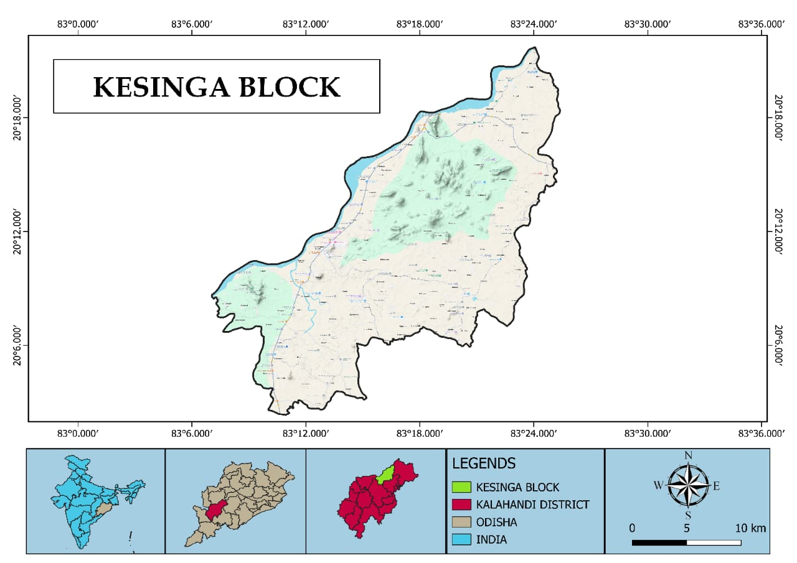
Figure 1. Showing study area i.e Kesinga block of Kalahandi district of Odisha, India
Methods
The survey was conducted in the Kesinga block of Kalahandi district, Odisha, India, during the summer and rainy seasons (March to September 2025). Collection made bimonthly from first and last week of month. The study primarily focused on the collection of adult Culex mosquitoes, both indoors and outdoors. Indoor sampling was carried out from cowsheds and sheep sheds, while outdoor collections were made from human dwelling sewage areas and household drainage sites. Adult Culex mosquitoes were collected using manual aspiration methods (Figure 2).
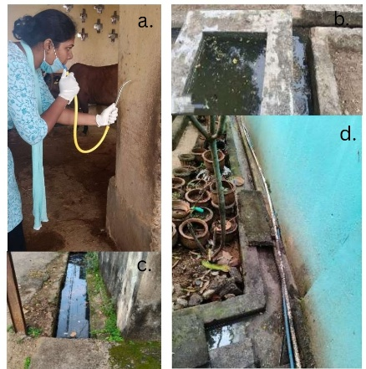
Figure 2. (a) capturing of mosquitoes by manual aspirator, (b), (c) & (d) different breeding sites of Culex mosquito
Following collection, two to three adult specimens were transferred into test tubes fitted with cotton stoppers to ensure proper aeration. All collected specimens were then transported to the laboratory for identification. During each collection, details such as time, date, geotagged photographs, and other relevant field data were recorded. Morphological identification of the specimens was conducted using recent standard identification keys (Reuben et al., 1994; Das, 2013; Gyawali et al., 2025; Andrews et al., 2025). Only Culex mosquitoes were selected for analysis, and the sex of each specimen was documented for further study. For every collection session, data were recorded on the total number of Culex mosquitoes captured, along with the counts of males and females. Secondary data were obtained from the Community Health Centre (CHC), Kesinga, which included information on the total number of individuals affected by Lymphodema. Meteorological parameters such as average temperature, relative humidity, and rainfall were collected from online sources (www.accuweather.com) and used for correlation analysis.
Data Analysis
A month-wise correlation analysis was conducted between the total mosquito population, total males, and total females with key environmental variables such as rainfall, relative humidity, and average temperature. The correlation coefficients were generated using appropriate statistical software to determine the strength and direction of these relationships.
RESULTS
A total of 197 adult Culex mosquitoes were collected from the study area during the study period, comprising 103 males and 94 females. The maximum number of adult mosquitoes (35) was recorded in August, followed by 31 in May, 30 in March, 27 in July, 26 in April, and 24 each in June and September. The lowest number of Culex mosquitoes was observed in June and September (Table 1).

Table 1. Monthly data on Culex mosquitoes were collected throughout the year 2025, including records of total males and females
Month (2025) | Total collected Culex mosquitoes | Male mosquitoes | Female mosquitoes
March | 30 | 20 | 10
April | 26 | 14 | 12
May | 31 | 13 | 18
June | 24 | 18 | 6
July | 27 | 16 | 11
August | 35 | 12 | 23
September | 24 | 10 | 14
Total | 197 | 103 | 94

The number of male mosquitoes was highest in March, followed by 18 in June, 16 in July, 14 in April, 13 in May, 12 in August, and the lowest number (10) in September. In total, 103 male Culex mosquitoes were collected. Similarly, 94 adult female mosquitoes were captured, with the maximum count (23) in August, followed by 18 in May, 14 in September, 12 each in April and July, 10 in March, and the minimum count (6) in June (Table 1). Seasonal variation indicated that mosquito density was higher during the rainy season compared to the summer season. A total of 110 adult mosquitoes were recorded in the rainy season (46 males and 54 females), whereas 87 adults were captured in the summer season (47 males and 30 females).
Morphological identification using taxonomic keys confirmed the presence of three common species of Culex: Cx. gelidus, Cx. quinquefasciatus, and Cx. vishnui (Figure 3). Among these, Cx. vishnui was the most abundant species in the study area.
A positive correlation was observed between the total number of mosquitoes captured and both average temperature and average rainfall, with correlation coefficients of 0.155 and 0.032, respectively. Conversely, the correlation between mosquito abundance and relative humidity was negative (-0.041).

DISCUSSION
Field identification of Culex mosquitoes is generally more straightforward compared to other mosquito genera. Based on established identification keys, the collected specimens were characterized by several morphological features. Adult Culex mosquitoes typically display a brown to grayish body coloration, lacking bright metallic scales or distinct leg banding. The abdomen is characteristically blunt or rounded at the apex rather than pointed, a distinguishing feature that helps separate this genus from others (Das et al., 2024). The wings are uniformly pigmented, without mottling or spotting (Edwards, 1926). In females, the maxillary palps are notably shorter than the proboscis, unlike in Anopheles females where both structures are approximately equal in length (Robinson, 1939; Becker, 2020). When at rest or feeding, Culex mosquitoes maintain their body parallel to the surface with the proboscis directed downward (Singh et al., 2024). Additionally, members of this genus lack bristles near the thoracic spiracles, a feature present in some other mosquito taxa. Therefore, diagnostic traits such as body coloration, abdominal shape, wing pattern, palp length, and resting posture provide reliable criteria for identifying Culex mosquitoes under field conditions. In the present study, three principal species Cx. gelidus, Cx. quinquefasciatus, and Cx. Vishnui were collected (Figure 3), each recognized as an important vector of various arboviral diseases in distinct geographical regions.

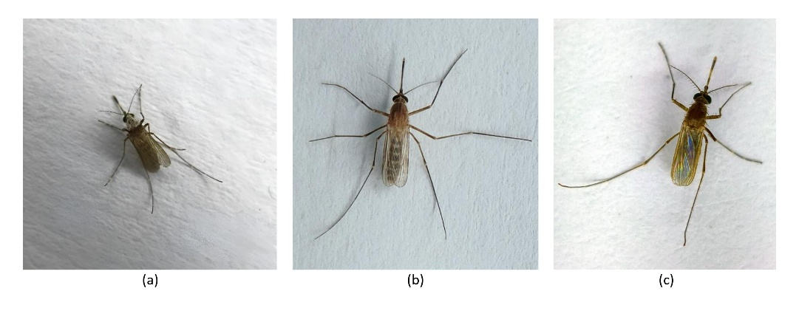
Figure 3. Culex gelidus (b) Culex quinquefasciatus, and (c) Culex vishnui

Three Culex mosquito species Cx. gelidus, Cx. quinquefasciatus, and Cx. vishnui were collected and differentiated based on distinct morphological characteristics (Figure 3). Cx. gelidus typically possesses a blunt or rounded abdominal tip. Its body is brown to grayish in color, lacking bright metallic scales or distinct leg banding, while the wings appear uniformly colored without speckling. The females have short maxillary palps, measuring distinctly less than the length of the proboscis (Reuben et al., 1994; Das, 2013; Gyawali et al., 2025; Andrews et al., 2025). Cx. gelidus is recognized as an emerging mosquito vector capable of transmitting multiple viral infections and is a major vector of Japanese encephalitis virus (JEV) in India, Southeast Asia, and Australia; and has expanded its geographic range from the Indian subcontinent to Japan, China, other Southeast Asian nations, and island countries within the Australasian region (Sudeep, 2014; George et al., 2024). The study of Sudeep (2014) there was notable rise in its population had been observed, particularly in urban and suburban areas, making it a dominant mosquito species (Cx. gelidus) in several countrie. however, in our study Culex gelidus was found to be the more dominant species compared with other Culex species. Owing to its significant vectorial capacity, numerous studies have been conducted on this species across different countries. Ang et al. (2025) recently examined the spatiotemporal prevalence and characterization of lineage I insect-specific viruses isolated from Cx. vishnui. Furthermore, Laojun et al. (2025) investigated the influence of meteorological factors and seasonality on the population dynamics and wing plasticity of Culex mosquitoes in coconut plantations of central Thailand. Several meta-analyses have also been conducted to assess the vectorial importance and ecological adaptability of this species (Griep et al., 2025), further emphasizing their epidemiological significance.

Cx. quinquefasciatus is a medium-sized mosquito, measuring approximately 4 mm in length. It is predominantly golden brown, with darker pigmentation on the proboscis, thorax, wings, and tarsi. The head appears lighter brown with a distinct central pale spot. The abdomen bears narrow, rounded, pale bands along the basal margins of the tergites, while the legs are uniformly colored, lacking distinct banding. The female antennae are nearly equal in length to the proboscis, and the wings are uniformly covered with dark scales (Reuben et al., 1994; Das, 2013; Gyawali et al., 2025; Andrews et al., 2025). This species is an important vector of several diseases and demonstrates vectorial importance comparable to that of Cx. gelidus (Buckner et al., 2025). Cx. quinquefasciatus exhibits a broad geographic distribution throughout tropical and subtropical regions, including the Indian subcontinent, Southeast Asia, Africa, Australasia, the Americas, and parts of Oceania (Samy et al., 2016). It thrives in a wide range of ecological habitats but shows a marked preference for urban and semi-urban environments, breeding primarily in polluted water bodies such as septic tanks, drains, and sewage systems (Mackay et al., 2009). The species is recognized as the principal vector of bancroftian filariasis, caused by the nematode Wuchereria bancrofti, thereby posing significant public health challenges in endemic regions (Krishnamoorthy et al., 2004).

Cx. vishnui can be morphologically distinguished by its relatively tapered abdomen, which is more slender than that of Cx. gelidus (Figure 3). The species displays faint banding on both the abdomen and legs, though these markings are less distinct compared to other Culex species. The female maxillary palps are short relative to the proboscis but slightly longer than those of Cx. gelidus. Cx. vishnui is a predominant vector species within the Oriental region, particularly across Southeast Asia, where it constitutes a major component of local mosquito fauna (Maquart et al., 2022). It is best known as a principal vector of the Japanese encephalitis virus (JEV), although it has also been reported to harbor at least thirteen other arboviruses of medical and veterinary importance (Maquart et al., 2022). Female Cx. vishnui mosquitoes primarily feed on pigs and birds, which serve as natural reservoirs of JEV, but they also feed on cattle and humans. This opportunistic feeding behavior enhances their role as bridge vectors, facilitating zoonotic transmission of arboviruses. Such ecological adaptability allows Cx. vishnui to sustain and amplify virus transmission in densely populated regions, thereby posing significant public health concerns. The species is widely distributed across the Asia-Pacific region, inhabiting rural, peri-urban, and urban environments. It is frequently associated with rice cultivation landscapes and other aquatic habitats rich in vegetation (Das et al., 2006).

Figure 4. Monthly collection of total Culex mosquitoes (male and female) and associated environmental parameters (average temperature, relative humidity, and rainfall)

The monthly variation in mosquito populations—male, female, and total—in relation to climatic factors such as rainfall, relative humidity, and average temperature from March to September reveals important patterns in Culex dynamics. Rainfall and relative humidity both show a marked increase from May through August, peaking in August, which coincides with the highest total mosquito population observed. Male and female numbers remain relatively low during drier months but increase significantly with increased rainfall and humidity. In contrast, average temperature fluctuates only slightly during this period and appears to have an inverse relationship with relative humidity. Interestingly, the total Culex mosquito collection in this study showed a significant positive correlation with average temperature and rainfall but a negative correlation with relative humidity. These findings align with previous research by Ciota et al. (2014), which reported increased mosquito mortality at temperatures above 30°C, leading to decreased adult longevity and reproductive output. Similarly, Cx. quinquefasciatus larvae develop faster as temperature rises toward an optimal point, favoring population growth, but excessively high temperatures have detrimental effects. The study by Tahir et al. (2023) further notes that correlations between relative humidity and Culex abundance can vary by region and species, sometimes lacking statistical significance, consistent with this study's finding of no significant relationship with humidity. Rainfall plays a critical role in breeding habitat availability for Culex mosquitoes. Moderate and consistent rainfall patterns optimize mosquito population peaks, whereas both insufficient and excessive rainfall limit abundance by either reducing breeding sites or flushing out larvae. Valdez et al. (2017) similarly found that rainfall influences Culex population dynamics, emphasizing the importance of an optimal rainfall range. This study confirms a significant positive correlation between Culex abundance and rainfall, underscoring rainfall’s pivotal role in shaping mosquito populations. The interplay of climatic factors drives Culex population fluctuations: temperature and rainfall positively influence abundance up to optimal thresholds, while relative humidity’s effect is more variable and context-dependent.

Study Limitations
This study has several important limitations that should be addressed in future research. Firstly, species-specific investigations of Culex are necessary to accurately assess population dynamics and the influence of environmental factors on each species. Molecular studies are also needed to examine the presence of viruses or other microbes in the gut of different Culex species, which could illuminate their role in pathogen transmission. Additionally, the geographic scope of the study should be expanded to cover a larger area for more comprehensive results. Continuous monitoring over multiple years is essential to understand long-term trends and variations in mosquito populations.
Another important aspect is the need to analyze the relationship between Culex populations and different types of vegetation or crop cultivation, as this might affect mosquito breeding and abundance. Importantly, investigations into the causes of local lymphoedema should be prioritized, given the apparent association with mosquito presence in the area. A thorough assessment should also be conducted to identify all Culex species present in the study region, as previous records indicate several lymphoedema cases that may be linked to mosquito vectors. Addressing these limitations will greatly enhance the understanding of Culex ecology and its public health implications in the area.
CONCLUSIONS
The study provides evidence of clear seasonal variation in Culex mosquito populations, closely associated with rainfall and temperature, wherein population peaks correspond to periods of increased rainfall and moderate temperatures. Rainfall is critical as it creates breeding habitats, while temperature influences mosquito development and survival, with extreme heat above optimal levels having a detrimental effect. Relative humidity exhibited variable relationships, showing a negative correlation in this study but differing regionally. The study highlights important limitations, including the need for species-specific population assessments, expanded geographic coverage, long-term surveillance, molecular pathogen studies, and investigations into local disease vectors like those associated with lymphoedema. These findings emphasize the necessity for integrated, multi-faceted research approaches to fully understand Culex mosquito ecology and improve vector control and disease prevention strategies.

REFERENCES
- Accu Weather, https://www.accuweather.com/en/in/kesinga/189830/april-weather/189830 (Accessed on 01/10/2025)
- Ali, A. S., Iqbal, A., Kamalanathan, T., Gnanaprakasam, A. R., Shajahan, S., Alsadeq, M. H., ... & Al-Deeb, M. A. (2025). The southern house mosquito Culex quinquefasciatus in Abu Dhabi, UAE, is developing resistance to deltamethrin insecticide. Scientific reports, 15(1), 3411. https://doi.org/10.1038/s41598-025-87843-6
- Andreadis, T. G. (2012). The contribution of Culex pipiens complex mosquitoes to transmission and persistence of West Nile virus in North America. Journal of the American Mosquito Control Association, 28(4s), 137-151. http://dx.doi.org/10.2987/8756-971X-28.4s.137
- Andrews, C., Longbottom, J., Lutomiah, J., & Lord, J. S. (2025). Field studies of Culex mosquitoes in Tanzania and Kenya: A systematic review motivated by changing Rift Valley fever virus transmission patterns. Medical and Veterinary Entomology. https://doi.org/10.1111/mve.12811
- Ang, C. C. W., Ang, A. T. Y., Yam, J., Lee, R. X., Lim, M. J., Loh, Z. Y., ... & Setoh, Y. X. (2025). Spatiotemporal prevalence and characterization of the lineage I insect-specific flavivirus, Quang Binh virus, isolated from Culex gelidus mosquitoes in Singapore. Journal of General Virology, 106(6), 002105. https://doi.org/10.1099/jgv.0.002105
- Becker, N. et al. (2020). Morphology of Mosquitoes. In: Mosquitoes. Fascinating Life Sciences. Springer, Cham. https://doi.org/10.1007/978-3-030-11623-1_5
- Brugman, V. A., Hernández-Triana, L. M., Medlock, J. M., Fooks, A. R., Carpenter, S., & Johnson, N. (2018). The role of Culex pipiens L.(Diptera: Culicidae) in virus transmission in Europe. International journal of environmental research and public health, 15(2), 389. https://doi.org/10.3390/ijerph15020389
- Buckner, E. A., Romero-Weaver, A. L., Schluep, S. M., Bellamy, S. K., Zimler, R. A., Kendziorski, N. L., ... & Whitehead, S. A. (2025). Evaluation of the In2care Mosquito Station against Culex quinquefasciatus mosquitoes (Diptera: Culicidae) under semifield conditions. Journal of Medical Entomology, 62(1), 146-154. https://doi.org/10.1093/jme/tjae124
- Burgess, N. R. H., & Cowan, G. O. (1993). Mosquitoes. In A Colour Atlas of Medical Entomology (pp. 9-30). Dordrecht: Springer Netherlands.
- Ciota, A. T., Matacchiero, A. C., Kilpatrick, A. M., & Kramer, L. D. (2014). The effect of temperature on life history traits of Culex mosquitoes. Journal of medical entomology, 51(1), 55-62. https://doi.org/10.1603/ME13003
- Crawford, J. E., Balcazar, D., Redmond, S., Rose, N. H., Youd, H. A., Lucas, E. R., ... & White, B. J. (2025). 1206 genomes reveal origin and movement of Aedes aegypti driving increased dengue risk. Science, 389(6766), eads3732. https://doi.org/10.1126/science.ads3732
- Das, B.P. (2013). Pictorial Key to Common Species of Culex (Culex) Mosquitoes Associated with Japanese Encephalitis Virus in India. In: Mosquito Vectors of Japanese Encephalitis Virus from Northern India. Springer Briefs in Animal Sciences. Springer, India. https://doi.org/10.1007/978-81-322-0861-7_3
- Das, P. K., Sivagnaname, N., & Amalraj, D. D. (2006). Population interactions between Culex vishnui mosquitoes and their natural enemies in Pondicherry, India. Journal of Vector Ecology, 31(1), 84-88. https://doi.org/10.3376/1081-1710(2006)31[84:PIBCVM]2.0.CO;2
- Das, S., Mukhiya, I.A., Hazra, T., Roy, S., Das, A. (2024). Mosquito Morphology: Anatomy to Adaptation in the Shadow of Evolution. In: Omkar (eds) Mosquitoes. Springer, Singapore. https://doi.org/10.1007/978-981-97-4163-2_3
- Dickson BFR, Graves PM, McBride WJ. Lymphatic Filariasis in Mainland Southeast Asia: A Systematic Review and Meta-Analysis of Prevalence and Disease Burden. Trop Med Infect Dis. 2017 Jul 27;2(3):32. doi: 10.3390/tropicalmed2030032. PMID: 30270890; PMCID: PMC6082107.
- Edwards, F. W. (1926). Mosquito notes.—VI. Bulletin of Entomological Research, 17(2), 101-131.
- Else, K. J., Keiser, J., Holland, C. V., Grencis, R. K., Sattelle, D. B., Fujiwara, R. T., ... & Cooper, P. J. (2020). Whipworm and roundworm infections. Nature reviews Disease primers, 6(1), 44. https://doi.org/10.1038/s41572-020-0171-3
- Fimbo, A. M., Minzi, O. M., Mmbando, B. P., Barry, A., Nkayamba, A. F., Mwamwitwa, K. W., ... & Aklillu, E. (2020). Prevalence and correlates of lymphatic filariasis infection and its morbidity following mass ivermectin and albendazole administration in Mkinga District, North-Eastern Tanzania. Journal of Clinical Medicine, 9(5), 1550. https://doi.org/10.3390/jcm9051550
- George, F. M., Venkatesan, S., Srinivasan, V., Semalaiyappan, J., & Kuttiatt, V. S. (2024). DNA barcoding and phylogenetic analysis of the vector Culex gelidus and its global and public health significance. Journal of Vector Ecology, 49(2), S5-S9.https://doi.org/10.52707/1081-1710-49.2.S5
- Gopalakrishnan, R., Veer, V. (2018). Bioecology, Insecticide Susceptibility and Management of Culex quinquefasciatus Say, 1823: A Major Vector of Lymphatic Filariasis in India. In: Tyagi, B. (eds) Lymphatic Filariasis. Springer, Singapore. https://doi.org/10.1007/978-981-13-1391-2_16
- Government of India Press Information Bureau Government https://www.pib.gov.in/PressNoteDetails.aspx?NoteId=152023&ModuleId=3 (Accedded on 01/10/2025)
- Griep, J. S., Grant, E., Pilgrim, J., Riabinina, O., Baylis, M., Wardeh, M., & Blagrove, M. S. (2025). Meta-analyses of Culex blood-meals indicates strong regional effect on feeding patterns. PLoS neglected tropical diseases, 19(1), e0012245. https://doi.org/10.1371/journal.pntd.0012245
- Gyawali, N., Russell, T. L., Burkot, T. R., & Devine, G. J. (2025). A morphological identification key to the mosquito disease vectors of the Pacific. Austral Entomology, 64(1), e70003. https://doi.org/10.1111/aen.70003
- Impact Assessment Report on Lymphatic Filariasis elimination Programme in India. https://india-pharma.gsk.com/media/7679/final-impact-assessment-report-on-lf-fy-22-23.pdf. (Accessed on 01/10/2025)
- Jemberie, W., Dugassa, S., & Animut, A. (2025). Biting Hour and Host Seeking Behavior of Aedes Species in Urban Settings, Metema District, Northwest Ethiopia. Tropical Medicine and Infectious Disease, 10(2), 38. https://doi.org/10.3390/tropicalmed10020038
- Krishnamoorthy, K., Subramanian, S., Van Oortmarssen, G. J., Habbema, J. D. F., & Das, P. K. (2004). Vector survival and parasite infection: the effect of Wuchereria bancrofti on its vector Culex quinquefasciatus. Parasitology, 129(1), 43-50. https://doi.org/10.1017/S0031182004005153
- Laojun, S., Sumruayphol, S., & Chaiphongpachara, T. (2025). Influences of meteorological factors and seasonality on the population dynamics and wing plasticity of Culex mosquitoes (Diptera: Culicidae) in coconut plantations in central Thailand. Journal of Animal Behaviour and Biometeorology, 13(2), 2025017-2025017. https://doi.org/10.31893/jabb.2025017
- Mackay, A. J., Amador, M., Diaz, A., Smith, J., & Barrera, R. (2009). Dynamics of Aedes aegypti and Culex quinquefasciatus in septic tanks. Journal of the American Mosquito Control Association, 25(4), 409-416. https://doi.org/10.2987/09-5888.1
- Manguin, S., Bangs, M. J., Pothikasikorn, J., & Chareonviriyaphap, T. (2010). Review on global co-transmission of human Plasmodium species and Wuchereria bancrofti by Anopheles mosquitoes. Infection, Genetics and Evolution, 10(2), 159-177. https://doi.org/10.1016/j.meegid.2009.11.014
- Maquart, P. O., Chann, L., & Boyer, S. (2022). Culex vishnui (Diptera: Culicidae): an overlooked vector of arboviruses in South-East Asia. Journal of Medical Entomology, 59(4), 1144-1153. https://doi.org/10.1093/jme/tjac044
- Nchoutpouen, E., Talipouo, A., Djiappi-Tchamen, B., Djamouko-Djonkam, L., Kopya, E., Ngadjeu, C. S., ... & Antonio-Nkondjio, C. (2019). Culex species diversity, susceptibility to insecticides and role as potential vector of Lymphatic filariasis in the city of Yaoundé, Cameroon. PLoS neglected tropical diseases, 13(4), e0007229. https://doi.org/10.1371/journal.pntd.0007229
- Panigrahi, S.K., Priyadarshini. O., Jena, A., Jhankar, A., Mishra, S. (2024). Review of feeding, biting and resting behaviour of Aedes aegypti and Aedes albopictus . Int J Mosq Res, 11(3):01-11. https://doi.org/10.22271/23487941.2024.v11.i3a.771
- Reuben, R., Tewari, S. C., Hiriyan, J., & Akiyama, J. (1994). Illustrated keys to species of Culex (Culex) associated with Japanese encephalitis in Southeast Asia (Diptera: Culicidae). Mosquito systematics, 26(2), 75-96.
- Robinson, G. G. (1939). The mouthparts and their function in the female mosquito, Anopheles maculipennis. Parasitology, 31(2), 212-242.
- Sabesan S, Raju KH, Subramanian S, Srivastava PK, Jambulingam P. Lymphatic filariasis transmission risk map of India, based on a geo-environmental risk model. Vector Borne Zoonotic Dis. 2013 Sep;13(9):657-65. doi: 10.1089/vbz.2012.1238. Epub 2013 Jun 29. PMID: 23808973; PMCID: PMC3777552.
- Samy, A. M., Elaagip, A. H., Kenawy, M. A., Ayres, C. F., Peterson, A. T., & Soliman, D. E. (2016). Climate change influences on the global potential distribution of the mosquito Culex quinquefasciatus, vector of West Nile virus and lymphatic filariasis. PloS one, 11(10), e0163863. https://doi.org/10.1371/journal.pone.0163863
- Samy, A. M., Elaagip, A. H., Kenawy, M. A., Ayres, C. F., Peterson, A. T., & Soliman, D. E. (2016). Climate change influences on the global potential distribution of the mosquito Culex quinquefasciatus, vector of West Nile virus and lymphatic filariasis. PloS one, 11(10), e0163863. https://doi.org/10.1371/journal.pone.0163863
- Sholikah, R. W., Nuriyah, A. R., & Indrawanti, A. S. (2025). MLMI-2024: The dataset of mosquito larvae microscopic images (Aedes aegypti and Culex quinquefasciatus) collected from Surabaya, Indonesia. Data in Brief, 111641. https://doi.org/10.1016/j.dib.2025.111641
- Singh, H., Akhtar, N., Gupta, S.K. (2024). Biology of Mosquitoes. In: Omkar (eds) Mosquitoes. Springer, Singapore. https://doi.org/10.1007/978-981-97-4163-2_5
- Sudeep, A. B. (2014). Culex gelidus: an emerging mosquito vector with potential to transmit multiple virus infections. Journal of Vector Borne Diseases, 51(4), 251-258.
- Tahir, F., Bansal, D., Rehman, A. U., Ajjur, S. B., Skariah, S., Belhaouari, S. B., ... & Al-Ghamdi, S. G. (2023). Assessing the impact of climate conditions on the distribution of mosquito species in Qatar. Frontiers in Public Health, 10, 970694. https://doi.org/10.3389/fpubh.2022.970694
- Tolsá-García, M. J., Wehmeyer, M. L., Lühken, R., & Roiz, D. (2023). Worldwide transmission and infection risk of mosquito vectors of West Nile, St. Louis encephalitis, Usutu and Japanese encephalitis viruses: a systematic review. Scientific Reports, 13(1), 308. https://doi.org/10.1038/s41598-022-27236-1
- Valdez, L. D., Sibona, G. J., Diaz, L. A., Contigiani, M. S., & Condat, C. A. (2017). Effects of rainfall on Culex mosquito population dynamics. Journal of theoretical biology, 421, 28-38. https://doi.org/10.1016/j.jtbi.2017.03.024
- Western, N. A. C. M. I. (1990). Relative abundance and blood feeding behavior of nocturnally active culicine mosquitoes in western Kenya.
- WHO, https://www.who.int/news-room/fact-sheets/detail/lymphatic-filariasis (Accessed on 01/10/2025)
- Zhao H, Xu T, Shen H. Global, regional, and national disability-adjusted life years and prevalence of lymphatic filariasis from 1990 to 2021: A trend and health inequality analysis based on the global burden of disease study 2021. PLoS Negl Trop Dis. 2025 Apr 29;19(4):e0013017. doi: 10.1371/journal.pntd.0013017. PMID: 40300002; PMCID: PMC12040265.

