Original Research Article

Improvement in the water quality of Ganesh idol immersed Indrayani River in the presence of AgNPs immobilized sodium alginate beads

.
ABSTRACT

Now a days, water pollution is serious problem but after the Ganesh festival it becomes a serious problem because of immersion Ganesh idol in River water. It affects pH of water, level of dissolved oxygen, increases hardness of water and majorly affecting aquatic life. Government has suggested many solutions for that for example provided separate tanks for the immersion of Ganesh Idol. But later what we do of that water, are we giving proper treatment to that water? Because that water also contains some amount of POP, toxic chemicals, metal ion.
This study investigates the impact of Ganesh idol immersion on the water quality of the Indrayani River at Alandi, Pune, during the period of August 2024 to January 2025. Key physicochemical parameters—pH, dissolved oxygen (DO), biological oxygen demand (BOD), chemical oxygen demand (COD), and total hardness—were analyzed before and after idol immersion. The results indicated a marked deterioration in water quality, with significant increases in BOD, COD, and hardness levels, and a sharp decline in DO. Additionally, silver nanoparticles (AgNPs) were tested for their antimicrobial potential in treating contaminated samples. AgNPs-treated samples showed reduced microbial growth and improved water quality parameters, confirming their potential as an eco-friendly purification tool. The study highlights the urgent need for sustainable immersion practices and the exploration of nanotechnology-based interventions for safeguarding aquatic ecosystems.

Keywords: Ganesh Idol immersion, AgNPs, BOD, COD etc

1. INTRODUCTION

Ganpati festival is one of the most important festivals in Maharashtra, but along with joy and enjoyment it also invites the tremendous pollution of water bodies which primarily affect aquatic life and water quality. This causes a kind of domino effect in which species depending on water bodies get affected and must face Sevier ecological damage within a span of only a few days and creates lots of problem to aquatic animals too.
If we trace the root cause for this damage, we can conclude that the idols contain various organic and inorganic chemicals. As immersion of idols takes place in water bodies concentration of these chemicals exceeds beyond permissible level as far as pollution standards are concerned. Nowadays these idols are made up of POP which is nothing but gypsum or Calcium Sulphate. Solubility of gypsum is only 0.26g per litter, so when lots of idols are immersed in a small pond it gets accumulated in that water body (1).
Ganesh idols are often decorated with toxic paints which contains heavy metals such as lead and mercury which seeps into the water after the idol immersion, and adds to the acidic level of water which is not good for the environment and marine life. It can also cause several diseases in humans (2).
Water quality is critical to ecological balance and public health. However, cultural, and religious activities often contribute significantly to river pollution in India. Ganesh Chaturthi, a widely celebrated festival, involves large-scale idol immersion in rivers such as the Indrayani, leading to the release of heavy metals, paints, and non-biodegradable materials. Previous studies have reported severe ecological consequences, including decreased dissolved oxygen, increased heavy metal concentrations, and biodiversity loss (3).
In response to growing concerns, researchers have explored advanced treatment methods. Silver nanoparticles (AgNPs) are of particular interest due to their antimicrobial and catalytic activities, showing potential for removing heavy metals and organic contaminants (3 and 4).
This study aims to: Assess the changes in water quality of the Indrayani River before and after idol immersion as well as the after the treatment of immobilized AgNPs, Evaluate the antimicrobial efficacy of silver nanoparticles in improving water quality, and suggest sustainable approaches for mitigating immersion-related pollution.

2. MATERIALS AND METHODOLOGY

Sodium alginate, Cacl₂, AgNO₃, NaOH, Manganese Sulfate and alkaline potassium iodide, HgSO_{4,} potassium dichromate, Sulphuric acid, ferrous ammonium sulphate, Ferroin indicator, Eriochrome black indicator all have purchased from Hi Media Pvt. Ltd.

2.1 Preparation of sodium alginate-AgNPs beads:
Sodium alginate (2%) beads and Fagopyrum esculentum starch, 5 mM silver nanoparticles were mixed and the drop-by-drop addition into 2N NaOH with the help of a syringe, and kept on a stirrer for the cross-linking of the silver nanoparticles for 1h.

2.2 Water Testing
The Indrayani River originates near Lonavala and flows through pilgrimage centers Dehu and Alandi. Samples were collected from Indrayani Ghat, Alandi (18.677901, 73.893817), before and after idol immersion.

Physical parameters
Temperature
Water sample collected from tap, before immersion of Ganpati idol and after immersion of Ganpati idol Indrayani River. Ensured the thermometer is cleaned and undamaged. Bulb of the thermometer was immersed into the liquid without touching the container’s sides or bottom. Thermometer was kept in container until the reading stabilizes (usually 30 seconds to 1 minute. Temperature was read at eye level, aligning with the top of the liquid column inside.
Temperature is a physical quantity that expresses the degree of hotness or coldness of a substance or environment. It reflects the average kinetic energy of the particles in a substance:
- Higher temperature = particles move faster.
- Lower temperature = particles move slower.
pH
Calibrated pH was used for pH checking of water. Electrode of pH was rinsed with DW to avoid contamination. Electrode was immersed in every collected sample of tap water, before immersion of Ganpati idol and after immersion of Ganpati idol Indrayani River water and gently stirred and wait for the reading to stabilize. pH value was recorded which displayed on the meter.

Dissolved Oxygen
BOD bottles were filled with all collected samples (tap water, before immersion of Ganpati idol and after immersion of Ganpati idol Indrayani River water) without any air bubble and sealed immediately. Manganese Sulfate (2 mL) and alkaline potassium iodide solution (2 mL) were added to the sample. Samples were mixed thoroughly by stopper the bottle tightly and inverting several times. If oxygen is present brown precipitate will form and let it settled down the precipitate forming a clear zone above. Finally concentrated sulfuric Acid (2 mL) was added to dissolve the precipitate. Mix thoroughly, Iodine equivalent to DO is now in solution.
Above samples were titrated against standard sodium thiosulfate solution until the color changes from yellow to pale straw. Starch indicator was added – the solution turns blue. Titration was continued with dropwise addition until the blue color disappears (end point).
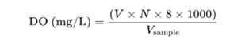
Biological Oxygen Demand (BOD)

BOD bottles were filled with all collected samples (tap water, before immersion of Ganpati idol and after immersion of Ganpati idol Indrayani River water) without any air bubble and sealed immediately. Manganese Sulfate (2 mL) and alkaline potassium iodide solution (2 mL) were added to the sample. Samples were mixed thoroughly by stopper the bottle tightly and inverting several times. If oxygen is present brown precipitate will form and let it settled down the precipitate forming a clear zone above. Finally concentrated sulfuric Acid (2 mL) was added to dissolve the precipitate. Mix thoroughly, Iodine equivalent to DO is now in solution. All BOD bottles were kept in BOD incubator for 5days of incubation. After incubation, above samples were titrated against standard sodium thiosulfate solution until the color changes from yellow to pale straw. Starch indicator was added – the solution turns blue. Titration was continued with dropwise addition until the blue color disappears (end point).
Chemical Oxygen Demand (COD)
Test for Chemical Oxygen Demand: Collected water samples (10 mL) were taken in a round bottom flask with some porcelain pieces to prevent the solution from bumping into the flask. During the heating of sample 1mL of mercury sulphate (HgSO₄) solution was added to flask and mixed. In the above mixture 5 mL of potassium dichromate (K2Cr2O7) solution was added. Finally, 15 ml silver sulphate sulphuric acid solution was added dropwise or carefully. Reflex condenser was connected and digestion of the content using a hot plate for 2 hours. After digestion, flask was cooled and rinsed with 25 ml of distilled water collecting in same flask.
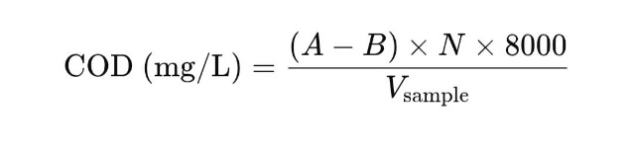
Ferroin indicator was added to flask and titrated against 0.025 M ferrous ammonium sulphate solution to the endpoint. Blank preparation was prepared in the same manner as sample using distilled water instead of the sample.

Total Hardness
Total hardness is caused mainly by the presence of calcium (Ca²⁺) and magnesium (Mg²⁺) ions in water. It is expressed in mg/L as CaCO₃. Collected water samples (50 mL) (tap water, before immersion of Ganpati idol and after immersion of Ganpati idol Indrayani River water) were pipette out into a clean conical flask. Followed with the addition of 2 mL of pH 10 buffer solution to maintain alkaline conditions. 2–3 drops of Eriochrome Black T (EBT) indicator was added. Solution turns in wine red in the presence of Ca²⁺ and Mg²⁺ ions. Finally, samples were titrating against 0.01 M EDTA solution and titrate until the color changes from wine red to blue (end point).
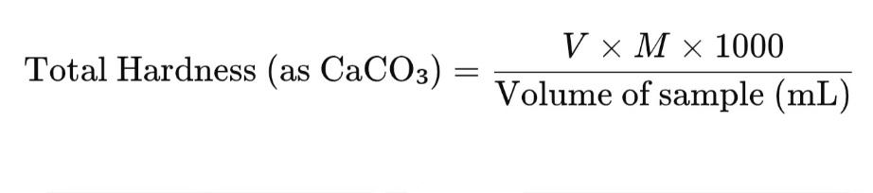
Antimicrobial Treatment
Cell vaibility checked using colony count method:::
The antibacterial activity of the collected water samples tap water, before immersion of Ganpati idol and after immersion of Ganpati idol Indrayani River water, Sodium alginate AgNPs beads (Na-AL AgNPs beads) treated water was investigated with the help of cell vaibility test using colony count method as follows: 10µL sample from collected water sample spread on LB agar plates. The plates were incubated for 24 h at 37 ⁰C. Bacterial count was calculated by counting colonies on all plates.

3. results and discussion

this study investigating how water quality is disturbing because of not proper dissolution of Ganpati Idol. Earlier there was only one idol in whole society but now complete culture has changed. Each house is curious for Ganpati Sthapana but this way we are only responsible for disturbance of environment. This Ganpati idol immersion in river water affects the quality of water and indirectly impacts on environment life. It releases chemical, metals in water and decreases the dissolved oxygen and increases the hardness of water.

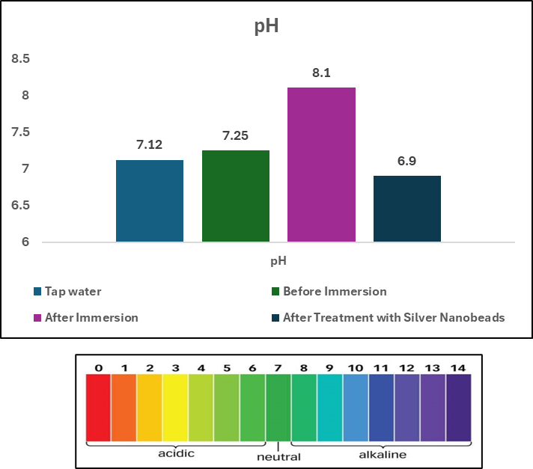

Figure 1: pH of all collected water samples

pH stands for “potential of hydrogen” and measures how acidic or basic (alkaline) a solution is. It is a scale from 0 to 14. As per the pH scale and figure 1 the pH of tap water is 7.12 which count as a neutral pH and about the water sample which is collected before the Ganesh idol immersion is 7.25 on the other hand the pH of water which is collected after the immersion 8.1 shows slightly alkaline properties. Due to the immersion of Ganesh idol affects the physiological parameters of water and it indirectly shows effect on aquatic life. It is a negative impact on aquatic animals.

Temperature:

Figure 2: Temperature of all collected water samples

Temperature is one important physical parameter which directly influence some chemical reactions in aquatic ecosystem. Low temperature favored the dissolution of dissolve oxygen. Warm water is more susceptible to Eutrophication a build-up of nutrients and possible algal Blooms, because photosynthesis and bacterial decomposition both works faster at higher temperature.
Immersion of Ganesh idol is not affecting temperature parameter of water as compared to before immersion. Temperature showed very slight increase (figure 2).

Dissolved oxygen
Dissolved oxygen in ground water refers to the concentration of free oxygen molecules available for aquatic life and geochemical process, typically measured in mg/L. Dissolved oxygen of collected samples of water was drastically reducing after immersion of Ganesh idol in river. Low DO suggests the high organic content and can lead anaerobic conditions. But after the treatment with Na-Al-AgNPs beads showed impact on dissolved oxygen increased the level of DO till the 4.2 (Figure 3) as compared to immersed water of river.
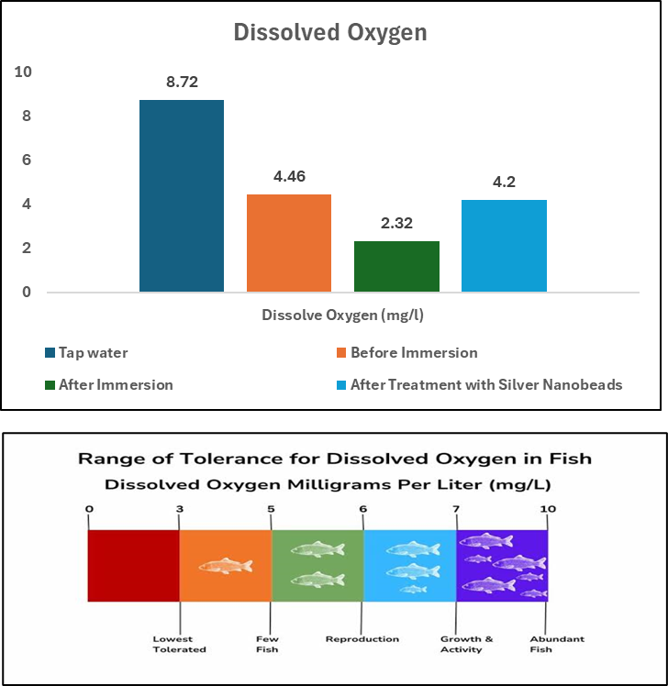

Figure 3: Dissolved Oxygen of all collected water samples

Biological Oxygen Demand

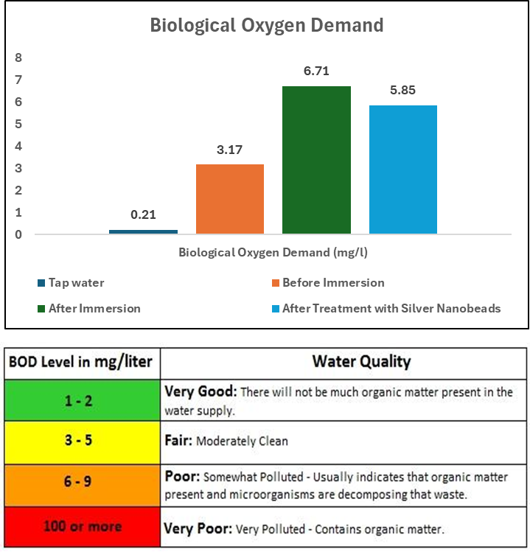

Figure 4: Biological Oxygen Demand of all collected water samples

As per seen in figure 4, immersion of Ganesh idol in river water it showed significant effect on BOD level of water. BOD of water it indicates how much water quality and it is clean as well as sustainability of aquatic life under water. As BOD level increases water quality decreases and sustainability of aquatic life is in danger. After the treatment of Na-AL-AgNPs beads slight increase in BOD was observed. AgNPs beads treatment is safe to clean the water organic content for maintain the life of water.

Chemical Oxygen Demand

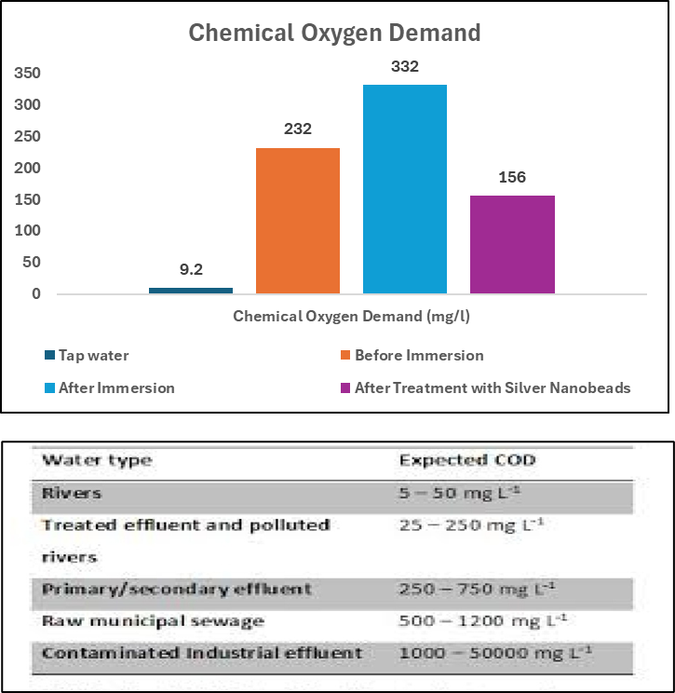

Figure 5: Chemical Oxygen Demand of all collected water samples

BIS (Bureau of Indian Standards) sets permissible limits for various water quality parameters, including COD (Chemical Oxygen Demand), which is a measure of the amount of oxygen required to oxidize organic and inorganic matter in water. So, the COD value of water sample of before immersion is 232 mg/L and after immersion the value comes 332 mg/L which consider as primary/secondary effluent as per the standard chart. As seen in the figure 5, Ganesh idol immersed water treated with Na-Al-AgNPs beads and observed that COD of water decreased. AgNPs are helping in the maintenance of COD of water.

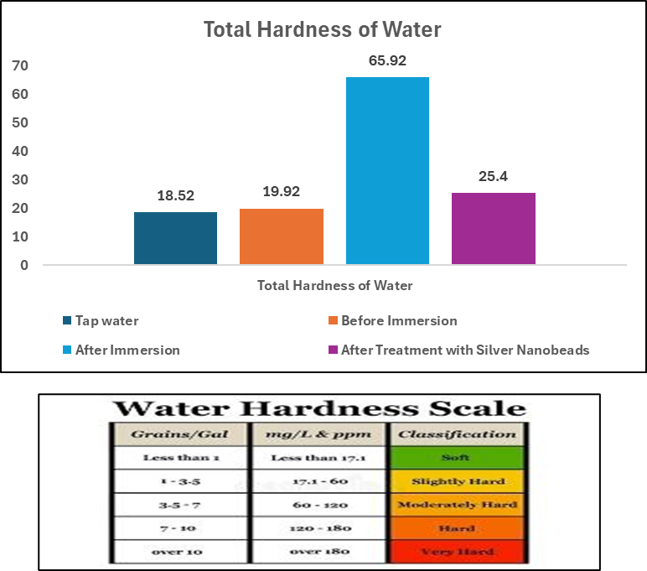

Figure6: Total hardness of all collected water samples

Total hardness of tap water is 18.52 mg/L consider as slightly hard. Water which is before immersion of Ganesh ideal is 19.52 mg/L. As per below chart it slightly hard. Total hardness of water which is after immersion of Ganesh idol is 65.92 mg/L which consider as moderately hard water. This immersed Ganesh Idol water treated with Na-Al-AgNPs beads and it seen that hardness of water decreased.

Antimicrobial activity of all collected and treated water samples
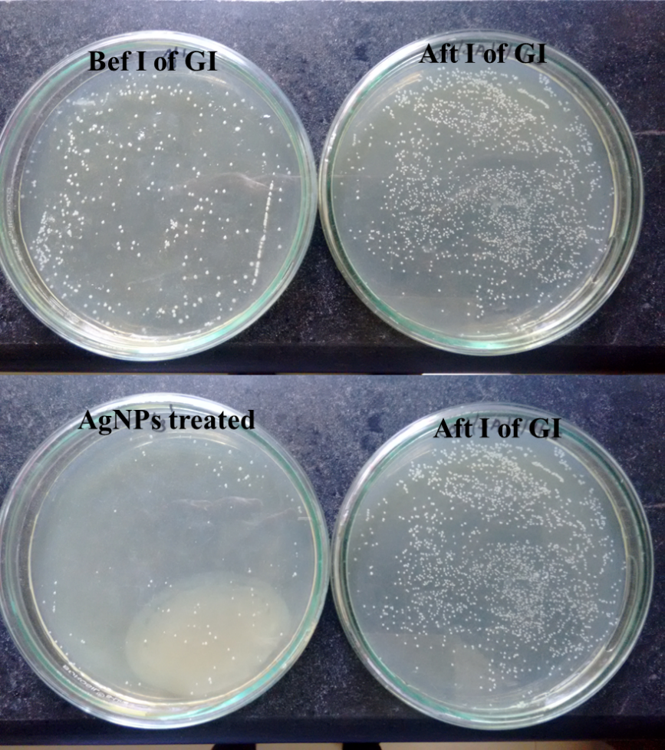

Figure 7: Antibacterial activity of all collected water against E.Coli
Bef I of GI- Before immersion of Ganpati Idol, Aft I of GI- After immersion of Ganpati Idol, AgNPs treated- Na-Al-AgNPs beads treated water

Bacterial growth observed of all collected water samples as well as Na-Al-AgNPs beads treated water which Ganpati Idol immersed water. As per seen in figure 6, before immersion of Ganpati idol Indrayani River showed moderate bacterial growth on LB plates and after immersion of Ganpati Idol Indrayani River water showed significant increase in bacterial growth that concludes water is contamination is increasing. But as observed in above figure bacterial contamination of Ganesh Idol immersed water was reducing after the treatment of Na-Al-AgNPs beads for minimum 5 days. This result concludes the antibacterial activity of silver nanoparticles.

4. Conclusion

The study demonstrates that Ganesh idol immersion significantly deteriorates Indrayani River water quality by increasing BOD, COD, and hardness while reducing DO levels. Silver nanoparticles exhibited strong antimicrobial properties and effectively improved water quality parameters in laboratory conditions.
It is also important to note that extended exposure to silver nanoparticles may cause toxicity due to ion release, as observed after 5 days in treated water samples. Hence, while AgNPs are promising in short-term microbial reduction, their safe application requires strict monitoring and regulatory evaluation before large-scale use.

References
- Banerjee, A., et al. (2021). Silver-based nanocomposites for festival water pollution treatment. Environmental Nanotechnology, Monitoring & Management, 16, 100344.
- Patil, P. N., & Ghole, V. S. (2005). Idol immersion activities cause pollution of water bodies. Environmental Science and Engineering, 47(4), 247–251.
- Ahmed, S., Saifullah, Ahmad, M., Swami, B. L., & Ikram, S. (2016). Green synthesis of silver nanoparticles using Azadirachta indica aqueous leaf extract. Journal of Radiation Research and Applied Sciences, 9(1), 1–7.
- Rai, M., Yadav, A., & Gade, A. (2009). Silver nanoparticles as a new generation of antimicrobials. Biotechnology Advances, 27(1), 76–83.
- Singh, R., Gautam, N., Mishra, A., & Gupta, R. (2016). Heavy metals and living systems: An overview. Indian Journal of Pharmacology, 43(3), 246–253.

