Original Research Article

GROSS AND HISTOPATHOLOGICAL SCORE LESIONS IN ISA BROWN COCKS EXPERIMENTALLY INFECTED WITH SALMONELLA GALLINARUM

ABSTRACT
The present study investigated the gross and histopathological score lesions in Isa brown cocks experimentally infected with salmonella gallinarum. A total of 40 Isa brown cocks were randomly assigned into two groups of 20 each: Salmonella gallinarum infected and Salmonella gallinarum uninfected. At twenty three-week-old, each bird in the infected group of cock was inoculated orally into the crop by oral gavage, with 9.0 x 10⁸ CFU/ml Salmonellagallinarum while cocks in the control group were administered 1ml of distilled water each. The clinical signs observed in the infected group were moderate (24.7%) with mortality and morbidity of 37% and 50%, respectively. The clinical signs include: loss of appetite, somnolence and yellow-green diarrhoea. The body weights in the infected cocks were significantly (P <0.05) lower than those of uninfected cocks. Gross pathology was mild in the infected cocks on days 21 and 28 post infection and which include enlarged and congested liver, enlarged spleen and congested kidneys; moderate on days 14 and 15 pi, and severe from days 8 to 12 post infection. Histopathological changes were mild in the infected cocks on day 28 pi and were severe on days 8 and 14 pi, but moderate on days 15 and 21 pi, and which include; lymphoid depletion in the spleen, necrosis of the renal renal tubules, diffused necrosis of the hepatic cords, testicular necrosis, desquamation of the bronchiolar epithelium. The gross and histopathology findings observed in the Salmonella gallinarum infected Isa brown cocks in this study, suggest that the severity of Salmonella gallinarum on the multiple organs of the infected Isa brown cocks which resulted in mortality as observed in this present study.
Keywords: Experimental infection, Isa brown cocks, Pathology, Salmonella gallinarum,

INTRODUCTION
Fowl typhoid (FT), is one of the most important peracute, acute or chronic septicaemic bacterial disease of poultry that affects primarily chickens and turkeys, but pheasants, quails, and guinea-fowl are also susceptible (Casagrande et al., 2014; Barde et al., 2017). Salmonella is a Gram-negative, facultatively anaerobic, non-spore-forming bacteria of the Enterobacte- riaceae family (Heredia et al., 2018; Ferrari et al., 2019; Zhou et al., 2022; Chacón et al., 2023).). Salmonella species are divided into two serovars (serotype) that is Salmonella enterica and Salmonella bongori based on the lipopolysaccharide (O), flagella protein (H), and sometimes the capsule (Vi) antigen (Minor, 1984; Ferrari et al., 2019). Salmonella enterica has six subspecies, namely, Salmonella enterica subsp. enterica, Salmonella enterica subsp. salamae, Salmonella enterica subsp. arizone, Salmonella enterica subsp. diarizone, Salmonella enterica subsp. houtenae, and Salmonella enterica subsp. indica (Hurley et al., 2014). The serovars that mostly affect the poultry industry are nonmotile and belong to the species known as Salmonella enterica subspecies enterica serovar gallinarum and pullorum (Barrow et al.,1994; Shivaprasad, 1997). Fowl typhoid (FT) has been listed by Office International des Epizooties (OIE, 2018) among notifiable diseases of the World because of the associated huge economic losses in the poultry industry world wide. economic losses in the poultry industry (Shivaprasad, 2000; Wigley, 2017; OIE, 2018).
The vast majority (about 99%) of Salmonella strains that cause infections in humans or other warm-blooded animals belong to the species Salmonella enterica (Pławinska et al., 2022), which due to the wide variety, has been divided into groups and serological types and currently includes 2659 serovars (Qin et al., 2022). The main reservoir of Salmonella enterica subsp. enterica are breeding animals such as poultry, pigs, and cattle (Shaheen et al.,2020). In humans, Salmonella typhi is responsible for systematic infections and typhoid fever, whereas paratyphoid is caused by the Salmonella enterica of the Paratyphi A, Paratyphi B, or Paratyphi C serovars (Dos Santos et al., 2018). Fowl typhoid (FT) Efforts at controlling fowl typhoid through the application of a co-ordinated policy of hygienic measures, together with serological testing and slaughter of positive reactors, led to the seemingly eradication of Salmonella enterica serovar gallinarum in many developing countries such United State, Canada, Western Europe and among others except in sporadic instances from backyard poultry flocks (Barrow & Freitas, 2011; Wigley, 2017; Zhou et al., 2022). Although, recently there has been renewed interest in Salmonella gallinarum as a model to be used for understanding host adaptation and pathogen evolution (Wigley, 2017). Despite the availability of vaccines, FT remains enzootic in Nigeria. In Nigeria, avian Salmonellosis has been reported to be a serious cause of mortality in the poultry industry (Agbaje et al., 2010; Saidu et al.(1994). A survey report revealed the prevalence of FT in sampled flocks at 2.54% and 4.3% Oladele and Raji (1997) respectively in Zaria. Ibrahim et al. (2003) reported an outbreak of fowl typhoid in three commercial poultry farms in Zaria, in which Salmonella gallinarum was isolated. The acute form of the disease manifests as respiratory distress and depression with a characteristic clinical sign of greenish-yellow to bloody diarrhoea (Garcia et al., 2010), and there may be enlarged and congested liver, spleen and kidney. The liver may have white foci of 2-4 mm in diameter (Beyaz et al., 2010). However, there is paucity
of information on the gross and histologic score lesions in response to S. gallinarum infection in Isa brown cocks. Therefore understanding the pathological response to FT infec tion in cocks is significant, as these could open windows for development of more diag nostic approach and, also, form the basis in development of more therapeutic remedies or vaccines for the disease in the future. In this study, we investigated the gross and histopathological score lesions in Isa brown cocks experimentally infected with salmonella gallinarum.

MATERIAL AND METHODS
Ethical Clearance
Approval for the study was given by the Ahmadu Bello University Committee on animal use and care (ABUCAUC) with approval number ABUCAUC/2023/155.
Experimental animals
Forty Isa brown cockerels that were unvaccinated against fowl typhoid, but vaccinated against other infectious diseases, were purchased at day-old from a reputable local commercial hatchery and brooded for four weeks and reared to 23 weeks of age, and were randomly assigned into two groups of 20 birds each: infected and uninfected group. The birds were kept on (deep litter system) and managed intensively in the Poultry Research Pen of the Department of Veterinary Teaching Hospital ABU Zaria. The pens were thoroughly washed with detergent and sprayed with formalin at a concentration of 4 ml/1 litre of water prior to arrival of the birds. Feed and water were supplied ad libitum to the birds throughout the experiment. General care of the birds was provided in accordance with the Institutional Animal Care and Use Committee.
Experimental Design
The birds in both groups that is, infected and uninfected were examined to certify them being Salmonella-free by taking cloacal swab samples from them before inoculating with Salmonella gallinarum. Cloacal swabs from individual bird were collected and then immersed in buffered peptone water, which is then followed by plating them in MacConkey agar (MCA) and blood agar (BA) in the Department of Veterinary Microbiology, Faculty of Veterinary Medicine, Ahmadu Bello University, Zaria Kaduna State. Both cloacal swab and plates were incubated in a bacteriological incubator at 37⁰C for 48 hours according to the standard laboratory methods (Wigley et al., 2001; OIE, 2018). The strain of Salmonella enterica serovar gallinarum, used for the study was obtained from the bacterial culture bank of the Central Diagnostic Laboratory, National Veterinary Research Institute (NVRI), Vom.
Salmonella gallinarum from the previously prepared slant was reactivated by inoculating
it onto MacConkey agar (MCA) and Blood agar. The inoculation dose (colony forming units [cfu]) was determined using McFarland turbidity standards. At twenty three weeks of age, all the cocks in the infected group were inoculated orally into the crop by oral gavage at a dose of 1.0 ml inoculum containing 9x10⁸ cfu/ml of Salmonella gallinarum, while the uninfected group were not challenged with the bacterium, but were given each 1 ml of distilled water only.
Beginning from the day of infection (day 0) and throughout the experimental period, that lasted 42 days, the live weights of the cockss were recorded weekly.
Clinical and Pathological Examination
Following inoculation of the birds with the Salmonella enterica serovar Gallinarum, the infected group was observed daily for clinical signs of fowl typhoid and findings were recorded. All observations made during the six-week of experiment were recorded, accordingly and were expressed as a percentage (%) of the total number of birds per group. The average per cent of the clinical signs was then calculated over the period of days until the end of the study.The severity of clinical signs of the birds per group was graded on a scale of 0-5 using the average % clinical signs as follows 0= no clinical signs (0%), 1=mild (1-20 %), 2= moderate (21-40 %), 3= severe (41-60 %), 4= very severe (61-80 %) and 5= critical (81-100 %) based on modification of the criteria described by Ward and Thoolen (2010). The morbidity and mortality rates were determined by using the formulae as follows (Rosner, 2015):

. Gross Examination
Birds that died of FT in the course of the experiment were subjected to postmortem examination and those showing clinical signs of the disease were humanely sacrified (embolism in the heart) on day 8th , 9th ,10th.and day 15th post-infection at the Necropsy Unit of the Department of Veterinary Pathology, Faculty of Veterinary Medicine, ABU, Zaria. Gross lesions, observed, were recorded.
The gross lesions of each organ were scored and graded based on modification of the criteria described by Ward and Thoolen (2010): congestion and paleness (1), oedema (2), exudate (3), enlargement (4), turgidity (5), haemorrhage (6).
The gross lesion score of each bird was itemized per organ/tissue as total lesions being considered were divided by the specific number of lesions. Then the sum total of gross lesion score was determined per group (total number of lesion been considered for all the birds/total specific number of lesions of the birds). The lesion score were later graded as follows; 0= no lesion, 1=mild, moderate=2 , ≥ 3= severe.
Histopathological Examination
Specimens from liver, spleen, lung, kidney, and other organs were fixed in 10% neutral buffered formalin, while the testes were fixed in Bouins solution. A block of testicular tissue with the attached epididymis was trimmed for processing, embedded in paraffin, sectioned at 5 to 6 mm, and stained with haematoxylin and eosin. Selected sections was also stained with Haematoxylin and Eosin and subsequently processed, using standard techniques, for histopathological examination (Rafael et al., 2008). The tissues were cleared with xylene, embedded in molten paraffin wax blocked and labelled appropriately (Baker et al., 2000; Oladele et al., 2008). The slides were studied using light microscope at ×40, x100, x200 and x400 magnifications in order to make microscopic morphological diagnoses of the lesions on the slides. The lesions were score and graded by modification of the methods described by Collan (1989) and Gilson-Corley et al., (2013). For the liver, lungs, testes and kidneys the score criteria were; no lesion (0), congestion (1), infiltration (2), oedema (3), haemorrhage (4), and necrosis (5). For spleen, the score criteria were; no lesion (0), depletion vacuolation (1), infiltration (2), oedema (3), haemorrhage (4), cyst formation (5) and thickened inter-follicular space (6). The lesion score obtained for different organs of each bird were summed up and divided by the number of lesions to get the lesion score for that bird. The lesion score were then graded as follows; 0= no lesion, 1=mild, moderate=2 , ≥ 3= severe.
Statistical analysis
Data generated for the study were subjected to student t-test using Graph Pad Prism Version 8.00 for Windows, GraphPad Software, San Diego California USA and values of P<0.05 were considered significant.
Results
During the experimental period, no abnormal signs or mortalities were recorded in the uninfected cocks. However, at 6 days post infection, 90% of Salmonella gallinarum-infected group showed a drop in feed and water consumption. At 8 days post infection, all the cocks in the infected group showed yellowish–greenish diarrhoea with soiled vent, depression, anorexia, dehydration, somnolence, ruffled feathers, weakness and anorexia (Plates 1, 2 and 3). Clinical signs progresses up to 15 days post infection. However, in the infected group. moderate clinical signs (24.7%) were observed (Table 1). There was significant (P < 0.05) loss of weight in the Salmonella gallinarum-infected group from 8 days pi to 42 days pi, when compared with the uninfected control group. The morbidity and the mortality rate recorded in the infected group was (50%) and (35%) respectively.
The mean weekly body weight of the Salmonella enterica serovar gallinarum experimentally infected and control groups were presented in Table 2.
Days post-infection
Clinical signs | Group | Number n/N of birds with clinical signs (%) |  |  |  |  |  |  |  | Overall (%)
 |  | 8 | 9 | 10 | 11 | 12 | 13 | 14 | 15
Anorexia | Control infected | 0/20 (0.0)  10/20 (50.0) | 0/20 (0.0)  6/18 (33.3) | 0/18 (0.0)  6/16 (37.5) | 0/17 (0.0)  3/15 (20.0) | 0/16 (0.0)  4/15 (26.7) | 0/16 (0.0)  3/14 (21.4) | 0/14 (0.0)  2/14 (14.3) | 0/13 (0.0)  0/13 (0.0) | 0.0  27.2
Depression | Control infected | 0/20 (0.0)  10/20 (50.0) | 0/20 (0.0)  7/18 (38.9) | 0/18 (0.0)  6/16 (37.5) | 0/17 (0.0)  3/15 (20.0) | 0/16 (0.0)  3/15 (20.0) | 0/16 (0.0)  2/14 (14.3) | 0/14 (0.0)  0/14 (0.0) | 0/13 (0.0)  1/13 (7.7) | 0.0  25.6
Ruffled feathers | Control infected | 0/20 (0.0)  8/20 (40.0) | 0/20 (0.0)  6/18 (33.3) | 0/18 (0.0)  5/16 (31.3) | 0/17 (0.0)  4/15 (26.7) | 0/16 (0.0)  2/15 (13.3) | 0/16 (0.0)  3/14 (21.4) | 0/14 (0.0)  2/14 (14.3) | 0/13 (0.0)  1/13 (7.7) | 0.0  24.8
Huddling | Control infected | 0/20 (0.0)  8/20 (40.0) | 0/20 (0.0)  8/18 (44.4) | 0/18 (0.0)  5/16 (31.3) | 0/17 (0.0)  4/15 (26.7) | 0/16 (0.0)  2/15 (13.3) | 0/16 (0.0)  2/14 (14.3) | 0/14 (0.0)  0/14 (0.0) | 0/13 (0.0)  1/13 (7.7) | 0.0  24.0
Greenish –yellowish diarrhea | Control infected | 0/20 (0.0)  7/20 (35.0) | 0/20 (0.0)  6/18 (33.3) | 0/18 (0.0)  4/16 (25.0) | 0/17 (0.0)  4/15 (26.7) | 0/16 (0.0)  5/15 (33.3) | 0/16 (0.0)  3/14 (21.4) | 0/14 (0.0)  3/14 (21.4) | 0/13 (0.0)  2/13 (15.4) | 0.0  27.2
Somnolence | Control infected | 0/20 (0.0)  7/20 (35.0) | 0/20 (0.0)  6/18 (33.3) | 0/18 (0.0)  4/16 (25.0) | 0/17 (0.0)  3/15 ((20.0) | 0/16 (0.0)  3/15 (20.0) | 0/16 (0.0)  2/14 (14.3) | 0/14 (0.0)  0/14 (0.0) | 0/13 (0.0)  0/13 (0.0) | 0.0  20.0
Overall | Control  Infected | 0/20 (0.0)  8.3/20 (41.7) | 0/20 (0.0)  6.5/18 (36.1) | 0/18 (0.0)  5/16 (31.3) | 0/17 (0.0)  3.5/15 (23.3) | 0/16 (0.0)  3.1/15 (21.1) | 0/16 (0.0)  2.5/14 (17.9) | 0/14 (0.0)  1.2/14 (8.5) | 0/13 (0.0)  0.83/13 (6.4) | 0.0  24.7
Table 1: Clinical sings observed in infected Isa brown cocks following infection with Salmonella Gallinarum
Key: n = Number of birds affected, N = total number of birds in the group

Weeks Control Infected
0 3733 ± 6.00 3723 ± 5.14
1 3756 ± 4.40 3344 ± 1.90
2 3769 ± 6.51 3103 ± 6.24
3 3984 ± 2.21 2757 ± 5.90
4 4434 ± 4.71 2311 ± 1.91
5 4877 ± 2.13 2126 ± 3.00
6 4891 ± 3.90 1843 ± 6.95
Table 2. Mean weekly Body weight (g) in Salmonella gallinarum infected and control cocks

Gross lesions of Isabrown cocks in the infected group experimentally infected with Salmonella Gallinarum
The various gross lesions observed in organs of the Salmonella enterica serovar gallinarum-
infected birds are shown in Plates 4-9. These lesions include, hepatomegally and multiple pale foci of necrosis of the liver, bronze discolouration of liver, splenomegaly enlarged, discoloured and congested kidney, congested and haemorrhagic testes with prominent vessels, congested and necrotic lungs, atrophied and abnormally shaped testes with purulent exudate and areas of necrosis.

The mean (SEM ±) gross lesions scores of infected Isa brown cocks and control cocks are presented inTable 3.0. In the control Isa brown cocks, a gross lesions score of zero (0) was recorded. In the infected Isa brown cocks, gross pathological changes were severe from day 8 to day 12 post-infection ( Score of 3). A moderate gross lesions score were recorded on days 14 and 15 post-infection ( Score of 2). A mild gross lesions score were recorded on days 21 and 28 post-infection (Score of 1).

Table 3: Gross lesions scores of infected Isa brown cocks and control cocks following infection with Salmonella Gallinarum

Uninfected cocks Infected cocks
Days post-infection Gross lesion score (Approximate value)
8 0 3.74 ± 0.23
9 0 3.83 ± 0.41
11 0 3.35 ± 0.11
12 0 3.25 ± 0.09
14 0 2.31 ± 0.19
15 0 2.12 ± 0.17
21 0 1.87 ± 0.16
28 0 1.87 ± 0.16
0 = No lesion, 1 = Mild, 2 = Moderate, ≥ 3= severe
The scoring criteria for lesions were;
Congestion and paleness = 1
oedema = 2
exudate = 3
enlargement = 4
turgidity = 5
haemorrhage = 6

Histopathological changes observed in the Salmonella Gallinarum-Infected lsa brown cocks
The various histopathological lesions observed in organs of the Salmonella enterica serovar gallinarum-infected birds are shown in Plates 10-16. These lesions include,marked diffuse necrosis of the hepatocytes and generalized heterophilic cellular infiltration mixed with lymphocytes, the necrosis of the splenic parenchyma and lymphoid depletion, thickened of interfollicular space of the spleen, necrosis of the glomerulus and renal tubules, pulmonary edema and necrosis of the bronchiolar epithelium, Lipid vacuole which is obvious in the testes and desquamation of the seminiferous epithelium, decrease in number of Sertoli cells, shrunken spermatogonia with pyknotic nucle

The mean ( SEM ±) histopathological score of infected Isa brown cocks and control cocks are presented in Table 3. In the control Isa brown cocks, there were no histopathological changes recorded ( Score 0). In the infected Isa brown cocks, histopathological changes recorded were severe ( Score of 3) starting from 8 to day 14 post-infection. Starting from day 8 to day 14 post-infection, the histopathological changes observed in the spleen were depletion of lymphocytes in the follicles, thickened of interfollicular space and necrosis.

Table 4: Histopathological scores of infected Isa brown cocks and control cocks following infection with Salmonella Gallinarum
Uninfected cocks | Infected cocks
Days post-infection | Histopathological score (Approximate value)
8 0 | 3.02 ± 0.12
9 0 | 3.42 ± 0.32
11 0 | 3.09 ± 0.23
12 0 | 3.04 ± 0.16
14 0 | 3.04 ± 0.10
15 0 | 2.76 ± 0.31
21 0 | 2.64 ± 0.07
28 0 | 1.98 ± 0.18
0 = No lesion, 1 = Mild, 2 = Moderate, ≥ 3= severe

The scoring criteria for the spleen were; The scoring criteria for the liver, kidney, lungs, testes, were;
No lesion = 0 Congestion = 1
Depletion vacuolation = 1 Cellular infiltration = 2
Infiltration = 2 Oedema = 3
Oedema = 3 Haemorrhage = 4
Haemorrhage = 4 Necrosis = 5
Cyst formation= 5
Thickened interfollicular space = 6

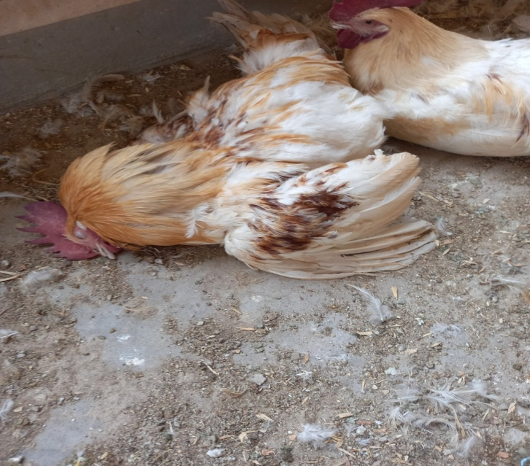
Plate 1 Isa brown cocks experimentally-infected with Salmonella enterica serovar gallinarum. Note: weakness, depression, ruffled feathers and death

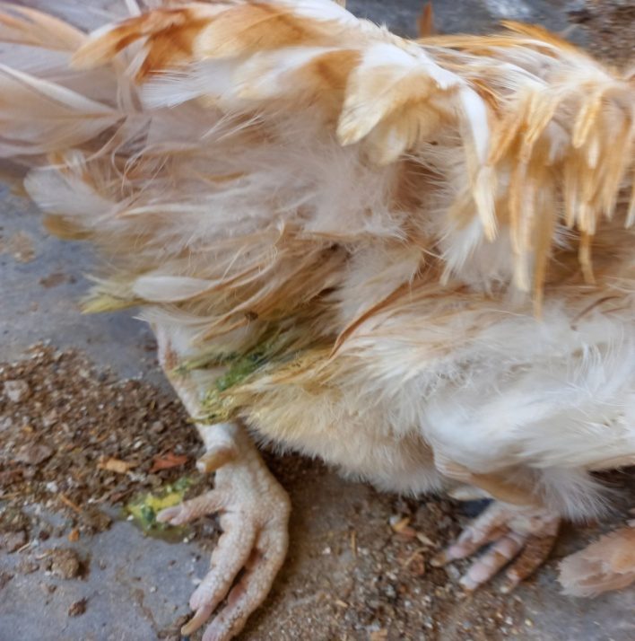
Plate 2 Isa brown cocks experimentally-infected with Salmonella enterica serovar gallinarum. Note: greenish-yellowish diarrhoea (red arrow)

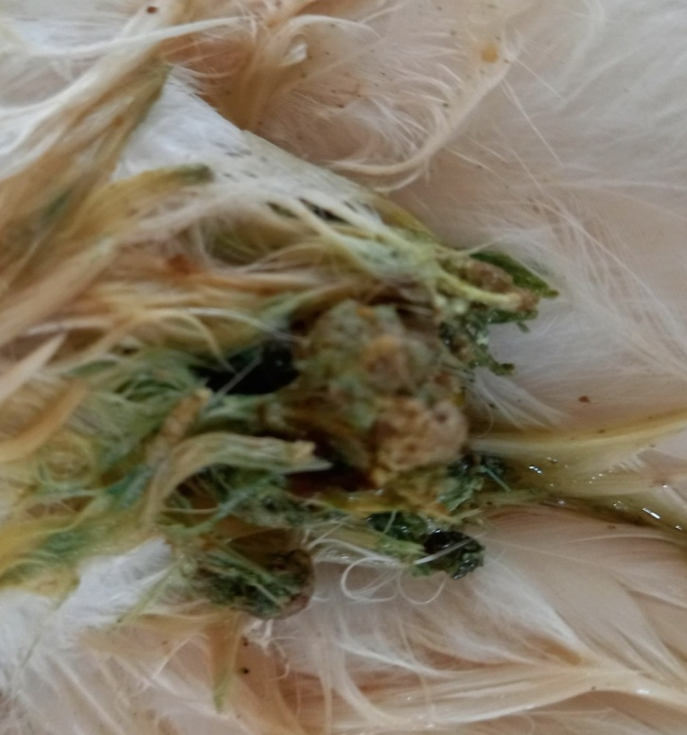
Plate 3 Isa brown cocks experimentally-infected with Salmonella enterica serovar gallinarum. Note: the greenish-yellowish diarrhea in the vent (red arrows)

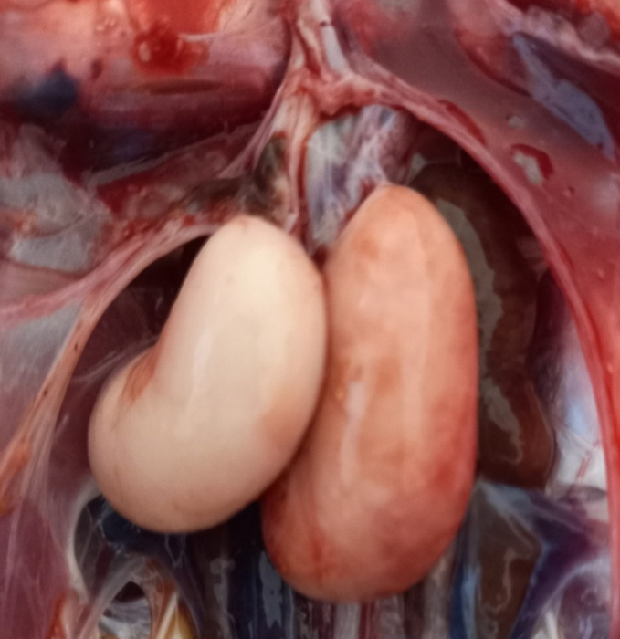
Plate 4 Photograghof testes of infected Isa brown cock. Note: Congestion and haemorrhage White arrow) (Day 14 pi)

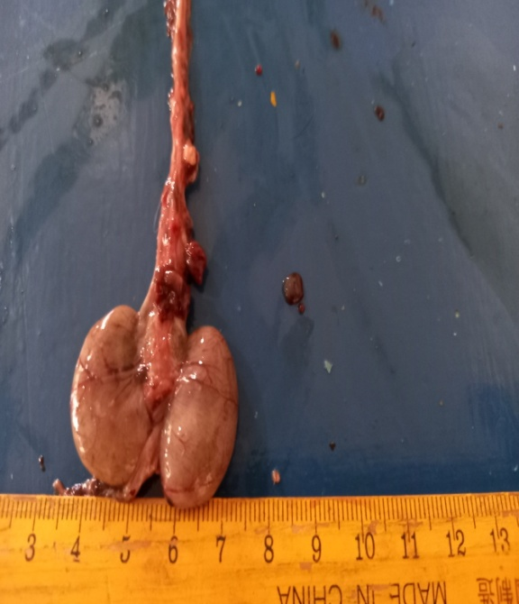

Plate 5 Photogragh of testes of Isa brown cocks experimentally infected with Salmonella Gallinarum..Note:atrophied and abnormally shaped testes with purulent exudate and areas of necrosis (Day 21 pi)

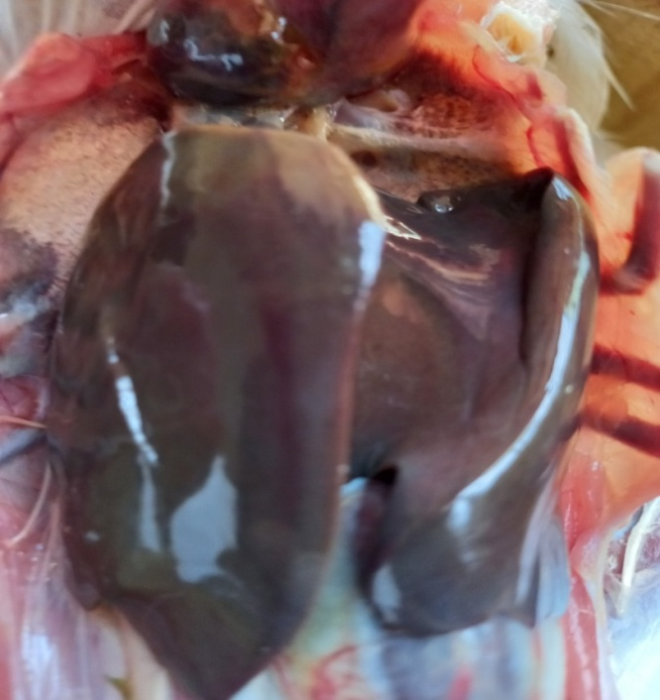
Plate 6 Photogragh of liver of infected Isa brown cock. Note: enlargement and bronze discolouration (Black arrow) ( Day 8 pi)

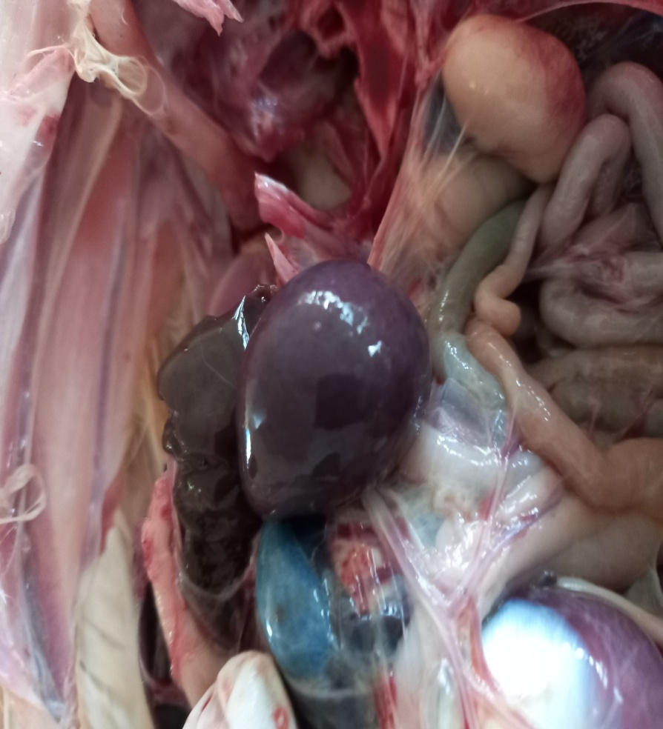
Plate 7 Photogragh of spleen of infected Isa brown cock. Note: enlargement of the spleen (Splenomegaly) (White arrow)

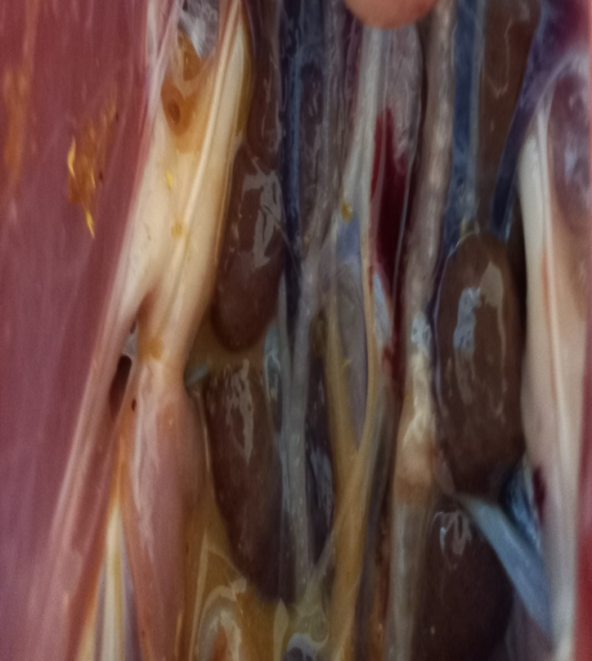
Plate 8 Photogragh of kidneys of infected Isa brown cock. Note: enlargement, discoloured and congested kidneys (White arrows)

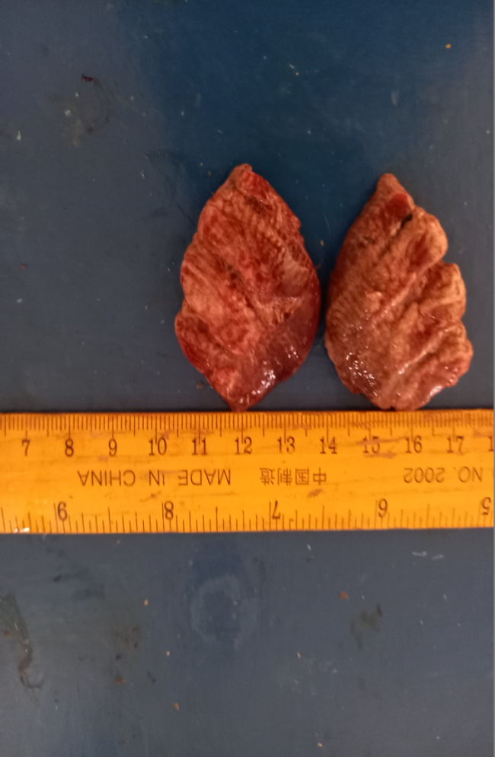
Plate 9 Photogragh of lungs of infected Isa brown cock. Note: enlargement,, congestion and necrosis ( Day 14 pi)

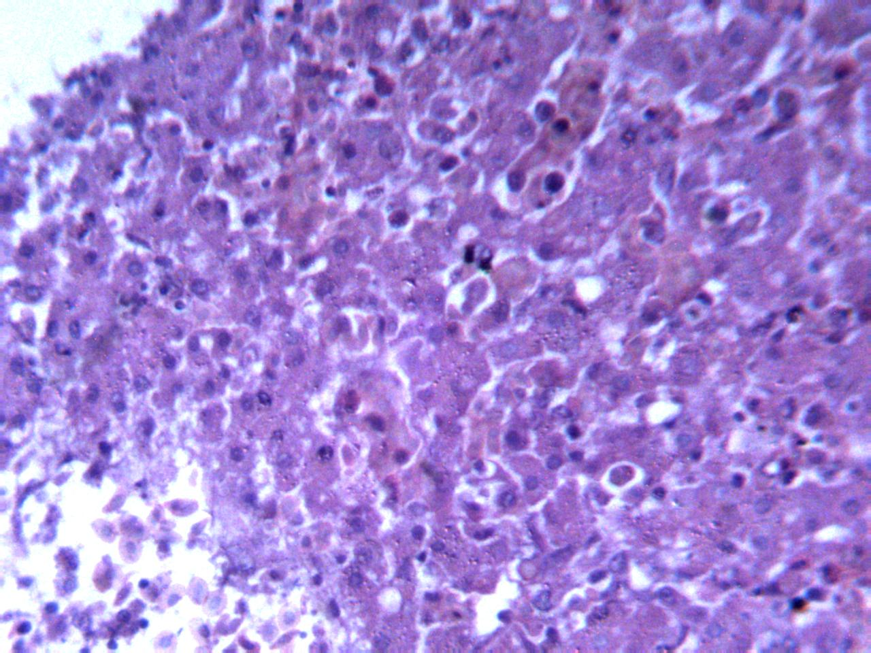
Plate 10 Photomicrograph of liver of infected Isa brown cock. Note marked diffuse necrosis of the hepatocytes and generalized heterophilic cellular infiltration mixed with lymphocytes. (Black arrows) (Days 11pi) H&E x250

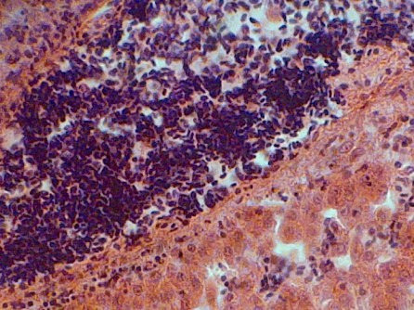

Plate 11 Photomicrograph of the liver of cocks experimentally-infected with Salmonella enterica serovar gallinarum. Note generalized heterophilic cellular infiltration mixed with lymphocytes in the hepatic portal vein (White arrows). H&E x400

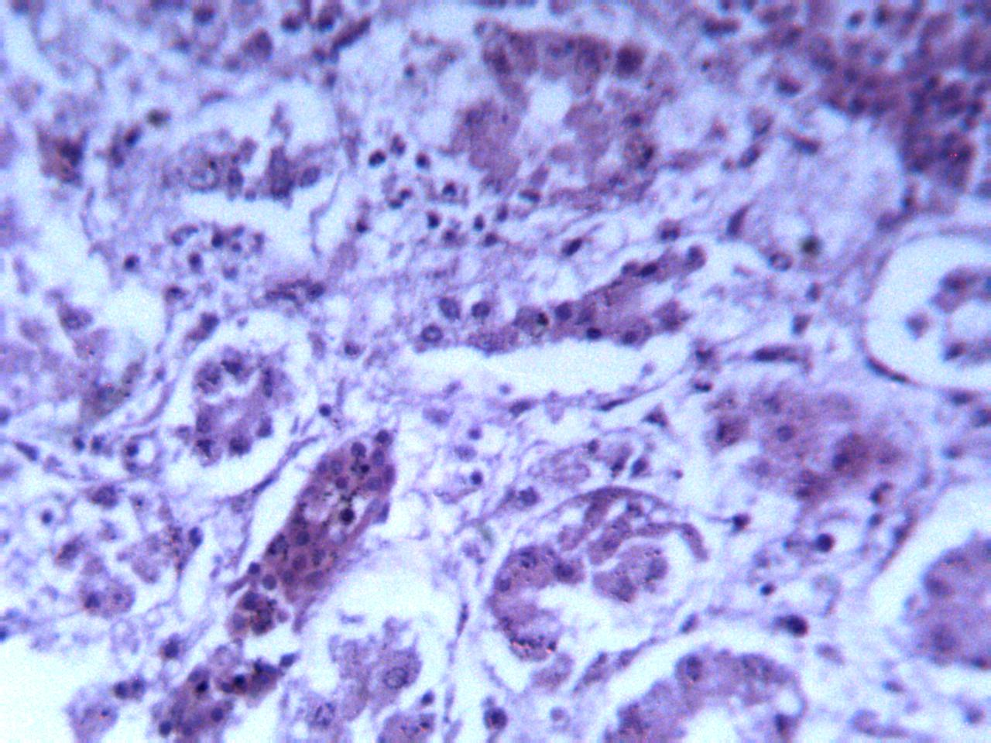
Plate 12 Photomicrograph of kidneys of infected Isa brown cock. Note: necrosis of the glomerulus and renal tubules (White arrows) (Day 14 pi) H&E x400

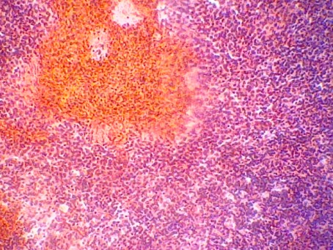

Plate 13 Photomicrograph of the spleen of cocks experimentally-infected with Salmonella enterica serovar gallinarum. Note the necrosis of the splenic parenchyma and depletion of lymphocyte (Black arrow). (Day 21 pi) H&E x400

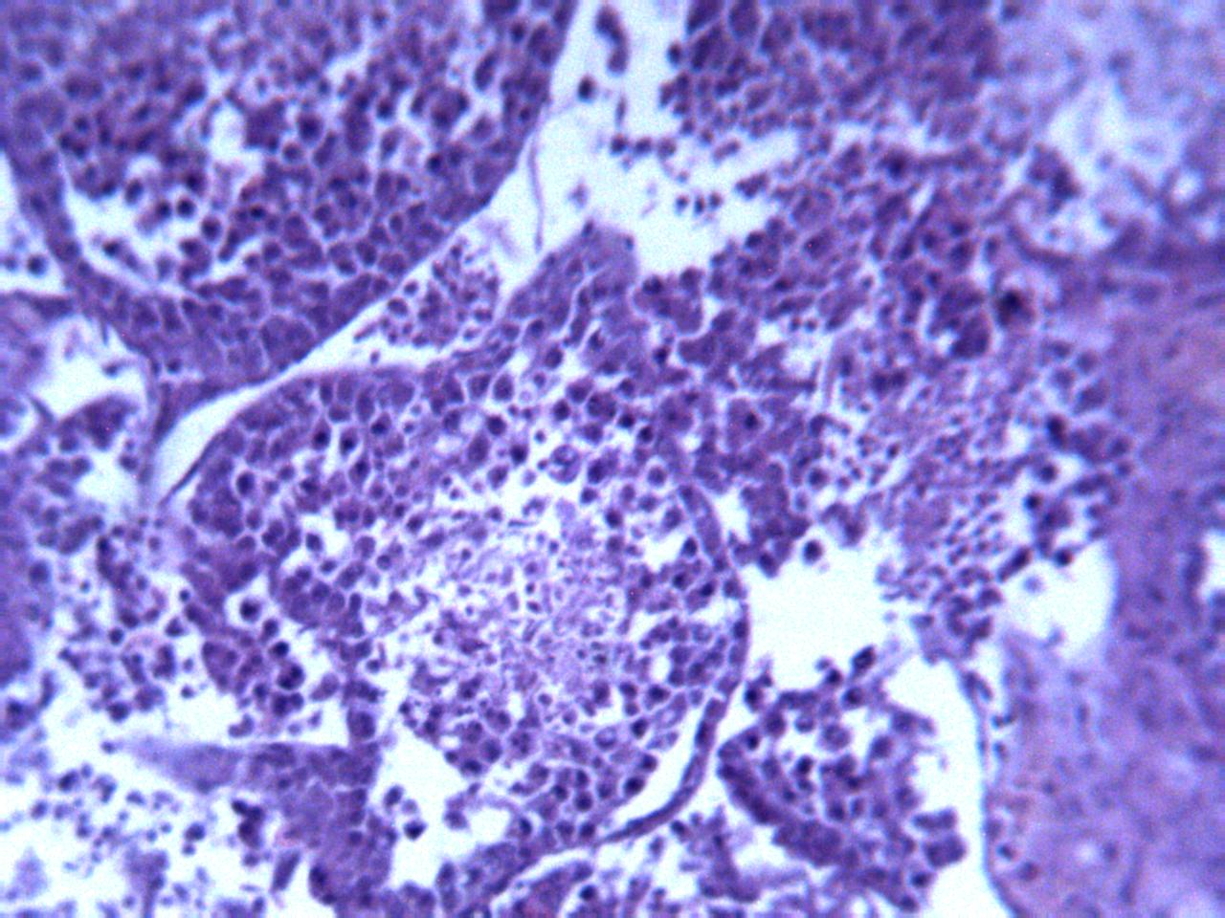
Plate 14 Photomicrograph of testes of infected Isa brown cock. Note: desquamation of the seminiferous epithelium, decrease in number of Sertoli cells, shrunken spermatogonia with pyknotic nuclei. (White arrows) (Day21pi). H&E x250

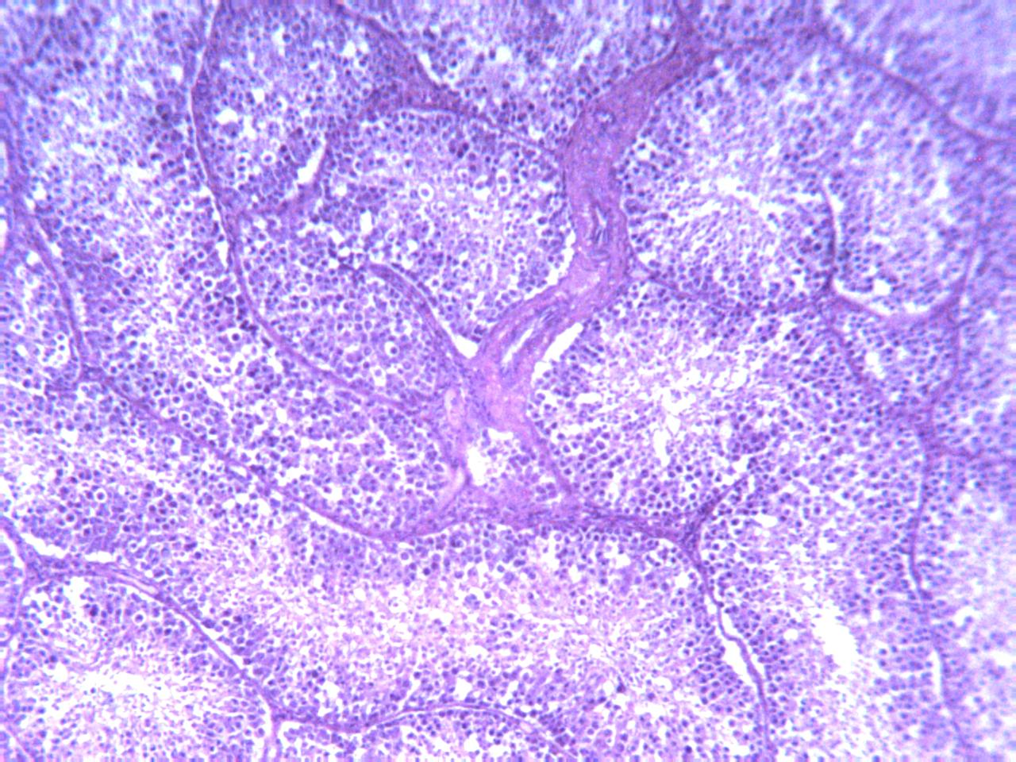
Plate 15 Photomicrograph of testes of infected Isa brown cock. Note: desquamation of the seminiferous epithelium, vacuolation, decrease in number of Sertoli cells, ( White arrows) (Day21pi). H&E x100

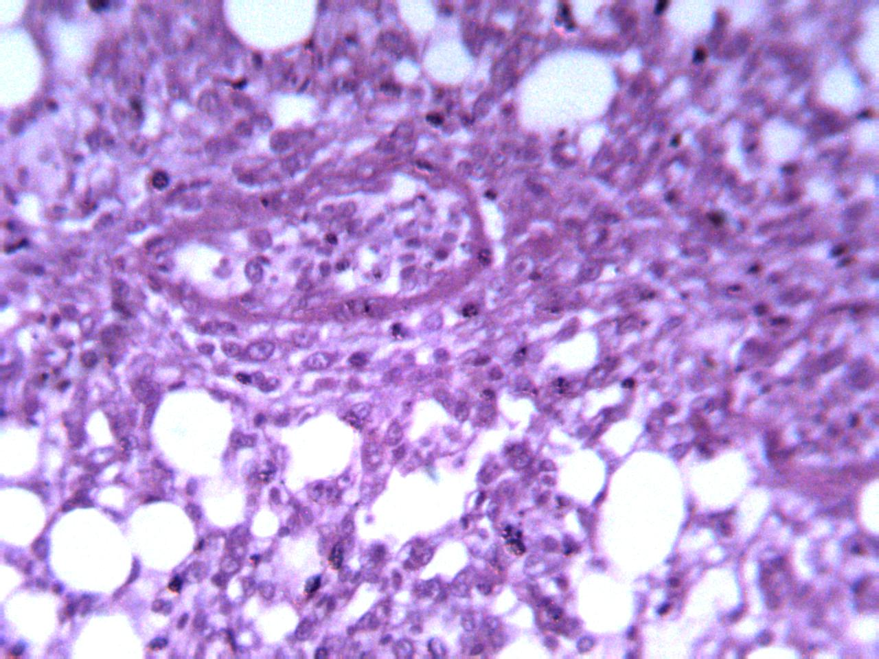
Plate 16 Photomicrograph of the lung of Isabrown cocks experimentally-infected with Salmonella Gallinarum. Note closed air cells, distention of the air cells, desquamation of bronchiolar epithelial cells and cellular infiltration. (White arrows) (Day 21 pi). H&E x250

DISCUSSION AND CONCLUSION
Following oral inoculation of the infected group with Salmonella gallinarum, the clinical signs observed in the infected Isa brown cocks in this present study include; depression, huddling, reduction in body weight, ruffled feathers, emaciation, somnolence, loss of appetite, greenish-yellow diarrhoea, paleness of the comb and wattle as well as mortality. Generally, pathological changes were characterized by hepatomegaly with multiple pale foci of necrosis and bronze discolouration of liver, splenomegaly, swollen and congested kidneys, congested liver, congested lung, congested shrunken and necrotic testes, cellular infiltration of the liver by heterophil mixed with lymphocytes, splenic disruption, cellular infiltration of the heart by heterophil mixed with lymphocytes, disorganized spermatogenic columns and fewer cells with replacement by necrotic cells, lipid vacuoles, the presence of rare Sertoli cells, few spermatids in the lumen these findings were similar to those reported by other authors (Van Roekel, 1965; Freitas Neto et al., 2007; Garcia et al., 2010; Barde et al., 2023) The lymphoid organs showed depletion of lymphocytes. The changes observed may be attributed to the virulence factors of Salmonella gallinarum. The endotoxins from Salmonella gallinarum, which is a Gram-negative bacterium, and the large virulence plasmids play a vital roles causing severe clinical signs and clinical disease in susceptible birds (Rychlik et al., 1998; Chacón et al., 2023). The gross lesions observed in the infected group may also likely due the cytopathic effect of Salmonella gallinarum lipopolysaccharide/outer memb rane proteins or indirectly by induction of antibodies or both, to the number of bacteria present in the tissues which can nitiate systemic inflammatory response by activating a variety of polymorphonuclear leukocytes and monocytic cells, thereby stimulating the release of proinflammatory cytokines (Garcia et al., 2013; Gast & Porter, 2020).
The clinical findings observed in the infected cocks in the present study may be attributed to several factors and which include; species, age, breed, the infective dose of the bacteria, dose and route of infection, the pathogenicity of the bacteria and host adaptability (Berchieri et al., 2000; Sreekantapuram et al.,2021). The clinical signs observed in the infected Isa brown cocks in this present study started at 8 days post-infection which contrast 3 days pi as reported by Garcia et al. (2010), and 7 days pi by Chiroma et al.( 2018). However, the 50% morbidity and 35% mortality
recorded in the present study in the infected cocks were not reported by other authors in 23-week-old cocks which suggests that the basis of virulence could be multifactorial. The loss of body weight observed in the Salmonella gallinarum-infected birds may be attributed to loss of appetite and dehydration, loss of villi of the small intestine which could have interfered with nutrients absorption and protein-losing enteropathy. The diarrhoea observed in the infected cocks may be due systemic infection adversely affecting normal intestinal function or may be as a result of microbial activity directly affecting the intestine. Gross pathology observed was mild in the infected cocks on days 21 and 28 pi and which include enlarged and congested liver, enlarged spleen, congested testes and congested kidneys; moderate on days 14 and 15 pi, and severe from days 8 to 12 pi and include; haemorrhage in the testes, enlarged spleen, pale spleen , intestinal haemorrhage and pulmonary necrosis. The production of septicaemia and systemic infection caused by Salmonella gallinarum in the present study could be attributed to the large plasmid virulence of Salmonella gallinarum and to the production of fowl typhoid Shivaprasad & Barrow, 2013. It has been postulated that the nature of pathogenicity of Salmonella enterica Serovar gallinarum is multifactorial (Kokosharov, 2003); however, its endotoxin plays an essential role and it is directly linked to the virulence of this micro-organism (Kokosharov, 2002). Salmonella gallinarum does not fully stimulate the innate immune system at the intestinal mucosa and that this facilitates the ability of the bacterium to cross the intestinal barrier thereby producing severe systemic disease (Lopes et al., 2016). Histopathological changes observed in the infected cocks were mild on day 28 pi, which include; congested liver, slight lymphoid depletion in the spleen; severe on days 8 and 14 pi, but moderate on days 15 and 21 pi , and which include; lymphoid depletion in the spleen, necrosis of the renal tubules, diffused necrosis of the hepatocytes, testicular necrosis, desquamation of the bronchiolar epithelium. These microscopic lesions observed in the infected cocks were similar to those early reported by (Van Roekel, 1965; Barde et al., 2023; Igwe et al., 2024). However, purulent exudates and congestion observed in the testes as well as desquamation of the bronchiolar epithelium were not reported by them. The gross and histo- pathological lesions observed in the infected cocks are highly indicative of septicaemic infection.
In conclusion, Salmonella gallinarum strain in the infected Isa brown cocks caused hepatomegaly with multiple pale foci of necrosis and bronze discolouration of liver, splenomegaly, swollen and congested kidneys, congested liver, congested lung, congested shrunken and necrotic testes, cellular infiltration of the liver by heterophil mixed with lymphocytes, splenic disruption, cellular infiltration of the heart by heterophil mixed with lymphocytes, disorganized spermatogenic columns and fewer cells with replacement by necrotic cells and among others. The information derived from this present study will be helpful in the accurate diagnosis of FT in cocks.

COMPLIANCE WITH ETHICAL STANDARDS
Funding:This research work was partly funded by the University of Maiduguri Staff Research grant scheme.

COMPETING INTERESTS DISCLAIMER:
Authors have declared that they have no known competing financial interests OR non-financial interests OR personal relationships that could have appeared to influence the work reported in this paper.

REFERENCES
Agbaje M, Davies R, Oyekunle MA, Ojo OE, Fasina FO.and Akinduti PA. 2010). Obser- vation on the occurrence and transmission pattern of Salmonella Gallinarum in commercial poultry farms in Ogun State, South Western Nigeria. African J of Microbiol Res, 4(9),796-800.
Barde IJ, Bale JOO, Fatihu MY, Dashe YG, Oluwadare ML, Ugbe DA, Oladele BS & Oke wole PA. 2017. Clinical signs associated with experimental infection of Salmonella ente rica serovar Gallinarum in Japanese quail (Coturnix coturnix japonica). Vom J of Vet Sci, 12(1), 49–56.
Barde IJ, Oladele SB, Fatihu MY, Abdu PA. 2023. Clinico-Pathological Lesions Associated with Experimental Infection of Salmonella enterica Subspecies Enterica Serovar gallinarum in Cockerels". Acta Scientific Vet Sci, 57, 159-167
Barrow PA, Huggins MB and Lowell MA. 1994. Host specificity of Salmonella infection in chickens and mice is expressed in vivo primarily at the level of the reticuloendothelial system. Infect Immun, 62:, 602-4610.
Barrow PA & Freitas Neto OC. 2011. Pullorum disease and fowl typhoid—new thoughts on old diseases: A review. Avian Pathol, 40(1), 1–13.
Baker, F.J., Silverton, R.E. and Pillister, C.J. (2000). Dehydration, impregnation, embedding technique and section preparation. Introduc to Med Lab Tech ,7th Edition. 199-242
Berchieri Jr A 2000. Salmoneloses aviárias. In: Berchieri Jr A, Macari M,editores. Doenças das aves. Campinas, Facta;.185-196.
Beyaz L, Atasever,A, Aydin F, Gumusoy KS.and Abay S. 2010. Pathological and clinical findings and tissue distribution of Salmonella gallinarum infection in turkey poults. Turkish J of Vet and Ani Sci, 34, 101-110
Casagrande RA, Wouters AT, Wouters F, Pissetti C, Cardoso MR and Driemeier D, 2014. Fowl Typhoid (Salmonella gallinarum) Outbreak in Japanese Quail(Coturnixcoturnix japo- nica). Avian Dis, 58, 491–494.
Chacón RD, Chacón JL, Ramírez M, Cueva CLR, Quispe-Rojas WU, Reyes-Moreno CB, Astolfi-Ferreira CS & Ferreira AJP. 2023. Complete genome sequence data of two Salmo- nella enterica subsp. enterica serovar Gallinarum: A 9R vaccine strain and a virulent Brazi lian field strain, 47(2352–3409): 108959.
Chiroma MA, Adamu S, Gadzama. JJ, . Esievo KAN, Abdulsalam H, Majama. YB, Bala- mi. AG, Muhammad Y, Gambo BG. 2018. Calcium metabolism-related hormonal changes in layers experimentally infected with Salmonella Gallinarum. Comparative Clinic Pathol https:// doi.org/10.1007/s00580-018-2699-0

Collan Y. 1989. General principle of grading of lesions in diagnostic histopathology. Pathology Res and Pract, 185, 539-543
Dos Santos, A.M.P.; Ferrari, R.G.; Conte–Junior, C.A. (2018). Virulence Factors in Sal -monella Typhimurium: The Sagacity of a Bacterium.Curriculum. Microbiol. 76: 762–773.
Ferrari RG, Rosario DKA, Cunha–Neto A, Mano SB, Figueiredo EES, Conte–Junior CA. 2019. Worldwide Epidemiology of Salmonella Serovars in Animal–Based Foods: A Meta–analysis. Applied. Environ Microbiol., 85, 591-19.
Freitas-Neto OC, Arroyave W, Alessi AC, Fagliari JJ. and Berchieri Jr A. 2007. Infection of commercial laying hens with Salmonella gallinarum:Clinical, anatomopathological and hae -atological studies. Brazilian J of Poult Sci, 9(2), 133-141
Garcia KO, Santana AM, Freitas Neto OC, Berchieri Jr.A. and Fagliari JJ. 2010. Experimen tal infection of commercial layers using a Salmonella enteric serovar Gallinarum strain: bl -ood serum component and histopathological changes. Brazilian J of Vet Pathol, 3(2), 111-117
Garcia KO, Berchieri Jr A, Santana AM, Alarcon MFF, Freitas Neto OC & Fagliari JJ 2013. Experimental infection of commercial layers with wild or attenuated Salmonella gallinarum mutant strains: anatomic pathology, total blood cell count and serum protein levels. Brazilian J of Poult Sci, 15(2), 91–104.
Gast RK & Porter Jr. RE. 2020. Salmonella Infections. In: Diseases of Poultry (DE Swa- yne, M Boulianne, CM Logue, LR McDougald, V Nair, DL Suarez, editors), fourteenth edition.Wiley-Blackwell, Hoboken, New Jersey, USA., 719–753.
Gilson-Corley KN, Olivier AK and Meyercholz, DK. 2013. Principle for valid histopath -ologic scoring in research. Veterinary Pathol, 50 (6), 1007-1015
Heredia N, García S.2018. Animals as sources of food–borne pathogens: A review. Animal Nutri., 4, 250–255
Hurley D, McCusker MP, Fanning S, Martins M. 2014. Salmonella—Host interactions Modulation of the host innate immune system. Front. Immun., 5, 481
Ibrahim NDG, Abdu PA, Njoku. CO,. Adeleye JO, 2003. Fowl typhoid in three commercial poultry farms in Zaria, Nigeria: Case reports. Nigerian Vet J, 24 (2): 63-67
Igwe AO, Akpan EI, Tchokote EY, Okonkwo CJ, Agada GOA, Ezema WS, Okoye JOA 2024. Pathology of experimental Salmonella gallinarum infection in turkeys (Meleagris gallopavo), Sokoto J of Vet Sci, 22(1): 41 - 53
Kokosharov T. 2002. Clinical and haematological effects of Salmonella Gallianum endotoxin in cockerel. Veterinarski Arhiv,72(5): 269-276.

Kokosharov T, 2003. Acid tolerance, bile salts and serum resistance of Salmonella Gallianum from hens. Veterinarski Arhiv, 73(5): 277-283.
Lopes PD, Freitas Neto OC, Batista DF, Denadai J, Alarcon MF, Almeida AM, Vasconcelos RO, Setta A, Barrow PA & Berchieri A Junior, 2016. Experimental infection of chickens by a flagellated motile strain of Salmonella enterica serovar Gallinarum biovar Gallinarum. The Vet J, 214(8): 40–46.
Office International des Epizooties (OIE), 2018. Fowl typhoid & Pullorum (woah.org)https:// www.woah.org/fileadmin/Home/eng/Health_standards/tahm/3.03.11_FOWL_TYPH OID. pdf, retrieved 15-05-2021.
Oladele SB and Raji MA, 1997. Retrospective studies of fungal and bacterial flora of chicken in Zaria, Nigeria. Bulletin of Ani Health and Produc in Africa, 45: 79-81.
Oladele SB, Enoch I and Ibrahim NDG. 2008.Changes in histopathology, haematocrit,haemoglobin, haemagglutination inhibition antibody titre and total protein of Japanese quails(Cotur nix coturnix japonica) administered different doses of Newcastle disease virus. Journal of Ani and Vet Advan 7(4):418-424
Pławinska–Czarnak J, Wódz K, Kizerwetter Swida, M, Bogdan J, Kwiecinski P, Nowak T,Strzał kowska Z, Anusz K, 2022. Multi–Drug Resistance to Salmonella species. When Isolated from Raw Meat Products. Antibiotics, 11, 876
Qin X, Yang M, Cai H, Liu Y, Gorris L, Aslam MZ, Jia K, Sun T, Wang X., Dong Q, 2022. Antibiotic Resistance of Salmonella Typhimurium Monophasic Variant 1,4,[5],12:i:–in Chi -na: A Systematic Review and Meta–Analysis. Antibiotics 11:532
Rafael M, Michael PM and John HB, 2008. Bacterial orchitis and epididymo-orchitis in broiler breeders, Avian Pathol, 37(6): 613-617,
Rosnerr B, 2015. Foundamental Biostatistic. 8th edition. Boston Massachusetts USA: Cenpage Learning, p 927
Rychlik I, Lovell MA & Barrow PA 1998. The presence of genes homologous to the K88 genes faeH and faeI on the virulence plasmid of Salmonella gallinarum. FEMS Microbiology Letters, 159(2): 255–260.
Saidu L, Abdu PA, Umoh JU and Abdullahi, US 1999. Diseases of Nigerian indigenous chickens, Bulletin of Ani Healt and Produc in Afri, 42:19-23
Shaheen A, Tariq A, Shehzad A, Iqbal M, Mirza O, Maslov DA, Rahman M, 2020. Tran- scriptional regulation of drug resistance mechanisms in Salmonella: Where we stand and what we need to know. World J. Microbiol. Biotech, 36, 85.
Shivaprasad HL, 1997. Pullorum disease and fowl typhoid. In B.W. Calnek., H.J. Barnes.,C.W. Beard,L.R. McDougald and Y.M. Saif (Eds.), Disease of Poult 10th edition (pp.82–96). Ames, IA: Iowa State University Press.
Shivaprasad HL 2000. Fowl typhoid and pullorum disease. Revue Scientifique et Technique (International Office of Epizootics) 19(2): 405–424
Shivaprasad HL & Barrow PA ,2013. Pullorum Disease and Fowl Typhoid. In: Diseases of Poultry (DE Swayne, JR Glisson, LR McDougald, LK Nolan, DL Suarez, V Nair, editors), thirteenth edition. Wiley-Blackwell, Ames, Iowa, USA. Pp 678–693
Sreekantapuram S, Christian B, Stefanie AB, Ulrich M, Angela B 2021. Interaction of Salmonella gallinarum and Salmonella Enteritidis with peripheral leucocytes of hens with different laying performance.Veterinary Res Pp 52:123. https://doi.org/10.1186/s13567-021-00994-y
Van Roekel H, 1965. Pullorum disease. In H.E. Biester & L.H.Schwarte (Eds.),Dis of Poult, 5th edition (Pp. 220259). Ames:The Iowa State University Press.
Ward JN, and Thoolen B, 2010. Grading of lesions. Toxicologic Pathol, 39: 227-235
Wigley P, Berchieri Jr A, Page KL, Smith AL, and Barrow PA, 2001. Salmonella enterica serovar Pullorum persists in splenic macrophages and in the reproductive tract during persistent, disease-free carriage in chickens. Infect and Immu, 69(12):7873-7879
Wigley P, 2017. Salmonella enterica serovar Gallinarum: addressing fundamental ques- tions in bacteriology sixty years on from the 9R vaccine. Avian Pathol, 46(2): 119–124
Zhou X, Kang X, Zhou K & Yue M, 2022. A global dataset for prevalence of Salmonella gallinarum between 1945 and 2021. Scientific Data, doi.10.1038/s41597-022-01605-x.

