Case Report

Recurrent Keratocysts of the Mandible in Association with Gorlin–Goltz (Nevoid Basal-Cell Carcinoma) Syndrome: A Case Report

Abstract
Objective: Odontogenic keratocysts (OKCs) are relatively rare benign intraosseous lesions of odontogenic origin. In 2005, the World Health Organization (WHO) reclassified OKCs as keratocystic odontogenic tumors due to their locally aggressive and recurrent behavior. However, the “tumor” designation was later reconsidered. In the 2017 WHO classification the term “odontogenic keratocyst” was reinstated. OKCs are typically solitary lesions presenting radiographically as unilocular or multilocular radiolucencies, most often in the mandibular molar region in the second to fourth decades of life, with a slight male predominance . Recent reports emphasize the importance of early genetic screening for PTCH1 mutations in recurrent or multiple OKCs, as they often represent the first sign of Gorlin–Goltz syndrome
Case: A 24-year-old male presented to our dental clinic with bilateral mandibular molar displacement and swelling of six years’ duration. Clinical and radiologic evaluation revealed multiple mandibular radiolucent lesions. After biopsy and subsequent genetic counselling, a diagnosis of Gorlin–Goltz syndrome (GGS) was established. The patient was followed for six years and underwent surgical excision of recurrent OKCs under general anaesthesia in 2019.
Conclusion: Early diagnosis of Gorlin–Goltz syndrome is essential due to its association with multiple cystic lesions and potential neoplastic manifestations. Detection of multiple OKCs, often the initial sign of this syndrome, allows early intervention and may prevent more severe tumours in the future.
Keywords: Gorlin–Goltz syndrome, odontogenic keratocyst, multiple keratocysts, mandibular cyst, PTCH1 gene.

Introduction
The odontogenic keratocyst (OKC) originates from remnants of the dental lamina and was first described in 1956 by Phillipsen. It is known for aggressive behaviour, rapid expansion, bone-infiltrative growth and a high tendency to recur after treatment [4,5]. Given these features and its association with the nevoid basal-cell carcinoma syndrome (NBCCS), also known as Gorlin–Goltz syndrome (GGS), the lesion’s classification has evolved over time. Gorlin–Goltz syndrome is a rare, autosomal dominant multisystem disorder characterised by developmental abnormalities and a predisposition to multiple neoplasms. It is principally caused by germline mutations in the PTCH1 gene, located on chromosome 9q22.3-q31 [6]. The syndrome has been denominated under several synonyms such as basal cell nevus syndrome, multiple basal cell carcinoma syndrome, and fifth phacomatosis.The estimated prevalence of GGS ranges from about 1 in 50,000 to 1 in 150,000 persons, with equal occurrence in males and females [6]. It is often expressed between the ages of 10 and 35, though sporadic cases and new mutations (35-50% of cases) are documented [6,7].
The syndrome displays remarkable heterogeneity, involving multiple organ systems derived from both ectodermal and mesodermal embryologic origins. The most characteristic manifestations include cutaneous, dental/oral, craniofacial, skeletal, cardiac, ophthalmic, neurological, and genitourinary anomalies [6-8]. Cutaneous findings are frequent: basal cell nevi or carcinomas occur in about 50–97% of patients, and palmar/plantar pits are present in roughly 90% of cases [6]. Other skin abnormalities include benign dermal cysts, palmar/plantar keratosis and dermal calcinosis. Dental anomalies often provide the first indication of the syndrome. Multiple OKCs are reported in 75–100% of affected individuals and may present earlier than other manifestations [5,6]. Additional dental features include maxillary hypoplasia, mandibular prognathism, high-arched palate or prominent palatine ridges, impacted or ectopic teeth, agenesis, and malocclusion.
Craniofacial changes such as calcification of the falx cerebri (37–79%), macrocephaly (~40%), frontal bossing (~25%), and coarse facial features (~50%) are also common [6]. Skeletal anomalies may include bifid, fused or splayed ribs (~26% of cases), scoliosis (~15%), hemivertebrae or other vertebral defects, spina bifida (~3%), osteoporosis (~3%), shortened fourth metacarpal (12%) and flame-shaped lucencies in the hands/feet. Cardiac fibromas (~3%), ophthalmic defects (hypertelorism 40%, strabismus ~15%, coloboma, glaucoma) and neurological features (medulloblastoma 3–5%, meningioma <1%) have also been documented. Genitourinary anomalies such as ovarian fibromas (~15%) and super-numerary nipples have been described [6-8]. Because of this broad clinical spectrum, comprehensive clinical and radiologic evaluation is essential. Dentists and maxillofacial surgeons have a pivotal role in early recognition, since multiple jaw cysts may present before cutaneous or skeletal signs.

Case Report
A 24-year-old male presented to our department complaining of displacement of molar teeth in the left and right mandibular regions of the face, noted six years previously. On clinical examination there was a firm, non-tender, diffuse swelling in the left mandibular third molar region intra-orally. Panoramic and advanced radiological examination revealed multiple radiolucent lesions bilaterally in the mandible, with impacted/retained and displaced teeth, especially on the left side (Fig 1).
A provisional diagnosis of multiple keratocystic odontogenic tumours was made. Given the multiplicity of jaw cysts, a syndromic association was suspected. In 2013, under local anaesthesia, an incisional biopsy of the right mandibular body was undertaken and histopathology revealed a parakeratin-variant OKC. In December 2018, during follow-up radiographic control, a new radiolucent lesion adjacent to retained and displaced teeth (47, 48) was detected. Surgical removal of the cystic lesion and extraction of tooth 47 under general anaesthesia was performed; histology again confirmed OKC.
Because of recurrence and emergence of new lesions, Gorlin–Goltz syndrome was suspected. Genetic counselling at the Institute of Human Genetics, University of Istanbul, revealed a PTCH1 gene mutation consistent with GGS. Under general anaesthesia a surgical procedure was performed: careful removal of the thin bone cortex, identification and separation of the cystic capsule from the bone with an obtuse instrument, with the aim of leaving no epithelial remnants (Fig 2-4). Due to the high recurrence risk, all affected teeth were extracted as part of the management. The patient has been followed up at 2‐month intervals and at the current follow-up (2 months post-surgery) there is no evidence of recurrence.

Discussion
Gorlin–Goltz syndrome (GGS) is an autosomal dominant condition characterised by developmental anomalies and a predisposition to neoplasms [6–8]. Early diagnosis is critical to prevent further progression to serious lesions such as basal cell carcinomas or medulloblastomas. The pathogenesis of GGS is linked to abnormal activation of the Sonic Hedgehog (SHH) signalling pathway — especially germline mutations in the PTCH1 tumour-suppressor gene, and less commonly in PTCH2, SUFU, or SMO genes [8,9]. In individuals with GGS, multiple OKCs frequently represent the earliest manifestation, typically appearing during the first to second decades of life, ahead of other syndrome-associated features [10]. Studies show that OKCs associated with GGS tend to develop earlier than sporadic OKCs, have higher recurrence rates and often occur in the mandibular molar–ramus region [8,9]. Multiple OKCs in GGS are more aggressive and have a higher risk for recurrence and new-lesion formation. A recent study of 12 patients with 36 OKCs reported a recurrence/new lesion rate of 83.3% after surgical treatment in GGS-associated cases, despite enucleation with Carnoy’s solution [0search0]. Satellite cysts, daughter cysts, solid epithelial proliferations, and increased mitotic activity are more common in GGS-associated OKCs, supporting a more neoplastic nature than non-syndromic OKCs [9]. In the current case, bilateral mandibular involvement over several years, recurrent lesions despite prior management, and displaced/impacted teeth were consistent with GGS-associated behaviour.
Treatment strategies for OKCs in GGS differ somewhat from sporadic OKCs given the elevated risk of recurrence and multicentric nature. Several approaches have been described: marsupialization or decompression for very large lesions, enucleation with peripheral ostectomy, chemical adjuncts (e.g., Carnoy’s solution), cryotherapy, and in extreme cases block resection [8,10]. Long-term follow-up is essential, often indicating that monitoring must continue for more than five years (some recommend at least 7 years or lifelong) (8).
In our patient, given the aggressive nature of recurrent lesions, extraction of affected teeth and careful removal of cyst capsules were adopted. At present there is no recurrence at short-term follow-up, but lifelong monitoring is planned. Dentists and oral & maxillofacial surgeons are crucial in the early detection of GGS, particularly when multiple jaw cysts or early-onset OKCs are encountered. Early recognition prompts genetic counselling, systemic evaluation and multidisciplinary care to monitor for cutaneous and intracranial neoplasms (8,10).

Conclusion
Gorlin–Goltz syndrome is a rare hereditary disorder with significant clinical implications. Multiple recurrent OKCs may represent the initial manifestation and should prompt suspicion of the syndrome. Early identification through clinical, radiographic and genetic evaluation allows timely management and interdisciplinary surveillance, potentially reducing morbidity from neoplastic complications. Lifelong follow-up is mandatory because of the high recurrence rate of cystic lesions and the risk of associated tumours.

References
- Sidransky D. Pathology and Genetics of Head and Neck Tumours. Barnes L, Eveson JW, Reichart P, editors. Lyon: IARC; 2005.
- Takata T, Slootweg PJ. In: WHO Classification of Head and Neck Tumours. El-Naggar AK, Chan JKC, Grandis JR, editors. Lyon: IARC; 2017.
- Speight PM, Takata T. New tumour entities in the 4th edition of the WHO classification of head and neck tumours: odontogenic and maxillofacial bone tumours. Virchows Arch. 2017;472(3):331-339.
- Stoelinga PJ. Long-term follow-up on keratocysts treated according to a defined protocol. Int J Oral Maxillofac Surg. 2001;30(1):14-25.
- Regezi JA. Odontogenic cysts, odontogenic tumors, fibroosseous, and giant cell lesions of the jaws. Mod Pathol. 2002;15(3):331-341.
- Casaroto AR, Loures DC, Moreschi E, Veltrini VC, Trento CL, Gottardo VD, et al. Early diagnosis of Gorlin–Goltz syndrome: Case report. Head Face Med. 2011;7:2.
- Woolgar JA, Rippin JW, Browne RM. A comparative histological study of odontogenic keratocysts in basal cell naevus syndrome and control patients. J Oral Pathol Med. 1987;16:75-80.
- Mendes RA, Carvalho JFC, van der Waal I. Characterization and management of the keratocystic odontogenic tumor in relation to its histopathological and biological features. Oral Oncol. 2010;46(4):219-225.
- Attur S, Patel JK, Attur K, Menat S. Gorlin–Goltz syndrome: Report of a rare case with an update on the review of the literature. Contemp Clin Dent. 2023;14(4):317-321. DOI:10.4103/ccd.ccd_139_23.
- Li JTW, Wan CCJ, Yeung AWK, Leung YY, Su YX. Clinical features and management of odontogenic keratocysts in Gorlin-Goltz syndrome. Int J Oral Maxillofac Surg. 2025 Jun 18:S0901-5027(25)01328-1. doi:10.1016/j.ijom.2025.06.009.
Fig 1: Panoramic film of the patient
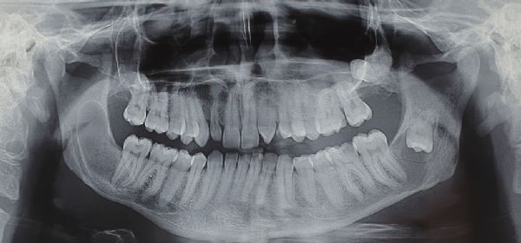

Fig 2: Surgery under general anesthesia

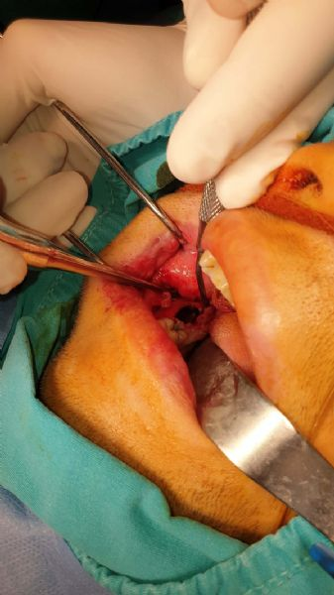

Fig 3: Surgery under general anesthesia
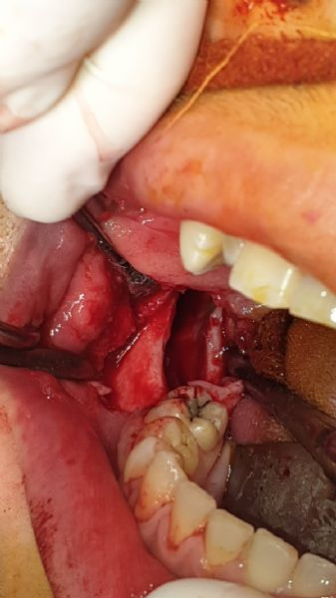

Fig 4: Lesion after surgery
