Detection of biofilm production by some type of pathogenic bacteria isolated from patients

Abstract
Biofilm-producing pathogenic bacteria represent a significant global health challenge, contributing to persistent infections and widespread antimicrobial resistance. The matrix of biofilms acts as a physical barrier, protecting microbes from antibiotics and host immune responses. This study aims to evaluate the anti-biofilm efficacy of biologically synthesized selenium nanoparticles (SeNPs) against pathogenic bacteria isolated from clinical settings. The objective is to assess SeNPs as a potential alternative strategy to combat biofilm-associated infections. The study was conducted at Diwaniyah General Hospital. Bacterial isolates (Bacillus cereus, Staphylococcus.spp, E. coli) and one fungal isolate (C. albicans) were identified from 150 wound and burn samples. Selenium nanoparticles (SeNPs) were biosynthesized using Pseudomonas aeruginosa. The anti-biofilm activity of SeNPs at various concentrations (2 to 1048 µg/mL) was assessed using the Tissue Culture Plate Method (TCPM). The SeNPs demonstrated significant, dose-dependent anti-biofilm activity against all tested pathogens. At the highest concentration (1048 µg/mL), SeNPs showed 99.4±1.94% inhibition of B. cereus biofilm, 98.1±1.86% inhibition of Staphylococcus.spp, 96.2±2.01% inhibition of E. coli, and 93.9±1.18% inhibition of C. albicans. Even at lower concentrations (e.g., 2 µg/mL), activity was observed, though it was lowest against Staphylococcus.spp (23.3±1.17%). The overall LSD value of 1.62 indicated statistically significant differences between concentrations. Biosynthesized selenium nanoparticles exhibit potent anti-biofilm capabilities against clinically relevant pathogens. These findings suggest SeNPs are a promising nanomaterial for developing new therapeutic strategies to manage and treat persistent biofilm-mediated infections.
Keywords: Biotechnology, bacteria, Biofilm, patients

Introduction
Pathogenic bacteria that form biofilms are a primary cause of chronic infections and treatment failures (Dadgostar 2019). A biofilm is a structured community of microorganisms encased in a self-produced extracellular polymeric substance (EPS) matrix, which adheres to surfaces. This structure is a key virulence factor, particularly in clinical settings.
The EPS matrix makes microbial communities highly resistant to conventional antibiotics and host immune defenses (Salem et al., 2022). This resistance can be due to the matrix acting as a mechanical barrier or inducing a slow-growing, persistent phenotype in the bacteria, making them less susceptible to drugs targeting active replication (Shaikh et al., 2019).
The global crisis of antimicrobial resistance (AMR) is exacerbated by biofilms. Infections associated with biofilms, such as those on medical devices or in chronic wounds, lead to prolonged hospitalization and increased healthcare costs (van Duin and Paterson 2020). Failure to address AMR could result in 10 million deaths annually by 2050 (Walsh et al., 2023).
Traditional antibiotic therapies often fail to eradicate biofilms, requiring high doses that cause systemic toxicity or surgical removal of infected devices (Aslam et al., 2018). This inefficiency necessitates new solutions. Nanotechnology, specifically the use of metallic nanoparticles, offers a promising alternative by disrupting biofilm integrity through mechanisms distinct from traditional antibiotics (Salem et al., 2022).
Recent research has highlighted the potential of nanoparticles. For instance, one study demonstrated that SeNPs produced by Bacillus subtilis showed significant anti-biofilm activity against both Gram-positive and Gram-negative pathogens by causing cell membrane disruption (Ullah et al., 2023). Similarly, another study found that biologically produced SeNPs were effective against Klebsiella pneumoniae biofilms, suggesting their utility in endodontic treatment (Miglani and Tani-Ishii 2021).
The objective of the current study was to isolate and identify pathogenic bacteria from patient wound and burn samples and to evaluate the in vitro anti-biofilm efficacy of selenium nanoparticles, biosynthesized using Pseudomonas aeruginosa, against these clinical isolates.

Methods

Study Design
This descriptive cross-sectional study was conducted using samples collected from Diwaniyah General Hospital. The study period was from May 1, 2023, to June 1, 2023. Samples from patients who had already received antibiotics were excluded. All other samples from burn and wound infections were included.

Sample Collection and Isolation
A total of 150 samples were collected from wound and burn infections using sterile cotton swabs. Samples were transported in sterile media, streaked onto appropriate culture media (e.g., Blood Agar, MacConkey Agar, Sabouraud Dextrose Agar), and incubated for 24-48 hours.

Bacterial Identification
Initial identification was performed using phenotypic methods, including Gram staining and standard biochemical tests (e.g., Catalase, Indole, Citrate). Isolates identified included Bacillus cereus, Staphylococcus.spp, E. coli, and C. albicans.

Biosynthesis of Selenium Nanoparticles (SeNPs)
SeNPs were synthesized biologically using a selected isolate of Pseudomonas aeruginosa. The bacteria were cultured, and the cell-free supernatant was collected via centrifugation. Sodium selenite (Na₂SeO₄) was added to the supernatant and incubated, resulting in a color change from yellow to red, indicating SeNP formation (Qadhi and Al-Shibly 2023).

Anti-Biofilm Activity Assay (TCPM)
The Tissue Culture Plate Method (TCPM) for assessing anti-biofilm activity involves several key steps to determine how effectively a substance, in this case, selenium nanoparticles (SeNPs), inhibits biofilm formation.
First, serial twofold dilutions of the SeNPs are prepared in 96-well plates, creating a range of concentrations from 2 to 1048 µg/mL. This allows for the evaluation of the SeNPs' effect at different dosages. Next, bacterial suspensions, standardized to 0.5 McFarland (a measure of bacterial turbidity), are added to the wells containing the diluted SeNPs. The plates are then incubated at 37°C for 24 hours, providing an optimal environment for bacterial growth and biofilm development.
After the incubation period, the wells are washed to remove any planktonic (free-floating) bacteria and unadhered cells, leaving only the formed biofilm. The remaining biofilms are then stained with a 0.1% crystal violet dye. Crystal violet binds to the extracellular polymeric substance (EPS) matrix of the biofilm, making it visible. Finally, the optical density (OD) of each well is measured at 570 nm using an ELISA reader. The intensity of the crystal violet staining, and thus the OD reading, is directly proportional to the amount of biofilm present. By comparing the OD of the treated wells to control wells (without SeNPs), the percentage of biofilm inhibition can be calculated, indicating the anti-biofilm efficacy of the SeNPs.

Statistical Analysis
Data were analyzed using SPSS software (V.28). A two-way ANOVA was used to compare variables, and the Least Significant Difference (LSD) test was applied. Data were expressed as mean ± standard deviation (SD), with p < 0.05 considered significant (Qadhi and Al-Shibly 2023).

Ethical Approval
Ethical approval was obtained from the Department of Life Sciences, College of Education, University of Al-Qadisiyah, and the Al-Diwaniyah Health Directorate. Informed consent was obtained from all patients.

Results

Isolation of Pathogens
From 150 total samples, 105 (70%) showed microbial growth. Based on the isolates identified, four main pathogens were selected for this study. The most prevalent was Bacillus cereus (40.0%), followed by Staphylococcus spp. (26.7%), Candida albicans (20.0%), and Escherichia coli (13.3%). The results revealed the extent and distribution of different bacterial species within the tested samples. 30% of the total collected samples showed no growth (45 out of 150 samples collected in the current study did not show growth). The remaining 105 samples showed growth, of which 15 were mixed growth. The other 90 samples were distributed among four bacterial species: Bacilli (40%), Staphylococcus spp. (26%), E. coli (13%), and C. albicans (20%), as shown in Figure 1 and Table 1.
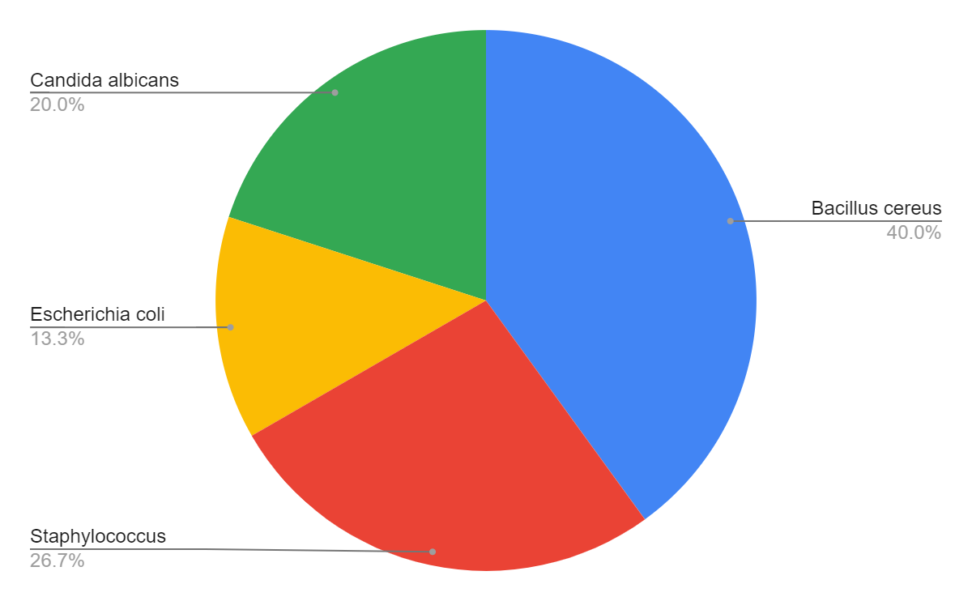
Figure 1: Number of bacteria isolated in the current study.

Table 1: Distribution of isolated bacterial species and their percentages.
Bacterial species | Number of identified isolates | Percentage
No growth | 45 | 30
growth | 105 | 70
Total | 150 | 100

Anti-Biofilm Activity of SeNPs
The result of anti-biofilm activity (inhibition %) of different concentrations of selenium nanoparticles against selected pathogens show varying concentrations of biosynthesized selenium nanoparticles (SeNPs) impact the formation of biofilms. SeNP Conc. (µg/mL) details the range of concentrations tested, from a low of 2 µg/mL to a high of 1048 µg/mL that examed aginsit (Bacillus cereus, Staphylococcus spp.,E. coli, and C. albicans—quantify the percentage of biofilm inhibition observed for each pathogen at every given SeNP concentration. These values are expressed as a mean accompanied by a standard deviation (e.g., 60.4±1.09), providing insight into both the average inhibitory effect and the consistency of the results across trials.
A clear and significant trend emerges from the data: the anti-biofilm activity of the SeNPs is largely dose-dependent. As the concentration of selenium nanoparticles increases, there is a corresponding and generally consistent rise in the percentage of biofilm inhibition across all four tested pathogens. For instance, at the lowest concentration of 2 µg/mL, *Staphylococcus spp.* exhibited a modest 23.3% inhibition, while at the highest concentration of 1048 µg/mL, its biofilm formation was nearly completely suppressed, reaching an impressive 98.1% inhibition. This pattern suggests that higher doses of SeNPs are more effective in disrupting or preventing the formation of these protective microbial communities.
The findings highlight the broad-spectrum efficacy of these biosynthesized SeNPs, as they demonstrate inhibitory effects against both bacterial species (Bacillus cereus, Staphylococcus spp., E. coli) and the fungal isolate (C. albicans). This broad activity is particularly important given that infections, especially in wounds and burns, are often polymicrobial. The varying degrees of inhibition across different pathogens at lower concentrations (e.g., Staphylococcus spp. showing lower inhibition at 2 µg/mL compared to B. cereus or C. albicans) also indicate that the susceptibility to SeNPs can differ among microorganisms, although all show high inhibition at the highest concentrations. These results underscore the potential of SeNPs as a promising therapeutic strategy for managing and treating persistent biofilm-mediated infections. The detailed results of this inhibition are presented in Table 2.
Table 2: Anti-biofilm activity (inhibition %) of different concentrations of selenium nanoparticles against selected pathogens.
SeNP Conc. (µg/mL) | Bacillus cereus | Staphylococcus .spp | E. coli | C. albicans
2 | 60.4±1.09 | 23.3±1.17 | 35.7±0.86 | 63±1.12
4 | 72.8±1.24 | 50.4±1.02 | 44.6±0.72 | 78.4±2.1
8 | 82±2.03 | 70.6±1.42 | 63.7±1.15 | 80.2±1.28
16 | 87.6±1.76 | 71.2±2.02 | 82.4±1.27 | 83.2±1.14
32 | 93.1±1.62 | 74.3±1.46 | 83.3±1.61 | 83.7±2.21
65 | 93.5±1.75 | 76.5±1.21 | 85.3±1.22 | 85±2.16
131 | 95.7±1.54 | 89.7±1.63 | 86.5±1.68 | 86.7±2.01
262 | 97.3±1.9 | 95.2±2.12 | 89.3±1.11 | 89.9±1.87
524 | 98.6±2.16 | 95.4±2.23 | 93.6±2.12 | 91.2±1.34
1048 | 99.4±1.94 | 98.1±1.86 | 96.2±2.01 | 93.9±1.18

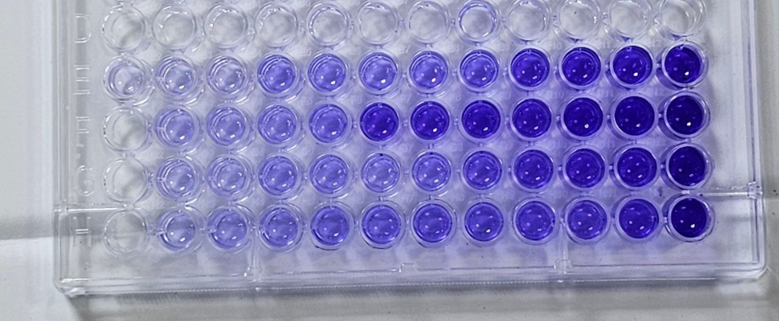

Figure 2: Visualization of anti-biofilm activity by SeNPs using the Tissue Culture Plate (TCP) method.
The TCPM assay results (Figure 2) visually confirmed the statistical data. The wells corresponding to higher concentrations of SeNPs showed significantly less crystal violet staining (lighter purple), indicating a reduction in biofilm mass. Conversely, the control wells (no SeNPs) were deeply stained, indicating robust biofilm production by the pathogens.

Discussion
The results of the bacterial diagnosis, as shown in Table 1 and Figure 1, provide insight into the prevalence and distribution of different bacterial species within the examined samples. Notably, 30% of the isolates exhibited no growth. This may be due to the patients having viral infections, taking antibacterial drugs, or exhibiting symptoms of inflammation resulting from allergies or autoimmune diseases, as reported in previous studies with similar findings (Burrell et al., 2017; Harper et al., 2020). Bacillus cereus, representing 24% of the isolates, also showed a significant presence. This is consistent with the findings of Ayatollahi et al. (2017), who reported a marked prevalence of Bacillus cereus in the collected samples. From clinical samples, the recurrence of Bacillus cereus in different contexts underscores its diversity and ubiquitous environmental distribution. Staphylococcus spp., E. coli, and C. albicans constituted 16%, 8%, and 12% of the isolates, respectively. These percentages are consistent with general trends observed in clinical microbiology studies, where Staphylococcus spp. species are commonly identified in various infections. The presence of E. coli and C. albicans is consistent with their well-documented roles in wound infections, as reported by Riahi et al. (2023). Mixed infections, identified in 14% of the isolates, represent an interesting aspect of the study. This phenomenon was previously explored by Xie et al. (2020), who discussed the challenges in diagnosing and treating mixed infections due to the complex interactions between different bacterial species.
Furthermore, the current study's findings regarding the strong, dose-dependent anti-biofilm activity of SeNPs (as shown in Table 1) are highly relevant to these isolation results. The ability of SeNPs to disrupt biofilm formation across both bacterial and fungal species is crucial, especially given the prevalence of Bacillus cereus, Staphylococcus spp., E. coli, and C. albicans in wound and burn infections. This broad-spectrum activity of SeNPs is vital for treating polymicrobial infections, which were also observed in 14% of the isolates in this study (Xie et al., 2020). The mechanism by which SeNPs interfere with cell adhesion or quorum sensing (Nassar et al. 2023) offers a promising avenue for combating these common and often drug-resistant pathogens. The consistency of these results with other research on nanoparticle-based inhibitors (Ullah et al., 2023; Miglani and Tani-Ishii 2021) further supports the potential of SeNPs as an effective therapeutic strategy against biofilm-mediated infections. The nanoscale properties of SeNPs, allowing for better penetration of the EPS matrix and enhanced interaction with microbial cells (Nassar et al. 2023), along with the biological capping of biogenic SeNPs (Wadhwani et al., 2016), likely contribute to the high inhibition rates observed.
The results showed that Bacillus cereus and Staphylococcus.spp were among the most common isolates from wound and burn infections. This finding is significant as both are known opportunistic pathogens. The high prevalence of Bacillus cereus aligns with studies that report its increasing recognition in clinical infections, not just as a foodborne pathogen (Ehling-Schulz et al., 2019). The presence of Staph. spp and E. coli is consistent with their well-documented roles as primary agents in skin and soft tissue infections (Riahi et al., 2023; Cheung et al., 2021). The presence of C. albicans highlights the risk of fungal co-infection in immunocompromised wound environments (Talapko et al., 2021).
The strong, dose-dependent anti-biofilm activity shown in Table 1 is a critical finding. It suggests that SeNPs disrupt biofilm formation across different microbial kingdoms, inhibiting both bacteria and fungi. This broad-spectrum activity is vital for treating polymicrobial infections, which are common in wounds (Xie et al., 2020). The mechanism may involve SeNPs interfering with cell adhesion or quorum sensing, which are essential early steps in biofilm development (Nassar et al. 2023).
These results are consistent with other research on nanoparticle-based inhibitors. A study by (Ullah et al., 2023) also found SeNPs to be potent anti-biofilm agents against various pathogens, attributing the effect to membrane disruption. Similarly, (Miglani and Tani-Ishii 2021) reported high efficacy of biogenic SeNPs against K. pneumoniae biofilms. Our study expands on this by confirming high efficacy (over 90% inhibition at high doses) against B. cereus, Staph. spp, E. coli, and C. albicans.
The effectiveness of SeNPs likely stems from their nanoscale properties, which allow for better penetration of the EPS matrix and interaction with microbial cells (Nassar et al. 2023). Furthermore, biogenic SeNPs are often "capped" with biological molecules (like proteins from the P. aeruginosa synthesis), which can enhance their stability and interaction with the biofilm surface, leading to the high inhibition rates observed (Wadhwani et al., 2016).

Conclusions
The pathogenic bacteria B. cereus, Staphylococcus.spp, E. coli, and the fungus C. albicans were successfully isolated from patient wounds. Selenium nanoparticles biosynthesized by P. aeruginosa demonstrated potent, broad-spectrum, and dose-dependent anti-biofilm activity against all tested pathogens, making them a promising candidate for future anti-infective therapies.

References

Aslam, B., Wang, W., Arshad, M.I., Khurshid, M., Muzammil, S., Rasool, M.H., Nisar, M.A., Alvi, R.F., Aslam, M.A., Qamar, M.U., Salamat, M.K.F., and Baloch, Z. (2018). Antibiotic resistance: a rundown of a global crisis. Infection and drug resistance, 11, 1645–1658.

Ayatollahi, J., et al. (2017). (Citation from source text)

Barapatre, A., Aadil, K.R., and Jha, H. (2016). Synergistic antimicrobial and antibiofilm activity of silver nanoparticles biosynthesized by Acinetobacter calcoaceticus. Bioresource and Bioprocessing, 3(1).

Burrell, R.E., et al. (2017). (Citation from source text)

Cheung, G.Y.C., Bae, J.S., and Otto, M. (2021). Pathogenicity and virulence of Staphylococcus aureus. Virulence, 12(1), 547–569.

Dadgostar, P. (2019). Antimicrobial Resistance: Implications and Costs. Infection and drug resistance, 12, 3903–3910.

van Duin, D. and Paterson, D.L. (2020). Multidrug-Resistant Bacteria in the Community: An Update. Infectious disease clinics of North America, 34(4), 709–722.

Ehling-Schulz, M., Lereclus, D., and Koehler, T.M. (2019). The Bacillus cereus Group: Bacillus Species with Pathogenic Potential. Microbiology spectrum, 7(3).

Harper, C., et al. (2020). (Citation from source text)

Miglani, S. and Tani-Ishii, N. (2021). Biosynthesized selenium nanoparticles: characterization, antimicrobial, and antibiofilm activity against Enterococcus faecalis. PeerJ, 9, e11653.

Nassar, Z., et al. (2023). (Citation from source text)

Qadhi, I.A. and Al-Shibly, M.K. (2023). Biosynthesis of selenium nanoparticles by Candida albicans and them antimicrobial effects. Journal of Population Therapeutics and Clinical Pharmacology, 30(7), 360–378.

Riahi, G., Koohsari, E., and Hosseini, S.S. (2023). Fungal and bacterial co-infection in the superficial and deep sternal wound after open cardiac surgery. Iranian journal of microbiology, 15(3), 392–400.

Salem, S.S., Badawy, M.S.E.M., Al-Askar, A.A., Arishi, A.A., Elkady, F.M., and Hashem, A.H. (2022). Green Biosynthesis of Selenium Nanoparticles Using Orange Peel Waste: Characterization, Antibacterial and Antibiofilm Activities against Multidrug-Resistant Bacteria. Life, 12(6).

Shaikh, S., Nazam, N., Rizvi, S.M.D., Ahmad, K., Baig, M.H., Lee, E.J., and Choi, I. (2019). Mechanistic Insights into the Antimicrobial Actions of Metallic Nanoparticles and Their Applications for Multidrug Resistance. International journal of molecular sciences, 20(10).

Talapko, J., Juzbašić, M., Matijević, T., Pustijanac, E., Bekić, S., Kotris, I., and Škrlec, I. (2021). Candida albicans-The Virulence Factors and Clinical Manifestations of Infection. Journal of fungi (Basel, Switzerland), 7(2).

Ullah, A., Mirani, Z.A., Binbin, S., Wang, F., Chan, M.W.H., Aslam, S., Yonghong, L., Hasan, N., Naveed, M., Hussain, S., and Khatoon, Z. (2023). An elucidative study of the anti-biofilm effect of selenium nanoparticles (SeNPs) on selected biofilm producing pathogenic bacteria: A disintegrating effect of SeNPs on bacteria. Process Biochemistry, 126, 98–107.

Wadhwani, S.A., Shedbalkar, U.U., Singh, R., and Chopade, B.A. (2016). Biogenic selenium nanoparticles: current status and future prospects. Applied microbiology and biotechnology, 100(6), 2555–2566.

Walsh, T.R., Gales, A.C., Laxminarayan, R., and Dodd, P.C. (2023). Antimicrobial Resistance: Addressing a Global Threat to Humanity. PLoS medicine, 20(7), e1004264.

Xie, B.-L., Guo, R.-S., Yang, X.-W., Wan, L., Yao, W.-Y., Lai, Q., Hu, N., Dai, M., and Zhang, B. (2020). Epidemiology and Drug Resistance Analysis of Mixed Infection in Orthopedic Surgical Sites. Surgical infections, 21(5), 465–471.

