Association Between Beta-Blocker Use and Suicidal Ideation in Patients with Coronary Artery Disease: A Retrospective Cohort Study

Abstract
Objective: To examine through large-scale hospital data analysis whether propranolol use is associated with an increased incidence of suicidal ideation in patients with coronary artery disease (CAD).

Methods: Our retrospective cohort study was performed using the TriNetX Research Network. After filtering for desired inclusion/exclusion criteria, two cohorts were created using TriNetX, resulting in 505,728 total patients in Cohort 1 and 56,284 total patients in Cohort 2, and the cohorts were compared for the outcome of suicidal ideation. The cohorts were comprised of predominantly male, white participants. The average age in the losartan cohort and the propranolol cohort was 65.3 and 62.7, respectively.

Results: Risk analysis demonstrated a 3% risk of a suicidal ideation diagnosis in the propranolol cohort and a 0.90% risk in the losartan cohort. The risk difference was -0.20 (95% CI: -0.022, -0.019, z= -42.465, p < 0.001) with a risk ratio of 0.320 (95% CI: 0.303, 0.339) and an odds ratio of 0.314 (95% CI: 0.297, 0.332). Survival analysis was conducted using the Kaplan-Meier curves, resulting in 98.37% survival for the losartan cohort and 95.31% survival for the propranolol cohort. It also calculated a hazard ratio of 0.317 (95% CI: 0.300,0.335, χ² = 35.044, df = 1, and p-value <0.001).

Conclusion: We found a significant link between propranolol use and the incidence of suicidal ideation in patients. However, there is a need for further investigation because current literature is inconclusive regarding this issue. Physicians should carefully consider a patient’s history of suicidal ideation before prescribing the drug.

Key Words
Propranolol, suicidal ideation, retrospective studies, coronary artery disease, mental disorders

Background
Coronary artery disease (CAD) has consistently been the leading cause of death not only in the United States but also worldwide, according to the WHO and the CDC.¹⁻³ This disease is caused by a buildup of plaque in blood vessels, resulting in the obstruction of blood flow and an inadequate oxygen supply to the heart.¹ Common risk factors for CAD include hypertension, obesity, lipid levels, and smoking.^{1,4-6} In recent years, CAD has also been linked to psychological variables. In the UK, there was a study in 2016 demonstrating increased depressive symptoms in patients with CAD when compared to a healthy control group.⁷ Additionally, a study from Canada reported that nearly 1 in 5 patients (18.8%) with a diagnosis of stable angina due to obstructive CAD developed depression, and these patients with depression were more likely to die or be admitted for myocardial infarctions compared to the patients who did not develop depression.⁸ Another study indicated that low levels of HDL and central obesity, which are risk factors for CAD, are positively associated with an increased risk of suicidal ideation.^{1,4}
Physicians typically prescribe beta-blockers and angiotensin receptor blockers (ARBs) to treat underlying conditions, such as hypertension and angina.^{1,5,6,9,10} Beta-blockers, such as propranolol, metoprolol, and atenolol, exhibit their effects by blocking beta-adrenergic receptors, thereby reducing the effects of adrenaline and ultimately slowing heart rate and decreasing blood pressure.^{11,12} Beta-blockers can be selective or non-selective, and they can be hydrophilic or lipophilic.¹¹⁻¹³ Propranolol is a non-selective and lipophilic beta-blocker that has garnered considerable attention over the years due to its ability to cross the blood-brain barrier and exert its effects on the central nervous system.^{1,11-13} Because of this, there have been case reports and studies indicating that propranolol use could lead to depression.¹⁴⁻¹⁷ However, numerous studies have also disproven this idea.¹⁸⁻²¹ Interestingly, the 2011 study by Luijendijk specifies that there is an association between propranolol use and depressive symptoms but not depressive syndromes.²⁰
Many have explored the connection between propranolol and depression, which has led to inconclusive results, but there are few studies examining the relationship between propranolol and suicidal ideation.²²⁻²³ Considering depression and suicidal ideation often coincide, there is a need to delve deeper and explore the connection between propranolol and suicidal ideation.²⁴⁻²⁶ The present study aims to contribute to the current discourse on whether there is a true association between the use of propranolol and mental health disorders, and also explore specifically the relationship between propranolol and suicidal ideation through retrospective data analysis.

Methods
This study is a retrospective cohort study conducted utilizing data from the TriNetX Research Network, which is comprised of de-identified electronic health records from 100 healthcare organizations HCO(s). The data is de-identified in compliance with the Health Insurance Portability and Accountability Act (HIPAA), and institutional review board approval was not required for this analysis.

I. Selection and Description of Participants
We examined patients between the ages of 18-75 with a diagnosis of atherosclerotic heart disease of native coronary artery without angina pectoris (ICD-10 code I25.10) and created two cohorts for comparison. Our control cohort included patients prescribed with losartan and excluded patients with a history of propranolol use, resulting in a total of 506,562 patients matching the query criteria. Our second cohort included patients prescribed with propranolol and excluded patients with a history of losartan use, generating a total of 56,780 patients matching the query criteria.
Further analysis was performed using the defined outcome measure for incidence of suicidal ideation (ICD-10 code R45.851), assessed between 1 and 1825 days (5 years) after the index event (when the patient first started taking losartan or propranolol, respectively). The final analysis excluded 834 patients in Cohort 1 and 496 patients in Cohort 2 because they met the index event more than 20 years ago, resulting in 505,728 total patients in Cohort 1 and 56,284 total patients in Cohort 2.

II. Statistics
To determine the risk of patients diagnosed with the outcome (suicidal ideation) for individual cohorts, risk analysis was determined through risk (%) (patients with outcome/ patients in cohort), risk difference (difference in the risks in cohort 1 and cohort 2), risk ratio (ratio of risks in cohort 1 and cohort 2), and odds ratio (ratio of the odds in cohort 1 and cohort 2).
Survival analysis was determined using the Kaplan-Meier curves to evaluate the probability of survival (no diagnosis of suicidal ideation) in both cohorts, measured at daily intervals. A log-rank test was used to compare survival distributions between groups, and the hazard ratio was computed to compare the instantaneous risk of the outcome occurring in one cohort versus the other.

Results
Using TriNetX, we identified 505,728 patients in the losartan (control) cohort and 56,284 patients in the propranolol cohort (Table 1). The average age in the losartan cohort was 65.3 (SD ± 8.08) and in the propranolol cohort was 62.7 (SD ± 9.95). The average age at the index event was 60.9 (SD ± 8.35 for the losartan cohort and 57.8 (SD ± 10.3) for the propranolol cohort. For both cohorts, there were more male patients than female. Of the 505,728 patients in the losartan group, 37.45% patients were female (n=189,375), 60.2% patients were male (n=304,448), and 2.35% were unknown (n=11,905). Of the 56,284 patients in the propranolol group, 46.66% patients were female (n=26,262), 51.54% patients were male (n=29,010), and 1.8% were unknown (n=1,012). Additionally, many of the patients were white in both losartan (62.92%, n=318,232) and propranolol (63.2%, n=35,571) groups. The rest of the reported races in the losartan group were 18.99% Black or African American (n=96,055), 8.37% unknown (n=42,321), 5.5% Asian (n=27,799), 2.83% other (n=14,319), 1.01% Native Hawaiian or Other Pacific Islander (n=5,097), and 0.38% American Indian or Alaska Native (n=1,905). The other reported races in the propranolol group were 17.79% unknown (n=10,013), 8.03% Asian (n=4,519), 7.97% Black or African American (n=4,483), 2.3% other (n=1,295), 0.39% American Indian or Alaska Native (n=222), and 0.32% Native Hawaiian or Other Pacific Islander (n=181). Moreover, 76.05% of patients in the losartan cohort were not Hispanic or Latino (n=384,592), while 6.87% of patients reported as Hispanic or Latino (n=34,736) and 17.08% reported as unknown (n=86,400). In the propranolol cohort, 70.65% of patients were not Hispanic or Latino (n=39,762), while 5.64% of patients reported as Hispanic or Latino (n=3,177) and 23.71% reported as unknown (n=13,345).

Table 1: Patient Characteristics
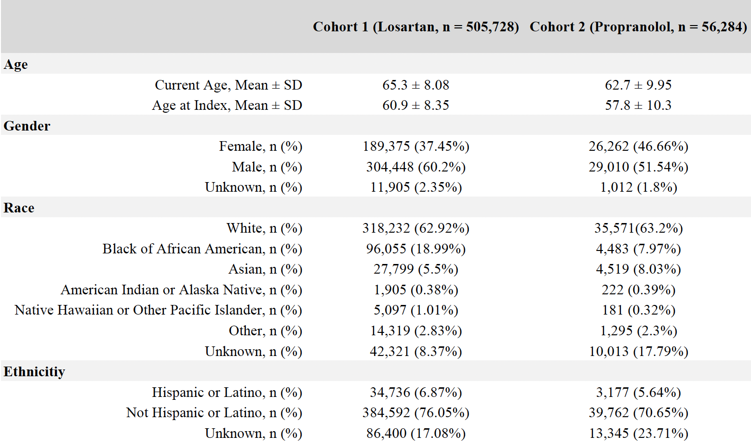

In this retrospective cohort study, we performed a risk analysis to observe whether patients on propranolol had a significantly higher chance of developing suicidal ideation compared to patients on losartan (Table 2). Of the 505,728 patients in the losartan group 4,796 patients were found to have suicidal ideation after their prescription, and of the 56,284 patients in the propranolol group, 1,666 patients were found to have suicidal ideation after their prescription, resulting in a 0.90% risk for those in the control cohort and a 3.00% risk for those in the propranolol cohort. This indicates that suicidal ideation was found to occur more frequently in patients taking propranolol. The risk ratio was 0.320 (95% CI = 0.303,0.339), and the odds ratio was 0.314 (95% CI = 0.297,0.332). Additionally, the difference in risk, which was -0.020 (95% CI = -0.022, -0.019), was calculated to be statistically significant with a z-value of -42.465 and a p-value < 0.001, further supporting the notion that suicidal ideation was more likely to occur in the propranolol group.

Table 2: Risk Analysis: Risk Difference, Risk Ratio, Odds Ratio
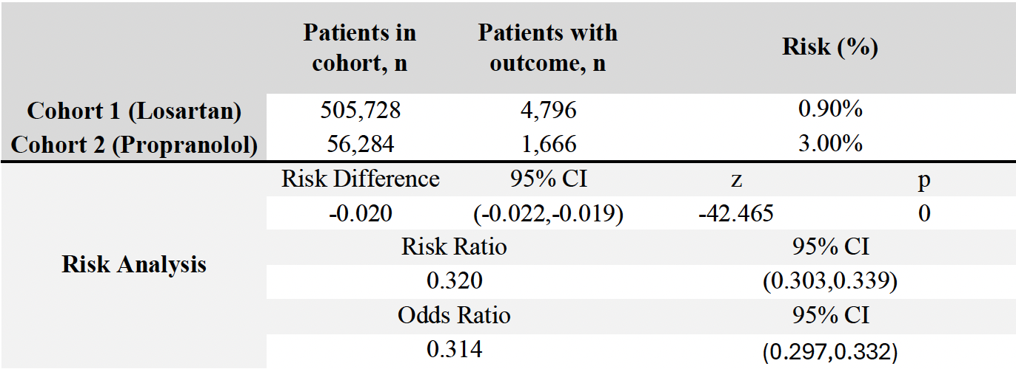

Lastly, the survival analysis and hazard ratio were calculated using the Kaplan-Meier Analysis (Table 3). This analysis produced a survival probability of 98.37% for the losartan cohort and 95.31% for the propranolol cohort at the end of the time window. The Log-Rank Test demonstrated a statistical significance of the survival analysis with a χ² = 1819.948, df = 1, and p-value <0.001. The hazard ratio was 0.317 (95% CI = 0.300,0.335), and its statistical significance was once again corroborated with a χ² = 35.044, df = 1, and p-value <0.001. Both these measures indicate a significantly lower occurrence of suicidal ideation in the losartan group than in the propranolol group.

Table 3: Kaplan-Meier Survival Analysis estimating occurrence of suicidal ideation in coronary artery disease patients taking propranolol versus taking losartan
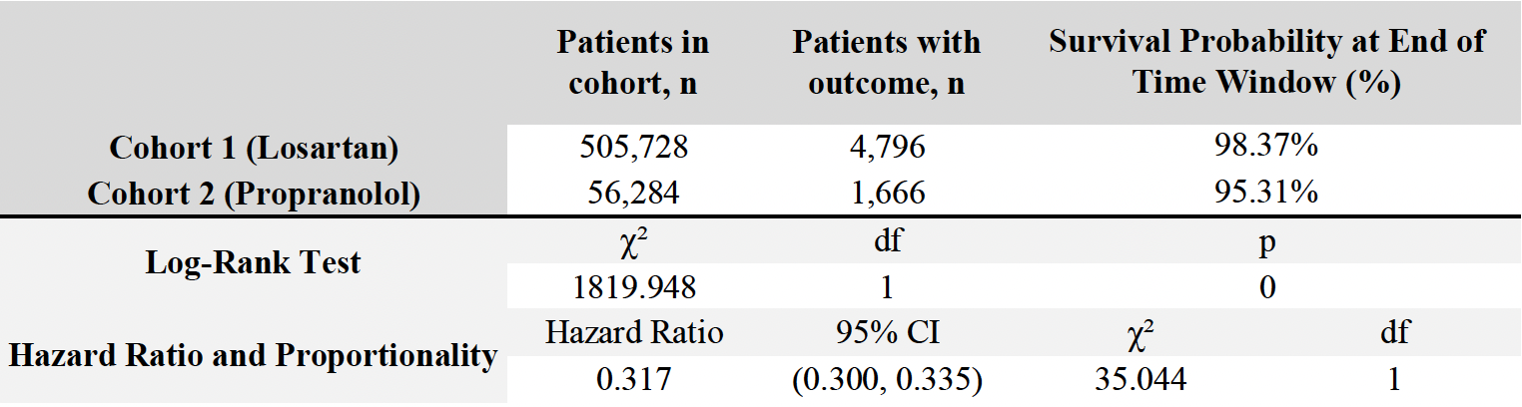
Discussion
Since the FDA approved propranolol as a treatment for cardiovascular diseases, there have been many case reports and studies indicating a significant relationship between propranolol and psychiatric conditions, especially depression.^{11,13,17,27} The goal of this study was to build upon current literature evaluating whether beta-blockers, specifically propranolol, increase the risk of suicidal ideation in patients. Therefore, we conducted a query examining the occurrence of suicidal ideation five years after patients were first prescribed losartan or propranolol. Our analysis indicates that patients on propranolol had approximately three times the risk of developing suicidal ideation compared to those on losartan. The results were statistically significant for all measures, highlighting a potential mental health safety consideration when prescribing propranolol.
The greatest strength of this study is the use of TriNetX for analysis, allowing us access to a larger and more diverse patient population. Hence, our results add to previous studies supporting an association between beta-blockers and suicidal ideation.^{22,23,28,29} For example, a longitudinal cohort study in Sweden also found that there was an increased risk of suicidal behavior in patients on beta-blockers.²² Also, there was a systematic review suggesting propranolol use is linked to depression in elderly patients.²³ Two other studies reported an increase in depressive symptoms but not with depressive syndromes.^{14,20} Additionally, Boal’s study compiled data from 144,000 patients aged 40-80 taking one type of blood pressure medication for at least 90 days, and they followed these patients for 5 years and noted if they were hospitalized for a mood disorder during this time. They found that patients on beta-blockers had twice the risk of hospitalizations for mood disorders, and patients on angiotensin receptor blockers (ex. losartan) had the lowest occurrence of hospitalizations.³⁰
Interestingly, a different study observed a relationship between beta-blockers and depression for short-term use (1-4 prescriptions) but not for long-term use (10 prescriptions or more).¹⁸ One thing to note about Bornand’s study and Molero’s study is that the increased risk of depression and suicidal behavior, respectively, was mostly limited to patients with a neuropsychiatric disorder or with a history of psychiatric hospitalizations or suicidal behavior. ^{18,22} This detail underscores a limitation within our study. The increased risk for suicidal ideation we observed in our study may be because the patients have an underlying psychiatric condition, not because of the drug.^{18,22} However, it is difficult to isolate the initial population to exclude patients with psychiatric conditions because psychiatric conditions are largely underdiagnosed and underreported.^{25,31} Moreover, propranolol is mainly prescribed when a patient is diagnosed with a cardiovascular condition. There have been studies linking an increased risk of suicide in patients with cardiovascular diseases or events, meaning that the increased occurrence of psychiatric conditions linked to beta-blockers may have been caused by other confounding factors.^{1,9,11,12,32,33} Another limitation of our study is that it’s a retrospective analysis of patient data, so it largely depends on the accuracy of these hospital records. It limits the ability to control confounding events.
With these limitations in mind, future studies should focus on defining depression and standardizing depression across studies to minimize the effects of confounding variables. If future studies could isolate a population with no underlying condition for depression or suicidal ideation, it would greatly contribute to the accuracy of the current discourse. Additionally, studies have alluded to timing being an important factor in observing the psychiatric side effects of propranolol. Bornand’s study specifically points out that short-term use may have a significant association, but many studies conduct longitudinal analyses.¹⁸ Hence, further stratification of the control population is important and will aid in strengthening causality between propranolol use and suicidal ideation.

Conclusion
This retrospective cohort study proposes a significant association between propranolol use and increased risk of suicidal ideation. Though present literature is inconclusive regarding propranolol’s effects on mental health, there are numerous case reports, systematic reviews, and controlled trials suggesting a link between the two, emphasizing the need for physicians to consider a patient’s risk or history for depression or suicidal ideation before prescribing propranolol.

Ethics Approval and Patient Consent
This study used retrospective patient data from the TriNetX Research Network, which is comprised of de-identified electronic health records in compliance with the Health Insurance Portability and Accountability Act (HIPAA). There was no collection, use, or transmission of identifiable patient information in this retrospective cohort study. Therefore, it was deemed exempt from approval from the institutional review board.

Data Availability
All data generated or analyzed during the present study are available from the corresponding author on reasonable request.
Declaration
Not applicable

References
- Shahjehan RD, Sharma S, Bhutta BS. Coronary artery disease [Internet]. In: StatPearls [Internet]. Treasure Island (FL): StatPearls Publishing; 2025 Jan– [cited 2025 Jun 20]. Available from: https://www.ncbi.nlm.nih.gov/sites/books/NBK564304/
- Murphy SL, Kochanek KD, Xu J, Arias E. Mortality in the United States, 2023 [Internet]. Hyattsville (MD): National Center for Health Statistics (US); 2024 [cited 2025 Jun 20]. Available from: https://www.cdc.gov/nchs/products/databriefs/db521.htm
- World Health Organization. The top 10 causes of death [Internet]. Geneva: World Health Organization; 2024 Aug 7 [cited 2025 Jun 20]. Available from: https://www.who.int/news-room/fact-sheets/detail/the-top-10-causes-of-death
- Qing G, Zhou Y, Ren Y, He H, Luan J, Yang G, Wei B. Association between cardiometabolic index (CMI) and suicidal ideation: A cross-sectional analysis of NHANES 2005 to 2018 data. Medicine (Baltimore). 2025 Mar 14;104(11):e41816.
- Ghamari ZT. Losartan: A pharmacotherapy in cardiovascular disease. New Emirates Med J. 2024;5.
- Bhatt DL, Steg PG, Ohman EM, Hirsch AT, Ikeda Y, Mas JL, Goto S, Liau CS, Richard AJ, Röther J, Wilson PW; REACH Registry Investigators. International prevalence, recognition, and treatment of cardiovascular risk factors in outpatients with atherothrombosis. JAMA. 2006 Jan 11;295(2):180-9.
- Zaninotto P, Sacker A, Breeze E, McMunn A, Steptoe A. Gender-specific changes in well-being in older people with coronary heart disease: evidence from the English Longitudinal Study of Ageing. Aging Ment Health. 2016;20(4):432-40.
- Szpakowski N, Bennell MC, Qiu F, Ko DT, Tu JV, Kurdyak P, Wijeysundera HC. Clinical Impact of Subsequent Depression in Patients With a New Diagnosis of Stable Angina: A Population-Based Study. Circ Cardiovasc Qual Outcomes. 2016 Nov;9(6):731-739.
- Zacharias FJ, Cowen KJ. Controlled trial of propranolol in hypertension. Br Med J. 1970 Feb 21;1(5694):471-4.
- Srivastava SC, Dewar HA, Newell DJ. Double-Blind Trial of Propranolol (Inderal) in Angina of Effort. Br Med J. 1964 Sep 19;2(5411):724-5.
- Srinivasan AV. Propranolol: A 50-Year Historical Perspective. Ann Indian Acad Neurol. 2019 Jan-Mar;22(1):21-26.
- U.S. Food and Drug Administration. Inderal (propranolol hydrochloride) tablets [package insert]. Silver Spring (MD): FDA; 2011. Available from: https://www.accessdata.fda.gov/drugsatfda_docs/label/2011/016418s080,016762s017,017683s008lbl.pdf
- Westerlund A. Central nervous system side-effects with hydrophilic and lipophilic beta-blockers. Eur J Clin Pharmacol. 1985;28 Suppl:73-6.
- Leissner P, Mars K, Humphries S, Karlström P, Yndigegn T, Jernberg T, Hofmann R, Held C, Olsson EMG. Short- and long-term effects of beta-blockers on symptoms of anxiety and depression in patients with myocardial infarction and preserved left ventricular function: a pre-specified quality of life sub-study from the REDUCE-AMI trial. Eur Heart J Acute Cardiovasc Care. 2024 Dec 3;13(11):789-797.
- Kedziora-Kornatowska K, Winiarek K, Murawska J, Mikut K, Kwiecien J, Wijata A, Al-Shaer A. Drugs increase the risk of suicide in the elderly. J Educ Health Sport. 2022;13(1):123-9.
- Keller S, Frishman WH. Neuropsychiatric effects of cardiovascular drug therapy. Cardiol Rev. 2003 Mar-Apr;11(2):73-93.
- Waal HJ. Propranolol-induced depression. Br Med J. 1967 Apr 1;2(5543):50.
- Bornand D, Reinau D, Jick SS, Meier CR. β-Blockers and the Risk of Depression: A Matched Case-Control Study. Drug Saf. 2022 Feb;45(2):181-189.
- Riemer TG, Villagomez Fuentes LE, Algharably EAE, Schäfer MS, Mangelsen E, Fürtig MA, Bittner N, Bär A, Zaidi Touis L, Wachtell K, Majic T, Dinges MJ, Kreutz R. Do β-Blockers Cause Depression?: Systematic Review and Meta-Analysis of Psychiatric Adverse Events During β-Blocker Therapy. Hypertension. 2021 May 5;77(5):1539-1548.
- Luijendijk HJ, van den Berg JF, Hofman A, Tiemeier H, Stricker BH. β-blockers and the risk of incident depression in the elderly. J Clin Psychopharmacol. 2011 Feb;31(1):45-50.
- Gerstman BB, Jolson HM, Bauer M, Cho P, Livingston JM, Platt R. The incidence of depression in new users of beta-blockers and selected antihypertensives. J Clin Epidemiol. 1996 Jul;49(7):809-15.
- Molero Y, Kaddoura S, Kuja-Halkola R, Larsson H, Lichtenstein P, D'Onofrio BM, Fazel S. Associations between β-blockers and psychiatric and behavioural outcomes: A population-based cohort study of 1.4 million individuals in Sweden. PLoS Med. 2023 Jan 31;20(1):e1004164.
- Kedziora-Kornatowska K, Winiarek K, Murawska J, Mikut K, Kwiecien J, Wijata A, Al-Shaer A. Drugs increase the risk of suicide in the elderly. J Educ Health Sport. 2022;13(1):123-9.
- Riera-Serra P, Navarra-Ventura G, Castro A, Gili M, Salazar-Cedillo A, Ricci-Cabello I, Roldán-Espínola L, Coronado-Simsic V, García-Toro M, Gómez-Juanes R, Roca M. Clinical predictors of suicidal ideation, suicide attempts and suicide death in depressive disorder: a systematic review and meta-analysis. Eur Arch Psychiatry Clin Neurosci. 2024 Oct;274(7):1543-1563.
- Cai H, Jin Y, Liu S, Zhang Q, Zhang L, Cheung T, Balbuena L, Xiang YT. Prevalence of suicidal ideation and planning in patients with major depressive disorder: A meta-analysis of observation studies. J Affect Disord. 2021 Oct 1;293:148-158.
- Nordentoft M, Mortensen PB, Pedersen CB. Absolute risk of suicide after first hospital contact in mental disorder. Arch Gen Psychiatry. 2011 Oct;68(10):1058-64.
- Stapleton MP. Sir James Black and propranolol. The role of the basic sciences in the history of cardiovascular pharmacology. Tex Heart Inst J. 1997;24(4):336-42.
- Zipursky JS, Macdonald EM, Luo J, Gomes T, Mamdani MM, Paterson JM, Juurlink DN; Canadian Drug Safety and Effectiveness Research Network. Lipophilic β-Blockers and Suicide in the Elderly. J Clin Psychopharmacol. 2017 Jun;37(3):381-384.
- Sørensen HT, Mellemkjaer L, Olsen JH. Risk of suicide in users of beta-adrenoceptor blockers, calcium channel blockers and angiotensin converting enzyme inhibitors. Br J Clin Pharmacol. 2001 Sep;52(3):313-8.
- Boal AH, Smith DJ, McCallum L, Muir S, Touyz RM, Dominiczak AF, Padmanabhan S. Monotherapy With Major Antihypertensive Drug Classes and Risk of Hospital Admissions for Mood Disorders. Hypertension. 2016 Nov;68(5):1132-1138.
- Fekadu A, Demissie M, Birhane R, Medhin G, Bitew T, Hailemariam M, Minaye A, Habtamu K, Milkias B, Petersen I, Patel V, Cleare AJ, Mayston R, Thornicroft G, Alem A, Hanlon C, Prince M. Under detection of depression in primary care settings in low and middle-income countries: a systematic review and meta-analysis. Syst Rev. 2022 Feb 5;11(1):21.
- Larsen KK, Agerbo E, Christensen B, Søndergaard J, Vestergaard M. Myocardial infarction and risk of suicide: a population-based case-control study. Circulation. 2010 Dec 7;122(23):2388-93.
- Liu CH, Wang JH, Weng SC, Cheng YH, Yeh MK, Bai MY, Chang JC. Is Heart Failure Associated With Risk of Suicide? J Card Fail. 2018 Nov;24(11):795-800.

