Original Research Article

Association Between Uterine Fibroid and Metabolic Syndrome in Premenopausal Women

Abstract
Background:
Uterine fibroids (UFs) are the most common benign tumors of the female reproductive tract and are often associated with significant gynecological morbidity. Metabolic syndrome (MetS), characterized by central obesity, dyslipidemia, hypertension, and hyperglycemia, has emerged as a potential risk factor for fibroid development through shared mechanisms such as insulin resistance, altered lipid metabolism, and chronic inflammation. However, evidence on the association between UFs and MetS in premenopausal women remains limited, particularly in South Asian populations.
Objective:
To investigate the association between uterine fibroids and metabolic syndrome in premenopausal women.
Method:
This case-control study was conducted at Chittagong Medical College Hospital, Bangladesh, from July 2023 to June 2024. A total of 152 premenopausal women were included: 76 with UFs confirmed by transvaginal ultrasonography and 76 age-matched controls without UFs. Data on demographic, clinical, and biochemical parameters were collected. MetS was defined according to NCEP: ATP III criteria. Statistical analysis included chi-square test, t-test, and multivariate logistic regression to assess independent risk factors.
Results:
The mean age of UF patients was 44.4±2.5 years, with menorrhagia being the most common symptom (92.1%). Women with UFs had significantly higher waist circumference (84.4±6.9 vs. 75.7±7.6, p<0.001) and lower HDL-C (32.8±6.5 vs. 47.3±7.7, p<0.001) compared to controls. The UF group had higher prevalence of abdominal obesity (73.7% vs. 22.4%, p<0.001), hyperglycemia (15.8% vs. 1.3%, p<0.001), hypertriglyceridemia (53.9% vs. 23.7%, p<0.001), and low HDL-C (97.4% vs. 51.3%, p<0.001). Overall, 68.4% of women with UFs had MetS compared to 19.7% in controls (p<0.001). Logistic regression analysis showed MetS was an independent risk factor for UFs, with women having MetS being nine times more likely to develop UFs (OR 9.08; 95% CI: 4.16–19.84; p<0.001).
Conclusion:
This study demonstrates a strong association between uterine fibroids and metabolic syndrome in premenopausal women, with MetS conferring a significantly increased risk of fibroid development. These findings highlight the importance of integrated clinical management that addresses both gynecological and metabolic health to improve outcomes in affected women.
Keywords: Uterine fibroids, Leiomyomas, Metabolic syndrome, Premenopausal women, Abdominal obesity, Dyslipidemia

Introduction
Uterine fibroids, also known as leiomyomas, are the most common benign tumors of the female reproductive tract, affecting up to 70–80% of women by the age of 50. These smooth muscle neoplasms develop within the myometrium and vary in size, number, and clinical presentation. ¹⁻³ While many fibroids remain asymptomatic, a significant proportion of women experience heavy menstrual bleeding, pelvic pain, infertility, and pregnancy-related complications, all of which contribute to impaired quality of life and increased healthcare burden. The pathogenesis of uterine fibroids is multifactorial, involving genetic, hormonal, and environmental factors, with estrogen and progesterone playing central roles in their growth and development.⁴
Metabolic syndrome, on the other hand, is a cluster of interrelated cardiometabolic risk factors, including central obesity, insulin resistance, dyslipidemia, and hypertension. It has become a global health concern due to its strong association with type 2 diabetes mellitus, cardiovascular disease, and overall mortality. ⁵ Premenopausal women, who were once considered relatively protected against metabolic and cardiovascular disorders due to hormonal influences, are increasingly being recognized as vulnerable to metabolic syndrome, particularly in the context of obesity and sedentary lifestyles.⁶
Recent evidence suggests a potential association between uterine fibroids and metabolic syndrome. Shared risk factors such as obesity, insulin resistance, chronic low-grade inflammation, and altered lipid metabolism may contribute to the coexistence of these two conditions. ⁷ Adipose tissue acts as an endocrine organ, promoting estrogen production and systemic inflammation, which may accelerate fibroid growth. Similarly, hyperinsulinemia and insulin-like growth factors can stimulate proliferation of uterine smooth muscle cells, further linking fibroid development to metabolic disturbances. ⁸
Premenopausal women with fibroids may represent a unique subgroup at increased risk of metabolic complications. Studies have indicated that women with fibroids are more likely to have higher body mass index (BMI), central adiposity, hypertension, and dyslipidemia compared to those without fibroids. Furthermore, racial and ethnic differences, particularly among women of African and Asian descent, suggest that genetic susceptibility, combined with environmental and lifestyle factors, may modulate this association. ⁹⁻¹⁰
Understanding the interplay between uterine fibroids and metabolic syndrome is clinically significant. Early identification of metabolic risks in women with fibroids could not only improve reproductive health outcomes but also reduce long-term cardiometabolic morbidity. Moreover, exploring this relationship may provide insights into shared pathophysiological mechanisms and open avenues for preventive and therapeutic strategies targeting both conditions simultaneously.
Objective
To investigate the association between uterine fibroids and metabolic syndrome in premenopausal women.

Methodology
This was a case-control study conducted at the Department of Obstetrics & Gynecology, Chittagong Medical College Hospital, Chattogram, Bangladesh. The study was carried out over a twelve-month period, from July 2023 to June 2024. The study population included women diagnosed with uterine fibroids (UF) by transvaginal ultrasonography (TVUS) who were admitted to the hospital during the study period.
Participants were divided into two groups: the case group, consisting of women with uterine fibroids, and the control group, consisting of apparently healthy women without uterine fibroids. The required sample size for the study was calculated using a standard formula for case-control studies. Based on prior data (Takeda et al., 2008), the proportion of UF patients with at least one component of metabolic syndrome (MetS) was 48.9%, while that of healthy controls was 20.8%. With a significance level of 5% (Zα = 1.96) and 95% power (Zβ = 1.64), the minimum required sample size was estimated to be 76 in each group. A convenience sampling technique was employed for participant selection.
The inclusion criteria for UF cases were: women aged 40–47 years, diagnosed with uterine fibroids on TVUS. Controls included apparently healthy women without uterine fibroids, matched for age. Exclusion criteria applied to both groups were: pregnancy, history of drug use that may cause hypertension, hypertriglyceridemia or hyperglycemia, history of previous hormonal treatment, and diagnosed cases of malignancy, chronic kidney disease, thyroid disease, or chronic liver disease.
The study variables were divided into four categories. Demographic data included age. Clinical variables covered age at menarche, parity, age at first birth, use of oral contraceptive pills, intrauterine device use, comorbidities, waist circumference, and blood pressure. UF-related variables included site, size, number, and symptoms. Biochemical variables assessed were fasting plasma glucose, serum triglycerides, and HDL-C levels. For operational definitions, metabolic syndrome (MetS) was defined according to the NCEP: ATP III criteria (Cleeman et al., 2001), where the presence of three or more of the following components was considered diagnostic: waist circumference ≥85 cm, fasting plasma glucose ≥110 mg/dl or treatment for diabetes, blood pressure ≥130/85 mmHg or treatment for hypertension, triglycerides ≥150 mg/dl or treatment for hypertriglyceridemia, and HDL-C <50 mg/dl. Premenopausal status was defined as regular menstrual cycles with the last menstruation occurring within three months before evaluation. Fibroids were classified as large if their size was ≥5 cm.
Data were collected using a pretested, structured case record form containing all relevant variables. After obtaining ethical approval, participants were consecutively screened and enrolled according to the eligibility criteria. Both cases and controls were recruited from the hospital. Data were obtained by face-to-face interviews and review of medical records. Anthropometric measurements were taken, blood pressure was recorded, and venous blood samples were collected after 12 hours of overnight fasting for glucose and lipid profile analysis.
Data analysis was carried out using SPSS version 23.0 for Windows. Quantitative variables were expressed as mean ± standard deviation, and categorical variables were presented as frequency and percentage. Chi-square test or Fisher’s exact test was used for categorical comparisons, while the independent sample t-test was applied for continuous variables. A multivariate binary logistic regression analysis was performed to determine the independent effect of MetS on UF, with odds ratios (ORs) and 95% confidence intervals (CIs) calculated. A p-value of <0.05 was considered statistically significant.
Results
In this study, the age of the women with FU ranged between 40-47 years, with a mean age of 44.4±2.5 years. Table I shows that about two-thirds of the women (47, 61.8%) were in the 45-47 age group, and the most common presenting symptom was menorrhagia (92.1%). Forty-five (59.2%) patients had single UF, and 19 (25%) had large UF. Most of the fibroids were submucosal (96.1%), and the most common anatomical location of fibroids was an anterior wall..

Table I: Demographic and clinical characteristics of the patients with FU (n=76)

Varibles | Frequency | Percentage
Age
40-44 years | 29 | 38.2
45-47 years | 47 | 61.8
Symptoms Menorrhagia | 70 | 92.1
Menometrorrhgia | 1 | 1.3
Subfertility | 5 | 6.6
Number of fibroids
Single | 45 | 59.2
Multiple | 31 | 40.8
Size of fibroid
<5 cm | 57 | 75.0
≥ 5 cm | 19 | 25.0
Anatomical location of fibroid Anterior wall | 25 | 38.5
Posterior wall | 20 | 30.8
Fundal wall | 4 | 6.2
Anterior and posterior wall | 6 | 9.2
Antero-fundal wall | 7 | 10.8
Postero-fundal wall | 3 | 4.6
Types of fibroids  Submucosal | 73 | 96.1
Intramural | 3 | 3.7

Table-2 shows women with UFs had a larger WC than women without UFs (84.4±6.9 vs 75.7±7.6, p <0.001). There was a significant difference between both groups regarding HDL-C, with the control group having higher values (47.3±7.7 vs 32.8±6.5, p<0.001). Both groups had similar SBP and DBP and mean TG levels.
Table II: Comparison of the mean values of the component of MetS between women with UFs and without

Characteristics | UF Group (n=76) | Non-UF Group (n=76) | P value
Waist circumference, cm | 84.4 ± 6.9 | 75.7 ± 7.6 | <0.001*
Systolic blood pressure, mmHg | 123.5 ± 16.1 | 119.2 ± 14.3 | 0.085*
Diastolic blood pressure, mmHg | 76.9 ± 10.7 | 75.6 ± 9.5 | 0.558*
Fasting plasma glucose, mmol/l | 5.1 ± 0.9 | 5.0 ± 0.6 | 0.060*
Triglyceride, mg/dl | 147.9 ± 49.8 | 139.8 ± 41.9 | 0.188*
High density lipoprotein-cholesterol, mg/dl | 32.8 ± 6.5 | 47.3 ± 7.7 | <0.001*

UF: Uterine fibroid; Data were expressed as mean ±SD; *Independent sample t test

Table 3 shows a higher proportion of women in the UF group had abdominal obesity (73.7% vs 22.4%. p<0.001), hyperglycemia (15.8% vs 1.3%, p<0.001), hypertriglyceridemia (53.9% vs 23.7%, p<0.001) and a low HDL-C (97.4% vs 51.3%, p<0.001
Table III: Presence of individual components of MetS between participants with and without UFs

UF Group |  | Non-UF Group
Characteristics | (n=76) | (n=76) | P value
Abdominal obesity | 56 (73.7) | 17 (22.4) | <0.001†
High blood pressure | 35 (46.1) | 28 (36.8) | 0.249†
Hyperglycemia | 12 (15.8) | 1 (1.3) | <0.001†
Hypertriglyceridemia | 41 (53.9) | 18 (23.7) | <0.001†
Low HDL-C | 74 (97.4) | 39 (51.3) | <0.001†
UF: Uterine fibroid; Data were expressed as frequency (%) †Chi-square test.

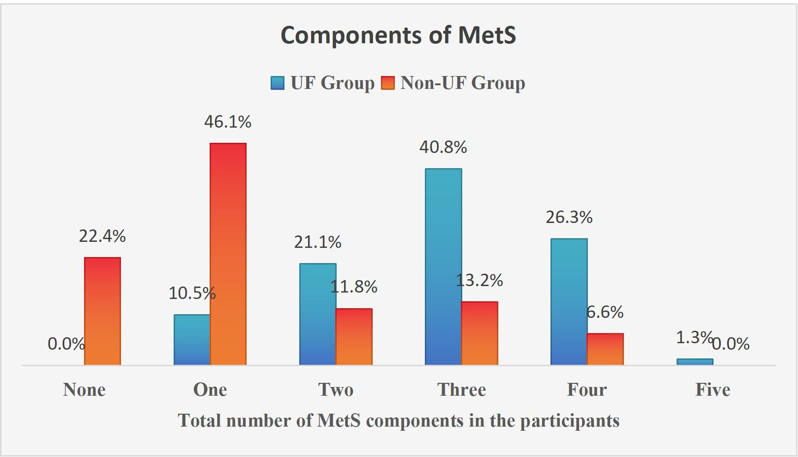

Figure 1: comparison of the total number of components of MetS between participants with and without UFs
Seventeen women (22.4%) in the non-UF group and one women (1.3%) in the UF group had no MetS component and had all the MetS component, respectively. Thirty one (40.8%) participants in the case group had three components and 35 (46.1%) participants in the control group had one component. The number of MetS components was significantly higher in the UF group than in the non-UF group (p<0.001).

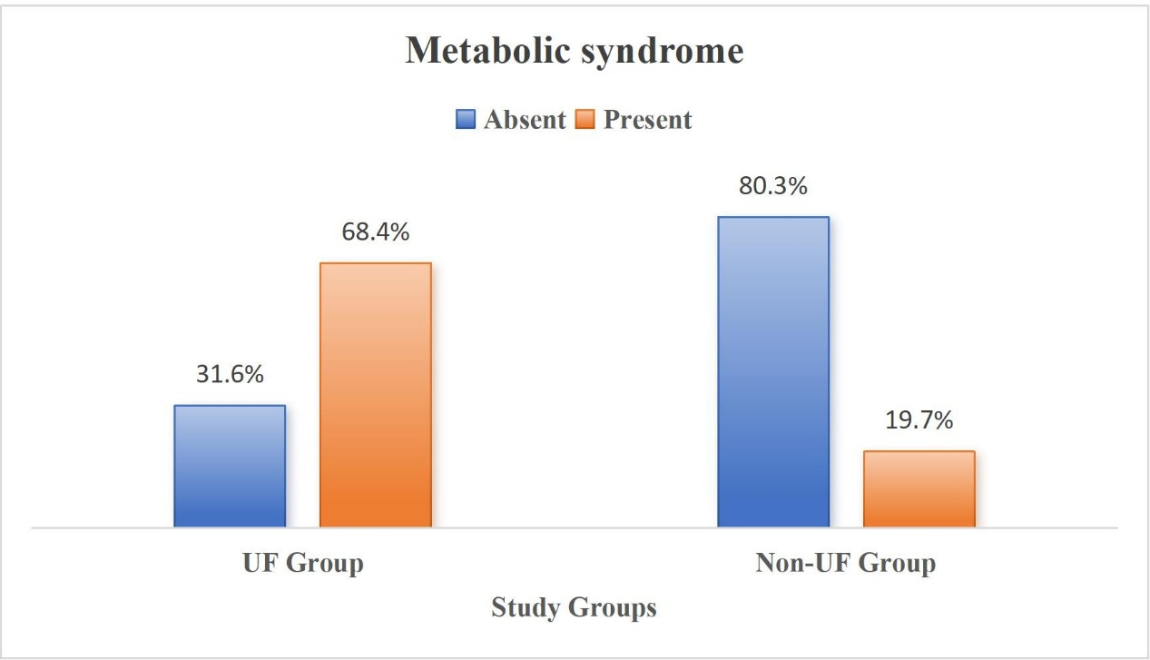

Figure 2: Proportion of the participants with MetS between case and control group
Out of 76 women with UF, 52 (68.4%) had MetS, compared to 15 (19.7%) out of 76 women without UF, and the difference was statistically significant (p<0.001).
Table 4 shows in multivariate analysis, only the presence of MetS revealed as an independent risk factor for UFs. Participants with MetS were nine times higher chance of having UF than the participants without MetS (OR; 9.08, 95%CI: 4.16- 19.84, p<0.001).
Table IV: Multivariate binary logistic regression analysis for odds ratio of factors associated with UF

Variables | B | P value | Odds Ratio (OR) | 95% CI for OR (Lower) | 95% CI for OR (Upper)
Age of menarche | 0.207 | 0.498 | 1.23 | 0.676 | 2.241
Parity | 0.2 | 0.376 | 1.222 | 0.784 | 1.904
Age at 1st childbirth | 0.53 | 0.2 | 1.699 | 0.756 | 3.82
Metabolic syndrome | 2.206 | <0.001 | 9.084 | 4.16 | 19.806
Dependent variable: Study group (UF Group vs. Non-UF group); Independent variables: Age of menarche, Parity, Age at 1st child birth, and presence of metabolic syndrome. CI: Confidence interval; OR: Odds ratio.
Table 5 shows differences in the proportion of metabolic abnormalities between participants with small and large UFs. More women with large UF had high blood pressure, hypertriglyceridemia, and MetS. However, only the difference in the proportion of hypertriglyceridemia between two groups reached statistical significance (p=0.046).

Table V: Association between components of MetS and the size of UF (n=76)

Small UFs |  | Large UFs
Characteristics | (n=57) | (n=19) | P value†
Abdominal obesity | 43 (75.4) | 13 (68.4) | 0.547
High blood pressure | 23 (40.4) | 12 (63.2) | 0.084
Hyperglycemia | 11 (19.3) | 1 (5.3) | 0.146
Hypertriglyceridemia | 27 (47.4) | 14 (73.7) | 0.046
Low HDL-C | 53 (93.0) | 17 (89.5) | 0.623
Metabolic syndrome | 38 (66.7) | 14 (73.7) | 0.569
UF: Uterine fibroid; Data were expressed as frequency (%) †Chi-square test.

Discussion
In this study, the mean age of women with uterine fibroids (UF) was 44.4±2.5 years, and the majority were in the 45–47 years age group. This finding is consistent with earlier reports suggesting that the prevalence of fibroids increases with age during the reproductive years, peaking in the perimenopausal period. The most common presenting symptom was menorrhagia (92.1%), which aligns with previous studies indicating that abnormal uterine bleeding is the predominant complaint among women with fibroids. Most fibroids in this study were submucosal (96.1%), located predominantly in the anterior wall, and nearly one-fourth were classified as large (≥5 cm). Similar anatomical and clinical distributions were reported other studies underscoring the role of fibroid size and location in symptom severity.¹⁰
A key finding of this study was the significant association between uterine fibroids and metabolic syndrome (MetS). Women with UFs had higher waist circumference and lower HDL-C compared to controls, while hypertriglyceridemia and hyperglycemia were also more prevalent. These findings support the hypothesis that metabolic derangements contribute to fibroid development, possibly through mechanisms involving insulin resistance, dyslipidemia, and chronic low-grade inflammation. Our results are in agreement with other study who reported that women with fibroids were more likely to exhibit features of MetS, particularly abdominal obesity and low HDL-C. ¹¹ Similarly, other study demonstrated that central adiposity and metabolic abnormalities were strongly correlated with UF risk in premenopausal women. ¹²
The present study showed that 68.4% of women with UFs had MetS, compared to only 19.7% of women without UFs, and MetS emerged as an independent risk factor with an odds ratio of 9.08. This is a much stronger association than previously reported who found a 2–3 fold increased risk. The higher odds ratio in our study may reflect differences in ethnicity, dietary patterns, and lifestyle factors in the Bangladeshi population. ¹³ Furthermore, the Asia-Pacific definition of abdominal obesity (WC ≥85 cm) may have contributed to a more sensitive detection of central obesity as a risk component.
Interestingly, we observed that large fibroids were more frequently associated with hypertriglyceridemia, although other components of MetS did not significantly differ by fibroid size. This suggests that metabolic abnormalities, particularly dyslipidemia, may play a role in fibroid growth dynamics. A similar association was highlighted who noted that obesity and lipid abnormalities were linked to larger fibroid volume. ¹⁴⁻¹⁵ However, our results did not find a significant difference in the prevalence of MetS between small and large fibroids, indicating that while metabolic dysfunction may contribute to fibroid development, other factors such as genetic predisposition and hormonal environment also influence fibroid size.
Taken together, these findings highlight a strong association between uterine fibroids and metabolic syndrome among premenopausal women. The results emphasize the need for a holistic approach in managing women with fibroids, with attention not only to gynecological symptoms but also to screening and management of metabolic risk factors. This dual approach could potentially improve reproductive health outcomes and reduce long-term cardiometabolic morbidity. Further longitudinal and multicenter studies are warranted to establish causal relationships and explore underlying mechanisms in diverse populations.
Conclusion
Based on the findings of this study, it can be concluded that uterine fibroids in premenopausal women are strongly associated with metabolic syndrome, with significantly higher rates of abdominal obesity, hyperglycemia, hypertriglyceridemia, and low HDL-C compared to women without fibroids. The presence of metabolic syndrome was identified as an independent risk factor, conferring a nine-fold increased likelihood of developing fibroids. These results suggest that metabolic abnormalities not only contribute to the occurrence of uterine fibroids but may also influence their clinical presentation, underscoring the importance of comprehensive evaluation and management that addresses both gynecological and metabolic health in affected women.
Reference:
- Moon, K.H., Ryu, S.K., Kim, K.K., Suh, H.S. and Hwang, I.C., 2013. Relationship between Metabolic Syndrome and Uterine Fibroids in Premenopausal Korean Women. Korean Journal of Family Pracice, 3(4), pp.437-441.
- Navarro, A., Bariani, M.V., Yang, Q. and Al-Hendy, A., 2021. Understanding the impact of uterine fibroids on human endometrium function. Frontiers in cell and developmental biology, 9, p.633180.
- Noubiap, J.J., Nansseu, J.R., Lontchi-Yimagou, E., Nkeck, J.R., Nyaga, U.F., Ngouo, A.T., Tounouga, D.N., Tianyi, F.L., Foka, A.J., Ndoadoumgue, A.L. and Bigna, J.J., 2022. Geographic distribution of metabolic syndrome and its components in the general adult population: A meta-analysis of global data from 28 million individuals. Diabetes research and clinical practice, 188, p.109924.
- Olusi, A.M., Rabiu, K.A., ODUOLA-OWOO, B.B., Rasheed, M.W., ODUOLA-
- OWOO, L.T. and Windapo, O.B., 2024. Relationship between Metabolic Syndrome and Uterine Leiomyoma: A Case Control Study. The Nigerian Health Journal, 24(1), pp.1058-1069.
- Pavone, D., Clemenza, S., Sorbi, F., Fambrini, M. and Petraglia, F., 2018. Epidemiology and risk factors of uterine fibroids. Best Practice & Research Clinical Obstetrics & Gynaecology, 46, pp.3-11.
- Potenza, M.V. and Mechanick, J.I., 2009. The metabolic syndrome: definition, global impact, and pathophysiology. Nutrition in Clinical Practice, 24(5), pp.560-577.
- Ranasinghe, P., Mathangasinghe, Y., Jayawardena, R., Hills, A.P. and Misra, A., 2017. Prevalence and trends of metabolic syndrome among adults in the asia-pacific region: a systematic review. BMC public health, 17, pp.1-9.
- Riaz, B.K., Islam, M.Z., Islam, A.S., Zaman, M.M., Hossain, M.A., Rahman, M.M., Khanam, F., Amin, K.B. and Noor, I.N., 2020. Risk factors for non-communicable diseases in Bangladesh: findings of the population-based cross-sectional national survey 2018. BMJ open, 10(11), p.e041334.
- Sadlonova, J., Kostal, M., Smahelova, A., Hendl, J., Starkova, J. and Nachtigal, P., 2008. Selected metabolic parameters and the risk for uterine fibroids. International Journal of Gynecology & Obstetrics, 102(1), pp.50-54.
- Sato, F., Mori, M., Nishi, M., Kudo, R. and Miyake, H., 2002. Familial aggregation of uterine myomas in Japanese women. Journal of epidemiology, 12(3), pp.249-253.
- Sharami, S.H., Fakor, F., Sani, M.K., Omidi, S., Jahromi, S.K., Ghalandari, M., and Attari, S.M., 2020. The characteristics of Uterine Leiomyoma and metabolic syndrome in the multiparous overweight women in northern Iran. Pakistan Journal of Medical & Health Sciences, 14(2), pp.1137-1142.
- Shen, M. and Shi, H., 2015. Sex hormones and their receptors regulate liver energy homeostasis. International journal of endocrinology, 2015(1), p.294278.
- Shikora, S.A., Niloff, J.M., Bistrian, B.R., Forse, R.A. and Blackburn, G.L., 1991. Relationship between obesity and uterine leiomyomata. Nutrition (Burbank, Los Angeles County, Calif.), 7(4), pp.251-255.
- Sivri, N., Yalta, T., Sayın, C., Yalta, K., Özpuyan, F., Taştekin, E. and Yetkin, E., 2012. Evaluation of cardiovascular risk factors in women with uterine leimyoma: is there a link with atherosclerosis?. Balkan medical journal, 2012(3), pp.320-323.

