Developing a Framework for Integrated Solid Waste and Flood Risk Management for Gombe Metropolis, Nigeria.

Abstract
The effect of poor solid waste management on flood risk is becoming more and more among cities around the world. The concept of solid waste basically considered rubbish, refuse, garbage, and trash or any unwanted materials from industrialized processes or household activities that are discarded. The flood risk is the function of hazard, exposure, vulnerability to floods. Gombe metropolis is facing a serious environmental issue of flooding which became annual event presently. On the same the Gombe urban population is highly increasing which subsequently increased the amount of amount of solid waste generate by residents. Many empirical research has established a correlation between poor waste management and flood risk. Hence, the aim of the research is to develop a framework for an integrated solid waste and flood risk management and the specific objectives are to assess flood risk, flood incidences and flood risk management, evaluate existing solid waste management practices and its efficiency, identification of linkages between solid waste and flood risk management and develop a comprehensive framework for integrated solid waste and flood risk management. Both Geographic Information System and statistical tool were use and findings are with respect to the link of solid waste and flood risk management about 60% of respondents perceived that poor solid management was responsible for blocking of streams/rivers/drainage fertilities. And 89% of respondent believed that the poor solid waste management was responsible for flood occurrences. A substantial number of residents (73%) perceived government efforts on solid waste and flood risk management are very effective to effective efforts. And finally, the research unveiled the high to very high flood risk districts as Bajoga, Ajiya, Dawaki, Bolari, Liji and Pantami, Tabra, Herwa Gana, and Garin Hamza district respectively.

Keywords: Solid waste Management, Flood Risk, Integration, Framework and Gombe Metropolis

Introduction

- Background of the Study
The issue of urban solid waste management and its negative impacts on the increasing flood risk is a global phenomenon affecting various cities. The concept of solid waste may be referred to rubbish, refuse, garbage, and trash or any unwanted materials from industrialized processes or household activities (Sulemanu et. al., 2019). The municipal solid waste generally include materials (such as vegetables, food, and garden waste), paper and paperboard (including paper, wrapper, cardboard, and packaging paper), plastics (including plastic bags, plastic bottles, and packaging material), glass/ceramics (including glass bottles, broken glass, pottery items and earthen pot), metals (cables, foils, ferrous and nonferrous material), (including textiles), and others including inert and a lot more (Mohammed et, al., 2021). Waste production rates are rising on a global scale. According to a World Bank report, the quantity of solid waste produced by cities worldwide in 2016 alone was 2.01 billion tons, or 0.74 kilos per person per day (World Bank, 2019). Urban centers in Nigeria have also witnessed a steady rise in waste generation due to urbanization and increase in population. In Nigeria, there is a steady increase in waste quantity and variety due to population growth and industrialization (Ajayi and Sambo, 2021). At a population growth rate of 2.03%, energy consumption and waste generation in Nigeria is expected to soar over the next few years. For instance, Abuja, the nation’s capital generates between 0.55-0.58 kg of waste per person per day, and Lagos, one of the most populous cities in the world generated 4 million tons of waste in 1995 and by year 2000 (Ajayi and Sambo, 2021). The study area, Gombe metropolis, is one of the most populous metropolitan cities in the northeastern part of Nigeria, with a population growth rate of 3.2% and urbanization rate of 3.5% per annum (NPC,2009), led to a higher solid waste generation of 21,297 tons and 5,832 tons per month for INEX and GOSEPA dumpsites respectively. Solid waste generations pose a problem beyond the scope of various solid waste management and this because rapid increases in population in Nigeria have resulted in a dramatic increase in the generation of municipal solid waste (Sulaiman and Maigari, 2016). The basic solid waste management system based on collection, transportation and disposal remains highly inefficient and ineffective, especially in the urban centers (Ajayi and Sambo, 2021)

The flood risk explained above as the function of hazard, exposure, vulnerability to floods (Crichton, et. al., 1999). The hazard means the threatening natural event including its probability of occurrence, and it generally quantified as the water depth and water flow velocity distribution. The exposure refers the people/assets that are present at the location involved. The vulnerability indicates the characteristics and circumstances of a community, system or asset that make it susceptible to the damaging effects of a hazard (Crichton and et. al., 1999). Various subjective reasons for flood risk in urban areas are generally analyzed as; climate change through increase in rainfall magnitude and intensity, topography, cities growth and development in areas liable to floods, poor development of drainage systems, physical development with influence to create impervious surfaces, large population increase, increased flood vulnerability in urban areas (Chaochao and et, al., 2016). The second flood risk factor is nature of the land form, this is because flooding is more likely to occur in low-lying plains with gentle slopes than in high-lying places with steep slopes (Wisner, et., al 2004), The third factor is urban growth and development. The fourth flood risk factor which is unavailable or poorly constructed drainage System. The lack of proper drainage channels and maintenance to clean the accumulated solid waste causes a partial loss of the network capacity and the network would be insufficient to drain the water, which probably leads to overflows and flooding in the streets (World Bank, 2011).
Typically, solid waste management system may comprise of the following: generation and storage of household waste, Reuse and recycling on household level including composting, primary waste collection and transport to transfer station or community bin, the transfer station or community bin management, secondary collection and transport to the waste disposal site and disposal of waste in landfills (Zoori and Ghani, 2017). The flood risk assessments investigate and, where possible, quantify the potential consequences of flooding from all sources to the exposed assets and the population across a given area (International Bank for Reconstruction and Development /The World Bank, 2023). The key elements of structural works have been reservoirs, dikes, detention basins, pumping stations, etc. Non-structural measures include flood forecasting, flood emergency planning and response, and post-flood recovery (Chaochao and et, al., 2016). Furthermore, the capacities of flood forecasting, early warming and flood control can be enhanced to mitigate the impact flood disasters. Solid waste management is an enduring problem in developed and developing countries and has become a major issue in flood risk incidences. For example, in Pakistan waste management is in its worse state because the poor measures to dump and recycle the waste results in blockage of drains and water channels which leads to the risk of urban flooding (Ijaz et., al. 2021). Hence, flood management literature regarding the importance of solid waste management in reducing flood risk have confirmed poor solid waste management as a major contributory factor to urban flooding across the globe with examples from Asia, Africa (Lamond et., al. 2012).
The term integration is defined as an act or process to combine, unite, bring together, or incorporate parts into a whole so that they work together (Hornby, 2010). Similar definition define integration to an approach to strengthen linkages between places, cooperation between sectors, or interconnections among policies (Kidd, 2007). Flood risk management can hugely benefit from the involvement of all stakeholders to increase the collective resilience of a city (Lamond et., al. 2013). This study developed and integrated solid waste and flood risk management for sustainable urban resilient to flood event. Creating a framework for integrated solid waste (ISW) and flood risk management (FRM) for Gombe Metropolis requires understanding of the city's unique challenges and characteristics. Gombe metropolis is the capital of Gombe State in northeastern part of Nigeria, experiencing rapid urbanization and population growth. This expansion, coupled with inadequate needed infrastructures, poses a significant challenge on waste management and flood risk mitigation (Idris and Dantata, 2018). Solid waste disposal in Gombe metropolis is predominantly done through open dumping and uncontrolled disposals, lacking proper segregation and recycling, inadequate funding and infrastructure for proper waste collection, transportation, and disposal, public awareness and engagement in sustainable waste practices are minimal. Informal waste pickers play a significant role in recycling but often operate under unsafe conditions. Gombe is prone to seasonal floods exacerbated by heavy rainfall intensity and the nature of the city's topography, with many residential areas found within the low-lying zones. Urbanization has led to the encroachment of built environment on areas liable to floods and the construction of buildings in areas with poor drainage facilities and all these probably increases the flood risks (Adaku, 2023). The existing drainage systems are often inadequate, narrow and poorly maintained, leading to frequent blockages by solid waste and sediment. Flood risk management is usually reactive especially after the occurrence of a flood rather than proactive, with limited early warning systems and emergency response plans. In addition, the metropolis is experiencing an insufficient coordination between urban planning, environmental management, and related flood disaster risk reduction agencies and lack of comprehensive flood risk assessment and resilient infrastructure. Hence, the integration of SWM and FRM is critical, as unmanaged solid waste often blocks drainage systems, exacerbating flood risks. Conversely, effective flood management can protect waste management infrastructure from damage.

Hence, the aim of the research is to develop a framework for an integrated solid waste and flood risk management and the specific objectives are to assess flood risk, flood incidences and flood risk management, evaluate existing solid waste management practices and its efficiency, identification of linkages between solid waste and flood risk management and develop a comprehensive framework for integrated solid waste and flood risk management. The components of the integrated framework will consist of assessment of the current solid waste and flood risk management systems, including infrastructure, policies, and practices, involving local government, communities, NGOs, and private sectors in planning and implementation, enhancing the capabilities of local government authorities and communities through training and resources, developing and enforcing regulations that support integrated SWM and FRM, utilize technology for real-time monitoring, early warning systems, and efficient waste processing.

It is expected that the finding of the research will immensely reduce flood risk and improved waste management efficiency, environmental quality and increased community resilience to urban flood hazard in Gombe Metropolis. Gombe metropolis have experienced a massive influx of people from the inception of the metropolis as the state capital city in year 1996 to date. As a result, civil servants relocated from the former state capital and people migrated from the neighboring rural settlements to the new city. Since then, the metropolis, faces a significant challenge related to solid waste generation and flood risk management. The solid waste management system in Gombe is struggling with inconsistent and inadequate waste collection and disposal practices. This inefficiency leads to the accumulation of solid waste in open areas, streets, and urban water drainage (Adaku, 2023). Accumulated solid waste, particularly nylon bags, plastic and other non-biodegradable materials, blocks the urban drainage facilities and this not only impedes runoff but also aggravates flooding during the rainy season. A significant portion of waste management is substantially handled by the informal sector such as waste scavengers roaming streets poor formal recognition, support, and regulation. This leads to unsafe and inefficient recycling and waste handling practices. Furthermore, the available drainage facilities in Gombe are in most places narrow, open drains and inadequately maintained. This results in frequent blockages and flooding, especially during heavy rains. Therefore, the rapid urban growth and poor building development control has led to the encroachment of settlements into areas liable to floods and this not only increases flood risks but also hinders effective flood management and disaster response. SWM and FRM efforts in Gombe metropolis are fragmented and lack coordination and the absence of an integrated approach means that flood control measures often do not account for waste management issues, and vice versa. Moreover, there is a lack of integrated planning and coordination between authorities responsible for SWM and FRM, leading to policy inconsistencies and inefficient use of resources, couple with poor community awareness and participation in sustainable waste disposal and flood prevention practices. Existing research works and practices in Gombe sees SWM and FRM as separate concerns, hence, the need for a comprehensive understanding of how different stakeholders (government, private sector, community) can collaborate effectively in an integrated management framework. Addressing these interconnected challenges through an integrated approach will improve Gombe urban resilience, reduce flood risks, enhance solid waste management, and contribute to the sustainable development of Gombe metropolis. The research will provide valuable insights for policymakers, urban planners, and community leaders on implementing effective, coordinated strategies for management of solid waste and flood risks in Gombe metropolis.

- Study Area and Methodology
The research will combine both qualitative and quantitative approaches to provide a comprehensive understanding of the integrated solid waste and flood risk management in Gombe metropolis. The methodology is explained according to the following themes:

5.1 Study Area
The study area is the whole of Gombe Metropolis districts which comprises of both Gombe Local Government Area (LGA) and some part of Akko Local Government Area (LGA). Gombe town as seen in figure 1 is relatively located in the North-Eastern region of Nigeria absolutely at Latitude 10⁰ 8¹ and 11⁰ 23¹ N and Longitude 11⁰ 20¹ and 10⁰ 24¹ E (Gombe State Ministry of Land and Survey, 2003). Though, the target research areas are flood prone communities within the metropolis. The projected (2016) population of Gombe Local Government stood at 367,500 persons (CITY POPULATION, 2020).
Gombe town has a tropical continental type of climate (Aw) based on Koppen’s classification scheme. It is characterized by strong rainfall seasonality with distinct wet and dry season and the rainfall is concentrated between the months of July and September (Abashiya 2006). The concentration of rain in these three months (July to September) has the potential of increasing the soil moisture condition, reducing infiltration capacity and hence causing flooding (Abashiya et al., 201).

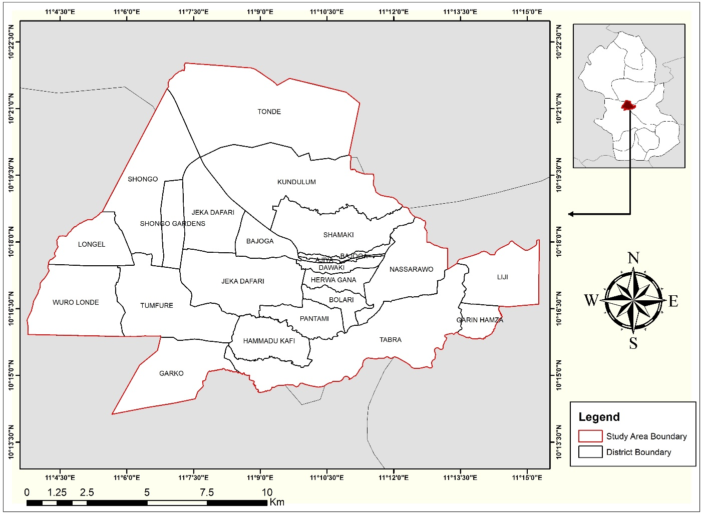
Figure 1: The Map of Study Area (Gombe Metropolis) Showing Districts.
Source: Author’s Work, 2025.

Gombe metropolis population was 312,467 in the 2006 census and is projected to reach about 573,000 in 2023 (Sulaiman and Maigari, 2016). Gombe metropolis have high rate of urbanization (3.5%) and population growth rate of 3.2%, it stands the potential of generating more municipal solid waste (NPC, 2009).
The research methodology is based on an integrated approach which includes flood risk assessment, flood incidence and management, soldi waste management and the link between soldi waste and flood risk management.

Flood hazard analysis is the initial step in risk analysis, using remote sensing and GIS tools. It involved annual average rainfall
Exposure

Data were basically collected through field survey and observations: The research have conducted a field observation through visiting solid waste management facilities, flood-prone areas, and collecting location points of waste dumping containers/bins and the final solid waste dump sites. Furthermore, field surveys, and oral interviews to gather data on solid waste generation, collection, and disposal practices, as well as flood risk factors in urban Gombe was undertaken. In addition, oral interviews was conducted with stakeholders, including government officials, State Emergency Management Agency (SEMA) and the Director on solid waste management, Gombe State Environmental Management Agency (GOSEPA)

Remote sensing and Geographic Information Systems (GIS) tools were for the assessment of the flood risk and the creation of the 2025 flood risk zones mapping and solid waste dumpsites mapping so as to enhance integrated management efforts. High resolution satellite images and handheld geographic position system (GPS) Etrex 30 were use for the analysis. Furthermore, the spatial data were analyzed in ArcGIS Pro version 10.8. and Google Pro. Further questionnaire survey was conducted to inquire about flood risk incidence, flood risk and solid waste management. A total 250 questionnaires were systematically administered to households residing on areas liable to flood in the metropolis.

- Result and Discussion
The result and discussion are presented according to the following sub themes:

  - Introduction
The result and the respective discussion are presented according to the objectives of the research and discussed on the basis of the existing relevant empirical works through the following sub themes; flood risk assessment, flood incidences and flood risk management, existing solid waste management practices and its efficiency, identification of linkages between solid waste and flood risk management and development of a comprehensive framework for integrated solid waste and flood risk management.

  - Gombe Metropolis Flood Risk Assessment
The key flood risk factors are hazards, exposure and vulnerability and while assessing the flood risk in Gombe metropolis various flood risk variables like hazard (rainfall), exposure (distance from river/stream, distance from road/drainage and elevation) were assessed using ArcGIS Version 8 and ArcGIS Pro. On the other hand, vulnerability variable of the flood risk and solid waste management were evaluated using field questionnaire survey conducted in the study area.

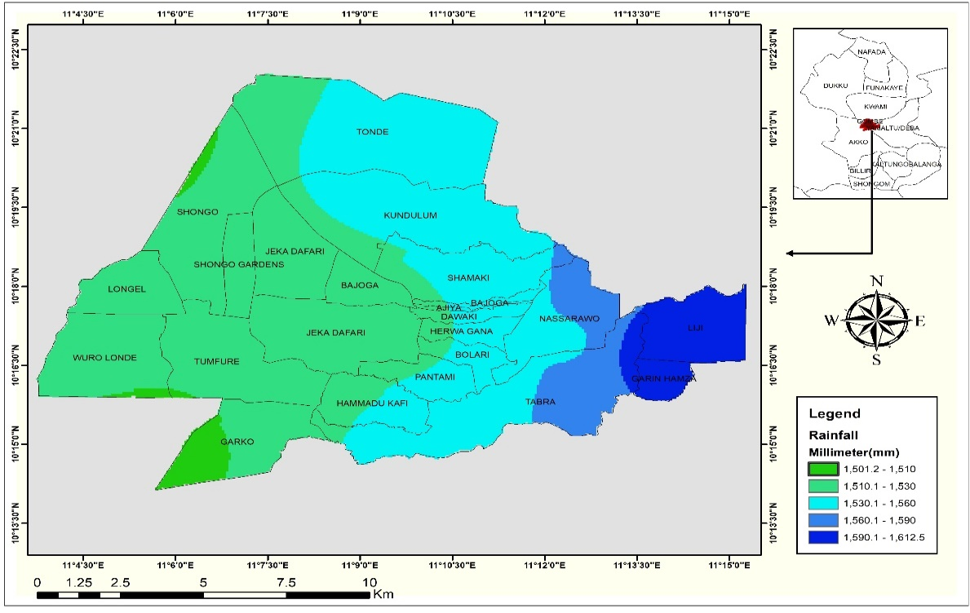
Figure 2: Gombe Metropolis Annual Average Rainfall Distribution from 2000-2025
Source: Author’s Work, 2025.

The hazard which is the rainfall data was obtained from NASA POWER rainfall data where it was interpolated and converted into raster format to represent spatial rainfall distribution across Gombe metropolis districts. There were four rainfall storms that occurred on the 25/8/2014, 29/8/2014, 2/9/2014, and 3/9/2014 with rainfall amount of 35.8 mm, 34.4 mm, 12.5mm, and 14.6 mm respectively (Abashiya et., al. 2019).
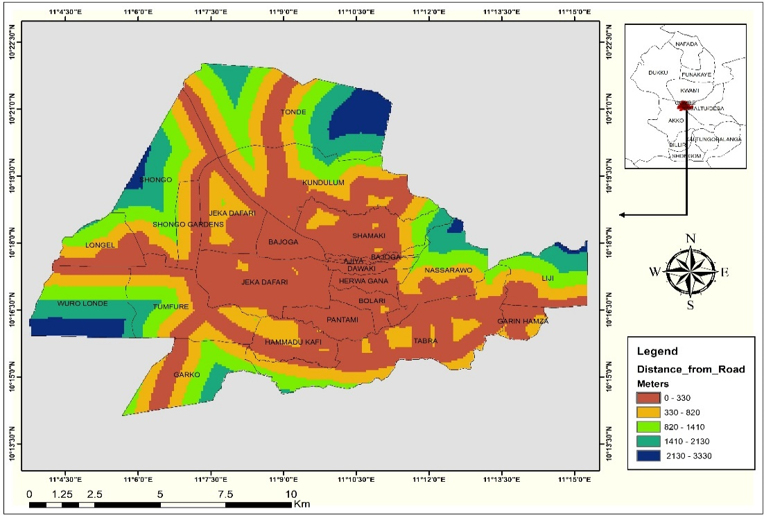
Figure 3: Distance of Household from Road Network.
Source: Author’s Work, 2025.

Figure 1 demonstrated that the lowest average annual rainfall is very common in the western part of the metropolis which covers district areas of Shongo Dongel, Wuro Longe, Shongo Gardens, Tumfure, Garko, Bajoga west, Jekadafari and part of Hammadu Kafi. The minimum amount of annual average rainfall can be found in Tonde, Kundulum, shamaki, Bajoga east, Ajiya, Dawaki, Herwagana, Bolari, Tabra, Nassarawo. While the areas with high amount of rainfall are district of Nassarawa and Tabra, Liji and Garin Abba. The exposure (distance from river/stream, distance from road/drainage and elevation) was also explained in the following figures. In distance to road the road network was digitized manually from the base map. Furthermore, Euclidean Distance tool was used to generate the distance to road raster, indicating proximity influence to flood risk.

The distance of households from road and drainage where most are times in urban flood water flows which means susceptible to flood risk. Figure 4 indicate that more build ups in the central town areas are found closer to the roads (0-330 meters), while only few buildings especially at the outskirt (margin areas) of the town are found far away from the roads (2130-3330meters).
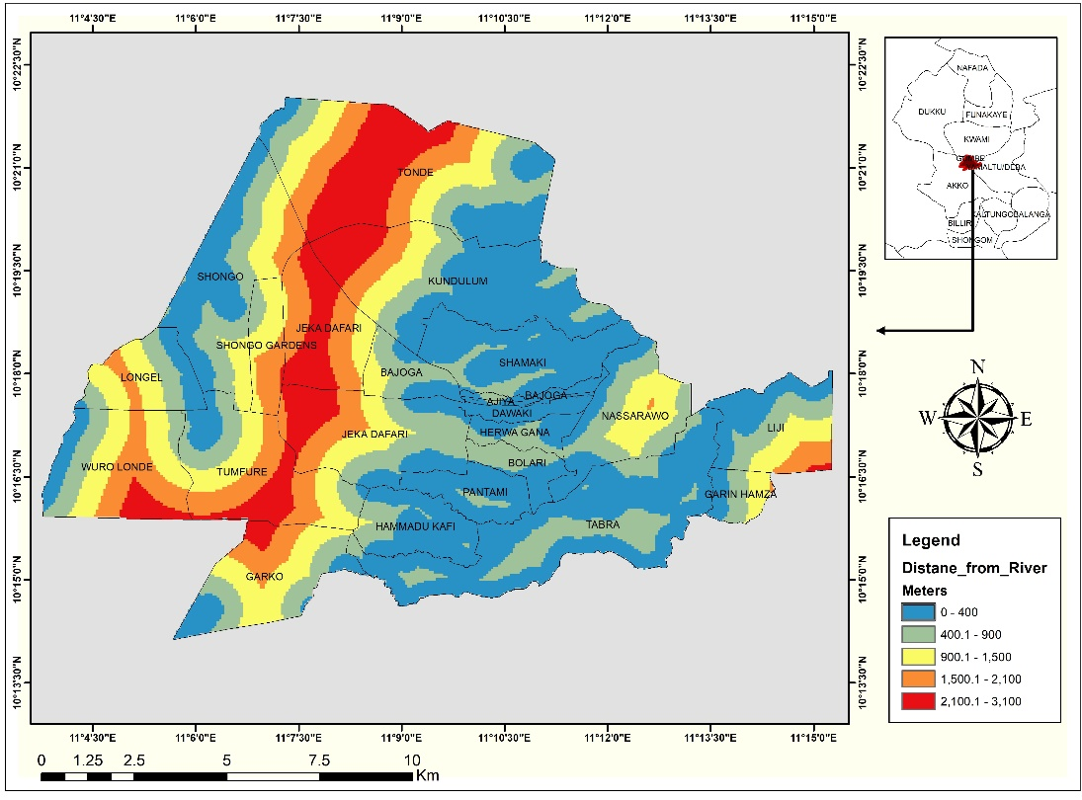
This shows that the central district areas have high risk of urban flood than the marginal areas. Stream networks were extracted from the DEM using the Hydrology Tools in ArcGIS (Flow Direction, Flow Accumulation, Stream Definition, and Stream Order). The Euclidean Distance tool was then applied to produce the distance-to-river map.

Figure 4: Built Up Areas Distance from Streams/Rivers.
Source: Author’s Work, 2025.

Concentration of building close to the river streams means they may be more vulnerable to flood risk. The map shows that some part of Shongo district, Kundulum, Shamaki, Bajoga East, Dawaki, Ajiya, Herwagana, Pantami, Hammadu Kafi,(0-400 meters) and Bolari, Bajoga West, Jekadafari, Tabra, and Garin Hamza (400-900 meters) are very more to more at risk of flood due to their proximity and exposure to river streams and areas liable to floods, However, Longel Wuro Londe, Garko Shongo Gardens, Tumfure and Liji district build up are far away (900-3,100 meters) from the river stream networks, hence, they are less at risk of floods.

Furthermore, Drainage Density was used as among the factors of flood risk. This because the density of streams/rivers in an area can make an area to be at risk of floods, while areas with stream/rivers will have less cases of floods. Using the Gombe metropolis stream network, Line Density analysis was conducted to compute drainage density, representing the degree of channel concentration.
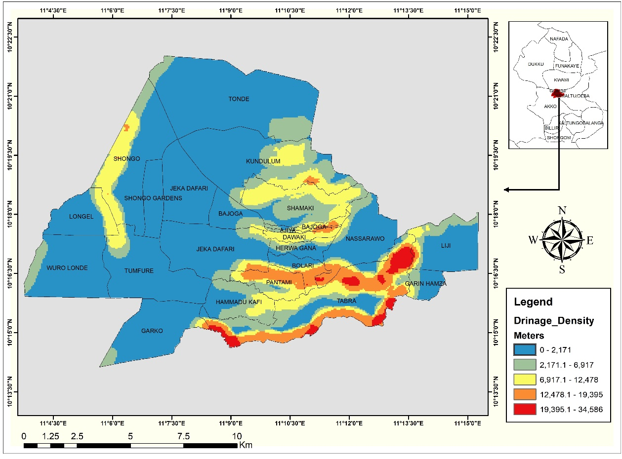Figure 5: Drainage Stream/River Density.
Source: Author’s Work, 2025.

The drainage basic shows that from the central to the western parts of the metropolis, the density of stream/river are less. However, from central towards the eastern part of the metropolis there are high density of streams/river, hence, there is high risk of floods in these areas. Because the drainage density of a geographical area has an inverse relationship with permeability; the higher the drainage density the lesser the amount of infiltration which increases the amount of runoff leading to flooding (Abashiya et., al. 2019).

An elevation of an area will normally make an area to be susceptible to flood risk. Hence, the study of the elevation as one the key factors of flood risk is necessary. The DEM data set of the Gombe metropolis was reclassified to represent varying elevation zones that influence surface runoff and flood potential districts in Gombe metropolis with higher elevations are range from a minimum of 487 meters to 703 meters above sea level and are concentrated in Shongo, Shongo Gardens, Longel, Wuro Londe, Tumfure, Tonde, Jekadafari West and East, Garko, Bajoga West. The low elevation districts in the metropolis start from an elevation of 351 meters to 487 meters above sea level and these districts are Kundulum, Shamaki, Ajiya, Bajoga East, Herwagana, Dawaki, Bolari, Pantami, Tabra, Nasarawo, Garin Hamza and Liji. Hence, all these districts are at risk floods due to their elevation status.

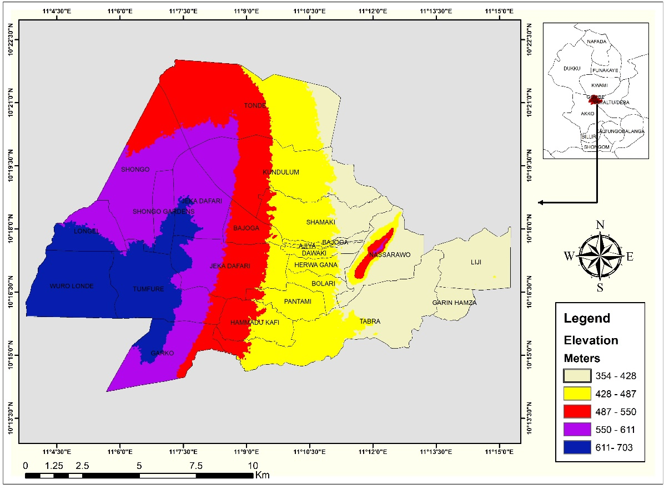
Figure 6: Elevation Map.
Source: Author’s Work, 2025.

In addition, the slope factor is also use due to the water flows. The slope map was derived from the DEM using the Slope tool to determine terrain steepness. Areas with lower slopes are generally more susceptible to flooding.

A very steep slope (0-2 degrees) as seen in figure 7 can be found at the extreme wester part of the metropolis where the slope steepness reduces to 41.33 degrees at eastern part of town. Hence, districts in this part of the metropolis are liable to floods.

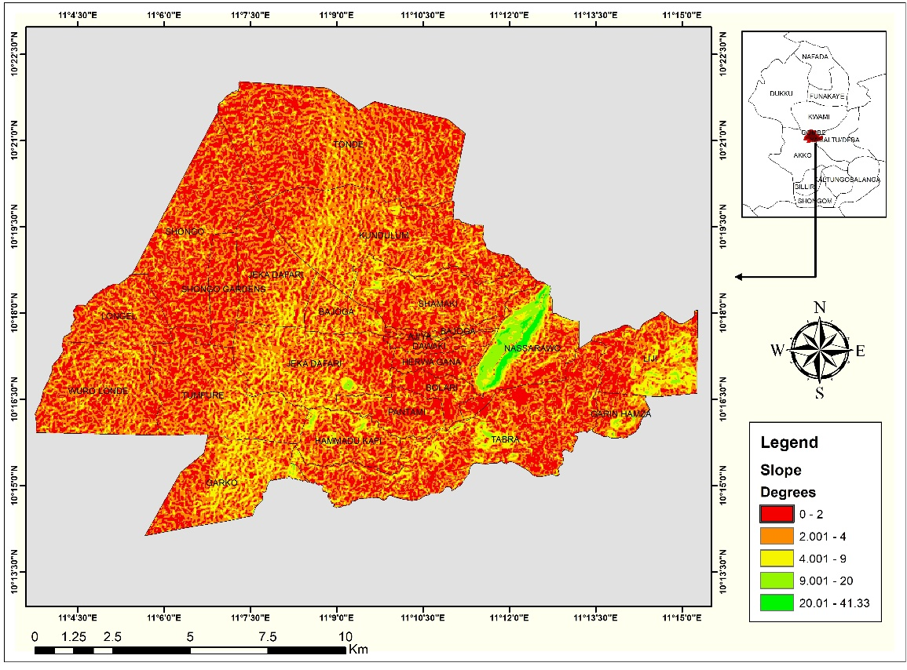
Figure 7: Built Up Areas Distance to River Map.
Source: Author’s Work, 2025.

The amount of pavement created by built environment is also one of the key factors of urban floods.
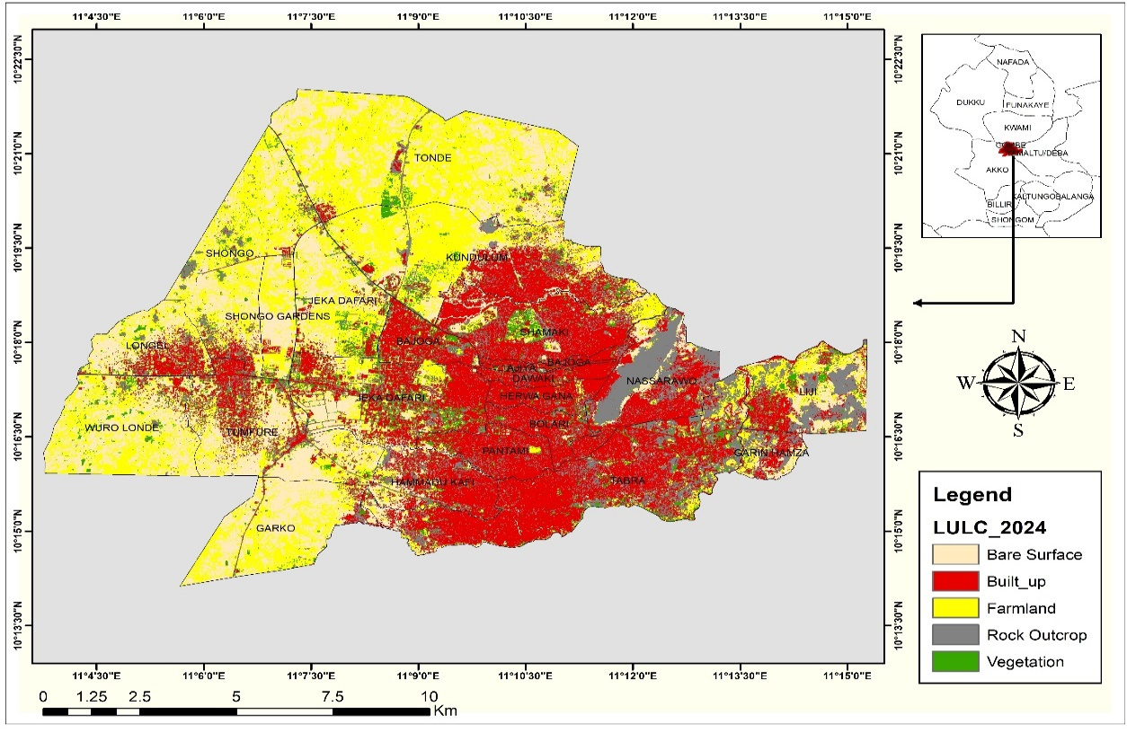
Figure 8: Gombe Metropolis Land Use/Land Cover types in 2025.
Source: Author’s Work, 2025.
This is because rain water cannot easily penetrate into ground and this led a quick runoff that cause the flood. Land Use/Land Cover Map: Sentinel-2 imagery (10m) was classified into land cover classes and these include built-up, vegetation, water bodies, and bare land using supervised classification. Builup are highly concetrated at the center of the metropolis and these districts are Jekadafari, Bajoga West, Hammadu Kafi, Kundulum, Shamaki, Ajiya,Dawaki, Herwagana, Bajoga East, Bolari, Pantami, Nassarawo, Jekadafari East, and Tabra. Therefore, these distrcits will be more susceptble to floods due to the high builtup concetration.

Using all the flood risk factors such as the hazard (rainfall data set), the exposure (distance from road/river, drainage density, elevation, land use/land cover changes, the thematic layers were reclassified according to their influence on flood risk using the Reclassify tool. Weighted overlay analysis was then performed using the Weighted Overlay Tool in ArcGIS Pro.3.5 The criteria weights were use based on empirical literatures to came up with the final Gome metropolis flood risk map. The risk map categorized the districts into five flood risk zones; very low, low, moderate, high, and very high flood risk zones.
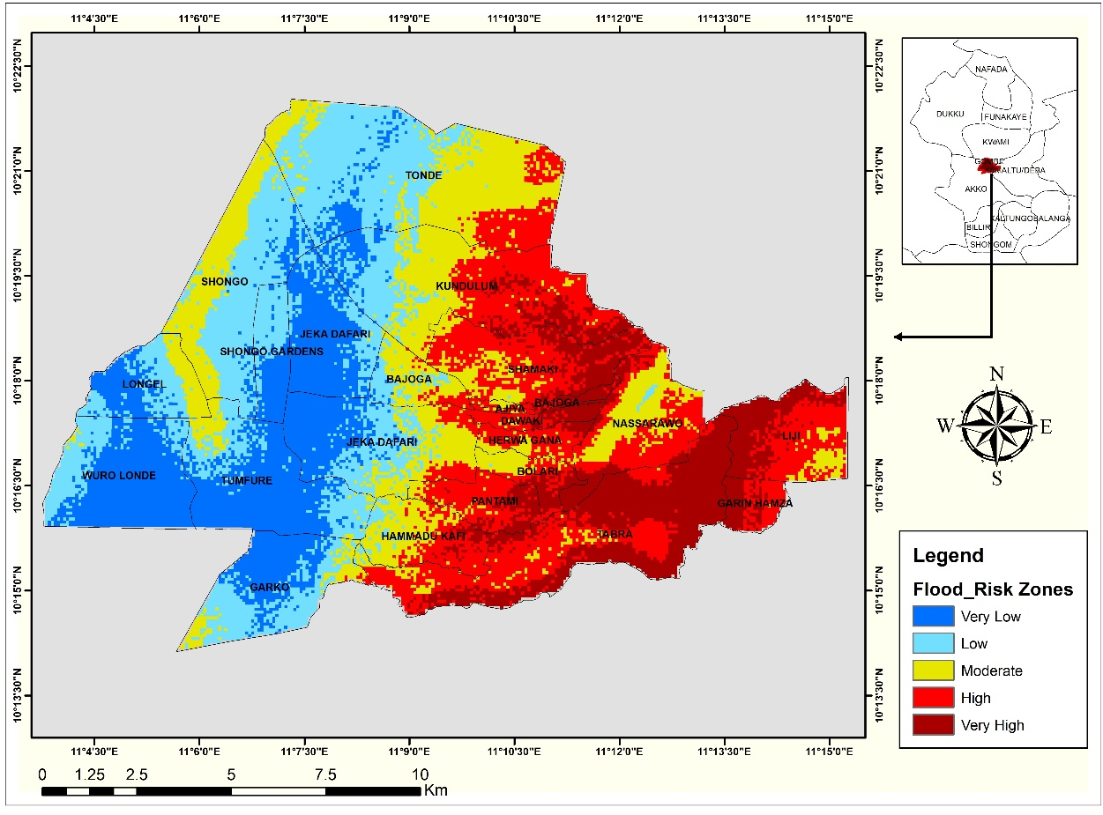
Figure 9: Gombe Metropolis Flood Risk Map 2025.
Source: Author’s Work, 2025.

The Gombe Metropolis flood risk map as seen in figure 8, reveal a significant spatial variation in flood susceptibility across the districts. The very low and low flood risk districts are Londe, Wuro Londe, Tumfure, Jekadafari, Shongo Gardens, Garko and Jekadafari West. These locations are typically situated on higher elevation zones or well-drained terrains. The gentle slope and distance from major drainage channels reduce the likelihood of inundation. In addition, these districts have low flood exposure, possibly as a result of better drainage systems, relatively elevated terrain, or reduced proximity to flood-prone channels. The moderate flood risk zones or districts covers districts part of Shongo, Bajoga west, some part of Hammadu Kafi, some part of Jekadafari west These districts may experience occasional flooding during heavy rainfall, particularly in poorly drained or low-lying areas because they represent transitional zones between high and low-risk distrcts. The high and very high flood risk districts are Bajoga, Ajiya, Dawaki, Bolari, Liji and Pantami, Tabra, Herwa Gana, and Garin Hamza respectively. These locations are more prone to seasonal flooding, often due to their proximity to river channels, drainage lines, or flat topography that encourages water accumulation and the subsequent floods.

  - Flood Incidences and Flood Risk Management.
The frequency of floods in Gombe metropolis has become an annual phenomenon prompting devastations on the urban communities (Abashiay, 2016). The field survey data revealed a significant incidence of flood occurrences in the Gombe metropolis in the previous years. The areas or districts affected by the flood incidence covers fifteen percent of the whole households in the Gombe metropolis as seen in figure 1.

Figure 10: Household Flood Experience.
Source: Author’s Fieldwork, 2025

Table 1 shows that the highest number of floods incidence (16 times) has happened from year 2016 to 2020 followed by 2021 to 2025 where we have 15 cases of flood occurrences. Furthermore, from year 2000 to 2015 has also recorded 7 number of flood incidence.

Table 1: Years of Flood Occurrence
Years | Number of times | Percentage
2000-2005 | 1 | 3
2006-2010 | 2 | 5
2011-2015 | 4 | 11
2016-2020 | 16 | 42
2021-2025 | 15 | 39
Total | 38 | 100
Source: Author’s Fieldwork, 2025.

The field survey data is well supported by the secondary data collected from Gombe State Emergency Management Agency (SEMA) where flood occurrences became more frequent in the previous years as seen in table 2.

Table 2: Summary of Reported Cases of Flood in Gombe Metropolis from 2006-2025
Years of Occurrence | Number of Household Affected | Number of Death | Number of Communities
7/08/2006 | 30 | - | 01
19/08/2007 | 252 | - | 06
26/08/2008 | 58 | - | 01
27/08/2008 | 85 | - | 01
29/08/2008 | 160 | - | 04
05/08/2014 | 1,022 | 06 | 12
10/07/2014 | 111 | - | 09
05/0/2017 | 75 | - | 08
28/05/2018 | 42 | 05 | 08
07/06/2019 | 26 | 04 | 02
20/07/2020 | 63 | 02 | 04
26/06/2025 | 69 | 02 | 06
Source: Gombe State Emergency Management Agency, 2025

Table 2 illustrate Gombe metropolis has started experiencing flood occurrence from year 2006 to 2025. However, the most devastating flood was in fifth August, 2014 and nineteen August 2007 covering six, seven communities and affected 1,022, 252 households respectively. Other devastating floods were recorded in 2008 and 2014through 2025 (Gombe State Emergency Management Agency , 2025). The key factors responsible for flooding in Gombe metropolis is basically flood risk hazard, which is the high amount of rainfall (36%) as perceived by the households and this is true when we look at the time of flood event which normally happens in August as seen in table 2. Furthermore, a empirical research work by Abashiya and et., al (2017) have shown that increased in rainfall in recent years is responsible for the recent flooding events in Gombe metropolis.

Table 3: Flood Factors
Factors | Percentage
Heavy rainfall | 36
Solid waste blockage | 18
Poor drainage system | 31
Constructions of building on floodplains | 11
Others | 5
Total | 100.0%
Source: Author’s Fieldwork, 2025.

Other factors are poor drainage system (31%), solid waste blockage of the waterways (18%) and construction of building on floodplains. Table 3 shows that almost all the interviewed households have built their houses in less than 50 meters away from the waterways, hence they are at risk of flood due to their exposure the flood hazards.

Table 4: Distance of Buildup from Waterways
Distance in Meters | Percentage
0-5 | 5.2
6-10 | 3.2
11-15 | 8,4
16-20 | 11.2
21-25 | 8.4
26-30 | 11
31-35 | 13.2
36-40 | 15.2
41-50 | 19.6
51 and above | 4.0
Source: Author’s Fieldwork, 2025.

Various flood mitigation measures have been used by the Gombe metropolis urban residents to mitigate the incidence of flood in their arears and table 5 shows that these are mostly planting of protective plants (42%), use of sand bags (38%) and construction of concrete works (20%).

Table 5: Flood Control Measures
Mitigation Measures | Percentage
Sand bags | 38
Protective plants | 42
Concrete work | 20
Total | 100
Source: Author’s Fieldwork, 2025.

One of the emerging flood management measures is flood awareness campaign and table 6 displays a poor awareness campaign because substantial number of respondents (66%) have not been given any awareness on flood risk while insignificant number were aware.

Table 6: Flood Awareness
Awareness | Percentage
Yes | 34
No | 66
Source: Author’s Fieldwork, 2025.7

  - Solid Waste Generation and Management System.
Solid Waste Management involves managing activities associated with generation, storage, collection, transfer and transport, processing and disposal of solid wastes (Ajayi and Sambo, 2021). Solid waste collection and disposal is still among the main environmental problems in (Sulaiman and Maigari, 2016).

The solid waste generation in Gombe metropolis as seen in table 7 below displays where 26% of the households generate one (10%) kilogram of waste in a week. Others generate 2 to 3 kilograms of waste weekly (12%). While four (4) to more than five (5) kilograms of waste are generated by more than fifty percent of the households (52%).

Table 7: Daily Amount of Solid Waste Generation in Kilogram
Solid Waste in Kilogram | Percentage
1 | 26
2 | 6
3 | 6
4 | 10
5 | 12
Above 5 | 40
Total | 100.0
Source: Author’s Fieldwork, 2025.

The types of waste common in Gombe metropolis are essentially food waste (35%), paper (28%) and plastic (24%) as shown in table 8. Other wastes are metal, glass and others (13%). This result is in agreement with the findings of Ajiya and Sambo (2021), where they found that the biodegradable waste as food and kitchen waste such as meat trimmings, vegetable peelings and the non-biodegradable items were glass and plastic bottles.

Table 8: Types of Waste in Gombe Metropolis
Types | Percentage
Food Waste | 35
Plastic | 24
Metal | 1
Glass | 1
Paper | 28
Others | 11
Total | 100
Source: Author’s Fieldwork, 2025.

The types of waste generated needs to be collected for disposal and table 9 revealed that 83% of the household does not have waste bins at home, although 67% of them accepted the availability of refuse dumpsite in their areas as seen in Figure 11and table 8.

GOSEPA (Gombe State Environmental Sanitation and Protection Agency) are the responsible agency for constructions of thewaste dumpsites.

Table 9: Availability of Waste Bins and Refuse Dumpsites
Availability Bins | Percentage
Yes | 83
No | 17
Availability of Refuse Dumpsite | Percentage
Yes | 67
No | 33
Source: Author’s Fieldwork, 2025.

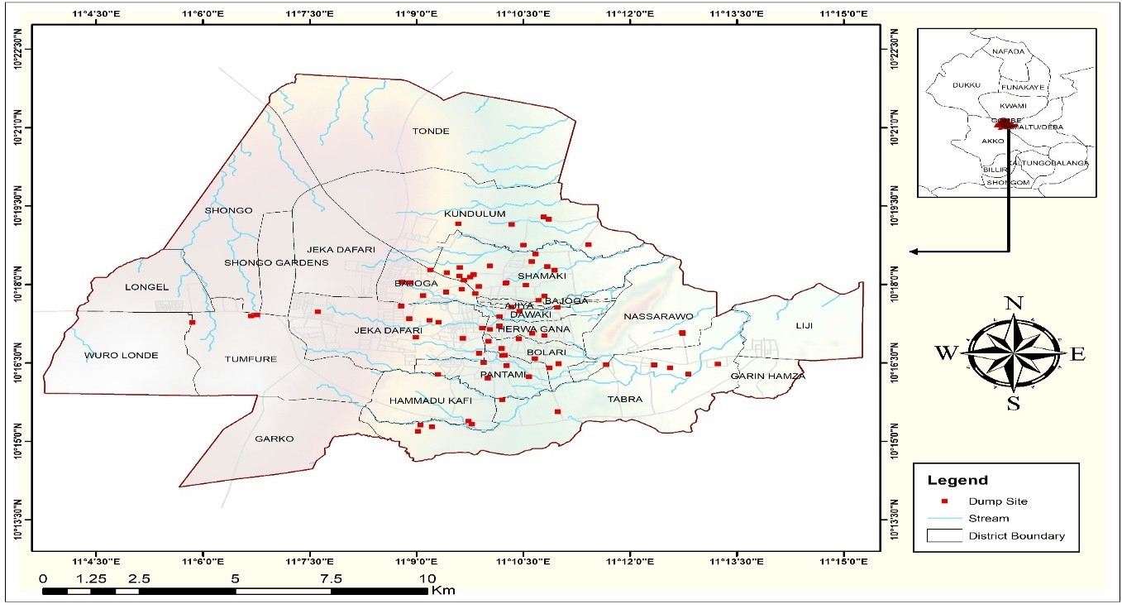
Figure 11: Existing Waste Dumpsites.
Source: Author’s Fieldwork, 2025.

Waste management in Gombe town is been handled by both formal and informal sectors. Table 10 demonstrate more than half of the waste (60%) generated are collected disposed into the constructed dumpsites or collected by the GOSEPA/INEX. About 29% or residents disposes waste into either drainage facilities or stream/river channels and this will have a positive effect on flood risk.

Table 10: Solid Waste Collection and Disposal Methods
Methods | Percentage
Burning | 10
Disposal into Drainage System | 8
Dispose into river/stream | 21
Dumpsite | 43
GOSEPA/INEX | 17
Others | 1
Total | 100
Source: Author’s Fieldwork, 2025

However, residents have to travel to a certain distance to disposes their generated waste and table 11 displays that they travel to a minimum of 2 to a maximum of 1000 meters but the average distance travel to dispose waste is 146 meters away from their homes which is quite fair and considerable for waste management.

Table 11: Dumpsite’s Approximate Distance from Household.
Number of Respondents | Meters
Number of Respondents | Minimum | Maximum | Mean | Std. Deviation
250 | 2 | 1000 | 146 | 174
Source: Author’s Fieldwork, 2025.

Table 12 shows that 77% of the households does not pay a penny for collection and disposal of their waste and this is clearly seen in table 13 where 67% of the waste are collected by the community or on personal basis. However, only 6% paid five hundred to one thousand five hundred naira per month. While 17% pay above two thousand naira in a month.

Table 12: Monthly Payment for Solid Waste Collection.
Monthly Charge in Naira | Percentage
0 | 77
500 | 1
1000 | 1
1500 | 1
2000 | 3
Above 2000 | 17
Total | 100
Source: Author’s Fieldwork, 2025.

Hence, there is need for an effective waste collection and disposal methods for a sustainable solid waste management in the metropolis and the amount to be paid for collection and disposal matters a lot. Gombe Metropolis solid waste collectors are basically five in numbers and this is proven by the questionnaire administered to household with the metropolis. Table 13 revealed that the waste collectors in Gombe metropolis are basically Community-Based Organizations (CBO) and personally by the respective households (67%). Although waste is also collected for disposal by the Gombe State Environmental and Protection Agency (GOSEPA), INEX and private waste collectors at 15%, 7% and 11% respectively. Gombe metropolis has challenges of managing the generated municipal solid waste of 21,297 tons and 5,832 tons per month for INEX and GOSEPA dumpsites respectively (Muhammed et, al., 2021).

Table 13: Gombe Metropolis Solid Waste Collectors
Waste Collectors | Percentage
GOSEPA | 15
INEX | 7
Private waste collectors | 11
Community-based collectors | 26
Other | 41
Total | 100
Source: Author’s Fieldwork, 2025

Table 14 shows most of the waste generated in metropolis are not collected for disposal (40%) or are collected only once in a week (31%). The poor waste management resulted in littering, heaping of waste and overflowing with waste in areas like Ajiya, Bajoga, Bolari, Dawaki, Kagarawal and Shamaki, etc (Ajayi and Sambo, 2021). Perhaps this will be the main reason why the metropolitan communities dispose their waste generated into the waterways as seen in table 3 above.

Table 14: Solid Waste Collections Per Week
Number of Times | Percentage
None | 40
Once | 31
Two times | 13
Three times | 1
Four times | .5
Five times | 11
Six times | 5
Seven times | 1.6
Total | 100
Source: Author’s Fieldwork, 2025

Hence, waste collection and disposal are either ineffective to very ineffective as revealed by more than half of respondents (51%) as shown in table 15. Although less than half of the respondents agreed that that waste collection is either effective or very effective (49%).

Table 15: Effectiveness of the Solid Waste collection and Disposal
Rating Scale | Percentage
Very Effective | 8
Effective | 31
Ineffective | 46
Very Ineffective | 15
Total | 100
Source: Author’s Fieldwork, 2025.
An effective waste management encourages solid waste recycling to reduce the amount generated before disposal. Table 16 indicate that 67% of the Gombe residents do not recycle their waste, while only 34 do waste recycling.

Table 16: Solid Waste Recycling
 | Percentage
Yes | 34
No | 67
Source: Authors Work, 2025

  - Identification of linkages between solid waste and flood risk management in Gombe Metropolis.
The research tried to identify a link between solid waste and flood risk management and this is done accordingly. Drainage Facilities cleaning is paramount to flood risk management and table 17 indicated 23% of the resident regularly clean the facilities and about half (48%) occasionally clean the drainage facilities. On the other hand, 29% don’t clean the facilities at all.

Table 17: Cleaning of Drainage Facilities by the Communities
Drainage Cleaning | Percentage
Never | 29
Occasionally | 48
Regularly | 23
Total | 100.0
Source: Author’s Fieldwork, 2025.

Table 18 revealed about 60% of respondents perceived that poor solid management was responsible for blocking of streams/rivers/drainage fertilities and the subsequently risk of floods.

Table 18: Solid waste blockage of waterways
Blockage Experience | Percentage
Yes | 59
No | 41
Source: Author’s Fieldwork, 2025.

In Gombe Metropolis the respondents were aware that indiscriminate waste disposal blocks water ways (Doka and et, al., 2023)

Table 19: Effect of Solid waste on Flood Risk
Effect | Percentage
Blocks drainage | 43
Reduces water flow | 52
Causes water stagnation | 4
Others | 1
Total | 100
Source: Author’s Fieldwork, 2025

Table 20 shows that the effect of solid waste blockage of the waterways causes drainage blockages, reduce water flow and water stagnation. Furthermore, the field survey data revealed that eight nine percent (89%) of respondent believed that poor solid waste management was responsible for flood occurrences in the metropolis, although eleven percent (11%) have a contrary view.

Table 20: Perception on Effect of Poor Waste Management on Flood Risk
Poor Waste Disposal | Percentage
Yes | 89
No | 11
Source: Author’s Fieldwork, 2025

The resident’s perceptions on effectiveness of governments efforts on solid waste and flood risk management revealed an overwhelming result and this shown on table 19 where 73% perceived a very effective to effective efforts while only 27% feels ineffective to very ineffective. Hence, government is commended according to public perceptions.

Table 21: Government’s Efforts on Management of Solid Waste and Flood Risk
Effectiveness | Percentage
Very Effective | 29
Effective | 44
Ineffective | 3
Very Ineffective | 24
Total | 100
Source: Author’s Fieldwork, 2025

  - Findings and Recommendations
The Geographic Information System (GIS) and the statistical analysis conducted revealed the following findings:

The research revealed that the areas with high amount of rainfall are districts of Nassarawa and Tabra, Liji and Garin Abba. It was also unveiled that the higher number of build ups in the central town areas are found closer to the roads (0-330 meters). Hence, districts of Shongo, Kundulum, Shamaki, Bajoga East, Dawaki, Ajiya, Herwagana, Pantami, Hammadu Kafi, (0-400 meters) and Bolari, Bajoga West, Jekadafari, Tabra, and Garin Hamza (400-900 meters) are very more at risk of flood due to their proximity and exposure to river streams and areas liable to floods. Furthermore, the research discovered that from central town towards the eastern part of the metropolis there are high density of stream/river and hence high risk of floods. It was revealed that the low elevation districts in the metropolis start from an elevation of 351 meters to 487 meters above sea level and these districts are Kundulum, Shamaki, Ajiya, Bajoga East, Herwagana, Dawaki, Bolari, Pantami, Tabra, Nasarawo, Garin Hamza and Liji. Therefore, all these districts may be at risk floods due to their elevation status. The research further found that the slope steepness reduces to 41.33 degrees at eastern part of town. Hence, districts in this part of the metropolis are liable to floods. In addition, It was found that builup are highly concetrated at the center of the metropolis and these districts are Jekadafari, Bajoga West, Hammadu Kafi, Kundulum, Shamaki, Ajiya,Dawaki, Herwagana, Bajoga East, Bolari, Pantami, Nassarawo, Jekadafari East, and Tabra. Therefore, these distrcits will be more susceptble to floods due to the high builtup concetration which tend to reduced infiltration of the rain water. And finally, the assessment discovered the high to very high flood risk districts as Bajoga, Ajiya, Dawaki, Bolari, Liji and Pantami, Tabra, Herwa Gana, and Garin Hamza district respectively

The research uncovered that fifteen percent of the whole Gombe metropolis households have experience flood incidence. It further revealed that the metropolis has experienced 31 times number of floods incidence from year 2016 to 2025. The most devastating flood was in fifth August, 2014 and nineteen August 2007 covering six, seven communities (districts) and affected 1,022 and 252 households respectively. The researched also exposed the key factors responsible for flooding in Gombe metropolis is basically flood risk hazard (high amount of rainfall incidence) which normally happens in the month of August in a given year and other factors are poor drainage system (31%), solid waste blockage of the waterways (18%) and construction of building on floodplain

The various flood mitigation measures in the Gombe metropolis are mostly planting of protective plants, use of sand bags and construction of concrete works. The work discovered substantial number of respondents (66%) have not been given any awareness on the potential flood risk.
It was found that more than five (5) kilograms of waste are generated by more than fifty percent of the households and the common types of waste in Gombe metropolis are essentially food waste, paper and plastic covering 87% of the waste. It was revealed that 83% of the household in Gombe metropolis does not have waste bins. However, refuse dumpsites are availability in 67% of the districts. The research revealed that more than quarter of residents disposes waste into either drainage facilities or stream/river channels. And about 80% of the household residents does not pay a penny for collection and disposal of their waste while only 6% pay five hundred to one thousand five hundred naira per month.

It was revealed that about 70% of the waste collectors are basically Community-Based Organizations (CBO) and personally by the respective households. And most of the waste generated in metropolis are not collected for disposal (40%) or are collected only once in a week (31%). In addition, the research found about 70% of the Gombe residents do not recycle their waste and although about half of the respondents agreed that waste collection is either effective or very effective. It was also found that about half (48%) of the residents occasionally clean the drainage facilities, while 29% don’t clean the facilities at all.

With respect to the link of soldi waste and flood risk management about 60% of respondents perceived that poor solid management was responsible for blocking of streams/rivers/drainage fertilities. And 89% of respondent believed that the poor solid waste management was responsible for flood occurrences. A substantial number of residents (73%) perceived government efforts on solid waste and flood risk management are very effective to effective efforts.

  - Development of a Comprehensive Framework for Integrated Solid Waste and Flood Risk Management in Gombe Metropolis.

The development of a framework for integrated solid waste management (reduce, reuse, recycle, efficient collection, and disposal) and flood risk management (flood risk assessment, mitigation, and adaptation measures) based on research findings and stakeholder inputs. Using the findings discovered from the flood risk assessment, flood incidence and management and solid waste generation and management the research came up with the following comprehensive framework on solid waste and flood risk management merging spatial flood-risk realities with waste-generation, disposal behavior, drainage settings, and institutional gaps to propose a harmonized, actionable framework for Gombe metropolis.

Table 22: Gombe Metropolis Integrated Solid waste and Flod risk management Framework
Component | Issues Identified from Research | Recommended Integrated Measures | Target Districts
Flood Risk Zoning | High rainfall, low elevation (351–487m), high built-up, proximity to rivers/streams | Establish Priority Flood–Waste Zones (PFWMZ), Enforce development controls in high-risk areas. | Very High Risk: Bajoga, Ajiya, Dawaki, Bolari, Liji, Pantami, Tabra, Herwagana, Garin Hamza
High-Risk Flood Districts | High built-up density (0–400m from roads), low slope (41.33° east) | Floodplain zoning,  Construction setbacks,  Relocation of structures on waterways. | High Risk: Kundulum, Shamaki, Nassarawo, Jekadafari, Bajoga West, Garin Abba
Household Waste Storage | 83% of households do not have waste bins | Mandatory household waste bin policy, Provide subsidized bins. | The whole districts, with priority to central & high-density zones
Waste Collection Frequency | 40% no collection; 31% weekly only | Bi-weekly collection in high-risk districts, Daily collection in central areas. | Pantami, Jekadafari, Ajiya, Bolari, Dawaki
Waste Collector System | 70% collectors are CBOs and informal operations | Formalize CBOs into City Waste License System, Training & performance incentives | All the districts
Waste Disposal Practices | 25% dump into drains/streams; 80% do not pay fees | Ban dumping in waterways Introduce monthly waste fees | High-risk drainage zones
Dumpsites & Transfer Stations | 67% have dumpsites but poorly managed | Create minor landfill. | Locate landfills near dense central districts
Recycling Programs | 70% do not recycle | Set up community recycling centers and Promote composting for organic waste | Markets, schools, Pantami, Bolari, Ajiya
Drainage Condition | Blockage due to waste (18%); poor drainage design (31%) | Reconstruct primary drains and conduct monthly community desilting | Eastern districts: Tabra, Liji and Garin Hamza
Waterway Protection | Buildings on floodplains increasing floods | Remove illegal structures and enforce 50m setbacks. | Along all major river/stream passages
Flood-Season Strategy (July–Sept) | Floods peak in August; city has had 31 floods since 2016 | Increase waste collection during rainy season, special drain cleanup campaigns. | Metropolis
Community Awareness | 66% have never received awareness | Waste and flood risk campaigns in public places | All districts
Early Warning System | Recurring floods; residents not informed early | Create short messages early warning alerts and Radio weather updates | High-risk districts
Structural Flood Controls | Sandbags and plants are insufficient | Retention ponds and Rainwater harvesting systems | Pantami, Tabra, Liji, Bolari, Ajiya
Drainage Cleanliness | 48% occasionally clean drains, 29% never clean | Enforce monthly community drainage cleanup. | All major drain channels
Institutional Action | Weak coordination between agencies | Create Integrated Flood–Waste Management Unit. | City-wide governance
Expected Impact | Recurrent floods; poor waste–flood interaction | 40–60% reduction in floods, 70% reduction in drain blockages and Improved recycling and bin ownership | The entire metropolis
Source: Author’s Work, 2025.

If this Integrated Solid waste and Flod risk Management Framework implemented there will be high expected impacts through reduction in 40-60% recurrent floods, 70% reduction in drain blockages and improvement in recycling and bin ownership in the entire metropolis. And finally pilot testing of the framework can be undertaking by the government relevant agencies in a selected area of Gombe to assess its feasibility and effectiveness.

Reference
Abashiya M., Abaje, I.B., Iguisi E.O., Bello A.L., Sawa B.A., Moses B.B. & Musa I. (2017). Rainfall characteristics and occurrence of floods in Gombe Metropolis, Nigeria, Ethiopian Journal of Environmental Studies and Management. http://dx.doi.org/10.4314/ejesm.v10i1.5.
Abashiya, M, Abaje, IB, Musa, I, Sule, S, Kollos, PN & Garba, HA (2019), Hydrogeomorphic Characteristics of Urban Flood Triggers in Gombe Town, Nigeria as Monitored in 2014, Journal Applied Science and Environmental Management; Vol. 23 (10).

Adaku J. E., (2023). Flooding and Waste Disposal Practices of Urban Residents in Nigeria, GeoHazards, 4(4), 350-366.
Ajayi A. P. & Sambo. I. S (2021), Assessment of Household Solid Waste Management in Gombe Metropolis, Journal of Environmental Science, Toxicology and Food Technology, 2319-2402, 15-8.
Chaochao Li, Xiaotao Cheng, Na Li, Xiaohe Du, Qian Yu and Guangyuan Kan (2016), International Journal of Environmental Research and Public Health.
Crichton, D. The risk triangle. In Natural Disaster Management; Ingleton, J., Ed.; (1999), Tudor Rose: Leicester, UK, pp. 102–103.
Doka Y1, Nsor C. A, Joseph J, Nya J, Babale A and Atukpa M. E (2023), Assessment of Municipal Waste Management in Gombe Metropolis for Sustainable Environment and Community Health.
Idris, S. & Dantata D. (2018), Solid Waste Management and Vulnerability to Floods in Gombe Metropolis, Nigeria, International Journal of Science and Research (IJSR), 8(7).
Gombe State Emergency Management Agency (2025), Summary Cases of Reported Flooding in Gombe LGA from 2016 to Date.
Gombe State Environmental Protection Agency (2016), Gombe State Water, Sanitation and Hygiene Policy - First Draft September.
Hornby, A. S. (2010). Oxford Advanced Learner’s Dictionary of current English (8th ed.). Oxford: Oxford University Press.
International Bank for Reconstruction and Development /The World Bank (2023), Urban Flood Risk Handbook, Assessing Risk and Identifying Intervention. Retrieved from www.worldbank.org on 20th August, 2025.
Lamond J., Bhattacharya N., Bloch R. (2012). The role of solid waste management as a response to urban flood risk in developing countries, a case study analysis
Lamond, J., Stanton-Geddes, Z., Bloch, R. and Proverbs, D. (2013) Cities and flooding: Lessons in resilience from case studies of inte- grated urban flood risk management. In: CIB 2013 World Congress, Special Conference Session: Making Cities More Resilient, Brisbane, Australia, 5-9 May 2013. Brisbane: CIB. Retrieved http://eprints.uwe.ac.uk/21745/.
Kidd, S. (2007). Towards a framework of integration in spatial planning: An exploration from a health perspective. Planning Theory & Practice, 8(2), 161–181. http://dx.doi. org/10.1080/14649350701324367.
Mohammed I, Chinade Abdullahi A, C, Victor I & Sani Jauro A (2021), African Journal Env, Design and Constructions Mgt, 22:4,
Ijaz S, Miandad M, Mehdi M. M Anwar M.M. & Rahman G. (2021). Solid waste management as a response to urban flood risk in Gujrat city, Pakistan, GEOGRAFIA, Malaysian journal of Society and Space, 7 (1).
Sulaiman, M.B. & Maigari A.U., (2016). "Physico-Chemical Properties and Heavy Metals Content of Groundwater around a Municipal Dumpsite in Gombe, Nigeria", International Journal of Science and Research (IJSR) 5(8) 1299 - 1304, DOI:10.21275/ART20161075.
Wisner, B., P. Blaikie, T. Cannon, and I. Davis (2004): At Risk: Natural Hazards, People’s Vulnerability and Disasters (2nd edition), Routledge UK.
World Bank (2019): “Solid Waste Management-Understanding Poverty Urban Development”- The World Bank-IBRD-IDA.
World Bank (2011) Climate change adaptation and natural disasters preparedness in the Coastal Cities of North Africa
Zoori M. & Ghani A. (2017). Municipal Solid Waste Management Challenges and Problems for Cities in Low-Income and Developing Countries, International Journal of Science and Engineering Applications; Vol 6 (2).

