ILLUMINATED SPACES: SPATIAL ANALYSIS OF NIGHT-TIME LIGHTS IN THE KOLKATA METROPOLITAN AREA

ABSTRACT:
Urban-scapes are illuminated by outdoor artificial lights. This work, in the scope of Nocturnal Geography, employs Night Time Light (NTL) as a parameter associating with urbanization. Focusing on the Kolkata Metropolitan Area (KMA), it explores how city categories and population influence NTL distribution. The study has been conducted on 142 diverse urban sites across six districts—Kolkata, Haora, Hooghly, North 24 Parganas, South 24 Parganas, and Nadia. The sites represent statutory towns (Municipal Corporation, Municipality with outgrowths, Municipality, Cantonment Board) as well as Census Towns. Cartographic and statistical tools were applied to correlate NTL with built-up space and population. Built-up areas were mapped using Global Human Settlement Layer (100 m), population from CIESIN GPWv4.11 (100 m), while NTL intensity (nanoWatts/sq.cm/sr.) was obtained from VIIRS Day/Night Band (463.83 m). The study spans 2013–2025 and uses Theil Index alongside mapping to analyze spatial dynamics. Findings indicate a moderately unequal distribution of NTL across KMA. Primacy of Kolkata emerges with concentrated high NTL intensity, contrasted by multiple smaller census towns exhibiting low intensity. Correlations with population, built-up space, distance from city core, and National Highways substantiate these disparities. NTL has more than urban infrastructure. Thus, equitable provision of adequate lighting emerges as a vital component for sustainable urban governance, urban resilience, and ensuring better quality of life in metropolitan regions.
KEY WORDS: Nocturnal Geography, Night Time Light, Theil Index, Visible Infrared Imaging Radiometer Suite, Global Human Settlement Layer, sustainable urban governance
CONFLICTS OF INTEREST:
“The authors reported no potential conflicts of interest.”

  - Introduction
Urbanization in the Global South in recent times has gone through uneven infrastructural escalation (Smit, 2021). One of the defining characteristics of an urban entity is artificial outdoor lights. The brightly lit avenues, illuminate the area around. This not only enhances visibility but also conveniently serve for discerning urbanized spaces from aerial or corresponding satellite imageries (Biljecki & Ito, 2021). The level of urbanization determines the amount of radiance and brightness (Roychowdhury, et.al. 2011). City lights replace the natural light which is although ubiquitous, but does not effectively help to distinguish between urban and non-urban areas. Thus, nocturnal illumination through artificial lights seems to be a crucial parameter to identify urbanized areas (Peretz Architecture, 2023). Our work attempts to study the spatial distribution and level of ubiquity of nocturnal lights and correlate the same with land use land cover (LULC) categories which will help us in finding the degree of urbanization at a primary level. This study aims at providing valuable insights into urban development patterns and contribute to more effective planning and management of such spaces. Night Time Light (NTL) using remote sensing data offers to study spatial and temporal extents of human activities (Li et.al, 2013) and levels of urbanization (Zheng, et.al., 2023). Here, we take a step ahead by corroborating NTL from remote sensing data with some selected site parameters in the context of of the global south, particularly the core urban area of eastern India, in highly urbanized southern districts of the State of West Bengal. NTL is a general urban infrastructure for noctural security by artificial illumination; expansion cultural, commercial and economic activities beyond day light time; urban aesthetics, leisure and beautification at darker hours and traffic-scape amenities in absence of natural light (Katabaro, K.M., et.al., 2022). But in the context of global south, where the disparity in level of urbanization is common, the distribution and illumination by NTL is also not pervasive. So, the purposes of NTL as mentioned the work of Katabaro et.al. (2022) remains non-uniform. This aspect of NTL will be highlighted through our work. Our work also hightlights urban sprwal through NTL which we intend to show through spatio-temporal cross-section. Conventionally, the spatial expansion of urban sprawl has been measured using indicators like density of population, LULC patterns, spatial dispersion of urban facilities etc. But in recent years, there has been attempts to estimate urban areas using nighttime light data observed by satellites (Kii and Matsumoto, 2023). We have tried to use such a methodology to our study area to understand the urban expansion in the southern West Bengal.
At the onset, let us understand the perception of ‘night’. It brings us to the question, which part of the 24 hours duration is called the night? Is it right after sun-down? Or after the cessation of the twilight? Or even later hours? Similarly, another question arises that duration of nocturnal darkness varies latitudinally. So, based on these factors nocturnal illumination through NTL also varies from place to place. Night has been perceived as the time, the duration unfolding between the setting and the rising of the sun and during which the latter is not visible (Gwiazdzinski, et.al., 2018). In the urbanized spaces of southern West Bengal, regular economic, socio-cultural activities range between 8 am to 8 pm. Gradually after 8 pm, most of the commercial activities come to closure. However, beyond 8 pm, there are certain activities such as corporate houses which interact with places of different time zones, medical and other emergency services etc. and sometimes even domestic chores go beyond the 8 pm official threshold (Satpati & Haldar, 2021). These activities are carried out under illumination by indoor lighting. Here, we are more interested in highlighting the road side NTL as obtained from the satellite imageries.
  - Literature Review
Remote sensing of Night Time Light (NTL) has risen as a prevailing tool for analyzing LULC for socio-economic activities, urban growth and spatial planning. Several scholarly works have contributed to its applications in the context of cities of the Global South.
Roychowdhury et al. (2011) demonstrated the potential of Landsat and DMSP-OLS night-time imagery in differentiating urban, suburban and rural areas. Their study highlighted how satellite-derived night lights can effectively delineate land cover types in rapidly urbanizing Indian cities. Kuffer et al. (2017) extended this by using ISS night light images to capture intra-urban variations in land use and socio-economic attributes. This work emphasized the utility of higher spatial resolution imagery to analyze complex urban forms in cities of the Global South, including India. Li (2017) provided a comprehensive overview of NTL remote sensing, positioning night light intensity as an alternative for human activity. The work detailed the relevance of NTL data in exploring urbanization, LULC changes and socio-economic dynamics, suggesting interdisciplinary applications. Stokes and Seto (2019) fused multi-temporal night light, population and land use data to track urban infrastructure transitions in line with the Sustainable Development Goals (SDGs). Their approach also enabled identification of informal settlements, highlighting NTL’s potential for addressing urban equity.
Levin et al. (2020) reviewed the historical development and future prospects of NTL remote sensing. The study covered diverse applications such as urban mapping, population and GDP estimation, disaster monitoring, and environmental impact assessment. Importantly, it emphasized the challenges posed by the global shift to LED lighting and the need for improvements in sensor resolution and spectral capabilities. Wu et. al. (2022) analyzed the relationship between 2D/3D urban landscapes and night-time light intensity using XGBoost regression and SHAP. Their findings at parcel and subdistrict levels showed strong correlations and complex interactions with implications for understanding urban socioeconomic structures. Zheng et. al. (2023) presented a critical review of NTL remote sensing for urban applications, identifying research gaps and future directions. The paper emphasizes the importance of integrating multi-source data and improving methodologies to better understand urbanization processes and policy implications.
  - Research Gap
Most of the literature on nocturnal lights as mentioned so far focus on the remote sensing processes. The studies highlight the wide range of changing methods of remote sensing to study the nocturnal lights in cities. The spurting use of NTL remote sensing data in urban studies has significantly contributed to understanding urban expansion, land use patterns and socio-economic activities. However, a critical assessment of the current literature reveals several thematic, methodological, and contextual research gaps, especially concerning Indian cities and the Global South.
Firstly, while works by Roychowdhury et al. (2011) and Kuffer et al. (2017) have demonstrated the usefulness of DMSP-OLS and ISS images in delineating urban, suburban and rural areas and understanding intra-urban variations, yet, there remains a lack of integration between night-time imagery and finer-scale land use datasets. In particular, informal settlements and peri-urban zones remain underrepresented due to the limited spatial resolution of earlier NTL datasets.
Secondly, the studies that link NTL to urban morphology (Wu et al., 2022) primarily focus on formal cityscapes with established urban patterns. However, in India, cities are marked by dual structures of formal and informal development and the relationship between urban form (2D/3D) and night-time lighting in such hybrid environments remains unexplored. Especially in the tier-II and tier-III cities, where urbanization is more fragmented, a deeper understanding of how different built environment typologies influence NTL intensity is necessary.
However, the present study focuses on NTL intensity and factors influencing it in the urban agglomeration of southern core of West Bengal that is KMA where such city infrastructural dimension has not yet been explored. The study area includes diverse urban sites like metropolitan area, municipalities and census towns which adds to the exclusivity of the study. It addresses both temporal and spatial dynamics of NTL.
  - Study Area and Objectives
Table 1 shows the variety of categories of urban sites in Kolkata Metropolitan Area (KMA) covering six districts—Kolkata, Haora, Hugli, North 24 Parganas South 24 Parganas and Nadia. It displaying diverse range of urban-rural continuum from metropolitan core of Kolkata under the Municipal Corporation to rurban features in the mentioned districts
Table 1: District-wise Distribution of Categories of Urban Sites under KMA
Category of Urban Sites | Kolkata | North 24 Parganas | South 24 Parganas | Haora | Hugli | Nadia | Total
Municipal Corporation | 1 | - | - | 1 | 1 | - | 3
Municipality with Outgrowth |  | 6 | 1 | 4 | 1 | 1 | 13
Municipality |  | 20 | 5 | 3 | 11 | 2 | 41
Cantonment Board |  | 1 | - | - | - | - | 1
Census Town |  | 10 | 3 | 45 | 23 | - | 84
Total Urban Sites under KMA |  |  |  |  |  |  | 142
Source: Compiled by the authors from the Primary Census Abstract, West Bengal, 2011
These sites form the Kolkata Metropolitan Area (KMA) where, outdoor artificial NTL is one of the key infrastructural indicators to assess the level of urban sprawl and consequent development. In the study area the main sources of outdoor street lights include: LED streetlights, High Pressure Sodium (HPS) streetlights and metal halide streetlights, providing essential illumination for roadways and public spaces (L&T SufIn, 2025). Besides, big metropolitan cities and highways have façade lighting such as linear flex lights, floodlights used to enhance the location of structures. We have selected few rurban sites which are found betweeen these urban centres to understand the level of urban shadow effect on them. Our humble attempt through this work is to find out the temporal variation of built-up space and NTL in the study area over a period from 2013 to 2023. It will also focus on the impact of land use land cover mainly the built-up area changes on NTL from 2015 to 2023 and thereby understand the impact of urban sprawl based on population expansion on NTL intensity.
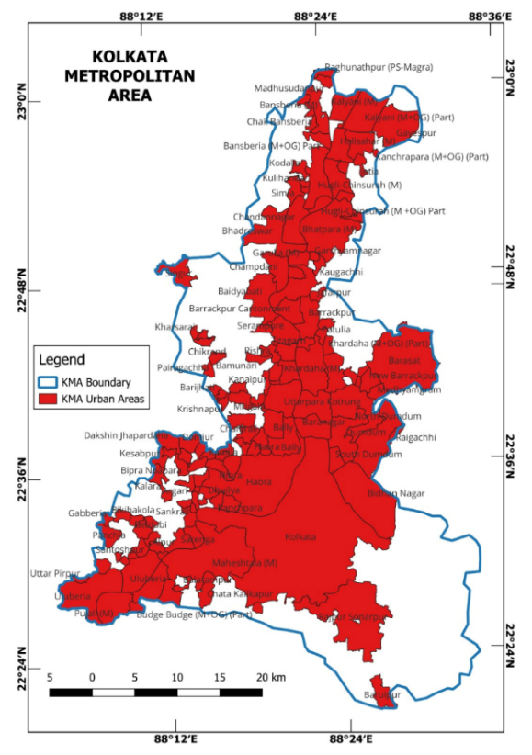

Figure 1: Expanse of the Study Area
Source: Prepared by authors

The urban core periphery contrast through decaying distance effect of NTL intensity from Kolkata and National Highway (NH) to 142 urban sites have also been studied.
- Materials & Methods
  - Database
The database for the study includes multiple independent variables influencing NTL intensity. The NTL measured in nano Watts/sr./sq.cm is the chief database for this work. Dataset on NTL has been obtained from the Visible Infrared Imaging Radiometer Suite (VIIRS) at spatial resolution of 463.83 meters using Day/Night Band (DNB). The VIIRS satellite's Day/Night Band (DNB) data provides information about intensity of nighttime lights, including city lights (Visible Infrared Imaging Radiometer Suite, 2022). VIIRS provides annual global VIIRS nighttime lights dataset is a time series produced from monthly cloud-free average radiance grids spanning from 2013 to 2023. Initially filtering has been used to remove sunlit, moonlit and cloudy pixels to generate rough composites containing lights and fire. The rough annual composites are cumulated on monthly basis and then combined to form rough annual composites. Subsequently, the twelve-month median radiance has been used to discard high and low radiance outliers, thereby filtering out most fires and isolating the background. Background areas are zeroed out using the data range calculated from 3×3 grid cells. The data range threshold for background is indexed to cloud-cover levels, with higher data range thresholds in areas having low numbers of cloud-free coverages (Elvidge, et.al. 2021).
NTL intensity is closely associated with the nature and type of LULC. It determines the nature and duration of outdoor activities for which NTL is essential. So, a study on the LULC using nocturnal illumination has been carried out using remote sensing data (Wang, 2019). Such data for the KMA has been obtained from global built-up surface using Global Human Settlement Layer (GSHL) Data Package for the years 2017-2023 and projected up to 2023 provided by European Commission’s Joint Research Center (EC JRC). The spatial resolution for the layer is 100 m. This uses four spectral bands—Blue (B2), Green (B3), Red(B4) and NIR (B8) of Sentinel-2 (Pesaresi & Politis, 2023).
NTL intensity is also closely associated with urban sprawl. Population at the peripheral region out of the urban core is an indicator of urban sprawl. As population at the urban periphery increases, the demand for artificial lighting outdoor rises as well because of several human activities. Hence, the association between NTL intensity and urban sprawl seem significant (Bharti, 2019). Inadequacy of Census data till 2021 has been alternated by Global Population Surfaces from 2017-2023 and projected up to 2030 derived from CIESIN GPWv4.11. This raster dataset depicts the spatial distribution of residential population, expressed as the absolute number of inhabitants of the cell as disaggregated from census or administrative units to grid cells, informed by the distribution, volume, and classification of built-up area as mapped in the global GHSL built-up surface layers. The spatial resolution for this dataset is 100 m (Schiavina, et.al., 2023).
Another correlation with NTL intensity and distance from National Highways (NH) could be drawn. Distance between 142 urban sites and their nearest NH have been calculated using Google Earth Pro distance measurer from 2013 to 2023.
  - Methods
The work takes a geospatial and quantitative approach to study NTL with its diverse factors ranging from LULC, urban sprawl along with distance from the nearest NH.
At the onset, the changing NTL intensity in 142 urban sites have been graphically plotted from 2013 to 2023 using MS Excel 2019 to evaluate its trend. Following this the distance decay effect of NTL intensity has been depicted from 2013 to 2023, with increasing distance from the urban core of Kolkata which has the highest intensity of NTL. This would be an indicator that how with passage of time, the NTL intensity transforms with increasing distance from Kolkata over a decade.
Statistical correlation has been used to understand the impact of association of LULC on NTL. For this, the influence of built-up space on NTL have been mapped in the study area for 2015, 2020 and 2025.
Population is the other variable which has been considered for finding its relation with intensity of NTL. We have mapped population distribution for the years 2015, 2020 and 2025 in the study area.
As the most essential part of the work, we have mapped night time light radiance in the urban units of the study area to find out the change over a decade 2013 to 2023. All maps have been prepared using Q-GIS 3.14 version software.
The work explores a spatial cross-section from urban core of Kolkata (Class I metropolitan city) to lesser tier urban areas, in order to find out the distance decay effect of the NTL. It reflects how spatially as well as temporally disperses from the core to periphery of urban spaces in KMA (Dey F. , 2021).
In a geographic context, it is important understand the statistical significance of distribution of NTL across the various districts as well as that between the various urban sites based on their urban status. In order to find the distribution, Theil Index (T) has been deployed. The Theil Index is a statistical measure to quantify how unequally a resource or an infrastructure is distributed. Value of Theil index being zero indicates perfect equality; while higher values indicate greater inequality. It is computed by the following formula (Lee, S., 2025):
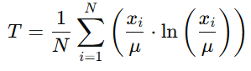

where, x_{i} is the value of individuals
μ is the mean
N is the total number of individuals
Here, N refers to the total number districts or categories of urban sites, while, x_{i} indicates the NTL intensities of each district or category of urban sites.
Theil Index is useful in this context because of its flexibility in capturing the entire data and not just extreme values. It is also significant because of its decomposability in assessing within the group and between the group inequality distribution of NTL intensity.
- Results and Discussion
3.1. Urbanization and distribution of NTL in KMA
Kolkata, has been growing and evolving as mega urban agglomeration displaying a tendency of primacy in the eastern India since its inception as a colonial city (Figure 2).
The built-up area in the KMA extended by 24.5% from 2000 to 2015 (Sahana et.al., 2018) and from 27.8% in 2002 to 68.8% in 2023. This has been and projected to reach 76.32% by 2033 (Mondal & Samanta, 2017). This urban growth is not uniform. Municipalities along the eastern bank of the Bhagirathi-Hugli river and those surrounding KMC experienced swift urban growth. Sub-urban areas away from the river also experienced expansion, while open spaces decreased in older municipalities. Peri-urban areas, particularly those further from the Hugli River, are experiencing rapid population growth, with some areas showing a decadal growth rate of 34.78% (Mondal D. & Banerjee.A, 2021). Studies indicate that the urban sprawl in the KMA has been significant, with the built-up area increasing at an average rate of 7.61% per year, while the population grew at a rate of 3.42% per annum (De & Roy, 2022). The following maps justify the changes in residential and non-residential built-up area in KMA.
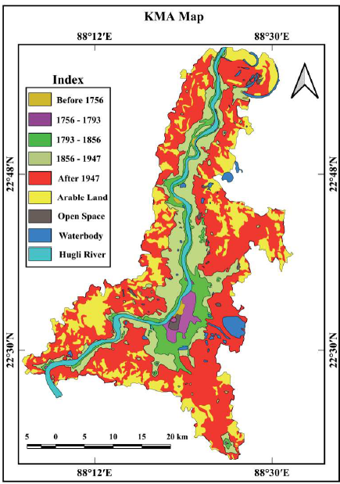
Figure 2: Evolution of Greater Kolkata Urban Agglomeration since inception
(Dey, F., 2021)

Figure 3a, 3b and 3c show the urban rresidential built up space from 2015-2025 with the urban core at Kolkata Municipal Corporation (KMC) area. It has been observed that sprawling of urban built up space have taken place progressively keeping Kolkata at the core to as far as Kalyani Municipality and beyond in the north in Nadia district over 63 km; Singur in Hugli district to west, 40 km; Uluberia in Haora district to the southwest, 43 km and Baruipur in South 24 Parganas district, 31 km (Chakraborty et.al., 2021) also corroborated from Figure 3.

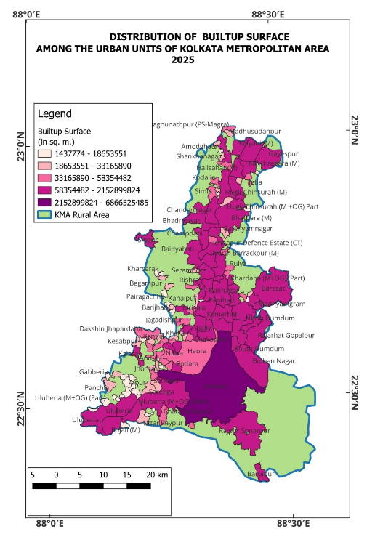
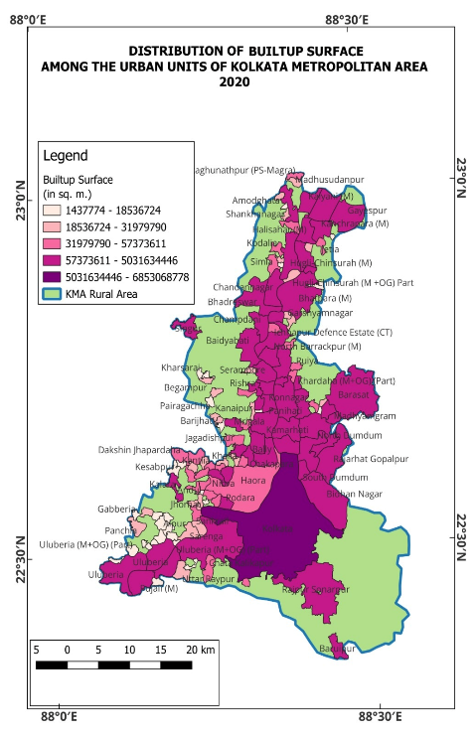
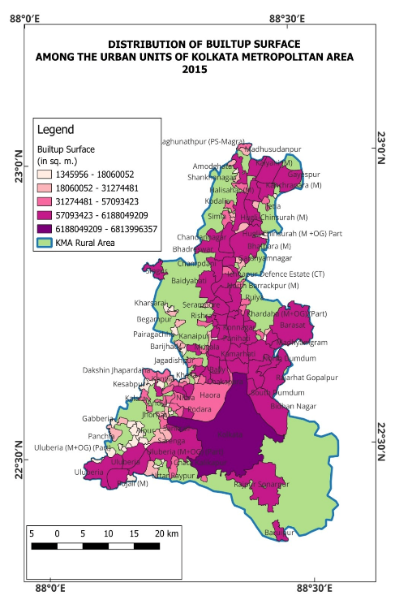
Figure 3a, 3b and 3c: Patterns of distribution of urban built up space KMA from 2015 to 2025 Source: Prepared by authors

The sprawling of built up space from the urban core of Kolkata is closely associated with population expansion in these sites as depicted through the following maps in Figure 4(a-c). The KMA experienced demographic changes across its municipalities and census towns. While the core city of Kolkata has a decline in population, the surrounding municipal towns and census towns are experiencing growth, with some showing very high growth rates (Dey & Bhaduri, 2017). The urban agglomeration has been projected to reach a population of 21.1 million by 2025. Municipalities and census towns adjacent to Kolkata are experiencing higher growth rates, indicating a shift in population towards the peripheral part of the KMA. Some municipalities such as Bidhannagar, Rajarhat-Gopalpur, Barasat, Rajpur-Sonarpur and Baruipur show very high decadal growth rates from 2001 to 2011. On the other hand, Khardah, Sreerampore-Uttarpara and Ichchapur experienced negative growth on becoming saturated in terms of residential space. The census towns have experienced very high growth rates. KMA is undergoing a demographic shift, with the core city experiencing a decline and the peripheral zones exeriencing growth, driven by residential development, economic opportunities and development of infrastructures (Anwaruzzaman et.al., 2018). Thus, a more polycentric urbanization pattern is emerging, where each census town acts as an independent node of development (Bhowmick & Sivaramakrishnan, 2021).
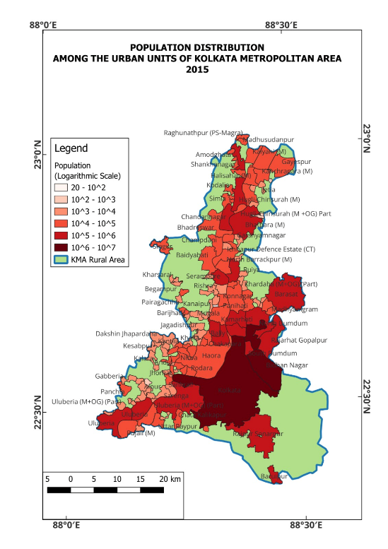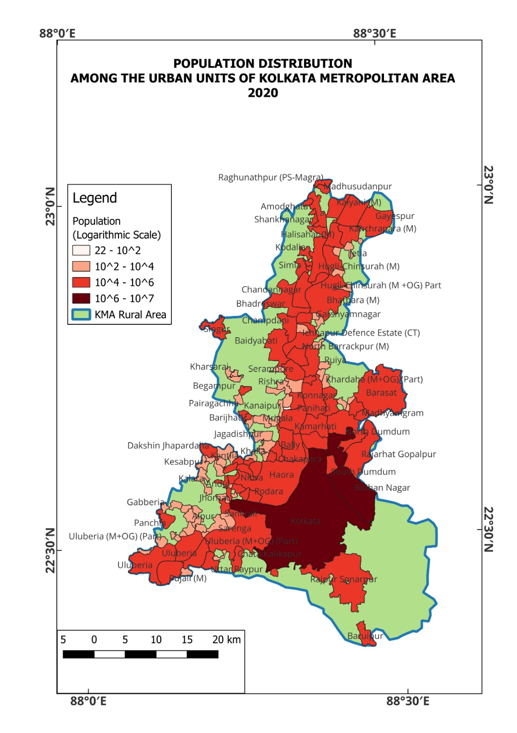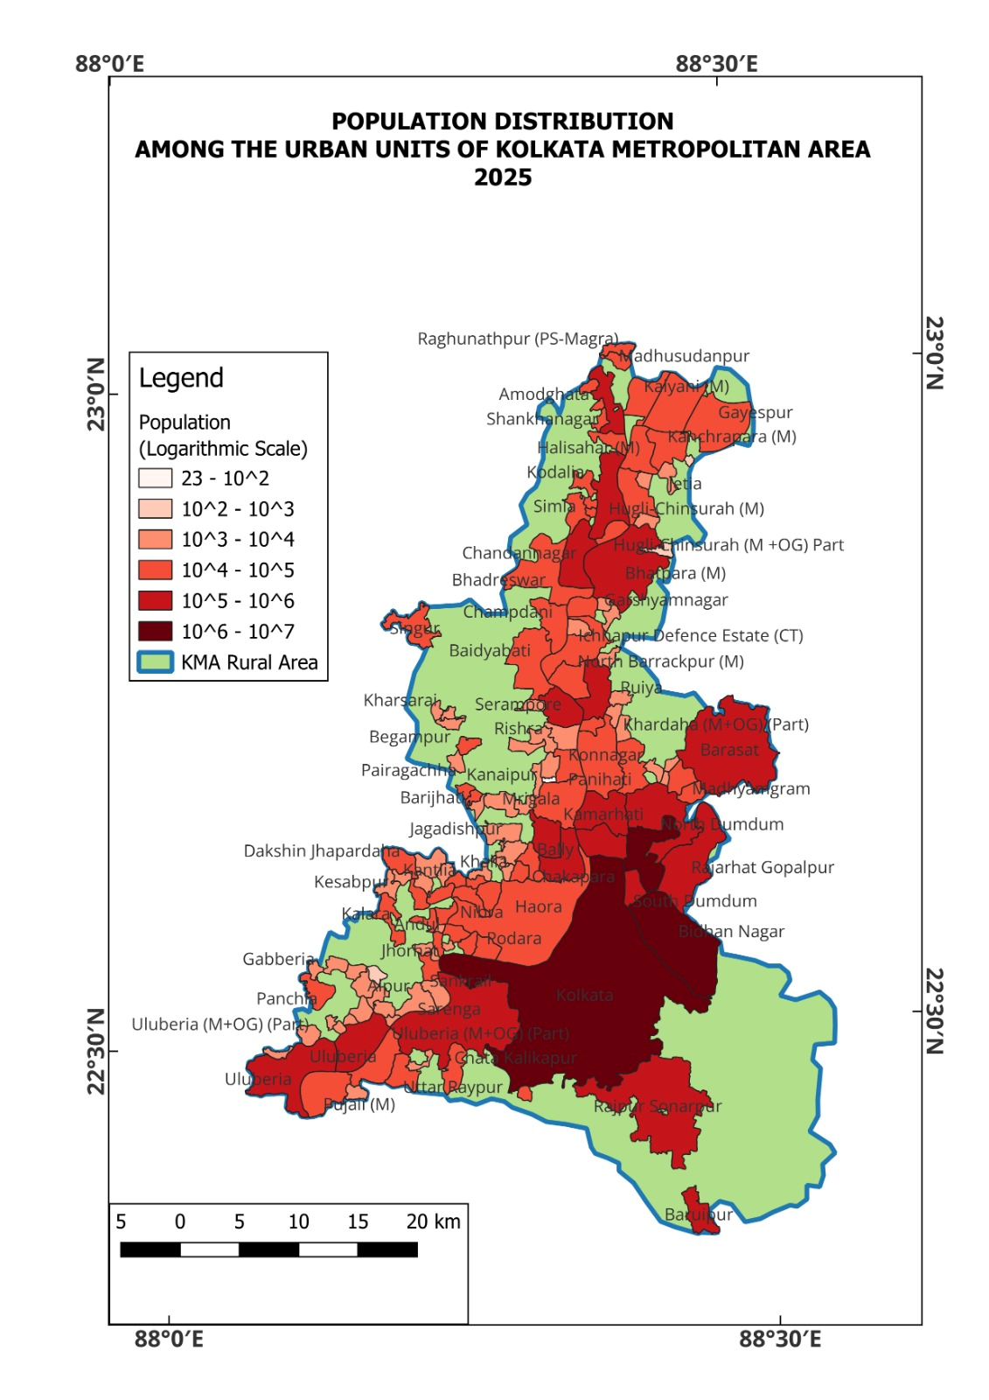Essentially these built up spaces have several urban commercial and other activities which require night time illumination through artificial lighting. Night-time lighting facilitates various economic activities operating after dark, late-night markets and transport services (Lambert, 2023).
Figure 4a, 4b and 4c: Patterns of population distribution KMA from 2015 to 2025 Source: Prepared by authors

Road side eateries and entertainment sites benefit from increased foot fall when streets are well-lit, promotion a vibrant night-time economy. Additionally, reliable lighting in commercial and industrial areas ensures smooth logistics and transportation operations, further boosting economic productivity (Fondalighting.com, 2025). Night-time lighting is decisive for safe mobility of pedestrians and accurate navigation of vehicles, ensuring haasle-free traffic flow and preventing accidents. Well-lit streets and public spaces are crucial of deterring risks of out-door crime, thereby providing a sense of security for residents, particularly during late night hours (Yeo-Kyeong et.al., 2023). The area under Kolkata Municipal Corporation(KMC) and the index mentioned in the work of Bedi, et.al. (2021) clearly reflects the nocturnal illumination in the KMA region. It is interesting note that this work not only highlights the illumination level but also the level of clarity of night sky as a consequence of such nocturnal illumination. Area under KMC being the main urban core shows very high illumination level but obscured night sky as a result of light pollution. The pockets of brightness index within the range 50 to 100 nanoWatts/sq. cm. /sr. form the Central Business Districts (CBD) of Kolkata at the heart and peripheral regions of the city, hence are well lit for various urban functions (Bedi et.al., 2021). It can also be commented that away from the core urban area, in the sub-urban spaces or lesser urbanized areas illumination levels are compaartively low (Ściężor, 2021). This can be corroborated with relatively lesser built up space than KMC area.

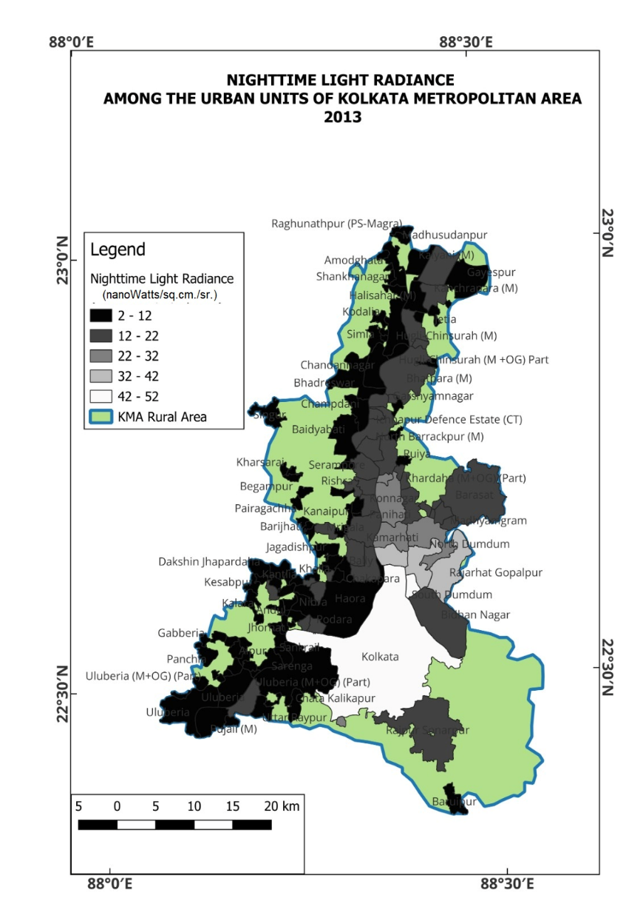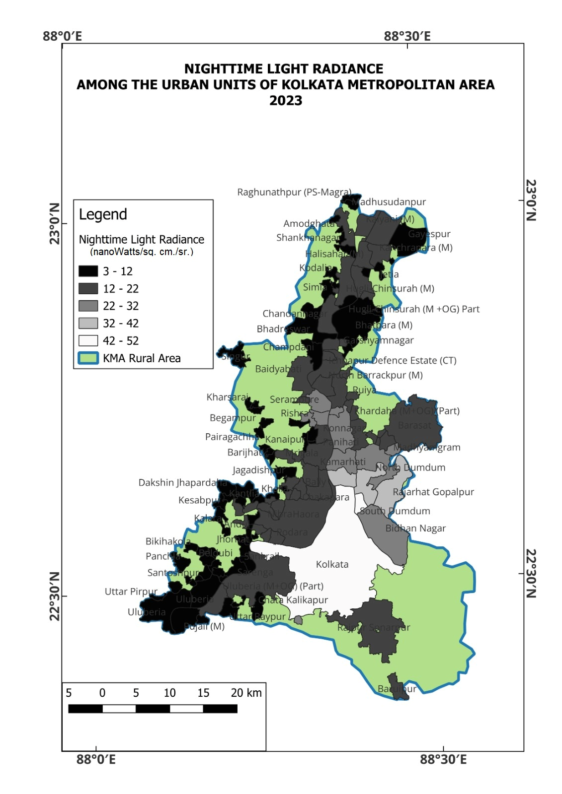
Figure 5a and 5b: Patterns of population distribution KMA from 2015 to 2025 Source: Prepared by authors

The above maps in Figure 5a and 5b depicts the intensity of NTL in the KMA over a decade (2013 to 2023). If comparison is drawn from Figures 3(a and b), 4(a, b and c) and 6(a and b), it certainly shows a strong association between built-up-space, population distribution and NTL. Snowballing effect of urban sprawl as evident through Figures 3(a, b and c) and 4(a, b and c) reflects higher proportion of built up space as well as distribution of population away from Kolkata urban core towards the periphery of KMA. This pattern exactly corresponds to the NTL radiance as shown in the work of Bedi et.al. over a decade, that high night lit up zone covers area under KMC; while the growing urbanized sites have also been lit up by artificial sources during night time.

A very interesting feature shows up from the cartographic representations that, although a peripheral shift of urbanization has taken place in the KMA in terms of built up space and population distribution, yet, there has been a distinct distance decay effect from Kolkata to the peripheral zones within the study area. This distance decay effect is more elaborately discussed in the following sections.
3.2. Temporal Trends of NTL in the KMA
Over 142 urban sites which are considered in this study, the temporal trend shows fluctuations from 2013 to 2020 but a steady rise after that. Figure 7, shows district-wise average of NTL. It is evident, that, Kolkata being the urban core, having, the highest proportion of built-up area as well as highest density of population—commercial and other activities which demand nocturnal artificial light is highest. Noth 24 Parganas is one of the districts, where the sprawl effect of urbanization has been highest (Sarkar et.al., 2020) during the period under consideration, so although much lesser than Kolkata, but nocturnal luminance happens to be the second highest in the region. Since early 1990s till the recent decade, the industrial districts of Haora and Hugli experienced significant decline in industrial space (Bhattacharjee & De, 2020) or in other words non-residential space for various reasons.
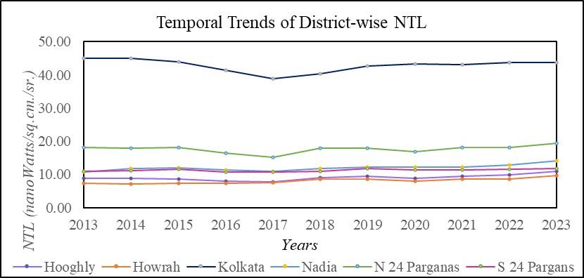
Figure 6 Source: Computed by authors

Thus, nocturnal industrial lighting is expected to decline subsequently, which is clearly reflected in the low radiance of NTL in urban sites of these two districts. The year 2020 hit by the COVID-19 pandemic and subsequent worldwide lock-down resulted in temporary closure of many commercial activities (apart from emergency and essential ones). This resulted in lesser demand
for artificial lights after sun down or during night (Calabria et.al., 2021). This trend had been found common for all the districts. Post 2020, all the districts show rise in NTL radiance for various commercial activities which are not just restricted to day light alone.
3.3. Distance Decay Effect of NTL Intensity from Urban Core Kolkata
Highest NTL intensity has been observed in Kolkata Municipal Corporation (KMC) area from 2013 to 2023 owing to its diverse commercial attainments over a complex urban morphology (Rashid, 2022). This demands wide usage of NTL. However, with increasing distance and decreasing proximity from the urban shadow of KMC area, NTL intensity is explicitly evident to decline (Figure 7).
Higher value of NTL intensity is recorded by Khardah and Uluberia Municipalities which are also closer to KMC area within 35 km. Further the towns away from Kolkata, NTL intensity progressively decreases. Lesser value of NTL intensity has been observed at urban sites much away from Kolkata, nearly at a distance of 60 km in Raghunathpur census town in Magra of Hugli district.

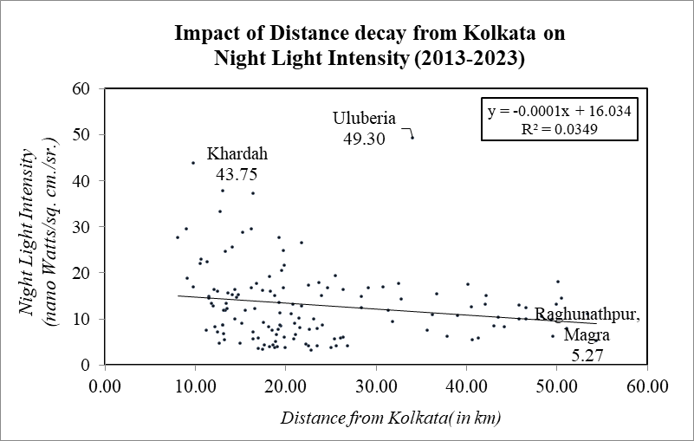
Figure 7 Source: Computed by authorsFigure 1: Expanse of the Study Area
Source: Prepared by authors

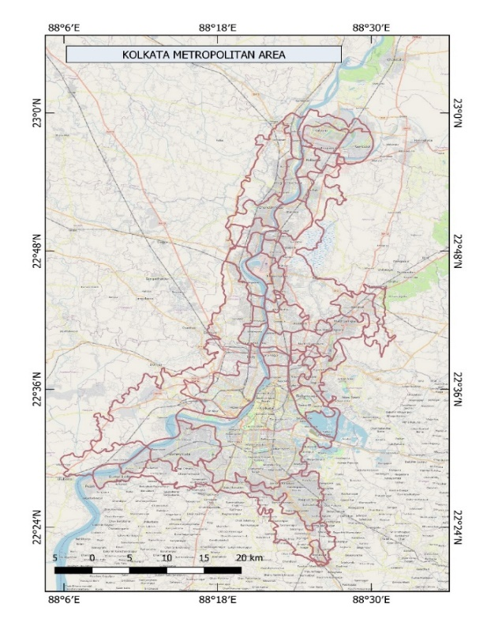
Figure 8
It is also important to note, that, level of urbanization has a clear link with NTL intensity. Higher tier cities which are also closer urban sprawl effect of Kolkata and hence experience higher NTL intensity. Those urban sites which are of lesser urban tier for their subdued functions (Khatua, 2016) which require less nocturnal illumination display lesser NTL intensity. However, areas under the Municipalities which although are away from urban core of Kolkata, but are moderately urbanized show relatively higher NTL intensity than the census towns. Such as Municipal areas under Chinsurah, Kanchrapara, Kalyani etc. as far as 50 km from Kolkata. This may be corroborated with Figure 5(a and b) as well. Thus, multi-polar urbanization in the KMA seems to play a crucial role in NTL intensity.
3.4. Distance Decay Effect of NTL from National Highways
National highways, can spur economic activity, trade and transportation facility and thereby contribute to urbanization (Asian Institute of Transport Development, 2011) and demand for NTL. Proximity to NH thus leads to urban development. Higher tier urban sites in KMA are located along the NH 12 (renamed from NH 34); while, with increasing distance from the NH, the level of urbanization gradually dwindles and fall under urban shadow zone. As observed from Figure 8, the NH 12 passing through the districts of Noth and 24 Parganas also Nadia, almost equally divides the districts (Alam & Banerjee, 2022). Therefore, the sprawl of the urban pockets has been evenly distributed. This has eventually resulted in emergence of a greater number of urban units along this NH.
While comparing the situation in Hugli and Howrah district, the National highways are passing through the eastern half of the districts leaving rest of the districts much away from the NH. This situation has created and uneven distribution of urban units (De, J., 2025). Moreover, industrial units, markets petrol pumps, hotels and restaurants transport headquarters have been established along the NH, which require NTL for their effective functioning. Corroborating with this, we see that, closer to the NH, urban sites display higher NTL intensity over a decade from 2013 to 2023 (Figure 9 a and 9b). There is a reciprocal relationship that with proximity to NH over the KMA, NTL intensity remains higher and decreases with the increasing distance.

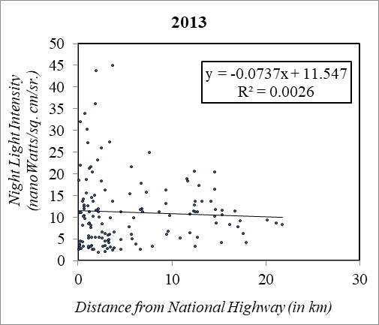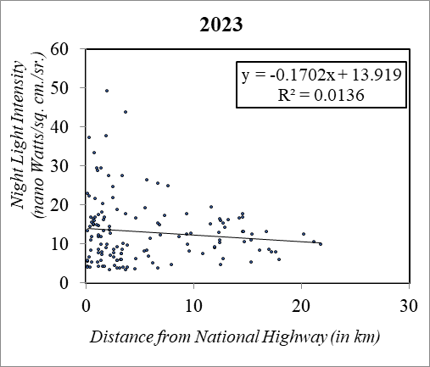
Figure 9 a and 9 b: Decadal Pattern of Distance Decay Effect of National Highways on NTL intensity
Source: Computed by authors

Thus, it may be remarked that urbanization is influenced by proximity to NH which in turn influences NTL intensity (Yang, 2024).
3.5. Spatial Distribution of NTL Intensity
The Theil Index of NTL intensity covering the six districts reveals its variability of spatial distribution across southern part of West Bengal, particularly KMA. The Theil Index value stands at 0.2053 score. This indicates a moderate inequality in distribution of NTL intensity over KMA. Kolkata being the largest metropolitan in the KMA, is the major contributor to the inequality with a high positive component score of 2.37 (Table 2). It contributes to higher night light intensity as compared to other districts, indicating higher concentration of economic or infrastructural development demanding NTL. Other districts have negative contributions, suggesting they are well below the mean and contribute to inequality through their lesser intensity of NTL. This is again suggestive of lesser demand for NTL due to relatively lesser commercialization of economic and other activities in the districts. The other districts have lesser number of Municipalities or big metropolitans; despite, concentration of large number of census towns. Although increase in census towns apparently enhance the process of urbanization, but the urban gap between lesser tier towns and big metropolitans remain constant. This enhances the inequality in diverse aspects—NTL intensity concentration in this regard.
Table 2: Theil Index Decomposition
Districts | NTL Intensity  (nanoWatts/sq. cm/sr.) | Theil Component | Contribution to Inequality
Kolkata | 42.80 | 2.3741 | 0.3957
North 24 Parganas | 17.67 | 0.0512 | 0.0085
Nadia | 12.00 | -0.2411 | -0.0402
South 24 Parganas | 11.27 | -0.2685 | -0.0448
Hugli | 9.05 | -0.3336 | -0.0556
Haora | 8.18 | -0.3506 | -0.0584
Source: Calculated by the authors,2025

3.6.1. Spatial Association of Built-up Space & NTL Intensity
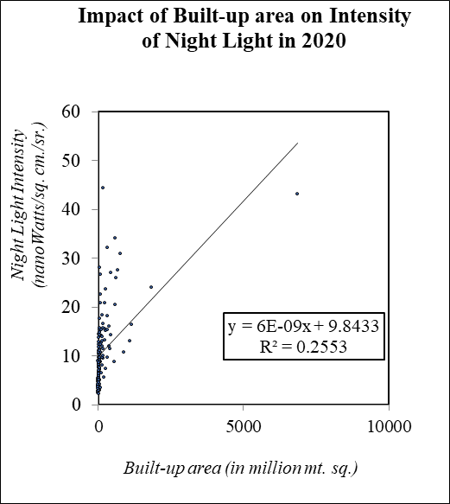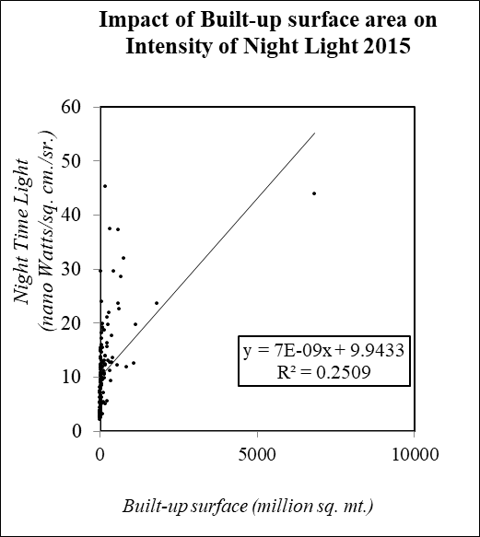The diagrams (Figure 10 a and 10 b) suggest that there is a positive correlation between the built-up area and NTL intensity—as the built-up surface area increases, the intensity of nocturnal lighting tends to increase. The regression equation is indicative that there is a minimum NTL even in areas with extremely less built-up space. Most urban sites are clustered in the lower range of built-up areas and night light intensity.
Figure 10 and 10b: Temporal Patterns of correlation between Built-up area and NTL Intensity
Source: Computed by authors
This implies that with higher number of census towns in the KMA, urbanization has not reached its peak, but, even in such lesser tier urban sites, a base level of NTL is there, although at lower intensity. One or two sites appear as outliers, with very large built-up areas and higher-than-average night light intensity, which may represent large metropolitan cities. The trend remains the same over the years
3.6.2. Spatial Association of Population & NTL Intensity
Influence of population on NTL intensity seems to be much similar to that of urban built-up space. Here also a positive correlation is evident indicating with higher concentration of population, NTL intensity tends to be higher (Figure 11 a and 11 b). Corroborating with Figure 11(a and b), here also urban sites with relatively lower population clusters are found where even with a bottom-line population, NTL intensity would be found. The outliers indicate larger metropolitan areas, with higher NTL intensity.
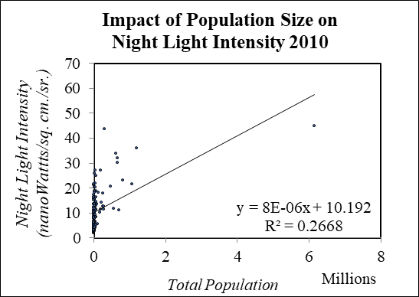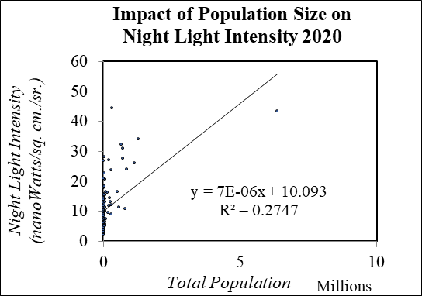
Figure 11a. and 11b.: Temporal Patterns of correlation between Population and NTL Intensity
Source: Computed by authors

4. Summarized Findings
The study reflects the spatial association of three variables—Night Time Light (NTL), urbanization through expansion of built-up area, and total population in the Kolkata Metropolitan Area (KMA). The overall growth of urbanization in the KMA has been gradual, so a conspicuous change in the built-up area has not been observed in the cartographic representations. Apart from Kolkata, large metropolitan city does not exist in the KMA. However, there has been proliferation of numerous census towns and municipalities in the recent time from 2011-2021, so a multi-polar urban unit have grown in the region with core concentration in and around Kolkata and 12 Municipalities with their outgrowths. Related to this is population distribution. The superfluous growth of census towns is mainly contributed by high population growth in small pockets away from the urban core of Kolkata or the Municipalities. The operation of core periphery factor works here. Centering the bigger town, census towns have although grown, yet, urban functions which demand NTL are concentrating with higher in the former ones than the latter. Consequently, NTL intensity is found to be higher at this lesser number of urban municipal cores than numerous peripheral census towns. So, the overall, NTL intensity in the KMA is not ubiquitous but has unequal distribution as evident statistically from the Theil Index and cartographically from the Figure 6(a and b). Although KMA is not noted as strategic region so far in the recent times, yet during the Bangladesh liberation war of 1971, in Kolkata (as it is very close to the Bangladesh border) black-outs had been a strategic practice to keep the citizens safe. NTL is also very significant for the general safety of the citizens on road. Lighting on roads keep people alert and serve as panopticon infrastructure for the potential offenders.
5. Concluding Remarks
The analysis of NTL, urbanization and population distribution in the KMA shows the evolving spatial dynamics of the urban agglomeration marked by a polycentric yet uneven urban expansion centering big cities and along the NH. While Kolkata remains the single dominant urban core with few municipalities, the mushrooming of census towns reflects a decentralized growth pattern, driven by population sprawl. This dynamic spatial core-periphery distribution of urban units and population influences NTL intensity. NTL therefore, is disproportionately clustered around established municipal centers rather than proliferating census towns.
The observed disparities in NTL distribution, as quantified by the Theil Index, highlight the inequalities in KMA’s urbanization process. Despite the proliferation of census towns, their limited capacity to sustain high-intensity NTL suggests infrastructural and economic dormancy, at late hours indicating the primacy of traditional urban centers. This dichotomy between municipalities and peripheral settlements emphasizes the need for equitable urban planning to reduce gaps in service provision and safety infrastructure.
Today, street lighting serves not only as a civic amenity but also as a critical tool for public safety, functioning as a vigilance infrastructure. The uneven distribution of NTL thus, carries implications beyond mere visibility, reflecting deeper inequities in urban governance. So, the policymakers must address these spatial imbalances for inclusive urbanization. Strengthening infrastructure in peripheral census towns, alongside targeted investments in NTL, could enhance regional resilience, ensuring that growth in the KMA is sustainable.

References
- Alam, T. &. (2022). Deciphering Urbanization and Spatial Disparity in South 24 Parganas district of West Bengal, India. 58th ISOCARP World Planning Congress, Belgium (pp. 63-87). Brussels: SOCARP.
- Anwaruzzaman, A. K. M., Mukherjee, A. & Biswas, R. (2018). Population Change in Statutory Towns in the Kolkata Metropolitan Area During 2001-2011: Nature, Causes, Consequences And Future Trend.
- Asian Institute of Transport Development . (2011). Socio-economic Impact of National Highway on Rural Population . New Delhi : Asian Institute of Transport Development.
- Bedi, T. P. & et.al (2021). Light pollution in India: appraisal of artificial night sky brightness of cities. Environment Development and Sustainability, 25-38.
- Bharti, A. & Kaur, R. (2019). Use of DMSP-OLS and VIIRS night-time lights for urban mapping and population estimation: A case study of Ludhiana, India. Geocarto International, 231--248.
- Bhattacharjee, R. & De, S. (2020). Prospects, Challenges and Threats of MSME of Howrah District . BKGC SCHOLARS , 8-17.
- Bhowmick, S. & Sivaramakrishnan, L. (2021). Growth behaviour of census towns in Kolkata Metropolitan region, West Bengal, India. Transactions, 2-12.
- Biljecki, F. & Ito, K. (2021). Street view imagery in urban analytics and GIS: A review. Landscape and Urban Planning, 79-95.
- Calabria, M. (2021). Effects of the COVID-19 Lockdown on Urban Light Emissions: Ground and Satellite Comparison. Remote Sensing, 159-175.
- Chakraborty, S. (2021). Spatio-temporal patterns of urbanization in the Kolkata Urban Agglomeration: A dynamic spatial territory-based approach. Sustainable Cities and Society, 185-209.
- De, J. (2025). Urban utilities and their distribution in Hugli-Chinsurah Municipality, India. Norwegian Journal of Geography, 23-39
- De, P. & Roy, A.. (2022). Urban Sprawl and Climate Change Resilience in Kolkata Metropolitan Area, India. SSRN Electronic Journal, 1-29.
- Dey, F. (2021). Dynamics of Urban Growth and Environmental Challenges: A Case Study of Kolkata, India. Geography, Environment, Sustainability, 24-31.
- Dey, F. & Bhaduri, S. (2017). Availability of drinking water, electricity connection and latrine facility in rural West Bengal: a Geo-Spatial analysis. Researchers World – Journal of Arts Science & Commerce, 103-115.
- Elvidge, C. Z. (2021). Annual time series of global VIIRS nighttime lights derived from monthly averages:2012 to 2019. Remote Sensing , 922.
- Fondalighting.com. (2025, April 4). The Importance of Street Lights in Urban Construction. Retrieved from https://www.fondalighting.com: https://www.fondalighting.com/article/the-importance-of-street-lights-in-urban-construction
- Gwiazdzinski, L. M. (2018). Geographies of the night. From geographical object to Night Studies. Bollettino della Società Geografica Italiana, 9-22.
- Katabaro, K. Y. (2022). A review of the effects of artificial light at night in urban areas on the ecosystem level and the remedial measures. Frontiers in Public Health, 1-15. doi:https://doi.org/10.3389/fpubh.2022.969945
- Khatua, S. (2016). Governance of Urban Periphery: A Case Study of Contemporary Kolkata . Kolkata: Centre for Urban Economic Studies. University of Calcutta.
- Kii, M. & Matsumoto, K. (2023). Detecting Urban Sprawl through Nighttime Light Changes. Sustainability. doi:https://doi.org/10.3390/su152316506
- Kuffer, M. & et.al. (2017). City nighttime light variations using ISS images. Joint Urban Remote Sensing Event, 29-40.
- Lambert, J. (2023, January 17). Keeping the Night Alive: Emotions, Economy, Efficiency. Retrieved from https://us.schreder.com/: https://us.schreder.com/en/blogs/smart-lighting-helps-cities-save-nighttime-economy
- L&TSufIn. (2025, February 28). Retrieved from https://lntsufin.com: https://lntsufin.com/blog/various-types-of-street-light/
- Levin, N. (2020). Remote sensing of night lights: A review and an outlook for the future. Remote Sensing of Environment, 161-180.
- Lee, S. (2025, April 26). The Ultimate Guide to Theil Index. Retrieved from Number Analystics: https://www.numberanalytics.com/blog/theil-index-guide-dev-econ
- Li, X. X. (2013). Potential of NPP-VIIRS nighttime light imagery for modeling the regional economy of China. Remote Sensing, 3057–3081.
- Mondal, B. & Samanta,G. (2017). Commuting and Metropolitan Development of Kolkata. Hill Geographer, 61-79.
- Mondal, D. & Banerjee, A. (2021). Exploring peri-urban dynamism in India: Evidence from Kolkata Metropolis. Journal of Urban Management, 382-392.
- Peretz Architecture. (2023, January 26). Urban Street Lighting as an Essential Element of Urbanism. Retrieved from https://www.peretzarc.com: https://www.peretzarc.com/post/urban-street-lighting-as-an-essential-element-of-urbanism-1
- Pesaresi, M., & Politis, P. (2023). GHS-BUILT-S R2023A - GHS built-up surface grid, derived from Sentinel2 composite and Landsat, multitemporal (1975-2030). European Commission, Joint Research Centre.
- Rashid, M. (2022). Urban Morphology and Historic Landscape Management: The Case Of Kolkata. In K. Silva, Routledge Handbook on Historic Urban Landscapes of the Asia-Pacific (pp. 103-116). New York: Routledge.
- Roychowdhury, K. T. & et. al. (2011). Delineating urban, suburban and rural areas using Landsat and DMSP-OLS night-time images. Joint Urban Remote Sensing Event.
- Sahana, M. H. (2018). Analyzing urban spatial patterns and trend of urban growth using urban sprawl matrix: A study on Kolkata urban agglomeration, India. Science of The Total Environment, 1557-1566.
- Sarkar, R. & Hossaine, M. (2020). Population Pressure and Urban Sprawl in Kolkata Metropolitan Area. In H. A. Rukhsana, Habitat, Ecology and Ekistics Case Studies of Human-Environment Interactions in India (pp. 163-178). Switzerland: Spinger.
- Satpati, L. & Haldar, A. (2021). Neoliberal urban sustainability in Old Kolkata, India: Case studies of contested developments. Regional Science Policy & Practice, 1825-1842.
- Schiavina, M., et.al. (2023). GHS-POP R2023A - GHS population grid multitemporal (1975-2030). European Commission, Joint Research Centre.
- Ściężor, T. (2021). Effect of Street Lighting on the Urban and Rural Night-Time Radiance and the Brightness of the Night Sky. Remote Sensing, 19-34.
- Smit, W. (2021). Urbanization in the Global South. Global Public Health, 58-79.
- Stokes, E. &. Seto, C. (2019). Characterizing urban infrastructural transitions for the Sustainable Development Goals using multi-temporal land, population, and nighttime light data. Remote Sensing of Environment, 59-70.
- Visible Infrared Imaging Radiometer Suite. (2022). Visible Infrared Imaging Radiometer Suite. Retrieved from SSCE: https://cimss.ssec.wisc.edu/viirs/
- Wang, Z. & et.al. (2019). Mapping urbanization dynamics in South Asia using DMSP/OLS and VIIRS night-time light data. Remote Sensing, 215.
- Wu, W. & et.al. (2022). Quantifying the influence of 2D and 3D urban morphology on the thermal environment across climatic zones. Landscape and Urban Planning, 60-80.
- Yang, H. (2024). Application of Smart Streetlights in Urban Road Lighting. Journal of Electronic Research and Application, 84-95.
- Yeo-Kyeong, K. & et.al. (2023). Natural Surveillance for Crime and Traffic Accidents: Simulating Improvements of Street Lighting in an Older Community. Urban Planning, 108-119.
- Zheng, Q. S. (2023). Nighttime light remote sensing for urban applications: Progress, Challenges, and Prospects. ISPRS Journal of Photogrammetry and Remote Sensing, 125-141. doi:https://doi.org/10.1016/j.isprsjprs.2023.05.028

