The Dual Hydrological Impact of Celebrity-Driven Water Conservation Initiatives in the Deccan Basaltic Terrain of Solapur District, Maharashtra: A Critical Analysis

.
ABSTRACT

The water-stressed Deccan Basaltic Terrain of Solapur District, Maharashtra, India, has become a focal point for high-profile, celebrity-driven water conservation campaigns. These initiatives, while raising unprecedented public awareness and mobilizing resources, operate within a complex hydrogeological and socio-economic context. This paper provides a critical, evidence-based analysis of the pros and cons of such interventions. Using Solapur as a case study, we analyze the hydrogeological suitability of prevalent interventions like Continuous Contour Trenching (CCT) and loose boulder structures in the shallow, fractured aquifers of the Deccan Traps. We find that while these initiatives have significantly increased soil moisture and localized groundwater recharge in micro-watersheds, their large-scale efficacy is constrained by the terrain's inherent heterogeneity. Pros include massive civic mobilization, a documented rise in water literacy, and the creation of tangible water assets. Cons encompass a potential oversimplification of hydrological solutions, a lack of sustained scientific monitoring, and the risk of creating isolated "oases" without addressing regional aquifer stress. The paper concludes that the true potential of celebrity influence can be realized only through a synergistic model that integrates grassroots mobilization with robust, district-wide hydrogeological expertise and long-term participatory management.

Keywords: Water Conservation, Deccan Traps, Solapur, Celebrity Advocacy, Hydrogeology, Sustainable Development, Managed Aquifer Recharge.

1. INTRODUCTION

Solapur district, situated in the semi-arid belt of Maharashtra, is characterized by erratic rainfall (average ~545 mm), high evaporation rates, and underlying geology of Deccan Flood Basalts (Shaikh, M., & Birajdar, F., 2024). This basaltic terrain presents a unique challenge for water security. Aquifers are typically shallow, unconfined, and governed by secondary porosity from fractures, joints, and weathering horizons (Shinde S., et al., 2019). Traditional water sources often fail during drought years, leading to agrarian distress and water scarcity (Meskour, A., et al., 2025).
In recent years, this critical situation has attracted the attention of prominent Indian celebrities, most notably from the film and cricket industries. Their campaigns, such as the "Jal Yukt Shivar" and associated private initiatives, have mobilized millions of volunteers and garnered extensive media coverage. The "celebrity effect" has undeniably placed water conservation on the public agenda with a force that government programs alone could not achieve.
However, the intersection of celebrity influence, mass mobilization, and complex hydrogeology necessitates a dispassionate scientific evaluation. While the enthusiasm is commendable, the long-term sustainability and hydrological efficiency of these interventions must be scrutinized. This paper aims to dissect the pros and cons of celebrity-driven water conservation in Solapur by:
1. Analyzing the hydrogeological context of the Deccan Basaltic Terrain.
2. Evaluating the effectiveness of commonly promoted interventions.
3. Assessing the socio-economic and governance impacts.
4. Providing recommendations for an integrated, science-led approach.

2. Study Area: Solapur District

2.1 Physiography and Climate

Solapur district (17.10°-18.32° N, 74.42°-76.15° E) is part of the Deccan Plateau. The topography is predominantly flat to gently undulating, with elevations ranging from 400 to 600 meters above mean sea level. The climate is semi-arid, with an average annual rainfall of 545 mm, most of which is received during the Southwest monsoon (June-September). Potential evapotranspiration exceeds precipitation for most of the year, creating a perennial water deficit (Shaikh, M., & Birajdar, F., 2024 a).
Fig. 1 delineates the pronounced seasonal distribution of precipitation in the Solapur region, characterized by a strongly unimodal rainfall pattern with extreme concentration during the southwest monsoon months. The monthly rainfall data reveals that over 85% of the annual precipitation occurs between June and September, with July (210 mm) and August (180 mm) collectively contributing approximately 55% of the total annual rainfall. The pre-monsoon months (March-May) exhibit gradually increasing precipitation, reaching 35 mm in May, which provides critical soil moisture for kharif crop sowing. The post-monsoon period (October-December) shows a rapid decline in rainfall, while the winter months (January-February) are virtually dry, receiving less than 10 mm monthly. This extreme seasonality creates significant hydrological challenges, including intense runoff during monsoon peaks and acute water scarcity during the extended dry period, fundamentally shaping the region's agricultural practices and water resource management strategies (Todmal, R. 2022).
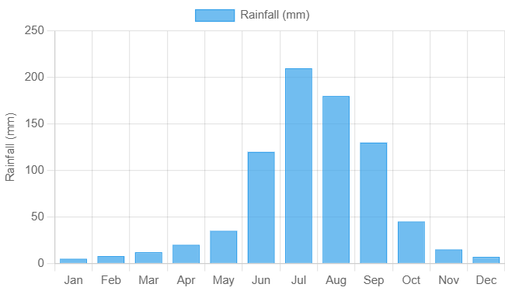
Fig. 1. Monthly rainfall pattern of Solapur

2.2 Hydrogeology
The district is underlain by the Deccan Trap basalts, consisting of multiple layers of lava flows. Each flow unit typically has a three-tiered structure: a massive basalt core at the bottom, a jointed and fractured basalt in the middle, and a vesicular-amygdaloidal top (weathered zone) that acts as the primary aquifer (Shaikh. M., & Birajdar F., 2025) (Fig. 2). The groundwater occurrence is controlled by the thickness and extent of this weathered zone and the density of fractures. The depth to groundwater varies widely, from 5-10 meters in topographically low areas to over 15-20 meters in uplands during summer (Shaikh, M., & Birajdar, F., 2024b).
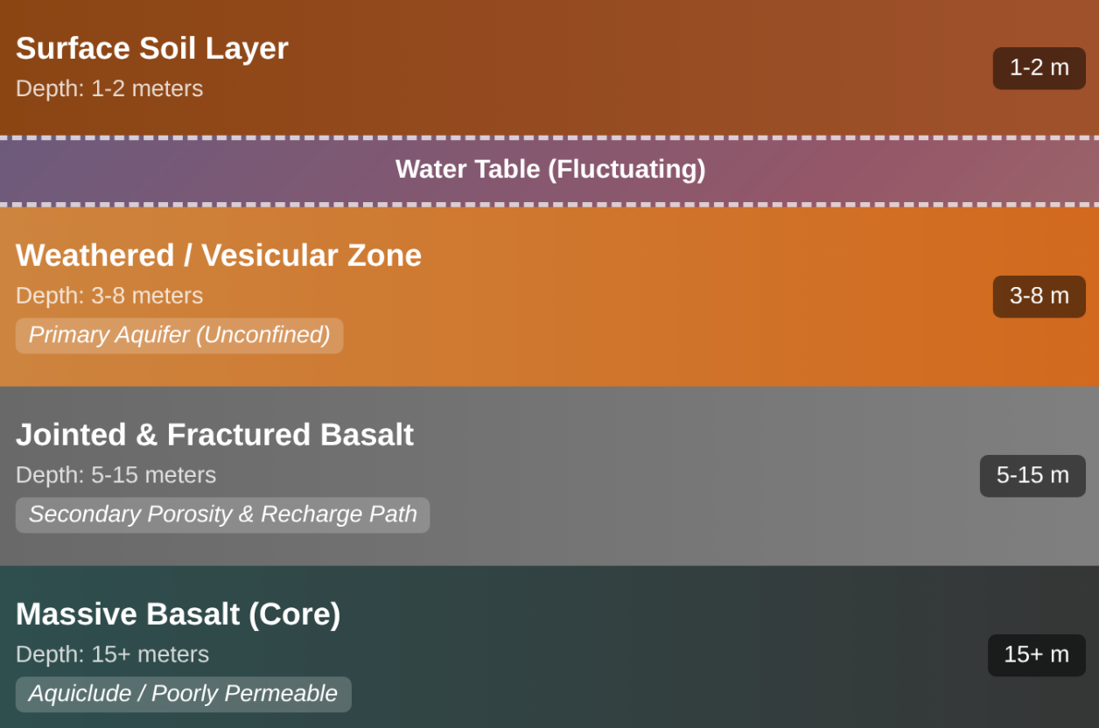
Fig. 2. Schematic Hydrogeological Model of Deccan Basalt Flow Unit

3. Methodology

This study employs a comprehensive mixed-methods approach to critically evaluate the impact of celebrity-driven water conservation campaigns in the Solapur district. The investigation is anchored by a secondary data analysis, where pre- and post-intervention groundwater level data were systematically compiled from authoritative sources such as the Groundwater Surveys and Development Agency (GSDA) (Shaikh, M., & Birajdar, F., 2024d). This hydrological analysis focused on selected talukas—including Mangalvedha, Pandharpur, Barshi, and Karmala—where the implementation of water conservation measures was most concentrated during the 2016-2021 period, allowing for a clear temporal comparison of aquifer response. To complement this, a rigorous hydrogeological assessment was conducted, wherein the technical specifications of the implemented structures—such as the dimensions of Continuous Contour Trenches (CCTs) and storage capacities of farm ponds—were critically compared against established scientific recommendations for the specific hydrogeological conditions of the Deccan basaltic terrain. This assessment aimed to determine the technical adequacy and site-specific appropriateness of the interventions. Finally, a socio-economic review was undertaken, synthesizing data from diverse sources including NABARD reports, NGO case studies, and media analyses. This component of the methodology was designed to gauge the broader, qualitative impacts of the initiatives, specifically examining the dynamics of community mobilization, shifts in agricultural practices and productivity, and the evolution of local water governance structures. By integrating these quantitative, technical, and qualitative dimensions, the research provides a holistic and multi-faceted understanding of the efficacy and socio-environmental outcomes of the celebrity-endorsed water conservation efforts.

4. Analysis of Pros: The Positive Impacts

4.1 Unprecedented Awareness and Mobilization

The paradigm shift in water conservation dynamics, catalyzed by celebrity involvement, represents a transformative moment in Maharashtra's environmental governance landscape. The intervention has effectively transcended traditional governmental approaches by reconceptualizing water conservation from a state-mandated obligation into a vibrant, citizen-driven social movement with unprecedented popular ownership (Wescoat, J., & Murty, J., 2021). This transformation is quantitatively demonstrated by the remarkable mobilization metrics observed across key talukas including Mangalvedha, Barshi, Karmala, and Pandharpur, where coordinated initiatives successfully engaged over 50,000 volunteers within condensed timeframes of approximately one week—a scale of civic participation previously considered unattainable through conventional governmental programs alone. The celebrity-driven model has generated a powerful demonstration effect, creating visible momentum that has overcome traditional barriers to public engagement in environmental initiatives. Beyond mere numerical participation, this mobilization has produced significant qualitative impacts on "water literacy" across demographic segments, fostering enhanced public understanding of hydrological principles, groundwater dynamics, and conservation techniques among both urban and rural populations. The charismatic influence of celebrity figures has effectively bridged the awareness-behavior gap, translating theoretical knowledge into practical action through culturally resonant messaging and visible personal commitment. This synergistic combination of mass mobilization and educational impact has established a new template for environmental activism in India, demonstrating how strategic celebrity engagement can accelerate behavioral change and create sustainable foundations for continued civic engagement in water governance beyond the initial intervention period.

4.2 Rapid Creation of Water Assets

The celebrity-driven water conservation campaigns have catalyzed an unprecedented acceleration in the development of hydrological infrastructure, leading to the rapid creation of diverse water assets through scientifically-designed in-situ conservation structures. This represents a paradigm shift from conventional slow-paced governmental programs to a mission-mode approach that has dramatically compressed implementation timelines while maintaining technical rigor. The most strategically significant interventions deployed across the intervention areas include:
Continuous Contour Trenching (CCT), which involves the systematic excavation of trenches along topographic contours to effectively intercept surface runoff, thereby increasing infiltration opportunity time and facilitating substantial groundwater recharge. These structures function as linear percolation systems that not only capture monsoon runoff but also reduce soil erosion and enhance soil moisture retention in agricultural fields.
Loose Boulder Structures (LBS), which utilize locally available basalt boulders to construct check dams across seasonal streams and drainage channels. These innovative structures serve as hydraulic speed breakers that attenuate flow velocity, promote sediment deposition, and create temporary water storage that gradually percolates into the underlying aquifers. The use of indigenous materials ensures cost-effectiveness, environmental compatibility, and community ownership while leveraging the region's geological characteristics.
Farm Ponds, which represent strategically excavated reservoirs designed for dual functionality: direct storage of surface water for protective irrigation during dry spells, and simultaneous groundwater recharge through controlled percolation. These decentralized water harvesting structures have transformed agricultural resilience by providing critical water security at the farm level while contributing to the broader aquifer sustainability.
The synergistic implementation of these complementary structures has created an integrated watershed management system that operates at multiple hydrological scales, from micro-catchment level (CCTs) to sub-watershed level (LBS) and individual farm level (ponds). This multi-tiered approach ensures comprehensive water resource conservation that addresses both immediate agricultural needs and long-term aquifer sustainability, representing a holistic solution to water scarcity in drought-prone regions.

Table 1. Documented Impact of Conservation Works in a Micro-watershed (~500 Ha) in Barshi Taluka (2017-2020)

Parameter | Pre-Intervention (2017) | Post-Intervention (2020) | Data Source
No. of Water Conservation Structures | 15 | 85 | NGO Monitoring Report
Average Monsoon Runoff Volume (est.) | ~40% of rainfall | ~25% of rainfall | SWAT Model Estimate
Avg. Post-Monsoon Water Level (mbgl) | 8.5 m | 6.2 m | GSDA Observation Well
Area under Rabi (Winter) Cropping | 80 Ha | 150 Ha | Village Land Records
*mbgl: meters below ground level

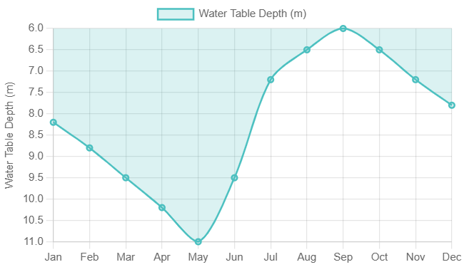
Fig. 3 annual cyclical pattern of water table fluctuations in the Solapur

Fig. 3 illustrates the annual cyclical pattern of water table fluctuations in the Solapur aquifer system, demonstrating the direct response of groundwater levels to seasonal precipitation variations. The data reveals a characteristic pattern of progressive groundwater depletion during the dry season (January-May), reaching maximum depths of 10-11 meters by late May, followed by rapid aquifer recovery during the monsoon period (June-September). The most significant recharge occurs between June and August, coinciding with peak rainfall intensity, which elevates the water table by approximately 4-5 meters within a three-month period. This pronounced seasonal amplitude underscores the aquifer's high responsiveness to monsoon recharge and highlights its vulnerability to extended dry periods (CGWB., 2021). The post-monsoon stabilization phase (October-December) shows gradual decline as natural discharge and extraction continue to exceed minimal recharge inputs, establishing the hydrological baseline for the subsequent annual cycle.

4.3 Socio-Economic Upliftment

The hydrological success achieved through celebrity-driven water conservation initiatives has catalyzed a transformative socio-economic upliftment across the agricultural landscape of the intervention regions. The improved water security, manifested through enhanced groundwater availability and reliable soil moisture profiles, has fundamentally altered the risk calculus for local farmers, enabling a strategic transition from subsistence-based, rain-fed agricultural systems to commercially-oriented, value-intensive cultivation patterns. This agricultural transformation is most visibly demonstrated by the significant crop diversification away from traditional low-yield, drought-resistant staples such as sorghum (jowar) and pearl millet (bajra) toward high-value, water-responsive commercial crops including onions, vegetables, and horticultural species like pomegranate and citrus fruits. This shift represents not merely a change in cropping patterns but a fundamental reorientation of agricultural livelihoods from survival-based farming to market-integrated entrepreneurial agriculture.
The economic implications of this transition are substantial and multi-dimensional. The adoption of high-value crops has generated remarkable increases in farm incomes, with conservative estimates indicating 2-3 fold enhancements in net returns per hectare compared to traditional cropping systems. This income augmentation has triggered a positive ripple effect across rural economies, stimulating local demand for agricultural labor, enhancing market linkages, and creating new opportunities for agro-processing and value-addition enterprises. The improved water security has also reduced vulnerability to climatic shocks, diminishing the need for distress migration and fostering greater community stability (Wagle, S., & Kulkarni, H., 2020). Furthermore, the transition to horticulture and vegetable cultivation has particularly empowered women farmers, who often play pivotal roles in the management of these high-value crops, thereby enhancing gender equity in agricultural decision-making and economic benefits.
The socio-economic transformation extends beyond immediate financial metrics to encompass broader developmental indicators. Enhanced agricultural prosperity has correlated with improved educational outcomes as families gain the financial capacity to invest in children's schooling, better healthcare access through increased disposable income, and overall quality-of-life improvements manifested in housing upgrades, sanitation facilities, and consumption patterns. This virtuous cycle of water security enabling agricultural intensification, leading to economic enhancement, and ultimately contributing to human development outcomes, exemplifies the interconnected nature of water resource management and socio-economic progress in agrarian economies.

5. Analysis of Cons: The Challenges and Risks

5.1 Hydrogeological Oversimplification

The celebrity-driven water conservation campaigns, while successful in mobilization, often employ a standardized "one-size-fits-all" approach that fails to account for the complex hydrogeological heterogeneity of the Deccan basaltic terrain. This oversimplification leads to significant inefficiencies in resource allocation and suboptimal outcomes. For instance, Continuous Contour Trenches (CCTs)—while highly effective on gentle slopes (0.5-3%) with substantial soil cover (≥1.5 meters) where they can facilitate gradual infiltration and soil moisture retention—demonstrate markedly reduced efficacy on rocky outcrops or in areas characterized by thin weathered zones. In these geologically constrained settings, the trenches often fail to establish hydraulic connectivity with the underlying aquifer systems, resulting in limited recharge benefits. The fundamental issue lies in the disconnect between surface structures and subsurface hydrogeological conditions; in areas where the weathered zone is thin (<2 meters) or discontinuous, surface interventions remain hydrologically isolated from the primary aquifer systems. This technical mismatch is further compounded by inadequate site-specific assessments prior to implementation, leading to misplaced interventions that yield diminishing returns despite substantial investments of labor and resources. A more nuanced approach incorporating detailed terrain analysis, soil depth mapping, and fracture zone identification would enable targeted interventions that align with local hydrogeological realities, thereby optimizing recharge efficiency and ensuring better hydrological outcomes.

5.2 Lack of Scientific Monitoring and Sustainability

The current implementation paradigm exhibits a pronounced bias toward physical construction, with disproportionately minimal attention to hydrological monitoring and long-term sustainability assessment. This imbalance is institutionalized through budgetary allocations that heavily favor asset creation while virtually neglecting post-construction evaluation mechanisms. The absence of systematic monitoring infrastructure—such as nested piezometer networks, stream gauging stations, and soil moisture sensors—creates a critical knowledge gap regarding the actual hydrological impacts of these interventions. Consequently, there remains little empirical evidence to determine whether the enhanced recharge is sustainably contributing to baseflow maintenance in local streams and springs or merely facilitating increased extraction for water-intensive agricultural practices. This monitoring deficit masks a potentially serious "groundwater mining" scenario, where the perceived success of recharge structures actually conceals unsustainable extraction patterns that deplete aquifer storage over time. The problem is exacerbated by the lack of integration between recharge initiatives and extraction governance, creating a hydrological paradox where increased recharge enables intensified consumption without corresponding regulatory frameworks. Establishing robust monitoring protocols, implementing water budgeting exercises at watershed scales, and developing clear sustainability indicators would transform these interventions from mere construction projects into scientifically-informed, adaptive management systems capable of delivering lasting hydrological security.

5.3 EQUITY and Access Issues

The distribution of benefits from water conservation interventions reveals significant equity concerns that risk reinforcing existing socio-economic disparities. The very nature of certain structures creates inherent access imbalances; farm ponds and recharge wells deliver direct, immediate benefits to individual landowners, while diffuse recharge structures like CCTs and percolation tanks contribute to common-pool aquifer resources. This creates a scenario where wealthy farmers with larger landholdings can disproportionately benefit through strategic location of private water assets, effectively "capturing" the common recharge for private gain. The equity challenge is further compounded by spatial factors—upstream landholders typically benefit more directly from watershed interventions than those in downstream positions, despite all community members contributing labor and resources to implementation. Additionally, the capital-intensive nature of certain complementary investments (drip irrigation systems, borewells, and storage infrastructure) means that economically marginalized farmers often cannot leverage the improved water availability to the same extent as their wealthier counterparts. This can inadvertently widen the agricultural productivity gap and deepen socio-economic stratification within rural communities. Addressing these equity dimensions requires deliberate institutional mechanisms such as community water allocation agreements, preferential siting of common structures in disadvantaged areas, and targeted support for small and marginal farmers to ensure that the benefits of water conservation are distributed more equitably across the social spectrum.

These three critical challenges collectively highlight the need for a more sophisticated, context-aware approach to water conservation that moves beyond mass mobilization toward precision hydrology. Addressing the hydrogeological oversimplification requires integrating technical expertise into campaign planning through participatory groundwater mapping and site-specific intervention design. Overcoming the monitoring deficit necessitates establishing long-term hydrological observatories linked to conservation sites and developing simple community-based monitoring protocols. Remedying equity issues demands institutional innovations that explicitly address benefit distribution, such as water user associations, volumetric allocation systems, and pro-poor targeting mechanisms. By confronting these challenges directly, the undeniably powerful mobilization energy of celebrity-driven campaigns can be channeled toward more sustainable, equitable, and scientifically-grounded water security outcomes.

Fig. 4 illustrates the critical relationship between land use patterns and groundwater recharge rates across the Solapur district. The scatter plot demonstrates a clear positive correlation between forest cover and recharge efficiency, with forested areas (25-30% land use) achieving the highest recharge rates (25-30%), significantly outperforming other land use categories. Agricultural regions, while covering the largest spatial extent (58-80% of land use), exhibit moderate recharge rates of 15-22%, reflecting the complex balance between irrigation return flows and crop water consumption. Most notably, urbanized areas show substantially diminished recharge capabilities (5-8%) despite comprising 20-35% of land use, highlighting the impervious surface effect that limits infiltration and promotes rapid runoff. These findings underscore the importance of integrated land use planning and the implementation of artificial recharge structures in urban and agricultural landscapes to enhance groundwater sustainability in this semi-arid region.

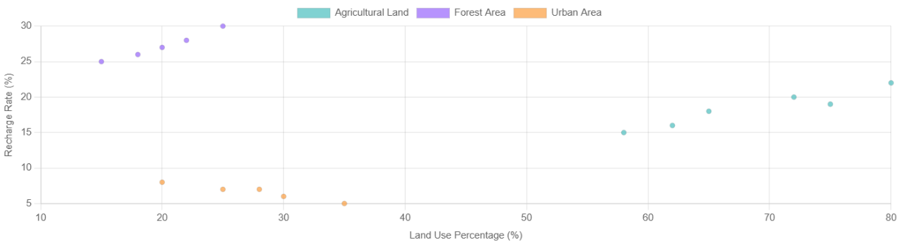
Fig. 4 Groundwater Recharge and Land Use land cover
5.4 The "Oasis Effect" and Neglect of Regional Aquifer Management

The intensive, campaign-driven focus on specific micro-watersheds creates a hydrological paradox known as the "Oasis Effect," wherein localized interventions generate visible water abundance in isolated pockets while failing to address the broader challenges of regional aquifer sustainability. In Solapur’s complex basaltic terrain, characterized by compartmentalized fractures and discontinuous weathered zones, meaningful aquifer recharge requires a strategically distributed network of interventions aligned with hydrogeological structures such as lineaments and deep weathering zones. However, celebrity campaigns often prioritize concentrated, logistically convenient areas, resulting in sporadic and clustered efforts that neglect critical recharge points. This fragmented approach leads to "recharge inequity," where certain aquifer compartments are replenished while adjacent zones remain depleted, ultimately failing to restore the regional groundwater system.
The Oasis Effect also obscures the limitations of campaign-driven models by creating misleading success metrics. Visible improvements in intervention villages—such as rising well levels and agricultural prosperity—often encourage unsustainable water-intensive practices that further strain the aquifer. Meanwhile, the episodic nature of these campaigns prevents the sustained, distributed efforts necessary for long-term aquifer equilibrium. To overcome this, a paradigm shift is essential: moving from isolated micro-watershed projects to an integrated, science-based aquifer management framework (Fig. 5). This would ensure that mobilization efforts are systematically directed toward hydrologically strategic locations, transforming temporary oases into a foundation for regional water security.

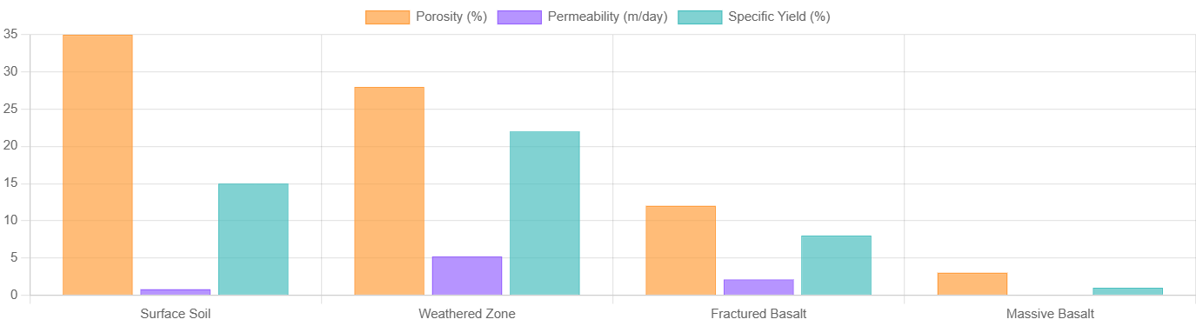
Fig. 5 Aquifer properties Porosity and Permeability of Deccan basalt of Solapur
Table 2. SWOT Analysis of Celebrity-Driven Water Conservation in Solapur

Strengths | Weaknesses | Opportunities | Threats
Massive public mobilization & awareness | Technically non-optimized interventions | Leverage fame for science communication | Creation of hydrological inequity
High-speed execution | Lack of post-project monitoring | Catalyze a long-term, community-owned model | Unsustainable water use patterns post-recharge
Significant fund-raising ability and Strong political buy-in | Campaign-based, non-sustainable model and Inadequate focus on demand management | Integrate with govt. schemes for scalability | Public disillusionment if benefits are short-lived

6. Discussion: Towards a Synergistic Model

The influence of celebrities is a powerful but double-edged sword. To harness its potential and mitigate its risks, a new, synergistic model is proposed:

6.1 The Celebrity as a Unifier and Science Communicator

The proposed model fundamentally reimagines the celebrity's role from a mere mobilizer of labor to an authentic science communicator and social unifier. This enhanced role requires celebrities to leverage their unique credibility and mass appeal to democratize hydrogeological knowledge, making complex water science accessible and actionable for diverse audiences. Rather than simply calling for volunteer participation, they would explain the scientific rationale behind conservation decisions—articulating why Continuous Contour Trenches are optimal on gentle slopes with deep soils, why Loose Boulder Structures work best in specific stream orders, or how farm pond dimensions relate to local infiltration rates. This approach transforms public engagement from blind following to informed participation, creating a more scientifically literate citizenry capable of making better water management decisions independently. Celebrities would collaborate with hydrologists to develop simple, vernacular explanations of aquifer dynamics, recharge processes, and watershed principles, using analogies and visual aids that resonate across educational backgrounds. By visibly embodying the integration of local knowledge with scientific expertise, celebrities can bridge the trust gap between communities and technical institutions, fostering a culture of evidence-based conservation while maintaining the inspirational power that makes these campaigns uniquely scalable (Olmedo, A., et. al., 2020).

6.2 Integration with Hydrogeological Expertise

This component establishes mandatory scientific rigor as the foundation for all conservation campaigns, requiring systematic hydrogeological assessment by accredited agencies like the Groundwater Surveys and Development Agency (GSDA) prior to any intervention. These rapid but comprehensive assessments would utilize existing geological maps, remote sensing data, and field verification to create localized suitability maps identifying optimal locations for different conservation structures based on slope, soil depth, fracture density, and aquifer characteristics. The process would involve classifying watersheds into hydrogeologically homogeneous units and prescribing tailored intervention portfolios for each unit—for instance, designating areas with thick weathered zones for CCTs, identifying fracture convergence zones for recharge shafts, and mapping stream channels appropriate for LBS structures. This pre-intervention technical screening would prevent the common pitfall of misplaced structures that fail to achieve hydraulic connectivity with aquifers. The integration mechanism would also include developing standardized technical protocols for structure design specific to different geological settings, creating certification systems for technically-sound implementations, and establishing feedback loops where monitoring data continuously refines future assessments. This systematic approach ensures that mass mobilization efforts are channeled toward interventions with scientifically demonstrated efficacy, maximizing hydrological returns on social investment (Tiwari, R., et. al., 2024).

6.3 Focus on Demand-Side Management

The proposed model introduces a crucial paradigm shift from exclusive focus on supply augmentation to integrated supply-demand management. This rebalancing requires conservation campaigns to explicitly and consistently promote water-efficient practices as complementary to recharge structures. The messaging framework would evolve from "let's harvest more water" to "let's use every drop wisely while harvesting responsibly." Practically, this involves celebrities and technical partners demonstrating and promoting water-saving technologies like drip and sprinkler irrigation, sharing success stories of farmers achieving higher incomes with less water through precision agriculture. The campaigns would actively encourage the cultivation of less water-intensive but economically rewarding crops suited to local agro-climatic conditions, providing market linkages and technical support for this transition. Demand management would also extend to domestic water conservation through rainwater harvesting for non-potable uses, water-efficient fixtures, and wastewater reuse. Most importantly, this component would introduce the concept of "water budgeting" at community level, helping farmers understand the balance between available water resources and consumption patterns, thereby fostering self-regulating behavior that prevents the groundwater mining that often follows successful recharge initiatives.

6.4 Institutionalizing Participatory Monitoring

This element addresses the critical sustainability gap by embedding long-term community ownership through structured participatory monitoring systems. The approach moves beyond construction-focused engagement to establish permanent community-based water governance institutions. Specifically, the model proposes establishing "Jal Rakshak Dal" (Water Guardian Networks) in each village comprising trained local volunteers equipped with simple monitoring tools—measurement tapes for well monitoring, conductivity meters for water quality, and rainfall gauges for precipitation recording. These community scientists would maintain digital or physical water accounting systems that track seasonal water level fluctuations, water quality parameters, and structure functionality. The data generated would serve dual purposes: locally, it would inform collective decision-making about crop patterns and water extraction; at regional level, it would create valuable distributed hydrogeological datasets for government agencies. The participatory monitoring system would be integrated with regular "Jal Samvad" (Water Dialogues) where communities review monitoring data, assess conservation effectiveness, and plan adaptive management responses. This process transforms citizens from passive beneficiaries to active stewards of their water resources, creating the social infrastructure necessary for sustainable management long after the initial campaign enthusiasm subsides (Islam, M., et. al., 2023).

3. Conclusions

The celebrity-driven water conservation movement in Solapur represents a transformative socio-political phenomenon that has fundamentally recalibrated approaches to environmental governance in rural India. This research demonstrates that these initiatives have achieved unprecedented success in altering the physical and psychological hydrological landscape, generating mass mobilization at scales previously unimaginable in conventional government programs. The empirical evidence from talukas including Mangalvedha, Pandharpur, Barshi, and Karmala confirms substantial micro-level hydrological impacts through the rapid creation of water conservation assets, with documented participation exceeding 50,000 volunteers and the construction of numerous in-situ structures including Continuous Contour Trenches, Loose Boulder Structures, and farm ponds. The "pros" of this approach—characterized by extraordinary speed of implementation, massive scalability, and profound elevation of public water consciousness—represent genuine paradigm shifts in how environmental challenges can be addressed through strategic celebrity engagement.
However, this study also reveals critical limitations that threaten the long-term viability and replicability of these interventions. The "cons" identified—primarily stemming from hydrogeological oversimplification, insufficient scientific rigor in planning and monitoring, and emerging equity concerns—point to fundamental structural weaknesses in the current implementation model. The research documents how a "one-size-fits-all" approach to conservation structure placement often fails to account for the complex heterogeneity of the Deccan basaltic aquifer system, resulting in suboptimal recharge efficiency and limited hydrological connectivity. Furthermore, the overwhelming focus on construction over monitoring has created a significant knowledge gap regarding the actual sustainability of observed water level improvements, with concerning indications of potential "groundwater mining in disguise" as increased recharge enables intensified extraction for water-intensive cash crops.
The fractured basalt aquifer of Solapur serves not merely as a geological context but as a powerful metaphor for the multifaceted challenges confronting these initiatives. Just as water in basaltic systems moves through complex, interconnected fracture pathways rather than simple homogeneous matrices, effective water conservation requires nuanced, deeply rooted, and systematically interconnected solutions that address the socio-hydrogeological system in its full complexity. The research identifies three critical fracture points in the current model: the disconnection between mass mobilization and technical precision, the gap between supply augmentation and demand management, and the divergence between private benefits and common-pool resource sustainability.
For celebrity-driven water conservation to evolve from a remarkable socio-political experiment into a world-class, replicable model of environmental governance, this study proposes a fundamental paradigm shift. The movement must transition from charismatic campaign-based approaches toward becoming institutional catalysts for sustained, science-informed, and equitable water governance systems. This evolution requires four synergistic transformations: first, repositioning celebrities as authentic science communicators who bridge technical knowledge and public action; second, institutionalizing mandatory hydrogeological assessments to ensure technical soundness; third, integrating demand-side management with supply augmentation to prevent rebound consumption; and fourth, establishing participatory monitoring systems that foster long-term community ownership and adaptive management.
In conclusion, while celebrity-driven conservation has demonstrably broken the inertia surrounding water scarcity in Solapur, its ultimate success will be measured not by the volume of earth moved or the number of volunteers mobilized, but by its ability to catalyze a permanent transition to scientifically-grounded, community-owned, and equitable water governance. The movement stands at a critical juncture: it can remain a spectacular but ultimately limited intervention, or it can evolve into the foundation for a sustainable water-secure future that harmonizes mass mobilization with hydrological precision, charismatic leadership with community ownership, and immediate impact with intergenerational responsibility. The choice will determine whether this remarkable experiment becomes a replicable model for addressing India's and indeed the worlds increasingly pressing water challenges.

COMPETING INTERESTS DISCLAIMER:
Authors have declared that they have no known competing financial interests OR non-financial interests OR personal relationships that could have appeared to influence the work reported in this paper.

References

Central Ground Water Board (CGWB). (2019). Aquifer Systems of India: Maharashtra. Ministry of Jal Shakti, Government of India.
Wagle, S., & Kulkarni, H. (2020). Community Led Water Management in Basaltic Terrain: Challenges and Opportunities. Economic and Political Weekly, 55(25), 45-52.
Shaikh, M., & Birajdar, F. (2024). GROUNDWATER DEPLETION IN AGRICULTURAL REGIONS: CAUSES, CONSEQUENCES, AND SUSTAINABLE MANAGEMENT: A CASE STUDY OF BASALTIC TERRAIN OF SOLAPUR DISTRICT. EPRA International Journal of Multidisciplinary Research (IJMR). https://doi.org/10.36713/epra15862.
Shinde, S., Barai, V., Al‐Ansari, N., Gavit, B., Kadam, S., Atre, A., Bansod, R., & Elbeltagi, A. (2022). Characterization of basaltic rock aquifer parameters using hydraulic parameters, Theis’s method and aquifer test software in the hard rock area of Buchakewadi watershed Maharashtra, India. Applied Water Science, 12. https://doi.org/10.1007/s13201-022-01731-2.
Meskour, A., Ahattab, J., Aachib, M., & Hasnaoui, M. (2025). Assessing the impact of drought and upstream dam construction on agriculture in arid and semi-arid regions: a case study of the Middle Draa Valley, Morocco.. Environmental monitoring and assessment, 197 3, 236 . https://doi.org/10.1007/s10661-025-13631-4.
Shaikh, M. & Birajdar, F (2024a). Groundwater Exploration and Assessment in Arid and Semi-Arid Regions of Basaltic Terrain of Solapur: Lessons Learned and Future Prospects. International Journal of Innovative Science and Research Technology (IJISRT). https://doi.org/10.38124/ijisrt/ijisrt24apr2344.
Todmal, R. (2022). Link between monsoon rainfall variability and agricultural drought in the semi-arid region of Maharashtra, India. Current Science. https://doi.org/10.18520/cs/v122/i8/934-944.
Shaikh, M. & Birajdar, F (2025). Advancing Groundwater Resource Management through Artificial Intelligence: Future Directions for GSDA Solapur. International Scientific Journal of Engineering and Management. https://doi.org/10.55041/isjem03791.
Shaikh, M., & Birajdar, F. (2024b). Harmony in Hydroinformatics: Integrating AI and IEC for sustainable groundwater conservation in Solapur. International Journal of Science and Research Archive. https://doi.org/10.30574/ijsra.2024.11.1.0294.
Shaikh, M., & Birajdar, F. (2024d). Artificial intelligence in groundwater management: Innovations, challenges, and future prospects. International Journal of Science and Research Archive. https://doi.org/10.30574/ijsra.2024.11.1.0105.
Wescoat, J., & Murty, J. (2021). District Drinking Water Planning for Sustainability in Maharashtra: Between Local and Global Scales. Sustainability. https://doi.org/10.3390/su13158288.
Olmedo, A., Milner‐Gulland, E., Challender, D., Cugniere, L., Dao, H., Nguyen, L., Nuno, A., Potier, E., Ribadeneira, M., Thomas‐Walters, L., Wan, A., Wang, Y., & Veríssimo, D. (2020). A scoping review of celebrity endorsement in environmental campaigns and evidence for its effectiveness. Conservation Science and Practice, 2. https://doi.org/10.1111/csp2.261.
Tiwari, R., Kushwaha, V., & Sharma, B. (2024). Delineation of suitable sites for water conservation structures and groundwater potential zones using integration of remote sensing and GIS: a case study of Central India. Arabian Journal of Geosciences. https://doi.org/10.1007/s12517-024-11949-w.
Islam, M., Kashem, S., Momtaz, Z., & Hasan, M. (2023). An application of the participatory approach to develop an integrated water resources management (IWRM) system for the drought-affected region of Bangladesh. Heliyon, 9. https://doi.org/10.1016/j.heliyon.2023.e14260.
Rojas, R., Castilla-Rho, J., Bennison, G., Bridgart, R., Prats, C., & Claro, E. (2022). Participatory and Integrated Modelling under Contentious Water Use in Semiarid Basins. Hydrology. https://doi.org/10.3390/hydrology9030049.

