Original Research Article

Evaluation of Oxidative Stress and Histological Changes Caused by a Common Laundry Detergent in the Freshwater Fish, Channa punctatus

Abstract: Detergents are extensively used chemicals at home and in industry, and most of their ingredients are highly toxic to aquatic organisms. This study aims to investigate the effect of a common laundry detergent, Ariel, on oxidative stress and histopathological alterations in liver and gill tissues of freshwater fish, Channa Punctatus. The probit method was used to determine the median lethal concentration (LC₅₀) of Ariel detergent. The LC₅₀ value of Ariel detergent for 96 hours was 32 ppm. To evaluate the detergent-induced toxicity, the fish were exposed to 1/5th of 96h LC₅₀ concentration (6.4 ppm) for a period of 7 and 14 days. Detergent caused a significant decrease in the activities of superoxide dismutase (SOD), catalase (CAT), glutathione-S-transferase (GST), glutathione reductase (GR), and glutathione (GSH) levels, whereas the activity of xanthine oxidase (XO) and MDA levels increased in both liver and gill tissues after 7 and 14 days exposure to detergent. Histopathology of liver tissue from the treated group showed morphological impairments characterized by loosely arranges, irregularly distributed, and degenerated hepatocytes with increased sinusoidal space and vacuolization, whereas gill tissue showed hyperemia in the afferent and efferent branchial arteries and congestion in the secondary lamellae after 7 and 14 days detergent exposure while secondary lamellae of 14 days exposed group exhibit a tendency of curling and fusion with adjacent lamellae at the terminal part. However, among the groups, 14 days exposed group exhibited significant perturbations in selected oxidative stress markers and histopathological impairments than seven days exposed group; further, the toxic effect of detergent was higher in gill tissue than liver tissue. In conclusion, our data indicate that Ariel detergent profoundly induces oxidative stress associated with histopathological impairments in selected tissues suggesting that the deleterious effect caused by the detergent was probably due to the combined effects of the ingredients of detergent further, these impairments were found to be time-dependent.

Keywords: Ariel, Detergent, oxidative stress, histopathology, fresh water fish

Introduction
The contamination of aquatic ecosystems is increasing at an alarming rate due to the discharge of untreated sewage of urban and industrial origin directly into the aquatic environment (Donat et al. 2020). Laundry and cleaning chemicals are commonly used substances in everyday life and are used in large quantities (Doyinsola and Kafilat 2020). Currently, the global use of surfactants increases every year and is estimated to exceed US$28.8 billion until 2023 (Brycki et al. 2017). As a result, large quantities of detergents and their components of wastewater enter the environment and are relatively toxic to aquatic life. In recent years, considerable attention has been focused on laundry and cleaning chemicals and the environmental risks associated with their manufacturing use and disposal. Among the contaminants found in this sewage, effluents are organic pollutants such as detergents, which can cause severe toxicity problems for the fish and other forms of aquatic biota (Uc-Peraza and Delgado-Blas 2012). Detergents are mixtures of different cationic and anionic surfactants and additives such as water softeners, preservatives, bleaching agents, pigments, enzymes, foam stabilizers, colorants, perfumes, and other minor constituents (Bajpai and Tyagi 2007). However, most of these ingredients of cleaning products are persistent pollutants and cause various toxicities to the fish and other aquatic organisms (Uc-Peraza and Delgado-Blas. 2012). The synthetic detergents reaching the aquatic environment are of particular concern as they can potentially adversely affect aquatic organisms. Synthetic detergents are made with different surfactant ingredients, such as alkyl benzene sulfonate (ABS), dodecylbenzene sulfonate (DBS), and alkyl lauryl sulfonate (LAS) and additives (Uc-Peraza and Delgado-Blas 2015, PROFEPA 2002). In recent years, a very few studies have investigated the toxic effects of the principal constituent of detergents and other components of detergents with their toxic effects assessed in algae (Jonsson 2009), Daphnia Magna (Pettersson et al. 2000), microalgae (Azizullah et al. 2011), and their genotoxic effects in human leukocytes (Pedrazzani et al. 2012). However, fish can be considered one of the most reliable models to assess the impact of pollution in the freshwater systems as they quickly respond to stress from cellular to population levels (Begum et al. 2005).

The surfactants have been demonstrated to damage the cell membrane of living cells by producing oxidative stress and damage of biomolecules in organisms (Li et al. 2015). Detergents at low concentrations affect cell membrane permeability and disturb cellular metabolism (Argese et al.1994), resulting in depletion of stock due to massive fish mortalities and other aquatic fauna (Me-Hui 2008). Bradai et al. (2014) reported that synthetic detergent LAS is a complex mixture of anionic surfactants and causes ROS production leading to tight junction disruption and cytotoxicity in human Caco-2 cells. It has also been documented that detergents and their components induce tissue damage and histopathological degradations to vital organs such as the liver, kidney gills, skin, heart, and brain of fishes (Kumar et al. 2007, Varsha et al. 2013) by increasing ROS and oxidative stress. The increased ROS is neutralized by the specific antioxidant enzymes and non-enzymatic antioxidants such as catalase (CAT), superoxide dismutase (SOD), glutathione peroxidase (GPx), and glutathione (GSH). However, the antioxidant system may have been inhibited due to excess free radical generation due to altering the ability of the enzymes to protect against oxidative damage (Shukla and Trivedi 2018). Experimental studies also demonstrated that exposure to high concentrations of these products causes changes in fish behavior producing erratic movements, muscular spasms, and body torsion (Cserhati et al. 2002). Recently, few studies investigated the acute toxicity of common household detergents, Surf, Tide and Nirma, and found that fishes exhibited several behavioral and biochemical changes, reduced oxygen consumption, and loss of body balance (Chandanshive 2013 and 2015, Choudary and Jha, 2013). A commercial detergent Ariel was found to induce adverse effects on oxidative enzymes and proteins of liver and heart and degenerative changes in the respiratory lamellae, and the chronic exposure led to drastic changes like separation of epithelium layer and atrophy in Oreochromis mossambiccus (Nkpondion et al. 2016, Ubong et al. 2015, Raju et al. 1994).
The toxicity of the major components of commercial detergents to various aquatic organisms has been reported relatively well. However, the effects of detergent as a whole have rarely been considered. Further, these components can interact either antagonistically, additively, or synergistically towards toxicity in the aquatic environment (Warne and Schifko 1999). Further, evaluating the individual effects of surfactants or other ingredients does not reflect either the actual or net influence of a detergent on the aquatic environment; thus, it is necessary to estimate the biological effects of detergent formulations whole (Azizullah et al. 2011, Markina and Aizdaicher 2007). Considering the information mentioned above, this study aimed to determine the mean lethal concentration (LC₅₀) of Ariel commercial detergent as a whole and aims to evaluate detergent-induced oxidative stress and its consequent histopathological impairments using freshwater fish Channa punctatus. The study's findings will significantly illuminate the underlying mechanism of aquatic toxicology elicited by a commonly used laundry detergent.

Materials and Methods
Fish maintenance and Experimental design
Healthy Adult Channa Punctatus with mean weight 50 ± 2g and mean standard length 10 ± 2cms were obtained from the fisheries department, Tirupati, Andhra Pradesh, India. Fishes were immediately transported to the laboratory treated with 0.05% KMnO4 solution for 2 minutes to avoid dermal infection, kept in large cement tanks and supplied with clean dechlorinated tap water and were acclimatized for about 2 weeks before the experiment with a photoperiod of 12:12 light and dark cycle with constant aeration and filtration. During the period of acclimatization, the fish were fed with commercial fish feed to satiety twice daily. Water was renewed every day to provide fresh water rich in oxygen and to prevent hypoxic conditions, if any.
Test Chemical: The commonly available laundry detergent Ariel (Procter & Gamble GmbH, Germany) obtained from the local market was used in this study, which is the most commonly used domestic detergent in India.
Determination of Sub Lethal Concentration of Ariel (LC50) and Exposure
To find out the approximate toxic range of the test chemical, healthy and almost equal-sized fish were exposed to different concentrations of Ariel. After finding the approximate toxic range, ten logarithmic concentrations were selected to determine the LC₅₀ value of Ariel detergent. The concentration ranges chosen for the Ariel detergent for the toxicity test on C. punctatus were ranged from 23 to 40 ppm, and the duration of the experiment was 96 hours. After 96 hrs, the LC₅₀ was calculated using a modified method (Finney 1971, Stephan 1977). The fish were divided into four groups viz. a control group without any test chemical and two other treatment groups, exposed to 1/10th of LC₅₀ concentration of Ariel detergent for 7 and 14 days.
Mitochondrial Oxidative Stress Enzymatic Assays:
After the exposure period, on days 7 and 14, fishes were sampled of each group to remove their gills and liver. Homogenized tissues were stored at -80⁰C, until enzymatic determinations.

Superoxide dismutase (SOD): SOD activity was determined according to the method of Misra and Fridovich (1972). The selected tissues were homogenized in ice-cold 50 mM phosphate buffer (pH 7.0) containing 0.1 mM EDTA to give 5% homogenate (w/v). The homogenates were centrifuged at 10,000 rpm for 10 min at 40C in an ice-cold centrifuge. The supernatant was separated and used for enzyme assay. 100 µl of tissue extract was added to 880 µl (0.05 M, PH 10.2, containing 0.1 mM EDTA) carbonate buffer and 20 µl of 30 mM epinephrine (in 0.05% acetic acid) was added to the mixture and measured the optical density values at 480 nm for 4 min on a Hitachi U-2000 Spectrophotometer. The activity of the enzyme was expressed as superoxide anion reduced/mg protein/min. One unit is equal to 50% inhibition of the photoreduction.

Catalase activity (CAT): CAT activity was measured by a slightly modified version of Aebi (1984). The homogenates were centrifuged at 10,000 rpm for 10 min in the cold centrifuge. The resulting supernatant was used as an enzyme source. 10 µl of 100% EtOH was added to 100 µl of tissue extract and then placed in an ice bath for 30 min. After 30 min the tubes were kept at room temperature, followed by the addition of 10 µl of Triton X-100 RS. In a cuvette containing 200 µl of phosphate buffer and 50 µl of tissue, the extract was added 250 µl of 0.066 M H2O2 (in phosphate buffer) and decreased in optical density measured at 240 nm for 60 s in a UV spectrophotometer. The molar extinction coefficient of 43.6 M cm-1 was used to determine CAT activity. One unit of activity is equal to the moles of H2O2 degraded /mg protein /min.

Glutathione peroxidase (GPx): GPx activity was measured in a coupled enzyme system by measuring the decrease of NADPH at 340 nm (Tappel et al 1982). The reaction mixture contained 48.5 μmol Tris-HCl buffer pH 7.8, 77 mM of EDTA, 0.25 μmol reduced glutathione (GSH), 0.12 μmol NADPH, 0.5 units (0.5 μmol NADPH oxidized per min) glutathione reductase, and 0.20 μmol cumene hydroperoxide. The extinction coefficient for NADPH at 340 nm of 6,200 M−1 cm−1 was be used in the calculations. The activity of GPx is given as micromoles NADPH oxidized/mg of protein/min.

Glutathione reductase (GR): The GR activity was determined by measuring NADPH oxidation at 340 nm (Carlberg and Mannervik 1975). The reaction mixture contained 600 µl of buffer (0.1 M potassium phosphate + 0.5 mM EDTA + 0.1 mM KCl; pH 7.5), 100 µl of 0.1 mM NADPH, 100 µl of H2O and 100 µl of homogenized tissue. After 5 min of pre-incubation (37C), the reaction was initiated by adding 100 µl of 1 mM GSSG. The GR activity was expressed as µM NADPH oxidized/min/mg of protein.

Glutathione-S-transferase (GST): GST activity was measured with its conventional substrate, 1-Chloro 2, 4-Dinitro Benzene (CDNB) at 340 nm as per the method of Habig et al. (1974). The tissues were homogenized in 50 mM ice-cold Tris-HCl buffer (pH 7.4) containing 0.2 M sucrose and centrifuged at 16,000 g for 45 at 40C. The pellet was discarded, and the supernatant was used as the enzyme source. The reaction mixture in a total volume of 3 ml contained 2.4 ml of 0.3 M potassium phosphate buffer (pH 6.9), 0.1 ml of 30 mM CDNB, 0.1 ml of 30mM GSH, and 0.4 ml of enzyme source. The addition of glutathione initiated the reaction, and the absorbance was read at 340 nm against the reagent blank, and the activity was expressed in µ moles of thioether formed / mg protein/min.

Total Glutathione level (GSH): The level of total glutathione was assayed as reduced glutathione (GSH) by a spectrophotometric reader assay coupled with an enzymatic recycling method previously described by Rahman et al. (2006). This method for GSH involves oxidation of GSH by the sulfhydryl reagent 5,5′-dithio-bis(2-nitrobenzoic acid) (DTNB) to form the yellow derivative 5′-thio-2-nitrobenzoic acid (TNB). An aliquot of 100 µL tissue homogenate was treated with 150 µL of a working mixture containing 0.5 mM DTNB and GRed (6.3 U/mL) prepared in a GSH buffer (185 mM phosphate buffer, pH 7.4, and 6.3 mM EDTA). After 5 min of shaking, 50 µL of 1 mM NADPH diluted in GSH buffer was added, and the absorbance was measured at 412 nm.. The results were expressed in mg/g protein.

Xanthine oxidase (XO): Xanthine oxidase activity was assayed by the dye reduction method of Srikanthan and Krishnamurthy (1955). The assay mixture contained 100 µ moles of sodium phosphate buffer (pH 7.4), 50 µ moles of xanthine, 0.1 µ moles of NAD, 0.4 µ moles of INT, and the enzyme source. The reaction was initiated by the addition of 20 mg of enzyme source and incubated at 370C for 30 min. The reaction was stopped by adding 5 ml glacial acetic acid, and the formazan formed was extracted into 5 ml of toluene and read at 495 nm against toluene blank. The activity was expressed in µ moles of formazan formed / mg protein/hour.

Lipid peroxidation (MDA levels): The MDA concentration of the tissues was determined using the thiobarbituric acid (TBA) reaction described by Ohkawa et al. (1979). The tissues were homogenized (5% - w/v) in 50 mM phosphate buffer (pH 7.0) containing 0.1 mM EDTA. The homogenates were centrifuged at 10,000 rpm for 10 min in a cold centrifuge. The separated supernatant part was used for the estimation. 200 µl of the tissue extract was added to 50 µl of 8.1% sodium dodecyl sulphate (SDS), vortexed, and incubated for 10 min at room temperature. 375 µl of 20% acetic acid (pH 3.5) and 375 µl of thiobarbituric acid (0.6%) were added and placed in a boiling water bath for 60 min. The samples were allowed to cool at room temperature. A mixture of 1,25 ml of butanol:pyridine (15:1) was added, vortexed, and centrifuged at 1000 rpm for 5 min. The colored layer was measured at 532 nm. LPO activity was expressed as MDA/mg protein/min.

Protein Concentration: The protein concentration of samples was determined according to the method of Bradford (1976) to express enzymatic activities taking into account the protein content of the analyzed tissues.

Histology analysis:
The tissues (liver and gill) fixed in 4% formaldehyde for 24 h were subsequently dehydrated in gradient ethanol, cleared in xylene, and then embedded in paraffin. A section of 4-5µm on a rotary microtome (paraffin machine, Leica RM, Germany) and mounted on glass microscope slides. Sections of liver and gill tissues were stained with Delafield's hematoxylin and alcohol eosin and then air-dried. Histological images were captured using an optical microscope (Olympus, Japan).

Statistical Analyses
Statistical analysis was performed with the SPSS 10.1 computer program (SPSS Inc. Chicago, IL, USA). The results were expressed as the mean ± SD. Significant differences between groups were analyzed by one-way analysis of variance and Student-Newman–Keuls (SNK) post hoc test where appropriate. The significance of the results was ascertained at p<0.05.
Results

96 h LC50 of Laundry Detergent
In the present study, the percentage mortality of C. punctatus exposed to different concentrations of commercial detergent (Ariel) at 96 h is presented in Fig. 1. The LC₅₀ values at 96 h for the selected detergent tested from 23 to 40 ppm, the mean 96 h LC₅₀ for fish species C. punctatus was determined as 32 ppm. However, 4-30% mortality was observed between 25 to 29 ppm, 30 to 70% mortality was registered for 29 ppm to 34 ppm, and between 70 to 100% mortality was observed from 34 to 40 ppm. These results indicate that the percent mortality of C. punctatus increased with an increase in the concentrations of the detergent tested (Fig.1).

Oxidative Stress Marker Enzymes
Oxidative stress plays an important role in toxicity generated by laundry detergent, here we examined the effects of Ariel detergent on different antioxidant enzyme activities (superoxide dismutase (SOD), catalase (CAT), xanthine oxidase (XO), glutathione peroxidise (GPx), glutathione-s-transferase (GST), glutathione reductase (GR) and glutathione (GSH), and lipid peroxidation assay (MDA levels) in liver and gill tissues of fish C. punctatus. The effect of Ariel detergent on the activity of antioxidant enzymes in liver and gill tissue samples shown in Fig. 2 to Fig.9. Ariel detergent caused a time-dependent decrease in CAT, GPx, and GR activities and GSH levels, while the activities of XO and GST showed a time-dependent increase in liver and gill tissues after 7 and 14 days exposure when compared to controls. On the other hand, SOD activity showed an increase after 7 days of exposure, whereas 14 days exposure group showed a decrease in SOD activity in liver and gill tissues of fish. Detergent exposure exerted signiﬁcant perturbation in all the enzyme markers was greater in 14 days exposed group (-24.2% in liver & -47% in gill in SOD; -31.2% in liver & -42.3% in gill in CAT; 31% in liver & 29.4%in gill in XO; -30.3% in liver & -42.2% in gill in GPx; -30.9% in liver & -37.6% gill in GR; -31.2% in liver & -51.2% in gill in GST and -36.2% in liver & -42.3 in gill in GSH) than 7 days exposed group. MDA (malondialdehyde) concentrations examined the gill and liver tissues reflecting the damages produced by free radical increased with time exposition to the detergent (Fig.10). MDA levels in liver and gill were 15.5 ± 1.3 and 8.8 ± 0.4 at 7 days and 15.9 ± 1.8 and 9.6 ± 0.9 at 14 days in control liver and gill, respectively. We observed an increase in MDA levels was11.2% in the liver and 24.7% in gill tissues after 7 days exposure, whereas MDA levels were 28.3% in the liver and 39.7% in gill tissues after 14 days exposure. Among the groups, 14 days exposed group exhibited great perturbations in selected oxidative stress markers than 7 days exposed group. However, the toxic effect of detergent was higher in gill tissue than liver tissue (Fig. 2 to 10).

Histopathological Analysis of Liver and Gill
The liver and gill tissues of fish of control and Ariel detergent exposed groups are shown in Fig. 10 (a&b). In the control group, normal liver parenchyma is arranges in lattice network where well-differentiated hepatocytes and large numbers of blood sinusoids are seen (Fig. 10a). The liver from the treated group showed morphological impairments characterized by loosely arranges, irregularly distributed, and degenerated hepatocytes with increased sinusoidal space (Fig. 10a). Moreover, some other alterations viz, increased vacuolization, and hepatocyte with pyknotic nuclei was also observed in the exposed group (Fig. 10a). The gill architecture of C. punctatus from the control water body exhibits normal features. Terminal parts of the primary and secondary lamellae are intact, and they maintain uniform interlamellar spaces (Fig. 10 (a)). However, the ﬁshes from contaminated water bodies exhibit pathological changes. They show hyperemia in the afferent and efferent branchial arteries and congestion in the secondary lamellae, while secondary lamellae from 14 days exposed group exhibit a tendency of curling and fusion with adjacent lamellae at the terminal part. Tip of secondary lamellae become eroded in many places, and the uniformity of interlamellar spaces are lost. In addition, the epithelium was found to have degenerated in the exposed fishes and got separated from the lamellar tissue and showed a distorted appearance indicating severe damage and degenerative structural changes (Fig. 10b). The detergent exposure also induced hyperplasia in the lamellae, lamellar fusion, loss of filament epithelium, and necrosis (Fig. 10b).

Discussion

Since detergents are complex mixtures of different chemical substances that may adversely affect aquatic ecosystems, information on the toxicity of laundry detergent products and certain detergent ingredients is limited. Due to this fact, it is important to know the effect of the laundry detergents on the biochemical parameters and morphology of the tissues of the fish and other aquatic fauna, which facilitate the effective regulation of environmentally harmful chemicals in the production of cleaning agents. Ecotoxicological studies reported that aquatic organisms are negatively affected by the anionic and non-anionic surfactants at concentrations ranging from 0.0025 to 300 ppm and 0.3 to 200 ppm, respectively (LIwarska-Bizukojc et al. 2005). In this study, the detergent evaluated gave an LC50 value of 32 ppm against C. punctatus after 96 h exposure. The percent mortalities registered for the different concentrations of the detergent ranged from 23 to 40 ppm. Almost similar results have also been reported by Ndome et al. (2013), who examined the toxicity of Ariel detergent on fingerlings of Nigeria and found that toxicity levels (LC₅₀ at 96 h) ranged between 37.43-39.79 ppm. Comparing our results with those of other aquatic organisms, we can observe that C. punctatus is more resistant to Ariel detergent than other aquatic organisms. For example, Nkpondion et al. (2016) examined the toxicity of Ariel detergent to the African Mud catfish (Clarias garepinus) and found that the LC50 value for 96 h acute bioassay test was 0.11g/L. In another study, Markina and Aizdaicher (2007 and 2010) found that Ariel at a 10 mg L-1 adversely affected the marine microalgae Attheya ussurensis, Plagioselmis prolonga, and Dunaliella salina. Azizullah et al. (2011) evaluated the toxicity of Ariel detergent at four different incubation times, i.e., 0, 6, 24, and 72 h using the freshwater flagellate Euglena gracilis. After 6, 24, or 72 h, the EC50 values calculated for motility were 512, 736, and 917 mg L-1, respectively. Moreover, previous studies reveal a large variation in the toxicity of different detergents and surfactants to different organisms. As a result, it is very difficult to conclude which species is more sensitive to detergents or which detergent is more toxic to the aquatic environment suggest that the toxicity data for detergents obtained with one species cannot be applied to other species in the aquatic environment. There is a need for the toxicity assessment of detergents for individual species.
It has been reported that exposure to different concentrations of detergent causes oxidative stress by inducing ROS production (Shukla and Trivedi 2018). The increased ROS neutralized by the specific antioxidant enzymes such as SOD, CAT, GPx, GST, GR, and GSH and has been reported to protect against ROS in fish exposed to different environmental contaminants (Gyimah et al, 2020, Sobrino-Figueroa 2013). SOD and CAT are the first line of defense against oxidative stress caused by xenobiotics (McCord 2000). SOD converts superoxide radicals (O₂⁻) generated in peroxisomes and mitochondria to hydrogen peroxide, and CAT then acts on the hydrogen peroxide converting them to harmless molecules (Ni et al. 2019). Our results showed a decrease in CAT activity after short and long-term exposures to Ariel detergent, while SOD activity showed an increase after 7 days and a decrease after 14 days exposures to detergent in liver and gill tissues of selected test species. Shukla and Trivedi (2018) found that exposure to a lesser concentration of LAS showed a significant effect on CAT and SOD activities after long exposure periods, while impairments in enzymatic activities remain insignificant after a shorter exposure period in tissues of C. punctatus. Alvarez-Murioz et al. (2006) reported anionic surfactant LAS-induced oxidative stress causes increased CAT activity in the gills of calm, Ruditapes phillipinarum, whereas another non-ionic surfactant NPEO induces a reduction in CAT activity in gills. Another study, Mustapha and Bawa-Allah (2020), reported that significant decrease in both activities of SOD and CAT exposed to anionic and non-ionic surfactants in fish. The activity of antioxidant enzymes could be elevated or inhibited depending on their mode of action and concentration of the toxicant (Padmani and Rani 2009). Both enzymatic and non-enzymatic antioxidants are essential for maintaining the redox status of fish. Among the non-enzymatic antioxidants, the tripeptide GSH plays an important role in the cellular defense against ROS.
GST belongs to the multifunctional family of phase II biotransformation enzymes. GPx & GRd exerts its protective role by acting as a scavenger for high concentrations of hydrogen peroxide and reducing it to lipid hydroperoxides in organisms. Together they all constitute a strong line of the defense system in fish against oxidative stress induced by detergents and other xenobiotic pollutants (Flora et al, 2008). In the present study, we found that the fish exposed to Ariel detergent for a period of 7 and 14 days reflected a decrease in the activities of GPx, GR and GSH levels while the activities of GST and XO increased in liver and gill tissues of exposed fish when compared to controls. GRd was found to be stimulated after detergent treatment, suggesting that the detergent-induced accumulation of ROS has interfered with the antioxidant enzymes in the tissues of exposed fish, especially the balance between reduced and non-reduced glutathione level (Mukherjee et al, 2017). The fish exposed to a detergent, sodium dodecylsulphate (SDS), was responsible for a significant decrease in the activity of GRd and marginal alterations in GPx and GST activities in Artemia parthenogenetica (Nunes et al, 2006). Lie et al, (2015) reported that increased ROS and decreased function of antioxidant enzymes are harmful to cells and can initiate lipid peroxidation, cause DNA strand breaks, and indiscriminately oxidize virtually all molecules in biological membranes and tissues, resulting in injury. The MDA concentrations found in the gill and liver tissues reflecting the damages produced by free radicals and reduced function of mitochondrial sensitive oxidative stress enzymes, which is increased with time exposition to the detergent. Recent studies demonstrated that the detergent induced accumulation of ROS has interfered with the antioxidant enzymes, which can lead to genotoxic stress in fish, and DNA damage suggests that micronuclei induction could be used as efficient biomarkers in response to detergent pollution load (Gyimah et al., 2020, Shukla and Trivedi 2019; Sobrino-Figueroa 2013). However, the exact mechanism of such alterations is yet to be known; it can be established that ROS is one of the prime causes for such aforementioned toxicological insults in the fishes.

The correlation between decreases in antioxidant enzyme activity, the severity of the pathological liver injury, and gill damage were quite apparent. Thus, the lowest antioxidant enzymes were found in fish with the most severe tissue injury (Gyimah et al, 2020, Shukla and Trivedi 2019, Sobrino-Figueroa 2013). The results of our study show that increased pathological liver and gill injury was accompanied by decreased activities of antioxidant enzymes of fish. Gills are the primary target organ of several pollutants because of their very large interface area and constant contact with the environmental medium. Histopathological studies showed that there were degenerative changes in primary and secondary lamellae erosion in the gill structure of fish exposed to the detergent. In addition, the epithelial cells of gill lamellae showed a distorted appearance indicating severe damage that led to dysfunctions in respiration and osmoregulation. Ariel at 5ppm was found to induce moderate degenerative changes in the respiratory lamellae in oreochromois mossambiccus on 2 days of exposure. Chronic exposure led to drastic changes like separation of epithelium layer and atrophy (Raju et al, 1994). Although previous studies reported the gill damage caused by chronic exposure to synthetic detergents evidenced the gradual destruction of the gills filaments, swelling and thickening of the respiratory epithelium, clubbing and adhesion of the secondary lamellae, and eventual breakdown of the gill tissue and also killed the fishes due to asphyxia (Pratibha Saxena et al., 2005; Byrne et al, 1989). Chandanshive (2014) reported that toxic elements of detergents also cause excessive secretion of mucus over gill filament and irritation of gill epithelium which alters and interferes in respiration as well as reduced gill diffusing capacity, resulting in a decrease or increase in oxygen consumption in freshwater fish Mystus montanu. The histological observations of the liver tissue revealed that the regularly arranged and nucleated hepatocytes of liver tissues become distorted with disintegrated upon Aerial exposure. Anionic surfactant has been found to induce histopathological damage in the liver of C. punctatus (Shukla and Trivedi, 2018). Naeemi et al. (2013) have also reported similar observations, viz., congestion, dilation of sinusoid, vacuole degeneration, and hepatocyte degenerations on account of LAS exposure in liver tissues of R. frisiikutum further which depends on the concentration of detergent. It has also been documented that the generation of ROS altered the capacity of the antioxidant defense mechanisms and contributed to the development of hepatocyte necrosis and hepatotoxicity in fish (Alvarez-Munoz et al. 2009, Jaeschke et al. 2002). Thus, our findings conform with those of earlier workers revealed that exposure to a common laundry detergent could cause adverse effects on mitochondrial antioxidant enzymes associated with histopathological impairments in the gill and liver of fish. However, similar damage is caused by a wide variety of toxicants. How far the gill and liver damage is generalized response and what aspects of the response are specific to a particular detergent is unknown.

Conclusion
Our findings demonstrated that either short-term or long-term exposures to a common laundry detergent, Ariel alter the activities of mitochondrial antioxidant enzymes resulting in impairment in liver and gill tissues of C. punctatus. The combined effects of its components probably caused the deleterious effect of Ariel detergent suggests that the toxicity of Ariel detergent depends on the duration of exposure. Given the toxic effects of this detergent, it can be inferred that indiscriminate discharge can be detrimental to aquatic biota. Hence, there is an urgent need to monitor and regulate surfactants' concentration and residues in aquatic habitats and need to use more environmentally friendly active ingredients in household and industrial cleaning agents.
Data availability
All data generated or analysed during this study are included in this published article.
Compliance with ethical standards
Conflict of interest: The authors declare that they have no conflict of interest.
Ethics statement: The fish were humanely treated in accordance with the institutional ethical clearance committee (India).
Consent to publish: Informed consent was obtained from all individual participants included in the study.

COMPETING INTERESTS DISCLAIMER:
Authors have declared that they have no known competing financial interests OR non-financial interests OR personal relationships that could have appeared to influence the work reported in this paper.

References
AebiPP H (1984) Catalase in vitro. Methods in Enzymology 105: 121–126.
Alvarez-Mun˜oz A, Go´mez-Parra DA, Blasco J, Sarasquete C, Gonza´lez-Mazo E. (2009) Oxidative stress and histopathology damage related to the metabolism of dodecylbenzene sulfonate in Senegalese sole. Chemosphere 74 (9): 1216–1223.

Álvarez-Muñoz D, M Sáez J, Blasco A, Gómez-Parra1 E, González-Mazo (2006) Enzymatic activity of acid and alkaline phosphatase and catalase in Ruditapes philippinarum as biomarkers of stress caused by anionic (C11-LAS) and non-ionic (NPEO2.8) surfactants. Ciencias Marinas 32(2B): 447–455.

Argese E, Marcomini A, Miana P, Bettiol C, Perin G (1994) Submitochondrial particle response to linear alkylbenzene sulfonates, nonylphenol polyethoxylates and their biodegradation derivatives. Environ Toxicol Chem 13(5):737–742.
Azizullah A, Richter P, Ha¨der DP (2011) Toxicity assessment of a common laundry detergent using the freshwater flagellate Euglena gracilis. Chemosphere 84(10):1392–1400.
Bajpai D, Tyagi VK (2007) Laundry detergents: an overview. J Oleo Sci 56(7):327-40.

Begum A, Amin MN, Kaneco S, Ohta K (2005) Selected elemental composition of the muscle tissue of three species of fish, Tilapia nilotica, Cirrhina mrigala and Clarius batrachus, from the fresh water Dhanmondi Lake in Bangladesh. Food Chemistry 93 (3): 439–443.

Bradai MJ, Han AEl, Omri N, Funamizu S, Sayadi HI (2014) Cytotoxic effect of linear alkylbenzene sulfonate on human intestinal Caco-2 cells: Associated biomarkers for risk assessment. Environ Sci and Pollu Res 21 (18): 10840–10851.
Bradford MM (1976) A rapid and sensitive method for the quantitation of microgram quantities of protein utilizing the principle of protein-dye binding. Analyt Biochem 72: 248-254.
Brycki BE, Kowalczyk IH, Szulc A, Kaczerewska O, Pakiet M (2017) Multifunctional gemini surfactants: structure, synthesis, properties and applications. R. Najjar (Ed.), Application and Characterization of Surfactants. InTech 10.5772/intechopen.68755.

Byrne P, Speare DJ, Ferguson HW (1989). Effects of a cationic detergent on the gills and blood chemistry of rainbow trout Salmo gairdneri. Diseases of Aquatic Organisms 6(3): 185-196.
Carlberg I, Mannervik B (1985) Glutathione reductase. Methods Enzymol 113:484–490.

Chandanshive NE (2013) Studies on Toxicity of Detergents to Mystus montanus and Change in behaviour of Fish, Res J Animal Veterinary and Fishery Sci 1(9): 14-19.

Chandanshive NE (2014) Effects of different Concentrations of Detergents on Dissolved Oxygen Consumption in fresh water fish Mystus montanus. Int Res J Environment Sci 3(8): 1-5.

Chandanshive NE (2015) Impact of Detergents on Nutritive values of Freshwater catfish Mystus Montanus Int Res J Environment Sci 4(8): 33-38.
Choudhary G, Jha BS (2013) Influence of the household detergents on some serum biochemical parameters of freshwater fish Channa punctatus (Bloch). Bioscan 8 (4): 1343–1345.

Cserhati T, Forgacs E, Oros G (2002) Biological activity and environmental impact of anionic surfactants. Environ Int 28: 337–348.
Donat-P Häder , Anastazia TB,Virginia EV, Maite AN, Raúl AG, Walter HE (2020) Anthropogenic pollution of aquatic ecosystems: Emerging problems with global implications Sci Total Environ 15, 713:136586.
Doyinsola SM, Kafilat AB (2020) Differential toxicities of anionic and nonionic surfactants in fish. Environ Sci Pollut Res Int 27(14):16754-16762.
Finney DJ (1971) Probit Analysis. Cambridge University Press, New York, USA, Pp. 337.

Flora SJS , Megha Mittal, Ashish Mehta (2008) Heavy metal induced oxidative stress & its possible reversal by chelation therapy. Indian J Med Res 128(4):501-23.
Gyimah E, Dong X, Qiu W , Zhang Z, Xu H (2020). Sublethal concentrations of triclosan elicited oxidative stress, DNA damage, and histological alterations in the liver and brain of adult zebrafish. Environ Sci Pollut Res Int 27(14):17329-17338.
Habig WH, Pabst MJ, Jacoby WB (1974) Glutathione-S-Transferase. The first enzymatic step in mercapturic acid formation. J Biol Chem 249: 7130-7139.
Jaeschke H, Gores GJ, Cederbaum AI, Hinson JA, Pessayre D, Lemasters JJ (2002) Mechanisms of hepatotoxicity. Toxicological Sciences 65 (2): 166–176.

Jonsson P (2009) Tres lecturas de las novelas de Mario Vargas Llosa: interpretacio´n psicoanalı´tica de la produccio´n novelesca de un autor. Lund: Lund University.
Kumar M, Trivedi SP, Abha Misra, Shuchi Sharma (2007) Histopathological changes in testis of the freshwater fish, Heteropneustes fossilis (Bloch) exposed to linear alkyl benzene sulphonate (LAS) . J Environ Biol 28(3):679-84.
Li F, Zhu L, Wang L, Zhan Y (2015) Gene expression of an arthrobacter in surfactant-enhanced biodegradation of a hydrophobic organic compound. Environ Sci Technol 49 (6) 3698-3704.
Liwarska-Bizukojc E, Miksch K, Malachowska-Jutsz A, Kalka J (2005) Acute toxicity and genotoxicity of five selected anionic and nonionic surfactants. Chemosphere 58(9):1249-1253.

Markina ZV, Aizdaicher NA (2007) Influence of laundry detergents on the abundance dynamics and physiological state of the benthic microalga Attheya ussurensis (Bacillariophyta) in laboratory culture. Russ J Mar Biol 33:391-398.

Markina ZV, Aizdaycher NA (2010) Influence of the ariel detergent on the growth and physiological state of the unicellular algae Dunaliella salina (Chlorophyta) and Plagioselmis prolonga (Cryptophyta). Hydrobiol J 46:49-56.
McCord JM (2000) The evolution of free radicals and oxidative stress. Am J Med 1;108(8):652-9.

Mei-Hui L (2008) Effects of nonionic and ionic surfactants on survival, oxidative stress, and cholinesterase activity of planarian. Chemosphere 70, 1796–1803.
Misra HP, Fridovich I (1972) The role of superoxide anion in the autoxidation of epinephrine and a simple assay for superoxide dismutase. J Biol Chem. 25;247(10):3170–3175.
Mukherjee Mainak, Moniruzzaman Mahammed, Kumar Saheli, Das Debjit, Chakraborty Suman Bhusan (2017) Neuronal and Oxidative Damage in the Catfish Brain Alleviated After Mucuna Seed Extract Treatment. International Journal of Pharmacognosy and Phytochemical Research 9(1); 52-57.
Naeemi A, Jamili S, Shabanipour N, Mashinchian A, Shariati Feizabadi S (2013) Histopathological changes of gill, liver and kidney in Caspian kutum exposed to Linear alkylbenzene sulfonate. Iranian Journal of Fisheries Sciences 12 (4): 887–897.

Ndome Christopher B, Dominic A, Mowang, Tonkumo T, Ayibaemi (2013) Comparative acute toxicity of local detergents (Omo and Ariel) on fingerlings of the Clarias gariepinus. Interl Jour of the Bioflux Soci 6:4. 415-420.
Ni H, Peng L, Gao X, Ji H, Ma J, Li Y, Jiang S (2019) Effects of maduramicin on adult zebrafish (Danio rerio): acute toxicity, tissue damage and oxidative stress. Ecotoxicol Environ Saf 168:249–259
Nkpondion NN, Ugwumba OA, Esenowo IK (2016) The Toxicity Effect of Detergent on Enzymatic and Protein Activities of African Mud Catfish (Clarias gariepinus). J Environ Anal Toxicol 6: 361.
Nunes B, Gaio AR, Carvalho F, Guilhermino L (2008) Behaviour and biomarkers of oxidative stress in Gambusia holbrooki after acute exposure to widely used pharmaceuticals and a detergent. Ecotoxicol Environ Saf 71(2):341-54.
Ohkawa H, Ohishi N, Yagi K (1979) Assay for lipid peroxidation in animal tissues by thiobarbituric acid reaction. Annals of Biochemistry 95:351–358.
Padmini E, Usha Rani M (2009) Evaluation of oxidative stress biomarkers in hepatocytes of grey mullet inhabiting natural and polluted estuaries. Sci Total Environ 15;407(15):4533-41.

Pedrazzani R, Ceretti E, Zerbini I, Casale R, Gozio E, Bertanza G, Gelatti U, Donato F, Feretti D (2012) Biodegradability, toxicity and mutagenicity of detergents: integrated experimental evaluations. Ecotoxicol Environ Saf 84:274-281.
Pratibha Saxena, Subhasini Sharma, Shweta Sharma, V Suryavathi, Ruby Grover, Pratima Soni, Suresh Kumar, K P Sharma (2005). Effect of an acute and chronic toxicity of four commercial detergents on the freshwater fish Gambusia affinis Baird & Gerard. J Environ Sci Eng 47(2):119-24.

PROFEPA (Procuraduría Federal de Protección al Ambiente) (2002) Analisis de calidad de detergentes. Revista del consumidor. (Mexico).
Rahman I, Kode A, Biswas, SK (2006) Assay for quantitative determination of glutathione and glutathione disulfide levels using enzymatic recycling method. Nat Protoc 1, 3159–3165.

Raju CS, Anil Kumar DMHS, Praskasa Babu P, Jayantharao K (1994) Effect of detergent (Ariel) on oxidative enzymes and histology of the teleost Oreochromis mossambicus, J Ecotoxic Environ Monit 4(3), 227-230.

Shukla Anubha, Trivedi Sunil P (2019) Anionic detergent induced DNA damage in fish channa punctatus (Bloch, 1793) Global Journal of Bio-Science and Biotechnology 8(1); 92-96.

Shukla Anubha, Trivedi Sunil P (2018) Anionic Surfactant, Linear Alkyl Benzene Sulphonate Induced Oxidative Stress and Hepatic Impairments in Fish Channa punctatus.Proceedings of the Zoological Society 71, 382-389.
Sobrino-Figueroa AS (2013) Evaluation of oxidative stress and genetic damage caused by detergents in the zebrafish Danio rerio (Cyprinidae). Comp Biochem Physiol A Mol Integr Physiol 165(4):528-32.
Srikanthan TN, Karishanmoorthy C (1955) Terazolium test for dehydrogenase. J Sci Indust Res 14: 206.
Stephan CE (1977) Methods for calculating an LC₅₀. In: Mayer F. L, HamelinkJL (eds). Aquatic toxicology and harzard evaluation. ASTM, STP 634, American Society for Testing and Materials Philadelphia Pp 65-84.
Tappel ME, Chaudiere J, Tappel AL (1982) Glutathione peroxidase activities of animal tissues. Comparative Biochemistry and Physiology 73B, 945-949.

Ubong G, Ini-Ibehe Nabuk E, Ekanim MP, Ubong O (2015) Acute toxicity of ariel detergent on the survival of fingerlings of nile tilapia (oreochromis niloticus). Int Jour Curre Resear 7:04, 14825-14828.
Uc-Peraza RG, Delgado-Blas VH (2012) Determinacio´n de la concentracio´n letal media (CL50) de cuatro detergentes dome´sticos biodegradables en Laeonereis culveri (Webster, 1879) (Polychaeta, Annelida). Rev Int Contam Ambient 28(2):137–144.
Uc-Peraza RG, Delgado-Blas VH (2015) Acute toxicity and risk assessment of three commercial detergents using the polychaete Capitella sp. C from Chetumal Bay, Quintana Roo, Mexico. International Aquatic Research 7, 251-261.

Varsha JK, Mishra, Govid P (2013) Effects of linear alkyl benzene sulfonate on the liver tissues of Puntius ticto fish. International Journal of Chemical and Life Sciences 2 (01): 1068-1070.

Warne MSJ, Schifko AD (1999) Toxicity of laundry detergent components to a freshwater cladoceran and their contribution to detergent toxicity. Ecotoxicol Environ Safety 44:196-206.

Figure Legends
Fig. 1 (a)
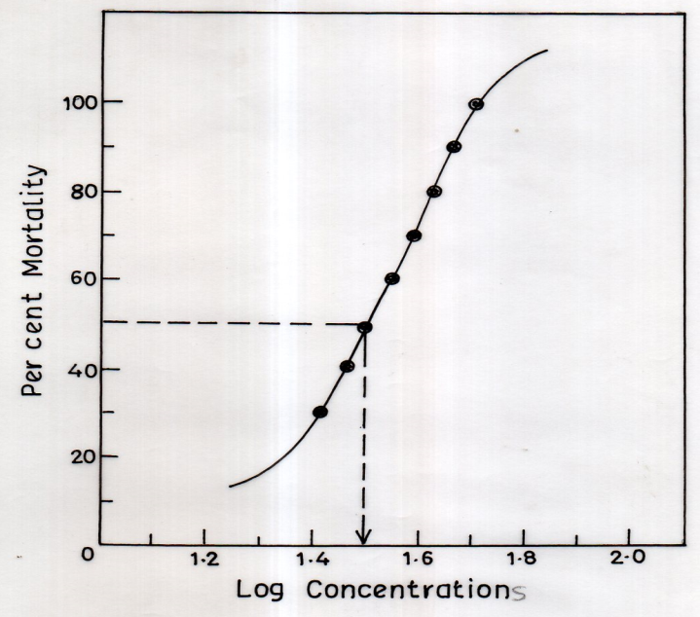
Fig.1 (b)

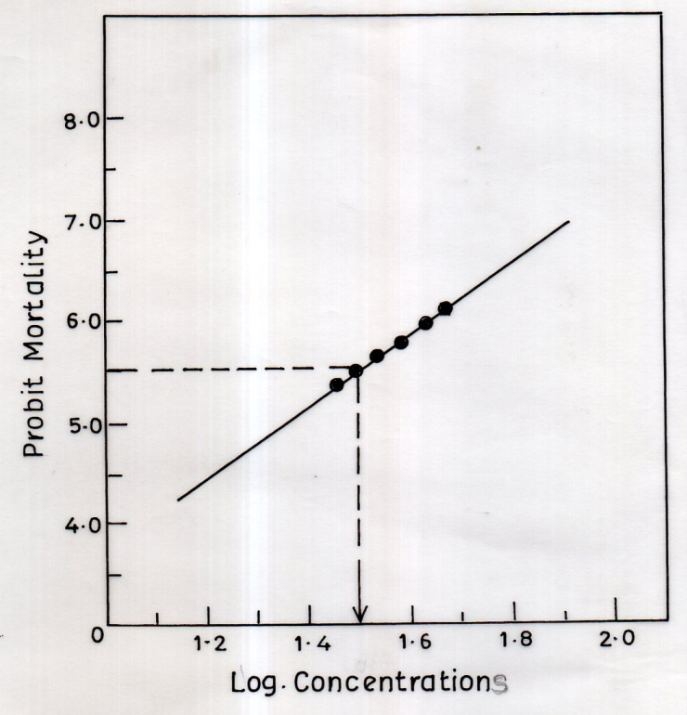

Fig. 1 (a&b) Probit for the percent mortality of freshwater fish, Channa punctatus exposed to varying concentrations of a common laundry detergent, Ariel for 96 h under laboratory conditions.
Fig.2

Fig. 2 Effects of Ariel detergent on superoxide dismutase (SOD) activity in liver and gill tissues of freshwater fish, Channa punctatus. Fish were exposed to 1/5th of 96h LC₅₀ concentration (6.4 ppm) for a period of 7 and 14 days. All the values are mean±SD of six individual observations. The values marked with ‘‘asterisk’’ are significantly different from corresponding controls as evaluated by the ANOVA followed by Student-Newman-Keuls (SNK) post hoc test (p<0.05).
Fig. 3
Fig. 3 Effects of Ariel detergent on catalase (CAT) activity in liver and gill tissues of freshwater fish, Channa punctatus. Fish were exposed to 1/5th of 96h LC₅₀ concentration (6.4 ppm) for a period of 7 and 14 days. All the values are mean±SD of six individual observations. The values marked with ‘‘asterisk’’ are significantly different from corresponding controls as evaluated by the ANOVA followed by Student-Newman-Keuls (SNK) post hoc test (p<0.05).
Fig. 4
Fig. 4 Effects of Ariel detergent on xanthine oxidase (XO) activity in liver and gill tissues of freshwater fish, Channa punctatus. Fish were exposed to 1/5th of 96h LC₅₀ concentration (6.4 ppm) for a period of 7 and 14 days. All the values are mean±SD of six individual observations. The values marked with ‘‘asterisk’’ are significantly different from corresponding controls as evaluated by the ANOVA followed by Student-Newman-Keuls (SNK) post hoc test (p<0.05).
Fig. 5

Fig. 5 Effects of Ariel detergent on glutathione peroxidase (GPx) activity in liver and gill tissues of freshwater fish, Channa punctatus. Fish were exposed to 1/5th of 96h LC₅₀ concentration (6.4 ppm) for a period of 7 and 14 days. All the values are mean±SD of six individual observations. The values marked with ‘‘asterisk’’ are significantly different from corresponding controls as evaluated by the ANOVA followed by Student-Newman-Keuls (SNK) post hoc test (p<0.05).
Fig. 6

Fig. 6 Effects of Ariel detergent on glutathione reductase (GRd) activity in liver and gill tissues of freshwater fish, Channa punctatus. Fish were exposed to 1/5th of 96h LC₅₀ concentration (6.4 ppm) for a period of 7 and 14 days. All the values are mean±SD of six individual observations. The values marked with ‘‘asterisk’’ are significantly different from corresponding controls as evaluated by the ANOVA followed by Student-Newman-Keuls (SNK) post hoc test (p<0.05).
Fig. 7

Fig. 7 Effects of Ariel detergent on glutathione-s-transferase (GST) activity in liver and gill tissues of freshwater fish, Channa punctatus. Fish were exposed to 1/5th of 96h LC₅₀ concentration (6.4 ppm) for a period of 7 and 14 days. All the values are mean±SD of six individual observations. The values marked with ‘‘asterisk’’ are significantly different from corresponding controls as evaluated by the ANOVA followed by Student-Newman-Keuls (SNK) post hoc test (p<0.05).
Fig. 8

Fig. 8 Effects of Ariel detergent on glutathione (GSH) levels in liver and gill tissues of freshwater fish, Channa punctatus. Fish were exposed to 1/5th of 96h LC₅₀ concentration (6.4 ppm) for a period of 7 and 14 days. All the values are mean±SD of six individual observations. The values marked with ‘‘asterisk’’ are significantly different from corresponding controls as evaluated by the ANOVA followed by Student- Newman-Keuls (SNK) post hoc test (p<0.05).
Fig. 9

Fig. 9 Effects of Ariel detergent on MDA levels in liver and gill tissues of freshwater fish, Channa punctatus. Fish were exposed to 1/5th of 96h LC₅₀ concentration (6.4 ppm) for a period of 7 and 14 days. All the values are mean±SD of six individual observations. The values marked with ‘‘asterisk’’ are significantly different from corresponding controls as evaluated by the ANOVA followed by Student-Newman-Keuls (SNK) post hoc test (p<0.05).

Fig.10 (a) Liver
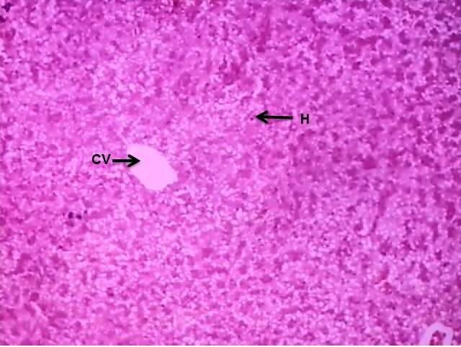 | 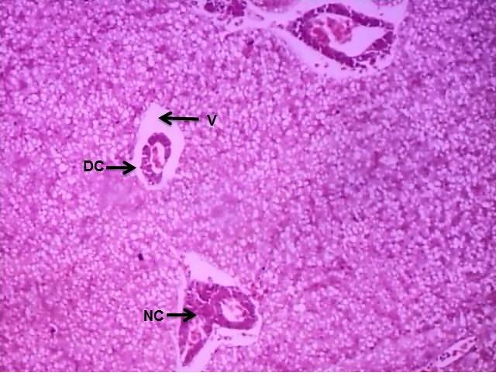 | 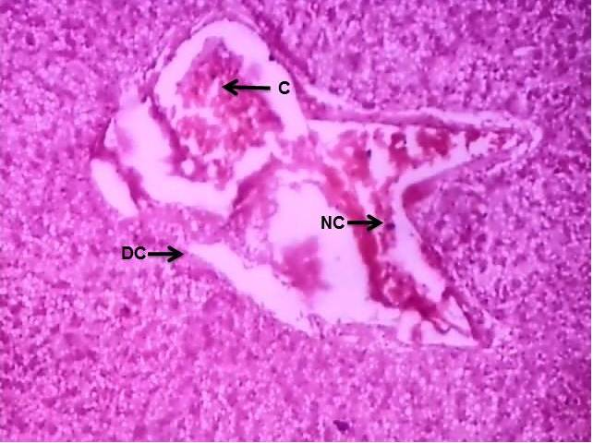
Control | 7 days Exposure | 14 days Exposure
Fig. 10 (b) Gills
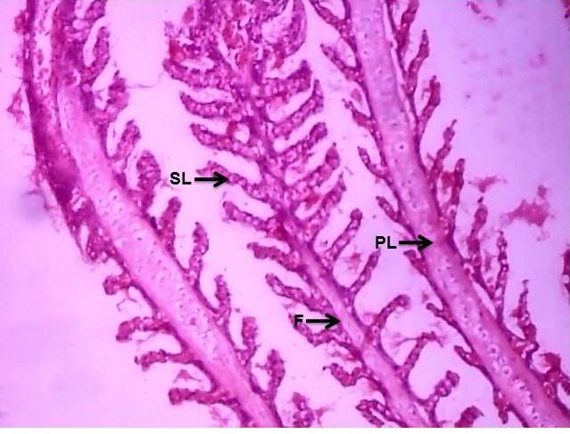 | 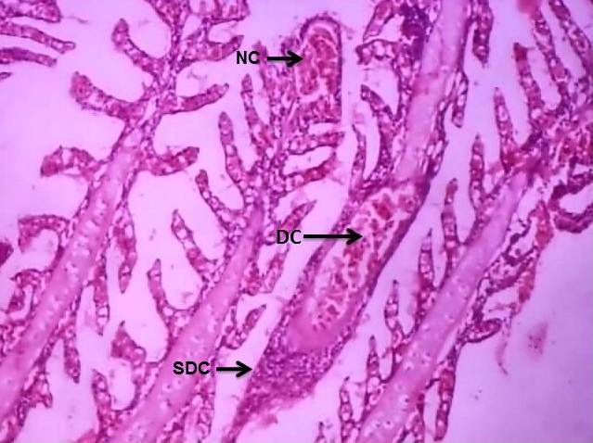 | 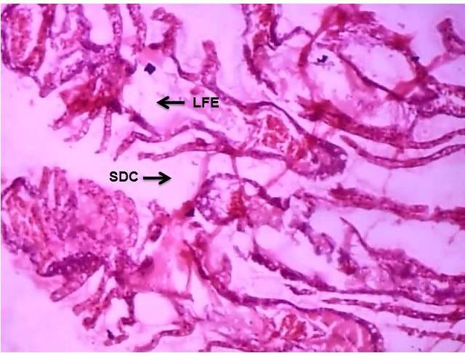
Control | 7 days Exposure | 14 days Exposure

Fig. 10 (a&b) Histograms of liver (a) and gill (b) tissues of freshwater fish, Channa punctatus. Fish were exposed to 1/5th of 96h LC₅₀ concentration (6.4 ppm) for a period of 7 and 14 days. All the values are mean±SD of six individual observations. The values marked with ‘‘asterisk’’ are significantly different from corresponding controls as evaluated by the ANOVA followed by Student-Newman-Keuls (SNK) post hoc test (p<0.05). [C=Congestion; CV=Central Vein; DC=Degenerative Changes; H=Hepatocytes; NC=Necrotic Changes; V=Vacuolization].

