Advancing sustainable entrepreneurship through digital innovation: a systematic review

Abstract
Sustainable entrepreneurship, as a vital model for development, seeks to balance environmental, social, and economic objectives. This goal, however, is increasingly influenced by the profound pressures and opportunities of the digital transformation. Addressing this dynamic requires the adoption of innovative digital approaches within sustainable business models and their supporting ecosystems. In this article, we conduct a systematic literature review of 350 papers published from 2014 to 2024 to analyze the significance of digitalization and innovation in promoting sustainable entrepreneurship. Bibliometric and thematic analysis tools were used to identify main trends, key contributors, emerging issues, and critical research gaps. Our results indicate a rapidly growing integration of digital technologies within the framework of sustainable entrepreneurship. The research landscape reveals that core themes revolve around innovation, the creation of sustainable business models, and the direct impact on environmental and social performance. Our findings underscore the necessity for a comprehensive, interdisciplinary approach that combines technological adoption with entrepreneurial strategy. Various mediating factors, such as stakeholder engagement, digital capabilities, and supportive government policies, were identified as essential in enhancing the impact of digitalization on sustainable outcomes. Our findings offer significant actionable insights, guiding researchers toward underexplored areas and providing policymakers with recommendations for the design of innovation policies to support the next wave of sustainable ventures.
Keywords: Sustainable Entrepreneurship, Digital Transformation, Innovation, Sustainability, Business Models, Systematic Review, Bibliometric Analysis.
1. Introduction
The accelerating environmental, social, and economic challenges of the twenty-first century have profoundly reshaped the way entrepreneurship is conceived and practiced. Within this evolving context, the concept of sustainable entrepreneurship (SE) has emerged as a dynamic paradigm that redefines the traditional profit-oriented logic of entrepreneurship by embedding social equity and environmental stewardship alongside economic performance (Rosário et al., 2022). Sustainable entrepreneurship thus represents a systemic transformation in entrepreneurial thought and practice, one that aims to generate shared value extending beyond financial returns to encompass societal and ecological well-being (Terán-Yépez et al., 2020).
Over the past two decades, sustainable entrepreneurship has evolved from a niche idea into a central pillar of global economic and policy discourse. Its growing prominence has been reinforced by major international initiatives such as the Paris Agreement and the 2030 Agenda for Sustainable Development, as well as by the proliferation of green economy frameworks advocating the integration of sustainability principles into business models and operations (Alkaraan et al., 2024). These initiatives have reoriented business ecosystems toward the simultaneous pursuit of profitability, social inclusion, and environmental protection, thereby positioning entrepreneurship as a pivotal driver of sustainable transformation (Cardella et al., 2020).
At the theoretical level, sustainable entrepreneurship draws upon Elkington’s Triple Bottom Line (TBL) framework, which conceptualizes sustainability through three interdependent dimensions: economic viability, social justice, and environmental preservation (Elkington, 1998). However, despite an emerging consensus around this triadic logic, the concept of SE remains fluid and context-dependent. Scholars have approached it from multiple disciplinary perspectives, ranging from innovation management and strategic entrepreneurship to sustainability transitions and ecological economics, leading to considerable variation in definitions, analytical frameworks, and empirical applications. This multidimensionality reflects both the richness and the conceptual complexity of the field (Dias et al., 2019).
A growing body of research emphasizes that the distinctive feature of sustainable entrepreneurship lies in its dual mission orientation: it simultaneously seeks to capture market opportunities while addressing pressing social and environmental challenges (Breuer et al., 2018). In this view, SE is understood as a process of opportunity recognition and exploitation within ecological and social boundaries, where entrepreneurs act as institutional change agents and sustainability leaders. In contrast, translating this vision into practice requires the development of new business logics, governance structures, and innovation processes capable of reconciling economic growth with resource efficiency and social inclusiveness (Mrad & Boujelbène, 2024).
Within this evolving landscape, innovation, and more specifically, digital innovation, has emerged as a decisive enabler of sustainable entrepreneurship. Digital technologies such as artificial intelligence (AI), blockchain, the Internet of Things (IoT), cloud computing, and big data analytics are transforming how firms design, produce, and deliver sustainable solutions. These technologies enable transparent supply chains, data-driven sustainability reporting, optimized resource management, and new forms of value creation through platform-based and circular business models (Gupta et al., 2023; Hlady-Rispal & Schneider, 2018). They further empower small and medium-sized enterprises (SMEs) and start-ups to scale sustainable solutions more effectively by lowering transaction costs and facilitating global collaboration (Mrad et al., 2019).
Digital innovation thus operates both as a means and an accelerator of sustainable entrepreneurship. As a means, it provides the technological infrastructure necessary for environmental efficiency, social inclusion, and long-term resilience (Holzmann & Gregori, 2023). As an accelerator, it drives systemic transformation across industries by reshaping value chains and altering competitive dynamics. Nevertheless, the interplay between digital innovation and sustainable entrepreneurship remains complex and nonlinear, involving intricate interdependencies among technology adoption, organizational culture, entrepreneurial orientation, and institutional frameworks.
From a policy perspective, integrating digital innovation into sustainability-oriented entrepreneurship constitutes both a challenge and an opportunity. Governments and international organizations increasingly acknowledge the necessity of digital sustainability policies that leverage technological transformation to advance environmental and social goals (Page et al., 2021). However, disparities in digital infrastructure, innovation capacity, and regulatory adaptability continue to hinder the scalability of sustainable digital ventures in many regions. Consequently, understanding the mechanisms through which digital innovation fosters sustainable entrepreneurship has become not only a theoretical imperative but also a strategic policy priority (Moher et al., 2009).
Despite the growing scholarly attention to both digital innovation and sustainable entrepreneurship, the existing literature remains fragmented. Most systematic reviews and bibliometric studies have examined these concepts in isolation, focusing either on the technological dimension of entrepreneurship or on the sustainability aspect of innovation (Trapp & Kanbach, 2021). The intersection between the two, digital sustainable entrepreneurship has only recently begun to crystallize as a distinct domain of inquiry. This conceptual gap constrains our understanding of how digital transformation processes enhance the sustainability performance of entrepreneurial ventures and how digital ecosystems can be structured to promote sustainable business creation (Mrad et al., 2025).
Accordingly, the present study seeks to bridge this gap by conducting a comprehensive analysis of the relationship between digital innovation and sustainable entrepreneurship. Specifically, it aims to identify the mechanisms, fields of action, and mediating factors through which digital innovation fosters sustainability-oriented entrepreneurship. The following research questions guide this investigation:
• What role does digital innovation play in promoting sustainable entrepreneurship?
• How has the relationship between digital innovation and sustainable entrepreneurship been addressed in the literature?
• Through which mediating factors can digital innovation enhance the sustainability of entrepreneurial ventures?
This study contributes to the literature in three main ways. First, it synthesizes and systematizes the dispersed body of research connecting digital innovation and sustainable entrepreneurship, thereby establishing a conceptual foundation for future research. Second, it identifies the technological, organizational, and institutional enablers that underpin the digital transition of sustainable ventures. Third, it provides actionable insights for policymakers and practitioners seeking to harness digital tools in advancing sustainability objectives.
By addressing these aims, this research seeks to advance theoretical and practical understanding of how digital transformation can act as a catalyst for sustainable entrepreneurship. It also contributes to the broader discourse on the digitalization of the green economy and the transformation of entrepreneurial ecosystems toward sustainability. In doing so, the study not only fills a notable gap in academic literature but also offers strategic guidance for policymakers and business leaders aiming to align digital innovation with sustainable development priorities.
This article is structured as follows. The next section outlines the methodological framework adopted for the study, including the literature selection process and analytical procedures. The subsequent section presents and interprets the main findings, highlighting emerging research patterns and thematic orientations. These findings are then discussed in light of existing scholarship to identify conceptual gaps, converging perspectives, and promising avenues for future research. Finally, the conclusion summarizes the key insights and underscores their implications for both academic inquiry and policy formulation within the field of sustainable, innovation-driven, and blue economy development.
Table 1: Overview of Key Previous Literature Studies on Sustainable Entrepreneurship and Digital Innovation
Study Focus | Key Findings | Methodology | Implications
Sustainable Entrepreneurship in SMEs | Identified six thematic clusters: sustainable entrepreneurial orientation, performance, innovation and networks, sustainable business models, commitment to sustainability, and green entrepreneurship/circular economy. | Systematic literature review of 206 articles using bibliographic coupling and co-citation. | Provides a comprehensive understanding of SE in SMEs and highlights potential future research avenues.
Digital Sustainable Entrepreneurship Model Innovation | Explored the intersection of sustainability and lean innovation approaches contributing to SDGs. | Qualitative analysis of digital entrepreneurs’ perspectives. | Proposes a framework supporting sustainable business model innovation.
Digital Economy, Entrepreneurial Activities, and Sustainable Development | Emphasized the strategic role of digital innovation in fostering sustainable economic growth and addressing global challenges. | Systematic Literature Review (SLR). | Encourages the creation of inclusive digital policies and institutional frameworks.
Digital Technologies in Entrepreneurship | Examined the influence of digital technologies on business operations and sustainability initiatives. | Extensive literature review. | Provides insights into opportunities and challenges of adopting digital technologies.
Digitalisation and Sustainable Entrepreneurship | Identified major themes including digital innovation and societal/environmental impacts of digitalisation. | Bibliometric analysis using Scopus data. | Highlights the need to broaden research scope and investigate emerging subdomains.
Digital Entrepreneurship and Technological Innovation | Established technological innovation as a key driver of digital entrepreneurship, emphasizing digital skills. | Systematic Literature Review of 76 papers. | Offers a realistic view of digital entrepreneurship’s impact on economic prosperity.
Digital Transformation and Sustainable Development Goals | Identified key technologies and approaches enhancing innovation, transparency, and inclusion. | Descriptive review of 22 empirical studies. | Stresses the importance of multidisciplinary collaboration and institutional support.
Digital Entrepreneurship and Sustainable Innovation | Demonstrated how entrepreneurship fosters sustainable innovation capability through organizational commitment. | Questionnaire survey with 378 valid responses. | Provides insights into the mechanisms enabling sustainable innovation.
Green Entrepreneurship and Digitalization | Explored how digital transformation promotes green practices, efficiency, and innovation. | Bibliometric analysis using Web of Science data. | Suggests future research paths in green entrepreneurship and digitalization.
Digital Technologies in Sustainable Business Models | Highlighted both the opportunities and limitations of adopting digital technologies in sustainable ventures. | Comparative case study of 10 born-sustainable ventures in Mexico. | Offers a Global South perspective and practical lessons for sustainable digital entrepreneurship.
2. Methods
2.1. Methodological approach
This study adopts a bibliometric analysis approach to explore the relationship between sustainable entrepreneurship and digital innovation. Bibliometric analysis was chosen because it enables a quantitative and systematic mapping of the existing research landscape, offering insights into publication trends, influential sources, co-authorship networks, and thematic evolution (Page et al., 2021). Following the PRISMA 2020 protocol to ensure transparency in data selection, the analysis proceeded through three main stages: identification, screening, and bibliometric evaluation using specialized software tools.
In the identification phase, the research questions were operationalized to enable the broadest possible retrieval of relevant academic studies. This stage involved defining precise search terms, selecting reliable academic databases, and applying appropriate Boolean operators to ensure comprehensive coverage. During the selection phase, the retrieved records were systematically screened against predefined inclusion and exclusion criteria to ensure their alignment with the research objectives and methodological rigor. Finally, in the analysis phase, relevant information from the eligible studies was extracted, synthesized, and interpreted to identify dominant themes, emerging trends, and persistent gaps within the literature.
Through this process, the review provides a comprehensive and integrative understanding of how digital innovation supports sustainable entrepreneurship, both conceptually and empirically. It further underscores the evolution of the field, its interdisciplinary foundations, and the mechanisms through which digital technologies enable sustainability-oriented entrepreneurial practices.
2.2. Inclusion and search criteria
To ensure methodological rigor, the Scopus database was selected as the primary source of data collection. Scopus is widely recognized for its broad interdisciplinary coverage and inclusion of high-impact, peer-reviewed journals, making it particularly suitable for research on cross-cutting domains such as sustainability, entrepreneurship, and digital transformation. Compared with other databases such as Web of Science or IEEE Xplore, Scopus provides greater comprehensiveness, metadata accessibility, and citation linkage, thereby enhancing the validity, transparency, and reproducibility of systematic reviews.
The literature search was conducted in August 2024, using a combination of keywords and Boolean operators designed to capture studies situated at the intersection of sustainable entrepreneurship, digitalization, and innovation. The final search query was formulated as follows:
TITLE-ABS-KEY ("sustainable entrepreneurship" OR "green business" OR "eco-entrepreneurship" OR "social entrepreneurship") AND ("digitalization" OR "digital transformation" OR "technology adoption" OR "e-business") AND ("innovation" OR "startups" OR "business model" OR "value creation") AND ("sustainability" OR "environmental impact" OR "corporate social responsibility" OR "CSR")
To refine the search results and ensure quality and relevance, several filtering criteria were applied sequentially:
- Publication period: 2014–2024 (to capture the most recent and relevant developments following the acceleration of digital transformation and the rise of the sustainability agenda after the UN 2014 SDGs).
- Document type: Only peer-reviewed journal articles, excluding conference proceedings, book chapters, editorials, and review papers.
- Language: English only, to maintain consistency and accessibility.
- Subject areas: Environmental science, business, management, social sciences, and economics. Technical disciplines such as engineering or materials science were excluded to focus on socio-economic and managerial perspectives.
- Exclusion filters: Articles primarily focused on Covid-19 impacts, rural development, or specific regional case studies (e.g., Africa, India, Indonesia, China) were excluded when they did not address the research scope.
After iterative refinements and exclusion of duplicates, 514 relevant records were identified. Following the screening process described below, the final dataset included 350 unique articles for further thematic and bibliometric analysis.
Table 2. Criteria for article inclusion
Criteria | Description
Database | Scopus
Publication type | Peer-reviewed journal articles
Years of publication | 2014–2024
Language | English
Subject areas | Environmental science, business, management, economics, social sciences
Geographical scope | No restriction
Core focus | Sustainable entrepreneurship and digital innovation as primary or secondary research themes
2.3. Screening and analysis
The initial list of 464 records was screened through a two-stage process.
In the first screening stage, titles and abstracts were reviewed to exclude studies that did not meet the inclusion criteria. This led to the removal of conceptual notes, meta-analyses, and studies unrelated to digital innovation or sustainability-oriented entrepreneurship. In the second stage, the full texts of the remaining articles were examined in detail to evaluate their conceptual and empirical contributions.
Following this process, 350 articles were retained as the final dataset. These studies were then subjected to qualitative content analysis to extract key information such as research focus, methodology, findings, and theoretical frameworks. Bibliometric indicators (e.g., publication trends, thematic clusters, keyword co-occurrence) were also used to map the intellectual structure of the field and identify emerging subdomains.
To ensure reliability, the screening and coding were performed independently by two researchers. A 10% random subset of articles was double-checked for consistency. Any discrepancies in inclusion or classification were discussed until consensus was achieved.
This analytical process provides a comprehensive and validated overview of the academic landscape at the intersection of digital innovation and sustainable entrepreneurship, forming the basis for the thematic synthesis and discussion presented in the subsequent sections.
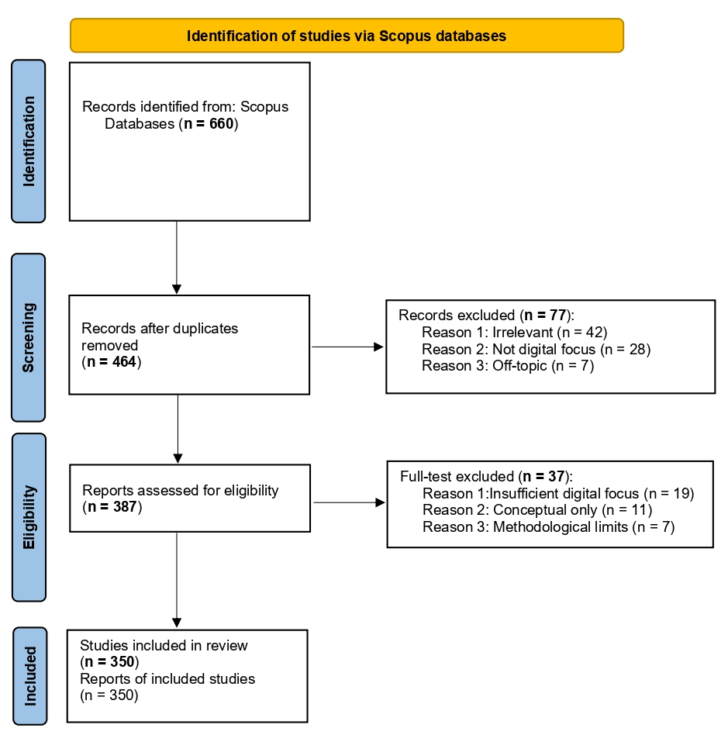
Fig. 1 The searching and screening process
3. Results
Based on the previous section, we will first conduct a descriptive analysis of the retrieved articles, by considering the trends, the temporal and the geographical distribution, as well as the methodological approaches used, followed by a content analysis to assess the main research topics examined in the literature.
3.1 Overview of selected papers
3.1.1 Trend in volume of publications
Table 3 provides a comprehensive descriptive overview of the articles reviewed. The study analyzed 350 documents published in 171 sources, exhibiting a robust annual growth rate of 55.25%, and an average citation count of 18.88 per document. These articles were authored by 1171 contributors with an average co-authorship of 6.24 authors per document, and involved 31.43% international co-authorships. This proportion requires further examination by geographical distribution to assess its concentration and potential research silos.
Table 3: Descriptive statistics of the analyzed articles
Description | Results
MAIN INFORMATION ABOUT DATA
Timespan | 2014:2024
Sources (Journals, Books, etc) | 171
Documents | 350
Annual Growth Rate % | 55,25
Document Average Age | 2,62
Average citations per doc | 18,88
References | 2923
DOCUMENT CONTENTS
Keywords Plus (ID) | 881
Author's Keywords (DE) | 1137
AUTHORS
Authors | 1171
Authors of single-authored docs | 0
AUTHORS COLLABORATION
Single-authored docs | 0
Co-Authors per Doc | 6,24
International co-authorships % | 31,43
DOCUMENT TYPES
article | 229
book chapter | 69
conference paper | 36
review | 16
Articles related to our research question started to be published in 2016, with a significant increase occurring between 2020 and 2024 (Fig. 2). During this period, these articles accounted for 88% of total publications, averaging 70 articles per year. This exponential trend indicates that the scientific community's interest in the link between digital innovation and sustainable entrepreneurship is relatively recent, and is situated more generally in an international context marked by the acceleration of digital transformation, the urgency of climate action, and progress towards the Sustainable Development Goals. Journals such as "Sustainability", "Journal of Cleaner Production", and "Journal of Social Entrepreneurship" have placed particular emphasis on this link (Fig. 3).
Fig. 2 Trends in annual publications on digital innovation and sustainable entrepreneurship
Fig. 3 Production of the most relevant sources over time
3.1.2 Geographic distributions and institutions
The geographical dimension of the articles, reflected by countries’ scientific contribution, collaborations between countries, authors' affiliations, funding institutions, and case studies, shows a strong concentration and a predominant position of China, the United States, and Western European nations (Fig. 4). The intensity of the color corresponds to the volume of contributions, while lighter shades signify lower publication activity. In relation to collaborations between these countries, Fig. 4 shows that while China and the USA have higher publication volumes, a strong academic cooperation network exists between them and with European partners (UK, Germany, Netherlands). Through this academic network, these clusters can enhance sustainable entrepreneurship by facilitating knowledge sharing, promoting technological innovations, and addressing common sustainability challenges.
Studies on the digital innovation-sustainable entrepreneurship nexus are mainly conducted by authors affiliated to "Tsinghua University","University of Oxford", and "Stanford University" (Table 4). They are mainly funded by the National Natural Science Foundation of China, a key promoter of innovative research and the advancement of socio-economic knowledge. Other funding comes from the EU through programs and institutions such as "Horizon 2020 research and innovation program", "European Commission", and national research councils. These funding bodies recognize the importance of research and innovation in tackling common challenges facing sustainable development.
Nearly half of the articles focus on China (46%), while 32% are devoted to regions in North America and Western Europe, 12% cover the international arena, 5% concern countries in Asia-Pacific (excluding China), and 5% refer to individual countries or emerging markets.
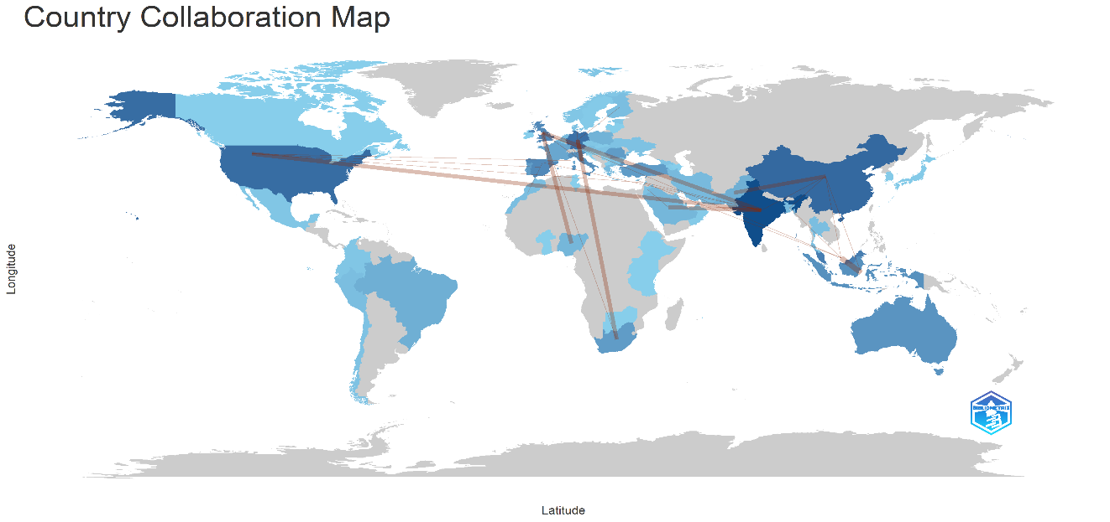
Fig. 4 Scientific production and collaboration by country
A more detailed analysis was conducted to identify the most influential documents in our research domain. The analysis revealed several key publications that are distinguished by their substantial citation counts, suggesting their structuring role in the advancement of scientific work in this field (Table 4). These works often provide foundational concepts or empirical evidence that subsequent research builds upon.
Table 4: Top 10 most globally cited documents
Paper | Total Citations | TC per Year | Normalized TC
TERÁN-YÉPEZ, 2020, J. CLEAN. PROD. | 286 | 47,67 | 5,01
GREGORI, 2020, J. CLEAN. PROD. | 240 | 40,00 | 4,20
CARDELLA, 2020, FRONT. PSYCHOL. | 230 | 38,33 | 4,03
DIAS, 2019, J. RURAL. STUD. | 165 | 23,57 | 4,19
BREUER, 2018, INT. J. ENTREP. VENTUR. | 163 | 20,38 | 3,85
GUPTA, 2023, TECHNOL. FORECAST. SOC. CHANG. | 124 | 41,33 | 8,10
HOLZMANN, 2023, INT. J. INF. MANAG. | 120 | 40,00 | 7,84
ALKARAAN, 2024, BUS. STRATEGY ENVIRON. | 119 | 59,50 | 17,42
TRAPP, 2021, J. CLEAN. PROD. | 117 | 23,40 | 4,00
HLADY-RISPAL, 2018, INT. J. MANAG. REV. | 115 | 14,38 | 2,72
In our analysis of the research areas explored, we examined the thematic evolution of keywords. This analysis was conducted using Bibliometrix software, with the results illustrated in Fig. 5. The positioning of various themes is based on their developmental status (Density) and influence (Centrality). The figure reveals four distinct clusters: (1) Motor themes, such as "entrepreneur, sustainability, innovation", which are well-developed and central to the field; (2) Niche themes, such as "business, commerce, competitiveness", which are highly developed but more specialized; (3) Basic themes, including "social entrepreneurship, economic and social effects", which are foundational and growing in importance; and (4) Emerging themes, such as "bibliometric techniques", which reflect the field's ongoing effort to synthesize its knowledge base.
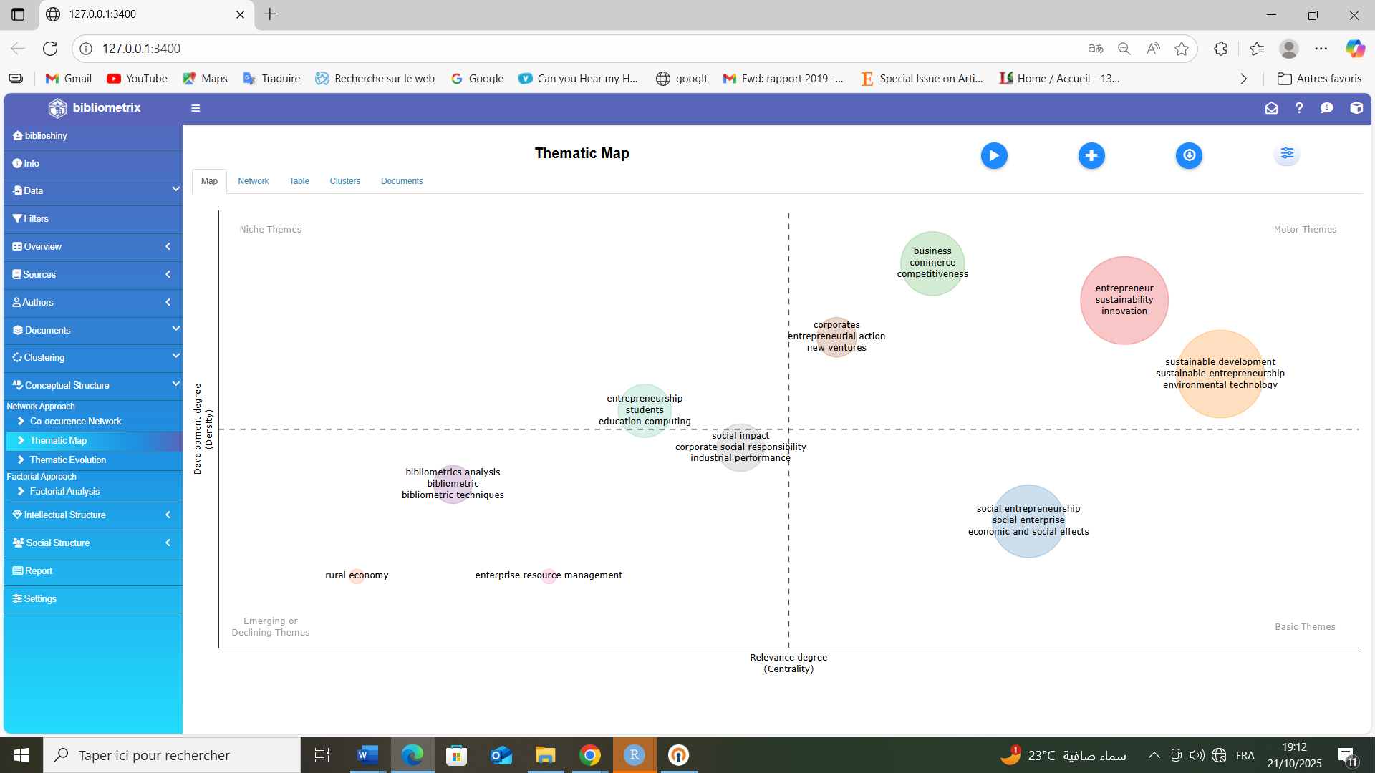
Fig. 5 Thematic evolution map
3.1.3 Top influential authors
A more detailed analysis using VOSviewer software was conducted to identify the most influential authors in our research domain. The analysis revealed three main authors, namely Patrick Gregori, Pankaj Sharma, and Maria Principato. These authors are distinguished not only by their substantial citation count (45 within our database) but also by their central position in the citation network (Fig. 6), suggesting their structuring role and significant influence in the advancement of scientific work in this field.
Co-citation analysis of authors is further conducted to track pairs of authors who are cited together in a third research document. Specifically, this analysis offers valuable insights into the intellectual structure of a research field. Fig. 7 illustrates the presence of five clusters of authors that are closely linked in the literature, either through collaboration, thematic similarity, or mutual influence. The leading authors in these clusters are: Gregori (green cluster - business models), Sharma (red cluster - digital platforms), Kumar (blue cluster - green technology), Holzmann (yellow cluster - research frameworks), and Yordanova (purple cluster - implementation barriers).
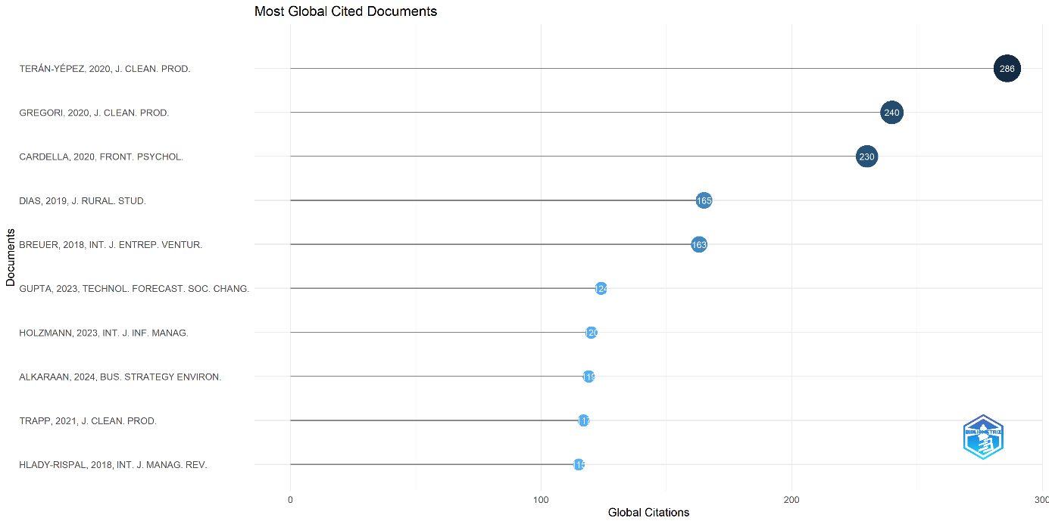
Fig. 6 Authors' citation analysis

3.1.4 Methodological approaches
Regarding the methodology, the articles reviewed employed a diverse range of approaches, including quantitative (65%), qualitative (25%), and mixed methods (10%). Quantitative methods include structural equation modeling (SEM), panel data analysis, regression models, and machine learning applications. The qualitative methods used include thematic and content analysis, multi-case studies, in-depth interviews, and Delphi methods. Mixed methods combine surveys with thematic analysis to provide triangulation. This diversity of methods reflects the complexity of this research subject, requiring the use of a variety of methods and, in some cases, their combination to provide a more comprehensive understanding and ensure the reliability of the results obtained.
3.1.5 Conceptual structure and thematic evolution
In our analysis of the research areas explored, we examined the keywords used by the authors. Due to their synthetic nature, these keywords provide a clearer indication of the primary themes and concepts underlying our research focus. This analysis was conducted using VOSviewer software, with the results illustrated in Fig. 6. The size of the nodes represents the frequency of occurrence of the keywords, while the distances between the nodes reflect the various interconnections among these terms. The figure reveals four distinct clusters:
- Sustainable entrepreneurship, which emphasizes business models, circular economy, and triple bottom line integration; (2) Digital transformation, highlighting AI, IoT, blockchain, and platform economy; (3) Sustainability outcomes, focusing on environmental impact, SDGs, and social performance; (4) Stakeholder dynamics, stressing collaboration platforms, ecosystem governance, and policy frameworks.

Fig. 7 Keywords co-occurrence networks
3.2 Digital innovation in sustainable entrepreneurship: perspectives from academic literature
This section is dedicated to the thematic analysis of the retrieved articles. This analysis enabled the classification of the articles into three primary themes: sustainable business model innovation, digital platforms for stakeholder synergies, and environmental technology. These themes primarily pertain to the areas of action through which digital innovation can enhance the sustainability of entrepreneurial ventures.
3.2.1 Sustainable business model innovation
The articles reviewed indicate that digital innovation is a primary catalyst for the development of new sustainable business models. Entrepreneurs leverage digital tools to embed sustainability into their core value proposition. This can result in a concentration of innovation activities that are facilitated by effective knowledge diffusion and a high absorption capacity for new technologies. Digitalization allows for the creation of circular economy models, data-driven efficiency improvements, and enhanced product-service systems. Blockchain technology enables transparent supply chains and trust-based transactions, while AI-powered platforms facilitate dynamic pricing and resource optimization in sharing economy models.
3.2.2 Digital platforms for stakeholder synergies
This subsection examines innovative approaches that use digital platforms to align economic development with social and environmental goals. Digital platforms are a critical factor for the success of sustainable ventures by enabling communication and collaboration among diverse stakeholders. These platforms can transform challenges into opportunities by creating transparent supply chains, fostering inclusive communities, and connecting social entrepreneurs with resources. Examples include B2B platforms for green procurement, crowd funding sites for sustainable startups, and data-sharing consortia for collective impact measurement. The preservation of trust and data security is of considerable importance for the effectiveness of these platforms, particularly in multi-stakeholder governance contexts.
3.2.3 Environmental technology
The reviewed articles indicate that the adoption of specific environmental technologies is a key enabler for green business. This includes AI for energy optimization and predictive maintenance, IoT for precision resource management and real-time monitoring, and big data analytics for lifecycle assessment and environmental impact tracking. These technological innovations are recognized as a key factor in market competitiveness and the promotion of sustainable development. Research indicates that the strategic adoption of green technology serves as a significant lever for sustainable growth, contributing to both environmental protection and economic viability through reduced operational costs, enhanced regulatory compliance, and improved brand reputation.
4. Discussion
This study provides the first comprehensive review of the scientific literature on the relationship between digital innovation and sustainable entrepreneurship. This review revealed that the role of digitalization lies in its ability to mitigate the negative impact of human activity on the environment, to decouple growth from resource overexploitation, and to foster progress in green and social ventures.
Our findings reveal that this relationship is complex and multifaceted. Consequently, several authors have employed mediating factors to clarify this connection. Specifically, these factors include green technology, innovative business models, high-quality digital talent, research, and sustainable financing modes. Complementary support factors are also identified to assist these mechanisms, as illustrated in Fig. 8.
The multidimensional nature of this relationship further underscores the diversity of the levers of action necessary to maximize the positive impacts of innovation. On the economic level, innovation contributes to high-quality development and competitiveness. On the environmental level, innovation enhances the sustainability of ecosystems through greater efficiency and circularity. On the social level, it helps ensure social equity and inclusive working conditions.
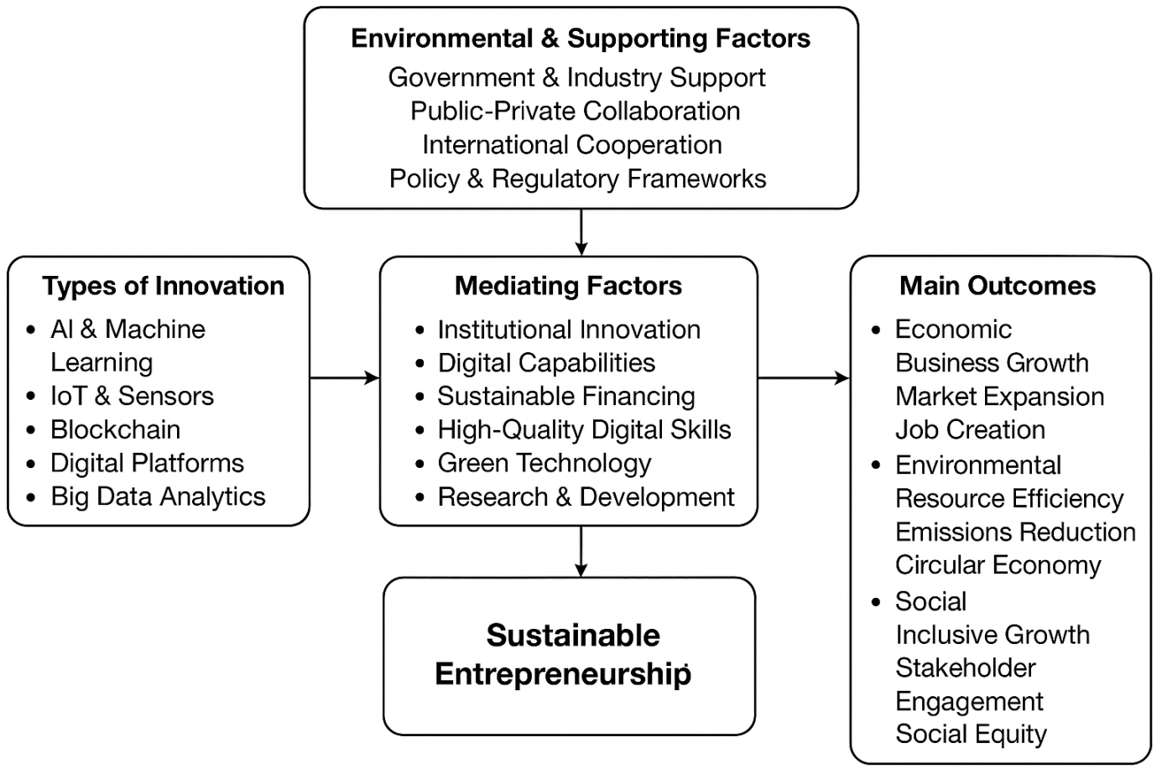
Fig. 8 Key mechanisms linking digital innovation to sustainable entrepreneurship sustainability
Overall, our review revealed that innovation acts as a driving force for sustainable entrepreneurship; in contrast, several challenges hinder its full exploitation, notably market dynamics and capacity gaps, such as a shortage of human capital and skills, inadequate information exchange among stakeholders, and societal resistance to new technologies. In this sense, a more inclusive and participatory approach, involving governments, businesses, local communities, and scientists, could mitigate these challenges.
6. Conclusion
This study closely examines a growing research topic, namely the relationship between digital innovation and sustainable entrepreneurship, by conducting a rigorous, in-depth literature review of the scientific papers published during the period 2014–2024. This review shows that attention and interest in this relationship have emerged relatively recently, beginning in 2020, mainly in response to challenges related to climate change and the growing commitment to sustainable development goals.
Our results extend our understanding of how digital innovation can affect sustainable development by identifying key mediating factors and supporting elements. These factors primarily include sustainable financing modes, green technology, data-driven research, and high-quality talent. To optimize their potential effects, these factors can essentially be supported by government support, stakeholder collaboration, and international cooperation.
This study provides significant actionable and policy implications. For governments, our research emphasizes the need to adopt comprehensive digital and sustainable strategies. For industries, promoting collaboration among various stakeholders is highly recommended to advance innovation. For researchers, our study underscores the importance of enhancing academic collaborations between the Global North and the South.
Future research should explore emerging technologies, such as AI ethics and Digital Twin technology, for sustainability. In addition, it is essential to fill the geographical gaps currently observed in the literature by devoting more attention to underrepresented regions whose specific dynamics could enrich the overall understanding of the link between innovation and sustainable entrepreneurship.

5. Limitations and future research
The analysis of these publications has allowed for the identification of several gaps that may lead to new research perspectives. First, the analysis revealed a notable geographical disparity in the level of contribution, with the prevalence of China and Western countries. African and South American countries are underrepresented and receive little scientific attention.
Second, beyond the USA and Europe, academic collaborations remain weak. Strengthening cooperation between countries is of primary importance to foster the sharing of knowledge, innovative practices, and the development of solutions adapted to local realities.
Third, our study has enabled the identification of various types of digital innovation. However, some innovations remain either unexplored or underexplored. Specifically, research on the "dark side" of digitalization, such as e-waste and the energy consumption of data centers, has received little attention. Additionally, one aspect of social innovation that has not been deeply explored is the innovation of behavioral and social norms in the digital era.
Fourth, at the sectoral level, few studies have been devoted to specific sectors. Emerging sectors like green fintech, sustainable agritech, and circular fashion deserve greater attention to fill the gaps in the literature.
Fifth, the results of our study are highly associated with the restrictions defined at the beginning of the study regarding language and the database. These limitations are inherent to the method adopted. The keywords used in our research may not be exhaustive. Additionally, the restriction of our investigation to the Scopus database, although rigorous, may reduce the scope of the results obtained.

References:
Alkaraan, F., Albitar, K., Hussainey, K., & Venkatesh, V. G. (2024). Reinforcing green business strategies with Industry 4.0 and governance towards sustainability: Natural-resource-based view and dynamic capability. Business Strategy and the Environment. Advance online publication. https://doi.org/10.1002/bse.3665
Belgaroui, R., Shili, A (2025). Extending the Theory of Planned Behaviour to Understand Entrepreneurial Intention Among Female University Students in Saudi Arabia: The Role of Entrepreneurship Education. Journal of Posthumanism 5(5):4226-4246. DOI: 10.63332/joph.v5i5.1897
Breuer, H., Finke, N., & Lideka, A. (2018). Exploring the link between business model innovation and sustainable performance: An empirical study on German manufacturing firms. International Journal of Entrepreneurial Venturing, 10(3), 251–273. https://doi.org/10.1504/IJEV.2018.092715
Cardella, E., Falco, A. L., Nehring, M., & Ventimiglia, L. R. (2020). Entrepreneurial education matters: Exploring the relationship between entrepreneurial education and resilience in higher education students. Frontiers in Psychology, 11, Article 15557. https://doi.org/10.3389/fpsyg.2020.01557
Dias, C. S. L., Rodrigues, R. G., & Ferreira, J. J. (2019). The relationship between entrepreneurial ecosystems and the performance of sustainable startups: A systematic literature review and research agenda. Journal of Rural Studies, 68, 106–119. https://doi.org/10.1016/j.jrurstud.2018.11.003
Elkington, J. (1998). Cannibals with forks: The triple bottom line of 21st-century business. New Society Publishers. (No DOI; book)
Gregori, P., & Holzmann, P. (2020). Digital sustainable entrepreneurship: A business model perspective on embedding digital technologies for social and environmental value creation. Journal of Cleaner Production, 272, Article 122817. https://doi.org/10.1016/j.jclepro.2020.122817
Gupta, S., Qian, X., Bhushan, B., & Matsui, Y. (2023). The impact of corporate social responsibility on financial performance: Evidence from India. Technological Forecasting and Social Change, 188, Article 122152. https://doi.org/10.1016/j.techfore.2022.122152
Hlady-Rispal, M., & Schneider, B. P. (2018). Corporate social responsibility in developing countries as an emerging field of study. International Journal of Management Reviews, 20(1), 4–24. https://doi.org/10.1111/ijmr.12112
Holzmann, P., & Gregori, P. (2023). The promise of digital technologies for sustainable entrepreneurship: A systematic literature review and research agenda. International Journal of Information Management, 68, Article 102593. https://doi.org/10.1016/j.ijinfomgt.2022.102593
Moher, D., Liberati, A., Tetzlaff, J., Altman, D. G., & PRISMA Group. (2009). Preferred reporting items for systematic reviews and meta-analyses: The PRISMA statement. PLoS Medicine, 6(7), Article e1000097. https://doi.org/10.1371/journal.pmed.1000097
Mrad, M., & Boujelbène, Y. (2019). An improved neural approaches for forecasting demand in supply chain management. International Journal of Computer Applications, 975, 8887. https://doi.org/10.5120/ijca2019918766
Mrad, M., & Boujelbène, Y. (2024). Multilayer perception neural networks method-based supply chain performance prediction by a new augmented of SCOR® metrics: SCOR®4.0. 2024 IEEE 15th International Colloquium on Logistics and Supply Chain Management (LOGISTIQUA). https://doi.org/10.1109/LOGISTIQUA61063.2024.10571519
Mrad, M., Frikha, M. A., & Boujelbene, Y. (2025). A comprehensive survey of artificial intelligence and robotics for reducing carbon emissions in supply chain management. Logistics, 9(3), Article 104. https://doi.org/10.3390/logistics9030104
Page, M. J., McKenzie, J. E., Bossuyt, P. M., Boutron, I., Hoffmann, T. C., Mulrow, C. D., Shamseer, L., Tetzlaff, J. M., Akl, E. A., Brennan, S. E., Chou, R., Glanville, J., Grimshaw, J. M., Hróbjartsson, A., Lalu, M. M., Li, T., Loder, E. W., Mayo-Wilson, E., McDonald, S., ... Stewart, L. A. (2021). The PRISMA 2020 statement: An updated guideline for reporting systematic reviews. BMJ (Clinical Research ed.), 372, Article n71. https://doi.org/10.1136/bmj.n71
Saadaoui, S., Belgaroui, R (2013). Social entrepreneurship: concept clarification. International Conference on Business, Economics, Marketing & Management Research (BEMM’13)Volume Book: Economics & Strategic Management of Business Process (ESMB).
Belgaroui, R., Ben Hamad, S (2021). The Good Practices of Academic Autonomy as Mechanism of Governance and Performance of Higher Education Institutions: Case of the University of Sfax. International Journal of English Literature and Social Sciences 6(1):177-184. DOI: 10.22161/ijels.61.20
Terán-Yépez, E., Marín-Carrillo, G. M., del Pilar Casado-Belmonte, M., & de las Mercedes Capobianco-Uriarte, M. (2020). Sustainable entrepreneurship: Review of its theoretical dimensions and the influence of contextual factors. Journal of Cleaner Production, 261, Article 119742. https://doi.org/10.1016/j.jclepro.2019.119742
Trapp, C. T. C., & Kanbach, D. K. (2021). Green entrepreneurship and business models: Deriving green technology business model archetypes. Journal of Cleaner Production, 297, Article 126694. https://doi.org/10.1016/j.jclepro.2021.126694

Rosário, A. T., Raimundo, R. J., & Cruz, S. P. (2022). Sustainable entrepreneurship: A literature review. Sustainability, 14(9), 5556.

