Navigating Dual Roles: The Experiences of Single-Parent Teachers in Balancing Work and Family Life

.
ABSTRACT

This qualitative phenomenology study explores the unique experiences faced by single-parent educators in managing the demands of both their professional and personal lives. Conducted among 10 public elementary and secondary school teachers, and identified as single parents in the Division of Davao del Sur, the study sheds light on how these educators navigate their dual roles. Through in-depth interviews, the research identifies three main themes that highlight the difficulties faced by single-parent teachers: work-related time constraints, mental, emotional and physical exhaustion, and the challenges in managing limited resources and responsibilities. The study also delves into the strategies employed by single-parent teachers to balance their responsibilities, including effective time management techniques, maintaining efficient familial communication, creating a personal support system, and using internet platforms and technology for communication and lesson delivery. Furthermore, in terms of support needed, the study identified three key areas that could significantly improve the work-life balance of single-parent teachers. These include the institutional support for single-parent teachers, financial aid programs, and empowering single-parent teachers through support and development. Participants highlighted areas such as flexible work arrangements, financial assistance, access to childcare, and mentorship programs as crucial for reducing their burdens and enhancing their overall well-being. The study underscores the emotional resilience required by single-parent teachers to balance the competing demands of work and family life. The findings highlight the importance of supportive policies and resources to help single-parent teachers thrive in both their professional and personal lives, ultimately contributing to their success and well-being.

Keywords: Single-Parent Teachers, Work-Life Balance, Educational Challenges, Experiences, Phenomenology

1. INTRODUCTION
Balancing professional and personal responsibilities is particularly challenging for single-parent teachers, affecting both classroom performance and emotional well-being. This is a global issue, as studies in the United States, Spain, and Mexico highlight high stress levels, burnout, and societal pressures faced by single-parent educators (Duncan & Brooks-Gunn, 2016; Gordon, 2018; Harris & Dempsey, 2021).
In the Philippines, single-parent teachers encounter similar difficulties, navigating work-life balance amid financial constraints, limited support systems, and cultural expectations (Bartolome et al., 2017; Reyes & Rojas, 2020; López & Castañeda, 2016). In Davao del Sur, these challenges are further compounded by time management pressures, emotional strain, and inadequate community support, including affordable childcare (Fajardo & Dela Cruz, 2018; Galaven & Villocino, 2024). Understanding their experiences is crucial for designing interventions and policies that promote teacher well-being and improve student outcomes.

2. MATERIALS AND METHODS
Research Design
This study employed a qualitative phenomenological research design to explore the lived experiences of single-parent teachers in balancing classroom responsibilities and family life (Pilarska, 2021; Tomaszewski et al., 2020; Williams, 2021). Phenomenology focuses on understanding the essence of human experiences, examining behavior, attitudes, emotions, and life contexts (McGregor, 2020; Davidov & Russo-Netzer, 2022; Van Manen, 2023). Data analysis followed Creswell’s (2013) structured approach: data preparation, initial review, coding, theme development, interpretation, and validation through member checking or triangulation.
Locale and Period of the Study
The study was conducted in public elementary and secondary schools in the Division of Davao del Sur during the first quarter of 2025. Davao del Sur, located in southeastern Mindanao, is culturally diverse and agriculturally rich. DepEd Davao del Sur oversees public schools, promoting inclusive education, improving teaching outcomes, and integrating technology in learning.

Figure 1. Geographical Location of Davao del Sur
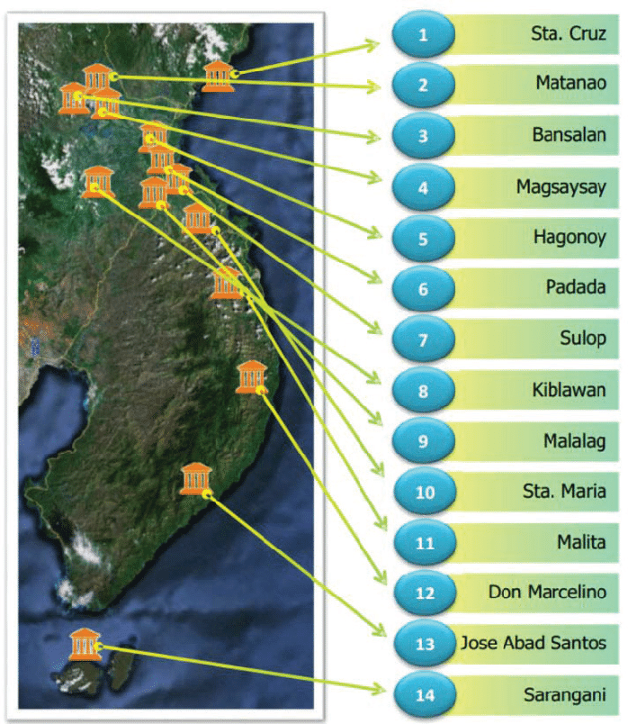

Research Participants
The study involved 10 public school teachers identified as single parents. This sample size aligns with Lewis (2015) and the principle of data saturation (Hennink & Kaiser, 2022; Moura et al., 2021; Yang & Zhang, 2022). Inclusion criteria required participants to be professional public teachers, assigned for at least one year, and single parents. Participation was voluntary, and participants could withdraw at any time without coercion.
Sources of Data and Instruments
Data were collected through semi-structured in-depth interviews (IDIs) with the 10 key informants. Questions focused on challenges, coping mechanisms, support needs, and recommendations. Interviews were transcribed immediately after recording.
Data Collection Procedure
The researcher obtained endorsements from the Graduate School Dean and Schools Division Superintendent, and sought approval from School Heads before contacting participants. Participants provided written consent and were briefed on ethical considerations, including confidentiality, voluntary participation, and the right to withdraw. Interviews lasted 30–60 minutes, conducted either in person or online. Audio recordings and transcripts were securely stored, and participants verified transcript accuracy. Follow-up meetings ensured the findings accurately reflected participants’ experiences.

3. results and discussion

This section comprises the presentation, analysis and interpretation of the data gathered from the study. Results and discussions are presented according to the problems of this study. The interview started by discussing the single-parents’ challenges in balancing classroom responsibilities and family life, ways of managing time and resources to fulfill professional and personal roles, support single-parent teachers need to improve work-life balance, and insights of single-parent teachers.

Lived Experiences in Balancing Classroom Responsibilities and Family Life

Teachers who are single parents have the particular difficulty of juggling the demands of their classroom duties with their personal family's requirements. Stress and emotional strain can increase when lesson planning, student participation, and administrative responsibilities are juggled with parenting and housework. In order to shed knowledge on how single-parent teachers attempt to balance conflicting priorities and preserve both professional performance and family well-being, this study explored the daily challenges they face.
Out of the responses from the participants of the study, four essential themes were drawn from the transcripts, as follows: 1) Work-related time constraints; 2) Mental, emotional and physical exhaustion; and 3) Challenges in managing limited resources and responsibilities.

Work-related Time Constraints

As they attempt to balance their professional and home obligations, single-parent teachers usually face substantial time-related stress. Structured timetables, long workdays, and the requirement to oversee extracurricular activities, administrative duties, and continuous student involvement are characteristics of the teaching profession. There is limited opportunity for parental and personal responsibilities under these expectations.
For single-parent educators, who frequently lack the support of a partner to share parenting responsibilities, the intricate junction between work and home life becomes even more apparent. According to research by Kim and Wang (2016), time-based conflict is a major factor in work-family imbalance, particularly for those who provide care. In occupations like teaching, where emotional labor and workload can affect personal life, this mismatch is exacerbated. The participant's sentiment is consistent with Allen and Kiburz's (2015) research, which showed that a lack of time and competing role expectations can make it difficult for a person to provide their best effort in either area, which frequently results in burnout or a decline in wellbeing.
Additionally, some academic periods—like exam weeks or grading periods—require more time and effort, which further strains single-parent teachers. Such times of greater work pressure are highly associated with higher levels of work-to-family conflict, especially for educators who do not
have personal support networks or flexible work schedules, according to Wang and Walumbwa (2021).
Teachers' psychological well-being and familial relationships are impacted by these time constraints in addition to their professional performance. Teachers who are under constant time pressure may be less satisfied with their jobs, be more stressed, and be less emotionally present at home (Yildirim, 2016). The fact that single-parent teachers have to constantly balance conflicting obligations without the advantage of joint household support makes matters worse.

Mental, Emotional and Physical Exhaustion

Teachers who are single parents often endure physical, mental, and emotional strain as they balance the demands of both teaching and parenting alone. The ongoing strain to care for their children and fulfill work obligations can result in burnout, exhaustion, and a decline in wellbeing.
Being a teacher and a single-parent are two extremely difficult jobs that single-parent instructors frequently find themselves juggling. Without the assistance of a co-parent, they must continually balance running classrooms and attending to their kids' needs, which can lead to severe mental, emotional, and physical exhaustion. Over time, the burden of these obligations becomes too much to bear, which frequently results in burnout and a sharp deterioration in general wellbeing. According to one participant, they feel overburdened with work and under stress, which is a reflection of the compounding nature of their daily responsibilities.
This lifestyle has a particularly high emotional cost. It is well recognized that teachers generally experience significant levels of occupational stress as a result of their workload, emotional labor, and rising performance expectations (Travers, 2017). These strains are exacerbated for single-parent teachers by the need to balance the psychological demands of their job with being emotionally present to their kids. Feelings of guilt, powerlessness, and even self-pity may arise from this. One participant highlighted the emotional vulnerability that frequently accompanies their everyday experience by stating, "very stressful on my part as a single parent and feel pity on self."
Another effect of cognitive stress from continuous multitasking is mental weariness. Managing parenting, lesson planning, student conduct, and administrative responsibilities might leave little time for self-care or recuperation. Another participant said that feeling overburdened and anxious from juggling two obligations encapsulates the mental strain that hinders their capacity to perform well in either capacity. One of the fundamental aspects of burnout, according to Maslach and Leiter (2016), is emotional weariness, which is especially common in occupations involving caregiving and education.
Physically, chronic exhaustion, sleep deprivation, and health problems can result from overlapping responsibilities that prevent rest and recuperation. In order to balance the demands of both professions, single-parent instructors frequently report compromising their physical health and sleep. Another teacher pointed out that this can lead to a lot of tension and anxiety in my days, which makes it hard for me to concentrate on work and parenting. This emphasizes how long-term physical and emotional stress impairs focus and performance in both areas.
Additionally, studies indicate that burnout impacts teachers individually as well as their connections with students and their own children, which may have an impact on academic and family results (Skaalvik & Skaalvik, 2017). Single-parent teachers continue to face the possibility of long-term psychological and physical harm in the absence of adequate institutional interventions or emotional support, which eventually compromises their efficacy and general well-being.
These results highlight the critical need for systemic support systems, like as wellness initiatives, mental health services, and more accommodating work schedules, to promote the overall wellbeing of educators who are single parents. In order to support their personal resilience and maintain the kind of education they offer; it is imperative that their particular challenges be acknowledged.

Challenges in Managing Limited Resources and Responsibilities

Single-parent teachers face significant challenges in balancing classroom responsibilities and family life. These educators operate within a dual role that demands not only time and energy but also the efficient management of constrained financial and emotional resources. With no partner to share the load, they must navigate the competing demands of lesson planning, classroom instruction, grading, student supervision, and administrative tasks while also managing household duties, parenting, and financial obligations. This constant juggling of responsibilities—often with minimal support—places them at a higher risk of burnout, emotional exhaustion, and reduced professional effectiveness.
Research supports these lived experiences. According to Mason and Gould (2020), single-parent educators frequently encounter resource scarcity—both financial and temporal—that limits their capacity to perform effectively in either role. Their study found that time poverty is a central challenge, as single-parent teachers often sacrifice personal time, self-care, or instructional preparation to meet the urgent demands of parenting. Similarly, Peters and Rios (2021) highlighted that the lack of institutional and familial support systems exacerbates the pressure on single-parent educators, who are forced to multitask continuously without relief. This tension can result in feelings of inadequacy, stress, and isolation.
Moreover, Cheng and Roberts (2019) argued that the intersection of limited financial resources and overwhelming professional duties contributes to a reduced quality of life, leading many single-parent teachers to experience chronic stress and difficulty maintaining work-life boundaries. Their findings indicate that without adequate financial and emotional support, single-parent teachers often prioritize one role at the expense of the other, which impacts their well-being and effectiveness.
More recently, Kumar and Valdez (2023) examined the struggles of educators with caregiving responsibilities and found that managing limited resources—such as time, money, and support—often leads to decision fatigue and emotional overload. They emphasize the need for school systems to provide targeted support, such as flexible scheduling or counseling services, to help mitigate the disproportionate burden on single-parent teachers.
In summary, the challenge of managing limited resources—both tangible and intangible—intensifies the stress experienced by single-parent teachers. These challenges are not only personal but also systemic, requiring more empathetic policies and practical interventions from educational institutions to support their dual responsibilities effectively.
Figure 2. Lived Experiences in Balancing Classroom Responsibilities and Family Life

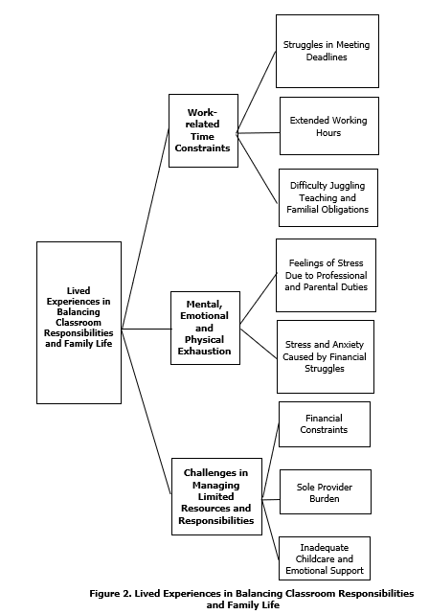

Strategies in Managing Time and Resources to Fulfill
Professional and Personal Roles

Efficient time and resource management is crucial for people who are trying to balance the demands of their personal and professional lives. Strategic planning, prioritization, and flexibility are necessary to balance work and family obligations. This study examined the different ways people divide their time and make use of their resources in order to be productive at work while maintaining their personal health and taking care of their families.
Out of the responses from the participants of the study, four essential themes were drawn from the transcripts, as follows: 1) Effective time management techniques; 2) Maintaining efficient familial communication; 3) Creating a personal support system; and 4) Using internet platforms and technology for communication and lesson delivery.

Effective Time Management Techniques

Successful time management strategies are essential for people to successfully manage their personal and professional obligations. Organizing work, establishing priorities, and establishing routines can help teachers in particular feel less stressed and be more productive at home and in the classroom.
​ For educators, especially those juggling work and personal obligations, efficient time management is essential. Stress can be considerably decreased and productivity much increased by putting techniques like work prioritizing, organized scheduling, and defined boundaries into practice. One participant pointed out that setting priorities and determining what is most needed are crucial for handling everyday responsibilities.
Time management has a good effect on teachers' job happiness and performance, according to research. Secondary school teachers who successfully managed their time reported higher levels of job satisfaction, according to a study by Khan et al. (2020). In a similar vein, Sahito and Väisänen (2017) found that teacher educators who used effective time management strategies were more motivated and satisfied with their jobs.
It is also commonly known that effective time management leads to less burnout. Teachers' classroom management self-efficacy and burnout traits including emotional weariness and depersonalization are strongly correlated (Aloe et al., 2014). Teachers can reduce the risk of burnout by improving their self-efficacy through the adoption of efficient time management techniques.
Additionally, time management skills that help one balance work and personal life enhance general wellbeing. Bley (2015) looked at K–12 music teachers and discovered that those who were good at managing their time had a better work-life balance, which enhanced their job performance and sense of fulfillment.
Teachers are better equipped to handle the challenges of their job when time management techniques are incorporated into their daily routines. Teachers can balance their professional obligations with personal needs by prioritizing work, creating clear schedules, and keeping lines of communication open. This will ultimately lead to a more fulfilling and long-lasting career.

Maintaining Efficient Familial Communication

For people who are trying to strike a balance between their personal and professional obligations, maintaining effective family communication is essential, particularly in the family context. Even with hectic work schedules, clear, regular, and open communication helps manage expectations, plan daily tasks, and build relationships.
As demonstrated by the experiences of working educators, such as one participant who shared, communication strategies are not just about logistics; they are tools for maintaining relational health and work-life integration. In the context of work-life balance, especially for individuals who juggle demanding professional roles and family responsibilities, maintaining efficient and effective familial communication becomes a cornerstone of harmony and productivity. For teachers, especially those who are also primary caregivers or single parents, daily responsibilities can be overwhelming. Open, regular, and structured communication within the family not only helps manage household expectations but also fosters emotional stability and cooperative task management.
According to educators, family communication acts as a protective barrier against pressures brought on by work-life conflict. Effective communication in families promotes emotional intimacy and lessens miscommunication, which in turn increases psychological resilience in the face of outside stressors (Fincham & Cui, 2018). According to Nomaguchi and Milkie (2020), families can better organize routines when there is regular and open communication, particularly in homes where one or both parents have time-consuming jobs. Writing down tasks and prioritizing them—as one educator put it, "writing down the task needed and ranking them from highest to lowest priority"—can serve as a cognitive and relational strategy in these kinds of homes, defining roles and lowering anxiety over overlapping responsibilities.
Furthermore, effective communication techniques are frequently linked to proactive time management and thorough planning. Another participant reflected the simultaneous commitment to both professional quality and familial presence when they said, "making lesson planning, recording, and computation ahead of time and during late at night then attending family needs all the time." This is consistent with the findings of Shockley et al. (2017), who claim that the detrimental consequences of time-based work-family conflict are considerably mediated by communicative coordination of roles and expectations. They contend that the household runs more smoothly and that emotional stress is reduced when family members are aware of and participate in the scheduling process.
All things considered, working parents' real-life experiences highlight how crucial effective family communication is as a cornerstone tactic for juggling several responsibilities. Even in the face of the demands of a demanding career, people can create a more manageable and encouraging home environment by making deliberate efforts including setting priorities for tasks, having open communication with children, and having a common knowledge of obligations.

Creating a Personal Support System

Establishing a personal support network is crucial for people juggling the demands of their personal and professional lives. Having a solid support system of family, friends, and coworkers gives educators mental fortitude, useful help, and a feeling of community—especially in trying times.
It may be quite difficult to balance the demands of one's personal and professional lives, especially for those in in-demand professions like teaching. The strain of juggling work obligations and caring might be too much for educators, particularly those who are single parents. Establishing and preserving a solid personal support network is crucial in these circumstances. This network of friends, family, and coworkers may offer practical assistance, emotional fortitude, and a feeling of belonging, all of which are essential for managing stress and preserving work-life balance.
One participant's comment emphasizes the importance of family, especially extended family, in offering vital support and making sure that duties are divided during difficult times.
A strong support network has long been shown to have a significant impact on mental and emotional health. According to a study by Allen et al. (2017), workers who have strong social and personal support system report feeling less stressed and burned out because the assistance lessens the mental and physical strain of juggling work and family obligations. Having a solid network, whether it be through family or coworkers, helps educators, who frequently endure high levels of emotional labor, lessen the effects of occupational stress.
The capacity to prioritize work and establish limits is another crucial component of keeping a support system in place. Effectively managing one's obligations is crucial to preventing burnout, as one participant put priority on given tasks, setting boundaries and give quality time to personal priorities, setting boundaries and prioritizing tasks ensures can focus on work while dedicating quality time to personal responsibilities. These behaviors protect the time and energy required for family life and personal well-being in addition to promoting productivity at work. This is corroborated by research by Greenhaus and Allen (2011), who claim that efficient time management and defined role boundaries are essential tactics for reducing work-family conflict.
Furthermore, especially in the early years of a child's life, the extended family plays a critical role in supporting child-rearing responsibilities. The responses of the participants illustrate how support networks are dynamic, with help from others being more intense during times of higher dependency and lessening as the child gains independence. Carlson et al. (2017) pointed out that this flexibility is essential for maintaining equilibrium over time, as the efficacy of work-family support is frequently dependent on shifting family requirements.
To sum up, creating a personal support network is essential for anyone juggling the responsibilities of both job and family. These networks, whether through professional assistance, family support, or teamwork among coworkers, offer the framework required to successfully negotiate the challenges of contemporary life and the workplace.

Using Internet Platforms and Technology for
Communication and Lesson Delivery

For educators who are trying to balance their work and personal obligations, using technology and online platforms for communication and lesson delivery has become crucial. In addition to providing flexibility and improving teaching effectiveness, these digital technologies enable educators to maintain relationships with students, parents, and coworkers outside of regular class times.
Digital technology and online platforms are becoming more and more important in education, especially for instructors who must balance their personal and professional commitments. Many educators find that technology provides a crucial solution to the time and workload constraints they frequently face, especially those who have caregiving responsibilities or complicated household dynamics, like single-parent instructors. Teachers can more effectively plan, carry out, and oversee their work while preserving meaningful relationships with students, parents, and coworkers outside of regular school hours by utilizing online communication tools and lesson delivery platforms.
The beneficial effects of technology on teaching methods are supported by recent research. Particularly in remote or hybrid contexts, digital tools have given teachers more flexibility over how they offer teaching, improved communication, and the ability to personalize learning experiences (Trust & Whalen, 2020). Teachers who are trying to manage their personal and professional lives will find this technological flexibility to be really helpful. This idea is supported by the study's participant responses. As an illustration of how digital tools reduce workload constraints, one instructor said that using technology at work is really beneficial because it makes work easier and reduces the amount of time needed to complete tasks.
Furthermore, social media sites like Facebook and Messenger have developed into unusual but really useful resources for business communication. Facebook Messenger and Facebook Messenger are excellent tools for communication and facilitate business, according to one participant. This is consistent with research by Greenhow and Chapman (2020), who found that social media platforms encourage collaborative participation and provide easily accessible avenues for communication between teachers, parents, and students when utilized appropriately. In addition to being affordable and easy to use, these platforms are mobile-friendly, enabling teachers to maintain connectivity even when they are not
on school property.
Furthermore, a number of educators stress how using online resources improves productivity and frees up more time for family time, which is crucial for people balancing teaching and child care. These testimonials, according to one instructor, are consistent with research by König et al. (2020), which found that teachers who were more proficient in digital skills were better equipped to adjust to online learning environments, enhancing work-life balance and lowering occupational stress.
When taken as a whole, these observations highlight how technology may revolutionize learning environments. By granting more authority over time and work management, it not only improves instructional efficiency but also promotes instructors' well-being. Digital platforms are essential support systems for educators juggling the demands of both job and home, in addition to being educational instruments.

Figure 3. Thematic Framework on Strategies in Managing Time and Resources to Fulfill Professional and Personal Roles

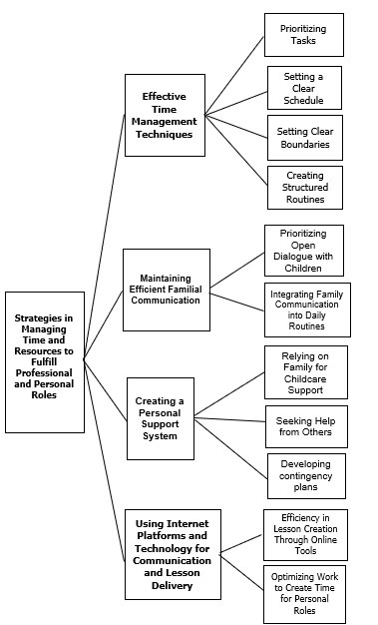

Needed Support of Single-parent Teachers to Improve Work-life Balance

Teachers who are single parents frequently encounter particular difficulties juggling the duties of their line of work with the obligations of raising a family alone. They need specific help in areas like flexible work hours, professional and emotional support, financial aid, and access to trustworthy daycare in order to attain a better work-life balance.
Out of the responses from the participants of the study, three essential themes were drawn from the transcripts, as follows: 1) Institutional Support for Single-Parent Teachers; 2) Financial Aid Programs; and 3) Empowering Single-Parent Teachers Through Support and Development.

Institutional Support for Single-Parent Teachers

Single-parent teachers face unique challenges in balancing their professional responsibilities with personal obligations. Institutional support plays a crucial role in helping them achieve a sustainable work-life balance.
Rivera and Martin (2024) conducted a study on university teacher-mothers with young children, revealing that these educators often experience conflicts between their teaching duties and parental responsibilities. The study emphasized the need for institutional support mechanisms, such as on-campus childcare facilities and flexible working hours, to alleviate these challenges.
Similarly, Aquino et al. (2023) explored the work-life balance of teacher-parents in the Philippines and found that institutional policies significantly impact their ability to manage professional and personal roles. The study highlighted the importance of supportive workplace environments and flexible scheduling to enhance teachers' well-being.
In the context of public elementary school teachers, Manalo and Velasco (2024) identified that various work-related factors influence their work-life balance. The study suggested that institutional support, including fair task distribution and strategic planning, is essential in helping teachers maintain a healthy balance between work and personal life.
Eloor and Menon (2024) reviewed the work-life balance of teachers and emphasized the importance of organizational support in mitigating work-related stress. The study recommended flexible work arrangements and professional development opportunities as effective strategies to promote a healthier work-life balance among educators.
Furthermore, Libit and Callo (2024) examined the role of instructional supervision practices in organizational performance and found that teachers' work-life balance significantly mediates this relationship. The study underscored the need for school leaders to support teachers in achieving work-life balance to enhance overall organizational performance.
These studies collectively underscore the critical role of institutional support in aiding single-parent teachers to navigate the complexities of their dual roles. Implementing family-friendly policies, providing flexible work options, and fostering supportive workplace environments are essential strategies to enhance the well-being and productivity of single-parent educators.

Financial Aid Programs

Single-parent teachers often face significant financial challenges as they strive to balance their professional responsibilities with the demands of raising children alone. Recognizing these difficulties, various financial aid programs have been implemented to provide essential support, helping these educators maintain a sustainable work-life balance.
The Philippine government has introduced several initiatives aimed at alleviating the financial burdens of public school teachers. For instance, the Department of Education (DepEd) has partnered with BDO Network Bank (BDONB) to offer financial literacy programs, enabling teachers to make informed decisions on budgeting, saving, and debt management. Such programs are particularly beneficial for single-parent teachers who may have limited financial resources.
Additionally, the Expanded Solo Parents Welfare Act (Republic Act No. 11861) provides single parents with various benefits, including a monthly cash subsidy of PHP 1,000 for those earning minimum wage or less, and educational benefits for their children. These provisions are crucial for single-parent teachers, as they help offset the costs associated with raising children while managing a teaching career.
Furthermore, the Philippine Public School Teachers Association (PPSTA) offers financial products tailored to educators. Programs such as the Sariling Sikap Loan Program provide low-interest loans with no collateral, which can be disbursed quickly and repaid through salary deductions. These financial aids are instrumental for single-parent teachers in addressing immediate financial needs without compromising their professional commitments.
Collectively, these financial aid programs play a pivotal role in supporting single-parent teachers, allowing them to focus on their dual roles as educators and caregivers. By alleviating financial stress, these initiatives contribute to improved job satisfaction and retention among single-parent teachers, ultimately benefiting the educational system as a whole.

Empowering Single-Parent Teachers Through Support and Development

Single-parent teachers often face complex challenges balancing their dual roles at work and at home, making empowerment through support and professional development essential to improving their work-life balance. Empowering single-parent teachers not only involves providing emotional and social support but also fostering opportunities for growth and skill enhancement that increase their confidence and job satisfaction. According to Rivera and Martin (2024), tailored professional development programs that address the specific needs of single-parent educators can significantly enhance their teaching efficacy and reduce feelings of isolation. By creating supportive networks and mentoring systems, schools can help single-parent teachers feel more connected and valued, which positively influences their overall well-being.
Moreover, Aquino et al. (2023) emphasized the importance of institutional initiatives that combine psychological support with capacity-building activities to empower single-parent teachers. These programs promote resilience by equipping teachers with coping strategies and time-management skills critical for managing stress both inside and outside the classroom.
Similarly, Manalo and Velasco (2024) found that empowerment through continuous training and inclusive school policies enables single-parent teachers to navigate professional demands more effectively, fostering a healthier balance between their work and family lives. Collectively, these findings highlight that empowering single-parent teachers through comprehensive support and development initiatives is vital in sustaining their motivation, performance, and personal well-being.

Figure 4. Needed Support of Single-parent Teachers to Improve Work-life Balance

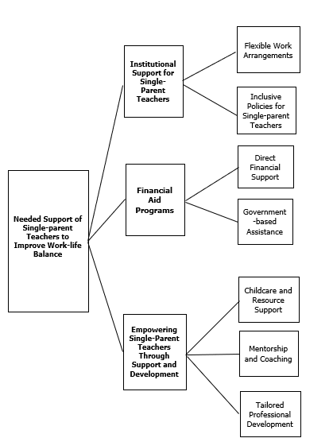

Insights of Single-parent Teachers

The insights of single-parent teachers offer valuable perspectives on the unique challenges they face in balancing the demands of their profession and family life. Their experiences shed light on the emotional, mental, and logistical hurdles encountered daily, as well as the strategies they use to manage these responsibilities.
Out of the responses from the participants of the study, two essential themes were drawn from the transcripts, as follows: 1) Teaching and being a single parent demand a high degree of emotional endurance; and 2) Personal techniques like prioritization and time blocking are necessary to balance obligations.

Teaching and Being a Single Parent Demand a High Degree of Emotional Endurance

As teachers must continually manage the emotional intricacies of their classroom tasks while taking on the obligations of raising children alone, both teaching and being a single parent require a high level of emotional endurance. Managing the requirements of students, fulfilling professional demands, and resolving personal issues can take an excessive emotional toll, which frequently results in stress and burnout.
Balancing the dual roles of educator and single parent demands significant emotional endurance. Teachers are required to navigate the complex emotional landscape of their classrooms, addressing diverse student needs and maintaining professional standards. Simultaneously, single parents must fulfill the multifaceted responsibilities of raising children independently. The convergence of these roles can lead to heightened stress levels and an increased risk of burnout.​
Research indicates that teachers often experience high levels of occupational stress due to factors such as workload, role ambiguity, and classroom management challenges. These stressors can result in emotional exhaustion, depersonalization, and a diminished sense of personal accomplishment, collectively known as burnout (Fiorilli et al., 2017). For single-parent teachers, the added pressures of sole childcare responsibilities can exacerbate these challenges, making effective coping mechanisms essential.​
Emotional intelligence (EI) has been identified as a critical factor in mitigating teacher burnout. A systematic review by Mérida-López and Extremera (2017) found that higher levels of EI are associated with lower burnout symptoms among educators. Teachers with elevated EI are better equipped to manage their emotions, navigate stress, and maintain positive interactions with students and colleagues. For single-parent teachers, enhancing EI can provide valuable tools to balance the emotional demands of both professional and personal roles.​
Resilience also plays a pivotal role in protecting teachers from chronic stress. De Vera García and Gambarte (2019) highlighted that resilience serves as a buffer against the adverse effects of prolonged stress, enabling teachers to adapt to challenges more effectively. Developing resilience can empower single-parent teachers to navigate the complexities of their dual responsibilities with greater ease and confidence.​
In the Philippine context, a study by Ebora and Calimutan (2020) explored the experiences of solo parent-teachers, revealing that while they find joy in financial independence and fulfilling their children's needs, they also face significant challenges such as financial strain, fatigue, and child discipline issues. These findings underscore the importance of tailored support systems that address the unique needs of single-parent educators.​
Implementing professional development programs focused on enhancing emotional intelligence and resilience can provide single-parent teachers with the skills necessary to manage stress effectively. Additionally, fostering a supportive work environment that acknowledges and accommodates their unique challenges can contribute to their overall well-being and professional satisfaction.
Personal Techniques Like Prioritization and Time Blocking are Necessary to Balance Obligations

For single-parent teachers to successfully manage their work and family commitments, personal strategies like time blocking and prioritization are crucial. They can lessen stress and make sure that both duties are performed by carefully planning their time, establishing clear priorities, and allocating specific blocks for professional and personal activities.
​Effective personal methods, particularly prioritization and time blocking, are necessary to balance the twin responsibilities of teaching and being a single parent. By using these strategies, people can set out particular times for their family and work commitments, guaranteeing that each receives enough attention. Single-parent instructors can more effectively manage their challenging duties by organizing their workload according to priority and urgency.
Setting priorities enables people to concentrate on high-impact activities first by evaluating tasks to ascertain their importance and due dates. This is complemented by time blocking, which reduces distractions and increases productivity by allocating predetermined time limits to particular tasks or groups of tasks. By putting these tactics into practice, everyday routines can become more regimented, which lessens the possibility that work will interfere with personal time and vice versa.
In a study published in 2019, Gellido and Epalan examined how parent-teachers dealt with juggling work and home obligations. According to the research, these instructors frequently use timelines and routines to arrange their schedules, allocating specific times for work or family. When unanticipated circumstances arise, they skillfully rearrange and rearrange assignments to meet new requirements. This strategy emphasizes how crucial flexibility and methodical planning are to juggling multiple responsibilities.
The work-family balance of school administrators who are single parents was also studied by Encila and Madrigal (2021). Their results demonstrated how important it is to manage time well, including scheduling and setting priorities, in order to spend quality time with kids without sacrificing work obligations. The study also found that coping strategies used by single parents to deal with everyday difficulties include looking for outside assistance and partaking in constructive pursuits.
Additionally, Lualhati (2019) highlighted that teachers who practice goal-setting, scheduling, and task prioritizing are better able to handle too much paperwork and interruptions, which results in more effective time usage and lower stress levels. These behaviors improve one's performance at work and help one lead a more balanced personal life.
Single-parent teachers can establish a systematic framework that balances their teaching and parenting commitments by implementing time blocking and prioritization into their daily routines. They may reduce stress, increase productivity, and make sure that neither part of their lives is neglected by deliberately allocating time and establishing clear priorities.

Figure 5. Thematic Framework on the Insights of Single-Parent Teachers

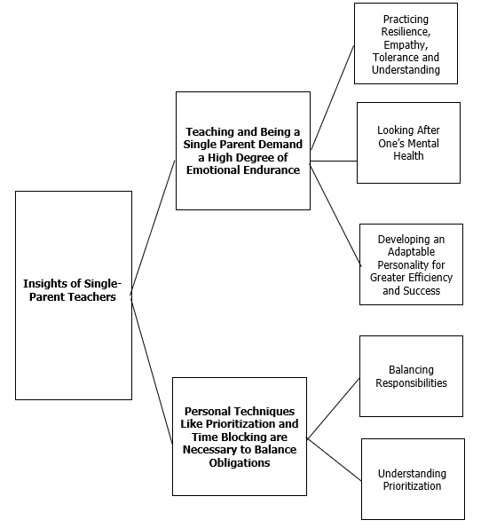

Consent

INFORMED CONSENT AND INTERVIEW GUIDE QUESTIONS

Dear Participants,

Greetings!

I am the Author, a student of Davao del Sur State College taking up Doctor of Philosophy in Education Management.

We are grateful that you agreed to participate in this study. Presently, we are conducting our study entitled: “Navigating Dual Roles: The Experiences of Single-Parent Teachers in Balancing Work and Family Life”.

In this interview, we will be asking relevant questions related to the study which basically about the experiences of single-parent teachers in the work field. This will take about 20 minutes.

Please be assured that any information that you provide will remain private.

Signature of the Participant: ___________________

Witness: __________________

Ethical approval
Ethical considerations were central to this study, guided by established standards of honesty, confidentiality, non-discrimination, and respect for participants (Horstkötter & de Wert, 2020; Bayley & Phipps, 2023; Friedrich-Nel & Ramlaul, 2020). Participants’ anonymity and confidentiality were ensured through the use of pseudonyms, secure storage of audio recordings and transcripts, and verification of transcriptions. Only confirmed data were included in the analysis, and all records were kept for three years before secure disposal.
Informed consent was obtained from all participants, detailing the study’s purpose, benefits, risks, and voluntary nature of participation. Participants could withdraw at any time without consequence. Interviews were conducted in safe, comfortable settings, either in person or virtually, and sensitive topics were approached with care.
The study’s social value lies in providing insights to improve support for single-parent teachers and inform educational policies. Transparency was maintained by allowing participants access to study results. The researcher’s qualifications as a professional single-parent teacher in the study locale strengthened credibility and understanding of participants’ experiences.

COMPETING INTERESTS DISCLAIMER:
Authors have declared that they have no known competing financial interests OR non-financial interests OR personal relationships that could have appeared to influence the work reported in this paper.

References

Aloe, A. M., Amo, L. C., & Shanahan, M. E. (2014). Classroom management self-efficacy and burnout: A multivariate meta-analysis. Educational Psychology Review, 26(1), 101–126. https://doi.org/10.1007/s10648-013-9244-0

Allen, T. D., Johnson, R. C., Kiburz, K. M., & Shockley, K. M. (2015). Work–family conflict and flexible work arrangements: Deconstructing flexibility. Personnel Psychology, 66(2), 345–376. https://doi.org/10.1111/peps.12012

Allen, T. D., & Kiburz, K. M. (2015). Trait mindfulness and work–family balance among working parents: The mediating effects of vitality and sleep quality. Journal of Vocational Behavior, 87, 230–238. https://doi.org/10.1016/j.jvb.2015.01.003

Allen-Revoredo, C., Ladera-Castañeda, M. I., Córdova-Limaylla, N. E., Briceño-Vergel, G., Cervantes-Ganoza, L. A., & Cayo-Rojas, C. (2022). Knowledge, attitudes, and practices on oral health prevention associated with sociodemographic factors of adolescent students from a Peruvian-Swiss educational institution. Journal of International Oral Health, 14(5), 475-486. https://journals.lww.com/jioh/fulltext/2022/14050/knowledge,_attitudes,_and_practices_on_oral_health.7.aspx

Bayley, J., & Phipps, D. (2023). Extending the concept of research impact literacy: levels of literacy, institutional role and ethical considerations. Emerald Open Research, 1(3). https://www.emerald.com/insight/content/doi/10.1108/eor-03-2023-0005/full/html

Bley, S. (2015). An examination of the time management behaviors and work-life balance of K-12 music educators. Bowling Green State University. https://www.proquest.com/openview/0c2f4e00a71853e65d28743b59ff14f4/1?pq-origsite=gscholar&cbl=18750

Creswell, J. W., & Poth, C. N. (2016). Qualitative inquiry and research design: Choosing among five approaches. Sage publications. https://books.google.com.ph/books?id=DLbBDQAAQBAJ&lpg=PP1&ots=-ir969IVVy&dq=Creswell%2C%20J.%20W.%20(2013).

Creswell, J. W. (2007). Research design: Qualitative, quantitative, and mixed methods approach (2nd ed.). Sage Publications. https://www.cambridgeenglish.org/Images/735110-studies-in-language-testing-volume-43.pdf#page=53

Davidov, J., & Russo-Netzer, P. (2022). Exploring the phenomenological structure of existential anxiety as lived through transformative life experiences. Anxiety, Stress, & Coping, 35(2), 232-247. https://doi.org/10.1080/10615806.2021.1921162

Dempsey, T. F. (2023). Teachers' experiences in navigating continuous professional development during the covid-19 pandemic. University of Johannesburg (South Africa). https://www.proquest.com/openview/3915eb4d48da03497427da0e2babe217/1?pq-origsite=gscholar&cbl=2026366&diss=y

De Vera García, M. I. V., & Gambarte, M. I. G. (2019). Resilience as a protective factor of chronic stress in teachers. European Journal of Investigation in Health, Psychology and Education, 9(3), 159–175. https://doi.org/10.30552/ejihpe.v9i3.332

Ebora, K. E. I., & Calimutan, J. M. (2020). Solitude: The joys, groans and hopes of solo parentteachers. Asia Pacific Journal of Multidisciplinary Research, 8(4). https://www.researchgate.net/profile/Karl-Ebora 2/publication/361806026_Solitude_The_Joys_Groans_and_Hopes_of_Solo_Parent-Teachers/

Encila, M. G. F., & Madrigal, D. V. (2021). Balancing work-family roles: The experiences of solo parent school administrators. Technium Soc. Sci. J., 20, 100. https://heinonline.org/HOL/LandingPage?handle=hein.journals/techssj20&div=10&id=&page=

Fernández Velasco, P. (2022). Disorientation and self-consciousness: a phenomenological inquiry. Phenomenology and the Cognitive Sciences, 21(1), 203-222. https://link.springer.com/article/10.1007/s11097-020-09659-1

Fiorilli, C., Albanese, O., Gabola, P., & Pepe, A. (2017). Teachers' emotional competence and social support: Assessing the mediating role of teacher burnout. Scandinavian Journal of Educational Research, 61(2), 127–138. https://doi.org/10.1080/00313831.2015.1119722

Fincham, F. D., & Cui, M. (2018). Romantic relationships in emerging adulthood. Cambridge University Press. https://books.google.com.ph/books?id=36qIAymTlPAC&lpg=PR11&ots=HidH8QsQye&dq=Fincham%2C%20F.%20D.%2C%20%26%20Cui%2C%20M.%20(2018).%20Romantic%20relationships%20in%20emerging%20adulthood.%20Cambridge%20University%20Press.&lr&pg=PR11#v=onepage&q&f=false

Friedrich-Nel, H., & Ramlaul, A. (2020). Ethical considerations. Medical Imaging and Radiotherapy Research: Skills and Strategies, 81-97. https://link.springer.com/chapter/10.1007/978-3-030-37944-5_6

Galaven, A. J. L., & Villocino, R. P. (2024). Against all odds: Probing the case of solo-parent teachers in raising the family alone. EPRA International Journal of Multidisciplinary Research (IJMR), 10(7). https://doi.org/10.36713/epra17839

Gellido, J. S., & Epalan, U. S. (2019). Time management strategies of parent teachers in a selected public high school: A phenomenological study. Ascendens Asia Journal of Multidisciplinary Research Abstracts, 3(2N). https://ojs.aaresearchindex.com/index.php/AAJMRA/article/view/11806

Greenhow, C., & Chapman, A. (2020). Social distancing meet social media: Digital tools for connecting students, teachers, and citizens in an emergency. Information and Learning Sciences, 121(5/6), 341–352. https://doi.org/10.1108/ILS-04-2020-0114

Greenhaus, J. H., & Allen, T. D. (2011). Work–family balance: A review and extension of the literature. In J. C. Quick & L. E. Tetrick (Eds.), Handbook of occupational health psychology (2nd ed., pp. 165–183). American Psychological Association. https://psycnet.apa.org/record/2010-06010-009

Hennink, M., & Kaiser, B. N. (2022). Sample sizes for saturation in qualitative research: A systematic review of empirical tests. Social Science & Medicine, 292, 114523. https://doi.org/10.1016/j.socscimed.2021.114523

Horstkötter, D., & de Wert, G. (2020). Ethical considerations (pp. 145-159). Springer International Publishing. https://link.springer.com/chapter/10.1007/978-3-030-36346-8_10

Johnson, J. L., Adkins, D., & Chauvin, S. (2020). A review of the quality indicators of rigor in qualitative research. American Journal of Pharmaceutical Education, 84(1), 7120. https://doi.org/10.5688/ajpe7120

Khan, I. A., Khan, U. A., & Khan, M. (2020). Relationship between time management practices and job satisfaction of secondary school teachers. Journal of Educational Research, 23(2), 51–63. https://jer.iub.edu.pk/journals/JER-Vol-23.No-2/5.pdf

Kim, H., & Wang, Y. (2016). Women's work-family conflict and career development perceptions. Family and Consumer Sciences Research Journal, 44(3), 231–246. https://doi.org/10.1111/fcsr.12143

König, J., Jäger-Biela, D. J., & Glutsch, N. (2020). Adapting to online teaching during COVID-19 school closure: Teacher education and teacher competence effects among early career teachers in Germany. European Journal of Teacher Education, 43(4), 608–622. https://doi.org/10.1080/02619768.2020.1809650

Lualhati, G. P. (2019). Time management practices of educators in a state university. PUPIL: International Journal of Teaching, Education and Learning, 3(1), 281–289. https://doi.org/10.20319/pijtel.2019.31.281289

McGregor, K. (2020). Toward a phenomenology of the material. Qualitative Inquiry, 26(5), 507–513. https://doi.org/10.1177/1077800419836690

Mérida-López, S., & Extremera, N. (2017). Emotional intelligence and teacher burnout: A systematic review. International Journal of Educational Research, 85, 121–130. https://doi.org/10.1016/j.ijer.2017.07.006

Moura, C. O. D., Silva, Í. R., Silva, T. P. D., Santos, K. A., Crespo, M. D. C. A., & Silva, M. M. D. (2021). Methodological path to reach the degree of saturation in qualitative research: grounded theory. Revista Brasileira de Enfermagem, 75, e20201379. https://doi.org/10.1590/0034-7167-2020-1379

Nomaguchi, K. M., & Milkie, M. A. (2023). Costs and rewards of children: The effects of becoming a parent on adults’ lives. Journal of Marriage and Family, 65(2), 356–374. https://doi.org/10.1111/j.1741-3737.2003.00356.x

Pilarska, J. (2021). The constructivist paradigm and phenomenological qualitative research design. Research paradigm considerations for emerging scholars, 64-83. https://www.degruyterbrill.com/document/doi/10.21832/9781845418281-008/pdf?licenseType=restricted

Sahito, Z., & Väisänen, P. (2017). Effect of time management on the job satisfaction and motivation of teacher educators: A narrative analysis. International Journal of Higher Education, 6(2), 213–230. https://doi.org/10.5430/ijhe.v6n2p213

Shockley, K. M., Shen, W., DeNunzio, M. M., Arvan, M. L., & Knudsen, E. A. (2017). Disentangling the relationship between gender and work–family conflict: An integration of theoretical perspectives using meta‐analytic methods. Journal of Applied Psychology, 102(12), 1601–1635. https://doi.org/10.1037/apl0000246

Skaalvik, E. M., & Skaalvik, S. (2017). Still motivated to teach? A study of school context variables, stress, and job satisfaction among teachers in senior high school. Social Psychology of Education, 20(1), 15–37. https://doi.org/10.1007/s11218-016-9363-9

Tomaszewski, L. E., Zarestky, J., & Gonzalez, E. (2020). Planning qualitative research: Design and decision making for new researchers. International Journal of Qualitative Methods, 19, 1609406920967174. https://doi.org/10.1177/1609406920967174

Travers, C. J. (2017). Current knowledge on the nature, prevalence, sources and potential impact of teacher stress. In T. M. McIntyre, S. E. McIntyre, & D. J. Francis (Eds.), Educator Stress: An Occupational Health Perspective (pp. 23–54). Springer. https://doi.org/10.1007/978-3-319-53053-6_2

Van Manen, M. (2023). Phenomenology of practice: Meaning-giving methods in phenomenological research and writing. Routledge. https://doi.org/10.4324/9781003228073

Wang, Z., & Wang, D. (2021). The influence and enlightenment of five public health emergencies on public psychology since new century: a systematic review. International Journal of Social Psychiatry, 67(7), 878-891. https://doi.org/10.1177/00207640211002222

Yang, L., QI, L., & Zhang, B. (2022). Concepts and evaluation of saturation in qualitative research. Advances in Psychological Science, 30(3), 511. https://journal.psych.ac.cn/xlkxjz/EN/Y2022/V30/I3/511

Definitions, Acronyms, Abbreviations

Definition of Terms
The following terms utilized in this research were operationally defined as follows for clarity and a common context of reference:
Classroom Responsibilities. This refers to the duties and tasks associated with teaching, including lesson planning, instruction, classroom management, assessment, and student engagement.
Coping Strategies. This includes strategies such as time management, seeking social support, engaging in self-care activities, and adopting a positive mindset. These coping mechanisms help individuals build resilience, reduce burnout, and sustain productivity despite the demands of balancing personal, professional, and social responsibilities.
Dual Roles. This refers to the simultaneous obligations and responsibilities that an individual fulfills in different spheres of life, in this case, as a teacher and as a parent.
Family Life. This refers to the daily experiences, interactions, and responsibilities related to raising and nurturing children within a household, encompassing emotional, financial, and logistical aspects.
Single-Parent Teachers. This refers to educators who are the primary caregivers for one or more children without the presence of a partner or spouse. This individual assumes full responsibility for both parenting and professional duties.
Work-Life Balance. This refers to the equilibrium between professional responsibilities and personal life commitments, which includes managing time and energy to fulfill both roles effectively.

