Assessing Architecture Students' Understanding of Fundamental Interior Design Principles: A Case Study of Ladoke Akintola University of Technology, Nigeria

Abstract
Despite the well-documented interdependent relationship between architecture and interior design by scholarly literatures, architectural education has fail to adequately incorporate interior design principles into its curricula. This study carefully examines architecture students' awareness/understanding of fundamental interior design principles such as space planning, lighting design, furniture selection, color theory, and material selection at Ladoke Akintola University of Technology (LAUTECH), Nigeria. A quantitative methodology approach was employed with structured questionnaires administered to 175 students across four academic levels (200–500 Levels) of the Department of Architecture. Descriptive statistical analysis showed impressive proficiencies in color theory (M = 4.00) and material selection (M = 3.97), and concerning deficiencies in lighting design (M = 2.88) and space planning (M = 3.42). These findings align with noted global trends of curricular inadequacy in architectural education identified by Guerin and Martin (2010). The study highlights the educational importance of integrating interior design principles more profoundly into architecture programs to achieve holistic design thinking and interdisciplinary collaboration. It recommends restructuring curriculum, improving studio-based learning, and encouraging interdisciplinary partnerships.

Keywords: Interior Design Education, Interdisciplinary Partnership, Architectural Pedagogy, Curriculum Assessment

1.0 INTRODUCTION
The quality of the built environment depends as much on interior spatial performance as on external architectural form: interiors shape movement, comfort, usability and the social life of buildings, and therefore are central to user-centred design outcomes (Grimley & Harris Smith, 2022). Despite this, interior design is frequently marginalised in architectural education and often appears within architecture programmes as an ancillary or elective subject rather than as a core, thoroughly integrated discipline (Enwerekowe et al., 2023; Akande et al., 2024). In the Nigerian context, several recent studies point to curricular and physical-environment gaps that limit students’ experiential learning and the capacity of architectural programmes to respond to evolving pedagogical and professional demands (Mba & Okeke, 2024).
Fundamental interior design principles commonly listed as balance, proportion/scale, rhythm, emphasis, unity/harmony and contrast provide the conceptual tools designers use to produce interior spaces that are both functional and legible to users (Grimley & Harris Smith, 2022). However, empirical work specifically assessing architecture students’ understanding and application of these principles is limited. International studies of interior-studio pedagogy (including adaptations during and after the pandemic) indicate that learning conditions (studio format, critique culture, blended teaching methods) materially affect student engagement with core design concepts (Özsırkıntı Kasap et al., 2022; Assali et al., 2023). Translating those findings to Nigerian architecture schools suggests that limited curricular emphasis, constrained studio facilities and pedagogical practices may impede students’ conceptual grasp of interior design principles and their consistent application in design work (Akande 2024).
This study is grounded in constructivist learning theory, which emphasises active engagement, social interaction and iterative reflection as central to knowledge construction (Piaget, 1972; Vygotsky, 1978). Applied to design education, constructivism predicts that students who experience hands-on, reflective, studio-based engagement with interior principles will develop stronger problem-solving skills and more user-centred design reasoning. Guided by this perspective, the present research assesses the extent to which architecture students at Ladoke Akintola University of Technology (LAUTECH) understand and apply fundamental interior design principles, identifies which principles show the largest comprehension gaps, and proposes curricular/pedagogical interventions to address those gaps.
The research addresses three specific questions: (1) To what extent are LAUTECH architecture students proficient in identifying and applying the key interior design principles (balance, proportion/scale, rhythm, emphasis, unity/harmony) in their studio work? (2) Which principles exhibit the most significant shortcomings in comprehension or application among these students? (3) What targeted curricular or studio-pedagogical interventions could strengthen students’ mastery and integration of interior design principles within architectural training? By answering these questions, the study contributes empirical evidence to debates on interdisciplinary design education and offers actionable recommendations for curriculum reform in Nigerian architecture programmes (Enwerekowe et al., 2023; Akande et al., 2024)
1.2 Study Area
The study was carried out in Ladoke Akintola University of Technology, (LAUTECH) Ogbomoṣo, Oyo state, Nigeria; Ogbomoso is situated on Latitude 8°8′0′′N of the Equator and Longitude 4o16′0′′E of the Greenwich meridian. LAUTECH was established in April 1990 and has a land mass of 9880.771 hectares.
The department of Architecture is dedicated in training innovative and environmentally conscious aspiring architects. Established under the faculty of Environmental Sciences, the department offers comprehensive academic and professional programs that blend theory, design, technology and sustainability. Through studio-based learning, research and practical exposure, students develop the technical and artistic skills required for effective architectural practice.

Plate 1: Lautech Imagery Showing the Department of Architecture
Source: Google earth, 2025

2.0 LITERATURE REVIEW
2.1 The role of interior design in architectural practice
Interior design is a discipline that goes beyond surface aesthetics to shape how people experience and use spaces through manipulation of scale, proportion, materiality, lighting and ergonomics (Ching & Binggeli, 2012). Empirical research shows that well-designed interiors positively affect comfort, productivity and wellbeing in institutional and work environments (Abouelela, 2022). In professional practice, architects frequently assume responsibility for interiors; when that responsibility is taken without specialist interior design training the outcome can be less functional or less attuned to user needs (Abouelela, 2022). In the Nigerian context, scholars have highlighted limited institutional emphasis on interior-design training and few clearly defined pathways for specialist interior education within many architecture faculties, which contributes to gaps in interior spatial literacy among graduates (Enwerekowe, Doyle & Adetula, 2023).
2.2 Curricular and pedagogical disconnects in design education
Internationally, design-education scholarship advocates integrating interior design principles throughout studio curricula (“threaded learning”) rather than leaving them to isolated electives, since studio modes of learning better support synthesis of principles such as balance, rhythm, scale and unity (Özsırkıntı Kasap, Altın & Ergene, 2022).Recent Nigerian studies corroborate concerns about curriculum-level weaknesses: a review of architectural education pointed to outdated curricula, inadequate facilities and uneven alignment between intended learning outcomes and assessment practices factors that constrain students’ opportunities to develop robust design competencies (Obi, Okeke & Nnaemeka-Okeke, 2022). Complementing this, research on design education in Nigeria emphasises that student learning styles and personality traits influence studio engagement and outcomes, suggesting that one-size-fits-all pedagogies may further limit students’ grasp of interior design concepts (Enwerekowe et al., 2023). Together, these studies imply that architecture students in Nigerian universities may receive insufficient, fragmented exposure to fundamental interior design principles, thereby hindering their application of those principles in real design work.
2.3 Learning Frameworks for Interior design Competence: Constructivist and Experiential Approaches
Constructivist and experiential learning theories underpin contemporary studio pedagogy. Constructivism argues that learners actively construct knowledge through experience and social interaction (Piaget, 1972; Vygotsky, 1978), while Kolb’s experiential learning cycle emphasises learning by doing followed by reflection, abstraction and re-testing (Kolb, 1984). Empirical work on interior/studio pedagogy during the COVID-19 pandemic shows that students’ conceptual development of design principles depends heavily on iterative studio tasks, critique culture and reflective practice features that are diminished when studio conditions or curricular emphasis are weak (Özsırkıntı Kasap et al., 2022). Applying these frameworks to the Nigerian situation indicates that embedding interior design principles across studio work, providing repeated hands-on exercises, and aligning assessment with those learning activities will likely improve students’ interior-design literacy and user-centred design capabilities.
3.0 METHODOLOGY
This study adopted a quantitative cross-sectional survey design to assess architecture students’ understanding of fundamental interior design principles at Ladoke Akintola University of Technology (LAUTECH), Ogbomoso, Nigeria. The design was suitable for examining differences in students’ comprehension across academic levels at a single point in time.The study population consisted of 210 undergraduate architecture students in the 2024/2025 academic session across 200–500 levels. A stratified random sampling technique was used to ensure proportional representation from each level. A total of 210 questionnaires were administered, and 175 valid responses were retrieved, giving an 83% response rate, which was considered adequate for analysis.
Data were collected using a structured questionnaire containing 23 items divided into two sections. Section A obtained demographic information such as gender, academic level, and prior exposure to interior design courses. Section B assessed students’ proficiency in key interior design principles including balance, rhythm, proportion, harmony, emphasis, scale, and functionality. Responses were rated on a five-point Likert scale ranging from 1 = Poor to 5 = Excellent. The questionnaire’s content validity was confirmed through expert review by specialists in architecture and interior design education. A pilot study conducted with 25 students, who were later excluded from the main survey, yielded a Cronbach’s Alpha value of 0.82, confirming internal reliability. Data collection spanned three weeks and was conducted during lecture hours with departmental approval. Participation was voluntary, and confidentiality was maintained.
Data analysis was carried out using IBM SPSS Statistics (Version 26). Descriptive statistics such as mean, standard deviation, and frequency distribution were used to summarize students’ proficiency levels. To test for significant differences across academic levels, a one-way Analysis of Variance (ANOVA) was employed, followed by Tukey’s Honestly Significant Difference (HSD) post-hoc tests where applicable. Statistical significance was set at p < 0.05. This methodological approach provided a structured and reliable basis for evaluating students’ understanding of fundamental interior design principles and identifying areas requiring curricular improvement within architectural education.
4.0 RESULTS AND DISCUSSIONS
4.1 Overall Proficiency
The results revealed varied levels of proficiency across the seven core interior design principles. Students demonstrated their strongest performance in Color Theory (M = 4.00, SD = 0.44) and Material Selection (M = 3.97, SD = 0.53), suggesting that these areas receive better curricular emphasis through design studio courses and theoretical modules. These competencies indicate that students understand chromatic harmonies, surface finishes, and sustainable material applications.
However, noticeable gaps emerged in Lighting Design (M = 2.88, SD = 0.92) and Space Planning (M = 3.42, SD = 0.86). About 62% of students rated their knowledge of lighting as “Fair” or “Poor,” reflecting inadequate exposure to artificial and natural lighting systems and their spatial implications. Similarly, only 38% demonstrated strong understanding of spatial zoning, circulation, and furniture ergonomics, suggesting a weakness in functional design thinking.
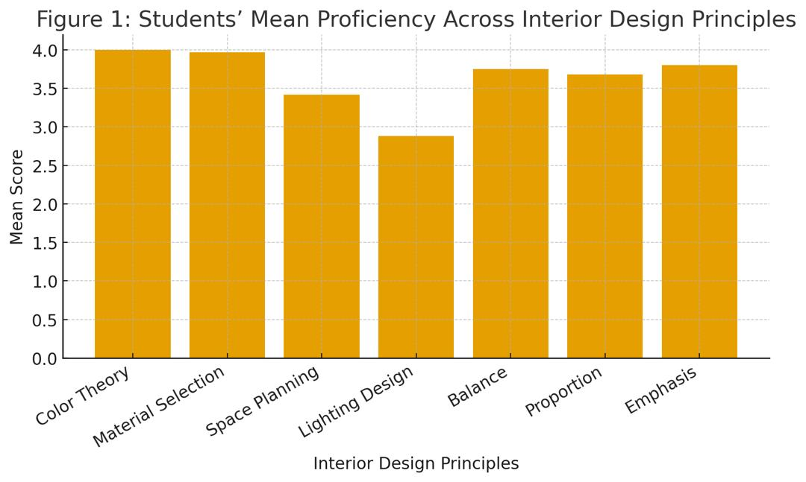
Figure 1: Showing Students’ Mean Proficiency across Interior Design Principles
4.2 Academic-Level Variations
Analysis of Variance (ANOVA) indicated a significant difference in students’ overall proficiency across academic levels (F(3,171) = 3.45, p = 0.018). Post-hoc Tukey tests revealed that 500-level students (M = 4.50) outperformed 200-level students (M = 3.33) and 300-level students (M = 3.67), while differences between 400-level (M = 3.97) and 500-level students were not statistically significant. This pattern demonstrates a steady improvement with academic progression, reflecting the cumulative effect of design studio exposure and applied coursework.
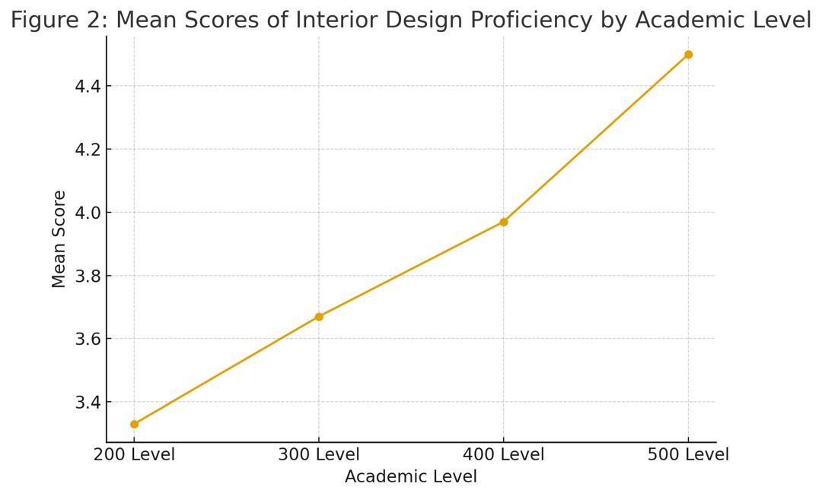
Figure 2: Illustrating Mean Scores for each Principle: Color Theory, Material Selection, Space Planning, Lighting, Balance, Proportion, and Emphasis.
Table 1. Mean scores of Interior Design Proficiency by Academic level.
Academic Level | Mean Score (M) | Significant Difference
200 Level | 3.33 | Lower than 500 Level
300 Level | 3.67 | Lower than 500 Level
400 Level | 3.97 | Not significantly different
500 Level | 4.50 | Higher than 200 & 300
Source: Author’s Compilation, 2025
The findings reveal a partial understanding of fundamental interior design principles among LAUTECH architecture students. The strong performance in color theory and material selection suggests that the curriculum effectively integrates aesthetic and sustainable material considerations into design studios. However, the weak outcomes in lighting design and space planning expose an instructional gap that undermines user-centered design outcomes.
These results align with global concerns about the marginalization of interior design knowledge in architectural education. Many programs prioritize structure, form, and technical construction over spatial functionality and sensory experience. This imbalance mirrors Pelletier’s (2017) assertion that architectural curricula often privilege structural systems over interior tectonics. As a result, graduates may be proficient in building form but less capable of designing responsive and livable interiors.
The significant progression in performance across academic levels underscores the value of progressive design studio training. By the 500 level, students demonstrate deeper integration of interior concepts, confirming the cumulative benefit of experiential learning. However, as Šafárová et al. (2019) cautioned, remediation at advanced stages is less effective than early integration. Therefore, interior design principles should be introduced earlier in the curriculum and reinforced consistently through studio projects, rather than as supplementary content.
Overall, the study highlights the need for a pedagogical restructuring that embeds interior design competencies as core components of architectural education. Strengthening modules in lighting, spatial organization, and human-environment interaction would enhance students’ design literacy and better prepare them for interdisciplinary professional practice.

7.0 CONCLUSION
This study revealed that while architecture students at LAUTECH appreciate the importance of interior design, many lack adequate proficiency in essential principles such as lighting design and space planning. These gaps reflect a broader pedagogical imbalance in Nigerian architectural education, where interior design is often treated as a secondary consideration.
However, the observed progression in students’ performance across academic levels underscores the transformative impact of studio-based experiential learning. A restructured curriculum that embeds interior design concepts from the early stages of training, supported by interdisciplinary teaching and technology-driven learning tools, will produce more well-rounded architects capable of integrating aesthetics, functionality, and user comfort.
Ultimately, aligning architectural education with holistic spatial thinking is vital for creating built environments that are both technically sound and experientially meaningful. Future research should adopt a longitudinal approach to evaluate how curricular reforms and interdisciplinary initiatives influence graduates’ professional competence and design innovation over time.

6.0 RECOMMENDATIONS
Based on the findings, the following recommendations are proposed to strengthen architecture students’ understanding of interior design principles and enhance curricular effectiveness:
1. Curriculum Restructuring
Architectural programs should embed core interior design competencies particularly lighting design and space planning into lower-level studio courses (200 Level). Early exposure will help students internalize the relationship between form, function, and user experience. Digital tools such as Building Information Modelling (BIM) and Virtual Reality (VR) should be integrated into the design process to simulate real-world interior conditions and spatial interactions, enabling students to visualize design outcomes more effectively.
2. Interdisciplinary Collaboration
Departments of Architecture should collaborate with Interior Design and Fine Arts programs through joint workshops, design charrettes, and interdisciplinary studio projects. Such partnerships promote a shared understanding of spatial design principles, human factors, and material application. Collaboration will also expose students to diverse design perspectives and foster professional synergy reflective of real-world practice.
3. Faculty Development
To sustain curricular innovation, instructors require continuous professional development. Universities should organize CPD workshops and training programs on interior design pedagogy, lighting systems, and ergonomics. Partnerships with professional bodies such as the Nigerian Institute of Architects (NIA) and the Royal Architectural Institute of Canada (RAIC) can enhance faculty expertise and ensure alignment with international best practices.
4. Resource Enhancement
Investing in studio equipment, lighting laboratories, and digital simulation software will improve students’ practical understanding. Access to interactive visual technologies and sustainable material libraries can bridge the gap between theoretical instruction and hands-on design experimentation.

COMPETING INTERESTS DISCLAIMER:
Authors have declared that they have no known competing financial interests OR non-financial interests OR personal relationships that could have appeared to influence the work reported in this paper.

References
- Abouelela, A. (2022). The effectiveness of the role of interior design in creating functional and institutional happiness for work environments: King Faisal University as a model. Designs, 6(3), Article 45. https://doi.org/10.3390/designs6030045
- Akande, O. K., Obi-George, C. L., Anikor, E. M., & Makun, C. Y. (2024). Evaluation of interactive spaces for enhanced learning in architecture department buildings in Niger State, Nigeria. ArtGRID: Journal of Architecture, Engineering & Fine Arts, 6(1), 96–110. https://doi.org/10.57165/artgrid.1387692.
- Assali, I., et al. (2023). A blended model of interior design studio practice due to COVID-19: students’ experiences and pedagogical implications. Frontiers / PubMed Central. https://www.ncbi.nlm.nih.gov/pmc/articles/PMC10390791/.
- Ching, F. D. K., & Binggeli, C. (2012). Interior Design Illustrated (3rd ed.). John Wiley & Sons.(Foundational textbook describing interior-design principles such as balance, scale, proportion, rhythm and unity; widely used in design education.)
- Enwerekowe, E. O., Doyle, J., & Adetula, I. A. (2023). Towards sustainable Nigerian architectural education: The relationship between design education, learning styles and personality types among architecture students. African Journal of Humanities and Contemporary Education Research, 13(1). (Full text) https://afropolitanjournals.com/index.php/ajhcer/article/download/90/130/161.
- Grimley, C., & Harris Smith, K. (2022). Universal Principles of Interior Design: 100 ways to develop innovative ideas, enhance usability, and design effective solutions. Rockport/Walter Foster. (Book; concise reference for principles such as balance, proportion, scale, rhythm, emphasis, unity/harmony).
- Kolb, D. A. (1984). Experiential Learning: Experience as the Source of Learning and Development. Prentice-Hall.
- Mba, E. J., & Okeke, F. O. (2024). Evolving trends and challenges in sustainable architectural design: a practice perspective (Enugu, Nigeria case). Sustainable Cities and Society / ScienceDirect. https://doi.org/10.1016/j.scs.2024.
- Obi, N. I., Obi, J. S. C., Okeke, F. O., & Nnaemeka-Okeke, R. C. (2022). Pedagogical challenges of architectural education in Nigeria: Study of curriculum contents and physical learning environment. European Journal of Sustainable Development, 11(4), 32–46. https://doi.org/10.14207/ejsd.2022.v11n4p32
- Özsırkıntı Kasap, H., Altın, E., & Ergene, A. İ. (2022). Design principles and concept research in “Interior Architecture Design Studio I” during the pandemic period. IDA: International Design and Art Journal, 4(2), 214–234. https://openaccess.iku.edu.tr/bitstreams/6e1585e8-fe17-4a15-8c22-45d90db05ab1/downl oad.
- Piaget, J. (1972). The psychology of the child. Basic Books. (Constructivist learning theory).
- Vygotsky, L. S. (1978). Mind in society: The development of higher psychological processes. Harvard University Press. (Social constructivist theory).

