Climate-Driven Early Flowering in Rhododendron: field observations across altitudes in Bageshwar, Western Himalaya

ABSTRACT
Climate change deeply impacts plant phenology, mostly in vulnerable high altitude ecosystems like the Himalaya. This study investigates climate-driven shifts in the flowering phenology of Rhododendron a keystone species and significant bio-indicator to climate warming across a multi-altitudinal gradient (1500-3000 m) in Bageshwar district, Uttarakhand. Combining decadal climate records, attentive field observations (December 2023- October 2024), and invaluable local ecological knowledge from interviews with a synthesis of recent literature. Analysis revealed a significant mean winter temperature increase of 1.3ºC in the study area. Results indicate significant advancement in flowering time, especially at lower and mid-altitudes, lower elevations experienced blooming 6-8 weeks earlier. While mid to high elevations showed 3-4 week advancement compared to historical norms. Essentially observation of community independently verified these shifts, with local inhabitants also residents also reporting a perceived decline Rhododendron populations at lower altitudes. These findings underscore the high climate sensitivity of Rhododendron arboreum and highlight profound ecological implications, including potentially phenological mismatches with pollinators and a risk of range contraction. The study emphasizes the urgent need for elevation specific monitoring and targeted conservation strategies to mitigate the adverse impacts of rapid climate change on Himalayan biodiversity.
Keywords: Phenology, Climate Change, Rhododendron, Altitudinal gradient, flowering advancement, Bio-indicator.

- INTRODUCTION
Climate change is a global concern affecting all living organisms, with plants often responding through shifts in phenology the timing of biological events such as flowering and leafing^{1, 2}. Rising global temperatures, glacier retreat, and erratic precipitation are altering ecosystems worldwide, with high-altitude regions like the Himalayas being particularly vulnerable^{3, 4}. High altitude plants like the well-known Himalayan Rhododendrons (Rhododendron spp.) are especially susceptible to the effects of climate change because of their unique needs for habitat and fragility to external stress⁵. Alpine floras are characterized by cold temperatures, powerful winds, bright sunshine, and harsh environmental conditions. Few longitudinal data sets investigate the implications of climate change on the Himalaya's remarkable alpine biodiversity⁶. The Himalayan Rhododendron, with its diverse species and ecological importance, provides an intriguing case study for investigating the effects of climate change on high-altitude flora. The Himalayan region is an important hotspot for researching how plant communities are being impacted by climate change because of its rich biodiversity and distinctive ecosystems. Worldwide plant species, distribution, and behavior are changing due to climate change, which also affects biodiversity and presents serious challenges to global ecosystems.
Rhododendron arboreum, the state tree of Uttarakhand, is a keystone species in Himalayan forests, valued for it’s ecological, medicinal, and economic roles^{7, 8}. Its bright red flowers, typically blooming from late winter to early summer, are culturally significant and support local livelihoods as a non-timber forest product^{9, 10}. However, climate change threatens Rhododendron populations through habitat loss, altered flowering times, and increased risk of extinction^{11, 12}. In India, more than 98% of Rhododendron spp. are situated in the Himalayas^{7, 13, 14}. In the Himalaya, Quercus (Oak) and Rhododendron (Burans) are the two species that form most of the ecosystem⁸. In hilly areas, Rhododendron is important in every aspect, medicinally, economically, and ecologically. They can preserve the water moisture at high amounts in mountains, which helps in maintaining transpiration rate and humidity with even low rainfalls in higher elevations. It also plays an important role in soil erosion, wind velocity, and maintaining mountain slope^{10, 15}. Climate has a huge impact on the phenology of plants as phenology has control over the timing of occurring biological events, affected by season, environmental factors such as temperature, precipitation, etc.^{16, 17, 9}. Despite their importance, comprehensive field-based studies on the phenological responses of Rhododendron species to climate change in Uttarakhand are limited¹⁸. This study addresses this gap by combining new field observations from Bageshwar with a review of recent literature, aiming to elucidate the drivers and consequences of early flowering in R. arboreum. The main objective of the study is to evaluate the impact of climate change on the flowering phenology of Rhododendron arboreum in Uttarakhand Himalaya by synthesizing existing research, analyzing climate data, and presenting new field observations.
- MATERIALS AND METHODS
  - Study area: The study was conducted in three distinct altitudes of Bageshwar district, Western Himalaya viz. Kausani (Lowest altitude), Dhaulinag-Vijaypur (Mid altitude), Dhakuri (High altitude). Many studies focus on broader regional climate patterns but fail to account for the specific microclimates that occur in mountainous territory. Especially in Bageshwar there is no specific study done even if it has Rhododendron forests. So this study area was chosen.
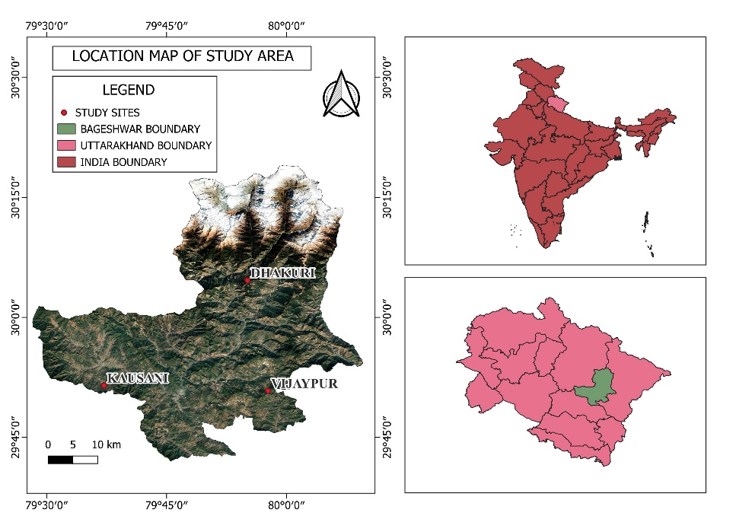
Figure 1 Location map of study area
2.2 Study Design: This study employs a qualitative, descriptive, and analytical approach, integrating field observations with secondary data analysis to assess the impact of climate change on Rhododendron flowering in Uttarakhand.
2.3 Data Collection:
2.3.1 Climate Data: Historical temperature and precipitation records were obtained from the Indian Meteorological Department (IMD) and NASA Data Access Viewer¹⁹.
2.3.2 Literature Review: Peer-reviewed articles, government reports, and recent meta-analyses on Rhododendron phenology in the Himalayas and Uttarakhand^{18, 12, 4}.
2.3.3 Field Observations: Field observations of Rhododendron spp. phenology were conducted at low, mid, and high altitudinal zones. During the following periods in 2024: December- January, April- May, and October- November. Specific observations for the high elevation zone during October- November including initial bud swelling and slight opening.
2.4 Data Analysis: The statistical data was analysed by Python (pandas) and MS excel.
- Results and Discussion
3.1 Climate Trends and Phenological Shifts: Significant winter warming occurred from 2003- 2022 (temperature increased from 11.70 to12.23°C; slope = 0.065°C/year, P < 0.05; Figure 1), with a 10% precipitation decline (slope = –0.05 mm/year, P < 0.05; Figure 2) and increased variability in precipitation, with notable declines in winter and pre-monsoon rainfall^{20, 21}. These changes coincide with advances in Rhododendron flowering dates across Uttarakhand. Field observations from January to February 2024 in Bageshwar documented Rhododendron flowering 6 to 8 weeks earlier than historical averages, with blooming observed at low (Kausani: 1,300- 1,800 m), mid (Vijaypur: 1,800- 2,200 m), and high altitudes (Dhakuri: 2,200- 2,700 m). This aligns with recent reports of early flowering in other parts of Uttarakhand and the central Himalayas^{4, 18}.
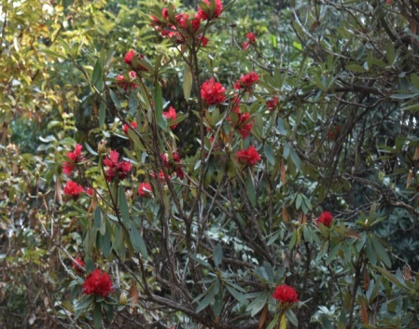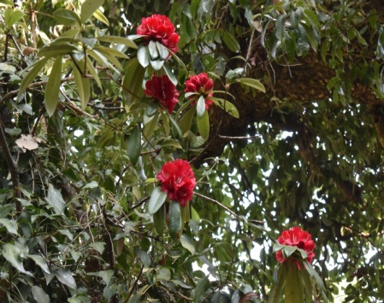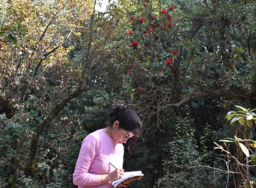
Photograph 1: Flowering during early January in lowest elevation of the study sites
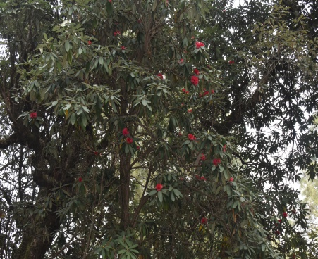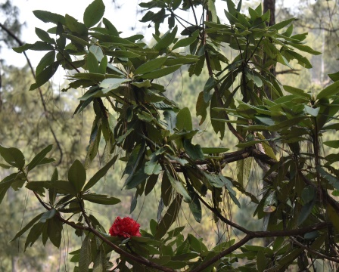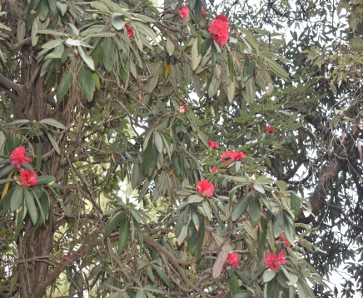
Photograph 2: Flowering during mid-January in middle elevation of the study sites
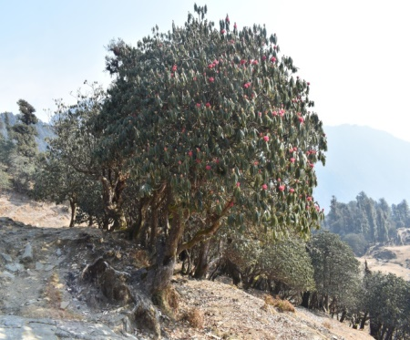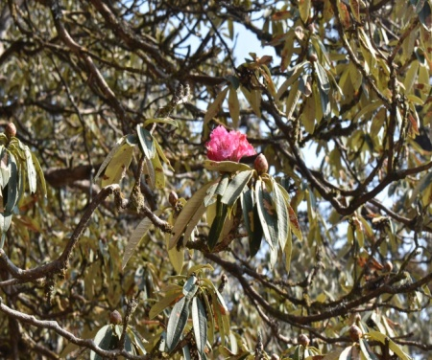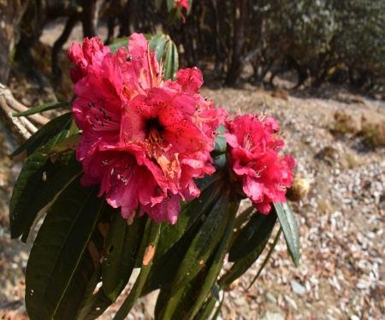
Photograph 3: Flowering during Last-January in highest elevation of the study sites
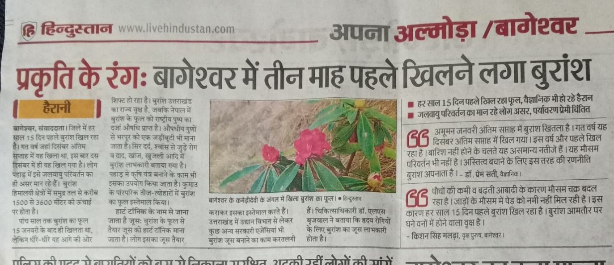
Photograph 4: News reports addressing early flowering
Image 1: Annual Temperatures of Uttarakhand Districts from 2000 to 2022
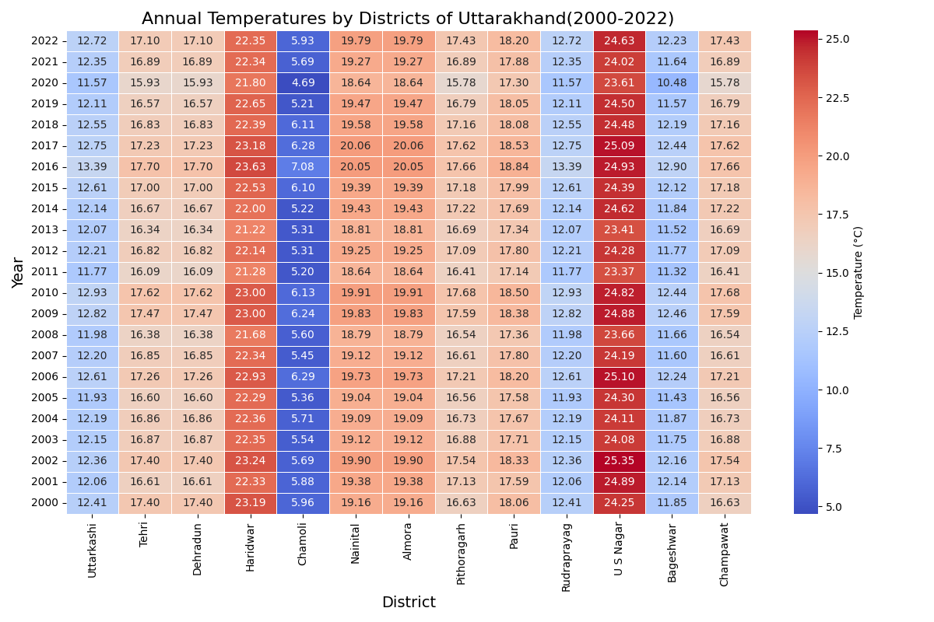

Image 2: Yearly trend of rainfall in Uttarakhand from 1st January, 2003 to 20th November, 2024
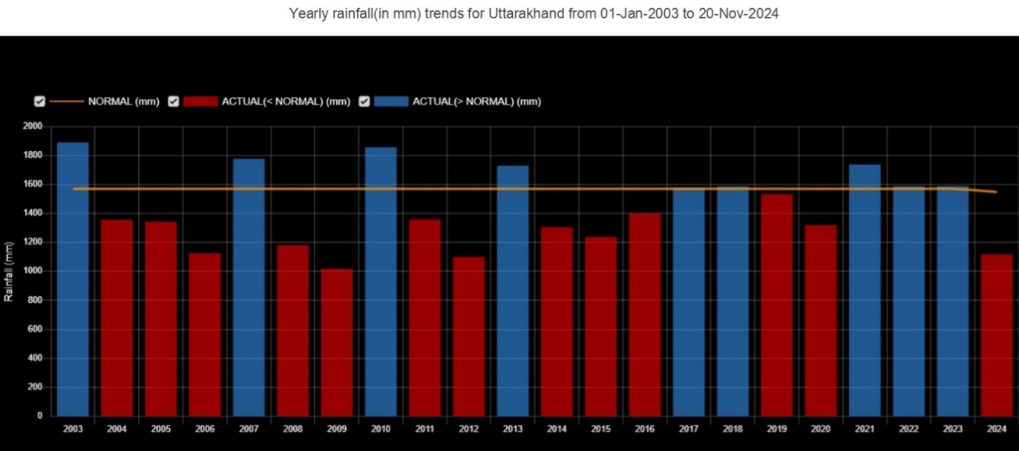
3.2 Flowering Advancement: Field data showed elevation divergence: Low elevation: 6- 8 weeks earlier (full bloom in late December to early January vs. historical late February; Table 1); High elevation: 3- 4 weeks earlier (partial bloom in late January vs. historical late March).
Table 1: Observed flowering advancement vs. Altitude.
Elevation zone (Masl) | Location (Uttarakhand) | Observed flowering period (2023-24) | Historical average  (based on previous records) | Advancement (weeks earlier)
Low (1300-1800) | Kausani | Last December - first January | Late February- Early March | ~6-8 weeks
Mid (1800-2200) | Vijaypur | Mid-Late January | Mid-March | ~5-6 weeks
High (2200-2700) | Dhakuri | Late Jan- Mid February | Late March- Early April | ~3-4 weeks
*masl: meters above sea level
3.3 Local Knowledge: Surveys of 150 residents supported the field data. Approximately 80% of low-elevation respondents reported earlier flowering (1-2 months) and population declines, consistent with field data; and a decline in R. arboreum abundance, while [90%] of high-elevation residents noted minimal phenological changes, consistent with observations of R. campanulatum and R. barbatum flowering in April–May.
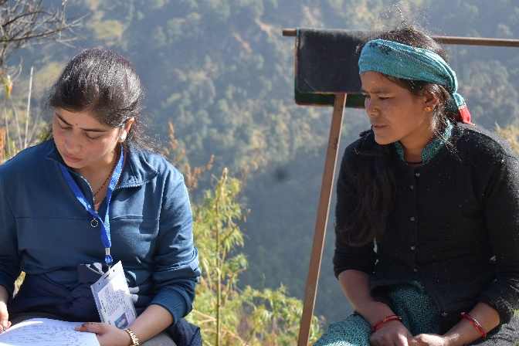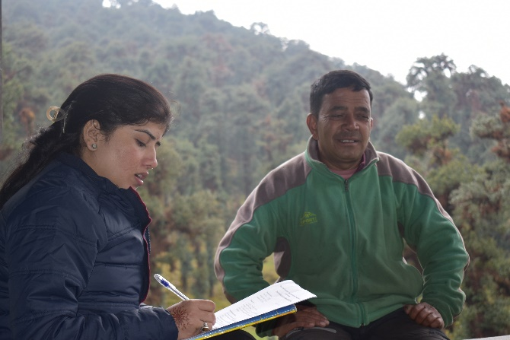
Photograph 5: Interviews with residents regarding phenological changes in Bageshwar.
3.4 Mechanistic Insights
Recent studies highlight the role of soil temperature, chilling requirements, and species-specific thermal thresholds in regulating flowering phenology^{21,} ⁴. For example, warmer winter soils may disrupt floral bud development, while insufficient chilling can delay or prevent flowering²². Specific chilling hours are unknown for R. arboreum.
- Chilling requirements: As buds are opening slightly in autumn, it suggests that the plant due to partial fulfilment of chilling or an immediate response to suitable temperatures before deep winter dormancy synchronize.
Table 2: Various studies conducted on the effect of climate change on Rhododendron species in Uttarakhand
S.N. | Rhododendron species | Major outcomes of the study | Explored sites | References
1 | R. arboreum | Early flowering due to increased temperature | Kumaun, Uttarakhand | Gaira et al., 2014 ²⁵
2 | R. arboreum | Change in phenology due to climate change | Kumaun, Uttarakhand | Singh et al., 2015 ²³
3 | R. arboreum | Struggling to survive in low and lower middle altitudinal zones. | Uttarakhand | Mamgain and Uniyal 2017 ²⁶
4 | R. campanulatum | Shifting upwards due to climate change | Tungnath, Uttarakhand | Singh et al., 2018 ²⁷
5 | R. arboreum,  R. barbatum,  R. campanulatum, R. anthopogon | Flowering affected | Garhwal, Uttarakhand | Vashisht, 2019 ⁹
6 | R. arboreum | Movement to high elevation areas because of climate change. | Uttarakhand and Himanchal Pradesh | Veera et al., 2019 ²⁸
7 | R. arboreum | Flower color polymorphism at different climatic conditions | Kumaun, Uttarakhand | Mamgain A., 2022 ²⁹
8 | R. arboreum | Early flowering due to climatic variations | Garhwal, Uttarakhand | Prem Chand et al., 2022 ³⁰
9 | R. arboreum | Confirmed distribution in the mid and high altitude. | Garhwal, Uttarakhand | Anand et al., 2022 ³¹
10 | R. arboreum | The species is shifting altitudinally and longitudinally as well with changing climate. | Uttarakhand and Himanchal Pradesh | Veera et al., 2023 ³²
11 | R. arboreum | Survival mortality of seedlings is greatly influenced by the season. | Pauri and Rudraprayag,  Uttarakhand | Iqbal et al., 2023 ³³

3.5 Discussion
The advancement of R. arboreum flowering in Uttarakhand is a clear indicator of climate-driven phenological change, consistent with global and Himalayan trends^{2, 12}. The observed shifts are primarily attributable to rising temperatures and altered precipitation regimes, with local factors such as soil moisture, altitude, and microclimate further modulating responses ^{18, 21}.
3.5.1 Ecological Implications: Earlier flowering may disrupt synchrony with pollinators, increase vulnerability to late frosts, and affect seed set and regeneration^{12, 4}. there is also growing evidence of altitudinal migration and potential habitat contraction for Rhododendron species under future climate scenarios¹².
3.5.2 Knowledge Gaps: Despite recent advances, there remains a paucity of long-term, high-resolution phenological data for R. arboreum in Uttarakhand. Integrating remote sensing, citizen science and experimental approaches will be critical for future research²².
4. Conclusion
This study concludes that Rhododendron arboreum in Uttarakhand is exhibiting significant advances in flowering phenology, driven by climate warming and changes in precipitation. These ground-based observations in Bageshwar present strong, locality-specific evidence of Rhododendron arboreum earlier flowering trends, which supports the influence of climate change on modifying phenological calendars. The use of ground trothing in future studies is essential to construct stronger conservation strategies specific to high-altitude Himalayan ecosystems. These findings underscore the need for continued, localized monitoring and adaptive conservation strategies to safeguard Himalayan biodiversity. Future research should focus on multi-scale, interdisciplinary approaches to unravel the complex drivers of phenological change and to inform effective management of vulnerable mountain ecosystems.
CONSENT: The authors declare that participants were informed that the data would be used for research and publication purposes in an anonymized form.
ETHICAL APPROVAL: The study was carried out under the supervision of Dr. Vijay Arya and Dr. Balwant Kumar at Soban Singh Jeena University Almora. Ethical considerations were strictly followed during data collection. Verbal informed consent was obtained from all 150 participants before the survey, and their participation was entirely voluntary.
References:
- Cleland, E. E., et al. (2007). Shifting plant phenology in response to global change. Trends in Ecology & Evolution, 22(7), 357–365.
- Parmesan, C., & Yohe, G. (2003). A globally coherent fingerprint of climate change impacts across natural systems. Nature, 421(6918), 37–42.
- IPCC (2022). Sixth Assessment Report.
- Singh, R., et al. (2024). Phenological Responses of Rhododendron arboreum to Climate Variability in the Central Himalaya. Journal of Mountain Science, 21(2), 101–112.
- Srivastava, P. Rhododendron arboreum: An overview. J. Appl. Pharm. Sci. 2012, (Issue), 158–162.
- Salick, J., Fang, Z. and Hart, R. Rapid changes in eastern Himalayan alpine flora with climate change. Am. J. Bot. 2019, 106(4), 520–530.
- Mao, A. A., et al. (2001). Rhododendron diversity in India.
- Mamgain, A. (2018). Morphological and phenological changes in Rhododendron arboreum.
- Vashisth, S. P. Phenological response of four Rhododendron species with reference to climatic change. Shodhganga@INFLIBNET 2019.
- Chauhan DS, Lal P, Singh D. Composition, population structure and regeneration of Rhododendron arboreum Sm. temperate broad-leaved evergreen forest in Garhwal Himalaya, Uttarakhand, India. J Earth Sci Clim Change. 2017;8(12):430.
- Gibbs, D., Chamberlain, D., & Argent, G. (2011). The Red List of Rhododendrons. Botanic Gardens Conservation International.
- Shrestha, K. K., et al. (2023). Early Flowering in Rhododendron Species Across the Himalayas: A Meta-Analysis. Global Change Biology, 29(5), 2100–2115.
- Bhattacharyya D, Sanjappa M. Rhododendron habitats in India. J Am Rhododendron Soc. 2008;62(1):14-8.
- Badola HK. Bud phenological studies as an aid to forestry research: an overview. In: Dogra PD, Dhiman RC, editors. Forestry Research and Education. Diamond Jubilee Publication, Indian National Science Academy, New Delhi; 1994. p. 142-53.
- Morisette JT, Richardson AD, Knapp AK, Fisher JI, Graham EA, Abatzoglou J, Liang L. Tracking the rhythm of the seasons in the face of global change: phenological research in the 21st century. Front Ecol Environ. 2009;7(5):253-60.
- Negi, D. S., & Rawat, G. S. (2023). Altitudinal Shifts and Flowering Patterns of Rhododendron arboreum in the Western Himalaya. Plant Ecology & Diversity, 16(4), 345–358.
- Indian Institute of Remote Sensing (IIRS). (2023). Phenological Shifts in Himalayan Flora.
- Kumar, S., et al. (2024). Climate Change and Phenological Shifts in Keystone Himalayan Flora: A Case Study of Rhododendron arboreum. Climate Research Letters, 12(1), 55–68.
- Pandey, A., & Joshi, H. (2024). Integrating Citizen Science and Remote Sensing for Monitoring Rhododendron Flowering in Uttarakhand. Ecological Informatics, 78, 102211.
- Ahmad MP, Ali S, Wahab S, Perween T, Shahzad N, Dhami DB. Traditional uses, pharmacology and phytochemistry of national flower of Nepal, Rhododendron arboreum: A review. J Drug Deliv Ther. 2022;12(4):162-6.
- Bharali S, Paul A, Khan ML, Singha LB. Species diversity and community structure of a temperate mixed Rhododendron forest along an altitudinal gradient in West Siang District of Arunachal Pradesh, India. Nature Sci. 2011;9(12):125-40.
- Bhattacharayya D. Rhododendron habitats in India. J Am Rhododendron Soc. 2008;2:14-8.
- Chamberlain DF, Hyam R, Argent G, Fairweather G, Walter KS. The genus Rhododendron: its classification and synonymy. Royal Botanic Garden, Edinburgh; 1996. p. 181.
- Chandra S, Singh A, Mathew JR, Singh CP, Pandya MR, Bhattacharya BK, Joshi R. Phenocam observed flowering anomaly of Rhododendron arboreum Sm. in Himalaya: a climate change impact perspective. Environ Monit Assess. 2022;194(12):877.
- Chandra S, Singh A, Mathew JR, Singh CP, Pandya MR, Bhattacharya BK, Joshi R. Phenocam observed flowering anomaly of Rhododendron arboreum Sm. in Himalaya: a climate change impact perspective. Environ Monit Assess. 2022;194(12):877.
- Chauhan, P. S., et al. (2017). Rhododendron as a keystone species in the Himalayan ecosystem.
- Chettri SK, Sharma G, Gaira KS, Pandey A, Joshi R, Chettri N, Pradhan BK. Forest resource use pattern in fringe villages of Barsey Rhododendron Sanctuary and Singalila National Park of Khangchendzonga landscape, India. Int J For Res. 2021;2021:1-11.
- Dhār U. Conservation implication of plant endemic in high-altitude Himalaya. Curr Sci. 2002;82:141-8.
- Gaira KS, Rawal RS, Rawat B, Bhatt ID. Impact of climate change on the flowering of Rhododendron arboreum in central Himalaya, India. Curr Sci. 2014;107(10):1735-8.
- Giriraj A, Irfan-Ullah M, Ramesh BR, Karunakaran PV, Jentsch A, Murthy MSR. Mapping the potential distribution of Rhododendron arboreum Sm. ssp. nilagiricum (Zenker) Tagg (Ericaceae), an endemic plant using ecological niche modelling. Curr Sci. 2008;95(11):1605-12.
- Iqbal K, Negi AK. Rhododendrons in Uttarakhand: diversity and conservation. Int J Environ. 2017;6(1):31-45.
- Joshi AP. Uttarakhand: Rhododendron yet again blooms early, sparks worry. Times of India. 2021 Jan 22. Available from: https://timesofindia.indiatimes.com/city/dehradun/rhododendron-yet-again-blooms-early-in-january-rather-than-in-spring-worrying-experts/articleshowprint/80391460.cms
- Lal P, Chauhan DS. Descriptive study of Burans (Rhododendron arboreum Smith) in the Uttarakhand, India, North West Himalaya. J Agric For Meteorol Res. 2019;2(1):59-62.
- Leemans R, Eickhout B. Another reason for concern: regional and global impacts on ecosystems for different levels of climate change. Glob Environ Change. 2004;14(3):219-28.
- Mamgain A, Bhandari PK, Semwal DP, Uniyal PL. Population assessment, mapping and flowering response of Rhododendron arboreum Sm.-A keystone species in central Himalayan region of Uttarakhand, India. Int J Ecol Environ Sci. 2017;43(3):205-20.
- Mamgain A. Altitudinal variation in flower color and attraction pattern of Rhododendron arboreum Sm. in central Himalayan Region of Uttarakhand, India. Isr J Plant Sci. 2022;69(3-4):224-37.
- Mao AA, Gogoi R. Rhododendrons of Manipur and Nagaland, India. NeBio. 2012;3(1):1-10.
- Namgay S, Sridith K. Distribution pattern of the genus Rhododendron in Bhutan Himalayan range. Sci Asia. 2020;46(4):429-35.
- Negi GCS, Rawal RS. Himalayan biodiversity in the face of climate change. In: Tropical Ecosystems: Structure, Functions and Challenges in the Face of Global Change. 2019. p. 263-77.
- Pai DS, Rajeevan M, Sreejith OP, Mukhopadhyay B, Satbha NS. Development of a new high spatial resolution (0.25×0.25) long period (1901-2010) daily gridded rainfall data set over India and its comparison with existing data sets over the region. Mausam. 2014;65(1):1-18.
- Paul A. Studies on diversity and regeneration ecology of Rhododendrons in Arunachal Pradesh (Doctoral dissertation, Assam University, Silchar). 2010.
- Paul, A., Bhattacharjee, S., Choudhury, B. I. and Khan, M. L. Population structure and regeneration status of Cyathea gigantea (Wallich ex Hook. f.) Holttum, a tree fern in Arunachal Pradesh, India. J. For. Environ. Sci. 2015, 31(3), 164–176.
- Paul, A., Dutta, P. K., Khan, M. L. and Das, A. K. Rhododendrons: A major resource of fuelwood in high altitude region of Arunachal Himalaya, India. Biodiversitas J. Biol. Divers. 2019, 20(9).
- Prem Chand, V., Sukumaran, A. and Prasad Khanduri, V. Reproductive phenology and floral visitors in Rhododendron arboreum (Ericaceae) in a temperate forest of Garhwal Himalaya. Scientia Forestalis 2022, 50.
- Purohit, A. N. Potential impact of global climate change in Himalaya. In: Impact of Global Climate Changes on Photosynthesis and Plant Productivity, Oxford and IBH, New Delhi, 1991, pp. 591–604.
- Ralhan, P. K., Khanna, R. K., Singh, S. P. and Singh, J. S. Phenological characteristics of the tree layer of Kumaun Himalayan forests. Vegetatio 1985, 60, 91–101.
- Ranjitkar, S., Kindt, R., Sujakhu, N. M., Hart, R., Guo, W., Yang, X. and Luedeling, E. Separation of the bioclimatic spaces of Himalayan tree rhododendron species predicted by ensemble suitability models. Glob. Ecol. Conserv. 2014, 1, 2–12.
- Salick, J., et al. (2019). Phenological shifts in Himalayan alpine flora.
- Saxena, A. K. and Singh, J. S. A phytosociological analysis of woody species in forest communities of a part of Kumaun Himalaya. Vegetatio 1982, 50(1), 3–22.
- Singh, H. Uttarakhand: Rhododendron yet again blooms early, sparks worry. Times of India 2021, January 22. Available at: https://timesofindia.indiatimes.com/city/dehradun/rhododendron-yet-again-blooms-early-in-january-rather-than-in-spring-worrying-experts/articleshowprint/80391460.cms
- Singh, N., Ram, J., Tewari, A. and Yadav, R. P. Phenological events along the elevation gradient and effect of climate change on Rhododendron arboreum Sm. in Kumaun Himalaya. Curr. Sci. 2015, 109(1), 106–110.
- Singh, P., Arya, V., Negi, G. C. S. and Singh, S. P. Expansion of Rhododendron campanulatum krummholz in the treeline ecotone in Tungnath, Garhwal Himalaya. Trop. Ecol. 2018, 59(2), 287–295.
- Singh, R., Rawat, M., Chand, T., Tripathi, S. K. and Pandey, R. Phenological variations in relation to climatic variables of moist temperate forest tree species of western Himalaya, India. Heliyon 2023, 9(6), e16669.
- Singh, S. and Chatterjee, S. Value chain analysis of Rhododendron arboreum squash ‘buransh’ as a non-timber forest product (NTFP) in Western Himalaya: Case study of Chamoli district, Uttarakhand in India. Trees Forests People 2022, 7, 100200.
- Singh, S. P., Bhattacharyya, A., Mittal, A., Pandey, A., Tewari, A., Latwal, A. and Singh, P. Indian Himalayan timberline ecotone in response to climate change—initial findings. Curr. Sci. 2021, 120(5), 857–863.
- Tewari, D., Sah, A. N. and Bawari, S. Pharmacognostical evaluation of Rhododendron arboreum Sm. from Uttarakhand. Pharmacogn. J. 2018, 10(3), 565–570.
- Wang, X., Li, L., Zhao, W., Zhao, J. and Chen, X. Rhododendron aureum Georgi formed a special soil microbial community and competed with above‐ground plants on the tundra of the Changbai Mountain, China. Ecol. Evol. 2017, 7(18), 7503–7514.

