Effectiveness and Optimization of Chlorine Tablets for Total Coliform Removal in Hospital Wastewater Effluent

ABSTRACT

Background : Hospital wastewater contains pathogens and chemicals that endanger health and the environment. Conventional treatments in Indonesia often fail to meet microbial standards. Chlorination is effective but requires optimal dosage and contact time to ensure safe and efficient disinfection. Objective : This study aimed to determine the optimal dosage and contact time of chlorine tablets for effective and safe disinfection of hospital wastewater under Indonesian conditions. Methods : A survey at a Surakarta hospital found Total Coliform levels of 5,400 MPN/100 mL, exceeding the national limit of 3,000 MPN/100 mL (Regulation No. 68/2016). A pretest–posttest batch experiment tested chlorine tablet dosages of 200 g, 400 g, and 600 g with contact times of 30, 40, and 50 minutes. Parameters measured were Total Coliform, pH, and temperature to evaluate disinfection efficiency and stability Results: The results showed Total Coliform removal efficiencies of 68% for 200 g/50 min, 99.87% for 400 g/40 min, and 100% for 600 g at all durations. Although higher dosages and longer contact times enhanced microbial removal, the 600 g dosage raised pH above 8.0, potentially reducing chlorine stability and increasing residual chemical risks. The 400 g dosage maintained pH within acceptable limits while achieving near-complete microbial removal, indicating a balance between efficiency and safety. Conclusion: The optimal condition was 400 g chlorine with 40 minutes contact time, achieving 99.87% Total Coliform removal while maintaining safe pH levels. This study supports efficient, safe, and regulation-compliant hospital wastewater disinfection in Indonesia..

Keywords: Chlorine tablet, Total Coliform, Hospital wastewater, Wastewater treatment, Disinfection optimization

- INTRODUCTION
Wastewater produced as a by-product of healthcare services constitutes a significant source of environmental pollution, with the potential to disturb the ecological balance of surrounding environments. It is commonly divided into three categories: medical wastewater, non-medical wastewater, and hazardous and toxic substances (HTS), each potentially containing toxic chemicals, pathogenic microorganisms, and infectious biological agents (Ajala et al., 2022) When inadequately treated, these pollutants can infiltrate surface waters, accumulate through the food chain, and contribute to long-term ecological degradation as well as the proliferation of waterborne diseases, posing serious risks to human health and aquatic ecosystems (Nishmitha et al., 2025)
The assessment of wastewater quality generally involves both physicochemical and microbiological parameters. Physicochemical indicators, including Biological Oxygen Demand (BOD), Chemical Oxygen Demand (COD), and Total Suspended Solids (TSS), reflect organic loading and particulate concentrations, serving as key metrics of treatment performance (Aib et al., 2024) Microbiological parameters particularly Total Coliform are widely used to evaluate fecal contamination and the likelihood of pathogenic microorganisms being present. High Total Coliform counts indicate insufficient disinfection and a heightened risk to public health and the environment..
Within Indonesia, hospital wastewater effluent quality is regulated under Ministry of Environment Regulations No. 5/2014 and No. 68/2016, which stipulate a maximum allowable Total Coliform concentration of 3,000 Most Probable Number (MPN) per 100 mL (Sulistiawati, 2022). Monitoring at a hospital in Surakarta in March 2023 showed that, although BOD, COD, and TSS levels met the required limits, the Total Coliform concentration at the wastewater treatment plant (WWTP) outlet was 5,400 MPN/100 mL, exceeding the regulatory threshold. This indicates shortcomings in the disinfection process and highlights the need for operational improvements (Yan et al., 2020)
Chlorination using calcium hypochlorite (Ca(ClO)₂), commonly known as bleaching powder, is one of the most widely applied disinfection methods in hospital WWTPs due to its reported efficiency, operational simplicity, and cost-effectiveness (Romanovski et al., 2024) Its performance, however, is highly dependent on two critical parameters: chlorine dosage and contact time. Insufficient dosage or contact time can result in incomplete pathogen inactivation, whereas excessive dosing may leave high residual chlorine levels and generate hazardous disinfection by-products (DBPs), such as trihalomethanes (THMs). Therefore, identifying an optimal balance between dosage and contact duration is essential to ensure effective microbial control while minimizing chemical usage and potential environmental harm (Wang et al., 2025)
Optimizing chlorine use aligns with resource efficiency and green chemistry principles, enabling hospitals to achieve effective disinfection with minimal chemicals, lower costs, and reduced environmental risks. This supports SDG 6 (Clean Water and Sanitation) and SDG 12 (Responsible Consumption and Production) through safe water management and responsible chemical use (Shafik, 2025)
This study evaluates the disinfection efficiency of calcium hypochlorite tablets at three dosages (200 g, 400 g, and 600 g) and three contact times (30, 40, and 50 minutes) for reducing Total Coliform in hospital wastewater. It aims to determine the optimal combination of dosage and contact time that meets regulatory standards, ensures chemical safety, and maximizes cost-efficiency. As the first study in Indonesia to assess combined dosage–time effects under real WWTP operating conditions, it integrates microbiological performance, physicochemical impacts, and economic analysis to provide evidence-based recommendations for sustainable and regulation-compliant hospital wastewater disinfection
- RESEARCH METHODS
  - Study Site and Sample Collection
The research was carried out at a state-owned psychiatric hospital in Central Java, Indonesia. Designated as a Type A facility, it accommodates 260 inpatient beds. The hospital has earned advanced-level national accreditation and ISO 9001:2015 certification (Wolniak, 2021), demonstrating its dedication to high standards of healthcare quality and patient safety. The hospital’s Environmental Sanitation Unit plays a strategic role in the planning, implementation, and supervision of integrated environmental hygiene measures to ensure a clean and regulation-compliant hospital environment in accordance with national standards.
Wastewater samples were collected from two key locations within the hospital’s Wastewater Treatment Plant (WWTP): the inlet (before treatment) and the outlet (after treatment). The sampling process was systematically planned and carried out in accordance with the Indonesian National Standard SNI 6989.57:2008 for wastewater sampling procedures and SNI 6989.1:2019 for manual water sampling techniques. (Susetyaningsih et al., 2023). Samples were collected using sterile sampling bottles and immediately stored in a cool box at 4 ± 2°C to preserve the stability of measured parameters. All samples were analyzed within 24 hours of collection to ensure data integrity, particularly for microbiological indicators such as Total Coliform. The analysis of physicochemical parameters (pH and temperature) and microbiological parameters (Total Coliform) was performed at the hospital’s Environmental Sanitation Laboratory. The laboratory follows standard operational procedures for environmental testing and operates in accordance with SNI ISO/IEC 17025:2017 which certifies the competence of testing and calibration laboratories and ensures the reliability and traceability of results (Wijaya et al., 2022),
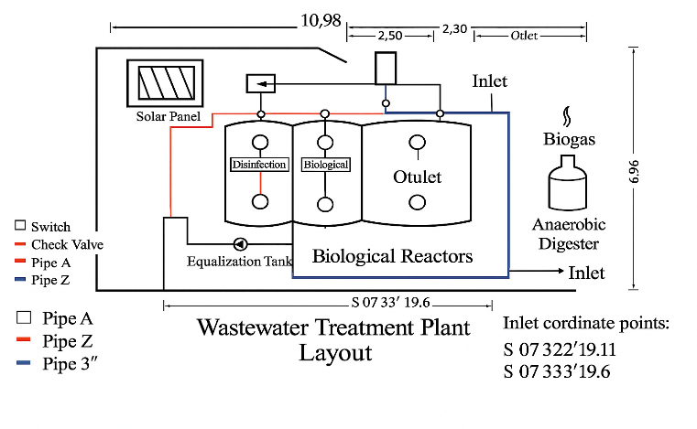
Figure 1. Sampling Locations at the Hospital Wastewater Treatment Plant (WWTP)

This figure illustrates the two primary sampling points used in the study: the inlet, which represents untreated hospital wastewater before chlorination, and the outlet, which represents treated effluent after chlorination. These sampling points were selected to evaluate the effectiveness of chlorination in reducing Total Coliform levels and to observe changes in physicochemical parameters such as pH and temperature across treatment stages.
  - Materials and Equipment
This study utilized standard laboratory equipment, including sterile glass sampling bottles with ground-glass stoppers sterilized by autoclave, sampling ropes with weights, and a Hanna digital pH meter for measuring pH and temperature. Microbiological analysis was conducted using an incubator (maintained at 36–37.5°C), colony counter, sterile pipettes, digital analytical balance, laboratory blender, and EC Compact Dry Plates as the culture medium. All procedures were performed aseptically using sterile gloves, 70% ethanol, and alcohol swabs to prevent contamination. The materials used in this study included wastewater samples from the WWTP, LB and BGLB 2% culture media, sterile Buffered Peptone Water (BFP), sulfuric acid (H₂SO₄) as a preservative when necessary, and sterile water for serial dilutions. All procedures adhered to standardized protocols to ensure the accuracy and validity of the experimental results.(Mulyati et al., 2024)
  - Research Procedure

This study aimed to evaluate the disinfection effectiveness of calcium hypochlorite (Ca(ClO)₂) in treating hospital wastewater by applying chlorine tablets at dosages of 200 g, 400 g, and 600 g, with contact times of 30, 40, and 50 minutes. The selected dosage and contact time ranges were determined from preliminary trials and supported by previous studies on chlorine-based disinfection in healthcare wastewater systems. These ranges are operationally feasible for medium-scale wastewater treatment plants in Indonesia, where contact times of 30–60 minutes and dosages below 1,000 g have been shown to reduce microbial contamination effectively while minimizing chemical use. Treatment parameters were also aligned with WHO disinfection guidelines and operational constraints in Indonesian hospitals. Wastewater samples were collected from the inlet and outlet of the hospital’s Wastewater Treatment Plant (WWTP) to assess pre- and post-treatment conditions. Each dosage–contact time combination was replicated three times to ensure data reliability. The pH and temperature were measured before and after chlorine application to evaluate changes in physicochemical characteristics. Microbiological analysis was performed using the Most Probable Number (MPN) method to determine Total Coliform counts as an indicator of biological contamination. Results were compared against the effluent quality standard specified in the Indonesian Ministry of Environment and Forestry Regulation No. 68 of 2016, which sets a maximum limit of 3,000 MPN/100 m (Azwarudin et al., 2023)
  - Total Coliform Testing and Data Analysis
    - Total Coliform Testing
The analysis of Total Coliform was performed using the Most Probable Number (MPN) method, employing a three-tube serial dilution technique in accordance with standard environmental microbiology protocols. The procedure commenced with a presumptive test, wherein wastewater samples were inoculated into Lactose Broth (LB) medium and incubated for 24–48 hours to observe gas production in Durham tubes and turbidity as indicators of presumptive positive results. Tubes exhibiting positive indications were subsequently subjected to a confirmatory test using 2% Brilliant Green Lactose Broth (BGLB) and incubated at 36 ± 1°C for 48 hours. The presence of gas in the confirmatory stage verified the occurrence of Coliform bacteria. The final MPN value was then calculated based on the number of positive tubes obtained.(Yannawar, 2022)
    - MPN Calculation
Total Coliform levels were determined based on the number of positive tubes obtained across three serial dilutions (10⁰, 10⁻¹, and 10⁻²). The corresponding MPN values were derived from a standard MPN table and calculated using the following equation: (Senthilkumar et al., 2021)
$$​MPN/100 mL=factorMPN table value×1​ / middle dilution$$
Explanation:
- MPN table value refers to the value obtained from the standard MPN table based on the combination of positive tubes at each dilution level.
- 1 is the conversion factor to express the result per 100 mL of sample.
- Middle dilution factor represents the dilution level in the series that occupies the middle position (e.g., in dilutions of 10⁰, 10⁻¹, and 10⁻², the middle dilution factor is 10⁻¹).
    - Experimental Design
This study employed a pretest–posttest experimental design without a control group. Chlorine tablets were applied at three dosages (200 g, 400 g, and 600 g) and three contact times (30, 40, and 50 minutes), with each dosage–contact time combination replicated three times to ensure data reliability. In total, nine inlet samples (pre-treatment) and twenty-seven outlet samples (post-treatment) were analyzed, representing the nine dosage–contact time combinations. Total Coliform concentrations were determined using the Most Probable Number (MPN) method to evaluate disinfection performance, with results compared across treatment variations to assess reduction efficiency (Mulyati et al., 2024)(Ge et al., 2025)
    - Data Analysis
MPN results were evaluated using descriptive statistics to obtain mean values, standard deviations, and percentage reductions of Total Coliform, and inferential statistics through one-way and two-way ANOVA to examine the influence of chlorine dosage, contact time, and their interaction. Significant differences between groups were further explored using Tukey’s HSD post hoc test. Data were presented in tabular form, graphical illustrations, and effectiveness curves. Cost-effectiveness was assessed by calculating chlorine consumption per cubic meter for each treatment scenario, with the optimal dosage determined by achieving the greatest statistically significant microbial reduction while meeting regulatory standards (≤3,000 MPN/100 mL) and minimizing chemical usage. A breakpoint chlorination curve was developed to identify the saturation threshold, providing a basis for efficient and sustainable dosing practices in hospital wastewater treatment (Harahap et al., 2021)
- Result

  - Layout Design and Performance of the Hospital Wastewater Treatment Plant (WWTP)

The hospital Wastewater Treatment Plant (WWTP) features an integrated design that combines sequential treatment units, including the inlet channel, equalization tank, anaerobic digester, biological reactors, and disinfection unit. Each unit performs a specific and complementary role, ranging from flow equalization and organic matter degradation to pathogen inactivation through chlorine tablet dosing. Renewable energy systems, such as solar panels and biogas recovery, are incorporated to enhance sustainability, while a color‑coded piping network equipped with strategically positioned check valves ensures hydraulic efficiency and prevents backflow. As summarized in Table 1, each component contributes to the overall performance of the WWTP, enabling efficient operation and consistent compliance with national effluent quality standards.

Table 1. Layout design, functions, and performance contributions of the WWTP components
WWTP Component | Function | Design Features | Performance Contribution
Inlet Channel | Directs raw wastewater into the treatment system. | Connected to inlet coordinates (S 07° 32′ 19.11″ and S 07° 33′ 19.6″). | Ensures proper entry and distribution of influent wastewater.
Equalization Tank | Homogenizes flow and equalizes pollutant load fluctuations. | Equipped with flow distribution control. | Prevents shock loading and enhances downstream treatment efficiency.
Anaerobic Digester | Facilitates anaerobic decomposition and produces biogas. | Connected to biogas capture unit. | Reduces organic load and generates renewable energy.
Biological Reactors | Supports aerobic and anaerobic biological degradation of organic matter. | Divided into aerobic and anaerobic zones. | Removes biodegradable organic matter and nutrients.
Disinfection Unit | Inactivates pathogenic microorganisms using chlorine tablets. | Chlorine tablet dosing system with adjustable dosage. | Ensures microbial safety of effluent before discharge.
Solar Panel System | Provides renewable energy for control and monitoring systems. | Integrated with system automation. | Reduces operational carbon footprint and supports sustainability.
Pipe A | Transports treated/untreated water between units as part of main flow. | Indicated in layout diagram as red pipeline. | Maintains continuous and efficient water transport.
Pipe Z | Secondary transport line for optimized water routing. | Indicated in layout diagram as blue pipeline. | Optimizes hydraulic efficiency in treatment process.
Pipe 3″ | Additional high-capacity transport for wastewater flow. | Indicated in layout diagram as black pipeline. | Supports peak flow handling and hydraulic balance.
Check Valves | Prevents backflow to maintain unidirectional water movement. | Positioned between critical pipeline connections. | Prevents contamination and maintains system integrity.

  - Physicochemical Parameters (pH and Temperature)

Baseline measurements of pH and temperature in the hospital wastewater were collected over three consecutive days at three intervals each morning (Table 2). The pH values ranged from 6.9 to 7.4, while temperatures remained between 28.3 °C and 28.7 °C. Following chlorination, the pH of the treated wastewater remained within the regulatory range of 6–9, and temperatures stayed below the maximum allowable limit of 30 °C, demonstrating compliance with national effluent quality standards. These baseline values were used as reference conditions for assessing the impact of chlorination.

Table 2. Daily monitoring of pH and temperature variations in hospital wastewater prior to and after chlorination treatment
Date | Time | pH | Temperature (°C)
23-Apr-25 | 08:28 WIB | 6.9 | 28.4
 | 08:38 WIB | 7.2 | 28.5
 | 08:48 WIB | 7.1 | 28.5
24-Apr-25 | 08:28 WIB | 7.1 | 28.3
 | 08:38 WIB | 6.9 | 28.5
 | 08:48 WIB | 7.3 | 28.6
25-Apr-25 | 08:28 WIB | 7.2 | 28.3
 | 08:38 WIB | 7.1 | 28.7
 | 08:48 WIB | 7.4 | 28.5
  - Microbiological Parameter (Total Coliform)

Total Coliform concentrations in the WWTP effluent were measured before and after chlorination with chlorine tablets at doses of 200 g, 400 g, and 600 g over three consecutive days (Table 3). Prior to chlorination, all recorded values exceeded 3000 MPN/100 mL, surpassing the permissible regulatory threshold. Post-treatment results revealed a clear dose–response pattern, with higher chlorine dosages resulting in greater microbial reductions. The 200 g dose reduced Total Coliform levels to 1800–950 MPN/100 mL, the 400 g dose lowered counts to 550–4 MPN/100 mL, and the 600 g dose achieved complete elimination (0 MPN/100 mL) in all measurements, confirming its effectiveness in meeting and exceeding national effluent quality standards

Table 3. Baseline and post‑treatment Total Coliform levels in hospital wastewater effluent
Date | Time | Condition | Chlorine Dose (g) | Total Coliform (MPN/100 mL) | Standard Limit (MPN/100 mL)
23-Apr-25 | 08:28 | Before Chlorination | – | >3000 | 3000
23-Apr-25 | 08:38 | Before Chlorination | – | >3000 | 3000
23-Apr-25 | 08:48 | Before Chlorination | – | >3000 | 3000
24-Apr-25 | 08:28 | Before Chlorination | – | >3000 | 3000
24-Apr-25 | 08:38 | Before Chlorination | – | >3000 | 3000
24-Apr-25 | 08:48 | Before Chlorination | – | >3000 | 3000
25-Apr-25 | 08:28 | Before Chlorination | – | >3000 | 3000
25-Apr-25 | 08:38 | Before Chlorination | – | >3000 | 3000
25-Apr-25 | 08:48 | Before Chlorination | – | >3000 | 3000
23-Apr-25 | 08:30 | After Chlorination | 200 | 1800 | 3000
23-Apr-25 | 08:40 | After Chlorination | 200 | 1420 | 3000
23-Apr-25 | 08:50 | After Chlorination | 200 | 950 | 3000
24-Apr-25 | 08:30 | After Chlorination | 400 | 550 | 3000
24-Apr-25 | 08:40 | After Chlorination | 400 | 120 | 3000
24-Apr-25 | 08:50 | After Chlorination | 400 | 4 | 3000
25-Apr-25 | 08:30 | After Chlorination | 600 | 0 | 3000
25-Apr-25 | 08:40 | After Chlorination | 600 | 0 | 3000
25-Apr-25 | 08:50 | After Chlorination | 600 | 0 | 3000

- DISCUSSION
  - Layout Design and Performance of the Hospital Wastewater Treatment Plant (WWTP)
The layout design of a hospital Wastewater Treatment Plant (WWTP) represents a critical element in ensuring the effective management of hospital wastewater and adherence to environmental regulations (Fallah et al., 2025). As shown in Figure 1, the IPAL system adopts a compact yet functionally comprehensive configuration, comprising one equalization tank, three sequential biological reactors—including a dedicated disinfection unit—and an integrated anaerobic digester for sludge stabilization and biogas production. The hydraulic network incorporates three dedicated pipelines (Pipes A, Z, and 3″) that facilitate unidirectional flow from the inlet to the outlet, with strategically positioned check valves and switches enabling precise hydraulic regulation and preventing backflow. The integration of a photovoltaic solar panel for auxiliary power and a biogas recovery system from the anaerobic digester reflects a deliberate alignment with renewable energy adoption and circular economy principles, thereby enhancing the facility’s sustainability profile.
The system supports a stepwise treatment process, optimizing hydraulic retention time and operational stability. However, a semantic inconsistency in the geospatial data is noted, as both GPS coordinates are labeled as “inlet,” when one clearly corresponds to the outlet. This discrepancy warrants correction to ensure accurate process mapping and regulatory documentation. Given that treated effluent is discharged into a natural water body, compliance with the effluent quality standards mandated by the Indonesian Ministry of Environment and Forestry Regulation No. 68/2016 is imperative (Fallah et al., 2025). Technical validation remains essential, particularly regarding the efficiency of biological treatment stages, the reliability of the disinfection unit, and the adequacy of sludge handling systems.
Operational efficiency is determined not only by the physical and hydraulic design but also by key chemical parameters, notably pH and temperature, which significantly influence microbial inactivation during chlorination. In this study, the application of chlorine tablets at three dosage levels (200 g, 400 g, and 600 g) produced consistent and measurable changes in the physicochemical characteristics of the wastewater over a three-day monitoring period (Fallah et al., 2025). A steady increase in pH was observed in all treatment groups, from initial values of 6.9–7.4 to final values of 7.2–8.1, correlating with higher chlorine dosages and extended contact times. This increase in alkalinity can be attributed to the dissociation of calcium hypochlorite [Ca(ClO)₂], which yields calcium hydroxide (Ca(OH)₂) and hypochlorite ions (OCl⁻).
From a disinfection chemistry perspective, maximum antimicrobial activity is achieved when hypochlorous acid (HOCl)—80–100 times more potent than OCl⁻ predominates, which occurs optimally at pH 6.5–7.5 (Coaguila‐Llerena et al., 2024) Beyond pH 7.5, the equilibrium shifts toward OCl⁻, reducing the biocidal efficacy of chlorine. Concurrently, wastewater temperature exhibited only a modest increase, from 28.3–28.7 °C at the inlet to 28.8–29.3 °C at the outlet, remaining within the optimal thermal range for oxidation kinetics and biological stability.
Statistical analysis demonstrated a strong positive correlation between contact time and pH (R² > 0.97), exemplified by the regression model pH = 0.025x + 6.28 for the 400 g dosage (Fallah et al., 2025). While temperature followed a similar upward trend, its variation was less pronounced, indicating that pH is a more sensitive indicator of chlorine–wastewater interactions. Based on these findings, a chlorine dosage of 400 g with a contact time of 40–50 minutes was identified as the optimal operating condition—balancing disinfection efficacy, chemical consumption, and environmental sustainability. This configuration aligns with predictive and sustainable wastewater treatment strategies tailored for hospital settings (Titaley et al., 2020) (Fallah et al., 2025)

Table 4. Optimized Design and Operational Performance of a Hospital Wastewater Treatment Plant (WWTP) to Comply with Effluent Standards in Indonesia
Parameter | Description
System Components | One equalization tank, three sequential biological reactors (including disinfection unit), anaerobic digester for sludge stabilization and biogas production
Flow Configuration | Unidirectional flow via three pipelines (Pipes A, Z, and 3″) with check valves and switches to control flow and prevent backflow
Renewable Energy Integration | Photovoltaic solar panel for auxiliary power; biogas recovery system from anaerobic digester
Effluent Discharge Compliance | Must comply with Indonesian Ministry of Environment and Forestry Regulation No. 68/2016
Key Design Features | Compact footprint, stepwise treatment process, optimized hydraulic retention time
Operational Variables Monitored | pH, temperature, chlorine dosage, and contact time
Chemical Effects Observed | pH increased from 6.9–7.4 to 7.2–8.1 due to calcium hypochlorite dissociation; temperature rose from 28.3–28.7 °C to 28.8–29.3 °C
Optimal Disinfection Condition | 400 g chlorine dosage with 40–50 min contact time, balancing disinfection efficacy and environmental sustainability

Pursuant to the Ministry of Environment and Forestry Regulation No. 68/2016, the design and operational parameters described in this study conform to the prescribed national standards for hospital wastewater treatment facilities. Nevertheless, definitive confirmation of compliance requires verification through empirical laboratory testing of the treated effluent. Depending exclusively on design criteria and simulated operational data, without validation from actual performance measurements, may not adequately ensure conformity under real-world operating conditions
Based on Minister of Environment and Forestry Regulation No. 5 of 2021 on wastewater treatment plant design and Regulation No. P.68/2016 on domestic wastewater quality standards, the depicted WWTP layout generally meets the principles of sound design, including a clearly defined treatment flow from inlet through anaerobic–aerobic biological processes and disinfection to the outlet, separation of wastewater from stormwater channels, designated monitoring points with coordinates, and the inclusion of unit processes in accordance with regulatory standards. Nevertheless, full compliance requires further verification of tank dimensions, treatment capacity, peak flow rates, and effluent quality testing to ensure that all prescribed discharge standards are achieved (Rosari and Purwanti, 2020)

  - Statistical Analysis of Wastewater Physical Parameters Based on ANOVA and t-Test
The ANOVA test for outlet pH revealed a statistically significant difference among the three chlorine tablet dosage groups (200 g, 400 g, and 600 g), with an F-value of 5.868 and a p-value of 0.0387 (p < 0.05). This indicates that increasing chlorine dosages have a meaningful effect on pH levels following the disinfection process. These results align with empirical observations that higher chlorine dosages lead to greater increases in pH, due to the formation of alkaline compounds resulting from the dissociation of calcium hypochlorite. (Connelly, 2021)
In contrast, the ANOVA results for outlet temperature yielded a p-value of 0.7703—well above the significance threshold (p > 0.05)—with a correspondingly low F-value of 0.273. This suggests that there were no statistically significant differences in temperature across the chlorine dosage groups. Although minor temperature fluctuations were observed during treatment, they were not substantial enough to be considered statistically significant, indicating that temperature remained relatively stable and was not highly sensitive to chlorine dosage variations under the conditions of this experiment. Subsequently, independent-sample t-tests were conducted to assess pairwise differences in outlet pH and temperature between dosage groups. For outlet pH, the comparisons between 200 g and 400 g (p = 0.3046) and between 400 g and 600 g (p = 0.1194) did not yield statistically significant results. A similar pattern was observed for outlet temperature, where the comparisons between 200 g and 400 g (p = 1.000) and between 400 g and 600 g (p = 0.5734) also showed no significant differences. Overall, these findings confirm that pH is more responsive to chlorine dosage variation than temperature, both in terms of observed trends and statistical outcomes. While overall differences in pH across all groups were statistically significant (based on ANOVA), the pairwise comparisons using t-tests revealed that the magnitude of change between individual dosage levels was not sufficient to reach statistical significance. Therefore, disinfection process control strategies should prioritize dosage adjustment and continuous pH monitoring as the primary indicators of effectiveness, while temperature may be maintained as a secondary parameter to ensure system stability within the wastewater treatment plant. (Mompremier et al., 2024). This table displays the Pearson correlation coefficients between chlorine dosage, inlet and outlet pH, and inlet and outlet temperature. The results indicate the strength and direction of linear relationships among these operational parameters within the hospital wastewater treatment plant (WWTP) system.
Table 5. Pearson Correlation Matrix between Chlorine Dosage, pH, and Wastewater Temperature in the Hospital WWTP System (Azuma and Hayashi, 2021)
Variable | Chlorine Dosage | Inlet pH | Inlet Temperature | Outlet pH | Outlet Temperature
Chlorine Dosage | 1.00 | 0.44 | 0.11 | 0.80 | 0.25
Inlet pH | 0.44 | 1.00 | 0.15 | 0.67 | 0.70
Inlet Temperature | 0.11 | 0.15 | 1.00 | 0.50 | 0.70
Outlet pH | 0.80 | 0.67 | 0.50 | 1.00 | 0.74
Outlet Temperature | 0.25 | 0.70 | 0.70 | 0.74 | 1.00

Note: All values represent Pearson correlation coefficients (r), ranging from -1 to +1. Stronger associations are highlighted between chlorine dosage and outlet pH (r = 0.80), and between outlet pH and outlet temperature (r = 0.74).(Rolbiecki et al., 2022)

The results of the correlation analysis demonstrated a relatively strong positive association between chlorine dosage and the pH level at the outlet, as indicated by a Pearson correlation coefficient of 0.80.. This indicates that the increase in chlorine tablet dosage is consistently followed by a rise in the pH level of the wastewater at the outlet point. This phenomenon aligns with the chemical properties of calcium hypochlorite (Ca(ClO)₂), which dissociates to release hydroxide ions (OH⁻), thereby increasing the alkalinity of the wastewater within the treatment system.. This pH elevation is important to monitor, as although it contributes to the reduction of microbial presence, excessively high pH levels can diminish the effectiveness of the active disinfectant species (HOCl) and increase the risk of forming harmful disinfection by-products..(Trautmann et al., 2021). The study found a low correlation between chlorine dosage and outlet temperature (r = 0.25), indicating that temperature variations were mainly influenced by external conditions rather than treatment parameters. However, temperature remained within an optimal range (28.8–29.3°C), supporting efficient system performance. A moderate correlation between inlet and outlet pH (r = 0.67) highlights the importance of influent quality in treatment outcomes. Strong correlations between inlet and outlet temperatures (r = 0.70), and between outlet temperature and pH (r = 0.74), suggest consistent thermal conditions and possible exothermic contributions during chlorination. These findings underscore the need for comprehensive monitoring of both influent characteristics and operational parameters to ensure optimal disinfection.Chlorine dosage was found to be the most influential factor affecting outlet pH, which is critical to disinfection performance. The measured pH (7.2–8.1) and temperature (28.8–29.3°C) remained within the national effluent standards (Regulation No. 68/2016), indicating environmental safety. The optimal dosage of 400 grams of calcium hypochlorite with 40–50 minutes contact time effectively reduced Total Coliform levels, making it a practical solution for small to medium-sized hospitals. However, higher doses (e.g., 600 grams) may elevate pH and increase the risk of forming harmful disinfection by-products such as trihalomethanes (THMs). Therefore, maintaining balanced dosing and monitoring pH are essential to ensure effective and safe wastewater treatment.(Azuma and Hayashi, 2021)

The findings of Marín et al. (2023), which indicate that the optimal pH range for maintaining chlorine efficacy as hypochlorous acid (HOCl) is between 5.0 and 6.0, do not contradict but rather complement the results of this study. While the use of 400 grams of calcium hypochlorite in hospital wastewater treatment produced a pH range of 7.2–8.1—well within national discharge standards and effective in reducing Total Coliform levels—adjusting the pH toward a slightly acidic range, as recommended by Marín et al., could further enhance disinfection efficiency and reduce the formation of harmful disinfection by-products such as trihalomethanes (THMs). Therefore, integrating pH control strategies may strengthen treatment performance and support more sustainable wastewater management.
  - Changes in pH and Temperature of Wastewater Following Multi-Stage Chlorination

The disinfection effectiveness analysis using chlorine in the hospital wastewater treatment system provides strong evidence that variations in tablet calcium hypochlorite (chlorine) dosage significantly affect the reduction of Total Coliform levels. The ANOVA test yielded an F-value of 18.977 with a p-value of 0.0025 (p < 0.05), indicating a statistically significant difference in mean Total Coliform counts across the three dosage groups (200 g, 400 g, and 600 g). Subsequent t-tests supported this finding, revealing significant differences between the 200 g and 400 g doses (t = 3.928; p = 0.0171), as well as between 200 g and 600 g (t = 5.654; p = 0.0048). (Azuma and Hayashi, 2021)

In contrast, the increase from 400 g to 600 g did not result in a statistically significant difference (p = 0.2475), suggesting that 400 g represents the optimal dose in terms of both statistical and practical efficiency. Furthermore, linear regression analysis confirmed a negative correlation between chlorine dosage and Total Coliform levels. The derived regression equation, Total Coliform = 1928.22 − 3.475 × Chlorine Dose, with an R² value of 0.749, indicates that approximately 74.9% of the variation in bacterial count can be explained by variations in chlorine dosage. The downward trend was evident, with higher doses leading to progressively lower coliform levels, reaching complete elimination (0 CFU/100 mL) at 600 g. However, the marginal benefit of increasing the dose beyond 400 g was not statistically significant and may introduce adverse effects, such as elevated pH, residual free chlorine, and the potential formation of carcinogenic trihalomethanes (THMs), which must be avoided in accordance with the precautionary principle in wastewater management (Kumari and Gupta, 2022)
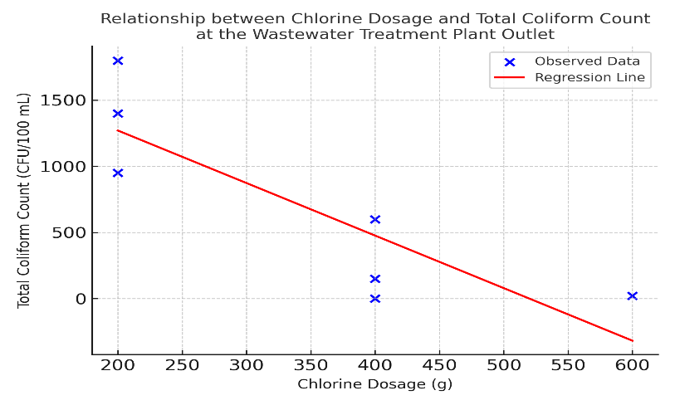
Figure 2. Relationship between Chlorine Dosage and Total Coliform Count at the Wastewater Treatment Plant Outlet.
Linear Regression Analysis of Chlorine Dosage and Total Coliform Reduction in Hospital Wastewater Treatment. The linear regression analysis between chlorine (calcium hypochlorite) dosage and Total Coliform count at the hospital wastewater treatment plant (WWTP) outlet demonstrates a strong and statistically significant negative correlation. The observed data reveal a consistent decreasing trend, wherein increasing the chlorine dosage from 200 grams to 600 grams leads to a substantial reduction in Total Coliform counts, culminating in complete elimination (0 CFU/100 mL) at the highest dose. The derived regression equation, Total Coliform = 1928.22 − 3.475 × Chlorine Dose, suggests that for every additional gram of chlorine applied, the bacterial load is predicted to decrease by approximately 3.48 CFU/100 mL.
The coefficient of determination (R² = 0.749) further substantiates this relationship, indicating that 74.9% of the variation in Total Coliform levels can be explained by differences in chlorine dosage. This finding underscores chlorine dosage as the principal determinant of disinfection performance within the hospital Wastewater Treatment Plant system. (Suwannasin et al., 2024)
The regression analysis demonstrates that a chlorine dosage between 400 and 600 grams is highly effective in meeting the national wastewater discharge standard for Total Coliform, as specified in Ministry of Health Regulation No. 3 of 2020 (<3000 CFU/100 mL). A dosage of 600 grams results in complete microbial elimination, offering a substantial safety margin. However, further increases beyond this statistically optimal range must be carefully evaluated due to potential chemical and environmental risks, such as elevated effluent pH and the formation of disinfection by-products like trihalomethanes (THMs), which are known carcinogens. This regression model not only provides strong empirical support for the disinfection efficacy of chlorination but also serves as a scientific foundation for optimizing hospital wastewater treatment practices in a manner that is both effective and environmentally sustainable. (Saufi, Arifin and Hamzani, 2024). To further quantify the strength of association between chlorine dosage and Total Coliform reduction, a Pearson correlation analysis was conducted, as presented in Table 6.

Table 6. Pearson Correlation between Chlorine Dosage and Total Coliform Count in Hospital WWTP Effluent
Variable | Chlorine_Dosage | Total_Coliform_Outlet
Chlorine_Dosage | 1 | -0,923
otal_Coliform_Outlet | -0.923 | 1

Note: The negative Pearson correlation coefficient (r = -0.923) reflects a statistically strong inverse association between chlorine dosage and Total Coliform concentration, indicating that higher chlorine application corresponds with lower microbial contamination in the hospital wastewater effluent.

The Pearson correlation coefficient of -0.923 between chlorine dosage and Total Coliform levels in hospital wastewater effluent indicates a very strong negative relationship—meaning that higher chlorine doses consistently lead to a significant reduction in microbial contamination. This supports earlier statistical analyses, which showed meaningful differences between lower (200 g) and higher (400–600 g) chlorine dosages. Based on these findings, a 400-gram dosage is considered optimal, as it effectively reduces Total Coliform to meet regulatory standards while avoiding unnecessary chemical use. Interestingly, this is consistent with the study by Sri Arofah Mulyati (2022), where a 200-gram dosage was sufficient to reduce Coliform by 98.55% in animal facility wastewater. The difference in dosage reflects the varying complexity of wastewater types hospital effluent tends to carry a heavier microbial and chemical load, thus requiring a stronger disinfection approach to achieve the same level of safety. (Mulyati et al., 2024). Moreover, disinfection effectiveness is collectively influenced by factors such as treatment scale, wastewater volume, WWTP design, contact time, and environmental conditions including pH and temperature. Methodological differences also play a role; while Mulyati’s study emphasized minimum effective dosing under controlled laboratory conditions, the present study aimed for maximum disinfection efficiency with a broader safety margin to ensure consistent effluent quality under real-world operational settings.(Temesgen et al., 2023)
A supporting study by Saufi, Arifin, and Hamzani (2024) demonstrated that administering 1–2 chlorine tablets (200–400 mg) effectively reduced Total Coliform by up to 99.9% in the effluent of the Banjarmasin Surgical Special Hospital’s WWTP, meeting the microbiological discharge standard (<3,000 MPN/100 mL). However, its impact on ammonia was statistically insignificant (p = 0.699), with initial concentrations of 14.753–15.962 mg/L only partially reduced (31.8–72.8%), remaining above the permissible limit of 10 mg/L. These findings confirm that while chlorination is highly effective for microbial disinfection, it is inadequate for chemical pollutants like ammonia. As such, integrating advanced treatment technologies such as Advanced Oxidation Processes (AOP), biological nitrification, or intensive aeration is necessary to meet comprehensive effluent standards. This study complements the present research by highlighting both the strengths and limitations of chlorination, thereby reinforcing the need for context-specific and integrated treatment strategies.(Saufi, Arifin and Hamzani, 2024)
  - Breakpoint Chlorination and Cost-Efficiency Analysis
Breakpoint chlorination analysis was conducted to determine the optimal chlorine dosage that achieves the highest disinfection efficiency against Total Coliform in hospital wastewater. The resulting curve demonstrates that increasing the chlorine dosage from 200 g to 400 g leads to a substantial reduction in Total Coliform counts, with removal efficiency exceeding 99%. However, further increasing the dosage to 600 g yields no significant additional benefit, indicating that the breakpoint where all interfering substances such as ammonia and organic matter have been fully oxidized—has been reached at 400 g. Beyond this point, excess chlorine merely results in free residual chlorine without improving disinfection efficacy. (Li et al., 2023) Accordingly, a dosage of 400 g is considered optimal, balancing microbiological effectiveness with efficient chemical usage. To complement this analysis, a cost-efficiency simulation was performed to assess the practical applicability, assuming a calcium hypochlorite tablet price of IDR 50 per gram and a treatment volume of 1 m³. The cost and effectiveness details are as follows:
- 200 g dosage: IDR 10,000/m³ with an estimated Total Coliform reduction efficiency of approximately 68%;
- 400 g dosage: IDR 20,000/m³ with a disinfection efficiency of 99.87%;
- 600 g dosage: IDR 30,000/m³ with only a marginal additional efficiency gain of 0.13%.
These findings indicate that the 400 g dosage not only meets the regulatory effluent quality standard for hospital wastewater (≤3,000 MPN/100 mL, as per Indonesian Ministry of Environment and Forestry Regulation No. 68 of 2016), but also represents the most rational choice in terms of cost and sustainability. The cost-efficiency curve reinforces that increasing the dosage beyond 400 g is economically unjustifiable, making it unsuitable for practical implementation in routine wastewater treatment operations. (Mugwili et al., 2023) (fig 3)

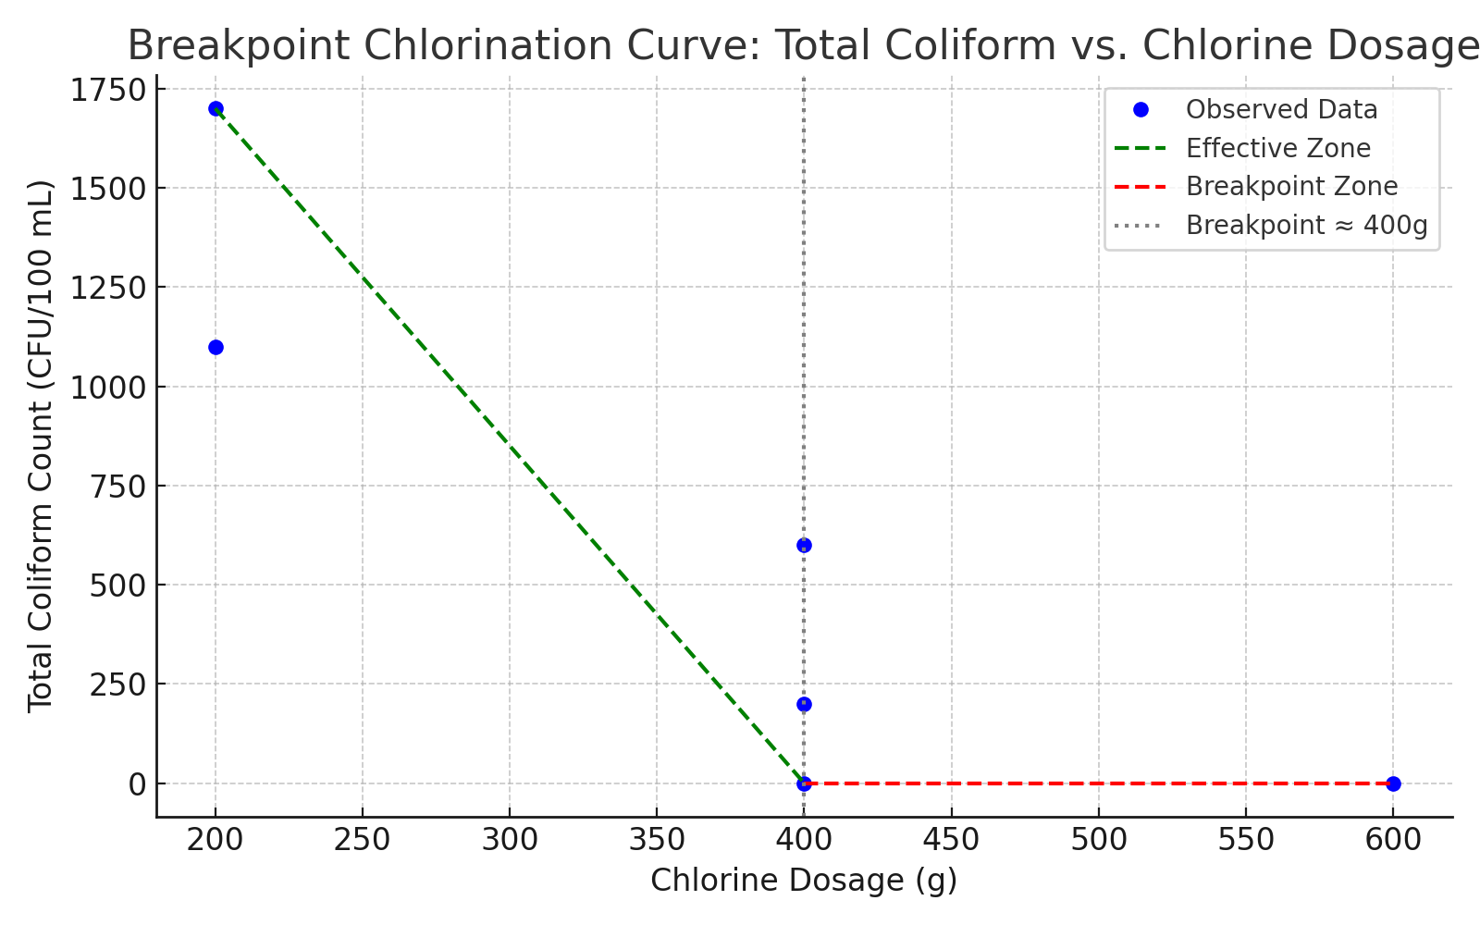
Figure 3. Breakpoint chlorination curve illustrating the relationship between chlorine dosage and Total Coliform reduction.

These findings are consistent with the preceding breakpoint chlorination analysis, wherein the 400 g dosage not only represents the microbiological disinfection threshold, but is also reinforced from an economic perspective as the most cost-efficient option for hospital wastewater treatment.

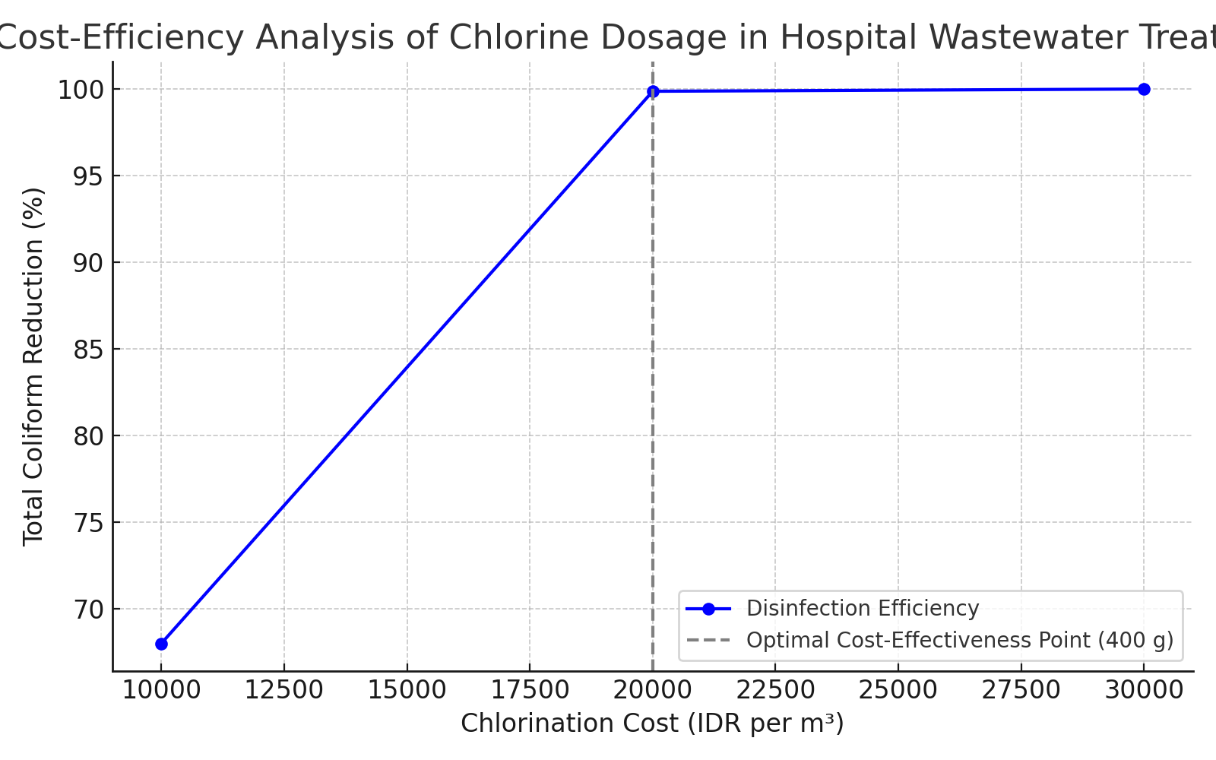
Figure 4. Cost-efficiency analysis of chlorination based on chlorine dosage and Total Coliform reduction effectiveness.
The cost-efficiency analysis of chlorine dosage in hospital wastewater treatment, as depicted in the corresponding graph, demonstrates a strong and consistent relationship between chlorine application costs and microbial disinfection efficiency. As chlorine dosage increases from 200 g to 400 g, the removal efficiency of Total Coliform rises significantly, reaching nearly complete elimination. This optimal point, which corresponds to an operational cost of IDR 20,000 per cubic meter, marks the most efficient balance between disinfection performance and financial expenditure. At this dosage level, all interfering substances such as ammonia and organic matter have likely been oxidized, allowing for maximum microbial inactivation. Beyond this point, further increases in chlorine dosage—such as to 600 g, equating to a cost of IDR 30,000 per cubic meter do not yield additional meaningful reductions in Total Coliform levels. This plateau in effectiveness indicates that the breakpoint chlorination threshold has already been reached, and any excess chlorine simply remains as free residuals, offering no added sanitary benefit but contributing to unnecessary chemical usage and increased operational costs. From a technical perspective, this practice becomes inefficient, and from an economic standpoint, it undermines cost-effective resource allocation.(Rosende et al., 2020) Therefore, the 400 g chlorine dosage serves a dual role: it represents both the microbiological breakpoint ensuring compliance with regulatory effluent standards such as those outlined in the Indonesian Ministry of Environment and Forestry Regulation No. 68 of 2016 and the economic optimum for hospital wastewater treatment. This dosage achieves the desired public health outcomes while minimizing waste and promoting sustainability. These findings reinforce the importance of integrating microbiological efficacy with cost-efficiency principles in wastewater treatment systems, especially in institutional settings like hospitals where operational sustainability and environmental compliance are critical.(Pariente et al., 2022)
- CONCLUSION

This study provides a comprehensive evaluation of chlorination performance in hospital wastewater treatment, identifying the optimal balance between microbial control, physicochemical stability, and environmental safety. Variations in chlorine tablet dosage and contact time significantly influenced Total Coliform reduction, with statistical analyses (ANOVA, t-tests, correlation, and regression) confirming that 74.9% of the variation in Total Coliform levels was attributable to chlorine dosage, showing a strong inverse correlation (r = –0.923). Incremental dosage increases from 200 g to 600 g resulted in substantial microbial reductions, with 400 g identified as the most efficient dose.

Chlorine dosage also significantly affected pH (p < 0.05), while temperature remained stable and non-significant across treatments. Maintaining pH within the optimal range of 6.5–7.5 is critical to preserving disinfection efficiency and preventing the formation of harmful by-products such as trihalomethanes (THMs). All observed pH (7.2–8.1) and temperature (28.8–29.3 °C) values complied with the discharge limits set by the Indonesian Ministry of Environment and Forestry Regulation No. 68 of 2016, confirming environmental safety.

From a technical and operational perspective, a 400 g chlorine dose with a 40–50 minute contact time is recommended as the most effective and sustainable strategy. Higher doses, such as 600 g, achieved complete Total Coliform elimination but offered no significant added benefit while potentially increasing THM risks. Continuous monitoring of pH, temperature, chlorine dosage, and Total Coliform, coupled with operator training, is essential for consistent process control. Future studies should investigate THM formation potential, residual free chlorine, and the cost-effectiveness of dosing strategies to ensure hospital wastewater treatment remains safe, efficient, and environmentally responsible.

REFERENCE
Aib, H. et al. (2024) ‘Evaluating the efficiency of wastewater treatment plants in the Northern Hungarian Plains using physicochemical and microbiological parameters’, Water, 16(24), p. 3590. doi:10.3390/w16243590.
Ajala, O.J. et al. (2022) ‘A review of emerging micro-pollutants in hospital wastewater: environmental fate and remediation options’, Results in Engineering, 16, p. 100671. doi:10.1016/j.rineng.2022.100671.
Azuma, T. and Hayashi, T. (2021) ‘On-site chlorination responsible for effective disinfection of wastewater from hospital’, Science of The Total Environment, 776, p. 145951. doi:10.1016/j.scitotenv.2021.145951.
Azwarudin, A. et al. (2023) ‘Suitable technology for a household scale workshop systems for the treatment of wastewater’, Jurnal Pijar Mipa, 18(3), pp. 430–435. doi:10.29303/jpm.v18i3.4927.
Coaguila-Llerena, H. et al. (2024) ‘Calcium hypochlorite cytotoxicity mechanism in fibroblasts and effect on osteoblast mineralization’, International Endodontic Journal, 57(1), pp. 64–77. doi:10.1111/iej.13983.
Connelly, L.M. (2021) ‘Introduction to analysis of variance (ANOVA)’, Medsurg Nursing, 30(3), pp. 218–221. doi:10.62116/MSJ.2021.30.3.218.
Fallah, N. et al. (2025) ‘Chemical disinfection of secondary municipal wastewater effluents: optimizing CT dose and tailing effects through high-intensity mixing’, Water Environment Research, 97(4), p. e70066. DOI:10.1002/wer.70066
Ge, B. et al. (2025) ‘Independent laboratory validation of a Salmonella Loop-mediated isothermal amplification assay in 27 human and animal food matrices of 9 ISO food categories’, Food Microbiology, p. 104821. DOI: 10.1016/j.fm.2025.104821
Harahap, J. et al. (2021) ‘A review: Domestic wastewater management system in Indonesia’, IOP Conference Series: Earth and Environmental Science, 739, p. 012031. doi:10.1088/1755-1315/739/1/012031.
Kumari, M. and Gupta, S.K. (2022) ‘Occurrence and exposure to trihalomethanes in drinking water: a systematic review and meta-analysis’, Exposure and Health, 14(4), pp. 915–939. doi:10.1007/s12403-022-00467-3.
Li, Q. et al. (2023) ‘Chlorine-mediated electrochemical advanced oxidation process for ammonia removal: mechanisms, characteristics and expectation’, Science of The Total Environment, 896, p. 165169. doi:10.1016/j.scitotenv.2023.165169.
Mompremier, R. et al. (2024) ‘Study of the combined effect of temperature and free chlorine concentration on the chlorine bulk decay coefficient in water supply systems’, Water Supply, 24(12), pp. 4046–4056. 10.2166/ws.2024.255
Mugwili, M.E. et al. (2023) ‘A pilot study on the removal of ammonia from aqueous solution using the integration of struvite synthesis and breakpoint chlorination’, Advances in Environmental Technology, 9(2), pp. 85–97. doi:10.22104/aet.2023.5912.1623.
Mulyati, T.A. et al. (2024) ‘Identification of pathogenic bacteria in liquid waste from “X” Hospital in Kediri City’, Ad-Dawaa’ Journal of Pharmaceutical Sciences, 7(2), pp. 109–116. doi:10.24252/djps.v7i2.50196.
Nishmitha, P.S. et al. (2025) ‘Understanding emerging contaminants in water and wastewater: a comprehensive review on detection, impacts, and solutions’, Journal of Hazardous Materials Advances, p. 100755. doi:10.1016/j.hazadv.2025.100755.
Pariente, M.I. et al. (2022) ‘Critical review of technologies for the on-site treatment of hospital wastewater: from conventional to combined advanced processes’, Journal of Environmental Management, 320, p. 115769. doi:10.1016/j.jenvman.2022.115769.
Rolbiecki, D. et al. (2022) ‘The impact of chlorine disinfection of hospital wastewater on clonal similarity and ESBL-production in selected bacteria of the family Enterobacteriaceae’, International Journal of Environmental Research and Public Health, 19(21), p. 13868. doi:10.3390/ijerph192113868.
Romanovski, V. et al. (2024) ‘Comparative analysis of the disinfection efficiency of steel and polymer surfaces with aqueous solutions of ozone and sodium hypochlorite’, Water, 16(5), p. 793. doi:10.3390/w16050793.
Rosari, N.L. and Purwanti, I.F. (2020) ‘Design of sewerage system and wastewater treatment plant in Asemrowo, Surabaya, Indonesia’, IOP Conference Series: Earth and Environmental Science, p. 012021. DOI:10.1088/1755-1315/506/1/012021
Rosende, M. et al. (2020) ‘Cost-effectiveness analysis of chlorine-based and alternative disinfection systems for pool waters’, Journal of Environmental Engineering, 146(1), p. 04019094. doi:10.1061/(ASCE)EE.1943-7870.0001610.
Saufi, Y., Arifin, A. and Hamzani, S. (2024) ‘The impact of chlorine tablets on ammonia and MPA coliform parameters in the effluent of the sewage treatment plant at Banjarmasin Surgical Special Hospital Emergency 2023’, Global Health & Environmental Perspectives, 1(2), pp. 101–106. doi:10.61848/ghep.v1i2.
Senthilkumar, M. et al. (2021) ‘Enumeration of Rhizobia: Most-Probable-Number (MPN) Technique’, in Rhizobia. Springer, pp. 9–17. doi:10.1007/978-1-0716-1080-0_2.
Shafik, W. (2025) ‘SDG 6: Clean Water and Sanitation—Smart Water Management’, in Factoring Technology in Global Sustainability: A Focus on the Sustainable Development Goals. Springer, pp. 223–248. DOI 10.1088/1755-1315/506/1/012021
Stevens, M., Ashbolt, N. and Cunliffe, D. (2003) ‘Review of coliforms as microbial indicators of drinking water quality’, NHMRC, Biotext Pty Ltd, Canberra. ISBN: 1864961651, Online ISBN: 1864961597
Sulistiawati, L.Y. (2022) ‘Challenges in marine plastic pollution regulation in Indonesia’, Asia Pacific Journal of Environmental Law, 25(1), pp. 100–118. doi:10.4337/apjel.2022.01.05.
Susetyaningsih, R. et al. (2023) ‘Water quality assessment to improve the ecological function of waters: the South Coast of the Yogyakarta Shrimp Farming Area’, Journal of Water and Land Development. doi:10.24425/jwld.2023.147244.
Suwannasin, S. et al. (2024) ‘Reduction and regrowth of total coliform bacteria, fecal coliform bacteria, and E. coli after chlorine and peracetic acid disinfection in the hospital effluent’, ScienceAsia, 50(1), p. 2024026. https://doi.org/10.2306/scienceasia1513-1874.2024.026
Temesgen, G. et al. (2023) ‘Evaluation of chlorination efficiency on improving microbiological and physicochemical parameters in water samples available in Sheble Berenta district Amhara region, Ethiopia’, Applied Water Science, 13(5), p. 120. DOI: 10.1007/s13201-023-01922-5
Titaley, C.R. et al. (2020) ‘Health care–seeking behavior of children with acute respiratory infections symptoms: analysis of the 2012 and 2017 Indonesia Demographic and Health Surveys’, Asia Pacific Journal of Public Health, 32(6–7), pp. 310–319. doi:10.1177/1010539520944716.
Trautmann, E. et al. (2021) ‘Hydrogen peroxide versus sodium hypochlorite: all a matter of pH?’, Journal of Endodontics, 47(2), pp. 297–302. doi:10.1016/j.joen.2020.10.016.
Wang, Y. et al. (2025) ‘Mechanism and risk control of chlorine-resistant bacteria in drinking water supply systems: a comprehensive bibliometric analysis’, Water, 17(7), p. 956. doi:10.3390/w17070956.
Yan, S. et al. (2020) ‘Guidelines for hospital wastewater discharge’, in Current Developments in Biotechnology and Bioengineering. Elsevier, pp. 571–597. doi:10.1016/B978-0-12-819722-6.00016-X.
Yannawar, V.B. (2022) ‘Most probable number [MPN] Coliform test to detect the presence of coliform from Godavari River water of Nanded city, Maharashtra, India’, Indian Journal of Applied & Pure Biology, 37(2), pp. 478–487. DOI: 10.47422/ijapb.v37i2.23
Zhu, G. et al. (2021) ‘Multi-linear regression model for chlorine consumption by waters’, Environmental Engineering Research, 26(4), p. 200402. doi:10.4491/eer.2020.402.

