Nanoplastics: An Upcoming Challenge to Ecological Health

ABSTRACT
Plastic is a polymer that revolutionised the world as a cheap and durable alternative to metal, glass, fibre, and paper. The civilisation adopted this straightforward alternative, which has indiscriminately resulted in new ongoing challenges. The utilisation and disposal of synthetic materials continues to present a significant challenge that is frequently neglected because of socioeconomic influences. Plastic has an extended shelf life, presenting challenges regarding its disposal; typically, disposal methods involve landfills and water bodies. Environmental factors like UV radiations and heat contribute to the partial disintegration of these plastics into smaller particles, referred to as microplastics, which may be found in terrestrial and aquatic environments. These microplastics subsequently degrade into smaller particles, known as nanoplastics, measuring just a few microns. The atmosphere enables the dispersion of nanoparticles in aerosol form across different regions. Water bodies contain nanoplastics due to industrial discharge, wastewater effluents, and the degradation of microplastics. Nanoplastics have been detected in food and water, leading to exposure to biota from where they can be easily consumed and biomagnified, causing a disarray in the existing food chains in terrestrial and aquatic ecosystems. Nanoplastics escalate risk because of their minuscule dimensions, capacity to penetrate biological barriers, and engagement with cellular structures. Nanoplastics can cause cellular stress, trigger inflammation, and damage DNA in living cells, leading to irreversible damage. Nanoplastics represent a growing issue for both the ecosystem and human health. Their extensive occurrence and potential risks to human health demand immediate action for mitigation.
Keywords: Nanoplastics, synthetic polymers, biomagnification, trophic transfer, ecotoxicity

- INTRODUCTION

The ability of plastics to be moulded into various shapes, along with attributes like strength, flexibility, non-toxicity, light weight, and economic manufacturing, has led to their widespread use worldwide. From 1950 to 2017, around 9.2 billion metric tons of plastic were produced, nearly half of that total occurring since 2004. According to preliminary estimates, the world's plastic production in 2023 surpassed 400 million metric tonnes, and is expected to cross over 1.3 billion tonnes annually by 2060. Figure 1 shows a diversity of different plastic polymer types used for their durability, heat resistance, and mouldability in various economic sectors of the society. The data for the same has been procured from Rai et al., (2021).
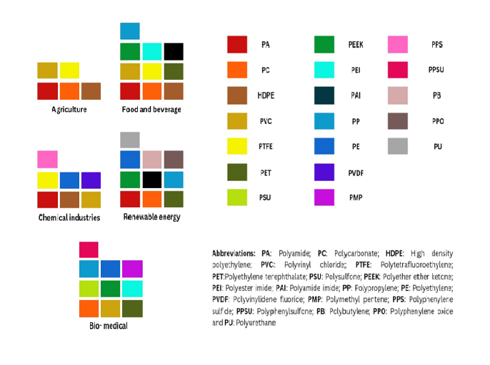
Fig. 1: Chart showing diversity of different types of plastics found in different sectors of the economy, ranging from agriculture, food and beverage industries, chemical industries, renewable energy, and the biomedical field.

Since production is high, the waste generated will also be in ginormous quantities. Based on the data obtained from the OECD Global Plastic Outlook, 2022, approximately 0.5% of the 353 million tonnes of generated plastic waste ends up in the ocean (OECD, 2022). Out of this amount, 1.5 million tonnes remain at the shore, 0.2 million tonnes sink to the bottom, and nearly 0.1 million tonnes are moved offshore on the surface, as illustrated in Figure 2 below.

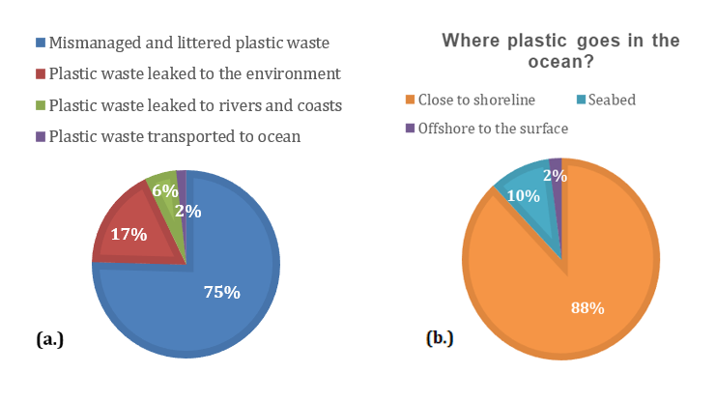
Fig. 2: The pie chart (a) shows the fate of plastic waste generated globally, with the percentages of all possible fates mentioned. The second chart (b) represents the destiny of plastic in the oceans.

From these plastic items, if improperly disposed of or even when mechanical or thermal deviations are added, they disintegrate into small microplastics, which further decompose into nanoplastics, which easily find their way into terrestrial and aquatic ecosystems. These nanoplastics also form part of particulate matter in the air as they are synthetically added to aerosols such as pesticides, deodorants, cosmetics, and even certain sprayable drugs. These plastic byproducts bioaccumulate within ecosystems, drastically influencing the biota found therein. Due to their nanosize, they can produce toxic effects by bypassing biological barriers (Kwon et al., 2020) and to alter the makeup of the gut microbiota, which may impact immunological and metabolic processes (Yong et al., 2020). Based on the studies, nanoplastics can induce inflammation and oxidative stress in cells, which can lead to cytotoxicity (Lehner et al., 2019). Through mimicking or interfering with hormonal action, nanoplastics can interfere with endocrine processes in animals, impacting their reproductive system (Gigault et al., 2021).

- SOURCES OF NANOPLASTICS IN THE ENVIRONMENT

Plastic, being an anthropogenic product, has its origin mostly on the land. Several human actions and natural phenomena are the terrestrial sources of nanoplastics, and they contribute enormously to contamination. Main sources include breakdown of plastic debris, like building materials, in agriculture, and packaging materials, which weather and are eroded due to mechanical action, and exposed to sunlight (da Costa et al., 2016). The other key contributor is the discharge of man-made fibres from clothing manufacturing (Prata et al., 2020), which leach into rivers and soil via sludge application and wastewater. Tire wear particles, generated through the abrasion of vehicle tires on roadways, release nanoplastics into roadside soil and urban runoff (Kole et al., 2017). Using biosolids and compost contaminated with plastic residues not only enhances soil contamination, but also leads to the breakdown of plastic mulch films into nanoplastics in the long run (Corradini et al., 2019). In addition, nanoplastics find their way into the environment directly through industrial processes such as garbage mishandling, recycling, and plastic manufacturing feedstocks and from air-blasted pellets or powdered plastic resin spills (Geyer et al., 2017; Zbyszewski et al., 2014). These terrestrial sources provide nanoplastics with a route to aquatic ecosystems and the atmosphere, intensifying their environmental dispersion and possible effects, as shown in Figure 03 below:

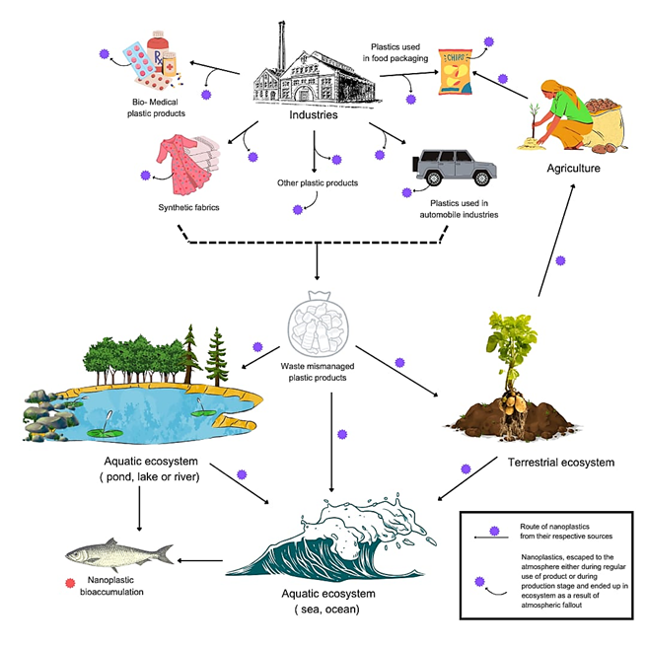
Fig. 3: Image showing the possible entries of nanoplastics in the environment.

Cosmetics and cleaning products released into household wastewaters are also the sources of micro- and nano-pollutants along with the derivatives of nanoimaging, nanosensors and pharmaceutical products in water bodies (Hernandez et al., 2017). Most recent research indicated other sources from synthetic clothing, atmospheric deposition, and even plastic in tea bags (Prata et al., 2020). Another source of micro- and nanoplastics is the fragmentation of large plastic items (Eerkes-Medrano et al., 2015). Current advances in 3D printing and the employment of polystyrene foam (Zhang et al., 2012), which is easily accessible for small-scale production and rapid prototyping, are some of the industrial processes that discharge nano-sized polymer particles measuring approximately 20 to 220 nm. The application of polymeric nanoparticles and nanocapsules in the biomedical field could also contribute to the environmental availability of these products (Pohlmann et al., 2013). These plastic products (like: plastic films, food packages, fishing equipment, etc.) or plastic derivatives (like: plastic pellets) when introduced into an aquatic environment get disintegrated into microplastics under a range of physio-chemical and biological processes (Horton et al., 2017), thereby acting as secondary sources of microplastics. Ship-generated litter, trash thrown away after recreational parties, and mismanaged plastic gears in fishing fleets are additional entries of plastics in aquatic bodies (European Commission, 2019). The microplastics that emerge from these secondary sources generally get further broken down into nanoplastics (Dawson et al., 2018), which can penetrate and bioaccumulate in food chains. Airborne pollutants can also carry nanoplastics by adsorbing them from the air. Nanoplastics can reach freshwater via wastewater treatment plants, agriculture, aquaculture, fishing, and air transport (Facciolà et al., 2021). The amount of nanoplastics in freshwater will be augmented due to their release from sewage sludge that is not fully filtered or retained in wastewater treatment (Vance et al., 2015). Such particles are smaller than what can be completely removed by traditional wastewater treatment processes. Rivers transport micro-sized particles, which they release into coastal and marine ecosystems. Moreover, fishing nets and garbage disposal from ships and boats are direct ocean-based sources (Wang et al., 2021) and provide more potential sources of nanoplastics.

- MIGRATION OF NANOPLASTICS IN THE ENVIRONMENT

The tiny size, surface features, and interactions with environmental factors drive nanoplastics to migrate in complex modes in the environment. Inert nature and low densities enable nanoplastics to migrate between the various components of an ecosystem, such as by flow between freshwater bodies, oceanic long-distance transport with marine currents, and wind-supported dispersion (Du et al., 2021). Their potential for toxicity to a large degree is controlled by their migration from source to sink, as they travel. Their persistence and accumulation in freshwater and terrestrial systems further justifies their classification as significant sinks, and nanoplastics move in both directions through several pathways from freshwater bodies (dominant sink) to land (dominant source). They (nanoplastics) can either drift in the water column or complex with organic matter for deposition into sediments (Koelmans et al., 2022). Of the nanoplastics, some are well known to move long distances, even remote areas of Arctic on the wind and air currents (Bergmann et al., 2019). If nanoplastics enter soil, they may stick to organic or inorganic particles and affect their mobility and bioavailability (de Souza Machado et al., 2018). They also recycle through food webs, owing to interactions with other organisms including microbes, plants and animals. These particles are highly contributed to the receiving waters from runoffs from industrial, recreational, urban and agricultural sites. They become loaded by flooding and irrigation in freshwater bodies and returned to the terrestrial ecosystem. About 70 to 80 percent of the total marine plastic waste originates at land. However, the transportation of nanoplastics from land to the marine environment is ruled by rivers. Once enter oceanic system, nanoplastics are widely distributed by waves, tides and oceanic current. Its surface area-based shipping by sea is indicative of their coverage of a wide region (Hamid et al., 2018). Moreover, as the vertical movement of nanoplastic to support their downward movement from the surface to bottom in form of a microbial biofilm (Wang et al., 2021). Airborne and oceanic spread can lead to such distribution worldwide. They can also act as condensation nuclei for clouds to form and travel far distances before precipitation brings the nanoplastics back to ground (Liu et al., 2019). The particles tend to settle via gravitational forces but are resuspended by environmental agencies such as wind or human actions. The release, suspension, and transport of nanoplastics in this complex interplay show this pervasive and persistent nanoplastic occurrence in ecosystems.

- FATE OF NANOPLASTICS IN THE ENVIRONMENT

Primary nanoplastics are produced for use in industrial operations, as biomedical manufacturing and for cosmetics, while secondary nanoplastics are formed through physio-chemical and biological processes such as the degradation of plastic products (Ter Halle et al., 2017). Complex environmental fate arises from physicochemical properties of nanoplastics, their interactive with natural components and environmental conditions (Gigault et al., 2018). Despite that, it is assumed that waterbodies would be places where these compounds will accumulate to higher levels, and the hydrophobic nanoplastic surface has a strong high degree of affinity for aggregation with other particles and organic matter of aquatic environment, leading to sedimentation and subsequent accumulation in benthic regions (Kooi et al., 2019). The behaviours of these systems are rather intricate because much of the marine debris remains floating on the ocean surface (Maximenko et al., 2012). Depending on their density, surface chemistry, and surrounding conditions, nanoplastics in water show a range of behaviour. Denser nanoplastics sink whereas buoyant ones remain floating on the water currents (Besseling et al., 2017). They are so small that they can penetrate soil pore, influence the microbial communities and the soil structure (Rillig et al., 2017). Nanoplastics experience numerous fragmentation processes in the environment. The settling of suspended solids, detritus and algae in hetero aggregation with nanoplastics is key to determine the fate and transmission of nanoplastics (Wang et al., 2015). Fate of nanoplastics is primarily controlled by the weathering and aggregate processes. There are a variety of stressors (environmental factors) like heat, water, UV radiation, oxidants, microorganisms, or a mix thereof that are involved in the environmental ageing of the nanoplastics (Lambert & Wagner, 2017) as illustrated in figure 4. To understand their environmental fate, aggregation is also an important theme (Wegner et al., 2012). Plants can take up nanoplastics using their roots, potentially affecting the efficacy with which they uptake nutrients and grow. As reported by Li et al. (2020), nanoplastics may pass from plant tissue to herbivorous organisms and thereby become part of the food chain. Organisms may ingest nanoplastics, leading to trophic transfer and bioaccumulation. Due to their persistence, nanoplastics raise concerns regarding long-term impacts on the environment. They possess the capability of altering the ecosystem forever if they become stored in sediments and biota. Additionally, nanoplastics serve as carriers for pollutants like heavy metals and enhance their toxicity (Koelmans et al., 2022).
Fig. 4: Diagram showing the decomposition reactions of significant plastic types mentioned in Fig. 1 of the text.

- POTENTIAL TOXICITY OF NANOPLASTICS IN NATURAL ECOSYSTEMS

As discussed earlier, introduction of nanoplastics from both primary and secondary sources severely affect the ecosystems, primarily the aquatic ecosystems in terms of possible bio toxicity by microbial biofilms resultant from micro-nanoplastic associations, acting as a potential source, carrier and sink of pollutants and also move up the trophic levels through planktotrophic food chain (Wang et al., 2015). Plastic characteristics like surface roughness and functional groups may impact the growth of microorganisms in biofilms, where rough surfaces, for instance, encourage the attachment of microorganisms. Particle size also influences formation of biofilms meanwhile environment is also a crucial factor in controlling biofilm formation like increase in temperature increases the microbial diversity inhabiting the biofilm and factors like increased salt concentration, decreases biofilm growth pointing to a possibility of much diverse biofilms to be formed in tropical freshwaters thereby increasing the possibility of organic pollutants and metal ions to enter and disrupt freshwater food web via these biofilms (Wang et al., 2021). As microplastics and nanoplastics break down, additives like triclosan, organotins, phthalates, flame retardants, bisphenol, etc. release in the ecosystems (Sait et al., 2021), therefore acting as pollutants, where some of them raise serious health concerns in humans along with the ecosystem in which these are present. Nanoplastics are also extensively dispersed in the atmosphere and act as a vector for pollutants like PM 2.5 (Dris et al., 2017), which may enter the human respiratory systems or aquatic ecosystems during atmospheric fallouts and result in further complications. The third possible source of harmful consequences by nanoplastics is the buildup of nanoplastics across trophic levels. As per Xu et al., (2021), nanoplastics get ingested by several organisms leading to many cellular problems. It has detrimental effects on fish development at population level, where their intestinal tract shows a slow pace of elimination of nanoplastics deposited within the body (Pitt et al., 2018). Kim et al., (2022) investigated exposure to nanoplastics can cause neurotoxic effects and decrease fish’s ability to swim. Additionally, according to Yeo et al., (2023), maternal transfer is another pathway for the rotifer's (Brachionus koreanus) offsprings to encounter nanoplastics which impeded growth. Tussellino et al., (2015) demonstrated that these nanoplastics can cross biological barriers when examined their distribution in tadpoles of African clawed frogs (Xenopus laevis). Nanoplastics can be widely distributed in the cytoplasm and had multiple entry points in the body. The particle size of nanoplastics also have a role on its biological accumulation and subsequent transportation. The nanoplastics with large size and strong affinity have more attachment points with bio macromolecules and thereby a high level of accumulation in organisms across trophic levels (Loos et al., 2014). Subsequently some animals are also seen to adapt to the presence of nanoplastics in environment like planaria have been shown to modify their eating habits. Cesarini et al., (2023) discovered that planaria (Girardia tigrine) showed no change in movement speed but a significant drop in feeding rate following exposure to nanoplastics as these plastic bits can generate a sense of false fullness.
Nanoplastics have been demonstrated to impact the soil microbiota in terrestrial ecosystems as they can inhibit the action of enzymes involved in the carbon, nitrogen, and phosphorus cycle. The presence of gut microbes in oligochaete Enchytraeus crypticus notably dropped after feeding oatmeal supplemented with polystyrene nanoparticles (Zhu et al., 2018). Till now, the discussion was limited to the fauna of an ecosystem, but it is required to understand that nanoplastics may potentially also affect plant development also. In addition to being translocated to aboveground tissues, nanoplastics can be absorbed and retained within the roots. Minute nanoplastics (∼ 30 nm) can cross the nuclear membrane, and larger nanoplastics can accumulate in the cytoplasm, disrupting the structure and function of chromatin. But in case of aquatic ecosystems, a contradictory phenomenon of notable rise in root biomass has been observed in Myriophyllum spicatum and Elodea sp., in response to polystyrene nanoplastics. It is thought that nanoplastics sorption onto the root surface prevents nutrients from being absorbed (van Weert et al., 2019). The macrophytes used in the study boosted their number of roots, length, and diameter to better absorb and transport vital nutrients, thus boosting the root biomass and overcoming this stress. The introduction of nanoplastics in biotic systems usually results in a range of events, as mentioned in the following diagram (Figure 5).

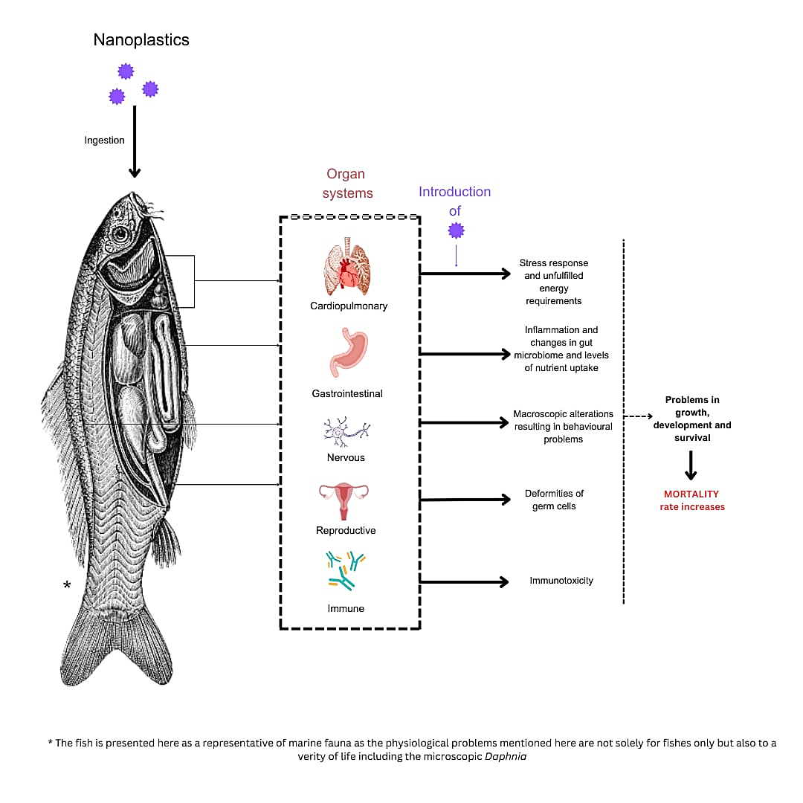
Fig. 5: The above image shows possible effects of nanoplastics on aquatic creatures' cells and physiology.

Nanoplastics can accumulate in tissues linked to different physiological systems (shown in Figure 5), and can trigger intracellular reactions which eventually end up in increasing the mortality rate of the respective organism. Although there is a significant research gap on this subject, nanoplastics frequently impact mitochondrial biology and metabolism, affecting some of the main cellular processes. The physiological and biological effects after ingestion of nanoplastics in terrestrial and aquatic life have been studied, and based on the current information, the toxic effects caused by nanoplastics in some organisms from both natural ecosystems have been summarized below in Table 1.

Table 1: Table showing a selection of studies based on some faunal interactions with nanoplastics. Polystyrene (PS) fluorescence is used to study the presence of these plastic particles in arthropods and larval models.

Animal species | Nanoplastic |  |  | Observations | Reference
Animal species | Polymer type | Particle size | Concentration | Observations | Reference
Aquatic ecosystem
Water flea  (Daphnia pulex) | PS | 70nm | 80.02 µg/ml | ROS production and resulting oxidative stress,  AMPK activation | (Liu et al., 2018)
Water flea  (Daphnia magna) | PS | 20 nm, 200 nm | 50 mg/L | Decreased moulting, growth and reproduction | (Pikuda et al., 2022)
Goldfish larvae (Carassius auratus) | PS | 70 nm | 10,  100, 1000 μg/L | Disordered cell arrangement | (Yang et al., 2020)
Rainbow trout (Oncorhynchus mykiss) | PS | 220 nm | 0.3, 3 mM | Decrease in viability of cells | (Bussolaro et al., 2019)
Zebrafish Larvae (Danio rerio) | PS | 25 nm,  50 nm,  70 nm | 0.2, 2, and 20mg/L  1 mg/L  0.5 ppm, 1.5 ppm | Transcriptional alterations of pck1 | (Brun et al., 2019)
Adult freshwater prawn  (Macrobrachium nipponense) | PS | 500 nm | 0.04, 0.4, 4, and 40 mg/L | Decreased moulting and oxidative stress | (Fan et al., 2022)
Japanese medaka  (Oryzias latipes) | PS | 100 nm | 0, 10, 104, and 106 particles/L | Decreased immunity and oxidative stress resulted in tissue damage and reduced reproductive capacity | (Zhou et al., 2023)
Terrestrial ecosystem
Rat | PS | 40 nm | 1–10 mg/kg | Endocrine disruption; impairment in tissues. | (Amereh et al., 2020)
Worm  (Eisenia crypticus) | PS  (with Tetracycline (10 mg/kg)) | 50–100  nm | 1 g/kg | Dysbiosis of gut microbiome. | (Ma et al., 2020)
Worm  (Eisenia fetida) | PS | 10 nm | 1000 μg/kg | Increased mortality, loss of weight | (Jiang et al., 2020)
Giant African land snail  (Achatina fulica) | PS | 20 nm | 10 mg/kg w/w | retarded growth and movements | (Chae & An, 2020)
Worm  (Caenorhabditis elegans) | PS | 500 nm | 1.0 m /L | Increased neurotoxicity and mortality | (Lei et al., 2018)
Worm  (Caenorhabditis elegans) | PS | 50 nm, 200 nm | 86.8 mg/L | Hampered metabolic activities | (Kim et al., 2019)

Although studies on the possible physiological, behavioural, and biochemical alterations in diverse fauna of aquatic ecosystems after introduction of nanoplastics have been lower compared to those of microplastics, but are still higher compared to the studies related to nanoplastic introduction in terrestrial ecosystems (Zhang et al., 2021). The main reason for this is the sheer complexity of interaction and subsequent translocation of nanoplastics and its consequent impact from soil to plants and subsequent bioaccumulation in animals, thereby also affecting human life in the end (Rillig et al., 2017).

- EFFECTS OF NANOPLASTICS ON HUMANS

Ingestion, cutaneous exposure, and inhalation are possible routes of exposure to nanoplastics, which diffuse throughout the human body through the inhalation of aerosols containing nanoplastics and the penetration of nanoplastics into the capillary system (Lim et al., 2019). Ingesting nanoplastics is the most common and well-researched method of exposure. The extensive use of plastic items in storage of drinking water exposes consumers to extreme levels of plastics (Xu et al., 2019). People can consume millions of nanoplastic particles from a single teabag (Hernandez et al., 2017). The primary site for nanoplastic absorption is the gastrointestinal (GI) tract because of its large surface area. In vitro studies affirm that nanoplastics can penetrate intestinal villi and enter blood vessels, creating a protein-plastic complex referred to as the "protein corona". Compared to virgin nanoplastics, protein-coated nanoplastics have the potential to exert a higher cytotoxic and genotoxic effect (Gopinath et al., 2019). This is likely because the bimolecular corona on the nanoplastic surface enables the nanoplastics to evade the immune system and circulate for longer periods in the blood. Nanoplastics may have irreversible impacts on the immune system, as evidenced by a few in vivo and in vitro studies performed on humans and rodents, respectively. Some common cytotoxic effects of nanoplastics include apoptosis induction, disruption of iron transport, oxidative stress, and cytokine regulation (Forte et al., 2016). From personal care items or contaminated air, or water, nanoplastics may come into contact with human skin. The skin's stratum corneum and the hydrophobic nature hinder nanoplastics' ability to pass through skin in water (Lehner et al., 2019). However, exploiting personal care products may increase the likelihood that nanoplastics will penetrate. The decomposition of agricultural polyethylene sheets, wind-driven transportation of nanoplastics from sludge fertilisers, clothing release, and sea salt aerosols are some of the sources of nanoplastics in the atmosphere (Wright & Kelly, 2017). Particle size and concentrations determine the toxicity of airborne nanoplastics, and further research should examine the potential health consequences of inhaling nanoplastics.

- CHALLENGES WITH NANOPLASTICS

Nanoparticles pose significant environmental, biological, and socio-economic challenges. Some of these challenges are highlighted below:
- Environmental persistence: Nanoplastics are incredibly resilient and long-lasting. They are easily distributed over a variety of ecosystems, including freshwater, marine, and terrestrial settings, because of their small size. The majority of synthetic polymers break down slowly because they lack readily biodegradable functional groups and have strong carbon-carbon bonds (Gigault et al., 2018). Their tenacity increases pollutants and makes clean-up more difficult. As they resist degradation, their persistence in ecosystems is a major concern (Andrady, 2011).

- Bioaccumulation and biomagnification: Body uptake of nanoplastic occurs in fish and molluscs consuming tainted food and water, dermal uptake common in amphibians, and respiratory uptake in terrestrial organisms (Wright & Kelly, 2017; Mattsson et al., 2017; Kögel et al., 2020). Nanoplastics can potentially biomagnify because they have the potential to concentrate in organisms and transfer from trophic levels. This threatens human health and biodiversity through the food chain (Mattsson et al., 2017).

- Toxicological effects: Nanoplastics can be used to adsorb and carry toxic substances of metal and persistent organic pollutants. Additionally, they can induce oxidative stress, inflammation, cellular injury on living organisms (Lehner et al., 2019). Research also found that nanoplastics can interfere with or simulate hormone function and can disrupt endocrine activity, leading to compromised reproductive health (Gigault et al., 2021), and can change the structure of gut microbiota and affect metabolism and the immune system (Yong et al., 2020).

- Detection and quantification challenges: Because nanoplastics are nanoscale, they are difficult to locate and quantify in environmental samples. It severely constrains our understanding of how they have affected concentration, distribution (Mitrano et al., 2021). Since analytical methods, such as spectroscopy and microscopy, provide conflicting results, it is difficult to detect and characterize it due to the absence of standardised approaches for its detection (Gigault et al., 2018). However, it is difficult to sample and identify nanoplastics as they might be altered through degrading or aggregating (Mattsson et al., 2018).

- Possible health risks in humans: Nanoplastics can enter the body through the skin, nose and mouth. Sharma & Chatterjee (2017) indicate an initial line of research suggesting that if they were able to permeate a biological barrier such as the blood-brain barrier, they would cause systemic health complications. According to Lehner et al., (2019), nanoplastics are inflammasome and oxidative stress inducing, and can cause damage and be toxic for cells. It is thought that nanoplastics can disrupt gut microbiota (Kumar et al., 2021), hormone signalling, and consequently cause hormonal imbalances and related diseases (Campanale et al., 2020).

Challenges cannot be resolved by policy and regulatory loopholes, and socioeconomic implications of mitigation and industry impacts including aquaculture and fisheries complicate this situation. The regulation schemes cannot be applied because there are no standardized methods of monitoring and measuring nanoplastics. This slows down global actions against effective elimination of nanoplastic pollution (Gigault et al., 2018). Tremendous costs may be incurred by clean-up procedures for nanoplastics as well as the damages they inflict on the environment. In addition, the impacts have economic costs on communities dependent on fishing or aquaculture, such as those described in Duis & Coors (2016). The present approaches reduce the emerging risk associated with nanoplastics by combining technological innovation, regulatory mechanisms, as well as raising public consciousness.

- MITIGATION STRATEGIES

Although nanoplastic contamination is an environmental pollutant, combined intervention of prevention, clean up, and remediation approaches may minimize the effect of the contamination. Policy intervention, innovative approaches in waste handling, and biologics as interventions may effectively counter the challenge (Gigault et al., 2018). Future studies ought to aim at assessing and enlarging the sustainable technology’s long-term ecological consequences. Therefore, the major way of solving these problems in the wake of nanoplastics is through developing, enacting, and educating new policies and technologies for remediation. Eco-friendly alternatives of plastic may be compostable and biodegradable products such as polylactic acid and polyhydroxyalkanoates (Napper & Thompson, 2019). To reduce toxins from entering into the food chain in a sustainable fashion, biopolymers that adhere to and obstruct nanoplastic ingestion are therefore required. They may be used to capture nanoplastics in water bodies ahead of moving into higher trophic levels (Rochman et al., 2014). Technology around waste collection, recycling, and waste disposal can reduce the leakage of plastic to the environment to the extent of reducing it disproportionately. Advanced sorting methods, such as artificial intelligence-based recycling or chemical recycling, will guarantee more efficient processing of plastic and plastic fragmentation (Zhu et al., 2020). They tend to get into water bodies through effluent. Wastewater treatment processes that are effective, such as highly sophisticated filtration processes including membrane filtration, biochar filtration, and electrocoagulation, are suitable to capture the nanoplastics in wastewater treatment plants (Nguyen et al., 2019). Using these sophisticated technologies, nanoplastic pollution can be cut down in water bodies. Another way to limit nanoplastic pollution is break down of plastic with microbes and enzymes to worthless byproducts (Danso et al., 2018). There are certain types of bacteria and fungi, however, that can break plastics into less toxic byproducts. Two specific bacteria can degrade plastics at the molecular level, i.e. Pseudomonas aeruginosa and Ideonella sakaiensis (Yoshida et al., 2016). PETase and MHETase enzymes, according to Wei et al., (2017), can break down of polyethylene Terephthalate (PET) to its monomers as well as shorten the plastic persistence in nature. Actinobacteria and Bacteroidetes are the primary hosts of these enzymes in terrestrial and marine ecosystems respectively. Unfortunately, for other nature-accumulated polymers, there are no highly active enzymes so far known to degrade them. Genetically modified microorganisms can be studied to find and improve the degradation efficiency of such enzyme which could provide an effective solution for nanoplastic pollution. Recently, phytoremediation, employing plants to uptake pollutants, has also been a potential method to counteract nanoplastics in the environment where certain plants have the capability to absorb nanoplastics from water and soil (Wang et al., 2021). Plants like Salvinia molesta and Lemna minor can take up and entrap nanoplastics with their root system and transport them in their tissues, providing a natural method of decontamination in aquatic ecosystems (Li et al., 2020). The ability of artificial wetlands with aquatic vegetation like Typha latifolia (cattail) and Phragmites australis (common reed) to trap and filter nanoplastics and microplastics from wastewater has been investigated (Trevisan et al., 2022). This indicates that plastic remediation can be done using wetland plants, and the development of such wetlands along the coastline prevents pollution of sea habitats.
The governments and industries must implement policies in favour of biodegradable substitutes and circular economy schemes to restrict plastic waste. Policy development on restricted plastic production and use is the most dependable way of managing nanoplastic risks. Since policymakers' interest in new pollutants often reaches its peak a few years later than scientific focus, additional interactions between researchers and policymakers are required to translate evidence-based knowledge into effective results as early as possible (Halden, 2015). As plastic items are an indispensable part of daily life, creating public awareness of nanoplastics can be an effective and feasible means of minimizing the risks related to them. This education and awareness are elementary but ineffective, as it often takes months or years to alter the perceptions of people, and any such process must be supported by quantifiable scientific evidence (Van der Linden et al., 2015).

- CONCLUSION

Nanoplastics are ubiquitous in the environment and pose serious ecological risks owing to their widespread dispersion, multifaceted sources, and intricate inter-ecosystem interactions. Their tiny size renders them highly problematic since they penetrate every ecosystem, impacting a broad spectrum of organisms, including humans. Once released into the environment, nanoplastics experience a range of physicochemical and biological transformations that affect their persistence. Nanoplastics are a developing environmental problem whose impacts on the ecosystem and on human health are substantial. Nanoplastics have been scientifically proven to generate oxidative stress, inflammation, and damage to cells in various organisms. Knowledge of their fate is key to put in place effective mitigation policies. Points that should demand immediate and coordinated action are their stability, bioavailability, and suspected toxicity. To better detect and characterize nanoplastics, existing approaches must be refined. Detection methods should be advanced in future research, health impacts of nanoplastic pollution should be understood, as should the development of effective mitigation strategies to effectively address the problem. Combining green chemistry, bioremediation, and nanotechnology will provide long-term solution to the contamination created by the nanoplastics in the environment. Therefore, promoting sustainable practices, incorporating laws and regulations, as well as investing in research, can help society lessen the effects of nanoplastics and get closer to a better and cleaner earth. Nanoplastics are too prevalent for immediate response from scientists, policymakers, and industries to limit their damage and implement sustainable methods of lessening their impact.

- REFERENCES

- Amereh, F., Babaei, M., Eslami, A., Fazelipour, S., Rafiee, M., (2020). The emerging risk of exposure to nano(micro)plastics on endocrine disturbance and reproductive toxicity from a hypothetical scenario to a global public health challenge. Environmental pollution, 261, 114158.
- Andrady, A. L. (2011). Microplastics in the marine environment. Marine pollution bulletin, 62(8), 1596-1605.
- Bergmann, M., Mützel, S., Primpke, S., Tekman, M. B., Trachsel, J., & Gerdts, G. (2019). White and wonderful? Microplastics prevail in snow from the Alps to the Arctic. Science advances, 5(8), eaax1157.
- Besseling, E., Quik, J. T., Sun, M., & Koelmans, A. A. (2017). Fate of nano-and microplastic in freshwater systems: A modeling study. Environmental pollution, 220, 540-548.
- Brun, N. R., Van Hage, P., Hunting, E. R., Haramis, A. P. G., Vink, S. C., Vijver, M. G., ... & Tudorache, C. (2019). Polystyrene nanoplastics disrupt glucose metabolism and cortisol levels with a possible link to behavioural changes in larval zebrafish. Communications Biology, 2(1), 382.
- Bussolaro, D.; Wright, S.L.; Schnell, S.; Schirmer, K.; Bury, N.R.; Arlt, V.M. (2019). Co-exposure to polystyrene plastic beads and polycyclic aromatic hydrocarbon contaminants in fish gill (RTgill-W1) and intestinal (RTgutGC) epithelial cells derived from rainbow trout (Oncorhynchus mykiss). Environmental pollution, 248, 706-714.
- Campanale, C., Massarelli, C., Savino, I., Locaputo, V., & Uricchio, V. F. (2020). A detailed review study on potential effects of microplastics and additives of concern on human health. International journal of environmental research and public health, 17(4), 1212.
- Cesarini, G., Coppola, F., Campos, D., Venditti, I., Battocchio, C., Di Giulio, A., ... & Scalici, M. (2023). Nanoplastic exposure inhibits feeding and delays regeneration in a freshwater planarian. Environmental pollution, 332, 121959.
- Chae, Y., & An, Y. J. (2020). Nanoplastic ingestion induces behavioral disorders in terrestrial snails: trophic transfer effects via vascular plants. Environmental Science: Nano, 7(3), 975-983.
- Corradini, F., Meza, P., Eguiluz, R., Casado, F., Huerta-Lwanga, E., & Geissen, V. (2019). Evidence of microplastic accumulation in agricultural soils from sewage sludge disposal. Science of the total environment, 671, 411-420.
- da Costa, J. P., Santos, P. S. M., Duarte, A. C., & Rocha-Santos, T. (2016). (Nano) plastics in the environment - sources, fates and effects. Science of the total environment, 566, 15–26.
- Danso, D., Schmeisser, C., Chow, J., Zimmermann, W., Wei, R., Leggewie, C., ... & Streit, W. R. (2018). New insights into the function and global distribution of polyethylene terephthalate (PET)-degrading bacteria and enzymes in marine and terrestrial metagenomes. Applied and environmental microbiology, 84(8), e02773-17.
- Dawson, A. L., Kawaguchi, S., King, C. K., Townsend, K. A., King, R., Huston, W. M., & Bengtson Nash, S. M. (2018). Turning microplastics into nanoplastics through digestive fragmentation by Antarctic krill. Nature communications, 9(1), 1001.
- de Souza Machado, A. A. D. S., Lau, C. W., Till, J., Kloas, W., Lehmann, A., Becker, R., & Rillig, M. C. (2018). Impacts of microplastics on the soil biophysical environment. Environmental science & technology, 52(17), 9656–9665.
- Dris, R., Gasperi, J., Mirande, C., Mandin, C., Guerrouache, M., Langlois, V., & Tassin, B. (2017). A first overview of textile fibers, including microplastics, in indoor and outdoor environments. Environmental pollution, 221, 453-458.
- Du, J., Zhou, Q., Li, H., Xu, S., Wang, C., Fu, L., & Tang, J. (2021). Environmental distribution, transport and ecotoxicity of microplastics: a review. Journal of Applied Toxicology, 41(1), 52-64.
- Duis, K., & Coors, A. (2016). Microplastics in the aquatic and terrestrial environment: sources (with a specific focus on personal care products), fate, and effects. Environmental Sciences Europe, 28(1), 2.
- Eerkes-Medrano, D., Thompson, R. C., & Aldridge, D. C. (2015). Microplastics in freshwater systems: a review of the emerging threats, identification of knowledge gaps and prioritisation of research needs. Water research, 75, 63-82.
- European Commission. (2019). Directive (EU) 2019/904 on the reduction of the impact of certain plastic products on the environment.
- Facciolà, A., Visalli, G., Pruiti Ciarello, M., & Di Pietro, A. (2021). Newly emerging airborne pollutants: current knowledge of health impact of micro and nanoplastics. International journal of environmental research and public health, 18(6), 2997.
- Fan, W., Yang, P., Qiao, Y., Su, M., & Zhang, G. (2022). Polystyrene nanoplastics decrease molting and induce oxidative stress in adult Macrobrachium nipponense. Fish & Shellfish Immunology, 122, 419-425.
- Forte, M., Iachetta, G., Tussellino, M., Carotenuto, R., Prisco, M., De Falco, M., ... & Valiante, S. (2016). Polystyrene nanoparticles internalization in human gastric adenocarcinoma cells. Toxicology in Vitro, 31, 126-136.
- Geyer, R., Jambeck, J. R., & Law, K. L. (2017). Production, use, and fate of all plastics ever made. Science advances, 3(7), e1700782.
- Gigault, J., Halle, A. T., Baudrimont, M., Pascal, P. Y., Gauffre, F., Phi, T. L., & El Hadri, H. (2021). Nanoplastics: A complex environmental pollutant. PLoS One, 16(5), e0253256.
- Gigault, J., Halle, A. T., Baudrimont, M., Pascal, P. Y., Gauffre, F., Phi, T. L., ... & Grassl, B. (2018). Current opinion: What is a nanoplastic? Environmental pollution, 235, 1030–1034.
- Gopinath, P. M., Saranya, V., Vijayakumar, S., Mythili Meera, M., Ruprekha, S., Kunal, R., ... & Chandrasekaran, N. (2019). Assessment on interactive prospectives of nanoplastics with plasma proteins and the toxicological impacts of virgin, coronated and environmentally released-nanoplastics. Scientific Reports, 9(1), 8860.
- Halden, R. U. (2015). Epistemology of contaminants of emerging concern and literature meta-analysis. Journal of hazardous materials, 282, 2-9.
- Hernandez, L. M., Yousefi, N., & Tufenkji, N. (2017). Are there nanoplastics in your personal care products? Environmental Science & Technology Letters, 4(7), 280-285.
- Horton, A. A., Walton, A., Spurgeon, D. J., Lahive, E., & Svendsen, C. (2017). Microplastics in freshwater and terrestrial environments: Evaluating the current understanding to identify the knowledge gaps and future research priorities. Science of the total environment, 586, 127-141.
- Jiang, X., Chang, Y., Zhang, T., Qiao, Y., Klobučar, G., & Li, M. (2020). Toxicological effects of polystyrene microplastics on earthworm (Eisenia fetida). Environmental pollution, 259, 113896.
- Kim, H. M., Lee, D. K., Long, N. P., Kwon, S. W., & Park, J. H. (2019). Uptake of nanopolystyrene particles induces distinct metabolic profiles and toxic effects in Caenorhabditis elegans. Environmental pollution, 246, 578-586.
- Kim, L., Cui, R., Kwak, J. I., & An, Y. J. (2022). Sub-acute exposure to nanoplastics via two-chain trophic transfer: From brine shrimp Artemia franciscana to small yellow croaker Larimichthys polyactis. Marine pollution bulletin, 175, 113314.
- Koelmans, A. A., Redondo-Hasselerharm, P. E., Nor, N. H. M., de Ruijter, V. N., Mintenig, S. M., & Kooi, M. (2022). Risk assessment of microplastic particles. Nature Reviews Materials, 7(2), 138-152.
- Kögel, T., Bjorøy, Ø., Toto, B., Bienfait, A. M., & Sanden, M. (2020). Micro- and nanoplastic toxicity on aquatic life: Determining factors. Science of the total environment, 709, 136050.
- Kole, P. J., Löhr, A. J., Van Belleghem, F. G., & Ragas, A. M. (2017). Wear and tear of tyres: a stealthy source of microplastics in the environment. International journal of environmental research and public health, 14(10), 1265.
- Kooi, M., & Koelmans, A. A. (2019). Simplifying microplastic via continuous probability distributions for size, shape, and density. Environmental science & technology letters, 6(11), 5726-5736.
- Kumar, R., Sharma, P., Manna, C., Jain, M., & Dutta, P. K. (2021). Micro(nano)plastics and human health: Physiological impacts and future perspectives. Environmental Research, 201, 111512.
- Kwon, W., Wepasnick, K. A., Smith, B. A., Olesik, J. W., & Avramescu, M. L. (2020). Nanoplastic transport and interactions with biological barriers. Environmental science & technology, 54(24), 15826–15836.
- Lambert, S., & Wagner, M. (2017). Environmental performance of bio-based and biodegradable plastics: the road ahead. Chemical Society Reviews, 46(22), 6855-6871.
- Lehner, R., Weder, C., Petri-Fink, A., & Rothen-Rutishauser, B. (2019). Emergence of nanoplastic in the environment and possible impact on human health. Environmental science & technology, 53(4), 1748-1765.
- Lei, L., Liu, M., Song, Y., Lu, S., Hu, J., Cao, C., ... & He, D. (2018). Polystyrene (nano) microplastics cause size-dependent neurotoxicity, oxidative damage and other adverse effects in Caenorhabditis elegans. Environmental Science: Nano, 5(8), 2009-2020.
- Li, D., Xie, M., Zhang, C., & Wang, X. (2020). Accumulation and translocation of microplastics in aquatic plants: A case study with Lemna minor. Science of the total environment, 743, 140667.
- Lim, S. L., Ng, C. T., Zou, L., Lu, Y., Chen, J., Bay, B. H., ... & Ong, C. N. (2019). Targeted metabolomics reveals differential biological effects of nanoplastics and nanoZnO in human lung cells. Nanotoxicology, 13(8), 1117-1132.
- Liu, K., Wang, X., Fang, T., Xu, P., Zhu, L., & Li, D. (2019). Source and potential risk assessment of suspended atmospheric microplastics in Shanghai. Science of the total environment, 675, 462-471.
- Liu, M., Lu, S., Song, Y., Lei, L., Hu, J., Lv, W., ... & He, D. (2018). Microplastic and mesoplastic pollution in farmland soils in suburbs of Shanghai, China. Environmental pollution, 242, 855-862.
- Loos, C., Syrovets, T., Musyanovych, A., Mailänder, V., Landfester, K., Nienhaus, G. U., & Simmet, T. (2014). Functionalized polystyrene nanoparticles as a platform for studying bio–nano interactions. Beilstein journal of nanotechnology, 5(1), 2403-2412.
- Ma, J., Sheng, G. D., Chen, Q. L., & O’Connor, P. (2020). Do combined nanoscale polystyrene and tetracycline impact on the incidence of resistance genes and microbial community disturbance in Enchytraeus crypticus? Journal of Hazardous materials, 387, 122012.
- Mattsson, K., Hansson, L. A., & Cedervall, T. (2018). Nano‐ and microplastics promote plastic particle uptake in zebrafish (Danio rerio). PLoS one, 13(3), e0195259.
- Mattsson, K., Johnson, E. V., Malmendal, A., Linse, S., Hansson, L. A., & Cedervall, T. (2017). Brain damage and behavioural disorders in fish induced by plastic nanoparticles delivered through the food chain. Scientific Reports, 7(1), 11452.
- Maximenko, N., Hafner, J., & Niiler, P. (2012). Pathways of marine debris derived from trajectories of Lagrangian drifters. Marine pollution bulletin, 65(1-3), 51-62.
- Mitrano, D. M., Wick, P., & Nowack, B. (2021). Placing nanoplastics in the context of global plastic pollution. Nature Nanotechnology, 16(5), 491-500.
- Napper, I. E., & Thompson, R. C. (2019). Environmental deterioration of biodegradable, oxo-biodegradable, compostable, and conventional plastic carrier bags in the sea, soil, and open-air over a 3-year period. Environmental science & technology, 53(9), 4775-4783.
- Nguyen, B., Claveau-Mallet, D., Hernandez, L. M., Xu, E. G., Farner, J. M., & Tufenkji, N. (2019). Separation and analysis of microplastics and nanoplastics in complex environmental samples. Accounts of chemical research, 52(4), 858-866.
- OECD (2022), Global Plastics Outlook: Economic Drivers, Environmental Impacts and Policy Options, OECD Publishing, Paris, https://doi.org/10.1787/de747aef-en.
- Pikuda, O., Dumont, E. R., Matthews, S., Xu, E. G., Berk, D., & Tufenkji, N. (2022). Sub-lethal effects of nanoplastics upon chronic exposure to Daphnia magna. Journal of Hazardous Materials Advances, 7, 100136.
- Pitt, J. A., Kozal, J. S., Jayasundara, N., Massarsky, A., Trevisan, R., Geitner, N., ... & Di Giulio, R. T. (2018). Uptake, tissue distribution, and toxicity of polystyrene nanoparticles in developing zebrafish (Danio rerio). Aquatic Toxicology, 194, 185-194.
- Pohlmann, A. R., Fonseca, F. N., Paese, K., Detoni, C. B., Coradini, K., Beck, R. C., & Guterres, S. S. (2013). Poly (ϵ-caprolactone) microcapsules and nanocapsules in drug delivery. Expert opinion on drug delivery, 10(5), 623-638.
- Prata, J. C., da Costa, J. P., Lopes, I., Duarte, A. C., & Rocha-Santos, T. (2020). Environmental exposure to microplastics: An overview on possible human health effects. Science of the total environment, 702, 134455.
- Rai, P. K., Lee, J., Brown, R. J., & Kim, K. H. (2021). Micro-and nano-plastic pollution: Behavior, microbial ecology, and remediation technologies. Journal of cleaner production, 291, 125240.
- Rillig, M. C., Ingraffia, R., & de Souza Machado, A. A. (2017). Microplastic incorporation into soil in agroecosystems. Frontiers in plant science, 8, 1805.
- Rochman, C. M., Kurobe, T., Flores, I., & Teh, S. J. (2014). Early warning signs of endocrine disruption in adult fish from the ingestion of polyethylene with and without sorbed chemical pollutants from the marine environment. Science of the total environment, 493, 656-661.
- Sait, S. T., Sørensen, L., Kubowicz, S., Vike-Jonas, K., Gonzalez, S. V., Asimakopoulos, A. G., & Booth, A. M. (2021). Microplastic fibres from synthetic textiles: Environmental degradation and additive chemical content. Environmental Pollution, 268, 115745.
- Shahul Hamid, F., Bhatti, M. S., Anuar, N., Anuar, N., Mohan, P., & Periathamby, A. (2018). Worldwide distribution and abundance of microplastic: how dire is the situation?. Waste Management & Research, 36(10), 873-897.
- Sharma, S., & Chatterjee, S. (2017). Microplastic pollution, a threat to marine ecosystem and human health: a short review. Environmental Science and Pollution Research, 24, 21530-21547.
- Ter Halle, A., Jeanneau, L., Martignac, M., Jarde, E., Pedrono, B., Brach, L., & Gigault, J. (2017). Nanoplastic in the North Atlantic Subtropical Gyre. Environmental science & technology, 51(23), 13689-13697.
- Trevisan, R., Ranasinghe, P., Jayasundara, N., & Di Giulio, R. T. (2022). Nanoplastics in aquatic environments: impacts on aquatic species and interactions with environmental factors and pollutants. Toxics, 10(6), 326.
- Tussellino, M., Ronca, R., Formiggini, F., Marco, N. D., Fusco, S., Netti, P. A., & Carotenuto, R. (2015). Polystyrene nanoparticles affect Xenopus laevis development. Journal of Nanoparticle Research, 17, 1-17.
- Van der Linden, S. L., Leiserowitz, A. A., Feinberg, G. D., & Maibach, E. W. (2015). The scientific consensus on climate change as a gateway belief: Experimental evidence. PloS one, 10(2), e0118489.
- van Weert, S., Redondo-Hasselerharm, P. E., Diepens, N. J., & Koelmans, A. A. (2019). Effects of nanoplastics and microplastics on the growth of sediment-rooted macrophytes. Science of the total environment, 654, 1040-1047.
- Vance, M. E., Kuiken, T., Vejerano, E. P., McGinnis, S. P., Hochella Jr, M. F., Rejeski, D., & Hull, M. S. (2015). Nanotechnology in the real world: Redeveloping the nanomaterial consumer products inventory. Beilstein journal of nanotechnology, 6(1), 1769-1780.
- Wang, H., Adeleye, A. S., Huang, Y., Li, F., & Keller, A. A. (2015). Heteroaggregation of nanoparticles with biocolloids and geocolloids. Advances in colloid and interface Science, 226, 24-36.
- Wang, L., Wu, W. M., Bolan, N. S., Tsang, D. C., Li, Y., Qin, M., & Hou, D. (2021). Environmental fate, toxicity and risk management strategies of nanoplastics in the environment: Current status and future perspectives. Journal of hazardous materials, 401, 123415.
- Wegner, A., Besseling, E., Foekema, E. M., Kamermans, P., & Koelmans, A. A. (2012). Effects of nanopolystyrene on the feeding behavior of the blue mussel (Mytilus edulis L.). Environmental Toxicology and Chemistry, 31(11), 2490-2497.
- Wei, R., & Zimmermann, W. (2017). Biocatalysis as a green alternative for plastic waste recycling. Current Opinion in Biotechnology, 48, 168-175.
- Wright, S. L., & Kelly, F. J. (2017). Plastic and human health: A micro issue? Environmental science & technology, 51(12), 6634-6647.
- Xu, D., Ma, Y., Han, X., & Chen, Y. (2021). Systematic toxicity evaluation of polystyrene nanoplastics on mice and molecular mechanism investigation about their internalization into Caco-2 cells. Journal of hazardous materials, 417, 126092.
- Xu, Y., He, Q., Liu, C., & Huangfu, X. (2019). Are micro-or nanoplastics leached from drinking water distribution systems?.
- Yang, H., Xiong, H., Mi, K., Xue, W., Wei, W., & Zhang, Y. (2020). Toxicity comparison of nano-sized and micron-sized microplastics to Goldfish Carassius auratus Larvae. Journal of hazardous materials, 388, 122058.
- Yeo, I. C., Shim, K. Y., Kim, K., & Jeong, C. B. (2023). Maternal exposure to nanoplastic induces transgenerational toxicity in the offspring of rotifer Brachionus koreanus. Comparative Biochemistry and Physiology Part C: Toxicology & Pharmacology, 269, 109635.
- Yong, C. Q. Y., Valiyaveettil, S., & Tang, B. L. (2020). Toxicity of microplastics and nanoplastics in mammalian systems. International journal of environmental research and public health, 17(5), 1509.
- Yoshida, S., Hiraga, K., Takehana, T., Taniguchi, I., Yamaji, H., Maeda, Y., & Oda, K. (2016). A bacterium that degrades and assimilates polyethylene terephthalate. Science, 351(6278), 1196-1199.
- Zbyszewski, M., Corcoran, P. L., & Hockin, A. (2014). Comparison of the distribution and degradation of plastic debris along shorelines of the Great Lakes, North America. Journal of Great Lakes Research, 40(2), 288-299.
- Zhang, B., Chao, J., Chen, L., Liu, L., Yang, X., & Wang, Q. (2021). Research progress of nanoplastics in freshwater. Science of the total environment, 757, 143791.
- Zhang, H., Kuo, Y. Y., Gerecke, A. C., & Wang, J. (2012). Co-release of hexabromocyclododecane (HBCD) and nano-and microparticles from thermal cutting of polystyrene foams. Environmental science & technology, 46(20), 10990-10996.
- Zhou, Y., Jin, Q., Xu, H., Wang, Y., & Li, M. (2023). Chronic nanoplastic exposure induced oxidative and immune stress in medaka gonad. Science of the total environment, 869, 161838.
- Zhu, B. K., Fang, Y. M., Zhu, D., Christie, P., Ke, X., & Zhu, Y. G. (2018). Exposure to nanoplastics disturbs the gut microbiome in the soil oligochaete Enchytraeus crypticus. Environmental pollution, 239, 408-415.
- Zhu, L., Zhao, S., Bittar, T. B., Stubbins, A., & Li, D. (2020). Photochemical dissolution of buoyant microplastics to dissolved organic carbon: Rates and microbial impacts. Journal of hazardous materials, 383, 121065.

