Comparative Evaluation of EQuIS and EIM for Effective Environmental Data Management and Remediation Decision-Making

Abstract
The environmental database management system, or EDMS, provide a set of fully-integrated high-tech tools enabling effective management of environmental data. EDMS provides a fundamental for successful remediation projects and assuring regulatory compliance. This study emphasis on the significant challenges that an organization face in choosing the appropriate environmental database system. This provides a comprehensive study and evaluation of two widely used platforms EQuIS (Environmental Quality Information System) and EIM (Environmental Information Management). The two standard systems are analysed by employing descriptive and analytical approach to evaluates the key factors such as data management, authentication, accessibility, automation, GIS integration, security, and reporting capabilities. The results show that EQuIS is highly effective in providing strong data validation features and compliance with strict environmental regulatory and, while EIM extends greater flexibility, user-friendly web interfaces, and cloud-based advantages that support dynamic enterprise needs. This research proposes a practical framework to help professionals and organisations to select suitable environmental database systems that supports the improving data quality and better decision-making in environmental remediation efforts.
Key words: EQuIS; EIM; Environmental Database Management; Data Quality; Regulatory Compliance; GIS Integration; Environmental Remediation; Decision Support

1.Introduction
Data governance is an emerging subject in the information system (IS) field. In recent years, the volume of data used within organisations has increased dramatically, playing a critical role in businesses operations (Tallon, et al.,2013) EQuIS (Environmental Quality Information System) is most widely used environmental data management software solution created by Created by EarthSoft, EQuIS is optimized to handle a broad-range of environmental data (EarthSoft Inc.2021). EQuIS automate workflows for the project and data collection, processing, verification and validation. The software support comprehensive environmental and geotechnical project workflows and provide solutions for variety of project requirements (Alhassan. et al.,2016). EIM (Environmental Information Management) is systematic framework that helps the organization in managing their environmental impacts and supports improvement in an organization and complies with regulations (Gayar. et al.,2006) and assess risk and ensures sustainable management (Gomes. Et al., 2024). EIM software gives the reliable metadata. Many organizations developed EIM software (Locus Technologies, 2020) to provide flexible environmental information management software to handle the most challenging data and calculations (Grimshaw, D. J. 2010 and U.S. Environmental Protection Agency, 2018)
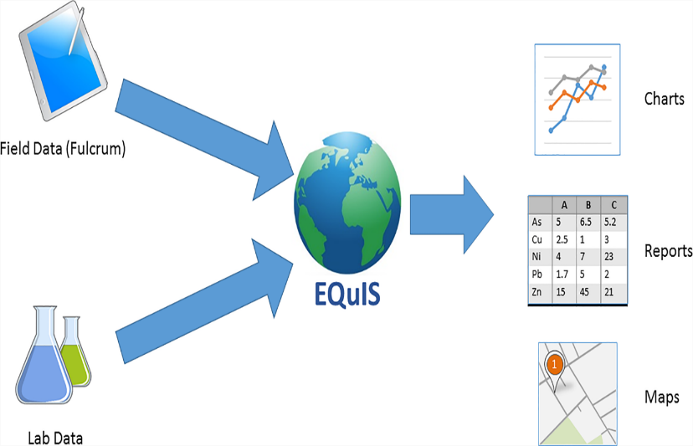

Figure 1- EQuIS weaves together the data streams and creates meaningful output (adopted from Aspect-A Geosyntec Company-Environmental Data Management,2016)

A CONCEPTUAL FRAMEWORK
The onion model representing in the figure 2 supports the environmental system of information. Outer layers represent demands for environmental management and environmental information by involved stakeholders, while the inner layers depict the support or supply for such demands reviewed from (Gayar.et al.,2006)
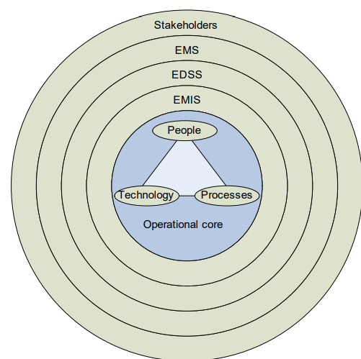

Figure 2- A framework for IS support for EM (adopted from Gayar.et al.,2006)
2. Methodology
The study compares the two prominent database systems EQuIS (Environmental Quality Information System) and EIM (Environmental Information Management) to evaluate the most suitable tool to adopt and assist organizations in better environmental remediation reporting by employing both descriptive, analytical design for enhanced assessment. The main objective of the research is to develop the framework to assist in selecting the appropriate database and decision making for an organization (Mthokozisi, et al.,2024).
Analytical method for analysing the data promote to evaluate the database system effectively through qualitative and descriptive assessment of EQuIS and EIM. Each platforms examined to identify the strength, weakness and specific features. Reports on case study, published reports, remediation projects were integrated to validate theoretical strengths.

2.1. Evaluation Criteria and Data Sources
Evaluation criteria develop a framework to assess each platform involved in environmental management system. The evaluation of the data is by gathering the available sources publicly as a primary data source include vendor documentation, demonstration materials, case studies and academic literatures.
Analysis of good industry practice and review literature are the primary criteria for the evaluation that include:
- Data Management and Validation capability: assess the system’s ability to input, store, ensure quality and validate environmental data accurately.
- User- Centred design: crucial for making complex data accessible.
- Automating data Integration: uses sensors, IoT devices for collecting and evaluating the data and integration connects the data from various operational platforms, software, and existing databases.
- GIS Integration: information system to store, manage, analyse and visualize spatial environmental data.
- Mobile/Field Tools: easy access for data collection in the field.
- Reporting and Visualization: uses charts, graphs, dashboards, specialized software for report the complex environmental data.
- Security and Auditability: crucial for data security, reliability, and regulatory compliance.
- Deployment and Licensing Models: based on choice, budget and users needs-considers options for on-premise, cloud, or hybrid deployment. Licensing models determined by intended use and commercial value. They can range from open to access complex, proprietary subscription- based system.
3.Result
Comparing both widely used tools EQuIS and EIM based on evaluation criteria as outlined in the methodology, the results validate the distinctive performance features of each environmental database tool.
3.1. Data Management and Validation -EQuIS adopts systematic approach and standardized data handling methods and validation, through its Environmental Data Deliverable (EDD) system. This ensures the prior quality of data which is beneficial for reporting strict regulatory compliance reporting. While, EIM provides a more reliable system with user-defined rules, allowing for greater adaptability to diverse data types and evolving project requirements by an organization.
3.2. Usability and User Interface -The EQuIS interface are clear, comprehensive and powerful, offering high configurability and an extensive set of features and typically requires significant user training to achieve full proficiency. EIM also provides a more intuitive and modern web-interface, easy to use systems. often it requires less training due to its responsive design and streamlined workflows, enhance user adoption across various skill levels.
3.3. Automation and Integration- EQuIS and EIM both support automation and integration functionalities. EQuIS offers application programming interface that follow Representational state transfer application to automated data transfer and reporting. EIM also provides a REST API capabilities, supports IoT devices and enabling real-time data monitoring.
3.4. GIS Integration EQuIS database provide advanced spatial data analysis and visualization tools that are essential for site characterization and plume modelling software. While EIM offers basic GIS overlay features which is a fundamental technique that combines two or more thematic map layers, suitable for general mapping, but it is not resilient for complex spatial analyses compared to EQuIS.
3.5. Mobile/Field Tools EQuIS uses advanced mobile and field data collections like EQuIS Collect and EDGE, ensuring data synchronization. while EIM doesn’t requires any specialized tools or app installation which assess flexibility and ease to use by utilizing web-based forms and responsive design for field data entry through any mobile device browser.
3.6. Reporting and Visualization EQuIS platform provide an excellent tool for reporting, graphics and visualization (e.g., EnviroInsite, charts and graphs, Interactive dashboards) suitable for agencies and organizations. EIM provides cloud -based system that uses own visualization and reporting tools (GIS mapping, Interactive charts, Dashboards, augmented reality) offers more flexible and reliable data visualization options that are prominent for internal operational analytics.
3.7. Security, Auditability, and Deployment Both systems as a specialized software prioritize data security and auditability. EQuIS supports ISO standards helps maintaining complete audit trail. EIM abide by ISO 27001 and SOC 2 Type II certifications thus providing a comprehensive audit log in real-time versioning. Deployment: EQuIS- on-premise, cloud, and hybrid options.
EIM is primarily cloud-native.

Table 1: EQuIS vs. EIM Features through evaluation criteria
Feature | EQuIS | EIM
Deployment | On-premise, Cloud, Hybrid | Cloud-native only
Regulatory Reporting | SEDD, EPA, NYSDEC, EPA EDD (Rigid) | Configurable, not regulator-specific (Flexible)
Data Validation | Rigid EDD-based QA/QC | Flexible user-defined rules
APIs and Automation | REST API, Report Scheduler | REST API, IoT-compatible
GIS Integration | ArcGIS, Esri Services (Advanced) | Google Earth, basic GIS overlay
Mobile/Field Tools | EQuIS Collect, EDGE (Dedicated Apps) | Web-based forms, responsive design (Browser-based)
Reporting Templates | Fixed and customizable regulatory formats | Dynamic dashboards and trend charts
User Interface | Dense, requires training | Intuitive, web-driven
Audit Logs | Complete audit trail | Real-time versioning
Security Standards | FedRAMP (optional), ISO support | ISO 27001, SOC 2 Type II
Licensing Model | Modular, license-per-user | Subscription-based, scalable
Ideal For | Regulatory agencies, consultants | Industrial clients, enterprise EHS programs

4.0 Discussion
The comparative evaluation of EQuIS and EIM demonstrates that both environmental database management systems exhibit strong yet distinct capabilities tailored to different organizational needs. While each tool supports comprehensive data management and regulatory compliance, their design philosophies and functional emphases diverge significantly, influencing their suitability for specific operational contexts.

4.1. Data Management and Validation
EQuIS’s structured approach, supported by the Environmental Data Deliverable (EDD) framework, emphasizes standardized data validation and regulatory conformity. This makes it particularly effective for agencies and consulting firms that must meet rigid compliance requirements. Conversely, EIM’s flexible, user-defined validation rules accommodate diverse data types and adaptive workflows. This adaptability supports organizations dealing with dynamic environmental monitoring needs or internal analytics where flexibility outweighs strict conformity.

4.2. Usability and User Experience
The usability contrast highlights different user bases. EQuIS’s feature-rich interface delivers extensive configurability but demands considerable training investment, favoring technically proficient users and large organizations with dedicated data teams. EIM’s modern, web-based interface, in contrast, enhances accessibility and reduces the learning curve. Its intuitive design encourages rapid user adoption across varied skill levels, making it well-suited for industrial clients or enterprises prioritizing efficiency over deep technical control.

4.3. Automation, Integration, and Connectivity
Both platforms exhibit robust automation and integration capabilities through REST APIs. However, EIM’s added compatibility with IoT devices positions it advantageously for real-time environmental monitoring and data-driven decision-making. EQuIS, while equally automated, is optimized for structured data exchange and reporting automation key for long-term environmental compliance programs.

4.4. GIS and Spatial Analysis
Spatial integration further differentiates the two tools. EQuIS integrates seamlessly with ArcGIS and Esri services, providing advanced plume modeling and site characterization features essential for geospatially complex projects. EIM’s GIS capabilities, though functional, remain more basic adequate for general mapping but limited in performing intricate spatial analyses. This distinction indicates EQuIS’s superior alignment with geotechnical and remediation projects requiring spatial precision.

4.5. Field Data Collection and Mobility
EQuIS’s mobile applications, such as Collect and EDGE, ensure controlled, synchronized field data acquisition, catering to structured field operations. EIM’s browser-based forms eliminate the need for app installations, offering flexibility and ease of use. This web-native mobility enhances accessibility, especially for distributed teams or short-term projects with diverse device usage.

4.6. Reporting, Visualization, and Analytics
Both tools support comprehensive visualization and reporting; however, their approaches differ. EQuIS provides formalized reporting outputs and interactive dashboards ideal for compliance submissions. EIM’s cloud-based visualization tools—augmented with GIS mapping and real-time dashboards offer greater interactivity and adaptability for internal analytics and operational monitoring. Thus, EQuIS excels in regulatory reporting, while EIM leads in operational intelligence and data storytelling.

4.7. Security, Auditability, and Deployment
Security and compliance form core strengths for both systems. EQuIS’s audit trail and optional FedRAMP compliance align with government and regulatory standards, while EIM’s ISO 27001 and SOC 2 Type II certifications assure enterprise-grade data protection. Deployment flexibility also differentiates the platforms: EQuIS supports on-premise, cloud, and hybrid environments, enabling organizations to align with internal IT policies, whereas EIM’s cloud-native design ensures scalability and ease of access with minimal maintenance overhead.

4.8. Overall Implications
Overall, EQuIS is best positioned for regulatory agencies, environmental consultants, and organizations prioritizing compliance, advanced geospatial analysis, and structured data management. EIM, on the other hand, caters to enterprises seeking agile, cloud-based solutions with high usability, flexible validation, and real-time operational insight. The results confirm that tool selection should align with an organization’s regulatory obligations, IT infrastructure, and data complexity rather than a one-size-fits-all approach.
5.Conclusion
Environmental Quality Information System (EQuIS) and Environmental Information Management Systems (EIMS or EMIS) are two leading environmental database systems. The comparative analysis of both flatforms provide systematic decision report on which an organization can choice the best, depends on the specific requirements by balancing the need which strictly compliance with regulation and operational adaptability for environmental remediation reporting services.
The Environmental Quality Information System (EQuIS) is a specialized environmental data management and decision-support platform with its EDD-based data validation and strong regulatory reporting feature. EQuIS is important in data accuracy, environmental monitoring, and scientific analysis for organizations. This software developed primitively for handling, monitoring, laboratory, and field sampling data related to all environmental attributes.​ EQuIS provide highly structured data management with strict regulatory compliance.
Environmental Information Management System (EIMS) database system often user-friendly cloud-native solution that are perfectly suitable for organizations in sustainable reporting, policy implementation, facilitate audit, integrating with IoT devices, prioritizing real-time data access, and sustainability in reporting for broader enterprise level- framework for environmental, health, and safety (EHS) programs. EMIS helpful in strategic management, regulatory compliance, and organization’s overall performance.
Together, both the tools considered as specialized systems that proves in providing quality environmental data into broader frameworks. The enterprise and organization made beneficial for corporate decision-making depends on the priorities, budget, requirements and sustainability management.​
6.0 References
- Albert Gomes, Nishat Margia Islam, Md Rashidul Karim (2024). Data driven Environmental risk management and sustainability analytics. Journal of Machine Learning, Data Engineering and Data Science. Vol. 01, Pg no: 100-113.
- EarthSoft Inc. (2021). EQuIS Professional and Enterprise User Guide. www.earthsoft.com
- El-Gayar, Omar and Fritz, Brian D. (2006) "Environmental Management Information Systems (EMIS) for Sustainable Development: A Conceptual Overview," Communications of the Association for Information Systems: Vol. 17, Article 34. DOI: 10.17705/1CAIS.01734
- Grimshaw, D. J. (2010). Bringing Geographical Information Systems into Business. Wiley.
- Ibrahim Alhassan, David Sammon & Mary Daly. (2016) Data governance activities: an analysis of the literature. Journal of decision system. Pages 64-75 | Published online: 16 Jun 2016
- Locus Technologies. (2020). EIM Platform Overview. www.locustec.com
- Mthokozisi, Masumbika, Ncube, Patrick, Ngulube (2024). Enhancing environmental decision-making: a systematic review of data analytics applications in monitoring and management. Discover sustainability. (2024) 5:290.
- Tallon, P. P., Ramirez, R. V., & Short, J. E. (2013). The information artifact in IT governance: Toward a theory of information governance. Journal of Management Information Systems, 30, 141–178.
- U.S. Environmental Protection Agency. (2018). Guidance for Environmental Data Management Systems. EPA QA/G-9.

