Original Research Article
Riparian Cover Types as Ecological Indicators of River Health: A Case Study of the Afro-Tropical Isiukhu River, Kenya

Abstract
Riparian zones have significant impacts on the ecological health of rivers. However, it’s unclear whether riparian cover types can be used as effective indicators of ecological health in Afro-tropical rivers. Therefore, we assessed the relationship between riparian cover types, water quality, and macroinvertebrate assemblages in the Isiukhu River, Kenya. The study was conducted between September 2023 to December, 2023. Water quality was determined using in-situ techniques. Macroinvertebrates were collected using D-frame net and identified using appropriate keys. Sentinel – 2A images identified riparian types - natural forest, grassland, agriculture and urban settlements within the study area. Identified riparian types were confirmed through ground-truth visualization with the aid of transect walks. The condition of the identified riparian types was classified and rated respectively as very high (4), high (3), moderate (2), and low (1). ANOVA and Pearson correlation coefficient were employed in data analysis. Statistical analysis revealed a significant variation in water quality across riparian cover types (F _{(5,19)} = 11.39, ρ <0.05). 1,350 macroinvertebrates belonging to 12 orders, 30 families and 30 genera were collected. There was a significant positive correlation between the genera abundance and riparian cover types (r=0.9633; ρ < 0.05). Other species indices were also positively correlated with riparian covers, though not significantly (ρ > 0.05). Different riparian types affected site-specific water quality and macroinvertebrates abundance and diversity. Therefore, our findings highlight the need for targeted riparian zone restoration to enhance water quality and biodiversity in the Isiukhu River and other world’s rivers.

Keywords: Allochthonous materials; Riparian cover types; Ecological health; Benthic Macroinvertebrates; Water quality.

1. Introduction
Rivers’ ecological health is defined by their capacity to support and sustain an integrated and balanced lotic ecosystem (Sitati et al., 2021). Riparian zones are critical ecological indicators that reflect the health and stability of river ecosystems (Gu & Li, 2024). Healthy riparian cover supports this function by regulating water quality, maintaining biodiversity, providing habitat, and sustaining hydrological connectivity (Singh et al., 2021). The quality and diversity of riparian cover types play a pivotal role in river ecosystem functioning, offering critical insights into the physical, chemical, and biological status of rivers (Gu & Li, 2024; Fugère & Masese., 2025; Masese et al., 2025). Therefore, changes in riparian types and quality due to natural and anthropogenic pressures significantly affects the ecological health of river systems, particularly Afro-tropical ecoregion that is highly vulnerable to fresh water ecosystem collapse across the globe (Akamagwuna et al., 2022).

Forested riparian cover plays a crucial role in river ecosystem functioning by stabilizing riverbanks, reducing water flow velocity, reducing sedimentation, and supplying organic matter that supports aquatic food webs (Allen & Richard, 2020; Sitati et al., 2021; Valyrakis et al., 2021). In forested riparian watersheds, allochthonous materials constitutes a key energy input that sustains macroinvertebrate communities and aquatic biodiversity (Fugère & Masese, 2025). This underscores the importance of maintaining natural forested riparian zones for sustaining water quality and aquatic biodiversity (Tolkkinen et al., 2021). However, anthropogenic activities such as deforestation, urbanization, and agricultural expansion, have led to the widespread fragmentation and conversion of complex natural riparian covers into simple covers, altering river biogeochemistry, hydrology, and ecosystem dynamics (Latella et al., 2020; Kominoski et al., 2021; Nsor et al., 2021).

There is a high river ecological connectivity with surrounding riparian landscape since, water quality and aquatic communities generally reflects both natural and anthropogenic changes that occur within their surrounding landscape (Matomela et al., 2021). These changes have far-reaching consequences on the river health, including reduced water quality, increased sedimentation, and loss of habitat for aquatic organisms (Tolkkinen et al., 2021). There is increased interest in providing ecological information on freshwater bodies in Afrotropical ecoregions to inform conservation planning (Chakona et al., 2020; Matomela et al., 2021). Little information is available on the specific effects of riparian cover types on Afrotropical stream ecology in an attempt to them to assess their efficiency as riverine ecological indicators.
In the African context, growing conservation and restoration efforts highlight the need to protect and restore riparian zones as part of broader strategies for sustaining freshwater resources and biodiversity (Wohl et al., 2024). Studies investigating the influence of land-use dynamics on macroinvertebrate assemblages further highlight the importance of riparian conservation (Lelpi et al. 2022; Datry et al. 2023). However, most research in Kenya has primarily focused on the impact of land cover changes on water quality, with limited emphasis on the ecological role of different riparian cover types on river health (Mzungu et al., 2023). Studies indicate a significant decline in riparian cover types in Kenya, from 6.8% at independence to just 2.6% by 2010 (NEMA, 2011), yet the ecological consequences of these riparian cover types changes remain underexplored. While benthic macroinvertebrates are widely used as bio-indicators of river health (Buss et al., 2015; Musonge et al., 2020; Raphahlelo et al., 2022), the influence of specific riparian cover types on their assemblages under varying disturbance regimes is not well understood, particularly in Afro-tropical rivers (Helson, 2012).
This study addressed these gaps by investigating the relationship between riparian cover types, water quality, and macroinvertebrate assemblages in the Isiukhu River, Kenya. By examining how riparian types influences river ecological health, this research contributes to ecological sustainability, water resource management, and conservation planning. The findings will provide critical insights for policymakers, land managers, and conservationists aiming to enhance river resilience, improve water quality, and support biodiversity in Afro-tropical river systems.
2. Materials and Methods
2.1. Study area
River Isiukhu, a tributary of River Nzoia is located in Kakamega county, Kenya. The watershed extends 34° 40' - 34˚ 50' East and 0° 15' - 0° 25’ North of the equator (Figure 1) at an altitude that ranges from 1240 -2000 metres above the sea level. The river Isiukhu watershed covers an area of approximately 683km² (Tela, 2023). The area receives an annual bimodal rainfall that varies from 1300mm to 2200 mm. Variation in annual rainfall determines the flow regime of the river. Mean annual temperatures range between 18˚C to 29˚C (County Government of Kakamega, 2013). The river Isiukhu, which has its source in the Nandi escarpments joins the river Nzoia that drains into Lake Victoria. River Isiukhu traverses different riparian cover types, that include, natural forests, agricultural areas and urban settlements. These cover types potentially affect the ecological health of the river, making it an ideal subject of this study.
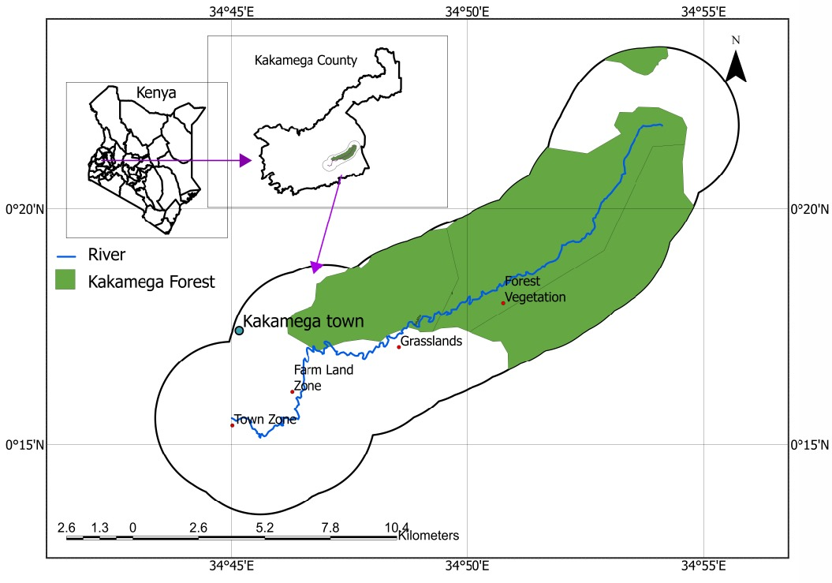
Figure 1: Isiukhu River, and sampling riparian cover types stations.
2.2. Riparian Cover Types’ Data Processing and Classification
Riparian cover types were classified using remote sensing techniques and ground verification. The data was obtained using sentinel-2A satellite images for the year 2023 and 2015. Sentinel-2A satellite imagery (10m resolution, cloud cover 0 - 5%) was obtained from Copernicus Open Hub. Copernicus Open Access Hub which is free and has unrestricted access to users was used to generate Sentinel-2A images (Gascon et al. 2014). Data from Sentinel-2A with global reference system (World Geodetic System, 1984), was projected from UTM 37N to UTM 36N for compatibility with the study region in western Kenya. The medians of the Red, Green, Blue, Near-infrared (NIR) were analyzed using Google Earth Engine (GEE), a cloud platform in which pixel-based (PB) and object-oriented (OO) Land Use Land Cover (LULC) classification approaches can be implemented (Tassi & Vizzari 2020).
The administrative boundary data of the Area of Interest (AoI) was downloaded from the ICPAC (geoportal available at https://geoportal.icpac.net). The study area was delineated using a 3-km buffer to capture the urban influences. ArcGIS has various useful functions such as clipping and buffering (Lopes et al., 2021). Training samples were generated by extracting spectral signatures from identified regions of interest (ROIs). Classification accuracy was determined by comparing satellite predictions with field observations, yielding an overall accuracy of 73.5% and a kappa coefficient of 0.714. Ground-truthing was performed using GPS coordinates, ground photographs, and field transects to validate classified riparian cover types. Riparian cover was rated based on canopy cover percentage, species composition (natural or exotic) and species richness. Classify categories included very high (4), high (3), moderate (2), and low (1) as shown in the table below (Table 1).
Table 1: Criteria for classification of riparian cover.
Classification | Rating | Riparian Cover Types Conditions
Low | 1 | Exotic planted cover >70%, < 20% canopy cover , and < 20% continuity of riparian vegetation cover on both sides of the river
Moderate | 2 | Exotic Planted cover 30%-70%, <60% canopy cover, < 60% canopy cover, and <60% continuity of vegetation cover on both sides of the river
High | 3 | Mixed natural and exotic cover , > 60% canopy cover, > 60% continuity of riparian vegetation cover on both sides of the river
Very high | 4 | Natural riparian cover, >80 % canopy cover, >80%continuity of vegetation cover on both sides of the river.

2.3. Sampling Technique
Stratified sampling technique will be used for the study. Quadruplet samples of water and macroinvertebrate were collected on a monthly basis at each riparian cover station for four months from September to December 2023, a period covering part of the wet season (September to October) and dry season (November to December), allowing for an assessment of riparian cover types and macroinvertebrate communities under different hydrological and climatic conditions. Sampling was conducted in four replicates per riparian cover type, leading to a total of 16 sampling sites in the entire study area. Sampling stations and sites were strategically selected based on the present riparian cover types and physical ecological characteristics of the sites respectively. This ensured a broad representation of riparian conditions and human disturbance gradients. Sampling stations were distributed along the upper, middle, and lower reaches of the Isiukhu River to capture spatial variability.

2.4. Water Quality and Macroinvertebrates Sampling
Water and macroinvertebrate samples were collected on four equally spaced transects at the midpoint of 25m interval along 100m river reach at each riparian cover type station. On each sampling occasion, water parameters were measured before macroinvertebrates were sampled. Temperature, electric conductivity (EC), pH, and Total Dissolved Solids (TDS) were measured using a water proof pH / EC/TDS and Temperature tester while turbidity was measured using a Turbidity Meter (Model WZB -170). Dissolved oxygen (DO) was determined using a DO Analyser portable meter (Model JPB-607A). Measurements were recorded immediately at each site to ensure accuracy and minimize variability.
Macroinvertebrates were collected using D-frame net (0.25mx 0.25m size with 0.5mm pore sizes) (Tela, 2023). Collection was conducted in undercut banks, leaf packs ad under snags, riffle zones, and tree root complexes. Collected macroinvertebrates were transferred into labelled plastic containers and preserved in 70% ethanol before laboratory analysis. Sorting and counting were performed under a dissecting microscope. Identification was done to the genus level using East African macroinvertebrate taxonomic keys (Masese et al., 2025).
2.5. Data Analysis
Statistical analyses were conducted using SPSS software (IBM Corp., 2017), with significance set at p < 0.05 in order to evaluate influence of riparian cover types on water quality and macroinvertebrates assemblage. Mean values of water quality parameters (e.g., turbidity, pH, TDS, temperature, DO, EC) were computed to express spatial characteristics of each riparian cover type stations. One-way ANOVA was performed to test for significant difference in water quality parameters across the different riparian cover types. The structure and composition of macroinvertebrates among riparian cover types categories were described using abundance, diversity (Shannon’s diversity index), evenness (Shannon’s evenness index), richness and dominance biodiversity metrics. Shannon’s diversity and evenness indices are given as:
Shannon Diversity Index (H) $=-\sum_{i=1}^{s}{pi Inpi}$ Whereby:
pi = proportion of individual macroinvertebrates of a particular community, divided by the total number of individuals (n/N)
In = species natural logarithm
S = number of macroinvertebrates’
Shannon Evenness Index (SEI) = $\frac{Shannon^{'}s Diversity Index(H)}{Hmax}$ Whereby:
Hmax = InS (natural logarithm of total number of species)
Species diversity and abundance were used as indicators of river health, with higher abundance and diversity indicating betters ecological condition. Pearson's correlation coefficient (r) was applied to determine the relationships between riparian cover types and macroinvertebrate indices, as well as riparian cover types and water quality parameters. Canonical Correspondence Analysis (CCA) was used to visualize elucidate the relationships between macroinvertebrate taxa and environmental variables, identifying key drivers of community structure.
3. Results
3.1. Major spatial riparian cover types
The study identified four distinct riparian cover types along the Isiukhu River: natural forest, riparian grasslands, agricultural land and urban settlements (Figure 2).
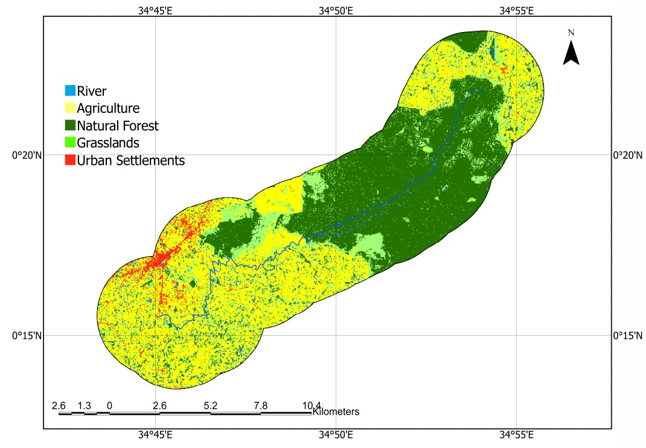Figure 2 a: Riparian cover types along the river Isiukhu (2023)
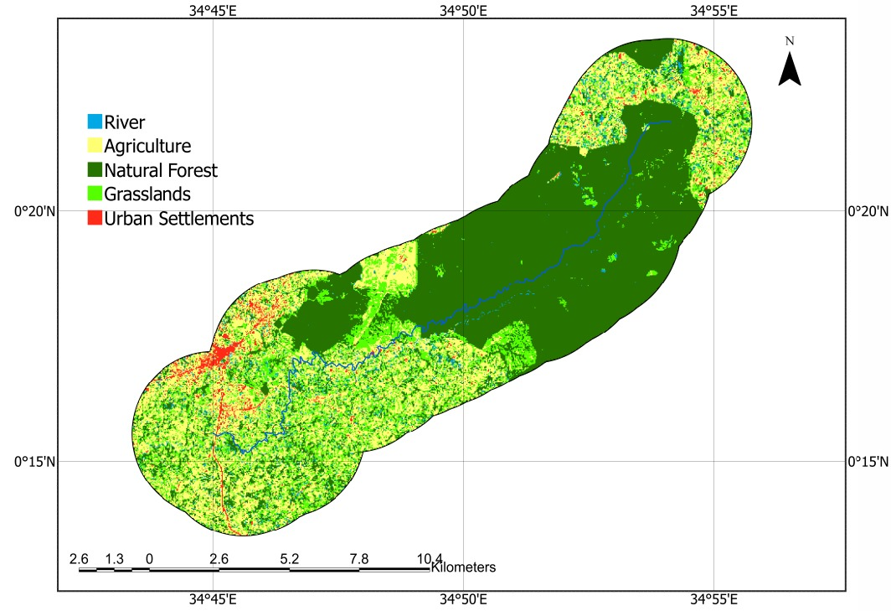
Figure 2 b: Riparian cover types along the river Isiukhu (2015)
Each cover type exhibited unique structural characteristics and varying degrees of human influence, which impacted river health differently. Natural forest, serving as the control site, was undisturbed and featured a dense, continuous canopy of native vegetation extending 30 meters on both sides of the riverbanks, in accordance with the Water Act of 2016 (Republic of Kenya, 2016). This riparian zone provided essential ecological functions such as erosion control, habitat provision, and water quality regulation, making it a baseline for comparing the effects of other riparian types. Grasslands were characterized by dominant grassy vegetation with scattered short trees, extending beyond the 30-meter riparian buffer. Agricultural riparian cover supported mixed land use, including both subsistence crop farming and livestock rearing. Urban riparian cover was found near Kakamega town and consisted of built-up areas, roads, and infrastructure that directly influenced river health. Storm water drainage and wastewater discharge from urban settlements contributed pollutants to the river system. The observed physical conditions of riparian covers are summarized in the table 2 and figure 3 below.
Table 2: Physical riparian cover conditions along River Isiukhu
Cover Types | Riparian Characteristics
Natural Forest | Relatively undisturbed with dense continuous natural vegetation covers and stable river banks
Riparian Grasslands | Continuous grass cover with short scanty trees. Used for grazing domestic animals. Some sections of river banks were unstable at entry points of livestock to the river for drinking water
Agriculture | Intensive small scale mixed farming and agroforestry. River banks were unstable
Urban Settlements | Included Kakamega Town whereby road side channels directed urban waste and storm water to this point. River banks were unstable .

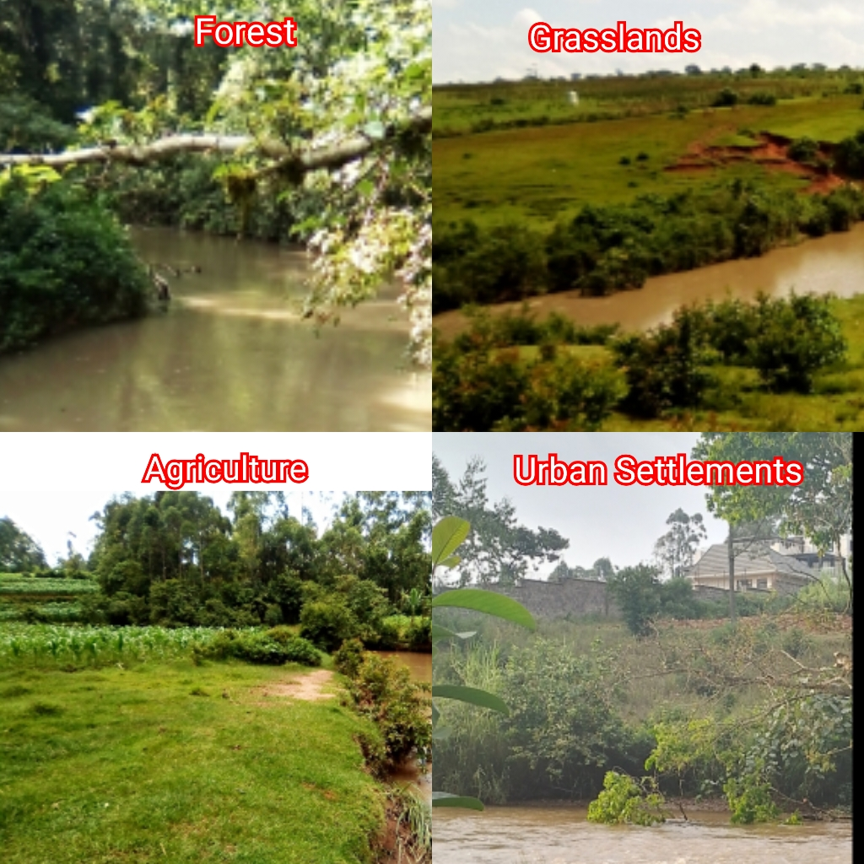
Figure 3: Ground photographs showing riparian cover types along the river Isiukhu
The spatial and temporal distribution and coverage of riparian types varies along River Isiukhu. In 2015, natural forest occupied 82.55 km² (49.90%) while agriculture accounted for 48.63 km² (29.40%). Grasslands occupied 30.79 km² (18.61%) while urban settlements occupied 3.46 km² (2.09%) (Table 3). In 2023, natural forest occupied 68.15 km² (41.20%) while agriculture accounted for 68.01 km² (41.11%). Grasslands occupied 25.66 km² (15.51%) while urban settlements occupied 3.61 km² (2.18%). General assessment revealed that natural forest and grassland decreased by 17.44% and 16.66% respectively between 2015-2023. Conversely, agriculture and urban settlements increased by 39.85% and 4.33% respectively over the same period, raising a lot of concern about their influence on the river’s ecological health. Urban settlements, which was identified after 3 km buffering of river Isiukhu watershed, exerted localized but substantial pressure on riparian integrity through drainage systems that directed storm water and waste runoff into the river.
Table 3: Riparian types coverage along River Isiukhu.
Riparian Types | Coverage (2015) |  | Coverage (2023) |  | % Change (2015-2023)
Natural Forest | 82.55 km² | 49.90% | 68.15 km² | 41.20% | 17.44% (Decrease)
Grasslands | 30.79 km² | 18.61% | 25.66 km² | 15.51% | 16.66% (Decrease)
Agriculture | 48.63 km² | 29.40% | 68.01 km² | 41.11% | 39.85% (Increase)
Urban settlements | 3.46 km² | 2.09% | 3.61 km² | 2.18% | 4.33% (Increase)
Total Coverage | 165.43 km² |  | 165.43 km²

3.2. Relationship between riparian cover types and water quality
Significant differences in quality were observed across riparian cover types (F _{(5,19)} = 11.3925, ρ <0.05). Water temperature varied significantly F _{(1,6)} =481.163, ρ < 0.05), with natural forest having the lowest mean temperature. Temperature increased progressively downstream through riparian grasslands, agricultural land, and urban settlements. Water pH showed significantly variation across riparian cover types (F _{(1,6)} =29.591, p<0.05), though the values remained relatively uniform across sites (Table 4). There was a negative correlation between pH and riparian cover types (r=-0.923, ρ>0.05). Dissolved oxygen (DO) levels varied significantly (F _{(1,6)} = 20.488, ρ>0.05), with the highest concentration in natural forest. DO levels declined progressively downstream. A strong positive association was found between DO and riparian cover types (r=0.998, ρ<0.05). Electrical conductivity (EC) increased downstream and varied significantly (F _{(1,6)} =1567.6968, ρ<0.05). A negative correlation between EC and riparian cover types was observed (r=-0.906, ρ>0.05). Total Dissolved Solids (TDS) increased progressively downstream, showing significant variation (F _{(1,6)} =962.968, ρ<0.05). A strong negative correlation was found between TDS and riparian cover types (r= -0.971, ρ<0.05) along river Isiukhu. Water turbidity (NTU) increased downstream and varied significantly across riparian cover types (F _{(1,6)} = 30.986, ρ<0.05), with a strong negative correlation (r= -0.981, ρ<0.05).
Table 4: Summary of the mean (± SE) water quality parameters of the study riparian cover types on Isiukhu River, September-December 2023
Water Parameters |  | Riparian Covers Types
 | Natural Forest | Grasslands | Agriculture | Urban Settlements
Temperature (˚C) | 19.4±0.54 | 20.75± 0.79 | 21.38± 0.40 | 21.85±0.12
Electric Conductivity (μs) | 90.75±9.31 | 89.75±10.18 | 94.5± 9.59 | 99.5±10.83
pH | 5.975±0.15 | 6 ± 0.47 | 6±0.13 | 6.05± 0.09
Dissolved Oxygen (mg/l) | 6.9± 0.65 | 6.325± 0.27 | 5.6±0.13 | 5.05± 0.21
Total Dissolved Solids (mg/l) | 43.75±2.72 | 45± 4.64 | 48.25±5.57 | 49± 4.68
Turbidity (NTU) | 52 ± 8.13 | 90.35±40.06 | 102.03±45.57 | 131.28± 0.90
The Canonical Correspondence Analysis (CCA) plot (Figure 4) illustrates the spatial associations between riparian cover types and water quality along the River Isiukhu. Forested riparian is positioned closer to higher DO and lower NTU, indicating improved oxygenation and reduced sedimentation. Grassland and agricultural zones exhibit moderate temperature and EC, reflecting anthropogenic influence on riparian land. Urban settlements align with elevated NTU, temperature, and TDS, signifying increased pollution and degraded riparian land. The vector orientations suggest that NTU and EC are key indicators of urban and agricultural impacts, while DO and pH remain more stable in forested regions. These findings highlight the role of riparian vegetation in preserving water quality.
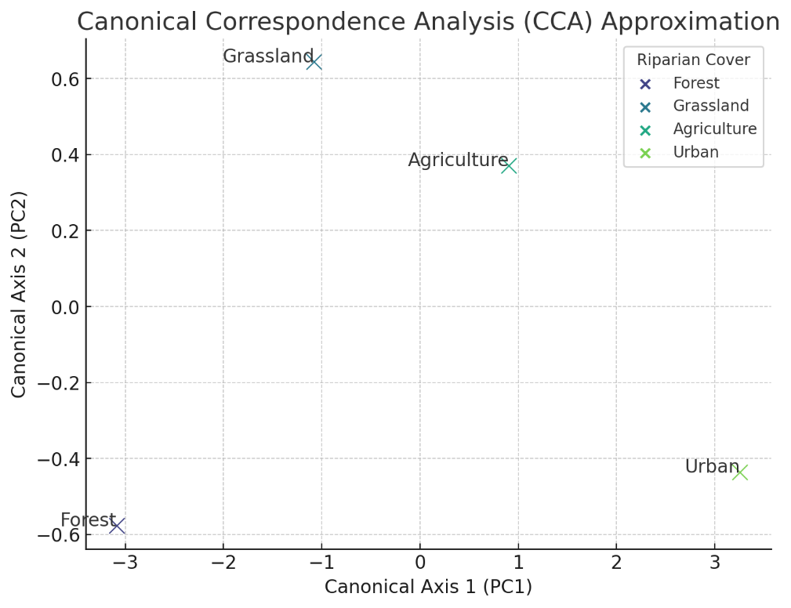Figure 4: CCA on water quality variation among riparian cover types.
3.3. Riparian cover types and macroinvertebrates assemblages
3.3.1. Benthic macroinvertebrates’ taxonomic composition
A total of 1,350 benthic macroinvertebrates were collected, representing 12 orders, 29 families, and 29 genera. Hemiptera was the most diverse order (5 genera), followed by Diptera and Ephemeroptera (4 genera each). Ephemeroptera exhibited the highest abundance (19.26%), while Gastropoda and Sphaeriida had the lowest (0.89% each). Macroinvertebrate abundance varied across riparian cover types (Figure 5). Diptera dominated urban settlements but was least abundant in grasslands. Hemiptera was most prevalent in natural forests and less dominant in grasslands. Coleoptera and Trichoptera were abundant in natural forests but less common in agricultural and urban areas. Plecoptera was primarily found in grasslands but was scarce in urban areas. Ephemeroptera dominated grasslands but was least abundant in agricultural riparian zones, whereas Odonata was most abundant in agricultural areas and least in grasslands. Decapoda was restricted to grasslands, while Oligochaeta was abundant in urban settlements but least common in grasslands. Hirudinea was exclusive to agricultural riparian zones. Sphaeriida was found in agricultural areas but absent in grasslands and urban settlements, while Gastropoda was only present in agricultural riparian zones.

Figure 5: Percentage macro invertebrates’ orders abundance along riparian cover types
3.3.2 Relationship between macroinvertebrates’ assemblages and riparian cover types
Natural forest had the highest species abundance, while urban settlements had the lowest (Table 5). Agricultural areas exhibited the highest species richness index, whereas the urban settlement had the lowest. A positive significant correlation was found between macro invertebrates’ abundance and riparian cover types (r=0.9633; ρ<0.05). A non-significant correlation existed between riparian cover types and species dominance index, evenness, diversity and richness (r=0.7795, ρ >0.05; r=0.6401, ρ>0.05; r=0.360, ρ>0.05; and r=0.2169, ρ>0.05 respectively.
Table 5: Macroinvertebrate metrics among riparian cover types
Riparian Cover Types | S | N | H’ | SEI | D
Forest Vegetation | 24 | 395 | 3.063 | 0.952 | 0.9438
Grasslands | 20 | 337 | 2.893 | 0.971 | 0.9352
Agriculture | 25 | 324 | 3.147 | 0.968 | 0.9422
Urban Settlement | 21 | 294 | 2.847 | 0.893 | 0.9083
N/B S=Richness index; N=Abundance index; H'=Shannon-Wiener index; SEI=Shannon evenness Index; D=Dominance index
Four species exhibited a strong significant correlation with riparian cover types (Figure 6). Chironomus spp. (r = -0.954, p < 0.05) showed a strong negative correlation, indicating higher abundance in disturbed habitats. In contrast, Elmis spp. (r = 0.987, p < 0.05), Belostoma spp. (r = 0.961, p < 0.05), and Lepidostoma spp. (r = 0.946, p < 0.05) displayed strong positive correlations, suggesting a preference for less disturbed environments.
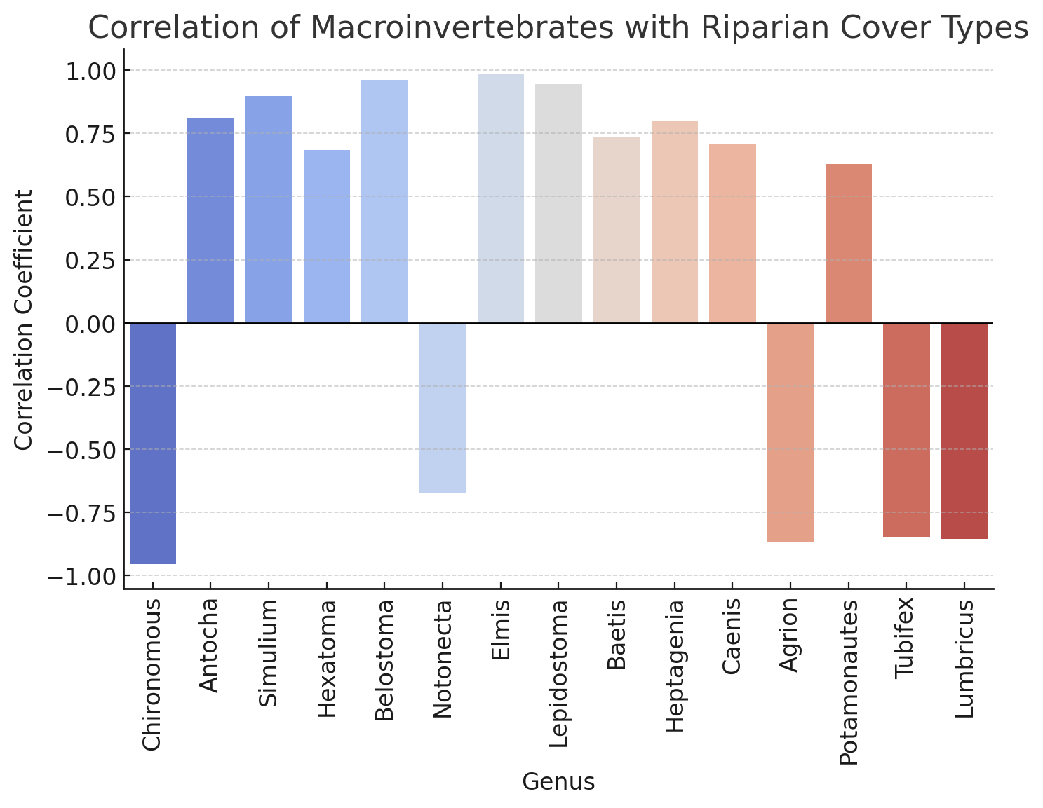Figure 6: The Correlation of macroinvertebrate species and riparian cover types
Ephemeroptera and Coleoptera were strongly associated with forested areas, whereas Diptera and Oligochaeta were more prevalent in urban and agricultural environments, indicating greater tolerance to pollution due to riparian degradation (Figure 7). The spatial distribution of macroinvertebrate groups suggests distinct habitat preferences, reflecting their sensitivity to environmental changes.
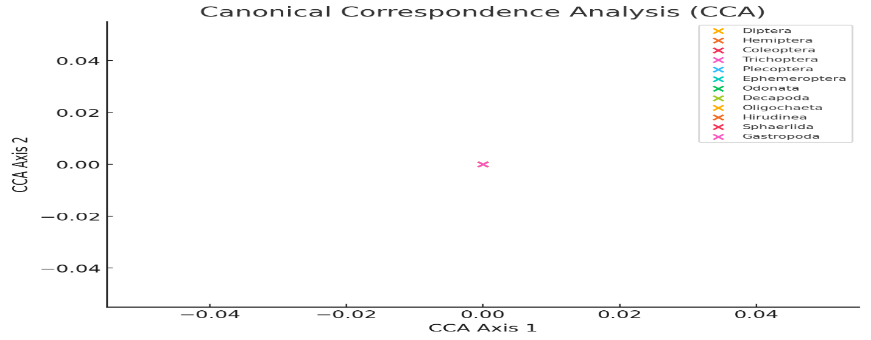
Figure 7: CCA on macroinvertebrate assemblage variation among riparian cover types.
3.4. Riparian Water Quality and macroinvertebrates assemblages
Canonical Correspondence Analysis (CCA) (Figure 8) revealed that DO and pH were associated with forested areas, supporting species like Baetis spp., Elmis spp., and Lepidostoma spp., indicating a preference for well-oxygenated environments. In contrast, NTU and EC were linked to urban and agricultural riparian areas, favoring pollution-tolerant species like Chironomus spp. Additionally, temperature and TDS correlate with degraded riparian environments, particularly in urban and agricultural regions, influencing species adapted to warm and nutrient-rich conditions.
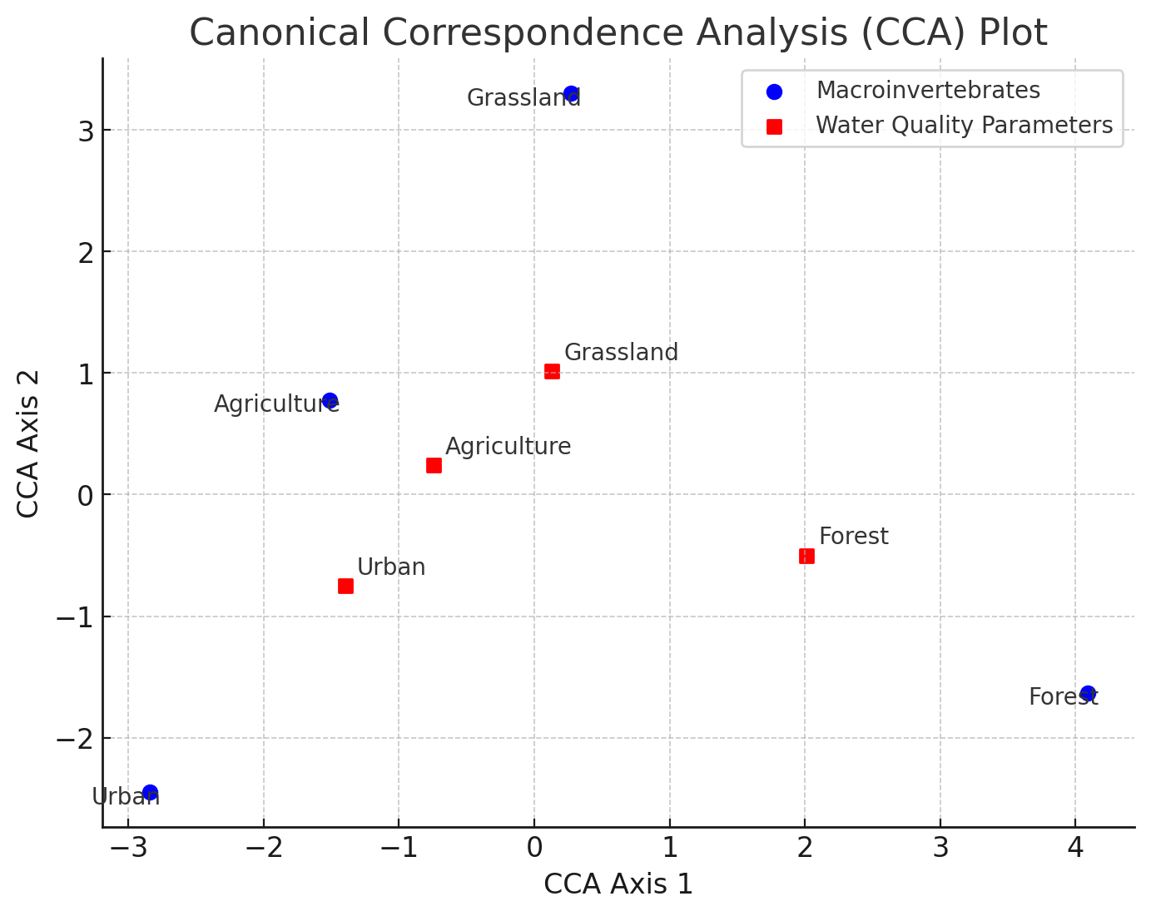
Figure 8: CCA plot showing the relationship between macroinvertebrate assemblages and water quality parameters along different riparian cover types
4. Discussions
This study demonstrates that riparian cover types significantly influence water quality and macroinvertebrates assemblages, offering valuable insights into the ecological health of rivers in Afro-tropical regions. Upstream riparian cover types (forest and grasslands) experienced low to moderate level of disturbances due to their proximity to protected Kakamega forest. Conversely, downstream riparian covers (agriculture and urban settlement) were highly disturbed due to unsustainable human activities, including deforestation, urban runoffs and farming. These findings align with previous studies linking land-use changes to river degradation (Li et al., 2023). Riparian forests provide organic matter input (leaf litter, woody debris), crucial for maintaining aquatic food webs and energy flow (Allen & Richard, 2020). However, in downstream regions, exotic vegetation dominance disrupts native biodiversity, leading to reduced habitat stability (Tela et al., 2023).

Water quality parameters exhibited significant spatial variability along different riparian cover types, supporting the hypothesis that riparian vegetation influences river water quality. These findings align with previous studies linking riparian land use with water quality (Ndichu et al., 2023; Gu &Li., 2024). In upstream forested zones, low water temperature was attributed to shading by dense vegetation, which reduced solar insolation and surface runoff. This agrees with Davies-Colley & Payne (2023), who noted that riparian vegetation canopies regulate water temperature by absorbing and scattering light energy. Downstream areas experienced higher temperatures due to vegetation loss, urban runoff, and increased surface exposure (Stephens et al., 2021). In contrast, downstream riparian zones experienced higher temperatures due to minimal vegetative cover and increased overland flow from agricultural and urban surfaces, as also reported by Stephens et al. (2021).

Higher DO levels in forested areas resulted from cooler temperatures, minimal pollution, and high organic productivity. Conversely, agricultural and urban riparian zones exhibited lower DO levels due to nutrient runoff and organic pollution (Mwaijengo et al., 2020; Eriksen et al., 2022; Ketabchy et al., 2023). A strong positive correlation was observed between dissolved oxygen and riparian cover types indicating that dense riparian vegetation supports higher oxygen levels, likely due to reduced organic pollution and greater aquatic plant productivity. Turbidity, electrical conductivity, and TDS levels increased downstream, reflecting higher sedimentation, erosion, and pollutant loads (Singh et al., 2021; Tela et al., 2023). A negative correlation observed suggests that natural riparian vegetation acts as a buffer, filtering sediments, reducing ion influx, and stabilizing riverbanks. Urban settlement zones had higher pH, likely due to waste discharge and altered riparian conditions, further impacting aquatic species composition.

Macroinvertebrate assemblages varied spatially along the riparian gradient, with sensitive taxa (Baetis spp., Elmis spp., Lepidostoma spp.) being more abundant in forested and grassland riparian zones with higher water quality and complex riparian vegetation that provides organic matter and stable habitats (Kominoski et al., 2021). In contrast, tolerant taxa (Chironomidae spp.) dominated disturbed downstream areas with low oxygen and high pollution levels due to their adaptability to such environments (Tela & Masayi, 2023). Therefore, macroinvertebrate diversity and abundance shift according to changes in water quality, with sensitive taxa being more prevalent in pristine environments and tolerant species dominating in polluted and degraded areas. A positive significant correlation between macroinvertebrate abundance with riparian vegetation underscores the critical role of natural riparian cover in supporting ecological health of rivers. Forested and grassland zones exhibited higher species richness, evenness, and abundance, consistent with findings by Sitati et al. (2021). Conversely, urban and agricultural zones exhibited lower diversity and evenness and dominance, reflecting habitat degradation, reduced organic food matter and pollution (Oruta et al., 2017). Therefore, riparian cover types are a cost effective and comprehensive indicators of river health since they integrate biological, chemical, and physical processes of the ecosystem. However, riparian cover alone cannot fully explain river health variations since climatic and other upstream factors also influence river health.

This study highlights the vital role of riparian cover in maintaining river ecosystem health, particularly in the face of increasing anthropogenic disturbances. The degradation of riparian zones in agricultural and urban areas of the Isiukhu River has significant ecological implications, including reduced water quality and biodiversity loss. Conservation efforts should prioritize the restoration and protection of riparian vegetation, particularly through the establishment of buffer zones and reforestation initiatives. Such measures could mitigate the negative impacts of degraded riparian zones on water quality and biodiversity. While this study provides important insights into the influence of riparian cover on river health, its main limitation is the short study duration (September to December 2023), which may not fully capture seasonal variations in water quality and macroinvertebrate assemblages. Future research should involve long-term monitoring to better understand temporal variability and the cumulative impacts of riparian land-use changes on river ecosystems. Therefore, this study recommends urgent policy actions and conservation efforts that integrates of riparian health assessments into water quality policies, community-based conservation strategies, and sustainable urban planning in order to ensure the long-term health of Afro-tropical rivers.
5. Conclusion
This study highlights the critical role of riparian cover types in sustaining the ecological health of river ecosystems. The findings reveal that relatively undisturbed natural forests and grassland riparian zones play a vital role in maintaining high water quality and fostering aquatic biodiversity. In contrast, disturbed riparian cover types, such as those impacted by agriculture and urban settlement, are associated with significant declines in water quality and aquatic ecosystem health. Given the essential functions of riparian forests in regulating water quality and supporting aquatic biodiversity, this study strongly advocates for targeted management and rehabilitation efforts in degraded riparian areas, particularly those affected by urbanization and agricultural activities. Concurrently, the conservation and protection of riparian forests and grasslands should be prioritized to preserve their significant contributions to aquatic ecosystem health. Implementing these measures will enhance the ecological health of rivers, increase their resilience to environmental challenges such as climate change and anthropogenic disturbances, and promote the sustainable use of freshwater resources. Furthermore, riparian cover types serve as effective multidimensional indicators of freshwater ecosystem health, reflecting the complex interplay of physical, chemical, and biological processes within river basins.

Conflict of Interest
The authors declare that the research was conducted in the absence of any commercial or financial relationships that could be construed as a potential conflict of interest.

Data Availability Statement
The data that support the findings of this study are available on request from the corresponding author. The data is not publicly available due to privacy or ethical restrictions.

References
Akamagwuna, C.F., Odume, N.O., & Richoux B.N. (2022). Exploring the community structure of Afrotropical macroinvertebrate traits and ecological preferences along an agricultural pollution gradient in the Kat River, Eastern Cape, South Africa. Ecological Indicators, 135.
Allen W.K. & Richard L.B. (2020). The importance of riparian vegetation to the river ecosystems. California Riparian Systems, 159-167.
Buss D.F., Carlisle D.M., Chon T.S., Culp J., Harding J.S., & Keizer-Vlek H.E. (2015). River biomonitoring using macroinvertebrates around the globe: a comparison of large-scale programs. Environ. Monit. Assess. 187 (1), 4132. https:// doi.org/10.1007/s10661-014-4132-8.
Chakona, A., Gouws, G., Kadye, W.T., Jordaan, M.S., Swartz, E.R. (2020). Reconstruction of the historical distribution ranges of imperilled stream fishes from a global endemic hotspot based on molecular data: implications for conservation of threatened taxa. Aquat. Conserv. Mar. Freshw. Ecosyst. 30 (1), 144–158. https://doi. org/10.1002/aqc.3251.
County Government of Kakamega. (2013). The First County integrated development plan 2013-2017. Retrieved from www.kakamegacounty.go.ke.
Davies-Colley, R.J. & Payne, G.W. (2023) Cooling streams with riparian trees: Thermal regime depends on total solar radiation penetrating the canopy. Austral Ecology, 48, 1064–1073. Available from: https://doi.org/10.1111/aec.13345
Datry, T., Truchy, A., Olden, J. D., Busch, M. H., Stubbington, R., Dodds, W. K., Zipper, S., Yu, S., Messager, M. L., Tonkin, J. D., Kaiser, K. E., Hammond, J. C., Moody, E. K., Burrows, R. M., Sarremejane, R., Delvecchia, A. G., Fork, M. L., Little, C. J., Walker, R. H., ... Allen, D. (2023). Causes, Responses, and Implications of Anthropogenic versus Natural Flow Intermittence in River Networks. Bio Science, 73(1), 9-22. https://doi.org/10.1093/biosci/biac098.
Eriksen, T.E., Jacobsen,D., Demars, B.O.L., Brittain, J.E., Søli, G., & Friberg,N. (2022). Effects of pollution-induced changes in oxygen conditions scaling up from individuals to ecosystems in a tropical river network. Science of The Total Environment. Volume 814. https://doi.org/10.1016/j.scitotenv.2021.151958.
Fugère, V., & Masese, F.O. (2025) Chapter 13 - Primary production and ecosystem metabolism. Editor(s): Tatenda Dalu, Frank O. Masese. Afrotropical Streams and Rivers. Elsevier. Pages 337-348.
Gascon, F., Cadau, E., Colin, O., Hoersch, B., Isola, C., Fernández, B. L., & Martimort, P. (2014). Copernicus Sentinel-2 mission: products, algorithms and Cal/Val. In Earth observing systems XIX (Vol. 9218, pp. 455-463). SPIE.
Gu, S., and Li, S. (2024). Riparian habitat quality as an indicator of land use/land cover effects on riverine water quality. Geography and Sustainability. Volume 5, Issue 1, Pages 135-143, ISSN 2666-6839. https://doi.org/10.1016/j.geosus.2023.11.005.
Helson, E.J. (2012). Macroinvertebrates community structure and function in seasonal, low land, tropical streams across a pristine rural-urban land use gradient. PhD thesis. University of Toronto.
IBM Corp. (2017). IBM SPSS Statistics for Windows. Armonk, NY: IBM Corp. Retrieved from https://hadoop.apache.org
Ketabchy, M., Buell, E.N., Yazdi, M.N., Sample, D.J., & Behrauz., M.S. (2023). The effect of piping stream channels on dissolved oxygen concentration and ecological health. Environ Monit Assess 195, 460. https://doi.org/10.1007/s10661-023-11070-7.
Kominoski, S.J., Chapman, S., Dodds, K.W., Follstad Shah, J.J., &., Richardson, S.J (202). Causes and Consequences of Changes in Riparian Vegetation for Plant Litter Decomposition Throughout River Networks. In book: The ecology of plant litter decomposition in stream ecosystems. DOI: 10.1007/978-3-030-72854-0_13
Latella, M., Bertagni, M. B., Vezza, P., & Camporeale, C. (2020). An integrated methodology to study riparian vegetation dynamics: From field data to impact modeling. Journal of Advances in Modeling Earth Systems. https://doi.org/10.1029/2020MS002094
Lelpi, A., Lapôtre G.A.M., Gibling, M.R., & Boyce, K.C. (2022). Impact of vegetation on meandering rivers. Nature Reviews Earth & Environment. DOI: 10.1038/s43017-021-00249-6.
Li, Y., Mi, W., Ji, L., He, Q., Yang, P., Xie, S., & Bi, Y. (2023). Urbanization and agriculture intensification jointly enlarge the spatial inequality of river water quality. Science of The Total Environment. Volume 878. ISSN 0048-9697. https://doi.org/10.1016/j.scitotenv.2023.162559.
Lopes, M. S., Veettil, B. K., & Saldanha, D. L. (2021). Buffer zone delimitation of conservation units based on map algebra and AHP technique: A study from Atlantic Forest Biome (Brazil). Biological conservation, 253, 108905.
Maestas, J. D., Wheaton, J.M., Bouwes, N., Swanson, S. R., & Dickard, M. (2023). Water is life? Importance and management of riparian areas for rangeland wildlife. In: McNew, L.B., Dahlgren, D.K., Beck, J.L. (eds). Rangeland Wildlife Ecology and Conservation. Springer, Cham.
Masese, F.O., Owade, C.A.A., Sitati, A., Yegon,M.J., Wanderi, E.W., Kimeli, J & Fry, C. (2025). Chapter 17 – Macroinvertebrates. Editor(s): Tatenda Dalu, Frank O. Masese, Afrotropical Streams and Rivers. Elsevier. Pages 431-475.
Matomela, H.N., Chakona, A., & Kadye, T.W. (2021). Comparative assessment of macroinvertebrates communities within three Afromontane headwater streams influenced by different land use patterns. Ecological Indicators.
Musonge, P. S. L., Boets, P., Lock, K., & Goethals, P. (2020). Drivers of benthic macroinvertebrate assemblages in equatorial alpine rivers of the Rwenzoris (Uganda). WATER, 12(6). https://doi.org/10.3390/w12061668
Mwaijengo G.N., Vanschoenwinkel B., Dube T., Njau K.N., Brendonck L. (2020). Seasonal variation in benthic macroinvertebrate assemblages and water quality in an Afrotropical River catchment, north-eastern Tanzania. Limnologica, 125780.
Mzungu, E., Yakub, S and Anyimba, E.S. (2022). Macroinvertebrates as bio-indicators of water quality in Omubira Stream, in Kakamega County, Kenya. International Journal of Fisheries and Aquatic Studies. 10(4): 70-77, DOI: https://doi.org/10.22271/fish.2022.v10.i4a.2707.
Ndichu NN, Tela SA, Kweyu RM, Makokha M and Okeyo F (2023). Analysis Of Riparian Land Rehabilitation on Water Quality and Macro Invertebrates’ Diversity Along Nairobi River, Kenya. Int J Water Res 5(4): 158.
NEMA (2011). National Environment Management Authority.
Nsor, C. A., Acolatse, R., Mensah, J. N., Oppong, S. K., Dompreh, D., & Addai-Wireko, L. (2021). Structural assemblages of plant species in the Owabi Ramsar Wetland in the Ashanti Region of Ghana. African Journal of Aquatic Science, 47(1), 100–114. https://doi.org/10.2989/16085914.2021.1982671.
Oruta, N.J., Oindo, O.B., & Bosire, K.E., (2017). Riparian Vegetation Cover and Macroinvertebrate Assemblages In Kuywa River, Kenya. Researchjournali’s Journal of Ecology. Vol .4/No.1
Raphahlelo, M.E., Addo-Bediako, A., & Luus-Powell, W.J. (2022) Distribution and diversity of benthic macroinvertebrates in the Mohlapitsi River, South Africa. Journal of Freshwater Ecology, 37:1, 145-160, DOI: 10.1080/02705060.2021.2023054
Republic of Kenya (2016). Water Act 2016: Laws of Kenya. Nairobi: Government Printer.
Singh, R., Tiwari, A.K., and Singh, G.S. (2021). Managing riparian zones for river health improvement: an integrated approach. Landscape and ecological engineering. 17: 195-223.
Sitati P.O. Raburu M. Nyaboke and F.O. Masese (2021). Macro invertebrate structural composition as indicators of water quality in head water rivers. African Environmental Review Journal 4(2), 110-122.
Stephens, C, M., Lall, U., Johnson, F.M., & Marshall, L.A. (2021). Landscape changes and their hydrologic effects: Interactions and feedbacks across scales. Earth-Science Reviews. Volume 212. https://doi.org/10.1016/j.earscirev.2020.103466.
Tassi, A., & Vizzari, M. (2020). Object-oriented lulc classification in google earth engine combining snic, glcm, and machine learning algorithms. Remote Sensing, 12(22), 3776.
Tela, S.A. (2023). Effects of riparian cover type on water quality and macro invertebrate population in River Isiukhu watershed, Kakamega County, Kenya. M.A thesis, Kenyatta University.
Tela S.A & Masayi, N.N. (2023). Relationships between Land Use Changes and Benthic Macroinvertebrates’ Community Structure in an East African Riverine Environment. Journal of Geography, Environment and Earth Science International, Volume 27, Issue 7, Page 1-13, 2023; Article no. JGEESI.100414
Tolkkinen, M., Vaarala, S., Aroviita, J. (2021). The Importance of Riparian Forest Cover to the Ecological Status of Agricultural Streams in a Nationwide Assessment. Water Resources Management. 35:4009–4020. https://doi.org/10.1007/s11269-021-02923-2
Valyrakis, M., Liu, D., Turker, U., & Yagci, O. (2021). The role of increasing riverbank vegetation density on flow dynamics across an asymmetrical channel. Environmental Fluid Mechanics, 21(3), 643–666. https://doi.org/10.1007/s10652-021-09791-9
Wohl, E. (2024). Resilience in river corridors: How much do we need? Perspectives of Earth and Space Scientists, 5, e2023CN000226. https://doi.org/10.1029/2023CN000226

