Geochemical and Multivariate Geostatistical Analyses to Depict Surface patterns of Groundwater Quality in Dutsin-Ma Town, Katsina State

ABSTRACT
The primary goal of this study is to analyse the geochemical properties and to depict the surface patterns of groundwater quality for drinking in Dutsin-Ma town. A total of 34 samples from boreholes and hand dug wells was obtained using a combination of stratified and purposive sampling techniques was used and 12 parameters were analysed based on standard laboratory procedures. Results of the geochemical analysis were subjected to multivariate geostatistical analysis to establish the groundwater quality variations. The Kriging interpolation technique using Geographic Information System (GIS) was used to map and classify drinking water quality parameters into 4 suitability visual representation based on WHO standard limits. Results revealed that significant WQPs including EC, Sulphate, TDS, Chloride were present in concentrations higher than the World Health Organization (WHO) permissible limits in certain localities. Mean values of measured parameters showed the means of 25.50 ± 32.84 µS/cm, 7.4 ± 0.51, 1.58 ± 0.85 mg/L, 2452.65 ± 1634.26 mg/L, 271.74 ± 606.30 mg/L, 33.06 ± 32.19 mg/L, 304.79 ± 597.66 mg/L, 722.56 ± 1537.76 mg/L, 0.46 ± 0.27 mg/L, 0.23 ± 0.33 mg/L, 0.03 ± 0.02 mg/L, 0.60 ± 0.66 mg/L for EC, pH, Turbidity, TDS, Sulphate, Phosphate, TH, Chloride, Lead, Manganese, Cadmium and Iron respectively. The student sample t-test showed no significant difference between the mean of the measured parameters and the standard for Turbidity, Pb, Cd, EC, PO₄, pH, TDS, Mn, and Fe. These visualizations are intended to assist government agencies in making informed decisions and implementing necessary actions and policies.
Keywords: Geographic information system, geochemical, geostatistical analysis, multivariate, groundwater quality.
1. INTRODUCTION
Water is an indispensable natural resource for human survival and development (Hui et al. 2020). It is one of the most requested of all urban and rural amenities, the most basic and critical requirement for human survival (Gupta & Gupta, 2021, Adagba et al., 2022), and is responsible for nourishing and productivity functions of any ecosystem (Barkat et al., 2021). It is a crucial natural resource which serves as a viable alternative to surface water especially for drinking, irrigation, and industrial purposes (Jang et al. 2013) and the most widely source of drinking water supply in dry and semi-arid areas. It is recognized throughout the world as the most fundamental and indispensable of all natural resources (Kanu et al., 2023). This makes the study and constant monitoring of water quality for the health and wellness of our communities extremely important (Beg et al., 2021).
Groundwater infers water located in aquifers and pore spaces beneath the earth's surface which constitutes about 98% of the world's fresh water (Barkat et al., 2022). It is the source of approximately one third of the fresh water consumed to meet all domestic, industrial and agricultural needs of the planet (Silva et al., 2021). The quality is better, less prone to contamination, and less susceptible to seasonal and long-term changes (Mohammed et al., 2023). It’s use requires little to no treatment as it is more stable and possess better microbial quality than surface water, this explains the increase in it’s demand.
Groundwater suitability for any purpose is determined by it’s quality which comprises of the chemical, physical, and biological state of the water. Its quality depends mainly on the type of dissolved salts present in the groundwater supply (Fallatah & Khattab, 2023). Groundwater contamination, on the other hand may occur either naturally owing to the physiographic, geological, structural and hydrogeological features of the region (Absametov et al., 2023), or artificially by the injudicious abstraction and rapidly increasing anthropogenic activities (Jha et al., 2020).
With factors like rapid growth in population, urbanization, industrialization, agricultural activities and poor waste management practices contributing majorly to alterations in the hydrological cycle, water contamination has become a subject of global discourse among professionals and researchers in the geo-scientific disciplines and public health. According to Sagar et al., (2024), groundwater depletion and its quality degradation may be due to rise in demography, climate change, global warming, and industrial demands. Despite efforts made by various international initiatives to emphasize the need of improved access to quality water especially in developing countries, substantial challenges still remain (WHO 2006; PDWS, 2008; Pruss-Ustun et al., 2004). In Nigeria, regulatory agencies such as the Standard Organization of Nigeria (SON) and the Federal Ministry of Environment (FME) have been mandated to ensure national water quality, however, 57% of the population still use hand-dug wells with 14% accessing borehole water.
Rapid physical expansion in Dutsin-Ma, occasioned by the establishment of the Federal University Dutsin-Ma, has made the constant monitoring of public water facilities mandatory. According to Idris (2017) improper waste management and rapid urbanization are the major risks to groundwater quality in Dutsin-Ma, Katsina State, Nigeria.
While the availability, accessibility, and sustainability are considered significant issues, water quality takes center stage. Hence, ensuring that water supplied to the communities does not only meet the quantity but also the quality criteria is necessary for maintaining good health standards, living conditions, and overall development. The Geographic Information System (GIS) technology is a powerful tool for water resource management (ESRI, 2006). It can aid mapping the spatial distribution of public water sources and with this visualization, identify potential pollution sources and areas needing the supply of potable water. (Rahman, et al., 2020). According to Khouni et al., (2021), the combination of a water quality assessment method and a spatial analysis tool, such as the IDW technique can greatly improve the visualization of research results.
Multivariate statistical approaches (MSA) have been commonly used to understand the mechanisms that affect water quality (Yang et al., 2020), in particular, correlation analysis (CA), factor analysis (FA), discriminant analysis (DA), and principal component analysis (PCA) (Liu et al., 2021). These tools have been extensively used to describe water quality (Abdulsalam et al., 2022; El Azhari, et al., 2023).
Groundwater quality assessment plays a crucial role in addressing potential human health challenges arising from exposure to toxic contaminants across diverse environmental media. Its objective is to estimate the severity or magnitude of the risk to human health posed by exposure to environmental hazards (Thlakma et al. 2018). Appraising surface patterns of groundwater quality is critical for identifying health-related risks and establishing the suitability of sources or sites for safe water supply infrastructure and management.
Several studies conducted on groundwater quality in Dutsin-Ma by (Jidauna et al., 2017; Ndabula et al., 2018; Ndabula et al., 2024; Akawu et al., 2025) have revealed various levels of groundwater quality that compromised drinking water standards. Most of these studies did not provide visual representation of these patterns.
El-Ladan and Maiwada, (2014) assessed groundwater properties to ascertain its quality and safety for drinking and domestic purposes from boreholes and hand-dug wells. He concluded that most of the water sources were safe except for a few sampling points. He recommended constant monitoring to prevent potential health hazards.
Idris, (2017) sought to assess the quality of water from the tap and boreholes in comparism with the FME (1997) water quality standard. Samples collected from six points during the rainy season were analyzed for various parameters including temperature, pH, turbidity. Results indicated that the water was safe for consumption with slight issues of turbidity, suspended solids, and BOD in some samples. He concluded that poor sanitation, water quality and poor water handling practices were responsible for the presence of water related diseases and although most water sources were safe, public health education on water-related diseases and sanitation is needed.
In a related research, Jidauna et al., (2017) also conducted a study to evaluate the water quality of several sources of water in Dutsin-Ma. Water samples collected were analysed. The study also conducted field interviews to complement the water sample data. The results of the analyses indicated that only the tap water met the WHO and SON standards for water quality. The study concluded that most of the water sources were safe while the high lead concentrations in some sources could pose a threat to health. It was recommended that measures such as periodic water quality monitoring and effective waste management be put in place so as to improve the water quality in the town.
GIS and geostatistics are widely used in environmental research, particularly groundwater quality studies (Farid et al., 2022). Multivariate analysis techniques are practical statistical tools that can be used to quickly identify the factors that affect the quality of a water system and change its geo chemical processes and assist in controlling those features to reduce contamination (Honarbakhsh et al., 2019). Traditional statistical analyses of groundwater quality often overlook spatial information and autocorrelation, which are essential for comprehensive assessment. Multivariate geostatistics is an extension of traditional geostatistics that deals with the analysis of multiple variables that are spatially correlated. Geostatistics can assess and represent the distribution of water quality parameters over space and time (Yeh et al., 2009). In geostatistical estimation, we wish to estimate a property at an unsampled location, based on the spatial correlation characteristics of this property and its values at existing sampled locations.
To ensure sustainability and accessibility, analysing the spatial pattern and quality of public water facilities is necessary, however, for previous researches in the study area, the distribution of water sources does not sufficiently consider its spatial accessibility. This research seeks to establish the quality of water from these public sources, understand the distribution of water sources and the types of public domestic water sources and also produce thematic maps to help understand the distribution of the measured parameters in the study area. This it seeks to achieve by analysing the parameters of these water sources using statistical analysis and the geographical Information system.
Surface patterns highlight specific sources of pollution, such as informal settlements, industrial waste, agricultural runoff, and poor sanitation infrastructure. This information allows for the implementation of tailored interventions, like improving sanitation in residential areas, regulating industrial effluents, and developing better urban planning. Surface patterns help identify vulnerable areas where groundwater is more susceptible to contamination from urban sprawl and other human activities, allowing for the implementation of preventative measures (Aydi, 2018).
Understanding groundwater quality patterns in urban areas is crucial for ensuring safe drinking water supply, protecting public health, and managing sustainable water resources. Surface patterns reveal how urbanization, land use (industrial, agricultural, residential), and poor sanitation pollute aquifers, guiding targeted interventions like improved sanitation, better urban planning, and effective management of waste and effluents from various sources. This knowledge helps identify contaminant sources, track contamination flow, assess management measure effectiveness, and establish new baseline conditions for urban groundwater in the face of accelerated land-use changes (Lapworth et al., 2022). Understanding these patterns allows for better monitoring of urban processes impacting groundwater. It provides a baseline to assess the effectiveness of management measures and track contamination trends over time, especially in rapidly urbanizing areas (Morris 2003).
By combining these methods, this study offers a detailed and geographically relevant assessment of public water quality in Dutsin-Ma. This integrated approach will provide a roadmap for sustainable groundwater management and development in the area. The results can inform policymakers, water management authorities, and the public about potential risks and guide future interventions to ensure access to safe drinking water for all residents.

2. THE STUDY AREA
Dutsin-Ma Local Government Area is located at the central part of Katsina State, under-basement complex, and lies between Latitudes 12⁰25 ′38.4′′ N to 12⁰28 ′16′′ N and longitude and 07⁰27′ 56′′ E 07⁰30′ 04′′ E (Abaje, et al., 2014). It is bounded to the North by Kurfi, some part of Charanchi and Kankia LGAs, Matazu in the South-East, Safana and Dan-Musa from west. Dutsin-Ma town is predominantly a Hausa-Fulani territory with a large percentage of land cultivators and few traders. With an annual population change of 3.7%, the population projection of Dutsin-Ma by 2022 was 303,500 (NGA021012). The 2006-population census however puts the population figures of Dutsin-Ma at about 169, 829 (NPC, 2006).
It has a semi-arid, tropical wet and dry climate (AW). The climatic patterns signify two main alternative seasons: that is dry season and wet seasons. The average annual rainfall is about 700mm, and the pattern of the rainfall in the area highly variable. The mean annual temperature ranges from 29⁰C to 31⁰C. April and May is the highest temperature and the lowest in December - February (Abaje, et al., 2014).
The relief consist of low undulated land plains, low valleys or channels full of sand materials. The soil is generally the tropical ferruginous red and brown soil of the basement complex. (Kankara, 2019). The area is drained by three major rivers, River Geranya and Kadangaru, while River Tinji. The river systems and several smaller streams making dendrite drains pattern covering the entire region and even beyond. The climate being tropical wet has dominant influence upon the rivers. Groundwater is also found in some patches in the areas where the geological conditions are favourable, these include areas like Badole, Darawa, Gizawa, Garhi, Turare, Kagara, Gago, among others. Hence, Borehole and open (concrete) well have been dug in some scattered locations usually in some family compound by the government and in some selected locations with high probability of underground water resources.
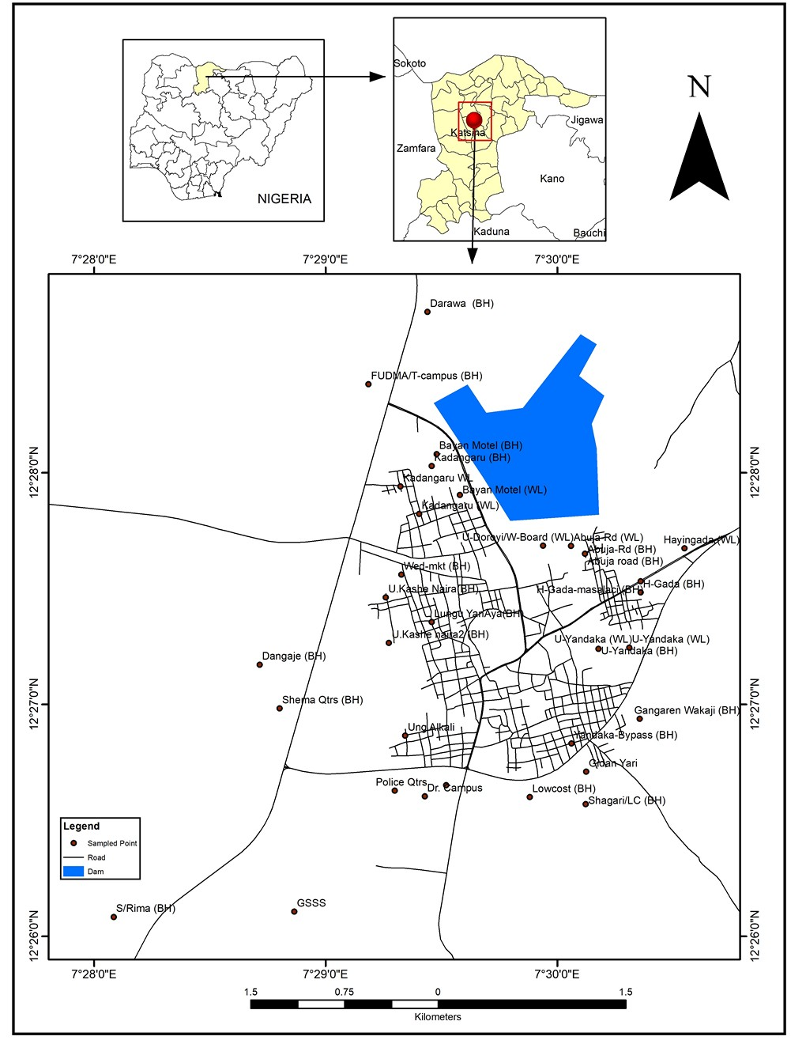
Fig. 1. Dutsin-Ma town showing public groundwater sources samples collection points.
Source: Field Work, (2022).
The vegetation of Dutsin-Ma region combines the characteristic feature of Guinea and Sudan Savanna vegetation zones of Northern Nigeria. (Tukur et al, 2013). One of such trees that has importance is Faidherbia albida (Gawo in Hausa) which is importance to African farmers, because, it provides fodder to livestock, keeps its leaves in dry season, serves as browse for livestock when little or no other fodder is available. At the end of the dry season, it drops protein rich pods-up to five tons per hectare, which can be used as fodder. Soil around the trees was enriched by the trees’ nitrogen fixing roots nodules by leaf fall and droppings of livestock that shelter them from the hot sun (Tukur et al, 2013).
The geology of Dutsin-Ma region is largely made up of basement complex rocks which are predominantly metamorphic. The oldest rocks are the igneous types which later metamorphose into metamorphic rocks as a result of heat and pressure (Kankara, 2019). The thickness of aquifer zones and the depth at which groundwater for dug well encountered is 10m - 20m while for that of boreholes is between 45 to 60m.
Dutsin-Ma area is an agrarian society. Sorghum, cowpea, maize, millet and peanut dominate crop production. Cotton and vegetables are the only cash crops produce in the area. The locals are known for their dry season irrigation farming. Crops grown during this period are mostly vegetables such as tomato, pepper, onion, and cereals such as maize and wheat. The local crafts in Dutsin-Ma include blacksmithing, carpentry and welding.

3. MATERIALS AND METHODS
3.1 Sampling and Analysis
Water samples for this study were collected from different public groundwater sources. The water samples were taken to the laboratory for assessment. The field work was divided into pre-field work which involved reconnaissance survey of the study area to identify different public groundwater sources within the study area and main field work which involved collection of samples. Stratified sampling technique was used in the selection of the sampling location for collection of samples. Using this technique, a total of 34 areas were identified as shown in Fig. 1. All parameters were analyzed in accordance with the relevant standards. Parameters considered included Turbidity (NTU), Lead (Pb), Cadmium (Cd), Manganese (Mn), Iron (Fe), Electrical Conductivity (EC), Chloride (Cl), Sulphate (SO₄²), Phosphate (PO₄), pH, Total Dissolved Solid (TDS), Total Hardness (TH). The Laboratory analysis was done in Soil Laboratory of Geography and Regional Planning Federal University Dutsin-Ma and Federal Ministry of Agriculture and Rural Development Zaria Kaduna State. Descriptive statistical and correlation analysis was carried out using the statistical package for social sciences (SPSS v26). The mean values of the measured parameters were compared with the guidelines and standards to establish any significant difference using the one sample t-test.

3.2 Mapping and spatial distribution of groundwater sources
The Global Positioning System (GPS) device was used in picking the coordinate points of the water sources that was used for mapping of the entire sampled area. The data obtained from the GPS was saved in the project folder in Excel and exported to ArcMap environment of ArcGIS 10.6. The data was converted to shape file and used to perform all the analysis.

4 RESULTS AND DISCUSSION
Table 1. Descriptive statistics of the measured parameters of public groundwater sources
 | N | Range | Min. | Max. | Mean | Std. Dev. | Variance | WHO | Remarks
NTU (mg/L) | 34 | 3.72 | 0.62 | 4.34 | 1.58 | 0.85 | 0.73 | 5.0 | Below limits
Pb (mg/L) | 34 | 0.97 | 0.10 | 1.06 | 0.46 | 0.27 | 0.07 | 0.01 | Above limits
Cd (mg/L) | 34 | 0.08 | 0.01 | 0.09 | 0.03 | 0.02 | 0.00 | 0.01 | Above limits
Mn (mg/L) | 34 | 1.33 | 0.00 | 1.33 | 0.23 | 0.33 | 0.11 | 0.1 | Above limits
Fe (mg/L) | 34 | 2.79 | 0.00 | 2.79 | 0.60 | 0.66 | 0.43 | 0.3 | Above limits
EC (μs/cm) | 34 | 181.13 | 0.07 | 181.20 | 25.50 | 32.84 | 1078.61 | 400 | Below limits
Cl (mg/L) | 34 | 5780 | 20 | 5800 | 722.56 | 1537.76 | 2364697.47 | 250 | Above limits
SO₄ (mg/L) | 34 | 2458 | 3 | 2461 | 271.74 | 606.30 | 367604.14 | 100 | Above limits
PO₄ (mg/L) | 34 | 118 | 0 | 118 | 33.06 | 32.19 | 1036.36 | 3.5 | Above limits
TH (mg/L) | 34 | 2480 | 10 | 2490 | 304.79 | 597.66 | 357201.14 | 100 | Above limits
pH | 34 | 2.00 | 6.60 | 8.60 | 7.47 | 0.51 | 0.26 | 7 | Within limits
TDS (mg/L) | 34 | 6650 | 350 | 7000 | 2452.65 | 1634.26 | 2670820.05 | 500 | Above limits
Table 2. Correlation for the measured parameters of public groundwater sources
 | Turbidity | Pb | Cd | Mn | Fe | EC | Cl | SO₄² | PO₄³ | TH | pH | TDS
Turbidity | 1
Pb | 0.54** | 1
Cd | -0.13 | 0.04 | 1
Mn | -0.03 | -0.53** | -0.19 | 1
Fe | -0.12 | -0.21 | 0.17 | 0.15 | 1
EC | 0.44** | -0.03 | -0.06 | 0.04 | -0.09 | 1
Cl | 0.30 | 0.06 | -0.10 | 0.01 | -0.17 | 0.74** | 1
S0₄² | 0.40* | 0.21 | -0.06 | -0.12 | -0.12 | 0.76** | 0.90** | 1
PO₄³ | -0.15 | -0.40* | 0.08 | 0.47** | 0.12 | -0.01 | -0.20 | -0.29 | 1
TH | 0.40* | 0.19 | -0.06 | -0.10 | -0.11 | 0.77** | 0.90** | 1.00** | -0.24 | 1
pH | 0.27 | 0.04 | -0.13 | 0.07 | -0.39* | 0.17 | 0.01 | -0.01 | -0.21 | -0.02 | 1
TDS | 0.36* | -0.06 | -0.29 | 0.35* | -0.12 | 0.35* | 0.12 | 0.06 | 0.18 | 0.07 | 0.16 | 1
**. Correlation is significant at the 0.01 level
*. Correlation is significant at the 0.05 level

The results of the descriptive analysis of the measured water parameters is as displayed in table 1. The range, mean values and standard deviations shows that Turbidity (NTU) – (0.62 to 4.34, 1.58 ± 0.85) mg/L, Lead (Pb) - (0.10 to 0.16, 0.46 ± 0.27) mg/L, Cadmium (Cd) - (0.01 to 0.09, 0.03 ± 0.02) mg/L, Manganese (Mn) - (0.00 to 1.33, 0.23 ± 0.33) mg/L, Electrical Conductivity (EC) - (0.07 to 181.20, 25.50 ± 32.84) µS/cm, Chloride (Cl) – (20 to 5800, 722.56 ± 1537.76) mg/L, Sulphate (SO₄²) - (3 to 2461, 271.74 ± 606.30) mg/L, Phosphate (PO₄) - (0 to 118, 33.06 ± 32.19) mg/L, Total Hardness (TH) – (10 to 2490, 304.79 ± 597.66) mg/L, pH - (6.60 to 8.60, 7.4 ± 0.51), while Total Dissolved Solids (TDS) - (350 to 7000, 2452.65 ± 1634.26) mg/L. Some of the mean values of these measured parameters as compared to the World Health Organisation standards were above the permitted limits.
The Pearson correlation coefficient was used to ascertain the relationship between these parameters. The analysis is as presented in table 2, which shows the interrelationship among these parameters. An average to weak positive correlation is observed between turbidity and Pb (r = 0.54), EC (r = 0.44), SO₄²⁻(r = 0.40), TH (r = 0.40), TDS (r = 0.36); Mn and PO₄²⁻(r = 0.47), TDS (r = 0.35); Significant positive correlation was observed between EC and Cl (r = 0.74), SO₄²⁻(r = 0.76), TH (r = 0.77). A weak correlation between EC and TDS (0.35) was also observed. This is however in variance with other researchers as high correlations between TDS and EC have been reported. (Adagba et al., 2021; Hailu & Haftu, 2023, Kothari et al., 2021, Onifade & Okwunjor 2024). This can be attributed to the presence of ions with low conducting abilities, non-ionic dissolved solids, the presence of colloids that do not contribute to conductivity or the presence of substances, such as organic acids which can form complexes with ions, thereby inhibiting conductivity measurements. Chlorine also showed a high positive correlation with SO₄²⁻(0.90) and TH (0.90) while SO₄²⁻ had a perfect relationship with TH (1.00). Significant negative relationship was observed between Pb and Mn (-0.53), PO₄³⁻(-0.40), with Fe²⁺ and pH (-0.39).

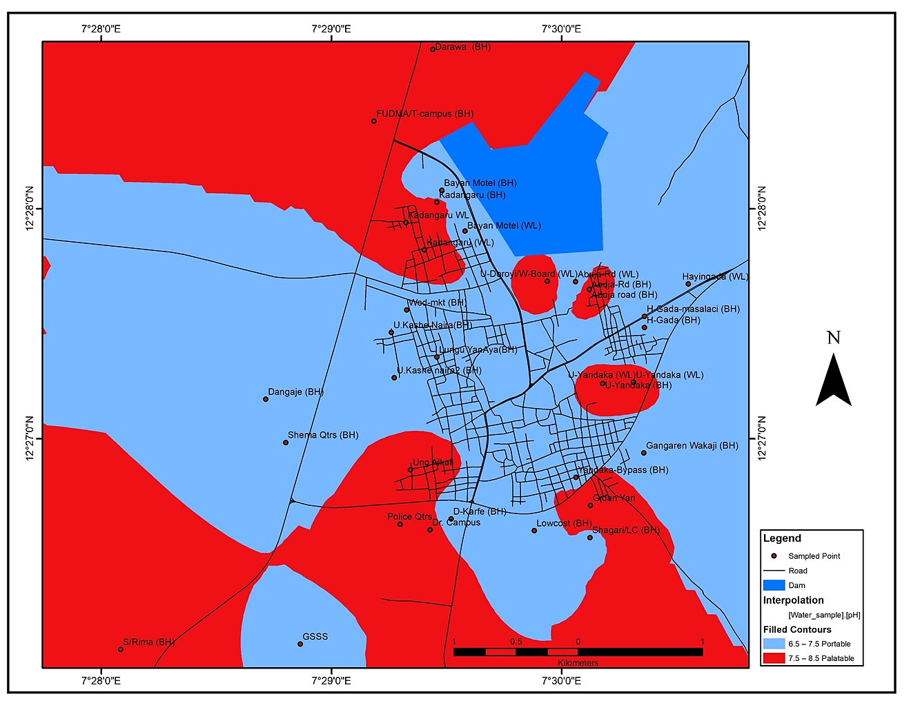
Fig. 2. Spatial pattern of pH levels in groundwater in Dutsin-Ma town
The spatial patterns of groundwater pH levels as presented in Fig. 2. above reveals that across the entire landscape (30.94 km²) of Dutsin-Ma town the pH levels fall within 6.5 to 8.5 classified into portable and palatible suitability zones covering 16.68 km² (53.91%) and 14.261 km² (46.09%) of the landscape reespectively .

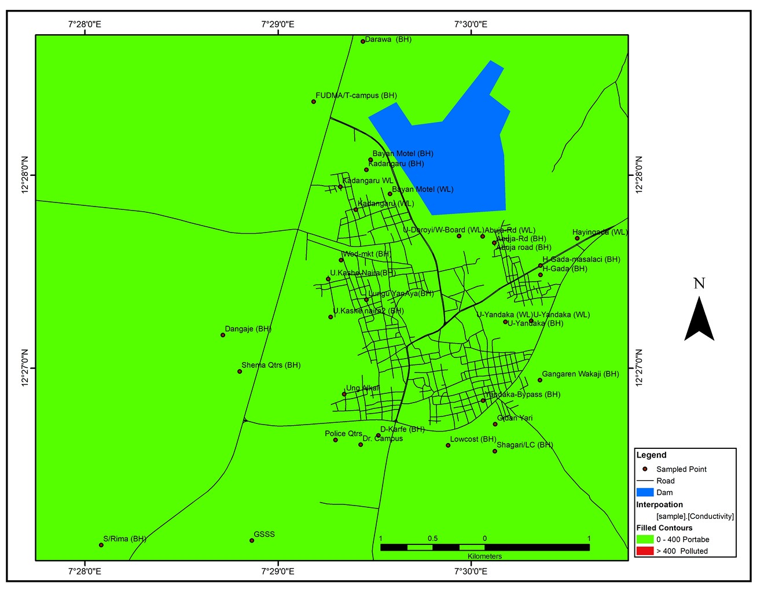
Fig. 3. Spatial pattern of EC levels in groundwater in Dutsin-Ma town
The groundwater quality surface patterns for electrical conductivity is as shown in Fig. 3. The interpolation layer shades the area mostly in green, which the legend indicates the water is potable with no significant red zone (>400 µS/cm conductivity polluted water) displayed, suggesting the area is generally within safe drinking water standards. This therefore means that 100% (30.94km²) falls under the potable category (0–400 µS/cm).

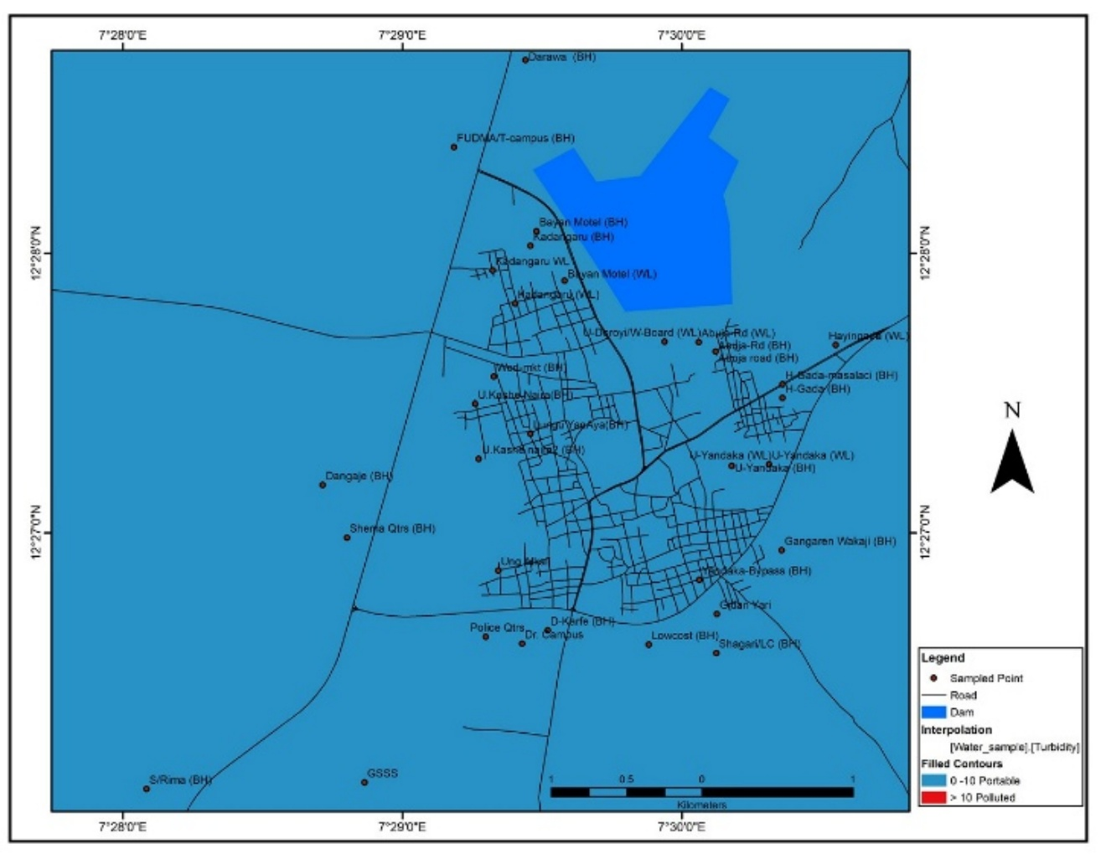
Fig. 4. Spatial pattern of Turbidy levels in groundwater in Dutsin-Ma town

The results of turbidity shown in Fig. 4. reveals that the entire landscape (30.94 km²) of the town is covered by the suitable portable zone. Turbidity is the measures of "cloudiness" or haziness of the water, caused by suspended particles like silt, clay, or organic matter. The nature of soils plays a significant role in the clear appearance of water if fetched undisturbed.

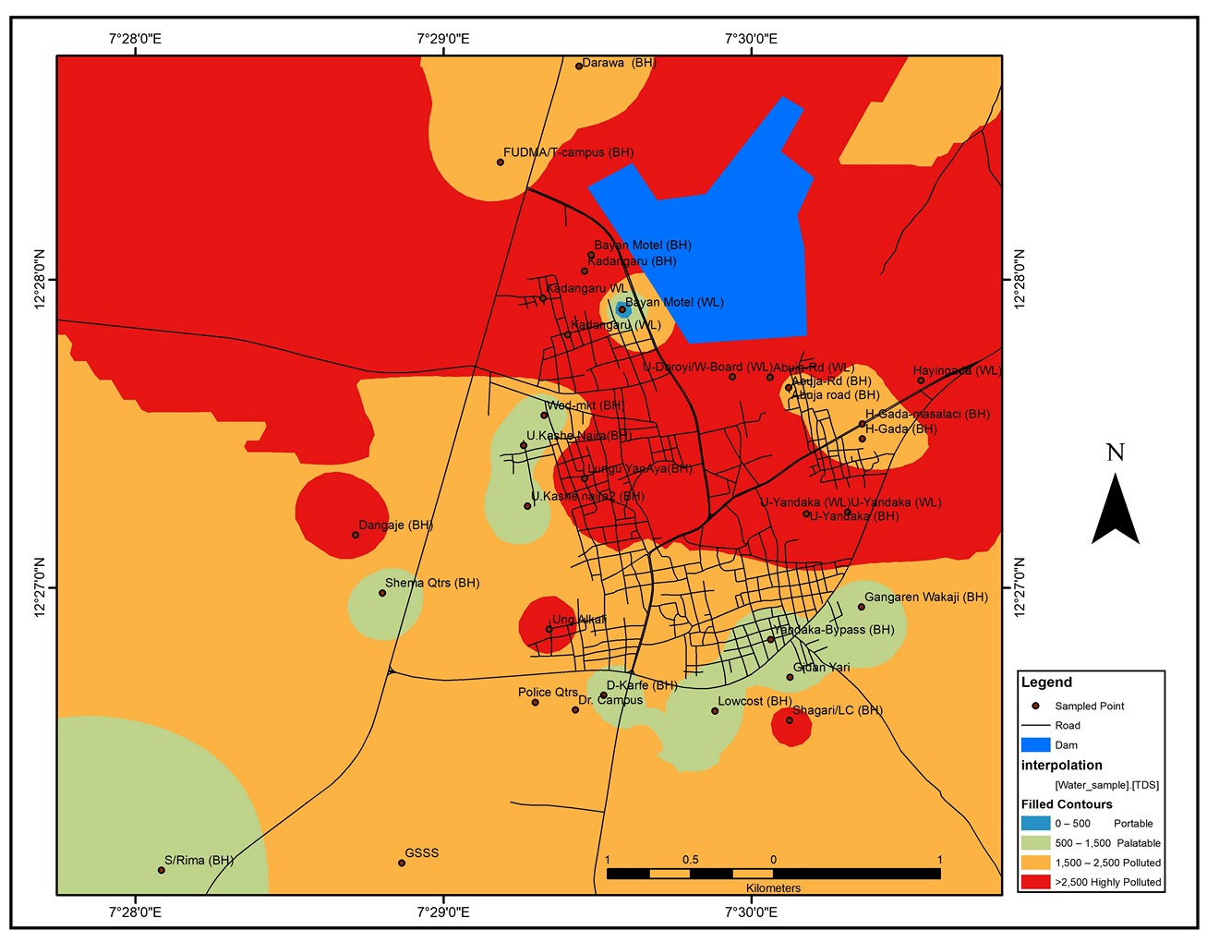
Fig. 5. Spatial pattern of TDS levels in groundwater in Dutsin-Ma town

The surface patterns of groundwater TDS levels as presented in Fig.5. above indicates that only 0.008 km² of the towns landscape is occupied by portable suitable area and 2,723 km² under palatable suitable zone. About 14.614 and 13.592 km² (i.e. 47.24 and 49.93%) are covered polluted and highly polluted TDS levels. This put the total of approximately 91% under unsuitable TDS landscape. TDS rrefers to all inorganic and organic substances dissolved in the water, such as salts and minerals.
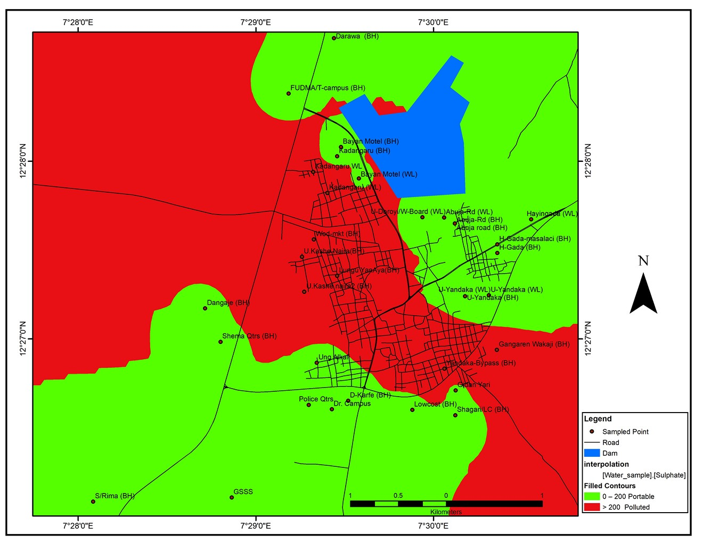
Fig. 6. Spatial pattern of Sulphate levels in groundwater in Dutsin-Ma town.

The surface patterns of groundwater sulphate levels as revealed in Fig.6. depicts that there is no area that depicts polluted or highly polluted levels. The entire landscape shared between portable or palatable levels with 16.07 and 14.87 km² (51.938 and 48.062%) respectively. Groundwater sulphate levels vary significantly, but levels above 250 mg/L are generally considered high and can cause aesthetic issues with taste and odour, while concentrations above 500 mg/L are associated with laxative effects like diarrhoea, particularly for those not acclimated to high-sulphate water. Levels greater than 600 mg/L can cause strong laxative effects and potential dehydration, especially for vulnerable groups like infants

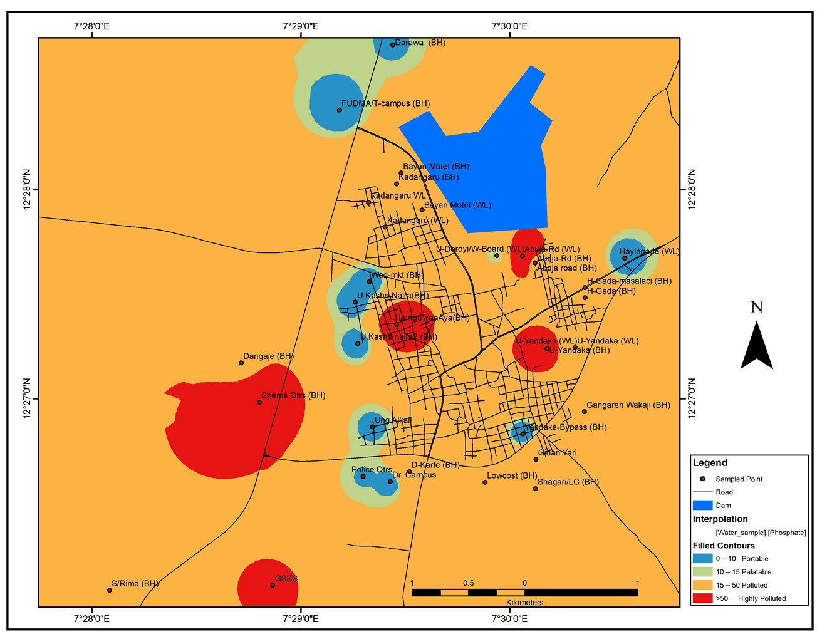
Fig. 7. Spatial pattern of Phosphate levels in groundwater in Dutsin-Ma town

While sulphate levels are suitable over the entire Dutsin-Ma town, phosphate levels as shown in Fig.7. occupies both suitable and unsuitable zones. Portable zone covers 0.64 while palatable zone 1.17 km². About 27.61 km² (89.32%) falls under polluted levels zones and 1.52 km² (4.91%) is occupied by highly polluted levels zone. Human activities are a major cause of elevated phosphate levels in groundwater. Runoff from agricultural usage of fertilizers and animal waste can transport excess phosphorus into the soil and then into groundwater. Industrial processes can release phosphorus into the environment. Decomposition of organic matter from human and animal waste can contribute to phosphorus in groundwater. Geogenic Sources or naturally occurring phosphate can come from rocks, minerals, and soils. The results in this study agree with earlier study by Ndabula et al., 2018.

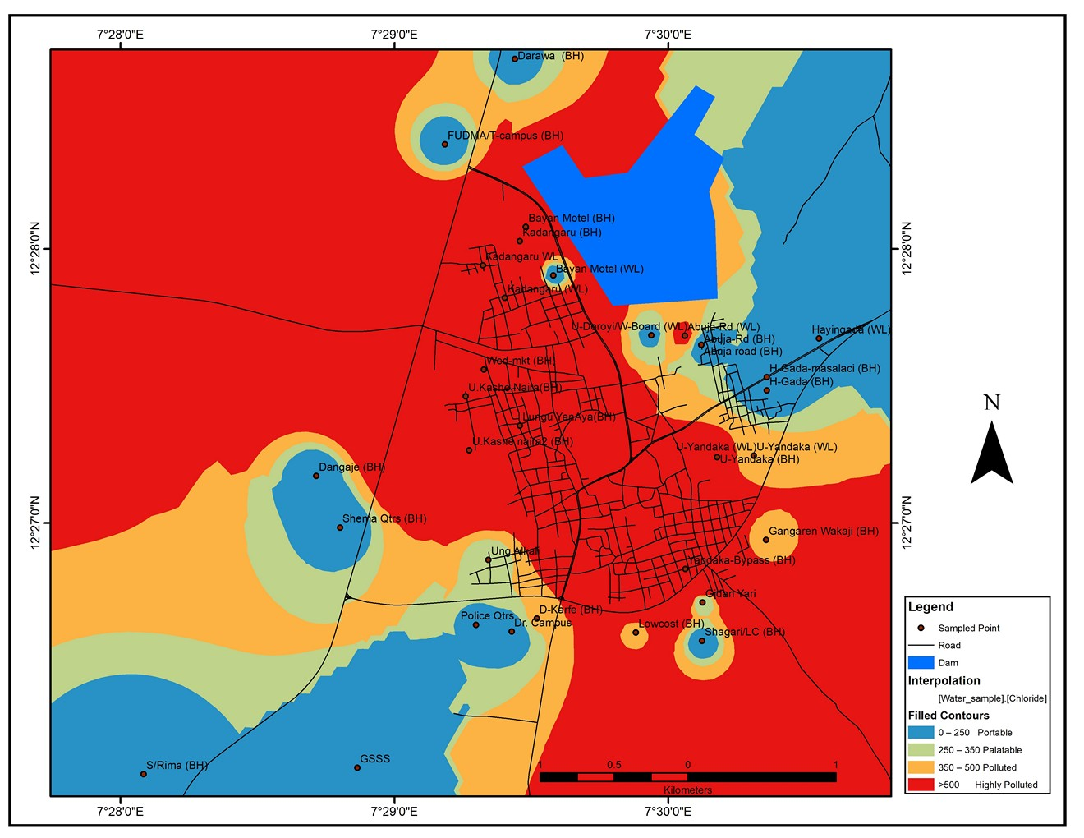
Fig. 8. Spatial pattern of Chloride levels in groundwater in Dutsin-Ma town
The outcome of chloride levels as depicted in Fig. 8. reveals that only 6.073 km² and 3.031 km² (i.e. 10.63 and 9.08%) respectively represents portable and palatible landscapes of the town, while 4.22 and 17.61 km² or (3.64 and 56.94%) occupies polluted and highly polluted zones of the landscape.

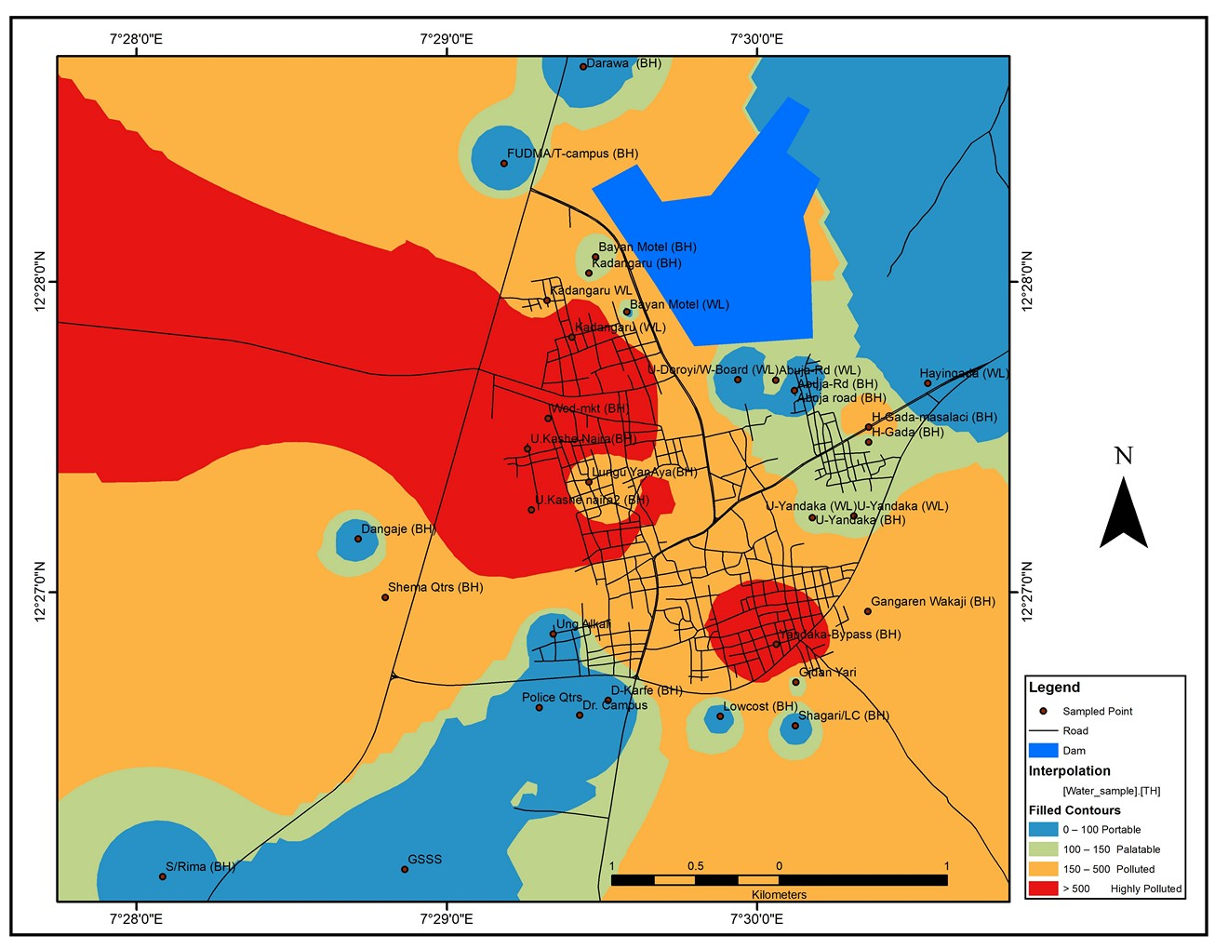
Fig. 9. Spatial pattern of Total Hardness levels in groundwater in Dutsin-Ma town

Surface patterns of groundwater total hardness levels as presented in Fig.8. shows that about 6.06 km²of the landscape is having portable suitable total hardness levels and another 3.44 km² under palatable levels zones. The remaining 15.52 and 5.81 km² (50.15 and 18.78%) are covered by unsuitable polluted and highly polluted total hardness zones respectively.

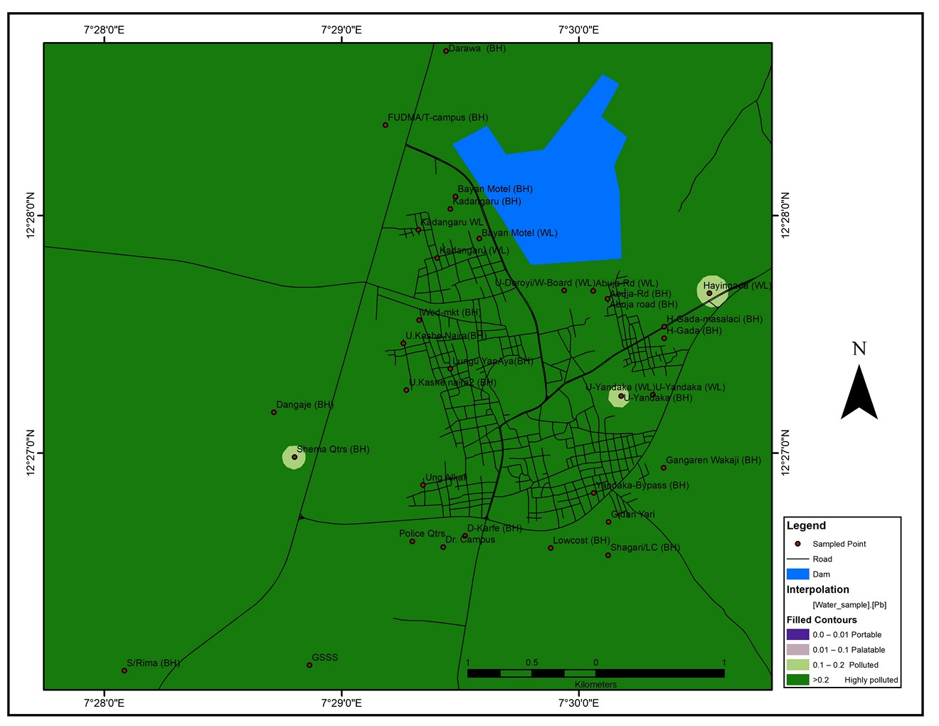
Fig. 10. Spatial pattern of Lead levels in groundwater in Dutsin-Ma town

Groundwater levels of lead a toxic metal as presented in Fig.10. shows that almost the entire Dutsin-Ma town’s landscape (30.84 km² or 99.67%) is under very highly polluted zone and the remainig 0.09 km² (0.33%) polluted zone. On the contrary, manganese levels in Fig.11. reveals that 30.73 km² (99.32%) of is spread over portable zone with only 0.04 km² (0.13%) covering polluted zone of the town.

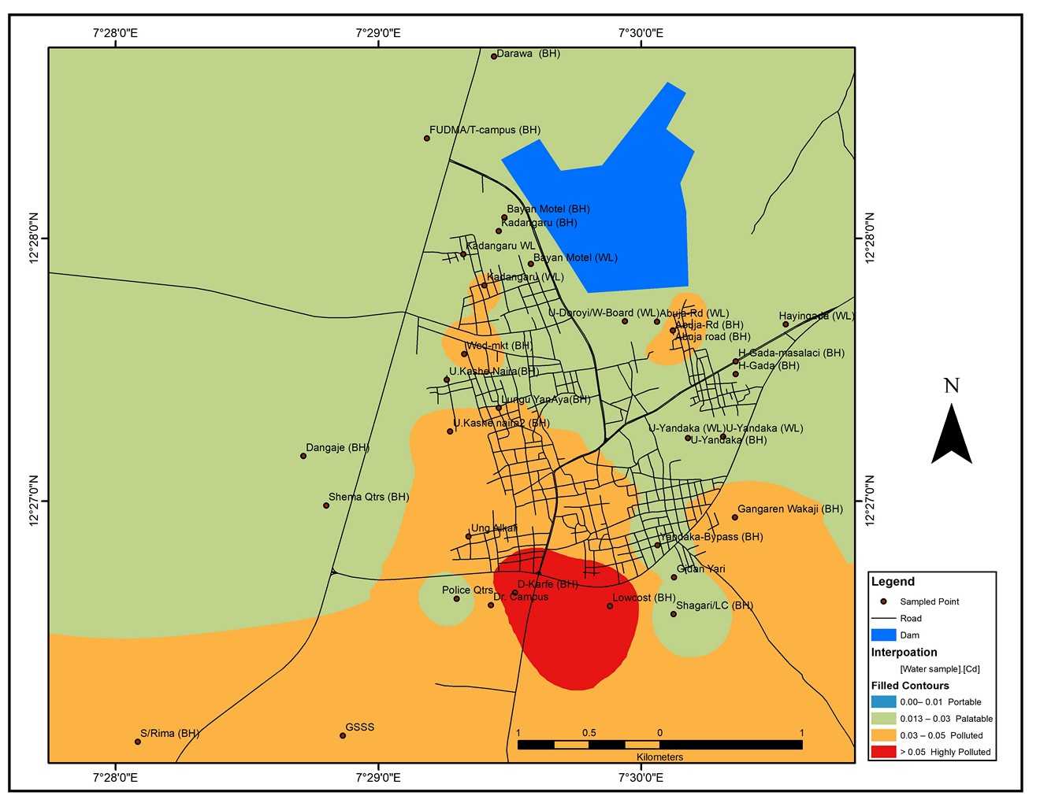
Fig. 11. Spatial pattern of Cadmium levels in groundwater in Dutsin-Ma town

Similarly, the results of cadmium toxic metal as presented in Fig.11. shows that suitable levels are spread over nearly the whole landscape (20.85 km² or 67.40% ) is covered under palatible suitability zone. While 9.37 km² (30.29%) only 0.72 km² or (2.33%) of the town respectively of the landscape is under polluted and highly polluted levels zone.

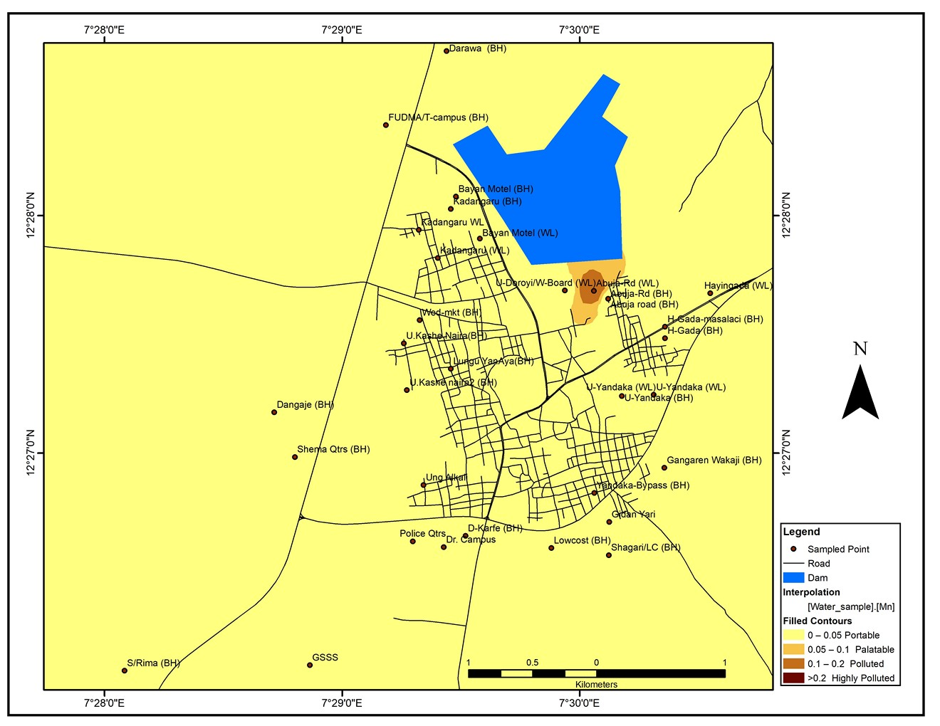
Fig. 12. Spatial pattern of Mn levels in groundwater in Dutsin-Ma town

Almost all (30.73 km² or 99.88%) of the Dutsin-Ma groundwater landscape reveals portable to palatable levels of manganese.

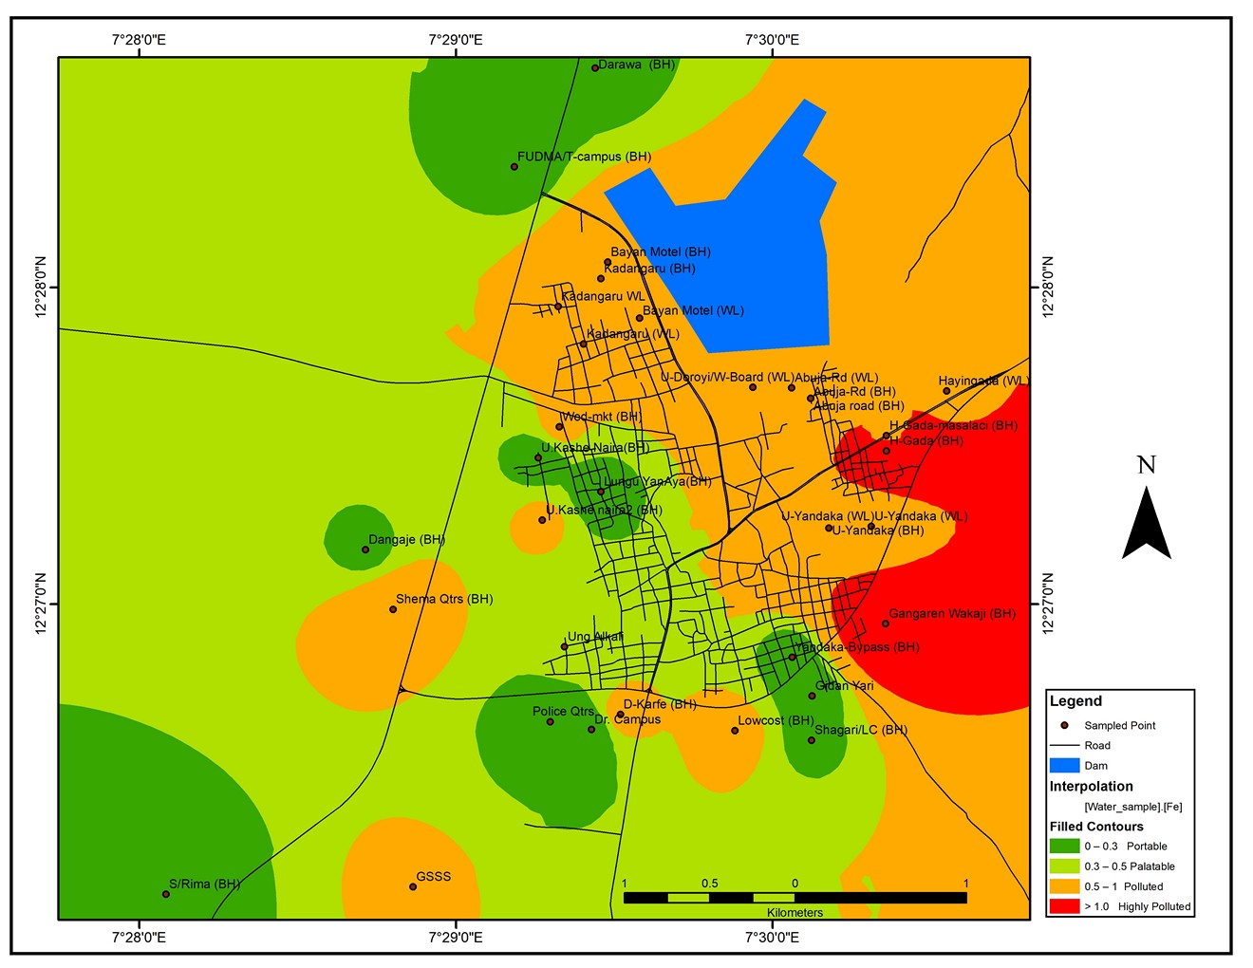
Fig. 13. Spatial pattern of Iron levels in groundwater in Dutsin-Ma town

Results of iron levels patterns as depicted in Fig.13. above indicate wide spread of various levels of distribution both between suitable (portable and palatable) and unsuitable (polluted and highly polluted) zones. The distribution of Iron metal in groundwater landscape showed that 19.07 km² (61.63%) is occupied by portable and palatable quality limits, while 3.26 km² (10.54%) and 8.61 km² (27.82%) are occupied by polluted and highly polluted iron levels. respectively.

5. CONCLUSION AND RECCOMMENDATIONS
This study presented the findings of the analysis of the geochemical indicators of groundwater quality in Dutsin-Ma town from 34 sampling locations. Results showed the means of 25.50 ± 32.84 µS/cm, 7.4 ± 0.51, 1.58 ± 0.85 mg/L, 2452.65 ± 1634.26 mg/L, 271.74 ± 606.30 mg/L, 33.06 ± 32.19 mg/L, 304.79 ± 597.66 mg/L, 722.56 ± 1537.76 mg/L, 0.46 ± 0.27 mg/L, 0.23 ± 0.33 mg/L, 0.03 ± 0.02 mg/L, 0.60 ± 0.66 mg/L for Electrical Conductivity, pH, Turbidity, Total Dissolved Solids, Sulphate, Phosphate, Total Hardness, Chloride, Lead, Manganese, Cadmium and Iron respectively. Statistical analysis revealed that there exist several significant relationships between some of the measured parameters with no significant difference was observed between the mean of the measured parameters and the standard for Turbidity, Pb, Cd, EC, PO₄, pH, TDS, Mn and Fe at a 95% confidence interval.
The study therefore recommended that water sources having concentration of these parameters above the recommended limits be monitored to ensure that sources of contamination are contained to reduce the risk of further contamination of these water sources. Develop a framework for domestic water quality monitoring which involves the creation of a GIS database by water managers for the purpose of updating spatial maps that will be necessary for their policy formation. Residents be enlightened and encouraged to apply domestic water treatment methods so as to reduce these levels to the acceptable limits while targeting and minimizing seemingly probably sources of contamination due to human activities. Further research is suggested to assess the spatio-temporal variations in the concentrations during different seasons of the year to ascertain levels of concentration during different times of the year.

REFERENCES
Abaje, I. B., Sawa, B. A. & Ati, O. F. (2014). Climate variability and change, impacts and adaptation strategies in Dutsin-Ma local government area of Katsina state, Nigeria. Journal of Geography and Geology. 6,(2) 103-112; http://dx.doi.org/10.5539/jgg.v6n2p103
Abdulsalam, A., Ramli, M.F., Jamil, N.R., Ashaari, Z.H. & Umar, D.A. (2022). Hydrochemical characteristics and identification of groundwater pollution sources in tropical savanna. Environ Sci Pollut Res 29, 37384–37398. https://doi.org/10.1007/s11356-022-18552-0
Absametov, M., Sagin, J., Adenova, D., Smolyar, V. & Murtazin, E. (2023). Assessment of the groundwater for household and drinking purposes in central Kazakhstan. Groundwater for Sustainable Development 21; 100907 https://doi.org/10.1016/j.gsd.2023.100907
Adagba, T., Kankara A. I. & Idris, M. A. (2021). Ground water quality assessment in the Kazaure environs for drinking purpose using the water quality index tool. Engineering and Scientific International Journal 8,(4) 147-152. https://doi.org/10.30726/esij/v8.i4.2021.84023
Adagba, T., Kankara, A. I. & Idris, M. A. (2022). Evaluation of groundwater suitability for irrigation purpose using GIS and irrigation water quality indices. FUDMA Journal of Sciences (FJS) 6(2); 63 – 80. https://doi.org/10.33003/fjs-2022-0602-925.
Akawu, C., Oluyori N.R., Oyatayo, T.K., Ndabula, C., & Jidauna, G.G. (2025). Spatial Patterns and Environmental Exposure to Groundwater Hardness Levels Across Localities in Dutsin-Ma Town, Katsina State, Nigeria. European Journal of Ecology, Biology and Agriculture, 2(4), 12-26. https://doi.org/10.59324/ejeba.2025.2(4).02
Aydi, A. (2018) Evaluation of groundwater vulnerability to pollution using a GIS-based multi-criteria decision analysis. Groundwater for Sustainable Development Volume 7; 204-211
Barkat, A., Bouaicha, F., Bouteraa, O., Mester, T., Ata, B., Balla, D., Rahal, Z. & Szabó, G. (2021). Assessment of complex terminal groundwater aquifer for different use of Oued Souf valley (Algeria) using multivariate statistical methods, geostatistical modelling, and water quality index. Water, 13, 1609. https://doi.org/10.3390/w13111609
Barkat, A., Bouaicha, F., Mester, T., Debabeche, M. & Szabó, G. (2022). Assessment of spatial distribution and temporal variations of the phreatic groundwater level using geostatistical modelling: The case of Oued Souf valley southern east of Algeria. Water, 14, 1415. https://doi.org/10.3390/w14091415
Beg, A. A. F., Awadh, S. M., Thamer, M. B. & AL-Sulttani, A. H. (2021). Assessment of groundwater quality for drinking purposes using water quality index and identifying the affecting mechanism in Rashdiya, central Iraq. Iraqi Geological Journal, 54(1F), 20- 32. https://doi.org/10.46717/igj.54.1F.3ms-2021-06-23
El Azhari, H., Cherif, E. K., Sarti, O., Azzirgue, E. M., Dakak, H., Yachou, H., Esteves Da Silva, J. C. G. & Salmoun, F. (2023). Assessment of surface water quality using the water quality index (IWQ), multivariate statistical analysis (MSA), and geographic information system (GIS) in Oued Laou mediterranean watershed, Morocco. Water, 15(1), 130. https://doi.org/10.3390/w15010130
El-Ladan, I. Y. & Maiwada, N. A. (2014). An assessment of some water quality properties of groundwater in Dutsin-ma metropolis, Nigeria. Int. J. Curr. Microbiol. App. Sci. 3(5): 644-649 http://www.ijcmas.com.
Environmental Systems Research Institute. (ESRI, 2006). Using Arc GIS geo statistical analyst (300p, USA).
Fallatah, O. & Khattab, M. R. (2023). Evaluation of groundwater quality and suitability for irrigation purposes and human consumption in Saudi Arabia. Water, 15(13), 2352. https://doi.org/10.3390/w15132352
Farid, H.U.; Ayub, H.U.; Khan, Z.M.; Ahmad, I.; Anjum, M.N.; Kanwar, R.M.A.; Mubeen, M.; Sakinder, P. (2022). Groundwater quality risk assessment using hydro-chemical and geospatial analysis. Environ. Dev. Sustain. 25; 8343–8365.
Gupta, S. & Gupta, S. K. (2021). A critical review on water quality index tool. genesis, evolution and future directions. Ecological Informatics 63:101299. https://doi.org/10.1016/j.ecoinf.2021.101299
Hailu, H. & Haftu, S., (2023). Hydrogeochemical studies of groundwater in semi-arid areas of northern Ethiopia using geospatial methods and multivariate statistical analysis techniques. Applied Water Science 13:86. https://doi.org/10.1007/s13201-023-01890-w
Dutsin-Ma Local Government Area in Nigeria. https://www.citypopulation.de/en/nigeria/admin/katsina/NGA021012__dutsin_ma/. Accessed 10th June, 2024.
Honarbakhsh, A.; Tahmoures, M.; Tashayo, B.; Mousazadeh, M.; Ingram, B.; Ostovari, Y. (2019). GIS-based assessment of ground water quality for drinking purposes in northern part of Fars province, Marvdasht. J. Water Supply Res. Technol. Aqua 68, 187–196.
Hui, T., Jizhong, D., Shimin, M., Zhuang, K. & Yan, G. (2020): Application of water quality index and multivariate statistical analysis in the hydrogeochemical assessment of shallow groundwater in Hailun, northeast China. Human and Ecological Risk Assessment: An International Journal. https://doi.org/10.1080/10807039.2020.1749827
Idris, S (2017). Evaluation of portable water quality in Dutsin-Ma town, Katsina State, Nigeria. International Journal of Scientific Research in Science and Technology (IJSRST) 3(3); 39-46
Jang, C. S., Chen, S. K. & Kuo, Y. M. (2013) Applying indicator-based geostatistical approaches to determine potential zones of groundwater recharge based on borehole data Catena (Amst), 101, 178–187.doi:10.1016/J.CATENA.2012.09.003.
Jha, M. K., Shekhar, A. & Jenifer, M. A. (2020). Assessing groundwater quality for drinking water supply using hybrid fuzzy-GIS-based Water Quality Index. Water Research 179 (2020) 115867 https://doi.org/10.1016/j.watres.2020.115867
Jidauna, G.G., Ndabula, C., Oche, C.Y. & Dabi, D.D (2017). Water quality assessment of selected domestic water sources in Dutsin-ma town, Katsina State. Science World Journal. 12(4) 43-50. www.scienceworldjournal.org
Kankara, I. A. (2019). The geology of Dutsin-Ma region: A Geographical Compendium GEO 105: Local Field Course Manual. Dept. of Geology, Federal University Dutsin-Ma.
Kanu, O. P., Ugwoha, E., Udeh, N. U. & Amah, V. (2023). Modelling groundwater quality of Aba in Abia state using Principal Component Analysis and Multiple Linear Regression. Journal of Engineering Research and Reports. 25(11) 39-54. https://doi.org/10.9734/JERR/2023/v25i111019
Khouni, I., Louhichi, G. & Ghrabi, A. (2021). Use of GIS based Inverse Distance Weighted interpolation to assess surface water quality: Case of Wadi El Bey, Tunisia. Environ. Technol. Innov., 24, 101892. https://doi.org/10.1016/j.eti.2021.101892
Kothari, V., Vij, S., Sharma, S. & Gupta, N. (2021). Correlations of various water quality parameters and water quality index of districts of Uttarakhand. Environmental and Suitability Indicators. 9:100093. https://doi.org/10.1016/j.indic.2020.100093
Lapworth DJ, Boving TB, Kreamer DK, Kebede S, Smedley PL.Sci Total Environ. 2022 Mar 10;811:152471. doi: 10.1016/j.scitotenv.2021.152471. Epub 2021 Dec 14.PMID: 34915019
Liu, J., Zhang, D., Tang, Q., Xu, H., Huang, S., Shang, D. & Liu, R. (2021). Water quality assessment and source identification of the Shuangji River (China) using multivariate statistical methods. PLoS ONE 16, e0245525. https://doi.org/10.1371/journal.pone.0245525
Mohammed, A. I., Naimi, S. & Dawood, A. S. (2023). Evaluation of the drinking and irrigation quality of groundwater in Basrah, Iraq. Journal of Ecological Engineering 24(9), 260–271. https://doi.org/10.12911/22998993/169177
Morris, B. L., Lawrence, A. R., Chilton, P. J, Adams, B, Calow, R & Klinck, B. A. (2003). Groundwater and its susceptibility to degradation: A global assessment of the problems and options for management. Early Warning and Assessment Report Series, RS, 03-3. UNEP, Nairobi, Kenya
NPC (2006). Report on 2006 National Population Census. Nigeria of Dawakin-tofa Local Government Area of Kano State Nigeria. Paper Published of America. Opening region, Journal of Geology Society of America..37,(5).
Ndabula, C., Oyatayo, K.T., Akawu, C Jidauna, G.G. (2024) A comparative analysis of the forms and levels of water hardness of domestic water intake sources in Dutsin-Ma town, Katsina State, Nigeria. Kashere Journal of Geography and Sustainable Environment (KJGSE), Vol.1, No. 1., Oct., 2024. ISSN: 0795-6266
Ndabula, C., Jidauna, G.G., Abaje, I. B., Adamu, G. K., Ubogu, A. E, Ati, O. F. & Odigie, V. A. (2018). Spatial analysis of Sulphate and Phosphate levels of major domestic water intake sources in Dutsin-ma town, Katsina State, Nigeria. FUDMA Journal of Sciences (FJS) 2(3): 146 – 153.
Onifade, Y. S. & Okwunjor, O. (2024). Correlation between Total Dissolved Solids and Electrical Conductivity of water in Ubeji and Iffic environs of Delta State. FUPRE Journal of Scientific and Industrial Research. 8(1): 89-97.
Progress on Drinking Water and Sanitation (PDWS, 2008). Special focus on Sanitation: 2008
Prüss-Üstün, A., Kay, D., Fewtell, L. & Bartram, J. (2004) Unsafe Water Sanitation and hygiene. In: Comparative Quantification of Health Risks: Global and Regional Burden of Disease Attributable to Selected Major Risk Factors, (eds. Ezzati, M., Lopez, A. D., Rodgers, A. and Murray, C. J. L), Volume 2, pp. 1321-1352, World Health Organization, Geneva.
Rahman, M. M., Islam, M. J., Bhuiyan, M. A. H. & Bodrud-Doza, K. S. (2020). Assessment of groundwater quality using GIS and water quality index in a coastal area of Bangladesh. Arabian Journal of Geosciences, 13(1), 22. https://doi.org10.1007/s12517-019-04992-9
Sagar, D. N., Basavarajappa, H. T. & Manjunatha, M. C. (2024). Groundwater quality assessment for domestic and irrigation purposes for Mandya district of Karnataka, India using geospatial tools. Indian Journal of Natural Sciences. 15(83); 71555 – 71563. www.tnsroindia.org.in
Silva, M.I., Gonçalves, A.M.L., Lopes, W.A., Lima, M.T.V., Costa, C.T.F., Paris, M., Firmino, P.R.A. & De Paula Filho, F.J. (2021). Assessment of groundwater quality in a Brazilian semiarid basin using an integration of GIS, water quality index and multivariate statistical techniques. Journal of Hydrology 598; 126346. https://doi.org/10.1016/j.jhydrol.2021.126346
Thlakma S. R., Tukur, M. M., Hena M. K., Abare M. L. & Muhammad K. A. (2018) GIS-based underground water quality risk mapping of Kaltungo L.G.A, Gombe State, Nigeria, Am. Sci. Res. J. Eng., Technol. Sci. (ASRJETS),44 (1),264–277.
Tukur, R., Adamu, G. K., Abdulrahid, I. & Rabi’u, M. (2013). Indigenous trees inventory and their multipurpose uses in Dutsin-Ma area, Katsina State. European Scientific Journal, 9(11), 288-300.
WHO (2006). Protecting Groundwater for Health: Managing the Quality of Drinking-water Sources. In O. Schmoll, G. Howard, J. Chilton and I. (Eds) Published by IWA Publishing, London, UK. Organization: Retrieved from http://www.who.int Accessed 10/06/2024.
WHO (2011). Guidelines for drinking-water quality, 4th Edn. World Health Organization, Geneva
Yang, F., Liu, S., Jia, C., Gao, M., Chang, W. & Wang, Y. (2020). Hydrochemical characteristics and functions of groundwater in southern Laizhou Bay based on the multivariate statistical analysis approach. Estuar. Coast. Shelf Sci., 250, 107153. https://doi.org/10.1016/j.ecss.2020.107153.
Yeh, H. F., Lee, C. H., Hsu, K. C. & Po-Hsun, C. GIS for the assessment of the groundwater recharge potential zone. Environ. Geol. 58, 185–195 (2009).

