The Power of Finance in a Warming World: A Bibliometric Analysis of Climate Finance (2015-2024) and its Role in Shaping a Sustainable Future

ABSTRACT

Climate finance has become a key enabler of global climate action, playing a pivotal role in mitigating greenhouse gas (GHG) emissions and enhancing resilience to climate impacts. Despite its growing importance, the field of climate finance remains complex and fragmented, with limited efforts to systematically map its intellectual structure and evolution. This study conducts a comprehensive bibliometric analysis of climate finance research from 2015 to 2024, leveraging data from the Scopus database. The study examines publication trends, influential authors and institutions, collaborative networks, and thematic evolution using performance analysis, science mapping, and network analysis. The findings reveal significant growth in climate finance research, driven by key milestones, including the Paris Agreement. Dominant research themes include the role of public and private finance, innovative financial instruments, and barriers to scaling up investments. Emerging topics such as blended finance, climate risk integration, and alignment with the Sustainable Development Goals (SDGs) are also identified. The study highlights the contributions of climate finance research to shaping a sustainable future while underscoring gaps in equity, transparency, and policy impact. By providing a holistic understanding of the field, this analysis offers valuable insights for researchers, policymakers, and practitioners seeking to advance climate finance and achieve global sustainability goals.

Keywords: Climate Finance, Bibliometric Analysis, Sustainable Development Goals (SDGs), Green Finance, Paris Agreement, Public and Private Finance, Blended Finance, Climate Risk Integration

1. INTRODUCTION

1.1 Background
Climate finance is the financial flows directed toward climate change mitigation and adaptation efforts (Hong et al., 2020). It has gained significant global attention, especially following the Paris Agreement 2015 (Muchiri et al., 2022). The agreement underscored the need for developed countries to mobilize $100 billion annually by 2020 to support climate action in developing nations, making climate finance a cornerstone of international climate policy (Rusydiana, 2024). This financial mechanism encompasses various forms of capital, including public funds, private investments, and innovative financial instruments like green bonds and carbon credits.
The urgency to combat climate change, coupled with the evolving landscape of global finance, has led to a burgeoning field of academic research focused on climate finance. Researchers, policymakers, and financial institutions are increasingly exploring how financial mechanisms can be optimized to support sustainable development goals (SDGs) and facilitate the transition to a low-carbon economy. This growing interest is reflected in the sharp rise in academic publications, conference presentations, and policy reports addressing various aspects of climate finance.
1.2 Emerging Trends in Bibliometric Analysis
Bibliometric analysis is a quantitative method for analysing academic literature and has become an indispensable tool for understanding the development of research fields, including climate finance. This method systematically examines publications, citations, and collaborative networks, offering insights into the structure and dynamics of scientific research (Donthu et al., 2021).
In recent years, bibliometric analysis has evolved to include more sophisticated tools and techniques (Bornmann & Mutz, 2015). Traditional bibliometric indicators, such as publication counts and citation analysis, are now complemented by advanced methods like co-word analysis, co-citation analysis, and network visualization (Donthu et al., 2021; Gusenbauer & Haddaway, 2020; Small, 1973). These techniques allow researchers to map the intellectual structure of a field, identify emerging research trends, and understand collaboration patterns among authors, institutions, and countries.
One of the emerging trends in bibliometric analysis is the integration of science mapping and network analysis (Callon et al., 1991; Newman, 2001). Science mapping visually represents the relationships between different research themes, revealing how specific topics within a field are interconnected. On the other hand, Network analysis focuses on the collaborative aspects of research, illustrating the relationships between authors, institutions, and even countries (Donthu et al., 2021).

2. materials and methods

2.1 LITERATURE REVIEW
Climate change is one of the most pressing challenges of the twenty-first century, with far-reaching implications for ecosystems, economies, and societies worldwide (Hong et al., 2020; Joshi & Dash, 2023). As global temperatures continue to rise, the need for effective mitigation and adaptation strategies has become increasingly urgent. In this context, climate finance has emerged as a critical tool for mobilizing resources to support climate action, particularly in developing countries that are most vulnerable to the impacts of climate change (CPI, 2019). Climate finance encompasses a wide range of financial mechanisms, including public and private investments, grants, loans, and carbon markets, to reduce greenhouse gas (GHG) emissions and enhance resilience to climate impacts (UNFCCC, 2015). Despite its growing importance, the field of climate finance remains complex and multifaceted, with significant gaps in understanding its evolution, trends, and impact on sustainable development.
Over the past decade, the academic literature on climate finance has expanded rapidly, reflecting the increasing recognition of its role in addressing climate change. However, the sheer volume of publications and the diversity of perspectives make it challenging to identify key trends, influential works, and emerging research themes. Bibliometric analysis, a quantitative method for analysing scholarly literature, offers a powerful approach to mapping the intellectual structure of a field, identifying research gaps, and highlighting areas for future inquiry (Muchiri et al., 2022). By systematically analysing publications, citations, and co-authorship patterns, bibliometric studies can provide valuable insights into developing a research domain and its contribution to broader societal goals (Debrah et al., 2023; Gusenbauer & Haddaway, 2020).
2.1.1 Evolution and Trends in Climate Finance Research
Climate finance research has grown exponentially since adopting the Paris Agreement in 2015, reflecting the increasing recognition of finance as a critical enabler of climate action. Studies have explored various dimensions of climate finance, including its sources, instruments, and allocation mechanisms (Shang & Jin, 2023). For instance, public finance from developed countries has been a significant focus, with discussions on the commitment to mobilize $100 billion annually to support climate action in developing nations (Weikmans & Roberts, 2019). However, private finance has also gained prominence, with research highlighting the role of green bonds, carbon markets, and impact investing in scaling climate investments (Flammer, 2021).
Despite this growth, the literature remains fragmented, with limited efforts to systematically map the evolution of climate finance research. While some studies have used bibliometric methods to analyse specific aspects of climate finance, such as green finance (Wang et al., 2025) or sustainable investments (Taneja et al., 2023), a comprehensive analysis of the entire field is lacking. This gap underscores the need for a holistic bibliometric review to identify trends, geographic distribution, and disciplinary focus over 2015–2024.
2.1.2 Influential Authors, Institutions, and Collaborative Networks
Contributions from various authors, institutions, and countries characterize the climate finance literature. Prominent scholars have examined topics such as the effectiveness of climate funds (Michaelowa & Michaelowa, 2015), the role of multilateral development banks (MDBs) in scaling up climate finance (Bhandary et al., 2021), and the challenges of mobilizing private capital (Muchiri et al., 2022). Institutions such as the World Bank, Climate Policy Initiative, and academic research centres have been pivotal in advancing the field (Bhandary et al., 2021; Weikmans & Roberts, 2019).
However, there is limited research on the collaborative networks that drive climate finance research. While some studies have explored co-authorship patterns in related fields, such as environmental economics (Zhang et al., 2018), few have focused specifically on climate finance. Understanding these networks is crucial for identifying knowledge hubs, fostering collaboration, and addressing disparities in research capacity, particularly in developing countries most affected by climate change.
2.1.3 Dominant Research Themes and Emerging Topics
The climate finance literature can be broadly categorized into several key themes:
- Sources and instruments: Studies have examined the role of public and private finance, as well as innovative instruments such as green bonds and climate risk insurance (Flammer, 2021; Surminski & Thieken, 2017).
- Allocation and effectiveness: Research has focused on how climate finance is allocated across regions and sectors and its effectiveness in achieving climate goals (Michaelowa & Michaelowa, 2015).
- Barriers and enablers: Scholars have identified barriers to scaling up climate finance, such as policy uncertainty and lack of investor confidence, as well as enablers like regulatory frameworks and capacity building (Chang, 2019).
Emerging topics include the role of blended finance, the integration of climate risks into financial decision-making, and the alignment of financial flows with the goals of the Paris Agreement (OECD, 2020). However, there is a lack of systematic analysis of how these themes have evolved over time and which topics are gaining traction. A bibliometric analysis can help identify these trends and highlight areas that require further exploration.
2.1.4 Contribution to a Sustainable Future
Climate finance is widely recognized as a key driver of sustainable development, potentially supporting mitigation and adaptation efforts while promoting economic growth and poverty reduction (UNFCCC, 2015). Studies have highlighted the synergies between climate finance and the Sustainable Development Goals (SDGs), particularly in renewable energy, sustainable agriculture, and disaster resilience (Nhamo et al., 2019). However, challenges remain in ensuring that climate finance is equitable, transparent, and aligned with the needs of vulnerable communities (Weikmans & Roberts, 2019).
Despite its potential, the literature on the impact of climate finance on sustainable development is still evolving. There is limited empirical evidence on how climate finance contributes to long-term sustainability outcomes, particularly in developing countries. Additionally, the role of research in shaping policy and practice remains underexplored. Addressing these gaps is critical for maximizing the impact of climate finance and ensuring that it delivers on its promise of a sustainable future.
2.1.5 Research Gaps Identified
Based on the literature review and the research gaps identified above the following research questions formed:
RQ1: What are the key trends and patterns in climate finance research from 2015 to 2024 in terms of publication output, geographic distribution, and disciplinary focus?
RQ2: Who are the most influential authors, institutions, and countries contributing to the field of climate finance, and what are their collaborative networks?
RQ3: What are the dominant research themes and emerging topics in climate finance, and how have they evolved over time?
RQ4: How has climate finance research contributed to shaping a sustainable future, and what are the implications for policy and practice?
By addressing these questions, this study aims to provide a holistic understanding of the state of climate finance research, its evolution, and its potential to drive transformative change in the face of a warming world. The findings will be valuable for researchers, policymakers, and practitioners seeking to navigate the complex landscape of climate finance and leverage its potential for achieving sustainable development goals (SDGs).

2.2 METHODOLOGY
2.2.1 Research Design and Scope
The bibliometric analysis was designed to comprehensively evaluate the scholarly literature on “Climate Finance” published between 2015 and 2024. The scope of the study includes articles, reviews, and conference papers written in English, focusing on identifying key trends, influential authors, prominent journals, and collaboration networks within the field. The analysis involved three main components: performance analysis, science mapping, and network analysis.
    - Data Collection
Data Source: The primary data source for this study is the Scopus database, which is widely recognized for its comprehensive coverage of high-quality peer-reviewed journals. This database provides robust metadata, including titles, abstracts, keywords, authors, affiliations, citations, and references, essential for bibliometric analysis.
Search Strategy: To ensure a comprehensive retrieval of relevant literature, the following search query was used:
KEY ((“climate finance” OR “green finance” OR “sustainable finance” OR “climate investment” OR “climate funding”) AND (“climate change” OR “global warming” OR “sustainability” OR “mitigation” OR “adaptation”)) AND PUBYEAR > 2014 AND PUBYEAR < 2025 AND (LIMIT-TO (LANGUAGE, “English”)) AND (LIMIT-TO (SRCTYPE, “j”) OR LIMIT-TO ( SRCTYPE, “p”)) AND (LIMIT-TO (DOCTYPE, “ar”) OR LIMIT-TO (DOCTYPE, “re”) OR LIMIT-TO (DOCTYPE, “cp”))
The search was limited to journal articles and conference papers published between January 2015 and December 2024.
Inclusion and Exclusion Criteria:
- Included: Studies explicitly focused on climate finance, including its mechanisms, instruments, policies, and impacts.
- Excluded: Studies not directly related to climate finance (e.g., general climate change studies without a financial focus) or those published in non-peer-reviewed sources.
Data Extraction: The retrieved records were exported in CSV format, including metadata such as title, authors, affiliations, publication year, journal, citations, and keywords. Duplicate records were removed using the reference management software Zotero. The total number of publications included in the study was approximately 921, reflecting a comprehensive overview of the field over the specified period.
2.2.3 Data Analysis Tools
This study employs a combination of bibliometric techniques to analyse the data, including performance analysis, science mapping, and network analysis. The following tools and software were used:
- Bibliometrix R Package: For performance analysis and data visualization (Aria & Cuccurullo, 2017).
- VOSviewer: For constructing and visualizing bibliometric networks.
- Gephi: For advanced network analysis and visualization.
2.2.4 Performance Analysis
Performance analysis focused on quantifying the research output and impact within the field of climate finance. Key indicators included:
- Publication Trends: The annual number of publications was tracked to identify growth patterns in the field over time (Bornmann & Mutz, 2015). This analysis revealed significant increases in research output following major international agreements and climate summits.
- Citation Analysis: Citation counts and h-index values were calculated for authors, journals, and institutions to assess the impact of their contributions (Hirsch, 2005). This analysis highlighted the most influential works and researchers in climate finance.
Flow chart 1: Bibliometric Analysis Process
2.2.5 Science Mapping
Science mapping was conducted to explore the intellectual structure of climate finance research. Key techniques included:
- Co-Word Analysis: This analysis identified the most frequent keywords and their co-occurrence within the literature, revealing core themes and emerging topics (Callon et al., 1991). The co-word network provided insights into the thematic evolution of climate finance research over the decade.
- Co-Citation Analysis: Co-citation analysis was used to determine the relationships between frequently cited articles and to identify foundational works in the field (Small, 1973). The analysis allowed for identifying key intellectual traditions and influential research clusters.
2.2.6 Network Analysis
Network analysis explored the collaborative aspects of climate finance research, focusing on:
Author Collaboration Networks: The analysis mapped the relationships between authors, identifying major research groups and their geographical distribution (Newman, 2001). The network analysis revealed both well-established collaborations and emerging research partnerships.

3. results and discussion

The performance analysis section delves into the quantitative aspects of climate finance research from 2015 to 2024, examining publication trends, citation metrics, journal impact, and the contributions of key authors and institutions.
3.1 Publication Trends
The annual number of publications in the field of climate finance has grown steadily from 2015 to 2024, reflecting the increasing importance of this topic in global policy and research agendas. This trend can be attributed to several factors, including the signing of the Paris Agreement in 2015, which galvanized international efforts to finance climate change mitigation and adaptation.
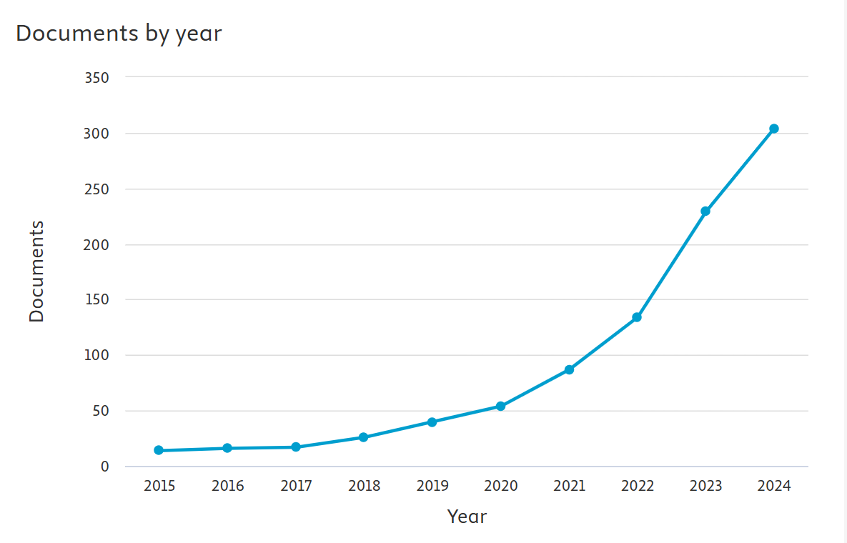
Figure 1: Year-wise publication trend in “Climate Finance” (2015-2024).
3.1.1 Growth Patterns
The publication growth was particularly notable in the years following the Paris Agreement. In 2015, only 14 articles were published on climate finance, but by 2020, this number had more than tripled. The years 2023 and 2024 saw significant spikes in publication output, likely corresponding to key global events such as the United Nations Climate Change Conferences and the increasing global focus on achieving the Sustainable Development Goals (SDGs) by 2030.
3.1.2 Thematic Evolution
An analysis of the thematic evolution over this period shows a shift from general discussions on climate finance mechanisms to more specialized topics. Early research (2015-2017) focused on defining climate finance, exploring its role in international climate agreements, and assessing the financial needs for climate mitigation and adaptation. In later years (2018-2024), the focus expanded to include topics like green bonds, carbon pricing, and integrating climate risks into financial decision-making.
3.2 Citation Analysis
Citation analysis assessed the impact and influence of individual articles, authors, and journals in climate finance. This analysis helps identify the most influential research contributions and provides insights into the field’s intellectual foundations.
3.2.1 Highly Cited Articles
Several articles published during 2015-2024 emerged as highly cited, indicating their significant influence on subsequent research.
Top-Cited Articles (2015-2024):
- Flammer, C. (2021). Corporate green bonds. Journal of Financial Economics, 142(2), 499–516.
- Irfan, M., Razzaq, A., Sharif, A., & Yang, X. (2022). Influence mechanism between green finance and green innovation: Exploring regional policy intervention effects in China. Technological Forecasting and Social Change, 182.
- Zhang, D., Zhang, Z., & Managi, S. (2019). A bibliometric analysis on green finance: Current status, development, and future directions. Finance Research Letters, 29, 425–430.
- Rasoulinezhad, E., & Taghizadeh-Hesary, F. (2022). Role of green finance in improving energy efficiency and renewable energy development. Energy Efficiency, 15(2).
- Li, C., & Umair, M. (2023). Does green finance development goals affects renewable energy in China. Renewable Energy, 203, 898–905.
3.2.2 Author Impact
The analysis also highlighted the contributions of key authors in the field.
Table 1: Top 5 most cited authors in “Climate Finance” (2015-2024)
Rank | Author Name | Number of Citations | H-Index
1 | Liu, Y | 47 | 6
2 | Roberts, J. T. | 66 | 6
3 | Siddik, A. B. | 11 | 6
4 | Taghizade-Hesary, F. | 108 | 6
5 | Wang, Y | 141 | 6
3.3 Journal Impact
The analysis of journal impact focused on identifying the most prolific and influential journals in the field of climate finance. These journals are critical for the dissemination of research findings and for shaping the discourse in the field. Several journals emerged as leading platforms for climate finance research.
Table 2: Top Journals in “Climate Finance” by Number of Publications (2015-2024)
Rank | Journal Name | Number of Publications
1 | Sustainability (Switzerland) | 92
2 | Resources Policy | 47
3 | Climate Policy | 34
4 | Energy Economics | 33
5 | Environmental Science and Pollution Policy | 28
3.4 Institutional Contributions
Institutions play a vital role in advancing research in climate finance. The performance analysis also examined the contributions of leading universities and research centres. The analysis identified several institutions that have made significant contributions to the field.
Table 3: Top 5 Institutions in “Climate Finance” by Research Output and Impact (2015-2024).
Rank | Institution Name | Number of Publications
1 | Qingdao University | 24
2 | Southwestern University of Finance and Economics | 21
3 | China University of Geosciences | 18
4 | Jiangsu University | 17
5 | Shenzhen University | 16

3.5 Science Mapping
Science mapping offers a detailed visualization of climate finance research’s intellectual structure and thematic evolution from 2015 to 2024. This section employs co-word analysis, co-citation analysis, and thematic mapping to explore the relationships among key concepts, the emergence of research clusters, and the development of core themes over time.
3.5.1 Co-Word Analysis
Co-word analysis examines the frequency and co-occurrence of keywords within the climate finance literature. This method helps identify the main research themes and how they are interrelated, providing a snapshot of the intellectual landscape of the field.
3.5.1.1 Identification of Core Themes
The co-word analysis revealed several recurring themes in climate finance research, which can be categorized into three broad areas:
- Financial Mechanisms and Instruments: Keywords such as “green bonds,” “carbon pricing,” “emission trading systems,” and “sustainable finance” were frequently co-occurring, highlighting the focus on financial tools used to support climate action.
- Policy and Governance: Terms like “Paris Agreement,” “climate policy,” “regulation,” and “climate governance” appeared together, indicating the emphasis on policy frameworks that enable or hinder climate finance initiatives.
- Risk and Impact Assessment: Words such as “climate risk,” “financial risk,” “investment,” and “economic impact” often co-occurred, reflecting research focused on assessing the risks and impacts associated with climate change and the corresponding financial responses.
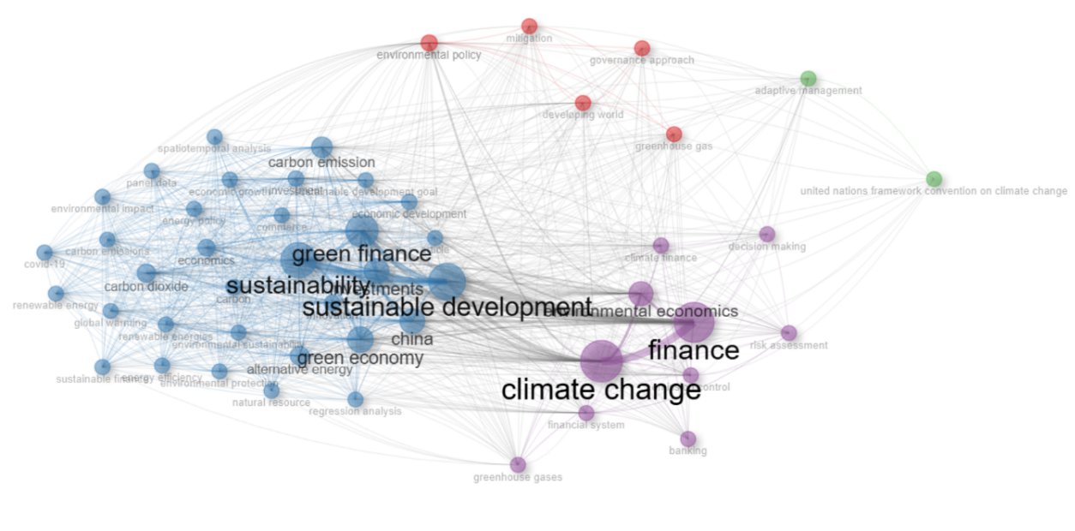
Figure 2: Co-word network map in “Climate Finance” (2015-2024).
3.5.1.2 Thematic Evolution
The analysis also revealed a shift in thematic focus over the study period. Initially, research was centred on the basics of climate finance, including definitions and establishing financial mechanisms. Over time, the focus shifted to more specialized areas, such as developing green financial markets, integrating climate risks into financial decision-making, and the role of private sector finance in achieving climate goals.
3.5.2 Co-Citation Analysis
Co-citation analysis examines how frequently pairs of articles are cited together, which helps to identify the foundational works and intellectual traditions within the field.
3.5.2.1 Foundational Works
The co-citation analysis identified several key papers that have served as foundational works in climate finance research. For example, Stern’s (2006) paper on the economics of climate change, which laid the groundwork for understanding the financial implications of climate action, was frequently co-cited with more recent works on sustainable finance.
Table 4: Top co-cited works in “Climate Finance” (2015-2024)
Rank | Author(s) | Title | Year | Journal | Citations
1 | Flammer, C. | Corporate green bonds | 2021 | Journal of Financial Economics | 771
2 | Irfan et al. | Influence mechanism between green finance and green innovation: Exploring regional policy intervention effects in China | 2022 | Technological Forecasting and Social Change | 468
3 | Zhang et al. | A bibliometric analysis on green finance: Current status, development, and future directions | 2019 | Finance Research Letters | 426
4 | Rasoulinezhad & Taghizadeh-Hesary | Role of green finance in improving energy efficiency and renewable energy development | 2022 | Energy Efficiency | 402
5 | Li & Umair | Does green finance development goals affects renewable energy in China | 2023 | Renewable Energy | 371
3.5.2.2 Intellectual Traditions and Clusters
The Clusters by Documents Coupling analysis identified several intellectual clusters within climate finance research:
- Sustainable Finance and Investment: This cluster includes works on green bonds, ESG (Environmental, Social, Governance) investing, and the role of financial markets in supporting sustainability.
- Climate Risk and Financial Stability: Another significant cluster revolves around assessing and managing climate-related financial risks, with notable contributions from central banks and financial regulators.
- Policy and International Agreements: A third cluster focuses on the role of international agreements, such as the Paris Agreement, in shaping global climate finance strategies.
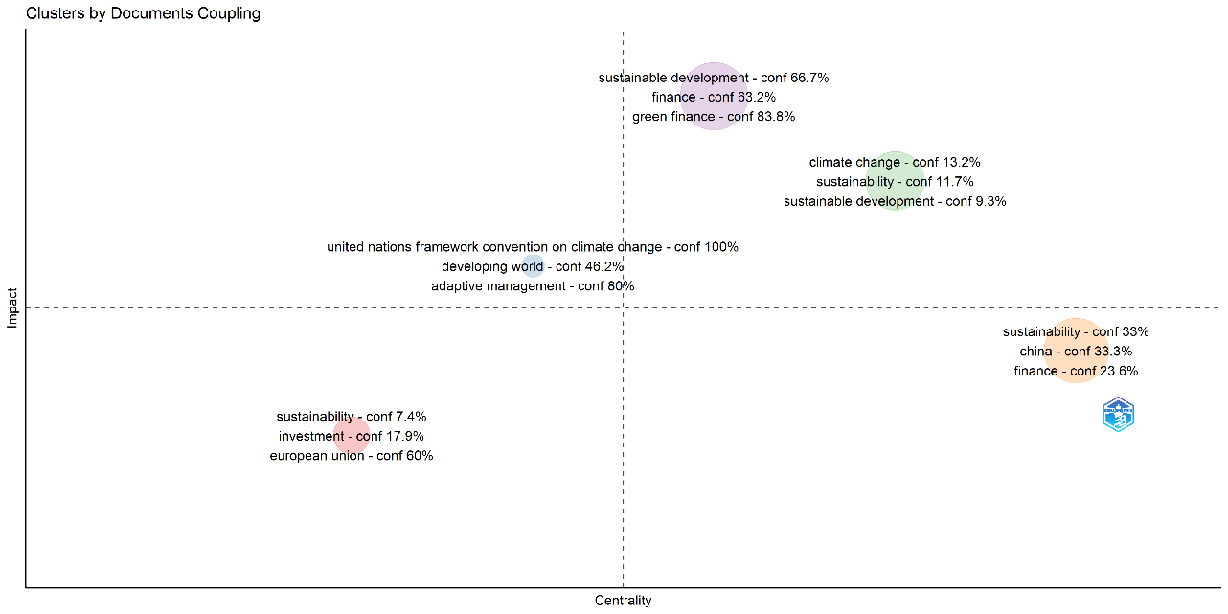
Figure 3: Clusters by Documents Coupling in “Climate Finance” (2015-2024).

3.5.3 Thematic Mapping
Thematic mapping categorizes the research landscape into themes based on centrality and density. Centrality measures the significance of a theme in the research field, while density indicates the development of the theme.
3.5.3.1 Strategic Themes
Themes that are both central and well-developed are considered strategic. In the context of climate finance, strategic themes identified include:
- Green Bonds and Sustainable Finance: These themes are central to the discourse and have seen substantial development, reflecting their importance in mobilizing finance for climate action.
- Climate Risk Assessment: This theme is also central and developed, indicating a strong focus on understanding and managing financial risks associated with climate change.
3.5.3.2 Emerging and Niche Themes
Emerging themes have high centrality but lower density, indicating their growing importance but lesser development. Niche themes, on the other hand, are highly developed but less central to the field.
Emerging Themes:
  - Nature-Based Solutions: Reflecting a growing interest in how natural ecosystems can be integrated into climate finance strategies.
  - Transition Finance: Focused on financing the transition to a low-carbon economy, particularly in heavy industries.
Niche Themes:
  - Voluntary Carbon Markets: Well-developed in terms of research but more specialized and less central to the broader climate finance field.
  - Adaptation Finance: Similarly well-developed but focused specifically on financing climate adaptation efforts, often in vulnerable regions.
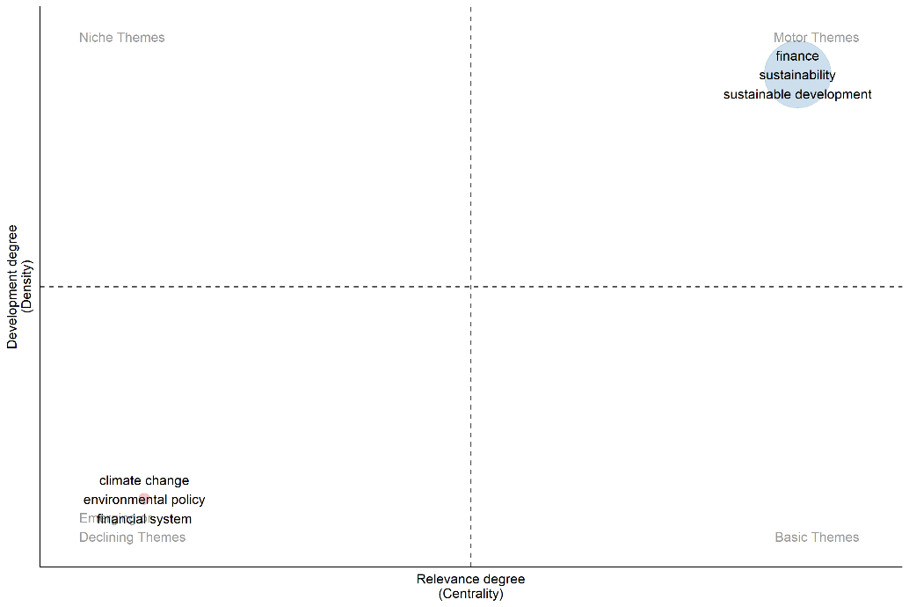
Figure 4: Thematic map of “Climate Finance” (2015-2024).

3.5.4 Keyword Co-Occurrence Analysis
Keyword co-occurrence analysis identifies how often pairs of keywords appear in the same document, providing insights into the relationships between different research topics. The keyword co-occurrence analysis provided a detailed visualization of how different research topics within climate finance are interconnected. For instance, “green finance” was closely linked with “climate risk,” “sustainable development,” and “investment,” highlighting the interconnected nature of these themes.
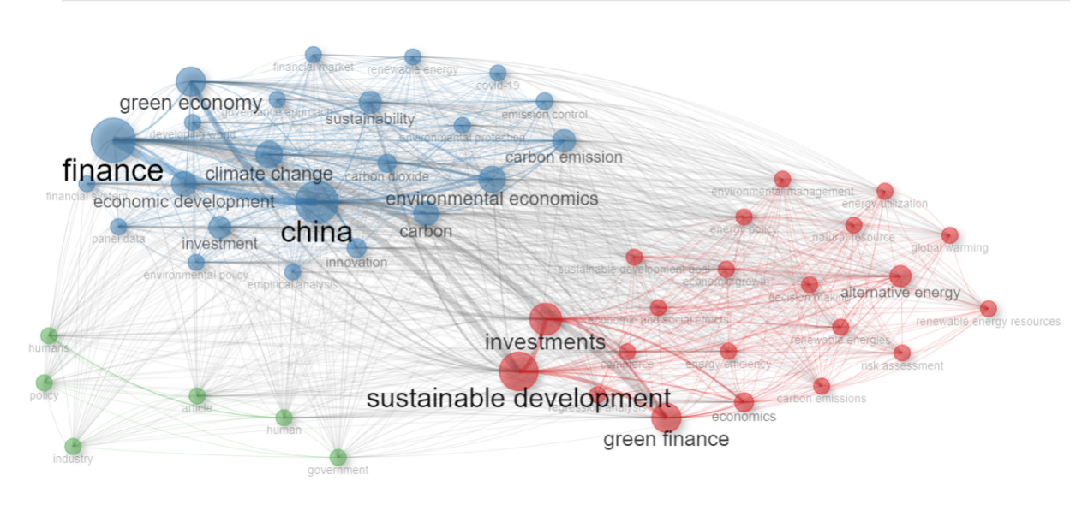
Figure 5: Keyword co-occurrence network in “Climate Finance” (2015-2024).

3.5.5 Collaboration Network Analysis
Collaboration network analysis examined the relationships between authors, institutions, and countries, revealing the structure of research collaborations in climate finance.
3.5.5.1 Author Collaboration Networks
The analysis of author collaboration networks showed that the field of climate finance is characterized by extensive collaboration, with several prominent researchers forming central hubs in the network. These hubs often represent large research projects or interdisciplinary initiatives.
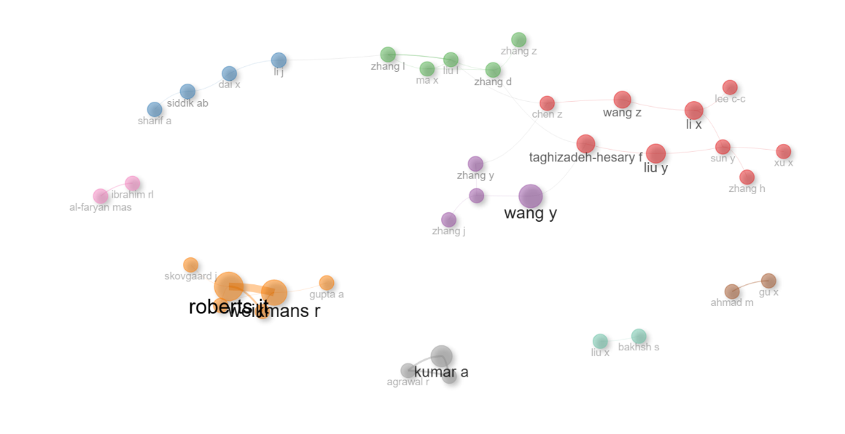
Figure 6: Author collaboration network in “Climate Finance” (2015-2024).

3.5.5.2 Institutional Collaboration Networks
Institutional collaboration was also prevalent, with top universities and research centres frequently partnering with international organizations like the United Nations and the World Bank. This collaboration has been instrumental in advancing research on climate finance and translating it into policy recommendations.
3.5.5.3 Country Collaboration Networks
Country collaboration networks revealed that a few leading countries, including China, the United Kingdom, Germany, the United States, Japan, Italy, and India, dominate climate finance research. However, emerging economies like China and India have also become increasingly active in this research area, often collaborating with established research centres in Europe and North America.
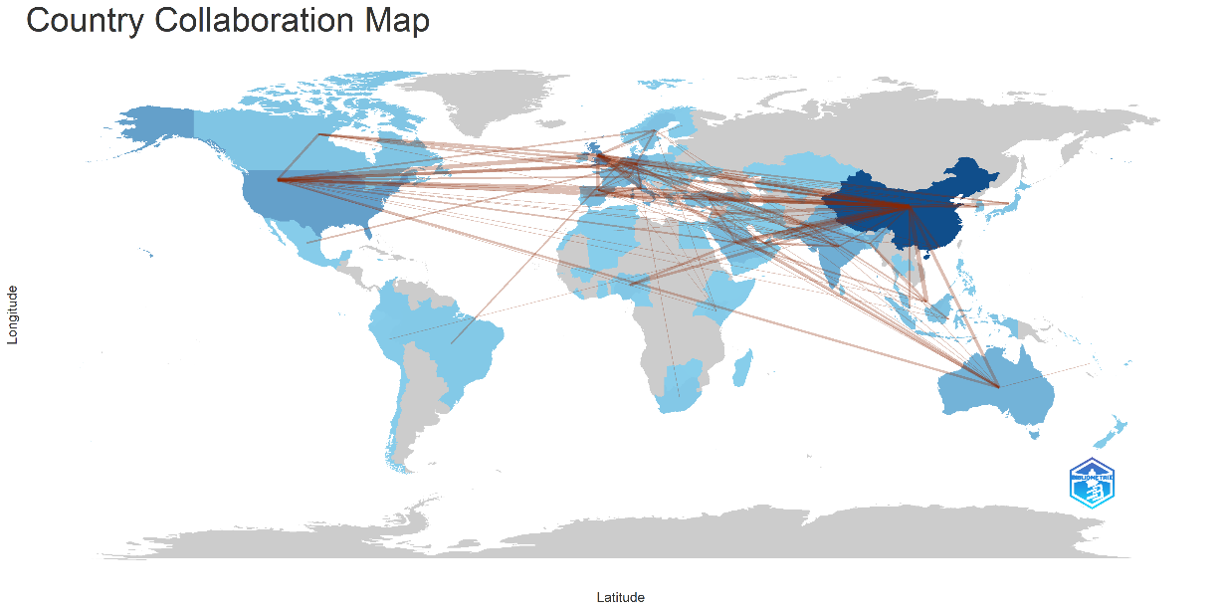
Figure 7: Country collaboration network in “Climate Finance” (2015-2024).

4. Conclusion

This bibliometric analysis of climate finance research from 2015 to 2024 provides a comprehensive overview of the field’s development, key contributions, and collaborative dynamics. The analysis highlights significant trends, influential works, and the evolving landscape of climate finance, offering valuable insights for researchers, policymakers, and practitioners.
The findings of this analysis have several implications:
- Policy and Practice: The insights into thematic evolution and influential works can guide policymakers in shaping effective climate finance strategies. Understanding the key research clusters and emerging trends helps align financial policies with current scientific knowledge and global climate objectives.
- Future Research Directions: Identifying emerging research fronts and gaps offers opportunities for future research. Areas such as the role of private sector finance in climate action and the integration of climate risks into financial models are ripe for exploration.
- Collaboration and Networking: The analysis underscores the importance of collaboration among researchers, institutions, and countries. Continued international and interdisciplinary partnerships are crucial for advancing climate finance research and addressing global climate challenges.
5. Limitations and Recommendations
While this analysis provides a comprehensive overview, it has some limitations:
- Data Constraints: The analysis is based on available bibliometric data, which may not capture all relevant publications or emerging research trends. Expanding the data sources and including non-English literature could provide a more complete picture.
- Dynamic Nature of Research: The field of climate finance is rapidly evolving, and new developments may not be fully reflected in this analysis. Ongoing monitoring and updates are necessary to capture the latest trends and contributions.
Future research should address these limitations by incorporating a broader range of sources and continuously updating the analysis to reflect the dynamic nature of climate finance research.
6. Tools and Methods Used in Bibliometric Analysis
Bibliometric Databases:
  - Scopus: For citation counts, author profiles, and journal impact factors.
Data Extraction and Management:
  - Zotero: For managing references and organizing bibliometric data.
  - Excel / Google Sheets: For data cleaning, organization, and basic statistical analysis.
Bibliometric Analysis Software:
Bibliometrix: An R package for performing comprehensive bibliometric analysis, including performance analysis, science mapping, and network analysis.

Consent (where ever applicable)

Not Applicable

Ethical approval (where ever applicable)

Not Applicable

References

- Aria, M., & Cuccurullo, C. (2017). bibliometrix: An R-tool for comprehensive science mapping analysis. Journal of Informetrics, 11(4), 959–975. https://doi.org/10.1016/j.joi.2017.08.007
- Bhandary, R. R., Gallagher, K. S., & Zhang, F. (2021). Climate finance policy in practice: A review of the evidence. Climate Policy, 21(4), 529–545. https://doi.org/10.1080/14693062.2020.1871313
- Bornmann, L., & Mutz, R. (2015). Growth rates of modern science: A bibliometric analysis based on the number of publications and cited references. Journal of the Association for Information Science and Technology, 66(11), 2215–2222. https://doi.org/10.1002/asi.23329
- Callon, M., Courtial, J. P., & Laville, F. (1991). Co-word analysis as a tool for describing the network of interactions between basic and technological research: The case of polymer chemsitry. Scientometrics, 22(1), 155–205. https://doi.org/10.1007/BF02019280
- Chang, Y. (2019). Green Finance in Singapore: Barriers and Solutions. ADBI Working Paper 915. Tokyo: Asian Development Bank Institute.
- Climate Policy Initiative (CPI), (2019). Global Landscape of Climate Finance 2019 [Barbara Buchner, Alex Clark, Angela Falconer, Rob Macquarie, Chavi Meattle, Rowena Tolentino, Cooper Wetherbee]. Climate Policy Initiative, London. Available at: https://climatepolicyinitiative.org/publication/global-climate-finance-2019/
- Debrah, C., Darko, A., & Chan, A. P. C. (2023). A bibliometric-qualitative literature review of green finance gap and future research directions. Climate and Development, 15(5), 432–455. Scopus. https://doi.org/10.1080/17565529.2022.2095331
- Donthu, N., Kumar, S., Mukherjee, D., Pandey, N., & Lim, W. M. (2021). How to conduct a bibliometric analysis: An overview and guidelines. Journal of Business Research, 133, 285–296. https://doi.org/10.1016/j.jbusres.2021.04.070
- Flammer, C. (2021). Corporate green bonds. Journal of Financial Economics, 142(2), 499–516. https://doi.org/10.1016/j.jfineco.2021.01.010
- Gusenbauer, M., & Haddaway, N. R. (2020). Which academic search systems are suitable for systematic reviews or meta‐analyses? Evaluating retrieval qualities of Google Scholar, PubMed, and 26 other resources. Research Synthesis Methods, 11(2), 181–217. https://doi.org/10.1002/jrsm.1378
- Hirsch, J. E. (2005). An index to quantify an individual’s scientific research output. Proceedings of the National Academy of Sciences, 102(46), 16569–16572. https://doi.org/10.1073/pnas.0507655102
- Hong, C., Mueller, N. D., Burney, J. A., Zhang, Y., AghaKouchak, A., Moore, F. C., Qin, Y., Tong, D., & Davis, S. J. (2020). Impacts of ozone and climate change on yields of perennial crops in California. Nature Food, 1(3), 166–172. https://doi.org/10.1038/s43016-020-0043-8
- Joshi, G., & Dash, R. (2023). A Bibliometric Analysis of Climate Investing. International Journal of Energy Economics and Policy, 13(3), 396–407. https://doi.org/10.32479/ijeep.14279
- Michaelowa, A., & Michaelowa, K. (2015). Do rapidly developing countries take up new responsibilities for climate change mitigation? Climatic Change, 133(3), 499–510. https://doi.org/10.1007/s10584-015-1528-6
- Muchiri, M. K., Erdei-Gally, S., Fekete-Farkas, M., & Lakner, Z. (2022). Bibliometric Analysis of Green Finance and Climate Change in Post-Paris Agreement Era. Journal of Risk and Financial Management, 15(12), 561. https://doi.org/10.3390/jrfm15120561
- Newman, M. E. J. (2001). The structure of scientific collaboration networks. Proceedings of the National Academy of Sciences, 98(2), 404–409. https://doi.org/10.1073/pnas.98.2.404
- Nhamo, G., Nhemachena, C., & Nhamo, S. (2019). Is 2030 too soon for Africa to achieve the water and sanitation sustainable development goal? Science of The Total Environment, 669, 129–139. https://doi.org/10.1016/j.scitotenv.2019.03.109
- Rusydiana, A. S. (2024). Bibliometric Analysis of Scopus-Indexed Climate Finance Studies. Text Analytics in Economics, 1(1). https://doi.org/10.58968/tae.v1i1.451
- Shang, Q., & Jin, X. (2023). A bibliometric analysis on climate finance: Current status and future directions. Environmental Science and Pollution Research, 30(57), 119711–119732. https://doi.org/10.1007/s11356-023-31006-5
- Small, H. (1973). Co‐citation in the scientific literature: A new measure of the relationship between two documents. Journal of the American Society for Information Science, 24(4), 265–269. https://doi.org/10.1002/asi.4630240406
- Surminski, S., & Thieken, A. H. (2017). Promoting flood risk reduction: The role of insurance in Germany and England. Earth’s Future, 5(10), 979–1001. https://doi.org/10.1002/2017EF000587
- Taneja, S., Kumar, P., Grima, S., Ozen, E., & Sood, K. (Eds.). (2023). Sustainable Investments in Green Finance. IGI Global. https://doi.org/10.4018/979-8-3693-1388-6
- United Nations Framework Convention on Climate Change (UNFCCC). (2015). Paris Agreement.
- Wang, G., Cui, H., & Hausken, K. (2025). The evolution of green finance research: A comprehensive bibliometric analysis. Heliyon, 11(3), e42161. https://doi.org/10.1016/j.heliyon.2025.e42161
- Weikmans, R., & Roberts, J. T. (2019). The international climate finance accounting muddle: Is there hope on the horizon? Climate and Development, 11(2), 97–111. https://doi.org/10.1080/17565529.2017.1410087
- Zhang, Q., Xue, H., & Tang, H. (2018). Knowledge Domain and Emerging Trends in Vulnerability Assessment in the Context of Climate Change: A Bibliometric Analysis (1991-2017). KNOWLEDGE ORGANIZATION, 45(6), 467–483. https://doi.org/10.5771/0943-7444-2018-6-467.

