Review Article

Green Marketing and Consumer Purchasing Behavior: A Systematic Literature Review through the Lens of Behavioral Economics

.
ABSTRACT

This paper discusses the relationship between green marketing and consumer purchasing behavior using a behavioral economics lens. A systematic literature review was used and followed the PRISMA guidelines in processing peer-reviewed studies published between 2015 and 2025. Relevant studies were gathered from Google Scholar and Mendeley databases. Results established that altruism, trust, knowledge and socially constructed norms have a stronger impact on the green purchasing decision than price and convenience. Nudge Theory has proven sufficient by recognizing the role of labeling of the environment, default options, and open communication convention to develop sustainable decisions. Generally, eco-branding, eco-packaging, and eco-labeling increase consumer loyalty and reduce the attitude-behavioral gap, indicating that the behavioral information may support the maintenance of sustainable consumption behavior and increase competitiveness of firms.

Keywords: Green Marketing, Consumer Purchasing Behavior, Behavioral Economics, Nudge Theory

1. INTRODUCTION

Human activities, particularly industrialization, have undeniably improved human life throughout the years by numerous services, products, and economic growth. But they have also caused the overexploitation of natural resources, which causes further pollution and significant threats to the human health and the stability of the environment (Edo et al., 2024). Since the concentration of greenhouse gases and ozone depletion in the atmosphere have risen to alarmingly high rates, the necessity of sustainability approaches on all levels of dealing with and management of consumption and livelihood has grown (Amoako et al., 2022). The issue has been justified by the high rates of sustainable consumption, conservation, and even the targeted utilization of natural resources as a priority among a large proportion of consumers over the past few years (Kar and Harichandan, 2022). Further, consumers had begun to enjoy greener companies, and, accordingly, they began to implement greener goods and processes (Garcia-Salirrosas and Rondon-Eusebio, 2022).
Green marketing has become one of the ways companies respond to the growing concern for the environment and consumer responsibility. Some businesses try to do this by using sustainable materials, practicing ethical branding, or lessening their impact on nature (Chen et al., 2020). This does not only show that they are aware of environmental issues but also that they are adjusting to the changing expectations of customers. As people become more mindful of how their choices affect the environment, many of them prefer products that fit their personal values. For businesses that promote sustainable products, this can open opportunities, but it also comes with challenges (Prakash et al., 2024). In fact, Deloitte’s 2023 global consumer insights report shows that in 23 countries, nearly half of consumers bought at least one sustainable product or service in April 2023. Many of them were also willing to pay an average premium of about 27%, showing that green products are not only widely accepted but also financially rewarded by sustainability-minded buyers.
The relationship between green marketing and consumer purchasing behavior has already been investigated in a number of existing studies. Most of these studies focus on marketing or management, and only a few look at the relationship from the perspective of behavioral economics. Therefore, this study aims to help fill this gap by conducting a systematic review of available literature on green marketing and consumer buying behavior in the context of behavioral economics. It also seeks to explore behavioral issues that influence the decision of consumers when purchasing sustainable products, and determine the green strategies of marketing business that can be adapted by other businesses, policymakers, and researchers in ensuring successful promotion of sustainable consumption.
An important model that will be used in this research is The Nudge Theory by Richard Thaler and Cass Sunstein (2008). It highlights how minor modifications in the way choices are framed, including the use of eco-labels, setting green options as the default or focusing on sustainability as a collective behavior can push consumers towards environmental-friendly behaviours without restricting their freedom of choice. These nudges can be used in green marketing to understand why people become more likely to buy sustainable products when these decisions become more visible, more accessible, and more socially attractive. Therefore, this theory provides crucial understanding on the ways through which marketing activities can help to fill the gap between the consumers attitude and their buying decision.

2. REVIEW OF RELATED LITERATURE

2.1 Green Marketing
Green marketing involves the adjustment of product, production process, labelling, advertising and packaging to minimize the environmental risk and safeguard the people, society and the planet (Osuagwu, 2023). Moreover, it has a positive influence on the consumer lifestyle, which subsequently boosts the interest and satisfaction to buy (Mazwan et al., 2023). Additionally, the number of green product-making companies and interested consumers is growing at a breakneck pace throughout the last decades (Dangelico & Vocaleili, 2017). Besides, green marketing aims to reduce the negative environmental footprint of the activities of a company, and it calls on businesses to implement green practices to actively address the new environmental considerations of consumers and environmental concerns (Zhang and Dong, 2020).
Green marketing has come to be a required strategy to those businesses that aim at meeting the fulfilment of environmental sustainability goals. According to recent studies, the strategic approach to green marketing brings significant enhancement in the sustainability rates of businesses, particularly in the presence of absorptive capacity that enables them to implement environmentally-friendly practices effectively (Ismail and Changalima, 2023). Similarly, research in the food industry also shows that actions, including waste management, reducing the environmental impact, and consumer interaction are key to increasing sustainability performance (Esmaelnezhad et al, 2023). In addition to personal activities, the combination of green marketing and supply chain activities has been shown to raise customer buying intentions, and institutional forces are encouraging the implementation of sustainable practices (Khan et. al, 2023). The concept of green marketing is becoming a necessity in the quest to develop sustainable economies at an international level, especially in Africa whereby companies employ these strategies in order to align with the sustainability principles of the United Nations. It is demonstrated in the corporate case studies, including the one of Toyota that has committed to becoming a global green brand, that the long-term integration of green marketing positively affects the environmental outcomes, brand image, and consumer trust (Simao and Lisboa, 2017). In general, these statistics demonstrate that green marketing assists in attaining the sustainability objectives and customer interest, so it is an important element that shapes the modern company practices.

2.2 Consumer Purchasing Behavior
Consumers are more likely to purchase eco-friendly products when they see benefits for both the environment and their personal health, and many are willing to pay a higher price for such items (Nekmahmud & Fekete-Farkas, 2020). Studies also show that a company’s green image can improve customer trust, satisfaction, and loyalty (Martínez, 2015).
Eco-labels can strengthen consumer trust because they give visible proof that a product is sustainable. This assurance often leads people to make more eco-conscious buying decisions (Hameed & Waris, 2018). Aside from eco-labels, other factors also shape consumer behavior. For example, eco-branding and eco-labeling provide confidence through clear claims, while green advertising helps encourage buyers to choose more sustainable options. Consumer innovativeness, or the openness to try new eco-friendly products, also has an influence since it makes people more likely to consider and purchase green products (Li, 2022).
When deciding what to buy, many consumers pay attention to eco-brands and environmental advertising. They tend to view these as distinct from regular products, giving them a sense of added value or responsibility (Mokha, 2017). Packaging is another big factor. Many check labels first before looking at ads or online info. Products that can be recycled or reused are usually more attractive, though some still see eco-packaging as just a trend (Orzan et al., 2018). A study in India also showed that buyers use eco-friendly products as a way of supporting the environment. Their choices were shaped by responsibility, their own experience with products, and how companies act. Businesses seen as responsible gained support, while those viewed as polluters were avoided (Kumar & Ghodeswar, 2015).
A wide range of psychological, social, and cultural factors influence consumer purchasing behavior for environmentally friendly items. In Korea, research found that while environmental education and consumers' trust in their own effectiveness greatly increased buy intentions, the actual conversion of intention into behavior was heavily influenced by eco-label legitimacy and simplicity of purchase (Kim & Lee, 2023). This intention-behavior gap is echoed in various situations, such as among European consumers, where humanitarian motives and green self-identity boosted eco-friendly purchases, while personal inconvenience served as a barrier, particularly for non-green consumers (Barbarossa & De Pelsmacker, 2016). A study in Pakistan found that quality was the most influential element in students' eco-friendly purchasing, followed by awareness and price, albeit perceived value was less important (Shahrukh et al., 2023). Similarly, in the Philippines, socially oriented behaviors and critical criteria such as availability and quality affected the purchase of eco-friendly clothing, although emotions were found to be less influential in driving behavior. Zver and Vukasović (2021) found that Slovenian consumers have a good attitude towards eco-friendly textiles, rely largely on certifications and labels when making purchase decisions, and are prepared to buy certified products in the future. These studies demonstrate that eco-friendly purchasing behavior is driven not only by individual attitudes and awareness, but also by structural factors such as product quality, labeling, accessibility, and pricing, all of which can support or hinder sustainable consumption.

2.3 Behavioral Economics
Behavioral economics examines the influence of psychological, cognitive, emotional, cultural and social elements impact an individual’s and institutions’ decisions. It is different from mainstream economics which assumes absolute rationality, as behavioral economics focuses on the limits of rationality. Behavioral economics employs psychological, neuroscience, and microeconomic theories insights to analyze how decisions are made in the market and mechanisms that drive the choices of the population (Alam, 2022). Behavioral economics, unlike neoclassical models that portray humans as utility-maximizing "Homo economicus," takes a more psychologically realistic approach, recognizing that people frequently use heuristics, exhibit biases, and make decisions under conditions of bounded rationality (Oliver, 2019; Chen, 2024). It goes beyond describing "perfectly rational" choices to investigate why real-world decisions are influenced by framing, social conventions, emotional responses, and information-processing constraints (ScienceDirect, 2020; University of Chicago News, 2019). By combining ideas such as loss aversion, mental shortcuts, and social impact with economic research, behavioral economics sheds light on why consumers may depart from "optimal" choice models in real-world markets and situations.
Thaler and Sunstein (2008) created nudge theory, which refers to minor changes in choice architecture that impact people's decisions without restricting their freedom of choice or dramatically modifying economic incentives. Unlike traditional policy tools like rules or taxes, nudges are intended to steer behavior in predictable ways while preserving autonomy (Benartzi et al., 2017). The most common type of nudges in consumer-related contexts is the default or information-framing or the strategic placement of eco-labels to streamline the decision-making process and promote environmentally conscious decision-making (Schubert, 2017; Ewert, 2020). However, recent studies indicate that such nudges as green defaults, energy efficiency labeling, and sustainable product placement are effective in increasing pro-environmental purchasing behavior by focusing on heuristics without basing their argument on rational cost-benefit analysis (Hummel and Maedche, 2019; Münscher, et al, 2016).
Green marketing with regards to Behavioral Economics is essential. Consumers do not always follow their buying intentions because of habits, the price of green products, or missing clear information even after showing their interest in the environment (Hameed and Waris, 2018). Eco-labels are examples of nudges that can be trusted as reliable evidence making it easier to make a decision due to clear communication of environmental benefits (Mokha, 2017). On the same note, researchers observed that consumers would choose products with the label of eco-friendly despite having the same products, creating a taste-preference bias because consumers thought it has health benefits and quality compared to the traditional products (Sörqvist et al., 2015). Moreover, the conclusions made in a study indicated that the effects of eco-labelling on the younger generations are positive because it provides a clear path of decision making whenever they want to make a purchase of green products because it makes them feel more comfortable to do so due to this aspect (Panopoulos, 2023).
Eco-branding and green advertising are behavioral nudges used to indicate that there is a value in the environment, it evokes trust and influences consumer decision making but does not affect essential costs or reduce choice. Indicatively, a mass Chinese survey found out that the intention to buy environmentally friendly products increases significantly when advertisers employ the green label, more so in customers who have knowledge in the environmental field and that the use of eco-branding and eco-labeling enhances this (Li, 2025). A study that was conducted in Ecuador indicates that green advertising has a significant impact on millennials environmental attitudes and environmental awareness which positively influence the actual purchase behavior but eco-labels directly influence the environmental attitude but not the behavior (Carrión-Bósquez et al., 2024). Framing studies reveal subtle effects: green appeals combined with emotional norms appeal more to consumers who are less susceptible to normative influence, whereas those seeking distinctiveness respond more favorably (Soomro et al, 2025). According to experimental research conducted in China, the effectiveness of green messaging is dependent on matching appeal type (e.g., warmth vs. competence) to message framing, which has a substantial impact on purchase intentions via perceived social or functional value. Finally, studies on green marketing tools show that eco-brands and environmental advertising favorably influence consumer purchase intentions, even when emotions play a little role as moderators (Ramanust, 2023).
Thus, the information provided by behavioral economics indicates that the choice made by consumers depends on subtle cues including labeling, branding, advertisement and is not always rational. Though existing literature is devoted to positive impacts of such tools on consumer trust and attitude to purchase, no extensive systematic reviews are given to study the impact of the tools taking a behavioral approach to economics. The given gap offers the basis of the current study that focuses on investigating the impact of green marketing strategies on the consumer buying behavior using the concepts of behavioral economics.
3. METHODOLOGY

This study made use of a Systematic Literature Review (SLR) to look at how green marketing affects consumer purchasing behavior from the perspective of behavioral economics. An SLR is a research method that collects and examines studies in a structured way. It involves identifying, reviewing, and combining findings from earlier work in order to answer a focused question while reducing possible bias (Gough et al., 2017; Snyder, 2019). Unlike a narrative review, it is more organized and gives a clearer and more reliable picture of what has already been studied in the field.
To make sure the review process is clear and transparent, this study followed the PRISMA (Preferred Reporting Items for Systematic Reviews and Meta-Analyses) guidelines. PRISMA provides a set of steps for carrying out systematic reviews, together with a checklist and a flow diagram (Moher et al., 2009; Page et al., 2021). These were used to record how the search was done, how articles were screened, how eligibility was checked, and which studies were finally included.
The review followed PRISMA’s four stages. First, in the identification stage, studies were collected from selected databases. After that, the screening stage was done, where duplicate records were removed. Next comes the eligibility stage, in which the full texts of potentially useful studies were checked to see if they meet the requirements. Finally, only studies that meet all inclusion criteria were analyzed. A PRISMA flow diagram was prepared to show the number of articles at each stage and the reasons for excluding others.
The population of this study consisted of published journal articles relating to green marketing, consumer purchasing behavior, and behavioral economics. The sample was limited to studies published between 2015 and 2025 to ensure that the literatures used are recent and relevant. The literature search was undertaken on Google Scholar and Mendeley, which were the key venues for locating relevant studies. The search strategy used the following keywords: “green marketing,” “consumer purchasing behaviors,” “behavioral economics,” “eco-labelling,” “eco-advertising,” and “eco-branding.”
To maintain transparency, clearly defined inclusion and exclusion criteria were used. Studies were considered if they are peer-reviewed journal publications published in English between 2015 and 2025 that directly address green marketing, consumer purchasing behavior, or behavioral economics. Studies were discarded if they were not peer-reviewed (e.g., blogs, reports, unpublished theses), were not written in English, or were not directly relevant to the research focus.
To improve the review's reliability and validity, two researchers worked together to filter and extract data. Any differences were settled through discussion until agreement was obtained, reducing subjectivity and potential bias. Furthermore, a critical appraisal of the included papers was carried out to assess methodological rigor and risk of bias.
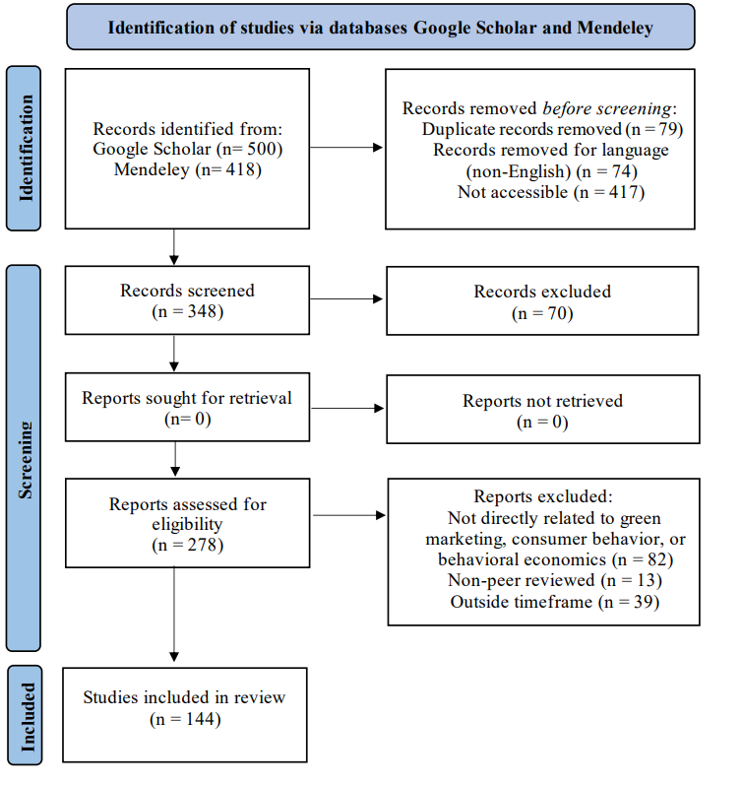

Fig. 1. PRISMA Flowchart

4. results and discussion

4.1 Characteristics of Selected Literature
The database search initially found 918 records, with 500 from Google Scholar and 418 from Mendeley. After removing duplicates and screening for accessibility, English language, and relevance to the study’s criteria, 278 papers remained. These were then thoroughly checked for appropriateness regarding the time frame, peer-review status, and relevance to the research topic. As a result, 134 articles were excluded for not meeting one or more of these requirements, leaving a final sample of 144 studies. After screening and full-text analysis, the findings were grouped into two major themes: (1) Behavioral Economics Perspectives on Consumer Purchasing Behavior and (2) Green Marketing Strategies Influencing Consumer Purchasing Behavior.
Figure 2 presents the number of sampled papers published every year. The first studies included in this review were published in 2016. The trendline highlights the increasing research output in this field. On average, a steady number of articles were published each year, with the years 2023–2024 showing the highest productivity.
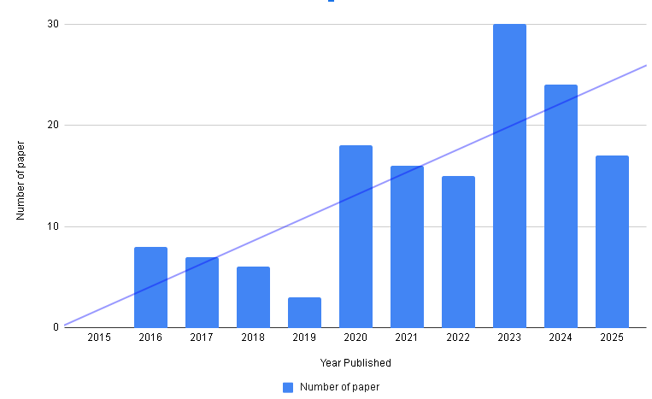
Fig. 2. Number of Published Papers
4.2 Researched Settings
The 144 papers included in this review span from 2015 to 2025 and cover 41 countries, with research predominantly concentrated in Asia (103 papers; 71.5%). India leads the contribution with 29 studies, followed by Indonesia (18), Pakistan (9), and Malaysia (9). Other Asian countries with multiple studies include China (6), Bangladesh (4), Sri Lanka (4), Kazakhstan (3), Turkey (3), Nepal (3), Vietnam (2), Iran (2), Thailand (2), Taiwan (2), UAE (1), Yemen (1), and the Philippines (1). Africa accounts for 15 studies (10.4%), with Nigeria contributing the largest share (6), followed by South Africa (3), Kenya (2), Algeria (2), Ghana (1), and Egypt (1).
Europe contributes 18 studies (12.5%), with Poland and Hungary leading (4 studies each), and the rest distributed across Portugal (2), Greece (1), Slovakia (1), Serbia (1), Spain (1), Denmark (1), Italy (1), Romania (1), and Croatia (1). North America accounts for 3 studies (2.1%), all from the United States, while South America represents 4 studies (2.8%) from Chile (1), Ecuador (2), and Peru (1). Oceania contributes a single study (0.6%) from Australia. This distribution reveals a clear dominance of Asian research, reflecting the growing interest in green marketing and behavioral economics in emerging markets. However, the inclusion of studies from Europe, Africa, the Americas, and Oceania ensures a diverse global perspective and enriches the synthesis of insights on consumer purchasing behavior. Figure 3 presents a pie chart showing the percentage distribution of studies across continents.
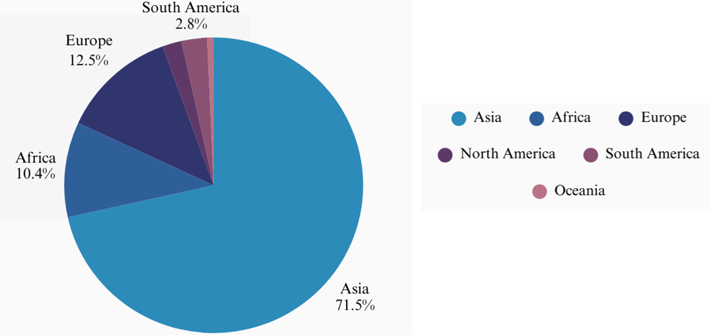
Fig. 3. Percentage Distribution of Studies across Continents

4.4 Behavioral Economics Perspective on Consumer Purchasing Behavior
Consumer purchasing behavior toward green products is shaped by more than price or convenience; it is influenced by habits, values, trust, and social pressures. Behavioral economics highlights that psychological factors such as altruism, self-efficacy, and environmental attitudes significantly drive purchasing decisions. Altruism encourages consumers to choose eco-friendly products even at higher costs, as these align with their moral values and the expectations of others (Yulianti et al., 2023). Self-efficacy and outcome expectations have been demonstrated to create a significant impact on purchase intentions and often overshadow the impact of external factors like subjective norms. This fact highlights how vital it is to provide the consumers with knowledge and confidence, which will empower them to make more independent decisions (Susanty et al., 2021). Even minor signals, such as eco-labels, certificates, and visible signs of sustainability, are behavioural nudges, whereas the level of environmental knowledge and application of plausible eco-branding increase purchase intent through the establishment of trust (Li, 2025; Erliani & Rinuastuti, 2025).
There are also social norms and generational factors which are important in determining sustainable consumption. Empirical studies have shown that positive purchasing intentions toward green purchases can be improved significantly through various policy interventions, social norms of support, and peer influence in strengthening positive attitudes and control of behavior (Saragih et al., 2025; Uddin and Khan, 2021). Generation Z, in turn, is more environmentally concerned, where social responsibility and green consumer knowledge mediate purchase behaviour, particularly when supported by advertising and brand trust (Borah et al., 2024). Responsible purchasing is becoming an essential part of the lifestyle of consumers, as a growing number of people seek to know how products affect the environment and do research on the reputation of companies before buying them (Garcia-Salirrosas and Rondon-Eusebio, 2022). Together with the previous results, these findings imply that the combination of intrinsic motivation, social influence, and believable marketing messages can prevent the attitudinal-behavior gap and make sustainable decisions more appealing and habitual as suggested by Nudge Theory.

4.5 Green Marketing Strategies Influencing Consumer Purchasing Behavior
Green marketing is about showing the environmental benefits of a product and proving that a company is serious about sustainability. People usually respond better when they believe the product truly helps the environment and when they can trust the brand behind it. Companies can use different ways to do this. A few examples like eco-branding, green advertising, eco-labels, and eco-packaging. When these are used together, they will often have a stronger influence on what consumers decide to buy. Studies also show that being honest and transparent about environmental impact builds trust and makes consumers more eager to support the product (Kulikova & Kondratenko, 2024; Rahman et al., 2016). Wazir and Khan (2021) found that green brands and ads not only raise awareness but also urge people to choose eco-friendly products. Eco-labels, according to Muposhi and Dhurup (2017) and Mallick et al. (2024), help increase loyalty and make consumers more open and willing to use green products. Ashoush and Kortam (2022) noted that all these strategies give the strongest effect on purchase decisions. In the end, green marketing does not only influence consumers what to buy. It also improves the company’s image, builds trust, and keeps the business competitive. This shows that sustainability, business growth and success can go together.
Some studies also show that green marketing is most effective when it matches what consumers value and how they comprehend sustainability. García Salirrosas and Rondon-Eusebio (2022) said that by promoting green products with eco-labels, and practicing sustainable advertising can promote awareness, build trust, and strengthen loyalty, which then motivate people to buy and use green products. Correia et al. (2023) found that honest and comprehensible ideas about sustainability have a significant influence on buying decisions, especially among educated consumers who cared about the environment. In the UAE, Shabbir et al. (2020) observed that eco labels, packaging, and pricing shaped how people thought about sustainability in a positive way. Borah et al. (2024) also showed that for Generation Z, green knowledge, social responsibility, and advertising all work together to encourage eco-friendly buying. All of these studies point out that green marketing is most effective when clear communication is combined with real sustainable practices, turning consumer expectations of authenticity into long-term commitment.
The discussion should not repeat the results, but provide detailed interpretation of data. This should interpret the significance of the findings of the work. Citations should be given in support of the findings. The results and discussion part can also be described as separate, if appropriate.

5. Conclusion

This study analyzes the important role of behavioral economics in explaining the relationship of green marketing concepts and customer buying behavior. Although the present literature has discussed this relationship through the lens of marketing-management, the intersection of behavioral determinants that explain how pro-environmental attitudes are translated into a consumer purchasing behaviour in addition to the implementation of Nudge theory and its support constructs makes us better understand which factors drive consumer interest in pursuing green-based purchasing behavioural patterns. These results show that consumer attitude towards green products depends on both rational determinants (price, convenience etc) and psychosocial aspects (altruism, self-efficacy, environmental knowledge, trust, and normative pressure).
The nudge theory proves the effectiveness of such micro-intervention strategies as eco-labels or selections of default-green interfaces and such macro-level measures as sustainability indicators to reduce the attitudinal-behavioural gap. The model provides both intrinsic motivation and external support as it promotes conditions to couple these nudges to encourage sustainable consumption and does not interfere with the autonomy of consumers. In reality, prudent use of green marketing, that is, ecobranding, eco-labeling, open communication, and eco-friendly packaging is expected to increase consumer confidence as well as brand allegiance, and provoke eco-friendly buying behaviour.
Altogether, this paper concludes that the deep knowledge of behavioural economics will enable the science of green marketing with the ability to affect consumer behaviour and make people follow the principles of sustainable consumption. The knowledge gained through this can be used to shape strategic agendas that at the same time contribute to competitive position and help firms, policymakers and scholars to achieve the goal of sustainability in society. The shift towards a long-term sustainability can be achieved through an integration of the marketing efforts with the behavioural motivators and this reduces the gap between the concern towards the environment and purchases behaviour.

DISCLAIMER (ARTIFICIAL INTELLIGENCE)

Authors hereby declare that NO generative AI technologies such as Large Language Models (ChatGPT, COPILOT, etc.) and text-to-image generators have been used during the writing or editing of this manuscript.

References

[1] Edo, G. I., Itoje-Akpokiniovo, L. O., Obasohan, P., Ikpekoro, V. O., Samuel, P. O., Jikah, A. N., Nosu, L. C., Ekokotu, H. A., Ugbune, U., Oghroro, E. E. A., Emakpor, O. L., Ainyanbhor, I. E., Mohammed, W. A., Akpoghelie, P. O., Owheruo, J. O., & Agbo, J. J. (2024). Impact of environmental pollution from human activities on water, air quality and climate change. Deleted Journal. https://doi.org/10.1016/j.ecofro.2024.02.014
[2] Amoako, G. K., Dzogbenuku, R. K., Doe, J., & Adjaison, G. K. (2020). Green marketing and the SDGs: emerging market perspective. Marketing Intelligence & Planning, 40(3), 310–327. https://doi.org/10.1108/mip-11-2018-0543
[3] Kar, S. K., & Harichandan, S. (2022). Green marketing innovation and sustainable consumption: A bibliometric analysis. Journal of Cleaner Production, 361, 132290. https://doi.org/10.1016/j.jclepro.2022.132290
[4] [57] [64] García-Salirrosas, E. E., & Rondon-Eusebio, R. F. (2022b). Green marketing practices related to key variables of consumer purchasing behavior. Sustainability, 14(14), 8499. https://doi.org/10.3390/su14148499
[5] Chen, Y.-S., Chang, T.-W., Li, H.-X., & Chen, Y.-R. (2020). The Influence of Green Brand Affect on Green Purchase Intentions: The Mediation Effects of Green Brand Associations and Green Brand Attitude. International Journal of Environmental Research and Public Health, 17(11), 4089. https://doi.org/10.3390/ijerph17114089
[6] Prakash, G., Sharma, S., Kumar, A., & Luthra, S. (2024). Does the purchase intention of green consumers align with their zero-waste buying behaviour? An empirical study on a proactive approach towards embracing waste-free consumption. Heliyon, 10(10), e25022. https://doi.org/10.1016/j.heliyon.2024.e25022
[7] Deloitte. (2023). Green products come of age. Deloitte Insights. Retrieved from: https://www.deloitte.com/us/en/insights/industry/retail-distribution/consumer-behavior-trends-state-of-the-consumer-tracker/sustainable-products-customer-expectations.html
[8] Thaler, R. H., & Sunstein, C. R. (2008). Nudge: Improving decisions about health, wealth, and happiness. Yale University Press, New Haven (2008), 293 pp
[9] Osuagwu, L. (2023). Green Marketing: conceptualizations, managerial practices, challenges and research agenda. Osuagwu | Journal of Sustainable Development Studies. https://www.infinitypress.info/index.php/jsds/article/view/2184
[10] Mazwan, M. Z., Windiana, L., Mahdalena, G., & Widyastuti, D. E. (2023). Green marketing attributes of coffee shops, purchasing interests, lifestyles: What really affects consumer satisfaction? Agro Ekonomi, 34(2), 84. https://doi.org/10.22146/ae.82199
[11] Dangelico, R. M., & Vocalelli, D. (2017). “Green Marketing”: An analysis of definitions, strategy steps, and tools through a systematic review of the literature. Journal of Cleaner Production, 165, 1263–1279. https://doi.org/10.1016/j.jclepro.2017.07.184
[12] Zhang, X., & Dong, F. (2020). Why Do Consumers Make Green Purchase Decisions? Insights from a Systematic Review. International Journal of Environmental Research and Public Health, 17(18), 6607. https://doi.org/10.3390/ijerph17186607
[13] Ismail, I. J., Amani, D., & Changalima, I. A. (2023). Strategic green marketing orientation and environmental sustainability in sub-Saharan Africa: Does green absorptive capacity moderate? Evidence from Tanzania. Heliyon, 9(7). https://doi.org/10.1016/j.heliyon.2023.e18373
[14] Esmaelnezhad, D., Lagzi, M. D., Antucheviciene, J., Hashemi, S. S., & Khorshidi, S. (2023). Evaluation of Green Marketing Strategies by Considering Sustainability Criteria. Sustainability (Switzerland), 15(10). https://doi.org/10.3390/su15107874
[15] Khan, M. R., Khan, N. R., Tufail, M. M. B., & Ali, L. (2023). A PATH TOWARDS A GREENER FUTURE: FOSTERING GREEN SUPPLY CHAIN, GREEN MARKETING, AND ENVIRONMENTAL SUSTAINABILITY. Logforum, 19(1), 1–14. https://doi.org/10.17270/J.LOG.2023.815
[16] Simão, L., & Lisboa, A. (2017). Green Marketing and Green Brand – The Toyota Case. In Procedia Manufacturing (Vol. 12, pp. 183–194). Elsevier B.V. https://doi.org/10.1016/j.promfg.2017.08.023
[17] Nekmahmud, M., & Fekete-Farkas, M. (2020). Why not green marketing? determinates of consumers’ intention to green purchase decision in a new developing nation. Sustainability, 12(19), 7880. https://doi.org/10.3390/su12197880
[18] Martínez, P. (2015). Customer loyalty: exploring its antecedents from a green marketing perspective. International Journal of Contemporary Hospitality Management, 27(5), 896–917. https://doi.org/10.1108/ijchm-03-2014-0115
[19] [38] Hameed, I., & Waris, I. (2018). Eco labels and eco conscious Consumer behavior: the mediating effect of green trust and environmental concern. Journal of Management Sciences, 5(2), 86–105. https://doi.org/10.20547/jms.2014.1805205
[20] [42] [52] Li, D. (2025). Impact of green advertisement and environmental knowledge on intention of consumers to buy green products. BMC Psychology, 13(1). https://doi.org/10.1186/s40359-025-02538-x
[21] [39] Mokha, A. K. (2017). Impact of green marketing tools on consumer buying behaviour. Asian Journal of Management, 9(1), 168. https://doi.org/10.5958/2321-5763.2018.00026.4
[22] Orzan, G., Cruceru, A., Bălăceanu, C., & Chivu, R. (2018). Consumers’ behavior concerning sustainable packaging: An exploratory study on Romanian consumers. Sustainability, 10(6), 1787. https://doi.org/10.3390/su10061787
[23] Kumar, P., & Ghodeswar, B. M. (2015). Factors affecting consumers’ green product purchase decisions. Marketing Intelligence & Planning, 33(3), 330–347. https://doi.org/10.1108/mip-03-2014-0068
[24] Kim, N., & Lee, K. (2023). Environmental Consciousness, Purchase Intention, and Actual Purchase Behavior of Eco-Friendly Products: The Moderating Impact of Situational Context. International Journal of Environmental Research and Public Health, 20(7). https://doi.org/10.3390/ijerph20075312
[25] Barbarossa, C., & De Pelsmacker, P. (2016). Positive and Negative Antecedents of Purchasing Eco-friendly Products: A Comparison Between Green and Non-green Consumers. Journal of Business EthicJ., Milkman, K. L., Sunstein, C. R., Thaler, R. H., Shankar, M., Tucker-Ray, W., s, 134(2), 229–247. https://doi.org/10.1007/s10551-014-2425-z
[26] Shahrukh, S., Bano, S., & Ullah, S. (2023). CONSUMERS PURCHASING BEHAVIOR TOWARDS ECO FRIENDLY PRODUCTS AMONG UNIVERSITY STUDENTS IN QUETTA. Pakistan Journal of Social Research, 05(02), 914–924. https://doi.org/10.52567/pjsr.v5i02.1205
[27] Zver, M. M., & Vukasović, T. (2021). Consumers’ attitude towards eco friendly textile products. Tekstilec, 64(2), 159–171. https://doi.org/10.14502/Tekstilec2021.64.159-171
[28] Alam, S. M. I. (2022). Behavioral Economics: Concepts, History, and Evolution. https://researchgate.net/publication/359176852
[29] Oliver, A. (2019). We’re all behavioral economists now. Journal of European Public Policy, 26(12), 1776–1794. https://doi.org/10.1080/1350178X.2019.1625210
[30] Chen, Y. (2024). Behavioral economics: Understanding the psychological factors driving consumer decisions. https://www.researchgate.net/publication/383522742_Behavioral_Economics_Understanding_the_Psychological_Factors_Driving_Consumer_Decisions
[31] ScienceDirect. (2020). Behavioral economics overview. In Topics in economics, econometrics and finance. https://www.sciencedirect.com/topics/economics-econometrics-and-finance/behavioral-economics
[32] University of Chicago. (2019). Behavioral economics, explained.
https://news.uchicago.edu/explainer/what-is-behavioral-economics
[33] Benartzi, S., Beshears, Congdon, W. J., & Galing, S. (2017). Should governments invest more in nudging? Psychological Science, 28(8), 1041–1055. https://doi.org/10.1177/0956797617702501
[34] Schubert, C. (2017). Green nudges: Do they work? Are they ethical? Ecological Economics, 132, 329–342. https://doi.org/10.1016/j.ecolecon.2016.11.009
[35] Ewert, B. (2020). Moving beyond the obsession with nudging–towards a more comprehensive strategy for behavioural change in public policy. Public Policy and Administration, 35(3), 337–360. https://doi.org/10.1177/0952076719854756
[36] Hummel, D., & Maedche, A. (2019). How effective is nudging? A quantitative review on the effect sizes and limits of empirical nudging studies. Journal of Behavioral and Experimental Economics, 80, 47–58. https://doi.org/10.1016/j.socec.2019.03.005
[37] Münscher, R., Vetter, M., & Scheuerle, T. (2016). A review and taxonomy of choice architecture techniques. Journal of Behavioral Decision Making, 29(5), 511–524. https://doi.org/10.1002/bdm.1897
[40] Sörqvist, P., Haga, A., Langeborg, L., Holmgren, M., Wallinder, M., Nöstl, A., Seager, P. B., & Marsh, J. E. (2015). The green halo: Mechanisms and limits of the eco-label effect. Food Quality and Preference, 43, 1–9. https://doi.org/10.1016/j.foodqual.2015.02.001
[41] Panopoulos, A., Poulis, A., Theodoridis, P., & Kalampakas, A. (2023). Influencing Green Purchase Intention through Eco Labels and User-Generated Content. Sustainability, 15(1), 764. https://doi.org/10.3390/su15010764
[43] Carrión-Bósquez, N. G., Ortiz-Regalado, O., Veas-González, I., Naranjo-Armijo, F. G., & Guerra-Regalado, W. F. (2024). The mediating role of attitude and environmental awareness in the influence of green advertising and eco-labels on green purchasing behaviors. Spanish Journal of Marketing – ESIC. https://doi.org/10.1108/SJME-08-2023-0217
[44] Soomro, S. A., Habeeb, Y. O., & Khoso, U. (2025). Consumer response to green advertising appeals: The role of susceptibility to normative influence and need for uniqueness. Management of Environmental Quality, ahead-of-print. https://doi.org/10.1108/MEQ-08-2024-0363
[45] Ramanust, S. (2023). Green Marketing Tools and Consumer Behavior: Exploring the Influence of Eco-Brands and Environmental Advertising on Purchasing Decisions. Journal of Energy and Environmental Policy Options, 6(4), 33-42. https://resdojournals.com/index.php/JEEPO/article/view/336
[46] Gough, D., Oliver, S., & Thomas, J. (2017). An introduction to systematic reviews (2nd ed.). SAGE.
[47] Snyder, H. (2019). Literature review as a research methodology: An overview and guidelines. Journal of Business Research, 104, 333–339
[48] Moher, D., Liberati, A., Tetzlaff, J., & Altman, D. G. (2009). Preferred reporting items for systematic reviews and meta-analyses: The PRISMA statement. PLoS Medicine, 6(7), e1000097.
[49] Page, M. J., McKenzie, J. E., Bossuyt, P. M., Boutron, I., Hoffmann, T. C., Mulrow, C. D., ... & Moher, D. (2021). The PRISMA 2020 statement: An updated guideline for reporting systematic reviews. BMJ, 372, n71.
[50] Yulianti, F., Zulfikar, R., & Lamsah. (2023). The Altruistic Connection: Unraveling How Altruism Drives Eco-Friendly Consumer Behavior in Green Marketing (Literature Review). Dialnet. https://dialnet.unirioja.es/servlet/articulo?codigo=9127117
[51] Susanty, A., Puspitasari, N. B., Prastawa, H., Listyawardhani, P., & Tjahjono, B. (2021). Antecedent factors of green purchasing behavior: learning experiences, social cognitive factors, and green marketing. Frontiers in Psychology, 12. https://doi.org/10.3389/fpsyg.2021.777531
[53] Erliani, A., & Rinuastuti, B. H. (2025). The role of Green Product Trust in mediating the influence of Eco-Branding and brand uniqueness on green purchase intention in KALIMBO Bag products. Path of Science, 11(1), 2026. https://doi.org/10.22178/pos.113-22
[54] Saragih, D. R. U., Silalahi, A., Eunike, I. J., & Arifiansyah, R. (2025). How Policy, Psychological Factors, and Green Marketing Influence Consumer Behavior and Electric Vehicle Adoption in Indonesia. https://doi.org/10.2139/ssrn.5139579
[55] Uddin, S. M. F., & Khan, M. N. (2021). Young Consumer’s Green Purchasing Behavior: Opportunities for Green Marketing. Journal of Global Marketing, 31(4), 270–281. https://doi.org/10.1080/08911762.2017.1407982
[56] [67] Borah, P. S., Dogbe, C. S. K., & Marwa, N. (2024). Generation Z’s green purchase behavior: Do green consumer knowledge, consumer social responsibility, green advertising, and green consumer trust matter for sustainable development? Business Strategy and the Environment, 33(5), 4530–4546. https://doi.org/10.1002/bse.3714
[58] Kulikova, E., & Kondratenko, I. (2024). Eco-branding and consumer behavior: Innovative marketing strategies in ecology and environmental sciences. In E3S Web of Conferences (Vol. 541, p. 04005). EDP Sciences.
[59] Rahman, S., Haq, M. M., & Noakhali, B. (2016). Eco-branding: A way to sustainable business opportunities in Bangladesh. European Journal of Business and Management, 8(9), 14-22.
[60] Wazir, K., & Khan, H. (2021). The Impact of Green Marketing Strategies on Consumer Purchasing Patterns. International Journal of Business and Management Sciences, 2(1), 44-67.
[61] Muposhi, A., & Dhurup, M. (2017). The influence of green marketing tools on green eating efficacy and green eating behaviour. Journal of Economics and Behavioral Studies, 9(2), 76-87.
[62] Mallick, S. S., Hota, S. L., Kumar, A., & Agarwall, H. (2024). The influence of eco-friendly marketing tools on sustainable consumer choices: A comprehensive review study. Environment and Social Psychology, 9(8), 1-11.
[63] Ashoush, N., & Kortam, W. (2022). The impact of green marketing strategies on consumers' purchasing intention. The Business & Management Review, 13(2), 263-275.
[65] Correia, E., Sousa, S., Viseu, C., & Larguinho, M. (2023). Analysing the influence of green marketing communication in consumers’ green purchase behaviour. International Journal of Environmental Research and Public Health, 20(2), 1356.
[66] Shabbir, M. S., Bait Ali Sulaiman, M. A., Hasan Al-Kumaim, N., Mahmood, A., & Abbas, M. (2020). Green marketing approaches and their impact on consumer behavior towards the environment—A study from the UAE. Sustainability, 12(21), 8977.

