Short Research Article

AN IN VITRO STUDY TO EVALUATE MICROLEAKAGE OF COMPOSITE INLAYS FABRICATED USING TWO DIFFERENT INDIRECT TECHNIQUES

Abstract

This in vitro study investigates the extent of microleakage in composite inlays fabricated using two different indirect techniques: conventional manual fabrication and advanced 3D printing. Twenty multirooted extracted human teeth were prepared with standardized inlay cavities and divided into two groups. Group 1 restorations were made using conventional impressions and layered composite resin, while Group 2 employed digital scanning and additive manufacturing to produce inlays. All restorations were cemented using self-adhesive resin cement and evaluated under a stereomicroscope following dye penetration with 1% methylene blue. The study revealed significantly lower vertical and angular microleakage in the 3D printed group, indicating superior marginal adaptation. These results highlight the clinical potential of 3D printed composite restorations in reducing polymerization shrinkage and enhancing marginal integrity. The findings underscore the evolving role of digital and additive technologies in restorative dentistry, promising improved accuracy, efficiency, and patient outcomes.
Keywords – additive manufacturing (AM), inlay , hybrid composite , indirect restoration , 3D printing , marginal integrity

Introduction
The clinical longevity of tooth-coloured restorations, whether direct or indirect, majorly depends on the strength of the restoration, marginal fit, and its bond strength to the tooth structures. The clinical success of indirect restoration depends on various factors. Polymerization shrinkage remains a major disadvantage of composite resin fillings, which causes stress to the filling material and to the restored surfaces and may lead to marginal leakage, discoloration and sensitivity¹. Volumetric shrinkage values between 1.08% and 4.68% are reported¹. Polymerization shrinkage in resin composites generates stress at the interface between the composite restoration and the tooth substance resulting in marginal gap formation and microleakage².Indirect restorations have been touted as a possible way to minimize this drawback³.(Abbasi et al). Indirect restorations play a significant role in control of polymerization shrinkage, secondary polymerization, enabling improved control over contacts and contours, physical properties and esthetics.
Computer aided design-computer aided manufacturing (CAD-CAM) can be subtractive (milling) or additive (three-dimensional (3D) printing).3D printing is also known as rapid prototyping or solid free form fabrication. 3D printing system presented some advantages over milling as production of complex geometries, less waste material, lower cost, higher accuracy, and faster production⁴.
Indirect 3D printed restorations is a viable option by fabricating dental restorations. With this technique systemic errors in the fabrication of restoration such as shrinkage can be compensated during the CAD process⁵. This technique also allows clinicians to optimize the roughness of the restoration’s bonding surface and the use of existing photocurable chemically curable or dual curable restorative material for indirect restorations. It also provides good reproducibility, minimizing human errors and technique reduces workload in large defects⁶.
The aim of the study was to evaluate the microleakage of indirect and 3 D printed composite inlay using conventional and digital impression techniques to compare two kinds of composite materials and techniques along with evaluation of microleakage.

Methodology
Multirooted teeth which had been extracted were obtained from department of Oral and Maxillofacial surgery, DAPM RV Dental college. Teeth have frossly decayed surfaces were eliminated. Inlay cavity were prepared on 20 extracted multirooted teeth .The samples were divided into two group. The samples were randomly divided into groups of indirect restorations fabricated using conventional technique and 3D printing.
Cavity Preparation
Group 1 Conventional Restoration
To produce indirect composite restoration inlay cavity preparation was done. Polyvinyl silicone impression were taken and die stone models of the samples were obtained. A micro-ceramic indirect composite resin was used for restoration. Composite layering was done after application of spacer. The filled samples were cured.
Fig .1 Conventional Restoration of teeth
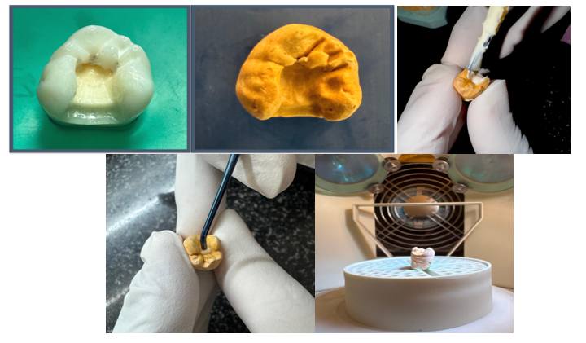

Group 2 : 3D Printed restoration
Similar to group 1 samples, inlay cavity were prepared. The samples were scanned using extra-oral digital scanners. 3 D printed models and restorations were obtained. The samples were cemented using light cure resin cements.
Fig .2 3D Printed restoration of teeth
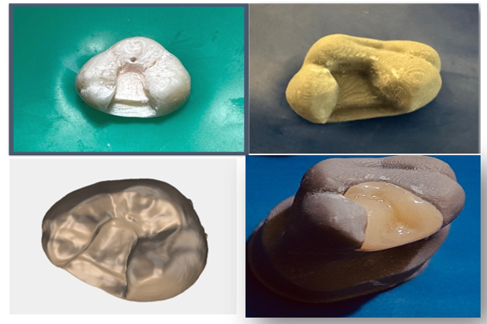

Stereomicroscope Image
After obtaining the laboratory prepared inlays, the restorations were cemented using self adhesive resin cement. The specimens were coated with a single layer of varnish. The specimens were immersed in 1% methylene blue dye for 24 hrs. The specimens were sectioned mesio-distally. The specimens were observed under stereomicroscopy under a magnification 20 x. Dye penetration was observed along two planes. Firstly a vertical line is drawn parallel to the axial wall and a horizontal line is drawn at the tooth-restoration interface at the gingival seat.
Fig .3 Stereomicroscopic Images

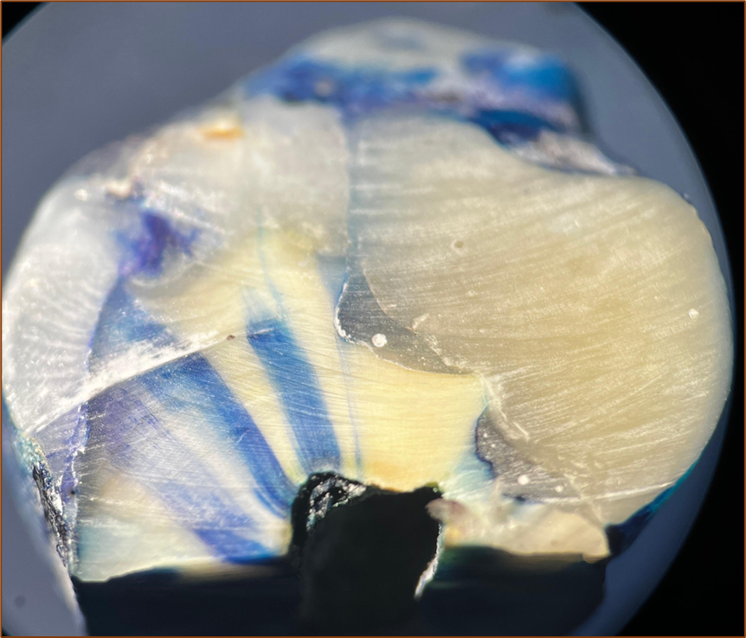
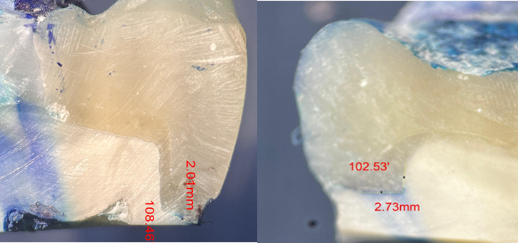

Table 1 Direction and measurements of teeth

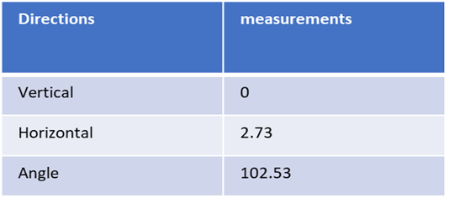
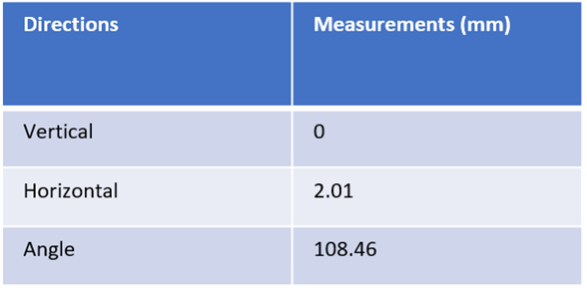

Results
Table 2. Morphometric analyses of length and area of dye penetration
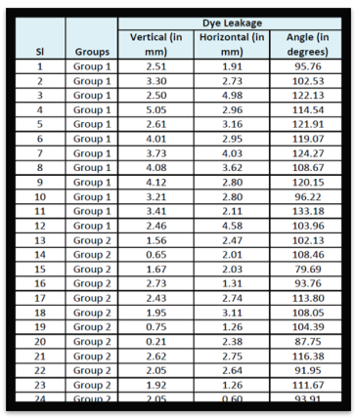
Statistical Analysis
The difference in the mean vertical length of dye leakage was statistically significant between 2 groups at p<0.001. The analysis demonstrates that Group 2 has a significantly lesser mean vertical length of dye leakage compared to Group 1.
The difference in the mean vertical length of dye leakage was statistically significant between 2 groups at p<0.001. The analysis demonstrates that Group 2 has a significantly lesser mean vertical length of dye leakage compared to Group 1.

Table 3 Comparison of mean vertical length of dye leakage
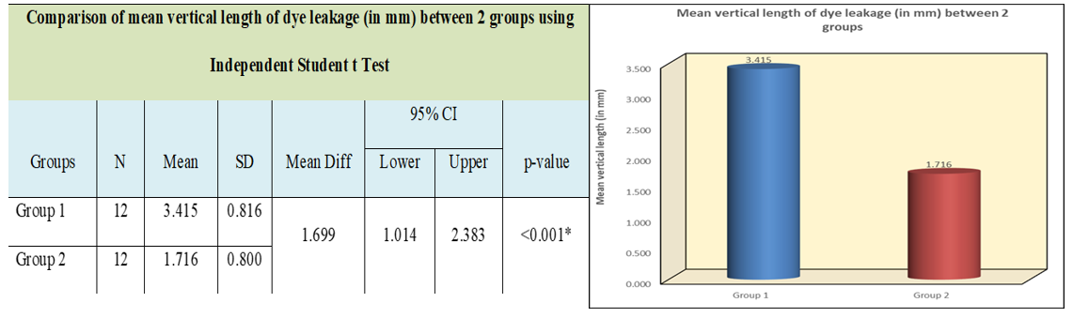
2 has a significantly lesser mean vertical length of dye leakage compared to Group 1.
Table 4 Comparison of mean horizontal length of dye leakage
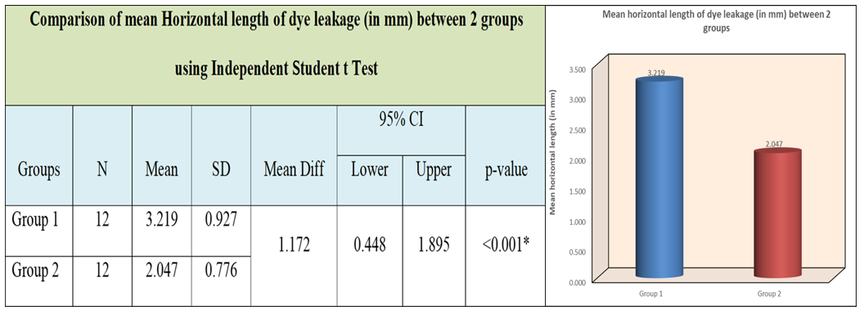
The difference in the mean angle of dye leakage was statistically significant between 2 groups at p=0.01. The analysis demonstrates that Group 2 has a significantly lesser mean angle of dye leakage compared to Group 1
Table 5 Comparison of mean angle of dye leakage
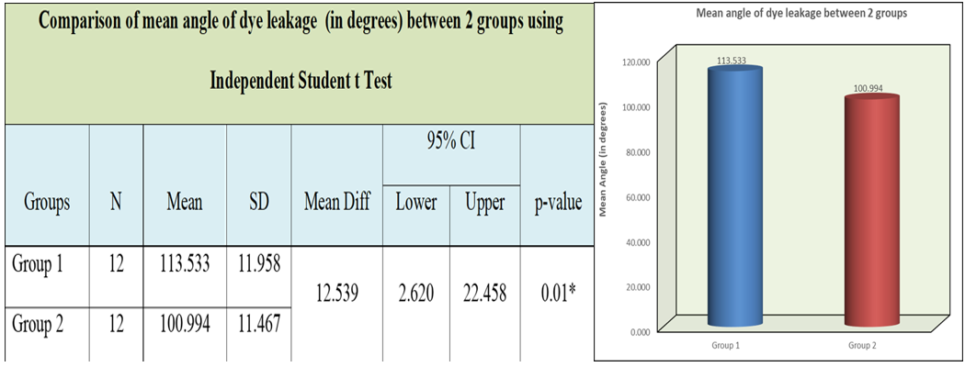

Discussion
In the present study marginal leakage was evaluated along the axial wall , gingival seat and also axial-gingival line angle of tooth restoration margin .Dye penetration is noted in all the specimens. Microleakage was observed more along the gingival seat (horizontal dimension) when compared to axial wall Ceramic hybrid resins were used in group 1 and group 2.
“Microleakage” is defined as the passage of bacteria and their toxins between restoration margins and tooth preparation walls.” In manual technique polymerization shrinkage refers to the volumetric decrease, leading to potential issues like marginal gaps, stress on the tooth structure, and post-operative sensitivity due to the shrinkage forces generated during the curing process⁷. Shrinkage is caused due to high stresses in the cavity wall influencing the C-factor, light activation protocols , filling technique ,micro tensile bond strength⁸ (A.D. Loguercio et al.) and visco-elastic behaviour⁹(R.R Braga et al).The present study reveals that the microleakage is significantly lesser for 3D printed resins as they are photopolymerized which results in minimal polymerization shrinkage. This is attributed to the Stereolithography (SLA) or digital light processing (DLP) mechanism used in 3D printing technology. Liquid resin is layered with a focused UV laser beam, creating a highly accurate, detailed dental restoration based on a digital design. This aids in obtaining restoration with intricate geometries and precise fit within the patient's mouth. Polymer shrinkage decrease with an increase in the inorganic filler content. Thus, the higher the inorganic filler content, the lower the polymerization shrinkage. The 3D printing technology comparatively resolved the contradiction between higher double-bond conversion rate and lower polymerization shrinkage. It might have great potential to reduce the incidence of marginal leakage in caries restorative procedures¹⁰ (M. Zhao et al. ) .Another crucial aspect is the margin adaptation that can affect the clinical success of the printed restoration.AM indirect restorations have better margin adaptation than subtractive-manufactured restorations.^{11,12}In the study group 2 had lower microleakage resulting in favorable adaptation.The present study has strengths, including the use of stable and precise printing technology, as well as the comparison between materials with similar characteristics and clinical applications, which differ in their composition and energy source for conversion; however, further studies are necessary to evaluate the potential of 3D printed restorations to its fullest.
Conclusion
3D printing already has diverse application, and holds a great deal of promise to make possible many new and exciting treatments and approaches to fabricate dental restorations.Digital manufacturing will change the face of dentistry in the near future in terms of treatment time and simplicity.While both additive and subtractive techniques can be used to produce restorations with adequate marginal fit, errors can arise depending on the CAD system used and the clinician's expertise .Application intertwined with improved skill considering patient comfort and demand must be focused .Moving forward, several key trends are anticipated to emerge in the field of 3D printing technology for polymer composites, profoundly impacting the design, preparation, and practical production applications of these materials. These trends will set new standards for performance, sustainability, and efficiency.
Dentistry is currently witnessing the beginnings of the additive age, where promising processes are developing in parallel. It is still uncertain which of these processes will ultimately prevail
REFERENCES
1. Susila AV. Role of Composition on Polymerization Shrinkage and Shrinkage Stress in Dental Composites. J Oper Dent Endod 2021;6(1):31–44
2.Battancs, E.; Sáry, T.; Molnár, J.; Braunitzer, G.; Skolnikovics, M.; Schindler, Á.; Szabó, P.B.; Garoushi, S.; Fráter, M. Polymers 2022, 14, 3463
3. Abbasi M, Moradi Z, Mirzaei M, Kharazifard MJ, Rezaei S. Polymerization Shrinkage of Five Bulk-Fill Composite Resins in Comparison with a Conventional Composite Resin. J Dent (Tehran). 2018 Nov;15(6):365-374. PMID: 30842797; PMCID: PMC6399456.
4. Bilgin MS, Baytaroğlu EN, Erdem A, Dilber E. A review of computer-aided design/computer-aided manufacture techniques for removable denture fabrication. Eur J Dent. 2016 Apr-Jun;10(2):286-291. doi: 10.4103/1305-7456.178304. PMID: 27095912; PMCID: PMC4813451.
5. Balestra, D.; Lowther, M.; Goracci, C.; Mandurino, M.; Cortili, S.; Paolone, G.; Louca, C.; Vichi, A. 3D Printed Materials for Permanent Restorations in Indirect Restorative and Prosthetic Dentistry: A Critical Review of the Literature. Materials 2024, 17, 1380. https://doi.org/10.3390/ma17061380
6. Alshargawi, Waleed & Tawhari, Feras & Aladwani, Ameerah & Hassanein, Zyad & Fageeh, Sahar & Almeshrf, Ahmed & Alamani, Saud & Neyaz, Aymen & Albalbisi, Asraa & Alsadiq, Belal & Alasmari, Abdulrahman. (2024). The effectiveness of direct versus indirect restoration techniques following canal therapy. International Journal Of Community Medicine And Public Health. 11. 10.18203/2394-6040.ijcmph20242686.
7. Schneider LF, Cavalcante LM, Silikas N. Shrinkage Stresses Generated during Resin-Composite Applications: A Review. J Dent Biomech. 2010;2010:131630. doi: 10.4061/2010/131630. Epub 2009 Sep 30. PMID: 20948573; PMCID: PMC2951111.
8.Loguercio AD, Reis A, Ballester RY. Polymerization shrinkage: effects of constraint and filling technique in composite restorations. Dent Mater. 2004 Mar;20(3):236-43. doi: 10.1016/S0109-5641(03)00098-8. PMID: 15209228.
9.Braga RR, Ballester RY, Ferracane JL. Factors involved in the development of polymerization shrinkage stress in resin-composites: a systematic review. Dent Mater. 2005;21(10):962-970. doi:10.1016/j.dental.2005.04.018
10.Zhao, Xy & Li, Sb & Gu, Lj & Li, Y. (2013). Detection of Marginal Leakage of Class V Restorations In Vitro by Micro-Computed Tomography. Operative dentistry. 39. 10.2341/12-182-L.
11. Donmez MB, Okutan Y. Marginal gap and fracture resistance of implant-supported 3D-printed definitive composite crowns: An in vitro study. J Dent. 2022;124:104216. doi:10.1016/j.jdent.2022.104216
12. Suksuphan P, Krajangta N, Didron PP, Wasanapiarnpong T, Rakmanee T. Marginal adaptation and fracture resistance of milled and 3D-printed CAD/CAM hybrid dental crown materials with various occlusal thicknesses. J Prosthodont Res. 2024;68(2):326-335. doi:10.2186/jpr.JPR_D_23_00089

