Review Article

Revolutionizing Oral Healthcare: The Role of Artificial Intelligence in Dentistry

ABSTRACT
Artificial Intelligence (AI) is revolutionizing dentistry by enhancing diagnostic accuracy, treatment planning, and patient care. AI-powered tools like virtual assistants, robotic systems, and deep learning algorithms streamline workflows and improve outcomes across dental specialties, including general dentistry, oral surgery, orthodontics, and pediatric care. AI also aids in dental education, research, and public health, offering personalized and efficient solutions. Despite its potential, challenges like data privacy, ethical concerns, and the need for regulatory oversight remain. AI serves as a powerful augmentation tool, complementing rather than replacing the essential role of human expertise in dentistry.
KEYWORDS
Artificial Intelligence, Dentistry, Diagnostic Accuracy, Treatment Planning, Virtual Assistants, Robotic Systems, Deep Learning, Ethical Considerations.
INTRODUCTION

“Artificial intelligence is the future of dentistry. It's not about replacing dentists; it's about empowering them with tools to provide better care." - Dr. Paul Sharpe

Artificial Intelligence (AI) is a branch of computer science that focuses on creating machines or systems that can perform tasks that would typically require human intelligence to complete.¹ The
concept of AI can be dated back to 1950 by Alan Turing. He was the first person to conduct substantial research in the field that he called “Computer Machinery and Intelligence” which eventually became The Turing Test, which experts used to measure computer intelligence.² The term “artificial intelligence” was coined and came into popular use in 1955 by John McCarthy, in a workshop at Dartmouth on “artificial intelligence” which is the first use of the word.³

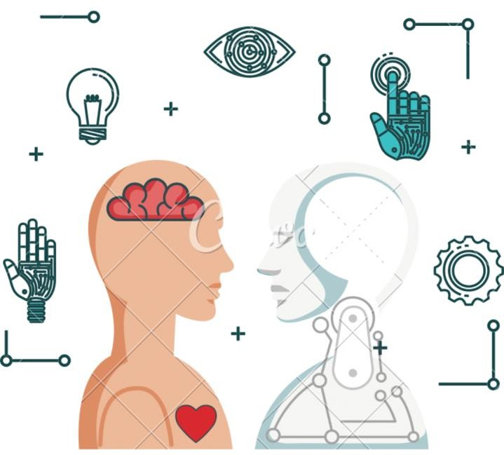

Fig .1 Use of Artificial intelligence
Artificial intelligence can be defined as the theory and development of computer systems that are able to perform tasks that normally require human intelligence, such as visual perception, speech recognition, decision-making and translation between languages.⁴
The fourth industrial revolution opens a new digital era, of which one of the most important contributions is Artificial Intelligence.³ With more and more electronic devices assisting people’s life comprehensively, the data recorded by those devices made it possible to easily use and analyze the data coming from those electronic devices by AI. Artificial Intelligence has emerged as a transformative force in a wide range of sectors, including dentistry, revolutionizing various facets of oral healthcare [8-10]. The word "AI" is used when the computer imitates analytical functions, such as "learning and problem - solving", that humans frequently associate with other human brains.⁵ It can mimic the intelligence of humans to undertake complex predictions and decision making in the healthcare sector, by reshaping the landscape of dentistry.⁶ The influence of Artificial Intelligence is already palpable in our daily routines, notably through a range of office and practice management tools [11,12]. From voice assistants like Siri and Alexa to various intelligent interfaces across devices and applications, AI is reshaping how we interact with technology. In healthcare, AI manifests in virtual and physical forms, powering tasks such as medication dosage calculations, diagnosis assistance, appointment scheduling and electronic health record management [13,14]. Meanwhile, physical applications include robotic support in surgery, telepresence for remote healthcare and the development of companion robots for elderly care.³
The integration of AI technologies holds immense promise in dental image diagnostics, caries detection, radiography, pathology, drug-drug interactions, preventive care, prognostic diagnosis, treatment planning, electronic record keeping, relation to scheduling, patient care, practice management within the dental field.³ As we navigate through the complexities of modern

dentistry, AI stands as a beacon of innovation, offering unprecedented opportunities to improve patient outcomes and streamline clinical workflows [15-17].
Artificial intelligence, machine learning and deep learning are frequently conflated, though they each denote distinct concepts. Artificial intelligence, also called machine intelligence, is a way of designing intelligent devices and systems that can address problems creatively that are often treated as a human prerogative [18-20]. Machine learning is an AI subset that helps in building AI-driven applications. Deep learning, often called deep neural learning or deep neural network, is a subset of machine learning that uses vast volumes of data and complex algorithms to train a model.

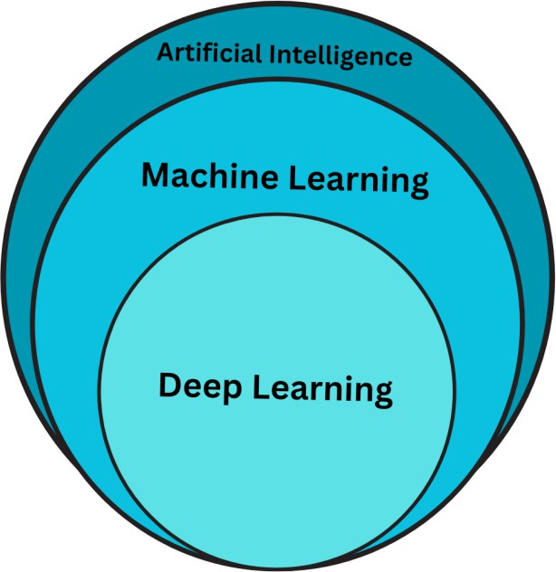

Fig .2 Artificial intelligence, machine learning and deep learning
AI systems are categorized as: artificial narrow intelligence (ANI), which has a narrow range of abilities, artificial general intelligence (AGI), which is on par with human capabilities and artificial super intelligence (ASI), which is more capable than actual human intelligence.

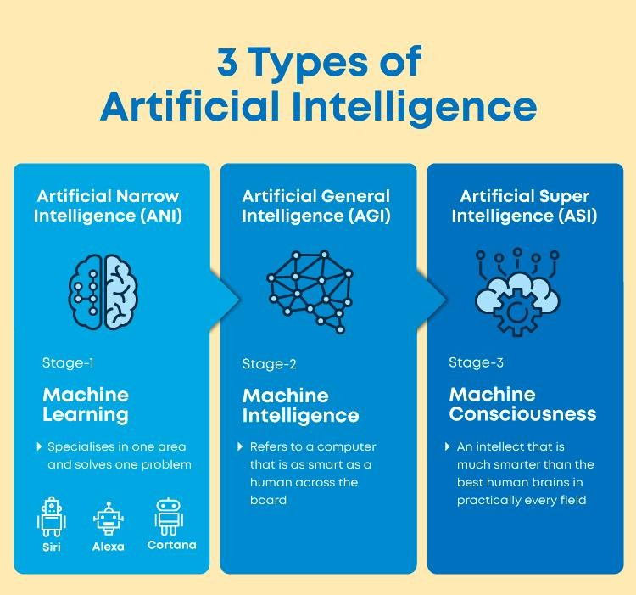

Fig .3 Types of AI
Source: Google Images

In the past, AI applications in dentistry were limited, primarily focusing on basic tasks such as data analysis and image recognition. However, with advancements in AI technology, its role in dentistry has expanded significantly. Presently, AI plays a pivotal role in enhancing diagnostic accuracy, developing personalized treatment plans and optimizing workflow management processes. Looking towards the future, AI-powered imaging technologies, predictive analytics, virtual treatment planning software and robotic assistance during dental procedures are among the key advancements driving innovation in dentistry.

Role of Artificial Intelligence in Dentistry:

E- Learning/ Dental Education and Scientific Writing: Intelligent Tutoring Systems: AI facilitates simulation-based learning, providing feedback to students and accelerating skill

development in a safe environment. Additionally, artificial intelligence (AI) aids in scientific writing by assisting researchers in data analysis, literature review, and manuscript preparation, thereby expediting the publication process and improving the quality of academic output.
Virtual Dental Assistants: represent another innovative application of AI in dentistry, aiding dentists during procedures and increasing workflow efficiency. These assistants leverage AI algorithms to perform tasks such as gathering patient information, providing chairside assistance, and even assisting with post-operative care, thereby freeing up valuable time for dental professionals to focus on delivering quality patient care.

Patient Management:

- Virtual Dental Assistants: AI-powered assistants handle clinical tasks, scheduling, insurance, and patient communication, enhancing accuracy and workflow efficiency.
- Emergency Teleassistance: In emergencies, AI-powered systems provide patients with immediate assistance and guidance, ensuring continuity of care.

Diagnosis, Treatment, and Prognosis:

- Disease Detection: AI aids in the detection and classification of oral diseases, including premalignant and malignant alterations, improving diagnostic accuracy.
- Treatment Planning: AI-based machine learning systems assist in developing treatment strategies and predicting treatment outcomes, enhancing decision-making and prognosis.

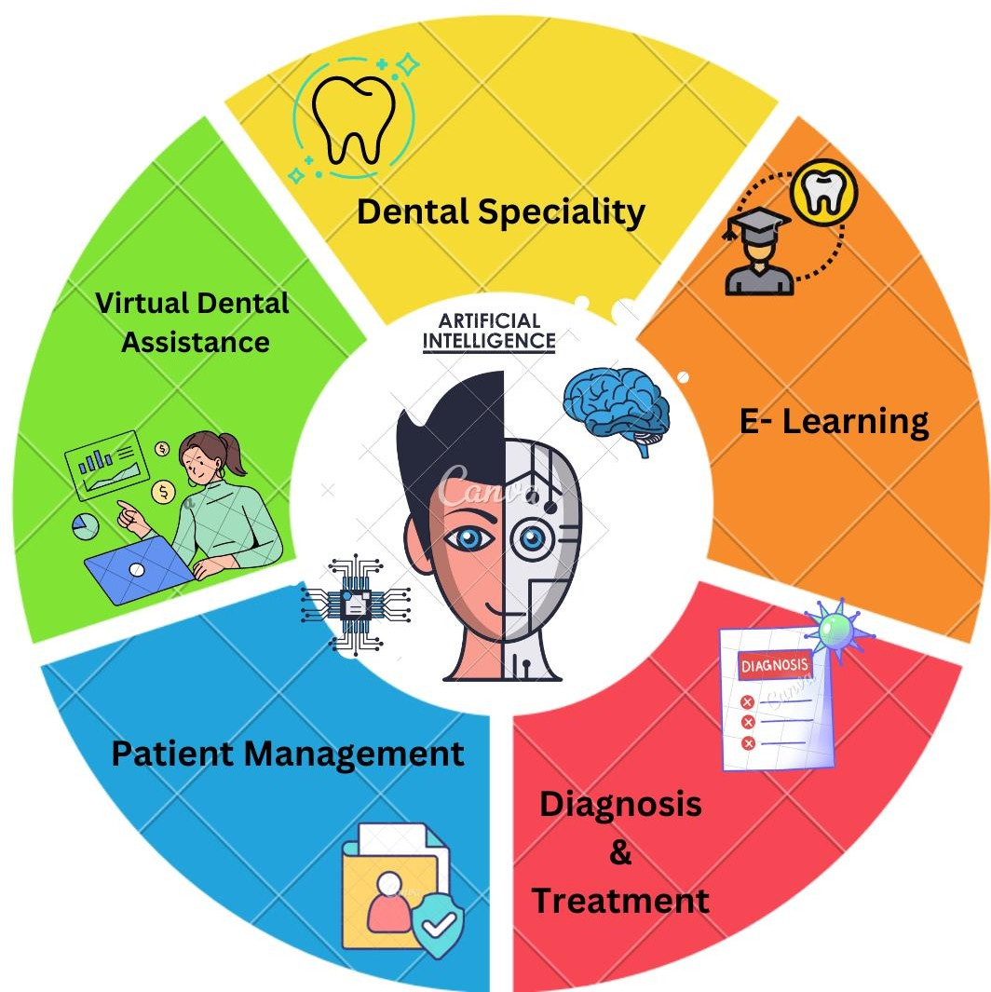
Fig.4 Role of AI

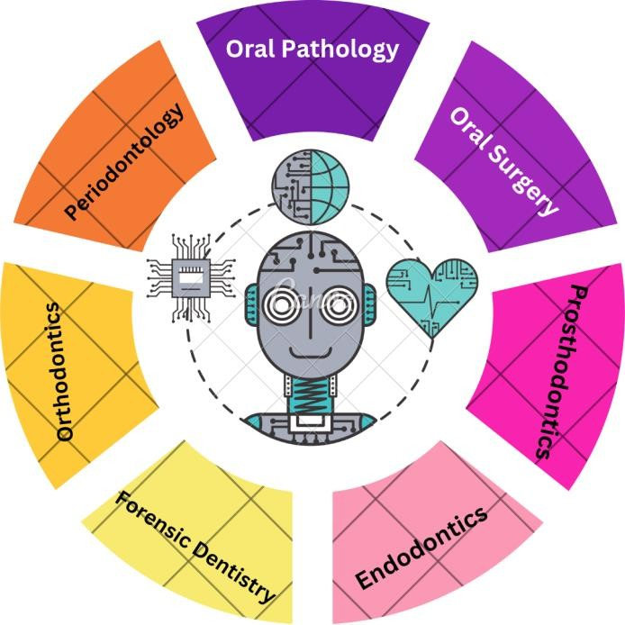
Role of Artificial Intelligence in various speciality of dentistry, offering innovative solutions across different branches of the field:

Fig .5 Role of Artificial Intelligence in various speciality of dentistry
General Dentistry:

- Imaging and Diagnosis: AI algorithms analyze dental images for accurate detection and diagnosis of oral diseases, leading to early interventions and improved outcomes.
- Treatment Planning: AI-based software assists dentists in developing personalized treatment plans by analyzing patient data and case histories, optimizing treatment strategies.
- Robotics and Automation: Robotic systems automate tasks like tooth preparation, implant placement, and orthodontic adjustments, enhancing precision and efficiency.
- Virtual and Augmented Reality: These technologies aid in patient education, treatment visualization, and procedural guidance, improving accuracy and patient satisfaction.
- Data Analysis and Predictive Analytics: AI processes large datasets to identify patterns, predict oral health conditions, and recommend personalized preventive measures, fostering proactive care.
- Administrative Support: AI-driven virtual assistants streamline administrative tasks, such as appointment scheduling and billing, optimizing practice efficiency.

Oral Medicine and Maxillofacial Radiology: AI plays a pivotal role in screening and classifying oral cavity lesions into suspicious altered mucosa, aiding in the early detection of premalignant and malignant changes. Moreover, it accurately predicts the genetic predisposition of oral cancer for a large population. The Mobile Mouth Screening Anywhere (MeMoSA) app facilitates remote interpretation of oral cavity images by specialists, while the integration of AI

into radiological procedures like digital RVGS/IOPA, 3D scans, and CBCT is revolutionizing diagnostic accuracy and treatment planning in dentistry, albeit requiring extensive data acquisition and processing for optimal functionality.
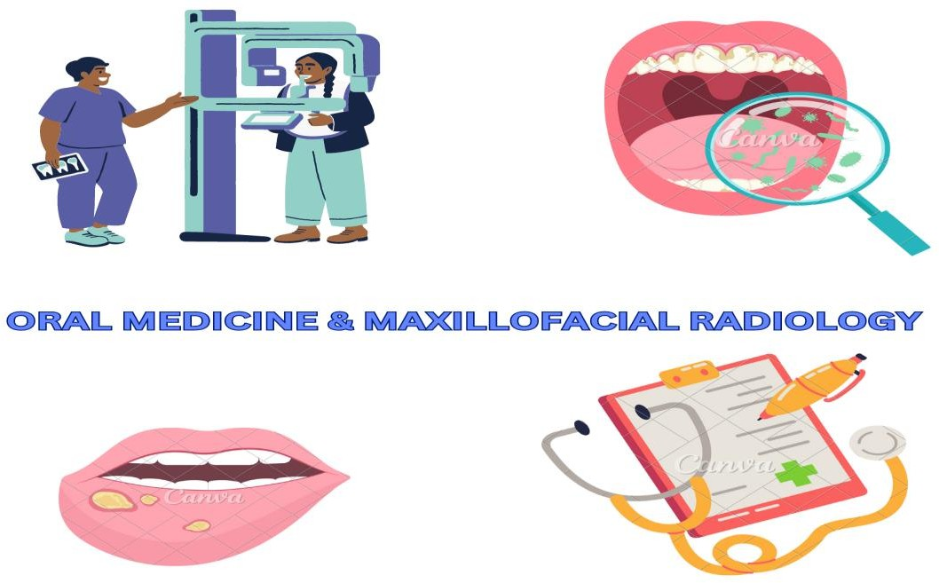

Fig .6 Use of AI in Oral medicine

Oral and Maxillofacial Surgery: Robotic Surgery- Artificial intelligence (AI) is transforming oral surgery through robotic surgery, replicating human body motion and intellect. Procedures like dental implantation, tumor removal, biopsies, and temporomandibular joint (TMJ) surgery benefit from image-guided cranial surgery, ensuring enhanced accuracy and safety. Comparative studies show improved precision with image guidance, reducing operation time and the need for revisions. AI-powered software aids in surgical planning, preserving vital structures with meticulous detail, while robotic surgeons execute semi-automated procedures under skilled supervision, marking a significant advancement in oral and maxillofacial surgery.

Fig. 7
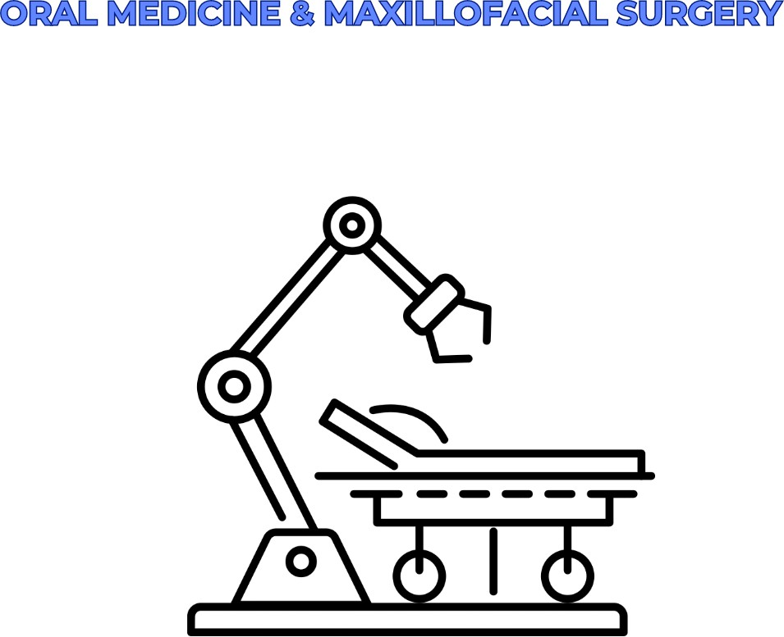

Prosthetic Dentistry: Prosthesis Design - In prosthodontics, the RaPiD design assistant integrates anthropological calculations, face dimensions, ethnicity, and patient preferences to deliver optimal aesthetic prostheses. By linking databases and employing logic-based frameworks, RaPiD streamlines the design process. Furthermore, AI-powered neural networks enable laboratories to autonomously produce high-quality dental restorations, revolutionizing dentistry and orofacial prosthetics. CADCAM technology replaces conventional casting, reducing errors with precise 2D and 3D models, while virtual reality simulation simulates post- treatment facial profiles, enhancing treatment planning and patient outcomes.

Fig.8
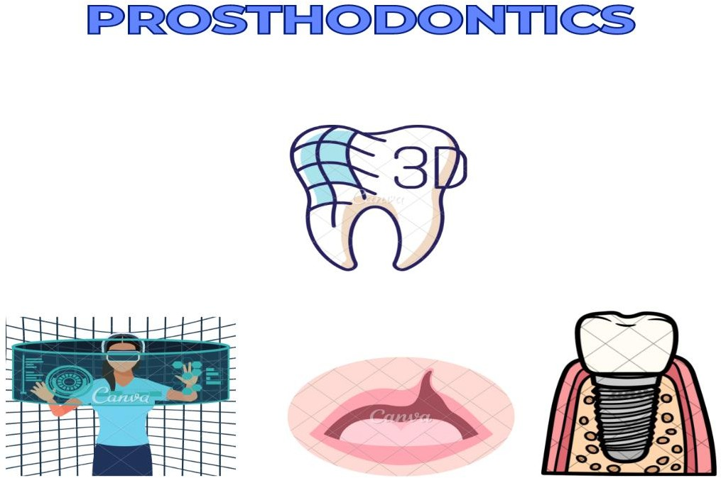

Orthodontics: Personalized Orthodontic Care: AI-powered personalized orthodontic care revolutionizes diagnosis, treatment planning, and monitoring by analyzing radiographs and images from intraoral scanners and cameras. This eliminates traditional laboratory procedures and offers precise results. Digital impressions from intraoral scanners and cameras feed data into AI algorithms, predicting tooth movements and treatment outcomes. Customized aligner-based orthodontics, combined with advanced technologies, enhance case acceptance and promise shorter treatment times with precise progress monitoring.

Fig.9
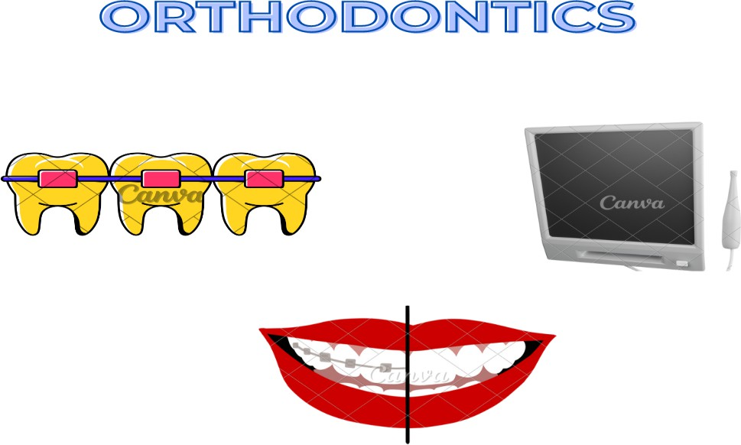

Pedodontics: AI-enabled innovations to enhance patient care. Computer-aided design and manufacturing revolutionize restorative dentistry, reducing treatment time and improving aesthetics for paediatric patients. AI-powered pain control devices offer injection-free alternatives, making dental visits more comfortable for children. Additionally, 4D goggles, movies, animations, and virtual reality games serve as behaviour modification aids, engaging young patients and reducing anxiety during dental procedures. These advancements collectively improve the overall experience and outcomes in paediatric dentistry

Fig .10


Conservative Dentistry and Endodontics: AI plays a crucial role in improving diagnostic accuracy and treatment outcomes. The Logicon Caries Detector aids in detecting and characterizing proximal caries, enabling early intervention. Additionally, AI assists in analysing the lifespan of restorative materials, guiding clinicians in selecting the most suitable options for individual cases. Furthermore, AI algorithms enhance precision in locating the minor apical foramen, strengthening the accuracy of determining working length during endodontic procedures and stem cell viability test. These advancements contribute to more effective and personalized treatment approaches in conservative dentistry and endodontics.

Fig .11

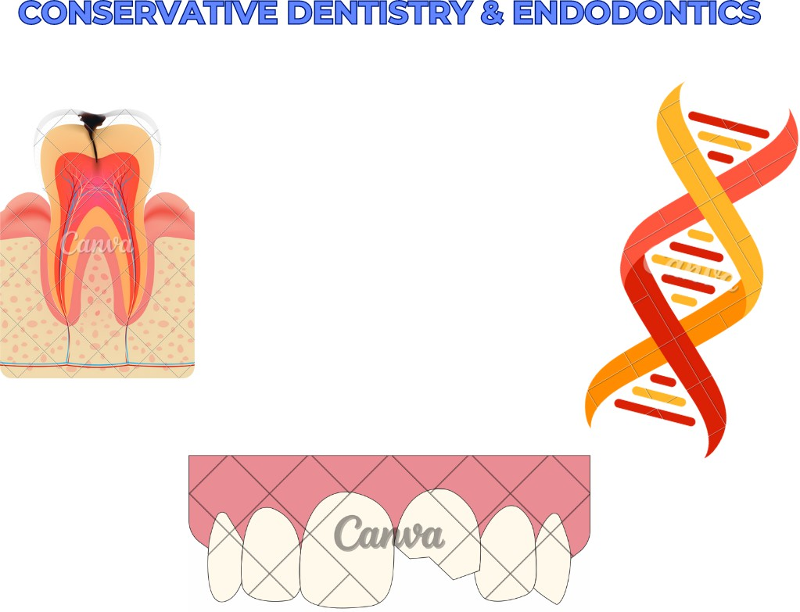

Periodontology: In deep learning analysis of radiographs facilitates early detection and treatment planning for periodontal diseases. By identifying periodontal changes, bone loss, alterations in bone density, and peri-implantitis, deep learning algorithms enable timely intervention in implantology. Furthermore, AI aids in predicting disease progression and response to treatment, optimizing patient outcomes. Additionally, AI-powered risk assessment tools help identify patients at high risk for periodontal disease, allowing for proactive preventive measures. These advancements in AI-driven diagnostics and treatment planning enhance the efficacy and efficiency of periodontal care.

Fig .12
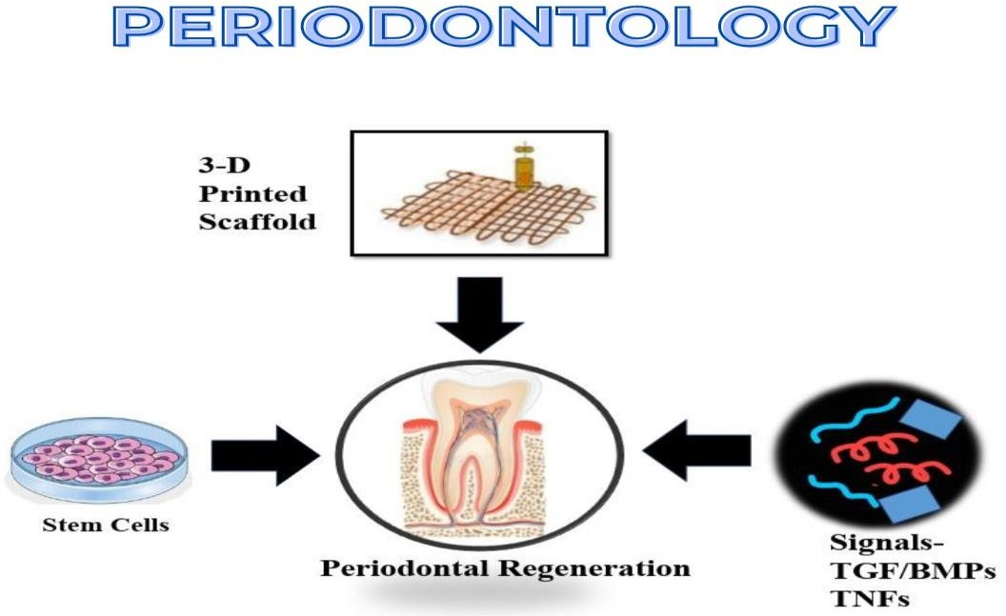

Community Dentistry: AI in public dentistry focuses on analysing prevention and treatment techniques in public health, enhancing patient outcomes. "Denta Mitra" is an AI-based mobile app empowering users to monitor their dental health using an innovative scanner.
Oral Pathology: AI aids in diagnosing and predicting diseases through image analysis and pattern recognition. It enhances accuracy and efficiency in identifying oral lesions, contributing to early detection and treatment interventions.
Forensic Odontology: AI in Forensic Medicine - AI aids in age and gender determination, bite mark analysis, and mandibular morphology prediction, improving forensic investigation accuracy.

Geriatric Dentistry: Personalized Care - AI helps in assessing and managing oral health risks in elderly patients, enabling personalized preventive measures and treatment plans.
Bioprinting: Tissue Regeneration - AI-driven bioprinting technology enables the creation of living tissue and organs, offering potential solutions for reconstructing oral tissues lost due to pathology or trauma.

Conclusion

Artificial intelligence (AI) is profoundly reshaping dentistry, offering innovative solutions to enhance patient care and outcomes. It revolutionizes diagnostic accuracy, practice management, research, and education in oral healthcare delivery. However, significant challenges such as data privacy, workflow integration, technical limitations, and ethical considerations must be addressed for the full realization of AI's potential. The American Dental Association underscores the importance of ethical considerations and regulatory oversight for patient safety and privacy. While AI enhances clinical practice, human expertise and judgment remain indispensable. AI-powered tools supplement rather than replace dentists, assisting in diagnosis, treatment planning, and productivity. Despite AI's capabilities, it cannot replace human intuition, empathy, or clinical judgment critical for individualized care and effective communication. Future research aims to improve AI generalizability and reliability, focusing on early lesion detection. AI holds promise in endodontics, outperforming specialists in some areas, particularly aiding novices and non-specialists. Ultimately, AI should be viewed as an augmentation tool, reinforcing professional relationships and patient-centered care, while recognizing the irreplaceable role of human interaction and intuition in dentistry.

REFERNCES

- Sarker IH. AI-based modeling: techniques, applications and research issues towards automation, intelligent and smart systems. SN Comput Sci 2022; 3: 158
- Copeland, J., ed. (2004). The Essential Turing: the ideas that gave birth to the computer age. Oxford, England: Clarendon Press. ISBN 0-19-825079-7.
- Aminoshariae A, Kulild J, Nagendrababu V: Artificial intelligence in endodontics: Current applications and future directions. J Endod. 2021, 47:1352-7. 10.1016/j.joen.2021.06.003
- Stevenson A. Oxford Dictionary of English. USA: Oxford University Press (2010).

- Deshmukh S: Artificial intelligence in dentistry. J Int Clin Dent Res Organ. 2018, 10:47.

10.4103/jicdro.jicdro_17_18

- Alexander B, John S: Artificial Intelligence in Dentistry: Current Concepts and a Peep Into the Future . Int J Adv Res. 2018, 30:1105-8. 10.21474/IJAR01/8242
- Schwendicke FA, Samek W, Krois J. Artificial intelligence in dentistry: chances and challenges. Journal of dental research. 2020 Jul;99(7):769-74.
- Nguyen TT, Larrivée N, Lee A, Bilaniuk O, Durand R. Use of artificial intelligence in dentistry: current clinical trends and research advances. J Can Dent Assoc. 2021;87(l7):1488-2159.
- Carrillo‐Perez F, Pecho OE, Morales JC, Paravina RD, Della Bona A, Ghinea R, Pulgar R, Pérez MD, Herrera LJ. Applications of artificial intelligence in dentistry: A comprehensive review. Journal of Esthetic and Restorative Dentistry. 2022 Jan;34(1):259-80.
- Chen YW, Stanley K, Att W. Artificial intelligence in dentistry: current applications and future perspectives. Quintessence Int. 2020 Mar 1;51(3):248-57.
- Tandon D, Rajawat J, Banerjee M. Present and future of artificial intelligence in dentistry. Journal of oral biology and craniofacial research. 2020 Oct 1;10(4):391-6.
- Katne T, Kanaparthi A, Gotoor S, Muppirala S, Devaraju R, Gantala R. Artificial intelligence: demystifying dentistry–the future and beyond. Int J Contemp Med Surg Radiol. 2019;4(4):D6-9.
- Khanagar SB, Al-Ehaideb A, Maganur PC, Vishwanathaiah S, Patil S, Baeshen HA, Sarode SC, Bhandi S. Developments, application, and performance of artificial intelligence in dentistry–A systematic review. Journal of dental sciences. 2021 Jan 1;16(1):508-22.
- Kurup RJ, Sodhi A, Sangeetha R. Dentistry and artificial intelligence. Acta Scientific Dental Sciences. 2020 Oct;4(10):26-32.
- Karan-Romero M, Salazar-Gamarra RE, Leon-Rios XA. Evaluation of attitudes and perceptions in students about the use of artificial intelligence in dentistry. Dentistry Journal. 2023 May 5;11(5):125.
- Jaiswal M, Gupta N, Singh A. Study on patient’s awareness towards role of artificial intelligence in dentistry. Int J Health Sci Res. 2019;9(10):35-9.
- Ding H, Wu J, Zhao W, Matinlinna JP, Burrow MF, Tsoi JK. Artificial intelligence in dentistry—A review. Frontiers in Dental Medicine. 2023 Feb 20;4:1085251.
- Roganović J, Radenković M, Miličić B. Responsible use of artificial intelligence in dentistry: survey on dentists’ and final-year undergraduates’ perspectives. InHealthcare 2023 May 19 (Vol. 11, No. 10, p. 1480). MDPI.
- Ayad N, Schwendicke F, Krois J, van den Bosch S, Bergé S, Bohner L, Hanisch M, Vinayahalingam S. Patients’ perspectives on the use of artificial intelligence in dentistry: a regional survey. Head & Face Medicine. 2023 Jun 22;19(1):23.
- Banerjee M. Artificial intelligence in dentistry: A ray of hope. CODS J Dent. 2021;13:58-60.

