Case report

Radial Artery Aneurysm Following Elective Percutaneous Coronary Intervention: A Case Report

Abstract
Background: Transradial approach for percutaneous coronary intervention (PCI) is frequently preferred because it has lower complication rates than femoral access. However, unusual vascular complications, such as radial artery aneurysms, might arise, requiring diagnostic and treatment challenges.
Case Summary: We present a case of a 68-year-old man who underwent an elective right radial percutaneous coronary intervention (PCI) with a 6 Fr sheath. Following the procedure, he experienced the development of a non-painful, progressively growing pulsatile mass at the site of access ten days later. A duplex ultrasound revealed a saccular pseudoaneurysm measuring 22 × 18 mm, characterized by a 2.5 mm neck and to-and-fro flow patterns. A CT angiography confirmed the presence of a localized pseudoaneurysm without any signs of distal embolization. After a discussion among specialists, a percutaneous thrombin injection was administered under ultrasound guidance (0.5 mL of thrombin at a concentration of 250 IU/mL), which resulted in immediate thrombosis of the sac, while maintaining the patency of the radial artery and avoiding any distal ischemia. The patient was discharged the next day and remained asymptomatic with duplex-confirmed thrombosis after 1 and 6 months.
Conclusion: A delayed pulsatile swelling following transradial procedures should lead to the use of duplex imaging. For anatomically appropriate radial pseudoaneurysms, ultrasound-guided thrombin injection is an efficient and minimally invasive treatment option.
Keywords: radial artery; pseudoaneurysm; percutaneous coronary intervention; transradial access; access-site complication.

Introduction
Percutaneous coronary intervention (PCI) with transradial access has become the preferred technique in several hospitals due to lower bleeding risk, earlier ambulation, and greater patient comfort. Despite its benefits, transradial access is not without risks. Hematomas, arterial occlusion, and pseudoaneurysms are among the most common vascular injuries documented. Radial aneurysms are extremely rare and frequently go undiagnosed.
Atrue aneurysm dilates all three layers of the vessel wall: intima, medium, and adventitia. Pseudoaneurysms, on the other hand, are caused by a rupture in the artery wall that is filled with blood from surrounding tissues. True aneurysms can develop after PCI due to mechanical damage, recurrent puncture, or infection. This article reports a rare example of a genuine radial artery aneurysm after elective PCI and outlines its clinical implications.

Case Presentation
A 68-year-old male patient known to be hypertensive and dyslipidemic presented with stable angina. Coronary angiography showed a severe stenosis in the proximal left anterior descending artery. Elective PCI was done through the right radial artery using a 6F sheath. The procedure was successful and the patient was discharged the next day with dual antiplatelet treatment.
Two weeks after discharge, the patient noticed a gradually increasing, painless swelling on the volar aspect of his right wrist. He denied experiencing fever, trauma, or neurological problems. The physical examination showed a 2.5 × 2.0 cm pulsatile mass with an audible bruit. The distal pulses were intact, and there was no evidence of ischemia or infection.
Doppler Ultrasound revealed a saccular aneurysm with intact arterial wall layers and laminar flow. CT Angiography was done and evealed a true aneurysm of the radial artery without evidence of thrombosis or distal embolization.

Management

Due to the size and pulsatile nature of the aneurysm, surgical intervention was considered essential. The procedure was performed under regional anesthesia, during which the aneurysm was removed, and the radial artery was repaired using end-to-end anastomosis. Intraoperative observations confirmed it was a true aneurysm with the arterial wall layers intact and no evidence of rupture or infection.

The recovery process post-surgery was uneventful. The patient was discharged on the third day following the surgery, with intact hand function and palpable distal pulsations.

Discussion

Radial artery aneurysms are uncommon complications that can arise from transradial PCI. The majority of documented cases involve pseudoaneurysms, which are more prevalent due to disruption of the arterial wall during the insertion of sheaths or manipulation of catheters. True aneurysms, like the one discussed here, are less common and may be attributed to repeated trauma or inflammatory conditions.

Possible causes include mechanical injury from sheath or catheter placement, multiple punctures during various procedures, infections that weaken the arterial wall, and disorders related to connective tissue.

Imaging techniques are essential for diagnosis. Doppler Ultrasound is the primary, non-invasive method that effectively distinguishes between true and pseudoaneurysms. CT Angiography offers detailed anatomical images and aids in surgical preparation.

Management strategies consist of conservative care for small, asymptomatic aneurysms, ultrasound-guided thrombin injection for pseudoaneurysms, and surgical removal and repair for symptomatic or growing true aneurysms.

An analysis of available cases indicates that the majority of radial artery aneurysms following PCI are pseudoaneurysms. True aneurysms are infrequently reported and often necessitate surgical intervention. Prompt identification is crucial to avoid complications such as rupture, thrombosis, or ischemia in the distal area.

Conclusion

This case highlights the necessity of post-PCI surveillance, particularly in patients having transradial access. Radial artery aneurysms, while rare, can cause catastrophic problems if not detected and treated early. When patients appear with forearm masses after catheterization, clinicians should exercise a high level of suspicion.

Figures
Figure 1: Doppler ultrasound showing saccular aneurysm with preserved arterial wall layers
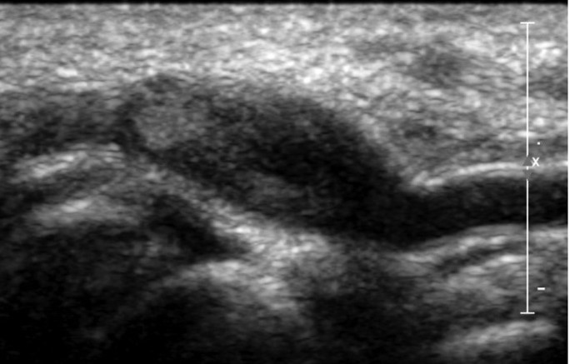

Figure 2: CT angiography confirming aneurysm morphology and absence of distal ischemia
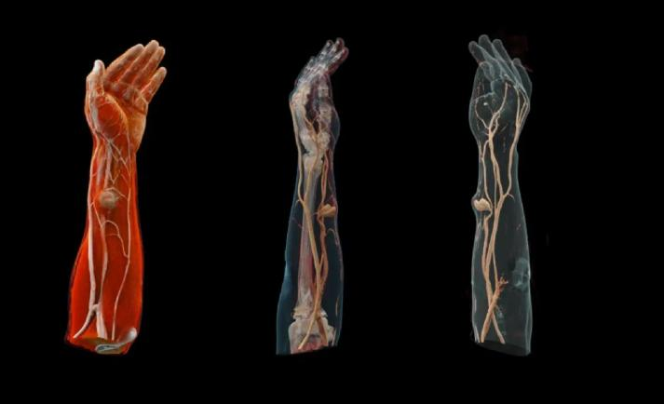

Table 1: Summary of Reported Radial Artery Aneurysm Cases Post-PCI
Author | Year | Type | Imaging Used | Management | Outcome
Cunha et al. | 2023 | Pseudoaneurysm | Doppler, CT Angio | Surgical | Full recovery
Papadoulas et al. | 2022 | Pseudoaneurysm | Doppler | Surgical | Good outcome
Majumdar et al. | 2016 | Pseudoaneurysm | Doppler, CT Angio | Surgical | No complications

Patient consent and ethics

Written informed consent for publication and use of clinical images was obtained from the patient. Institutional approval was obtained as required by local policy.

References
1. Cunha R, et al. Pseudoaneurysm of radial artery after coronary angiography. J Surg Case Rep. 2023;8:rjad446.
2. Papadoulas SI, et al. Surgical repair of post-catheterization radial pseudoaneurysm. Pan Afr Med J. 2022;41:261.
3. Majumdar G, et al. Radial artery pseudoaneurysm following transradial coronary intervention. J Cardiovasc Dis Diagn. 2016;S1:001.
4. Kiemeneij F, et al. Radial artery access for coronary procedures: review of complications. Catheter Cardiovasc Interv. 2003;59(3):357–362.
5.Bertrand OF, et al. Complications and failure of transradial approach for coronary interventions. JACC Cardiovasc Interv. 2010;3(10):1022–1031.

