Case report

Arrhythmogenic Left Ventricular Cardiomyopathy, the Great Imitator Unveiled by Cardiac MRI: A Case Report

Abstract:
Background: Arrhythmogenic left ventricular cardiomyopathy (ALVC) is a rare and often underdiagnosed subtype of arrhythmogenic cardiomyopathy (ACM), characterized by predominant left ventricular involvement and a high risk of arrhythmias. In contrast to the classic right dominant form, ALVC presents significant diagnostic challenges due to its phenotypic overlap with other cardiomyopathies and the limited availability of genetic testing.
Case Presentation: We report the case of a 55-year-old man with a history of hypertension and active smoking, who presented with progressive dyspnea, syncope, and palpitations. Initial evaluation revealed atrial fibrillation with rapid ventricular response, elevated cardiac biomarkers (troponin 176,000 ng/L; BNP 420 pg/mL), and signs of congestive heart failure. Transthoracic echocardiography demonstrated biventricular hypertrophic cardiomyopathy with severely reduced left ventricular ejection fraction (LVEF 34%) and global longitudinal strain (GLS) of -11.3%. Cardiac magnetic resonance (CMR) imaging showed moderate left ventricular dilation with significant septal hypertrophy, systolic dysfunction (LVEF 33%), and characteristic subepicardial and mid-myocardial late gadolinium enhancement (LGE) involving more than 30% of the myocardial mass, while the right ventricle remained unaffected. Comprehensive workup excluded cardiac sarcoidosis through negative angiotensin-converting enzyme levels, phosphocalcic assessment, salivary gland biopsy, and thoracic CT. Twenty-four-hour Holter monitoring revealed ventricular hyperexcitability with non-sustained ventricular tachycardia episodes and a 22% premature ventricular contraction burden.
Management and Outcome: Given the high risk of sudden cardiac death (SCD), the patient received an implantable cardioverter-defibrillator (ICD) and antiarrhythmic therapy with amiodarone, resulting in a significant reduction of arrhythmia burden, with premature ventricular contractions burden decreasing to 1.3%.
Conclusion: This case highlights the diagnostic complexity of ALVC and emphasizes the importance of multimodal imaging and the systematic exclusion of differential diagnoses. In settings with limited access to genetic testing, comprehensive clinical evaluation remains crucial for early recognition and appropriate risk stratification of this potentially life-threatening condition.
Keywords:
- Arrhythmogenic left ventricular cardiomyopathy
- Cardiac magnetic resonance
- Sudden cardiac death risk
- Implantable cardioverter-defibrillator
- Case report
Introduction:
Arrhythmogenic cardiomyopathy (ACM) is a genetic myocardial disease characterized by fibrofatty replacement, and clinically by ventricular arrhythmias [1]. It is often accompanied by regional or global ventricular dysfunction and represents a leading cause of sudden cardiac death in young individuals and athletes [2]. This condition is strongly linked to mutations in genes encoding desmosomal proteins, resulting in the loss of cardiomyocyte adhesion and disruption of intracellular signaling processes [1]. Initially, it has been described as a condition predominantly affecting the right ventricle (RV), with minor or late involvement of the left ventricle (LV). However, emerging evidence from multiple studies has demonstrated that LV involvement occurs frequently, with reported rates ranging from 16% to 76% of cases [3]. Consequently, this more nuanced understanding has led to the adoption of the term "arrhythmogenic cardiomyopathy", a designation that better captures the full phenotypic spectrum of the disease. As a result, the clinical classification of ACM has been expanded to include three primary phenotypes: the ‘right-dominant’ variant, the biventricular form, with equal involvement of both ventricles, and the ‘left-dominant’ variant, or arrhythmogenic left ventricular cardiomyopathy (ALVC), featuring predominant left ventricular involvement and minimal or no right ventricular abnormalities[4][5]. We present a case of suspected ALVC in a patient with symptomatic ventricular arrhythmias and high risk of sudden cardiac death, requiring the placement of an implantable cardioverter-defibrillator. The report highlights diagnostic challenges, including differentiating ALVC from other cardiac conditions, and emphasizes the importance of risk stratification in guiding management. Our paper was written according to the CARE guidelines[6].

Case presentation:
We report the case of a 55-year-old man with a history of hypertension and active smoking, admitted to our department with recently worsened dyspnea at rest, along with two episodes of syncope associated with palpitations occurring one week prior to admission. Additionally, he reported a three-month history of exertional palpitations that resolved completely with rest.
Upon admission, his vital signs were stable, with a blood pressure of 120/80 mmHg, tachycardia at 115 beats per minute, tachypnea at 22 breaths per minute, and normal oxygen saturation. The clinical examination revealed signs of congestive left heart failure.
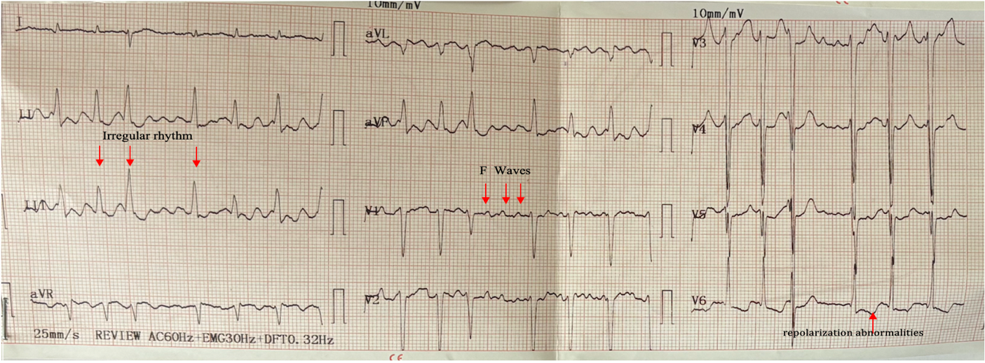
The electrocardiogram (ECG) revealed atrial fibrillation with a rapid ventricular response, along with multiple supraventricular and ventricular ectopic beats (Fig. 1, Fig. 2). Spontaneous restoration of sinus rhythm occurred without the need for external electrical cardioversion.
Fig.1- ECG showing atrial fibrillation rhythm, left ventricular hypertrophy with secondary repolarization abnormalities.

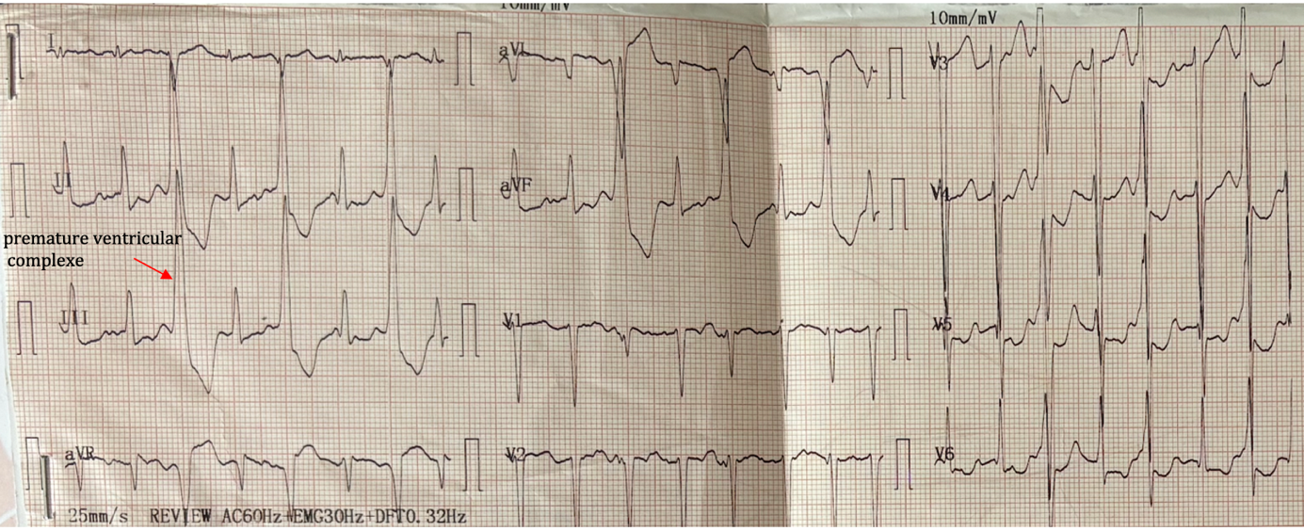
Fig.2- ECG showing monomorphic premature ventricular complexes (PVCs) in a bigeminy pattern, with a left bundle branch block (LBBB) morphology and a long R-on-T coupling interval.

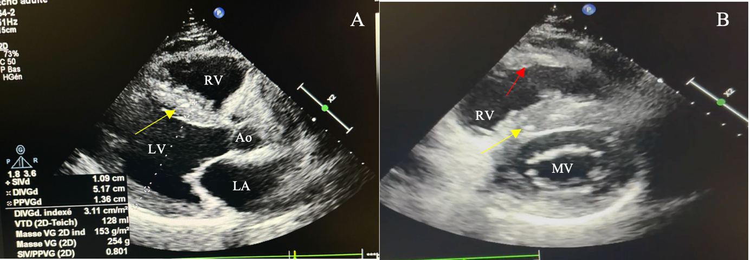
Biologically, the troponin level was significantly elevated at 176 000 ng/L, while BNP was also increased at 420 pg/mL. Transthoracic echocardiography (TTE) revealed features of biventricular hypertrophic cardiomyopathy with moderate dilation, globally altered wall motion, severely altered left ventricular ejection fraction (LVEF) at 34%, and global longitudinal strain (GLS) at -11.3%, along with atrial dilation (Fig.3).

Fig.3- Two-dimensional echocardiogram: (A) Parasternal long axis view showing a dilated hypertrophic left ventricle (yellow arrow), (B) Parasternal short axis view demonstrating biventricular hypertrophy (hypertrophic right ventricle: red arrow).

Cardiac function was further assessed with cardiac magnetic resonance imaging (CMR) revealing a moderately dilated left ventricle with significant hypertrophy measuring 15 mm in the basal anteroseptal and mid inferoseptal segments. It also demonstrated systolic dysfunction, with global kinetic abnormalities, intra-left ventricular asynchrony, and non-systematized regional wall motion anomalies, and a left ventricular ejection fraction (LVEF) of 33%. In contrast, the right ventricle exhibited no segmental or global wall motion anomalies. Late gadolinium enhancement (LGE) was detected in a subepicardial and mid-myocardial distribution, involving the basal and mid segments of the anterior, anteroseptal, and inferoseptal walls, and affecting more than 30% of the myocardial mass. The mean indexed left ventricular myocardial mass was 73 g/m². These findings suggest focal fibrosis, which may indicate cardiac sarcoidosis or left-dominant ACM according to the latest European consensus (Fig.4).

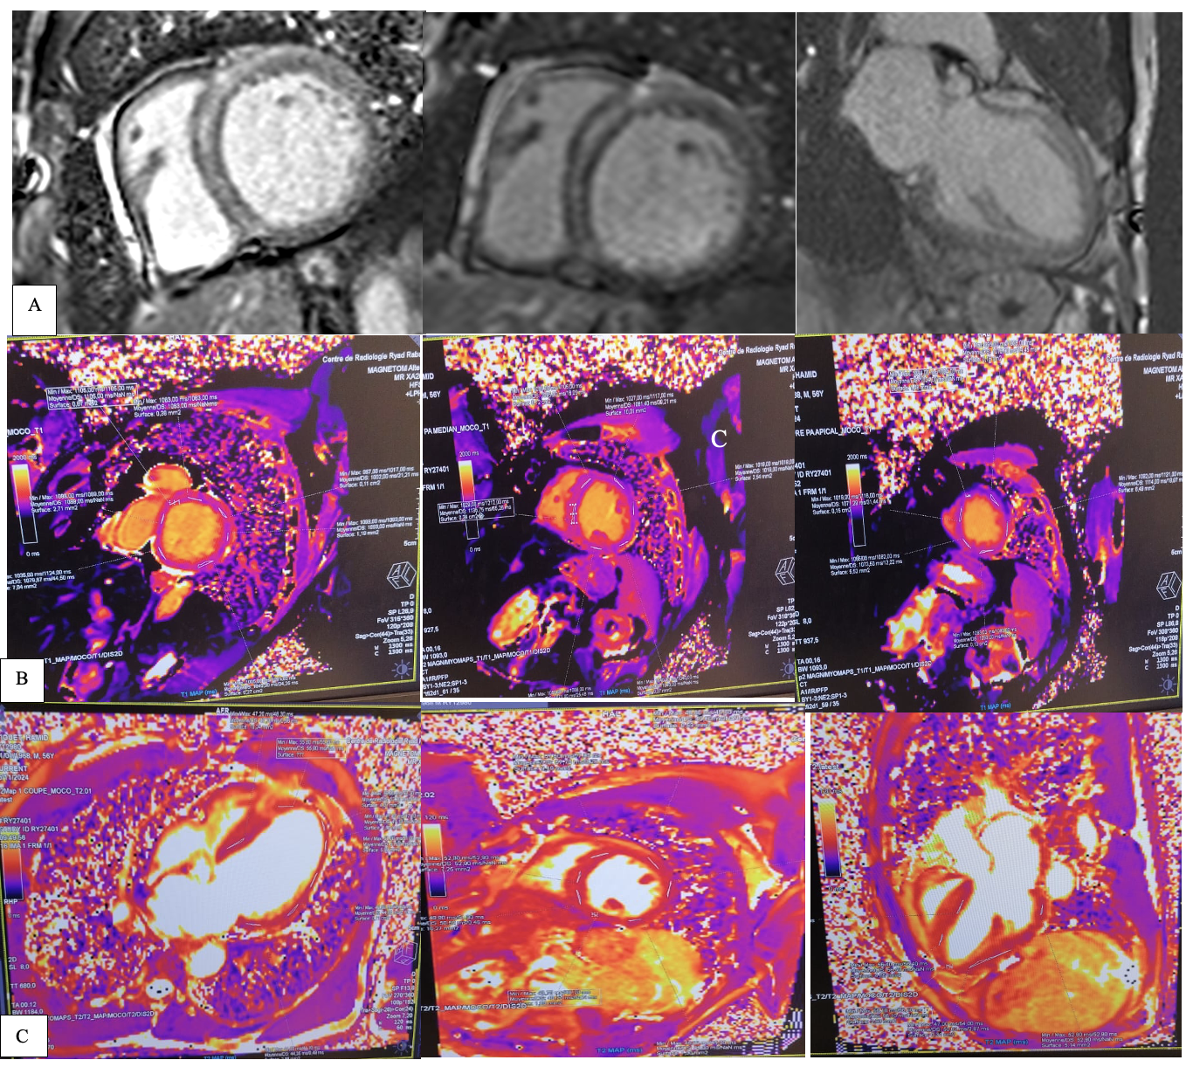 Fig.4 - Cardiac magnetic resonance imaging: A: LGE significantly delayed enhancement of the LV basal to mid anterior wall and interventricular septum B: Cardiac MRI demonstrates prolonged T1 mapping values (> 1050 ms), consistent with the presence of late gadolinium enhancement. C : Cardiac MRI showing normal native T2 mapping values, indicating the absence of myocardial edema.

For the etiological workup and to rule out differential diagnoses, measurement of angiotensin-converting enzyme levels, phosphocalcic assessment, salivary gland biopsy, and thoracic CT scan were conducted, all showing no evidence of sarcoidosis.

Although genetic testing plays a key role in the diagnosis of ALVC, it remains largely inaccessible in our country.

Lastly, and from a rhythmic standpoint, an initial 24-hour ECG monitoring showed ventricular hyperexcitability, with two non-sustained episodes of ventricular tachycardia (VT) and multiple premature ventricular contractions (PVC) with a PVC burden of 22%. Supraventricular hyperexcitability was also noted, with multiple episodes of supraventricular tachycardia (SVT). One month later, while on amiodarone therapy, the follow-up Holter monitor demonstrated a reduction in the burden of PVCs (1.3% over 36 hours), with occasional PVC couplets but no progression to VT. Additionally, a few supraventricular extrasystoles were also recorded, with no progression to SVT. Given the high risk of sudden cardiac death (SCD), the patient subsequently underwent implantation of an ICD (Fig.5).

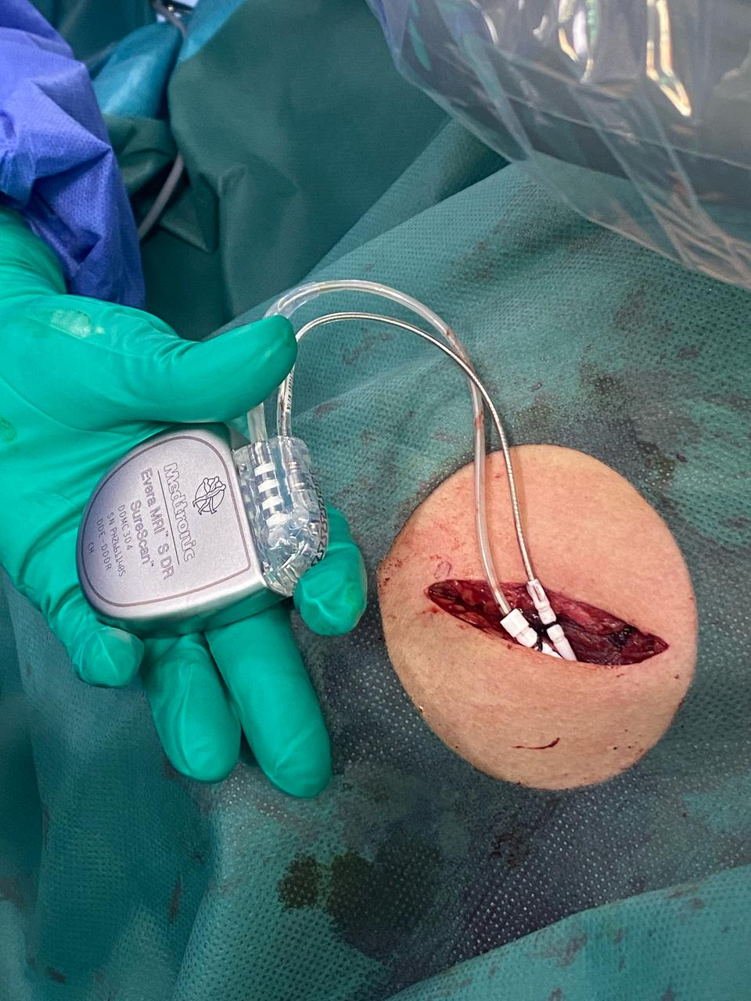
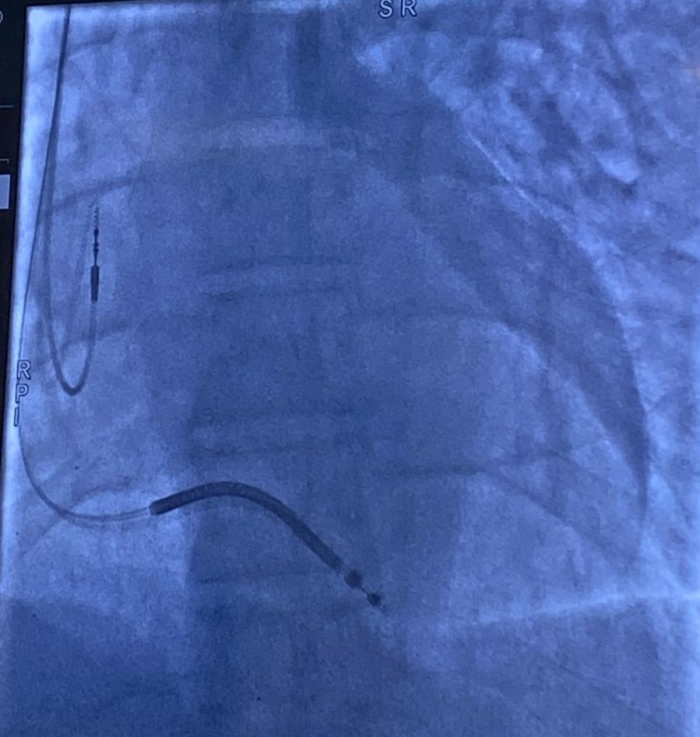

Fig.5 - A: Operative Image Demonstrating ICD Lead and Generator Positioning, B: Fluoroscopy of Defibrillator Electrode Placement

Discussion

Arrhythmogenic cardiomyopathy (ACM) affects approximately 1 in every 2,000 to 5,000 individuals [2], although the true prevalence of arrhythmogenic left ventricular cardiomyopathy (ALVC) is likely underestimated due to diagnostic challenges and limited genetic testing access. The clinical significance is evident from postmortem studies revealing ACM in up to 20% of sudden cardiac deaths among young individuals [7] and accounting for 10-15% of sudden deaths in athletes[8]. In isolated ALVC, lesions predominantly affect the posterior basal (68% of cases), anterolateral (58%), inferior, and inferolateral regions of the left ventricle [9], which is consistent with our patient's findings. The characteristic non-ischemic late gadolinium enhancement (LGE) pattern typically involves subepicardial layers while preserving subendocardial regions, thereby maintaining global LV systolic function. However, our patient demonstrated compromised function due to mid-myocardial involvement, highlighting the inadequacy of assessments based solely on global LV function [10].

ACM results from pathogenic mutations in genes encoding intercellular junction structural proteins [11], primarily cardiac desmosomal proteins including desmoplakin (DSP), plakophilin (PKP2), desmoglein (DSG2), and desmocollin (DSC2). Mutations in DSP, phospholamban (PLN), and filamin C (FLNC) are most frequently associated with left-sided forms [12]. The 2020 international consensus established "Padua criteria" for diagnosis (Table 1)[5]. However, in isolated LV forms, a definitive diagnosis requires either pathogenic ACM-related gene mutations or a positive family history, due to significant phenotypic overlap with conditions such as dilated cardiomyopathy, myocarditis, and sarcoidosis [13,14]. In this context, multimodal imaging, particularly cardiac MRI combined with global longitudinal strain, enhances diagnostic accuracy [15].

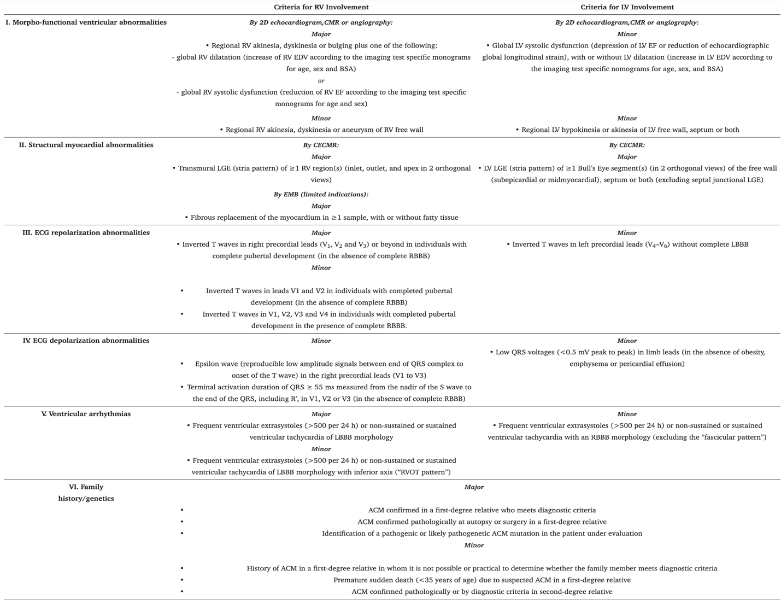
Table 1 : The ‘Padua criteria’ for diagnosis of arrhythmogenic cardiomyopathy [5].

Cardiac MRI plays a pivotal role in distinguishing ALVC from dilated cardiomyopathy, primarily through characteristic imaging patterns. ALVC typically demonstrates subepicardial inferolateral late gadolinium enhancement (LGE), whereas dilated cardiomyopathy more commonly presents with mid-septal LGE. Additionally, the extent of fibrosis in ALVC is more pronounced and directly correlates with left ventricular systolic dysfunction [16], a feature that was also observed in our patient. Furthermore, the "hypokinetic, non-dilated LV cardiomyopathy" variant, although classified as dilated cardiomyopathy, may more closely resemble ALVC due to its unique pattern of non-transmural scarring [17].
Cardiac sarcoidosis can similarly mimic ALVC through myocardial fibrosis and ventricular dysfunction; however, it more frequently involves infrahisian conduction abnormalities [18]. While biopsy remains the gold standard for diagnosis, cardiac MRI [19] and FDG-PET imaging [20] are increasingly used to detect basal septal enhancement and focal inflammatory uptake. Another notable differential diagnosis is isolated left ventricular scarring, often resulting from prior myocarditis. This highlights the crucial need for a comprehensive evaluation, including family history, clinical assessment, and genetic testing, to accurately distinguish it from ALVC [21,22].
In our setting, limited access to genetic testing means that ALVC diagnosis relies mainly on clinical, ECG, and imaging findings, despite the crucial role of genetics in confirmation and risk stratification. This underscores the need for thorough clinical evaluation and close follow-up, while emphasizing the importance of expanding genetic testing to improve diagnostic accuracy and personalized care.
Risk stratification focuses on arrhythmic severity and the extent of fibrofatty replacement, with independent predictors including a history of cardiac arrest, unstable ventricular tachycardia, younger age, and LV involvement with reduced ejection fraction [23]. Left-dominant variants demonstrate poorer outcomes compared to isolated right ventricular disease [24,25]. Management includes exercise restriction [26], antiarrhythmic therapy, and standard heart failure treatment for advanced cases [27].
ICD therapy remains a key strategy for preventing sudden cardiac death in patients with ALVC, [23,27].The 2015 Task Force consensus outlines a risk-based approach for ICD indication, stratifying patients into high-, moderate-, and low-risk categories [27]. ICD implantation is recommended with Class I indication for prior cardiac arrest, unstable ventricular tachycardia, or severe biventricular dysfunction (RV EF ≤ 35% and/or LV EF ≤ 35%). Based on these criteria, our patient is considered at high risk and met the indication for ICD implantation, which was subsequently performed.
Catheter ablation via epicardial approach can address scar-related VT [28], while heart transplantation remains the final option for end-stage disease [28].
Unlike dilated cardiomyopathy, where risk is primarily linked to impaired contractility, the development of malignant arrhythmias in ALVC is closely tied to extensive myocardial fibrosis, which acts as a potent arrhythmogenic substrate regardless of LV systolic function [10,29]. In our patient, device interrogation revealed that shocks had been appropriately delivered in response to detected arrhythmias.
Conclusion:
The primary takeaway lessons from this case report are the diagnostic complexity of ALVC and the need to maintain high clinical suspicion in patients with ventricular arrhythmias and left ventricular dysfunction. Despite the absence of genetic confirmation, our patient's presentation with characteristic subepicardial late gadolinium enhancement (LGE) on CMR and systematic exclusion of differential diagnoses supported the ALVC diagnosis.
The case highlights three key clinical points: the necessity of multimodal imaging including CMR for accurate diagnosis, the importance of excluding phenotypically similar conditions such as sarcoidosis and dilated cardiomyopathy, and the critical role of risk stratification in guiding ICD implantation. In resource-limited settings where genetic testing remains inaccessible, clinicians must rely on comprehensive clinical assessment and advanced imaging to establish diagnosis and implement appropriate management strategies.
Increased awareness of ALVC as a distinct phenotypic variant of arrhythmogenic cardiomyopathy is crucial for early recognition, appropriate risk stratification, and optimal patient outcomes.
References
C
C
B
A
B
A
[1] D. Corrado, C. Basso, and D. P. Judge, “Arrhythmogenic cardiomyopathy” Circ Res, vol. 121, no. 7, pp. 785–802, Sep. 2017, doi: 10.1161/CIRCRESAHA.117.309345
[2] A. W. G. J. Oomen, C. Semsarian, R. Puranik, and R. W. Sy, “Diagnosis of Arrhythmogenic Right Ventricular Cardiomyopathy: Progress and Pitfalls” Heart Lung Circ, vol. 27, no. 11, pp. 1310–1317, Nov. 2018, doi: 10.1016/j.hlc.2018.03.023
[3] C. Miles et al., “Sudden Death and Left Ventricular Involvement in Arrhythmogenic Cardiomyopathy” Circulation, vol. 139, no. 15, p. 1786, Apr. 2019, doi: 10.1161/CIRCULATIONAHA.118.037230
[4] D. Corrado et al., “Arrhythmogenic right ventricular cardiomyopathy: evaluation of the current diagnostic criteria and differential diagnosis” Eur Heart J, vol. 41, no. 14, p. 1414, Apr. 2019, doi: 10.1093/eurheartj/ehz669
[5] D. Corrado et al., “Diagnosis of arrhythmogenic cardiomyopathy: The Padua criteria” Int J Cardiol, vol. 319, pp. 106–114, 2020, doi: 10.1016/j.ijcard.2020.06.005
[6] D. S. Riley et al., “CARE guidelines for case reports: explanation and elaboration document” J Clin Epidemiol, vol. 89, pp. 218–235, Sep. 2017, doi: 10.1016/j.jclinepi.2017.04.026
[7] G. Thiene, A. Nava, D. Corrado, L. Rossi, and N. Pennelli, “Right Ventricular Cardiomyopathy and Sudden Death in Young People” New England Journal of Medicine, vol. 318, no. 3, pp. 129–133, Jan. 1988, doi: 10.1056/NEJM198801213180301
[8] B. J. Maron, T. S. Haas, A. Ahluwalia, C. J. Murphy, and R. F. Garberich, “Demographics and Epidemiology of Sudden Deaths in Young Competitive Athletes: From the United States National Registry” American Journal of Medicine, vol. 129, no. 11, pp. 1170–1177, Nov. 2016, doi: 10.1016/j.amjmed.2016.02.031
[9] D. Corrado et al., “Spectrum of Clinicopathologic Manifestations of Arrhythmogenic Right Ventricular Cardiomyopathy/Dysplasia: A Multicenter Study” J Am Coll Cardiol, vol. 30, no. 6, pp. 1512–1520, Nov. 1997, doi : 10.1016/s0735-1097(97)00332-x
[10] A. Cipriani et al., “Arrhythmogenic Right Ventricular Cardiomyopathy: Characterization of Left Ventricular Phenotype and Differential Diagnosis With Dilated Cardiomyopathy” Journal of the American Heart Association: Cardiovascular and Cerebrovascular Disease, vol. 9, no. 5, p. e014628, 2020, doi: 10.1161/JAHA.119.014628
[11] A. Zorzi et al., “Nonischemic Left Ventricular Scar as a Substrate of Life-Threatening Ventricular Arrhythmias and Sudden Cardiac Death in Competitive Athletes” Circ Arrhythm Electrophysiol, vol. 9, no. 7, p. e004229, Jul. 2016, doi: 10.1161/CIRCEP.116.004229
[12] J. B. Augusto et al.“Dilated cardiomyopathy and arrhythmogenic left ventricular cardiomyopathy: a comprehensive genotype-imaging phenotype study” Eur Heart J Cardiovasc Imaging, vol. 21, no. 3, pp. 326–336, Mar. 2020, doi: 10.1093/ehjci/jez188
[13] D. Corrado, C. Basso, and G. Thiene, “Arrhythmogenic right ventricular cardiomyopathy: diagnosis, prognosis, and treatment” Heart, vol. 83, no. 5, pp. 588–595, May 2000, doi: 10.1136/heart.83.5.588
[14] D. Corrado and C. Basso, “Arrhythmogenic left ventricular cardiomyopathy” Heart, vol. 108, no. 9, pp. 733–743, May 2022, doi: 10.1136/heartjnl-2020-316944
[15] Ø. H. Lie et al., “Left Ventricular Dysfunction in Arrhythmogenic Cardiomyopathy: Association With Exercise Exposure, Genetic Basis, and Prognosis” Journal of the American Heart Association: Cardiovascular and Cerebrovascular Disease, vol. 10, no. 8, p. e018680, Apr. 2021, doi: 10.1161/JAHA.120.018680
[16] D. Segura-Rodríguez et al., “Myocardial fibrosis in arrhythmogenic cardiomyopathy: A genotype-phenotype correlation study” Eur Heart J Cardiovasc Imaging, vol. 21, no. 4, pp. 378–386, Apr. 2020, doi: 10.1093/ehjci/jez277
[17] Y. M. Pinto et al., “Proposal for a revised definition of dilated cardiomyopathy, hypokinetic non-dilated cardiomyopathy, and its implications for clinical practice: A position statement of the ESC working group on myocardial and pericardial diseases” Eur Heart J, vol. 37, no. 23, pp. 1850–1858, Jun. 2016, doi: 10.1093/eurheartj/ehv727
[18] B. Philips et al., “Arrhythmogenic right ventricular dysplasia/ cardiomyopathy and cardiac sarcoidosis distinguishing features when the diagnosis is unclear” Circ Arrhythm Electrophysiol, vol. 7, no. 2, pp. 230–236, 2014, doi: 10.1161/CIRCEP.113.000932
[19] D. A. Steckman et al., “Utility of cardiac magnetic resonance imaging to differentiate cardiac sarcoidosis from arrhythmogenic right ventricular cardiomyopathy” American Journal of Cardiology, vol. 110, no. 4, pp. 575–579, Aug. 2012, doi: 10.1016/j.amjcard.2012.04.029
[20] W. K. Choo, A. R. Denison, D. R. Miller, O. J. Dempsey, D. K. Dawson, and P. A. Broadhurst, “Cardiac sarcoid or arrhythmogenic right ventricular cardiomyopathy: A role for positron emission tomography (PET)?” Journal of Nuclear Cardiology, vol. 20, no. 3, pp. 479–480, Jun. 2013, doi: 10.5582/irdr.2015.01023
[21] A. Zorzi et al., “Phenotypic expression is a prerequisite for malignant arrhythmic events and sudden cardiac death in arrhythmogenic right ventricular cardiomyopathy” EP Europace, vol. 18, no. 7, pp. 1086–1094, Jul. 2016, doi: 10.1093/europace/euv205

[22] R. Vio, A. Zorzi, and D. Corrado, “Myocarditis in the Athlete: Arrhythmogenic Substrates, Clinical Manifestations, Management, and Eligibility Decisions” J Cardiovasc Transl Res, vol. 13, no. 3, pp. 284–295, Jun. 2020, doi: 10.1007/s12265-020-09996-1
[23] D. Corrado et al., “Implantable Cardioverter-Defibrillator Therapy for Prevention of Sudden Death in Patients with Arrhythmogenic Right Ventricular Cardiomyopathy/Dysplasia” Circulation, vol. 108, no. 25, pp. 3084–3091, Dec. 2003, doi: 10.1161/01.CIR.0000103130.33451.D2
[24] G. D. Aquaro et al., “Prognostic Value of Magnetic Resonance Phenotype in Patients With Arrhythmogenic Right Ventricular Cardiomyopathy” J Am Coll Cardiol, vol. 75, no. 22, pp. 2753–2765, Jun. 2020, doi: 10.1016/j.jacc.2020.04.023
[25] Ø. H. Lie et al., “Prediction of Life-Threatening Ventricular Arrhythmia in Patients With Arrhythmogenic Cardiomyopathy: A Primary Prevention Cohort Study” JACC Cardiovasc Imaging, vol. 11, no. 10, pp. 1377–1386, Oct. 2018, doi: 10.1016/j.jcmg.2018.05.017
[26] A. Gasperetti, C. A. James, M. Cerrone, M. Delmar, H. Calkins, and F. Duru, “Arrhythmogenic right ventricular cardiomyopathy and sports activity: from molecular pathways in diseased hearts to new insights into the athletic heart mimicry” Eur Heart J, vol. 42, no. 13, pp. 1231–1243, Mar. 2021, doi: 10.1093/eurheartj/ehaa821
[27] D. Corrado et al., “Treatment of arrhythmogenic right ventricular cardiomyopathy/dysplasia: an international task force consensus statement” Eur Heart J, vol. 36, no. 46, pp. 3227–3237, Dec. 2015, doi: 10.1093/eurheartj/ehv162
[28] F. Migliore et al., “Subcutaneous implantable cardioverter defibrillator in patients with arrhythmogenic right ventricular cardiomyopathy: Results from an Italian multicenter registry” Int J Cardiol, vol. 280, pp. 74–79, Apr. 2019, doi: 10.1016/j.ijcard.2019.01.041
- [29] E. D. Smith et al., “Desmoplakin Cardiomyopathy, a Fibrotic and Inflammatory Form of Cardiomyopathy Distinct from Typical Dilated or Arrhythmogenic Right Ventricular Cardiomyopathy” Circulation, vol. 141, no. 23, pp. 1872–1884, Jun. 2020, doi: 10.1161/CIRCULATIONAHA.119.044934

