Case report
The Hidden Risk in Calot’s Triangle: Moynihan’s Hump Encountered During Laparoscopic Cholecystectomy-A Case Report

Abstract:
Moynihan’s or caterpillar hump is a rare variation of the right hepatic artery (RHA), where it courses tortuously near the gallbladder, often with a short cystic artery. This increases the risk of vascular injury during cholecystectomy. We report a case where Moynihan’s hump was identified intraoperatively and managed safely. This case highlights the need for vigilance and careful dissection in the Calot’s triangle.
Key words: Moynihan’s hump, Caterpillar hump, Right Hepatic Artery, Laparoscopic Cholecystectomy

Introduction:
Anatomical variations in Calot’s triangle are prevalent and constitute a significant factor in iatrogenic injuries during laparoscopic cholecystectomy, the most commonly performed hepatobiliary surgery globally[1]. One of these variations is Moynihan's hump, which is also called the caterpillar hump. It is a rare and clinically important problem with the right hepatic artery (RHA). In this variation, the RHA takes a winding, often exaggerated path close to the gallbladder. This is often linked to a short cystic artery[2,3]. The incidence of this anomaly is reported to be between 1.3% and 13.3%, but having it makes it much more likely that you will accidentally hurt a blood vessel, bleed, or have ischemic complications while dissecting Calot's triangle[4]. It is difficult to see Moynihan's hump before surgery because standard imaging techniques don't always show arterial variations clearly. Consequently, surgeons must depend on precise intraoperative dissection, comprehensive understanding of anatomical variations, and rigorous compliance with the principles of safe cholecystectomy, including the attainment of the critical view of safety[1,4].
We present this case to emphasize the intraoperative recognition and secure management of Moynihan’s hump during laparoscopic cholecystectomy. The case emphasizes the necessity of vigilance, meticulous dissection, and anatomical awareness to avert potentially disastrous vascular injuries, particularly in emergency or interval cholecystectomy contexts.

Case Presentation:
A patient in her late 40s was admitted to the emergency department with a 2-day history of acute right upper quadrant abdominal pain, fever, and associated non-bilious vomiting. On abdominal examination, there was marked tenderness in the right upper quadrant without any palpable lump. Laboratory investigations revealed marked leukocytosis (21,500 cells/cu mm). A blood culture was sent, and ultrasonography of the abdomen was suggestive of acute calculous cholecystitis.

The patient was initially resuscitated with intravenous fluids, analgesics, and empirical antibiotics. Based on the blood culture, which grew Escherichia coli after 72 hours, the antibiotic was escalated to intravenous meropenem. The patient was discharged 48 hours after intravenous antibiotic therapy, following resolution of abdominal pain, and was started on an oral diet. Six weeks later, the patient underwent laparoscopic cholecystectomy. Intraoperatively, during dissection of Calot’s triangle, a large pulsatile artery running parallel to the cystic duct was identified (Figure 1A, 1B). Further careful dissection confirmed a small cystic artery arising from the right hepatic artery, which was separately clipped and divided (Figure 2). The laparoscopic cholecystectomy was completed without injury to the right hepatic artery. The postoperative course was uneventful, and the patient was discharged the next morning. She remains well at 2-month follow-up.

Discussion:
Moynihan’s hump, also known as the caterpillar hump, is an anatomical variation of the right hepatic artery (RHA), with a reported incidence ranging from 1.3% to 13.3%. A recent meta-analysis estimates the incidence to be approximately 1.3% [5,6].Overall, anatomical variations in the hepatobiliary triangle, involving the cystic artery and biliary tree, are seen in 20% to 50% of individuals[1,6].
This variation arises when the RHA takes a tortuous course, looping either superiorly or inferiorly before giving off a small cystic artery to supply the gallbladder. This loop, resembling the shape of a caterpillar, gives the variation its name. The loop may appear as a single or double curve. When the cystic artery originates from the proximal part of the loop, it has a longer course. More commonly, as in our case, the cystic artery arises from the distal loop and follows a shorter course [2–4].
The primary surgical concern with Moynihan’s hump is the potential for vascular injury during laparoscopic cholecystectomy. This may necessitate conversion to open surgery in up to 1.9% of cases. Although mortality is low (approximately 0.02%), injury to the RHA can lead to right lobe hepatic ischemia, pseudoaneurysm formation, or significant hemorrhage that obscures the operative field [1].
To reduce these risks, adherence to the principles of “safe cholecystectomy” is essential. This includes achieving the “critical view of safety” (CVS), dissecting the lower one-third of the gallbladder from the cystic plate, and ensuring only the cystic artery and cystic duct are entering the gallbladder before clipping. Proper anatomical knowledge, clear exposure, and dissection close to the gallbladder wall are crucial [4].
Conclusions:
In conclusion, recognition of Moynihan’s hump is critical during laparoscopic cholecystectomy to prevent vascular injury. A large pulsatile artery in Calot’s triangle should raise suspicion for a tortuous right hepatic artery, and safe dissection with confirmation of the critical view of safety is essential to avoid complications and ensure a successful surgical outcome.

Ethics: Informed consent was obtained from the patient during the routine preoperative process for participation in research, including specific permission for the use of clinical details and images in a case report/publication

References:
1. Martín Pérez JA, Domínguez Rodríguez JA, De Alba Cruz I, Lara Valdés AJ, Sánchez Baltazar AL, Perna Lozada L. Moynihan’s Lump as an unusual variant of right hepatic artery during a laparoscopic cholecystectomy approach. A case report. International Journal of Surgery Case Reports. 2021 Aug;85:106221.
2. Rahate P, Haidar Z, Bangde A, Belsare A, Golchha V, Yadav K. Anatomical classification of catterpillar hump of RHA and its surgical importance (Nagpur classification).
3. Kavitha Kamath B. An anatomical study of Moynihan’s hump of right hepatic artery and its surgical importance. Journal of the Anatomical Society of India. 2016 Aug;65:S65–7.
4. Raghuwanshi DS, Ram M, Khan S, Anand K. Moynihan’s Hump: Our Eyes See What Our Mind Knows. Indian J Surg. 2021 Aug;83(4):1077–8.
5. Dandekar U, Dandekar K, Chavan S. Right Hepatic Artery: A Cadaver Investigation and Its Clinical Significance. Anatomy Research International. 2015 Dec 16;2015:1–6.
6. Marano L, Bartoli A, Polom K, Bellochi R, Spaziani A, Castagnoli G. The unwanted third wheel in the Calot’s triangle: Incidence and surgical significance of caterpillar hump of right hepatic artery with a systematic review of the literature. J Min Access Surg. 2019;15(3):185.

Figure 1: (A) Intraoperative image showing a short cystic artery originating from the right hepatic artery (RHA), forming a Moynihan’s hump within Calot’s triangle. (B) Schematic diagram illustrating Moynihan’s hump with a short cystic artery running parallel to the cystic duct.
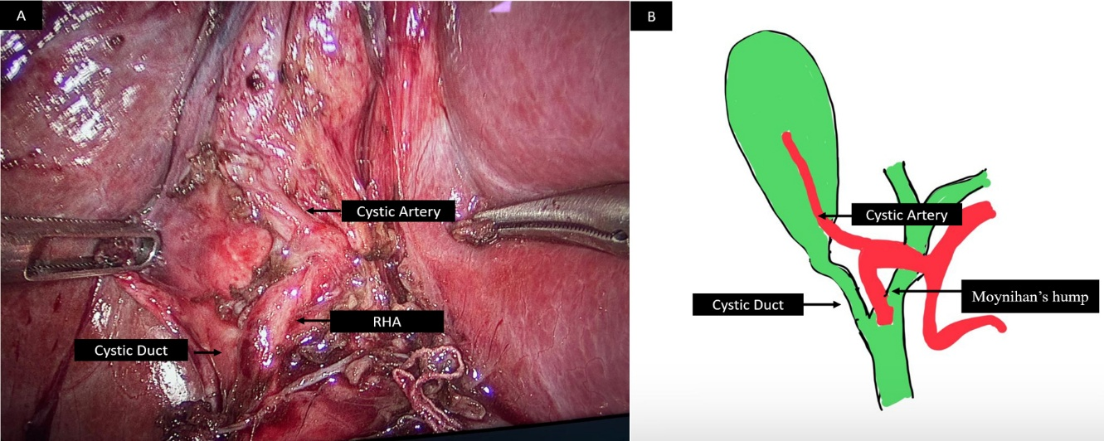

Figure 2: Clipping of the short cystic artery.
