Case report
PRIMARY SMALL BOWEL STONE (PRIMARY ENTEROLITH) IN A PATIENT WITH STRICTURING ILEAL CROHN’S DISEASE : A CASE REPORT

ABSTRACT
Introduction/aim of the work:
Intestinal stricture is a common complication of Crohn's disease, occurring in up to 50% of patients. It typically presents with manifestations of intestinal obstruction. A rare complication of such strictures is the formation of primary enteroliths (stones formed within the gastrointestinal tract), due to intestinal stasis. This aim of this report is to describe a case of a primary enterolith in a patient with stricturing ileal Crohn's disease.
Case presentation:
A 35-year-old male presented with symptoms of chronic intestinal obstruction (IO). His surgical history was significant for an exploratory laparotomy with small bowel resection for IO in 2004. The clinical diagnosis of an ileal stricture with an associated enterolith was radiologically confirmed by computed tomography (CT) and later verified by pathological and chemical analysis of the surgical specimen. Following nutritional optimization, the patient underwent successful abdominal exploration which included both stricturoplasty and resection with primary anastomosis of the affected bowel segment.
Conclusion:
This case report presents a rare complication of a common condition, underscores the utility of CT in its diagnosis, highlights the importance of nutritional management and provides the details of surgical intervention and its outcomes.
Keywords
Crohn’s disease, Small bowel stricture, Chronic intestinal obstruction, Primary enterolith
INTRODUCTION
Crohn’s disease (CD) is a chronic, relapsing inflammatory bowel disease (IBD) categorized into inflammatory, structuring, and penetrating [1]. While up to 80% of patients initially present with inflammatory behavior, 5%–28% present with stricturing disease [2-4]. Over a lifetime, nearly 50% of CD patients will develop a stricture [5].
The pathogenesis of CD stricture involves chronic inflammation that drives excessive deposition of extracellular matrix components, and smooth muscle hyperplasia. This leads to transmural thickening, culminating in fibrosis and stricture formation [6]. These pathological changes are primarily mediated by the cytokine transforming growth factor-β1 [7].
Strictures are distinguished as de novo or anastomotic. While de novo strictures involve the terminal ileum mainly, anastomotic strictures typically form at the ileocolonic anastomosis [8]. Predictors of de novo stricture development include disease severity, duration, small bowel involvement, and smoking [5, 9]. Following surgical resection for a stricture, patients have a 46% risk of stricture recurrence [10].
Given the high risk of intestinal obstruction (IO) in patients with CD-associated strictures, surgery is required in 24%–40% of cases, making IO the primary indication for operative intervention [11]. Furthermore, approximately one-quarter of CD patients who undergo surgery will require a second operation within five years of the first [12]. The risk of short bowel syndrome from multiple resections can be mitigated with bowel-saving approaches, notably endoscopic balloon dilation and stricturoplasty. [13].
Enterolithiasis, or the formation of stones within the gastrointestinal tract (GIT), is a rare clinical entity. Primary enteroliths develop in segments of intestinal stasis caused by conditions such as surgical anastomoses, or strictures from IBDs. Patients often present with non-specific symptoms like abdominal pain, nausea, and vomiting, which are attributable to the enterolith or the underlying pathology [14].
This article reports a case of primary enterolithiasis secondary to stricturing ileal CD, illustrating a rare complication of a common disease. It has been presented in line with the SCARE criteria.
CASE PRESENTATION
History
A 35-year-old male, with a smoking history of 20 pack-years, presented to the surgical outpatient clinic for evaluation of chronic abdominal symptoms. His surgical history was significant for an exploratory laparotomy with small bowel resection for IO in 2004; however, details of that procedure and the pathology of the resected bowel were unavailable.
For the past 20 years, since his surgery, the patient has been complaining of intermittent colicky abdominal pain, occasional vomiting, and chronic constipation alternating with diarrhea, without significant weight loss. Concurrently, he has received treatment for iron deficiency anemia, consisting of repeated intravenous (IV) iron therapy and approximately 4-6 units of packed red blood cell transfusions per year.
Physical examination
The patient’s weight was 52 kg, height 160 cm, and body mass index was 20.3 kg/m². On examination, his vital signs were normal. Abdominal examination revealed a well-healed scar of a right paramedian incision. There was no guarding, tenderness, or palpable masses.
Laboratory data
Pertinent abnormal laboratory findings included iron deficiency anemia (hemoglobin 6.0 g/dL), with low serum iron (50 µg/dL) and elevated transferrin (450 mg/dL). Additional findings were hypocalcemia (total calcium 8.1 mg/dL, ionized calcium 4.2 mg/dL), hypomagnesemia (1.5 mg/dL), and hypoalbuminemia (2.9 g/dL).
Imaging data
Plain abdominal radiographs showed several dilated small bowel loops, without evidence of pneumoperitoneum or air-fluid levels. A contrast-enhanced CT (CECT) scan of the abdomen and pelvis revealed multiple dilated, fluid and gas-filled small intestinal loops with a clear transition zone in the distal ileum where an intraluminal, well-defined, oblong high-attenuation focus was seen. The focus demonstrated radiopaque attenuation with peripheral lamellation and a mottled internal gas pattern, consistent with an intraluminal calcified/enterolith. Immediately proximal to the transition point, several ileal loops contained heterogeneous intraluminal material with gas interstices producing a “small intestinal feces sign” appearance. The obstructed segment exhibited circumferential mural thickening and stratified mural enhancement, with adjacent mild mesenteric edema and prominent vasa recta (“Comb sign”) [Fig 1].
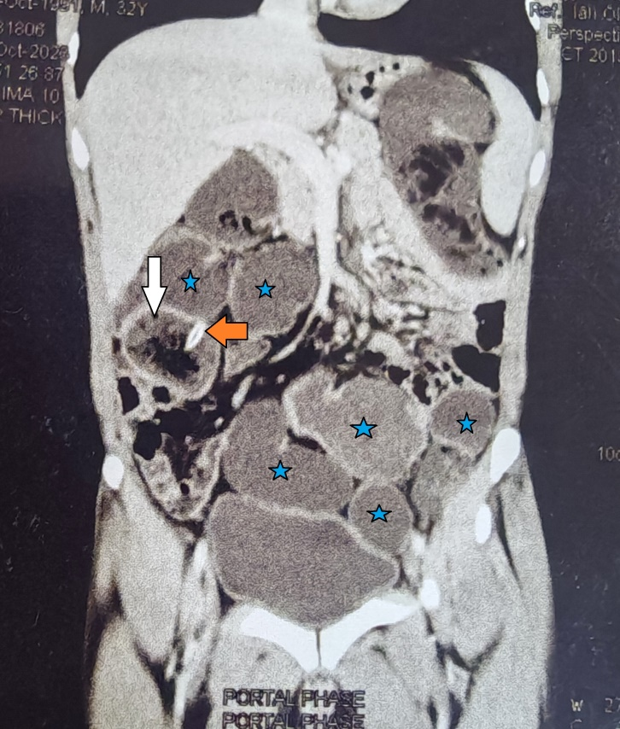
Fig [1]: Coronal CECT abdomen
Management and Decision Making
Based on the clinical and radiological findings, a decision was made to proceed with surgical exploration after optimizing the patient's nutritional and metabolic status. He was referred to the clinical nutrition service and placed on a high-protein, high-carbohydrate, low-fat, and low-fiber diet. This was supplemented with a protein-rich nutritional formula and micronutrients. To correct his anemia, he received IV iron and 6 units of packed red blood cells. After 8 weeks of preoperative optimization, repeat laboratory investigations confirmed the successful correction of all deficiencies.
Operative Findings and Postoperative Course
An exploratory laparotomy was performed through the scar of the previous paramedian incision. There were extensive intra-abdominal adhesions involving the entire small bowel, as well as the ascending, transverse, and sigmoid colons. The total small bowel length was approximately 370 cm.
Adhesions in the distal ileum were dense, thick, and formed an amalgamated mass involving multiple ileal loops, the cecum, ascending colon, and the mesenteric root. This amalgamated tissue contained multiple strictures with intervening areas of dilatation. One annular stricture contained silk sutures of previous anastomosis. A hard, oblong, regular enterolith measuring 6x2 cm was palpated within one of the dilated segments [Fig 2].
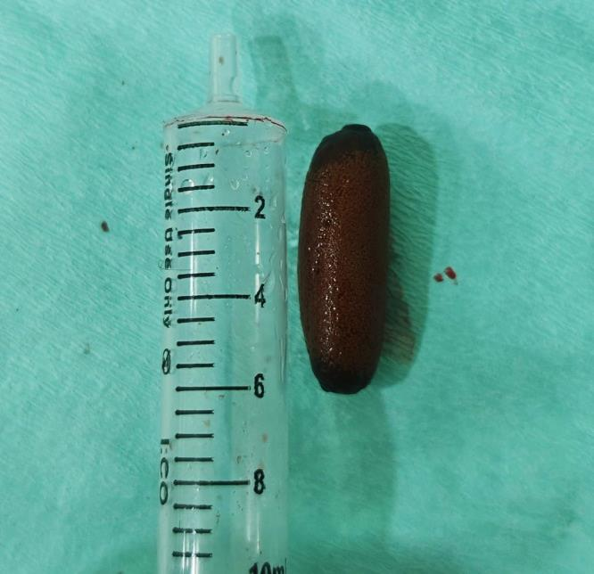
Fig [2]: The retrieved enterolith
The most distal 20 cm of the ileum was dissected free and preserved. However, the 50-cm segment just proximal to it was resected, as it contained multiple strictures and had sustained several enterotomies during adhesiolysis. A primary end-to-end anastomosis was performed and two seromuscular tears in the ascending and transverse colon were repaired. A short jejunal stricture 14 cm from the duodenojejunal flexure was managed with stricturoplasty. The remaining small bowel measured 320 cm long. The operative time was 280 minutes.
The postoperative course was uneventful. The patient resumed oral fluids on postoperative day (POD) 1, and semi-solid diet on POD 2. Bowel motion returned on POD 2, and the abdominal drain was removed on POD 3. All laboratory parameters remained within normal limits, and the PO hospital length of stay (LOS) was 4.
Starting from POD 5, the patient developed diarrhea, with 4-5 loose stools per day. After pathological confirmation of the diagnosis of CD, medical therapy was initiated, consisting of Mesalamine (400 mg every 6 hours), Prednisolone (20 mg every 12 hours), Pantoprazole (40 mg every 24 hours), and Ciprofloxacin/Metronidazole (500/500 mg every 12 hours), to which the patient responded well.
Pathological Findings
Gross examination of the resected bowel revealed a 50 cm long amalgamated bowel loops with multiple strictures separated by areas of intervening dilatation. The mucosal surface appeared grossly normal; however, the bowel wall was notably thickened and fibrotic. The mesentery thickened with multiple enlarged mesenteric lymph nodes. Microscopic examination demonstrated areas of focal deep ulcerations, dense mucosal inflammation, and pseudopyloric metaplasia. The submucosa showed hypertrophy of the muscularis mucosae, large non-caseating granulomas, with multiple multinucleated giant cells and lymphoid follicles. The inflammatory and fibrotic process involved all layers of the bowel wall. The mesenteric lymph nodes exhibited reactive changes. The pathological diagnosis was chronic stricturing ileal CD [Fig 3-5]. Chemical analysis of the intraluminal stone identified it as a primary enterolith, composed predominantly of calcium oxalate, uric acid, with traces of bile pigment and organic material.
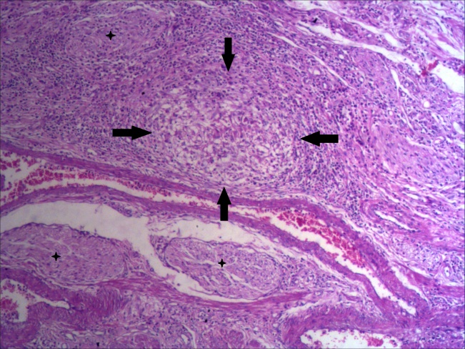
Fig [3]: Photomicrograph showing submucosa with a defined epithelioid granuloma [arrows] and neural hypertrophy [asterisk], with many eosinophils in the background infiltrate (H&E, X100)

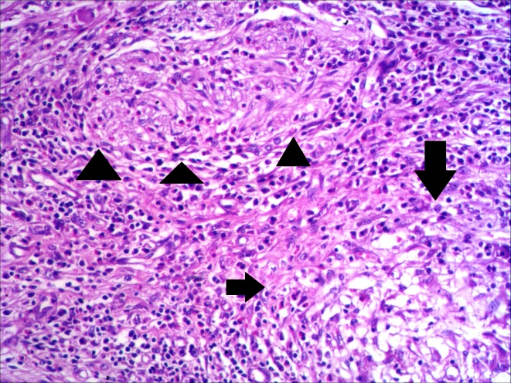
Fig [4]: Higher power photomicrograph from photomicrograph [3, A], of the granuloma [arrows] and neural hypertrophy [arrow heads] (H&E, X250)

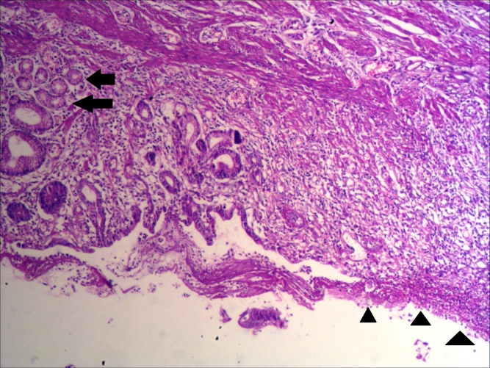
Fig [5]: Photomicrograph showing ulceration [arrow heads] with adjacent pseudopyloric metaplasia [arrow], a characteristic finding in chronic Crohn's disease (H&E, X100)

DISCUSSION
Enterolithiasis is a rare clinical entity, with only approximately 100 cases reported in the literature until 2014 [14], 30 of which were associated with CD [15]. The true incidence remains unknown and is likely higher than reported, since many cases are unrecognized due to their asymptomatic nature, the spontaneous passage of calculi, or their being undetectable on plain radiographs [16]. The first documented case of enterolithiasis was reported by Chomelin J in 1710 in the medical series of Historie de l'Académie Royale as a case of stone formation in a duodenal diverticulum discovered during an autopsy [17].
In 1947, Grettve proposed a classification of enteroliths into primary (formed within the GIT) and secondary (introduced from outside) types [16]. Primary enteroliths are typically formed in areas of stasis, including intestinal diverticulae, afferent loops in the Billroth II gastrojejunostomy and Roux-en-Y procedures, intra-abdominal adhesions, or proximal to the intestinal strictures in CD or intestinal tuberculosis. Primary enteroliths are further divided into true and false categories. True primary enteroliths consist of materials normally found in chyme, and are subdivided into two subtypes: the choleic acid and calcium stones. False primary enteroliths are formed from insoluble foreign materials found in the bowel and are divided into three subtypes: bezoars, varnish stones, and concretion of water-suspended insoluble salts (chalk, lime, barium sulfate). Mixed concretions can also be seen, such as when a false enterolith becomes externally calcified. Based on its radiological appearance and its chemical composition together with its association with chronic stricturing CD, the stone reported in the current case is classified as a mixed primary enterolith [14].
The age of presentation of enterolithiasis is largely determined by the underlying pathological condition. In one series of CD patients, the mean duration of symptoms before presenting with enterolith was 15.7 years, reflecting the increasing incidence of stricture complications over time [15]. This pattern is consistent with the history of our patient, who required surgery 20 years after the onset of symptomatic CD. Moreover, our patient had both de novo and anastomotic strictures, a finding supported by literature linking an increased risk of de novo stricture to risk factors as a history of ileal involvement, long history of the disease, smoking, and history of previous surgery. The anastomotic stricture detected in this case was also reported in up to 46% of patients with CD.
The presentation of enterolithiasis is often non-specific, but typically includes abdominal pain, nausea, and vomiting. Colicky abdominal pain, vomiting, and constipation are related to IO caused by the stricture, for which surgery is needed in 24-40% of patients [14]. These data align with the clinical presentation of our patient who presented with symptoms of chronic IO due to stricturing ileal CD.
The radiologic findings in our patient were typical of chronic small bowel obstruction (SBO) with an enterolith. The “small intestinal feces sign” describes the presence of particulate feculent material mixed with gas bubbles, resembling the colonic content, in the small intestine proximal to the transition point on CT scan. It is believed to be due to stasis in the distal small bowel, resulting in bacterial overgrowth and increased water absorption from the intestinal contents, leading to accumulation of gas bubbles and incompletely digested food. This sign is highly specific for low-grade SBO, and its recognition usually mandates surgery [18]. Again, these data align well with those in the current report.
Small bowel resection, chronic inflammation, and an ileal stricture had led to intestinal insufficiency, as defined by the European Society for Clinical Nutrition and Metabolism (ESPEN) [19], with subsequent macronutrient and multiple electrolyte deficiencies. Since major surgery in this context increases the risk of complications and the hospital LOS, ESPEN guidelines strongly recommends preoperative nutritional support [20]. The uneventful postoperative course and the short LOS in our patient can be attributed, at least partly, to this preoperative nutritional optimization, coupled with the early PO resumption of oral feeding.
The operative findings reported in this patient were highly suggestive of CD. Given this possibility and the patient’s history of previous small bowel resection, every effort was made to preserve as much small bowel as possible to prevent the development of short bowel syndrome. These efforts included stricturoplasty of the jejunal stricture, and limiting resection to the unsalvageable bowel only. Video [1]: Axial and Coronal CECT showing dilated small bowel loops, small intestinal feces sign and enterolith

CONCLUSION
Approximately 50% of patients with chronic CD will eventually develop stricture, which is the leading cause of IO mandating surgery in these patients. Furthermore, stricture-induced stasis may induce the formation of enteroliths. This case report illustrates this progression in an adult male who developed chronic SBO and a primary enterolith due to stricturing CD two decades after his initial surgery. Successful management hinges on a thorough preoperative workup to confirm the level of stricture and exclude other pathologies, coupled with careful nutritional optimization and meticulous surgical technique. Especially in patients with history of small bowel resection, stricturoplasty is strongly recommended, reserving resection to unsalvageable bowel segments only.

COMPETING CONFLICT
- The authors have declared that no competing interests exist

CONSENT
- All authors declare that ‘a written informed consent was obtained from the patient for publication of this case report and accompanying images. A copy of the written consent is available for review by the Editorial office/Chief Editor/Editorial Board members of this journal
ETHICS APPROVAL
- All authors hereby declare that all experiments have been examined and approved by the appropriate ethics committee and have therefore been performed in accordance with the ethical standards laid down in the 1964 Declaration of Helsinki.
REFERENCES
- Gasche, C., Scholmerich, J., Brynskov, J., D'Haens, G., Hanauer, S. B., Irvine, E. J., et al.. (2000). A simple classification of Crohn's disease: Report of the Working Party for the World Congresses of Gastroenterology, Vienna 1998. Inflammatory Bowel Diseases, *6*(1), 8–15. https://doi.org/10.1097/00054725-200002000-00002
- Henriksen, M., Jahnsen, J., Lygren, I., Stray, N., Sauar, J., Vatn, M. H., et al. (2007). Clinical course in Crohn’s disease: Results of a five-year population-based follow-up study (the IBSEN study). Scandinavian Journal of Gastroenterology, *42*(5), 602–610. https://doi.org/10.1080/00365520601076124
- Ramadas, A. V., Gunesh, S., Thomas, G. A., Williams, G. T., & Hawthorne, A. B. (2010). Natural history of Crohn’s disease in a population-based cohort from Cardiff (1986-2003): A study of changes in medical treatment and surgical resection rates. Gut, *59*(9), 1200–1206. https://doi.org/10.1136/gut.2009.202101
- Gower-Rousseau, C., Vasseur, F., Fumery, M., Savoye, G., Salleron, J., Dauchet, L., et al. (2013). Epidemiology of inflammatory bowel diseases: New insights from a French population-based registry (EPIMAD). Digestive and Liver Disease, *45*(2), 89–94. https://doi.org/10.1016/j.dld.2012.09.022
- Thia, K. T., Sandborn, W. J., Harmsen, W. S., Zinsmeister, A. R., & Loftus, E. V., Jr. (2010). Risk factors associated with progression to intestinal complications of Crohn's disease in a population-based cohort. Gastroenterology, *139*(4), 1147–1155. https://doi.org/10.1053/j.gastro.2010.06.070
- Rieder, F., Fiocchi, C., & Rogler, G. (2017). Mechanisms, management, and treatment of fibrosis in patients with inflammatory bowel diseases. Gastroenterology, *152*(2), 340–350. https://doi.org/10.1053/j.gastro.2016.09.047
- Bettenworth, D., & Rieder, F. (2014). Medical therapy of stricturing Crohn’s disease: What the gut can learn from other organs—a systematic review. Fibrogenesis & Tissue Repair, *7*, 5. https://doi.org/10.1186/1755-1536-7-5
- Peyrin-Biroulet, L., Loftus, E. V., Jr., Colombel, J. F., & Sandborn, W. J. (2010). The natural history of adult Crohn’s disease in population-based cohorts. The American Journal of Gastroenterology, *105*(2), 289–297. https://doi.org/10.1038/ajg.2009.579
- Lichtenstein, G. R., Olson, A., Travers, S., Diamond, R. H., Chen, D. M., Pritchard, M. L., et al. (2006). Factors associated with the development of intestinal strictures or obstructions in patients with Crohn's disease. The American Journal of Gastroenterology, *101*(5), 1030–1038. https://doi.org/10.1111/j.1572-0241.2006.00564.x
- Rutgeerts, P., Geboes, K., Vantrappen, G., Beyls, J., Kerremans, R., & Hiele, M. (1984). Natural history of recurrent Crohn's disease at the ileocolonic anastomosis after curative surgery. Gut, *25*(6), 665–672. https://doi.org/10.1136/gut.25.6.665
- Peyrin-Biroulet, L., Harmsen, W. S., Tremaine, W. J., Zinsmeister, A. R., Sandborn, W. J., & Loftus, E. V., Jr. (2012). Surgery in a population-based cohort of Crohn’s disease from Olmsted County, Minnesota (1970-2004). The American Journal of Gastroenterology, *107*(11), 1693–1701. https://doi.org/10.1038/ajg.2012.298
- Frolkis, A. D., Lipton, D. S., Fiest, K. M., Negrón, M. E., Dykeman, J., deBruyn, J., et al. (2014). Cumulative incidence of second intestinal resection in Crohn’s disease: A systematic review and meta-analysis of population-based studies. The American Journal of Gastroenterology, *109*(11), 1739–1748. https://doi.org/10.1038/ajg.2014.245
- Chan, W. P. W., Mourad, F., & Leong, R. W. (2018). Crohn's disease associated strictures. Journal of Gastroenterology and Hepatology, *33*(5), 998–1008. https://doi.org/10.1111/jgh.14106
- Gurvits, G. E., & Lan, G. (2014). Enterolithiasis. World Journal of Gastroenterology, *20*(47), 17819–17829. https://doi.org/10.3748/wjg.v20.i47.17819
- Mendes Ribeiro, H. K., & Nolan, D. J. (2000). Enterolithiasis in Crohn’s disease. Abdominal Imaging, *25*(5), 526–529. https://doi.org/10.1007/s002610000079
- Grettve, S. (1947). A contribution to the knowledge of primary true concrements in the small bowel. Acta Chirurgica Scandinavica, *95*, 387–410.
- Munnell, E. R., & Preston, W. J. (1966). Complications of duodenal diverticula. Archives of Surgery, *92*(2), 152–156. https://doi.org/10.1001/archsurg.1966.01320190094016
- Fuchsjäger, M. H. (2002). The small-bowel feces sign. Radiology, *225*(2), 378–379. https://doi.org/10.1148/radiol.2252011563
- Pironi, L., Cuerda, C., Jeppesen, P. B., Ziegler, U. E., Wanten, G., Bakhov, I., et al. (2023). ESPEN guideline on chronic intestinal failure in adults – Update 2023. Clinical Nutrition, *42*(10), 1940–2021. https://doi.org/10.1016/j.clnu.2023.07.011
- Weimann, A., Braga, M., Carli, F., Higashiguchi, T., Hübner, M., Klek, S., et al. (2021). ESPEN practical guideline: Clinical nutrition in surgery. Clinical Nutrition, *40*(7), 4745–4761. https://doi.org/10.1016/j.clnu.2021.03.031

