Case report

Transanal Specimen Extraction After Laparoscopic Sigmoidectomy for Recurrent Sigmoid Diverticulitis

Abstract
Introduction:
Natural orifice specimen extraction (NOSE) represents an evolution in minimally invasive colorectal surgery by enabling removal of the surgical specimen through natural orifices, avoiding an abdominal extraction incision. This may reduce postoperative pain, wound complications and incisional hernia compared with conventional laparoscopy.
Case Presentation:
We report the case of a 44-year-old woman with a history of two cesarean sections, abdominoplasty, and laparoscopic cholecystectomy, presenting with recurrent episodes of uncomplicated sigmoid diverticulitis. Colonoscopy confirmed diverticular disease. She underwent elective laparoscopic sigmoidectomy with intracorporeal anastomosis and transanal specimen extraction six months after the last acute episode. Postoperative recovery was uneventful, with minimal pain, early bowel function, and discharge on postoperative day 5.
Discussion:
Advances in minimally invasive colorectal surgery have established natural orifice extraction as a safe and feasible alternative to mini-laparotomy. The transanal route avoids additional abdominal wall incisions, reducing postoperative pain, SSI, and long-term risk of incisional hernia—particularly relevant in patients with previous abdominal operations.
Conclusion:
Transanal NOSE in laparoscopic sigmoidectomy is a safe and effective alternative for selected cases of diverticular disease, offering reduced wound morbidity and faster recovery.
Keywords:
Transanal specimen extraction; laparoscopic sigmoidectomy; diverticulitis; natural orifice surgery; minimally invasive colorectal surgery.

Introduction
Over the past few decades, colorectal surgery has witnessed remarkable progress in the field of minimally invasive techniques. Laparoscopic approaches are now well established in most surgical units. Conventional laparoscopic colectomy requires abdominal incision for specimen extraction, which may still lead to postoperative pain, wound infection, ileus, and incisional hernia^{1, 2}.
In recent years, attention has shifted towards intracorporeal anastomosis (ICA) as a strategy to further minimize bowel handling and reduce ileus rates³. Moreover, ICA allows for off-midline specimen extraction, which has been associated with a lower incidence of wound infection and hernia formation ⁴. Natural orifice specimen extraction surgery (NOSE) represents another major step in this evolution ^{5,6}. NOSE maintains standard laparoscopic dissection but differs by retrieving the specimen through a natural orifice. Depending on the clinical scenario, extraction can be performed via the rectum (transanal, Ta), the vagina (transvaginal, Tv), or, less commonly, transcolonic routes (Tc) ⁷.
Recent studies demonstrate comparable oncologic and functional outcomes with decreased postoperative morbidity and improved cosmetic results. By completely avoiding an abdominal extraction site, NOSE reduces postoperative pain and virtually eliminates complications related to the abdominal wall, such as wound infection and incisional hernia ^{8,9}. Despite these advantages, the technique is currently practiced in a limited number of centers worldwide ^{10,11}. Our department has progressively incorporated intracorporeal anastomosis in colorectal resections and has recently begun offering NOSE for selected indications.

Case report:

A 44-year-old woman with a history of two cesarean sections, abdominoplasty and laparoscopic cholecystectomy, presented with recurrent episodes of sigmoid diverticulitis. All the previous episodes were uncomplicated (confirmed by CT scans), and treated conservatively with antibiotics, without complications. Colonoscopy confirmed diverticular disease of the sigmoid colon. Elective laparoscopic sigmoidectomy with intracorporeal anastomosis and transanal specimen extraction was performed six months after the last acute episode.
Surgical procedure:

A mechanical and antibiotic bowel preparation was performed preoperatively.

The patient was placed in the modified lithotomy position. Pneumoperitoneum was established through an infraumbilical incision at a pressure of 12 mmHg, and a 10 mm port was inserted.

Four ports were used in total: a 10 mm port for the laparoscope, a 12 mm operating port in the right lower quadrant, and two 5 mm ports in the right mid-abdomen and left lower quadrant, respectively.

The left colon was mobilized, and the sigmoid colon was resected, preserving the mesentery. The resected segment was placed into an endobag. The rectal stump was marked with silk sutures (Figure 1) and subsequently opened (Figure 2).

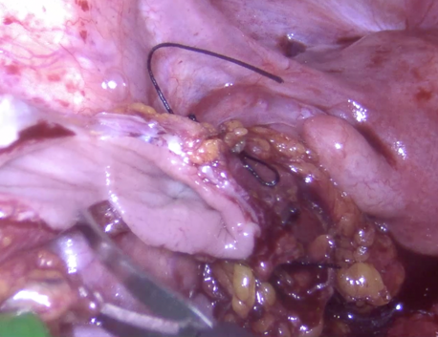
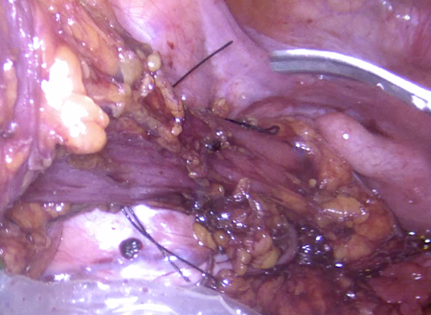

Figure 1 – Rectal marking Figure 2 - Rectal opening

The stump walls were held open using graspers. Resection of the endobag was aided by a clamp introduced through the anal canal into the lumen (Figure 3). The specimen was then retrieved transanally.
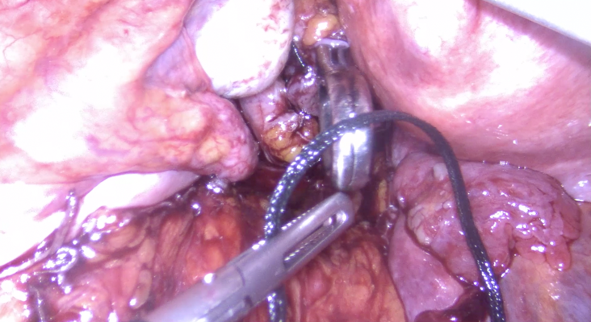
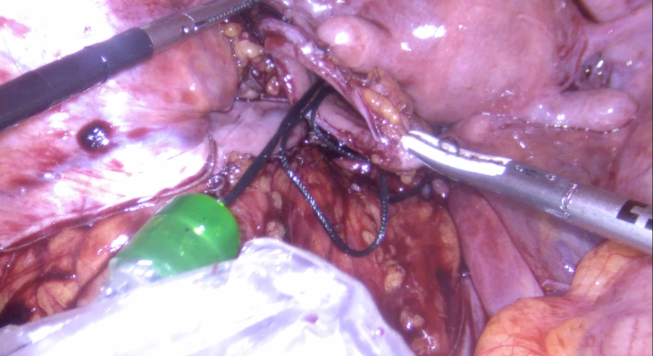

Figure 3 - Resection of the endobag

A 28-mm circular stapler head was introduced through the anus (Figure 4).
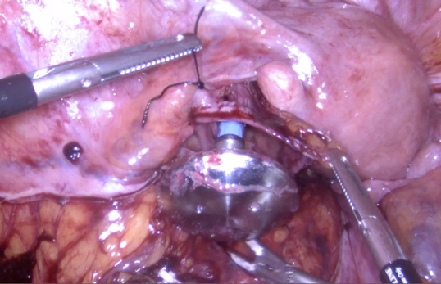

Figure 4- Introduction of 28-mm circular stapler head

The anvil was then inserted into the abdominal cavity, and the shaft was removed. The open rectal stump was closed using a linear stapler and retrieved through the 5-mm port. The anvil was positioned through a small opening in the colic taenia of the proximal colon and exteriorized at the staple line (Figure 5).

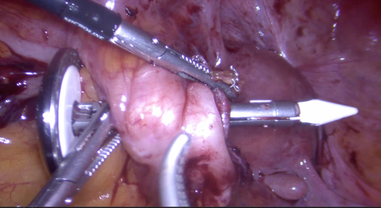

Figura 5 – Anvil position

The open area was subsequently closed with a continuous 2-0 V-Loc™ suture. An intracorporeal, end-to-end mechanical anastomosis was then performed using a CEEA 28 circular stapler. The underwater air-leak test was negative.

The patient had an uneventful postoperative recovery, resumed oral intake within 24 hours, and was discharged on postoperative day 5.

Discussion
With the evolution of minimally invasive colorectal surgery, specimen extraction through natural orifices (NOSE) has emerged as a safe and feasible alternative to traditional mini-laparotomy. The transanal route avoids additional abdominal wall incisions, thereby reducing postoperative pain, wound infection, and the long-term risk of incisional hernia.
The main advantage of the NOSE technique following laparoscopic colectomy is that no auxiliary incision is requiredfor specimen retrieval. This approach is gaining increasing acceptance among colorectal surgeons due to its superior cosmetic and patient comfort outcomes. Since specimen extraction is performed through the transanal route, only the small trocar-site incisions are necessary. Reported rates of trocar-site herniation after elective laparoscopic colon surgery range between 1.5% and 2.9% ^{14,15}, while overall incisional hernia incidence after laparoscopic colorectal surgery is approximately 5.2% at one year and 8.5% at four years ¹⁶.
NOSE techniques have been successfully applied in both benign and malignant colorectal disease, with oncological outcomes comparable to conventional laparoscopic approaches, contributing to the growing popularity of this method ¹⁷. In female patients, both transvaginal and transanal extraction routes are acceptable. While the transvaginal approach is preferred for larger specimens, transanal extraction is more appropriate for smaller ones due to the limited anal canal diameter ¹⁸. Although transvaginal extraction carries a low risk of fecal contamination—since both colonic ends remain closed—temporary opening of the colon during transanal extraction requires meticulous technique and caution to minimize contamination.
In laparoscopic colorectal surgery, natural orifice extraction remains technically more demanding than conventional methods. However, as surgeons gain experience, the procedure becomes reproducible and safe in the majority of patients. In our experience, anvil placement represented the most challenging and time-consuming step of the operation.
Surgical site infection (SSI) remains a significant concern after colorectal surgery, with reported rates between 14% and 26% ²². In a cohort study, SSI rates were 8.2% for open and 4.1% for laparoscopic sigmoidectomy ²³. Nevertheless, a comparative study of conventional versus NOSE extraction in laparoscopic colorectal cancer surgery found no significant difference in SSI incidence between the two methods ²⁴.
This potential advantage is particularly relevant in patients with a history of multiple abdominal operations, who inherently carry a higher risk of incisional hernia due to fascial weakening and scar formation. In our case, the patient had previously undergone two cesarean sections, an abdominoplasty, and a laparoscopic cholecystectomy, all contributing to an increased baseline risk of abdominal wall complications.
By employing a NOSE technique, we completely avoided the need for a new abdominal extraction incision, thereby further reducing the risk of wound-related morbidity. The postoperative course was uneventful, with minimal pain and early return to normal activity. These results are consistent with published evidence indicating that NOSE reduces wound complications without compromising oncologic or functional outcomes in appropriately selected patients. As surgical experience and instrumentation continue to evolve, this technique is likely to become standard practice for suitable colorectal cases.

Conclusion

Laparoscopic sigmoidectomy with transanal specimen extraction is a safe and effective approach that combines the advantages of minimally invasive surgery with complete avoidance of an abdominal extraction site. This is particularly beneficial in patients with a history of multiple abdominal operations, in whom the risk of postoperative incisional hernia is already elevated. In selected patients with recurrent diverticulitis, this technique offers excellent outcomes with reduced wound morbidity, faster recovery, and improved cosmetic results.

Declarations

Informed Consent: Written informed consent was obtained from the patient for publication of this case and accompanying images.

Conflict of Interest: The authors declare no conflicts of interest.

References
- Selznick S, Levy J, Bogdan RM, Hawel J, Elnahas A, Alkhamesi NA, et al. Laparoscopic right colectomies with intracorporeal vs extracorporeal anastomosis: reduced postoperative incisional hernias. Surg Endosc. 2023;37:5500–8.
- Zattoni D, Popeskou GS, Christoforidis D. Left colon resection with transrectal specimen extraction: current status. Tech Coloproctol. 2018;22:411–23.
- Wolthuis AM, de Buck van Overstraeten A, D’Hoore A. Laparoscopic natural orifice specimen extraction colectomy: a systematic review. World J Gastroenterol. 2014;20:12981–92.
- Pham TD, Larach T, Othman B, Rajkomar A, Heriot AG, Warrier SK, et al. Robotic natural orifice specimen extraction surgery for anterior resection. Ann Coloproctol. 2023;39:526–30.
- Lacy AM, García-Valdecasas JC, Delgado S, Castells A, Taurá P, Piqué JM, et al. Laparoscopy-assisted colectomy versus open colectomy for treatment of non-metastatic colon cancer: a randomised trial. Lancet. 2002;359(9325):2224–9.
- Kawada K, Sakai Y. Intracorporeal versus extracorporeal anastomosis in laparoscopic colectomy: a systematic review and meta-analysis. Surg Endosc. 2018;32(8):2891–902.
- Ma B, Gao P, Song Y, Zhang C, Ma J, Wang H, et al. Transanal natural orifice specimen extraction versus conventional laparoscopic resection for colorectal disease: a meta-analysis. Surg Endosc. 2015;29(8):2046–57.
- Wolthuis AM, Fieuws S, van Overstraeten A, D’Hoore A. Laparoscopic sigmoid resection with transanal specimen extraction: a systematic review. Colorectal Dis. 2015;17(5):O74–81.
- Li J, Gong J, Zhang W, Yang Y, Liu H, Cao G, et al. Natural orifice specimen extraction surgery (NOSES) for colorectal cancer: a systematic review and meta-analysis. Int J Colorectal Dis. 2020;35(1):65–79.
- Raskin E, Meyer J, Turan M, et al. Oncological safety of NOSE in colorectal cancer: long-term outcomes. Ann Surg Oncol. 2021;28(5):2524–32.
- Kaur J, Prakash A, Mehta N, et al. Natural orifice specimen extraction in minimally invasive colorectal surgery: current evidence and future directions. World J Gastrointest Surg. 2023;15(8):1545–60.
- Rollins KE, Javanmard-Emamghissi H, Lobo DN. Mechanical bowel preparation with or without oral antibiotics for elective colorectal surgery: updated systematic review and meta-analysis. Ann Surg. 2019;269(4):671–8.
- ASCRS Clinical Practice Guidelines Committee. Clinical practice guideline for enhanced recovery after colon and rectal surgery. Dis Colon Rectum. 2023;66(1):e1–25.
- Taylor GW, Jayne DG, Brown SR, Thorpe H, Brown JM, Dewberry SC, et al. Adhesions and incisional hernias after laparoscopic versus open colorectal cancer surgery in the CLASICC trial. Br J Surg. 2010;97:70–8.
- Owens M, Barry M, Janjua AZ, Winter DC. A systematic review of laparoscopic port-site hernias in gastrointestinal surgery. Surgeon. 2011;9:218–24.
- Fukuoka H, Watanabe J, Ota M, Suwa Y, Suwa H, Ishibe A, et al. Risk factors for incisional hernia after laparoscopic colorectal surgery: a multicenter retrospective study in the Yokohama Clinical Oncology Group. Surg Endosc. 2020;34:318–27.
- Liu RJ, Zhang CD, Fan YC, Pei JP, Zhang C, Dai DQ. Safety and oncologic outcomes of laparoscopic NOSE surgery compared with conventional laparoscopy for colorectal disease: a meta-analysis. Front Oncol. 2019;9:597.
- Gundogan E, Aktas A, Kayaalp C, Gonultas F, Sumer F. Two cases of total laparoscopic colectomy with natural orifice specimen extraction and review of the literature. Videosurgery Miniinv. 2017;12:291–6.
- Yagci MA, Kayaalp C, Novruzov NH. Intracorporeal mesenteric division of the colon may make the specimen more suitable for natural orifice extraction. J Laparoendosc Adv Surg Tech A. 2014;24:484–6.
- Wolthuis AM, De Buck Van Overstraeten A, D’Hoore A. Laparoscopic NOSE colectomy with camera sleeve: an evolving technique. Colorectal Dis. 2015;17:O123–5.
- Pellino G, Frasson M, García-Granero A, Granero-Castro P, Ramos Rodríguez JL, Flor-Lorente B, et al. Predictors of complications and mortality after left colectomy with stapled primary anastomosis for cancer: results of a multicenter study of 1111 patients. Colorectal Dis. 2018;20:986–95.
- Guzman-Pruneda FA, Husain SG, Jones CD, Beal EW, Porter E, Grove M, et al. Compliance with preoperative care measures reduces surgical site infection after colorectal operation. J Surg Oncol. 2019;119:497–502.
- Caroff DA, Chan C, Kleinman K, Calderwood MS, Wolf R, Wick EC, et al. Association of open versus laparoscopic approach with risk of surgical site infection after colon surgery. JAMA Netw Open. 2019;2:e1913570.
- Bu J, Li N, He S, Deng HY, Wen J, Yuan HJ, et al. Effect of laparoscopic colorectal cancer surgery with NOSE on patient recovery and prognosis. Minim Invasive Ther Allied Technol. 2022;31:230–7.

