Case report

Mesenteric Mass Misnomer: Unraveling the Differential

.
ABSTRACT

Introduction: Intra-abdominal cystic collections often masquerade as neoplastic or mesenteric masses in patients. Their infected variants are rare and may closely mimic GIST[gastrointestinal stromal tumor], mesenteric cysts, or lymphoma on imaging. This highlights such a diagnostic dilemma resolved through laparoscopic excision and histopathological confirmation.

Case presentation:
A 33-year-old male presented with vague abdominal pain for a month and dyspepsia. CT imaging showed a 5.3 × 3.1 × 8 cm lobulated infracolic mass adherent to the mesocolon and pancreatic tail. The patient underwent diagnostic laparoscopy, which revealed an infected pancreatic pseudocyst which was excised with complete recover.

Conclusion:
This case underscores the importance of including pseudocysts in the differential for cystic abdominal masses without classic risk factors and highlights the diagnostic and therapeutic value of minimally invasive exploration. Surgical excision remains the gold standard in infected or symptomatic pseudocysts, especially when malignancy cannot be excluded.

Keywords: pseudocyst, case report, diagnostic laparoscopy, pathological finding.

INTRODUCTION

Intra-abdominal masses with cystic or lobulated morphology often present a diagnostic puzzle as imaging and routine lab evaluations may not be sufficient to distinguish their origin. In young adults, such lesions may originate from gastrointestinal, mesenteric, lymphatic, or pancreatic structures, each carrying distinct clinical implications. The presentation of a 33-year old male with abdominal discomfort and a large infracolic mass prompted consideration of several differential diagnoses, including gastrointestinal stromal tumor (GIST), mesenteric cyst, lymphoma, and pancreatic cystic neoplasm. GISTs typically arise from the muscularis propria of the gastrointestinal tract and may present as exophytic masses with central necrosis or cystic degeneration; their proximity to bowel and potential for silent growth make them a frequent suspect when imaging reveals a lobulated lesion with heterogeneous enhancement.¹ Mesenteric cysts, though rare, can mimic neoplastic processes when large or adherent to surrounding structures, often presenting with vague discomfort or mass effect.² Lymphoproliferative disorders, particularly non-Hodgkin lymphoma, may manifest as bulky, infiltrative lesions without overt systemic symptoms in younger patients, encasing bowel or vessels without obstruction and lacking significant enhancement.³ Pancreatic cystic neoplasms including mucinous cystic neoplasms and intraductal papillary mucinous neoplasms also enter the differential when the lesion appears near the pancreatic tail; these lesions often demonstrate septations, peripheral calcifications, or mural nodules on imaging.^{4,5}

Case presentation:
A 33-year-old male presented with abdominal pain and dyspepsia for a month. Pain was insidious and gradually progressive in nature, episodes of vomiting were reported, vomit had presence of food particles, with no blood or bile stains. He denied fever, weight loss, loss of appetite, or jaundice. No history of blood in stools, no significant medical history was noted. On examination his vital signs were stable; systemic examination was largely unremarkable except the region of pain and mild tenderness over the epigastric region. No previous history of pancreatitis, trauma, or alcohol abuse was noted. His serology and hematologic investigations were within the normal limits. He was advised for a UGI Endoscopy, which showed normal mucosa with no GI lesions. Followed by Chest X-Ray which was normal. Then the patient was subjected to a CT of his abdomen which showed a 5.3 × 3.1 × 8 cm lobulated mass in the infracolic region, closely adherent to bowel, mesocolon, and pancreas. Initial suspicion included GIST, mesenteric cyst, lymphoma, or pancreatic neoplasm. Due to ambiguity in imaging, diagnostic laparoscopy was planned. Diagnostic laparoscopy revealed a mass in the infracolic region, adherent to bowel and mesocolon, extending from the pancreas[Fig1]. The lesion was cystic with internal debris, confirming an infected pancreatic pseudocyst. The cyst was excised completely and a surgical drain placed.
Intraoperatively, a mass was identified in the infracolic region. It was noted to be adherent to the small bowel, transverse colon, and mesocolon, with a connection to the pancreas, consistent with a pseudo-pancreatic cyst containing debris. The lesion was carefully dissected and excised from the surrounding tissue. Adequate hemostasis was achieved, and the operative field was irrigated with saline. No abdominal drain was placed, and the surgical wound was closed in layers. The patient tolerated the procedure well and was transferred to the postoperative ward in stable condition.
Postoperative, the patient was kept nil per oral (NPO) until further orders and managed with supportive therapy, including intravenous antibiotics (Inj. Xone 1 g IV, Inj. Pan 40 mg IV), analgesics (Inj. Paracetamol 1 g IV) and anti emetics (Inj. Emeset 4 mg IV). Daily wound assessment revealed clean healing. Drain output decreased and was removed on POD 5. The patient remained hemodynamically stable and was discharged with oral medications and follow-up advice.
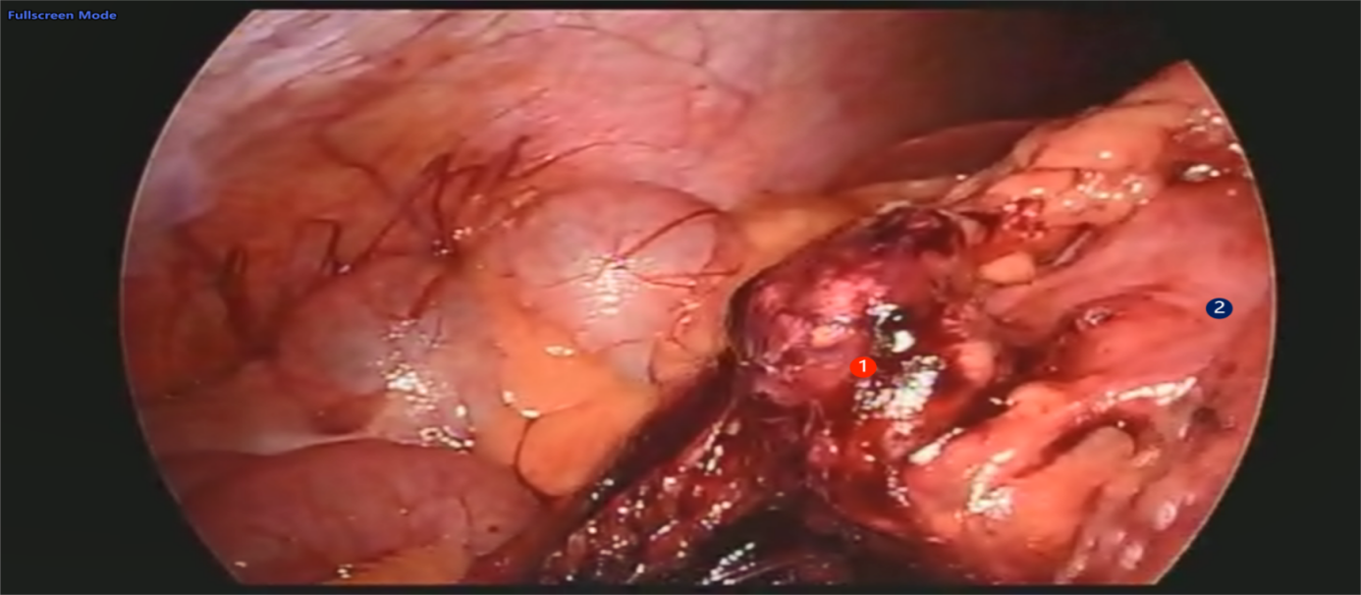
Fig1: Intraoperative image showing Cyst ① attached to Colon ②.

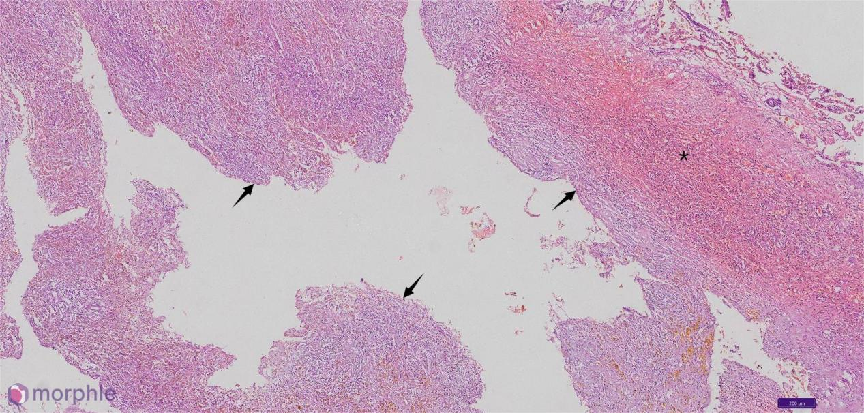
Fig 2: Showing cyst wall with fibro collagenous tissue[↑], granulation tissue and inflammatory infiltrate[*]. [10x magnification.]

Microscopy:[Fig2 & Fig3] Sections studied show fibro-collagenous cyst wall with granulation tissue, areas of fat necrosis, pigmented macrophages, mixed inflammatory infiltrate [10x magnification] with focal xanthogranulomatous collection and pigmented debris[20x magnification]. There is no evidence of epithelial lining seen in the sections examined.

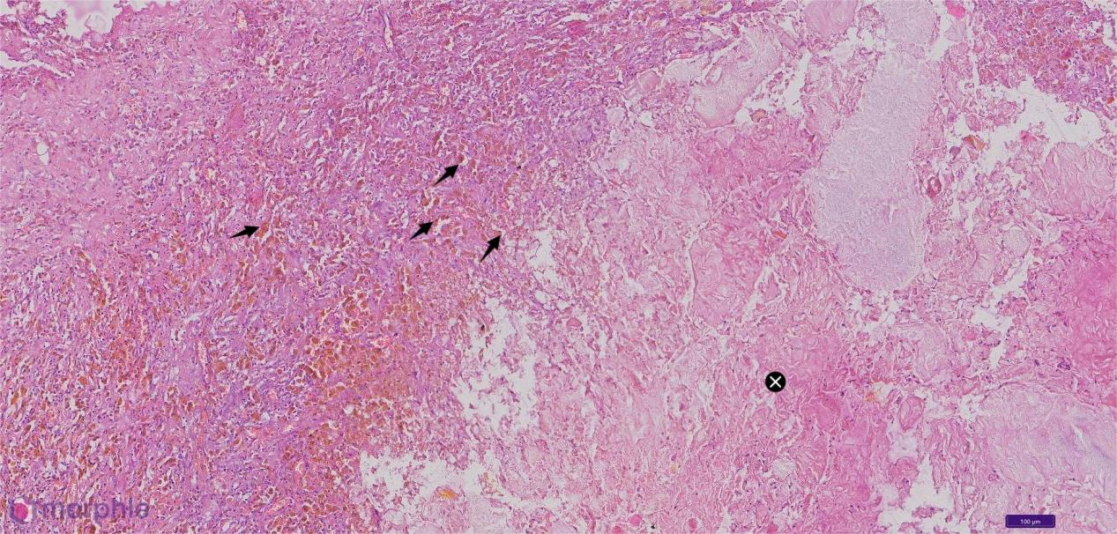
Fig 3: Showing pigmented macrophages[↑] and cellular debris[X], 20x magnification.

DISCUSSION:
The discovery of a lobulated infracolic mass in a 33-year-old man with no history of alcohol use, trauma, or pancreatitis immediately broadened our differential beyond classic pseudocyst. His normal liver and renal panels, unremarkable blood counts, and lack of fever or weight loss made high-grade malignancies and systemic inflammatory processes less likely. Gastrointestinal stromal tumor was first on the list given the lesion’s proximity to bowel and its lobulated appearance with possible central necrosis.¹ Yet the intact mucosal lining on endoscopy and absence of symptoms such as bleeding or anemia argued against GIST. Similarly, a mesenteric cyst remained a contender these benign fluid-filled sacs often sit quietly in the mesocolon but the lesion’s firm adherence to both bowel loops and the pancreatic tail without a clear mesenteric stalk rendered that diagnosis uncertain.² Lymphoma can cloak itself as a bulky, non-obstructing abdominal mass, especially in younger adults. However, our patient’s lack of B symptoms, negative viral serology, and normal hematologic workup weighed heavily against a lymphoproliferative process. The decision to proceed with diagnostic laparoscopy allowed direct visualization: a tense cystic cavity filled with infected fluid and necrotic material, tightly bound to the pancreatic tail and mesocolon. Surgical excision yielded tissue for histology, which ultimately confirmed an infected pancreatic pseudocyst. Diagnostic laparoscopy provided both diagnostic clarity and therapeutic resolution with minimal morbidity. Postoperative recovery was uneventful, underscoring the utility of minimally invasive surgery in atypical presentations.This case underscores that even in the absence of alcohol use or a clear history of pancreatitis, pancreatic pseudocysts can masquerade as neoplastic or mesenteric masses. Normal labs and non-specific imaging findings should not exclude them from consideration, and when noninvasive methods fall short, minimally invasive surgical exploration may be both diagnostic and therapeutic. Postoperative recovery was uneventful, further illustrating the utility of laparoscopy in atypical presentations.

Conclusion

Infected pancreatic pseudocysts, though rare, pose significant diagnostic and therapeutic challenges especially when presenting atypically or mimicking other abdominal masses. This case highlights the importance of clinical vigilance, early imaging, and the utility of diagnostic laparoscopy as both a definitive diagnostic and therapeutic modality. Prompt surgical excision remains an effective strategy when infection, anatomical adherence, or neoplastic suspicion is involved. Continued documentation of such rare presentations will aid in refining protocols and improving outcomes in resource-constrained surgical settings.

Consent
All authors declare that ‘written informed consent was obtained from the patient for publication of this case report and accompanying images.

Abbreviations

GIST - Gastrointestinal Stromal Tumour
CT - Computed Tomography
UGI - Upper Gastrointestinal
GI - Gastrointestinal
POD - Post Operative Day
IV - Intravenous

References

- Kluszczyk P, Tobiasz A, Madej A, Wosiewicz P, Mrowiec S, Jabłońska B. Pancreatic Pseudocysts: Evolution of Treatment Approaches. J Clin Med. 2024;14(17):6152. DOI:10.3390/jcm14176152.

- Duggal S, Nagineni L, Trivedi BS, Zuckerman M, Badillo R. Evolving Endoscopic Approaches to Pancreatic Pseudocysts and Walled-Off Necrosis: Case Series and Review of Evidence. J Investig Med High Impact Case Rep.2024;12:16.DOI:10.1177/23247096241304521.

- Tan JH, Chin W, Shaikh AL, Zheng S. Pancreatic pseudocyst: Dilemma of its recent management. Exp Ther Med. 2020;20(6): DOI:10.3892/etm.2020.9590.

- Tanaka M, Fernández-del Castillo C, Adsay V, et al. International consensus guidelines 2012 for the management of IPMN and MCN of the pancreas. Pancreatology. 2012;12(3):183–197.

- Schooler GR, Lee KK, Burton G, et al. State-of-the-art update of pancreatic cystic lesions: diagnosis and management. Dig Dis Sci. 2021;66(4):1050–1066

