Case report
Anteriorly Located Rib Osteoblastoma: Case Report

Abstract:
Rib osteoblastoma is a rare benign tumor that can occasionally undergo malignant transformation.
Case presentation:
This report details a case involving a 20-year-old female patient who developed a tender, hard swelling on the left side of her chest wall, along with persistent chest pain. A chest computed tomography (CT) scan revealed a well-defined, osteolytic, expansile intra-medullary bony lesion located at the anterior aspect of the left third rib. An ultrasound-guided true-cut needle biopsy proved challenging and inconclusive; however, it suggested the possibility of osteosarcoma. A fluorodeoxyglucose-positron emission tomography-computed tomography (FDG-PET CT) scan indicated that the tumor was metabolically active, with a maximum standardized uptake value (SUV max) of 6.8. The patient then underwent tumor resection and experienced an uneventful postoperative recovery. Histopathological examination confirmed the diagnosis of rib osteoblastoma. Six months after the surgery, a follow-up chest CT scan showed no evidence of recurrence.
Conclusion:
Rib osteoblastoma can exhibit metabolic activity on FDG-PET CT scans and should be included in the differential diagnosis of tumors located in the anterior or posterior parts of the ribs. A radical surgical approach is essential for accurate diagnosis and effective treatment.
Key words: Anterior, Rib, Osteoblastoma
Introduction:
Benign osteoblastoma is a term that was introduced by Lichtenstein in the 1950s. Initially, it was considered a separate pathological entity distinct from osteoid osteoma (Lichtenstein, 1956). Osteoblastoma is a rare, bone-forming vascular tumor that accounts for approximately 1% of all bone tumors and has the potential for malignant transformation (Berry et al., 2008; Galgano et al., 2016). While it predominantly affects the posterior elements of the vertebral column, long bones, and the sacrum, it can occur in any bone in the body. Rib osteoblastoma is particularly rare, with a reported incidence of less than 5% in the literature (Berry et al., 2008). All documented cases have been found in the posterior or posterolateral regions of the ribs. This tumor exhibits non-specific radiological features (Galgano et al., 2016; Ye et al., 2012), making the differential diagnosis for this lesion include both benign and malignant conditions. In this report, we present a case of rib osteoblastoma that appears in an unusual location: the anterior aspect of the left third rib.
Case Presentation:
A 20-year-old female presented to our department with a two-year history of atypical pain in the left anterior chest. Initially, the pain was attributed to a musculoskeletal cause. It was persistent but partially alleviated by non-steroidal anti-inflammatory medications. The patient denied any previous trauma, and her medical history was otherwise unremarkable. However, over the past few months, the pain significantly increased in intensity, prompting her to seek medical advice. During the physical examination, a very tender, hard swelling was noted at the anterior aspect of the left third rib. The chest examination showed no abnormal findings, and laboratory tests returned within normal ranges.
A multi-slice chest computed tomography (CT) scan revealed a well-defined, osteolytic, expansile intra-medullary bony lesion at the anterior aspect of the left third rib, measuring approximately 6.1 x 3.3 cm (Fig. 1A, 1B). This lesion indented the underlying costal pleura but showed no pulmonary extension, with the radiologist concluding that it appeared benign. An ultrasound (US)-guided true-cut needle biopsy was attempted, but the procedure was challenging and inconclusive. Nonetheless, it revealed a highly atypical spindle cell neoplasm suggestive of osteosarcoma. A whole-body positron emission tomography-computed tomography (PET-CT) scan was performed, indicating that the bony lesion was metabolically active with increased fluorodeoxyglucose (FDG) uptake. The maximum standardized uptake value (SUV max) measured 6.8 (Fig. 1C). No distant metastasis was observed.
The lesion was surgically excised completely with safety margins. The defect in the anterior chest wall was repaired using polypropylene mesh and bone cement, creating artificial ribs (Fig. 1D). The post-operative recovery was uneventful, and the patient was discharged on the fifth post-operative day.
Histopathological examination indicated a benign tumor composed of interconnected trabeculae of woven bone, bordered by plump osteoblasts and numerous osteoclast-like multinucleated giant cells. Intervening highly vascularized loose connective tissue exhibited variable-sized, thin-walled vascular channels filled with red blood cells (RBCs) (Fig.2A). The lesion was sharply demarcated from the surrounding medullary bone marrow by a sclerotic rim (Fig. 2B). There was no evidence of mitosis or necrosis, and no granulomatous reaction or malignant changes were detected. Based on these findings, the final diagnosis was osteoblastoma of the rib.
Discussion:
Osteoblastoma is a rare benign bone tumor, and cases involving the ribs are particularly uncommon (Berry et al., 2008). In our instance, the tumor is situated on the anterior aspect of the rib, which is an unusual location that, to our knowledge, has not previously been reported. The age of our patient aligns with the peak incidence noted in the literature (Tugcu et al., 2008); however, our patient is female, while osteoblastoma typically shows a male predominance. It is important to highlight that determining sex distribution in cases of rib osteoblastoma can be challenging due to the tumor's rarity (Galgano et al., 2016).

Radiologically, osteoblastoma presents with a highly variable and non-specific appearance. It can occur in different locations, such as intramedullary, intracortical, or periosteal sites (Shaikh et al., 1999). In this case, the osteoblastoma was identified as an intramedullary bony lesion with non-specific radiological features, making it improbable to achieve a definitive preoperative diagnosis. The inconclusive results from the ultrasound-guided true cut biopsy further complicated the situation. As a result, we opted for a whole-body PET-CT scan. Interestingly, the bone lesion demonstrated increased FDG uptake, with a maximum standardized uptake value (SUV) of 6.8. FDG-PET is an imaging technique commonly used for staging malignant tumors, as it detects increased glucose accumulation and metabolism in cancer cells. However, it is essential to note that this characteristic is not exclusive to malignancies. Multiple studies have shown that certain benign bone lesions, including osteoblastoma, can also exhibit FDG uptake, leading to significant overlap in the SUVs of benign and malignant bone lesions (Kole et al., 1998).
The maximum SUV reported in our case aligns with the ranges indicated in earlier studies on osteoblastoma, which suggested that increased 18F-FDG uptake is not related to the tumor's location (Kole et al., 1998; Jeong et al., 2011). Currently, it remains unclear which specific cells are responsible for the observed FDG uptake in osteoblastoma. We hypothesize that activated osteoblasts, along with other active cells such as osteoclast-like multinucleated giant cells, may contribute to the positive FDG imaging. A prior study highlighted the significant accumulation of FDG in particular benign bone lesions, especially those containing histiocytic or giant cells (Aoki et al., 2001).
Considering the tumor's location and the diagnostic dilemma, we were surprised to receive a diagnosis of rib osteoblastoma following surgery. The standard treatment for a solitary rib tumor is radical surgery, which is essential for obtaining an accurate diagnosis and preventing local destruction and recurrence. Rib osteoblastoma is generally associated with a favorable prognosis; however, it can recur (Jackson 1978). The incidence of recurrence in osteoblastoma cases typically ranges from about 10% in conventional instances to as high as 50% in more aggressive cases. Recurrence can occur as late as 5 to 10 years after resection (Galgano et al., 2016). Due to this potential for recurrence, long-term follow-up is essential for these patients. Six months postoperatively, a chest CT scan showed no evidence of recurrence (Fig. 1D).
Conclusion:
Rib osteoblastoma is a rare benign bone tumor that exhibits metabolic activity on FDG-PET CT scans. It should be considered in the differential diagnosis of both benign and malignant tumors located in the anterior or posterior regions of the ribs. A radical surgical approach is essential for accurate diagnosis and effective treatment.
Abbreviations list:
CT computed tomography
FDG fluorodeoxyglucose
PET-CT positron emission tomography-computed tomography
SUV max maximum standardized uptake value
RBCs red blood cells
US ultrasound
Declaration of competing interest:
We have no conflict of interest to disclose.
Authorship contribution statement
- Amr A Abdelwahab: Performed surgery, edited the manuscript, and followed up with the patient
- Amro R. Serag: Assisted in surgery, wrote, and edited the manuscript
Patient consent:
Written informed consent was obtained from the patient for publication of this case report and accompanying images. A copy of the written consent is available for review on request.
Ethical approval:
It is not applicable.
Disclaimer (Artificial intelligence)
Author(s) hereby declare that generative AI technologies such as Large Language Models, etc. have been used during the writing or editing of manuscripts. This explanation will include the name, version, model, and source of the generative AI technology and as well as all input prompts provided to the generative AI technology
Details of the AI usage are given below:
Grammarly, which is an AI assistant, was used for some grammar and language correction.
References:
- Aoki J., Watanabe H., Shinozaki T., Takagishi K., Ishijima H., Oya N., et al. (2001). FDG PET of primary benign and malignant bone tumors standardized uptake value in 52 lesions. Radiology, 219(3):774-7 DOI:10.1148/radiology.219.3.r01ma08774

- Berry M, Mankin H, Gebhardt M, Rosenberg A, Hornicek F. (2008) Osteoblastoma: a 30-year study of 99 cases. Journal of Surgical Oncology, 98:179–83. DOI: org/10.1002/jso.21105
- Galgano MA, Goulart CR, Iwenofu H, Chin LS, Lavelle W and Mendel E. (2016). Osteoblastoma of the spine: a comprehensive review. Neurosurgical Focus, 41;1-8. DOI:10.3171/2016.5.FOCUS16122.
- Jackson RP. (1978). Recurrent osteoblastoma: a review. Clinical Orthopedics and Related Research, 131:229-233. PMID: 657629
- Jeong YJ, Sohn MH, Lim ST, et al. (2011). Osteoblastoma in the nasal cavity: F-18 FDG PET/CT and Tc-99m MDP 3-phase bone scan findings with pathologic correlation. Clinical Nuclear Medicine, 36:214–217. DOI: 10.1097/RLU.0b013e318208f2f9.
- Kole AC, Nieweg OE, Hoekstra HJ, van Horn JR, Koops HS, Vaalburg W. (1998). Fluorine-18-fluorodeoxyglucose assessment of glucose metabolism in bone tumors. Journal of Nuclear Medicine, 39:810–815. PMID: 9591581
- Lichtenstein L. (1956). Benign osteoblastoma: a category of osteoid- and bone-forming tumors other than classical osteoid osteoma, which may be mistaken for giant cell tumor or osteogenic sarcoma. Cancer, 9:1044–1052
DOI: 10.1002/1097-0142(195609/10)9:5<1044::aid-cncr2820090523>3.0.co;2-o
- Shaikh MI, Saifuddin A, Pringle J, Natali C, Sherazi Z. (1999). Spinal osteoblastoma: CT and MR imaging with pathological correlation. Skeletal Radiology, 28:33-40 DOI:10.1007/s002560050469 - Pubmed 10.
- Tugcu B, Gunaldi O, Gunes M, Tanriverdi O, Bilgic B. (2008). Osteoblastoma of the temporal bone: a case report. Minimally Invasive Neurosurgery, 51:310–2. PMID: 18855299 DOI: 10.1055/s-0028-1083816
- Ye J, Liu L, Wu J, Wang S. (2012). Osteoblastoma of the rib with CT and MR imaging: A case report and literature review. World Journal of Surgical Oncology, 10; 49 DOI: 10.1186/1477-7819-10-49

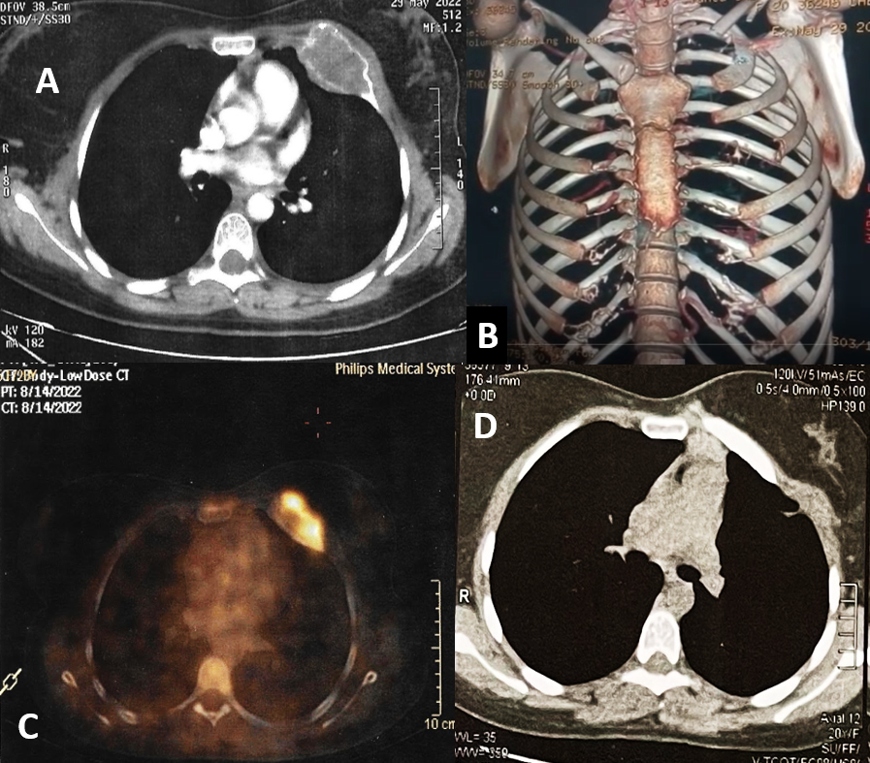
Fig 1: (A) CT chest with contrast shows a well-defined osteolytic expansile intra-medullary bony lesion at the anterior aspect of the left 3rd rib with no cortical disruption. It measures about 6.1X3.3 cm. (B) 3D Reconstruction of the bony chest wall shows destruction of the anterior aspect of the left 3rd rib (C)A whole body (positron emission tomography (PET)-CT shows that this bony lesion is metabolically active with increased fluorodeoxyglucose (FDG)-uptake. The maximum standardized uptake value (SUV max) was 6.8. (D) CT chest, 6 months postoperatively, shows no evidence of recurrence with good outcome regarding the reconstruction of the chest wall with artificial rib.

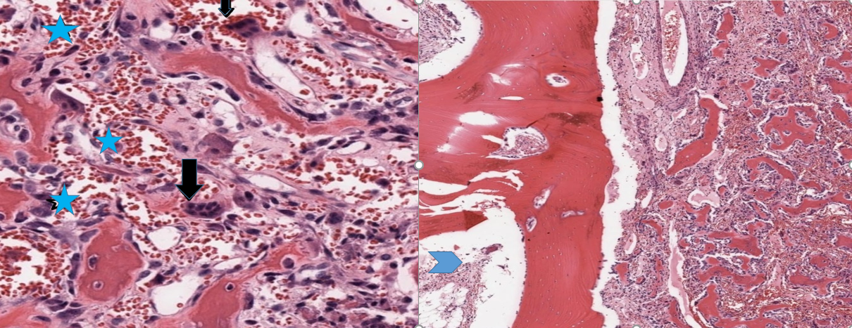
A B
Fig 2: (A) Histopathology image shows osteoblastoma; irregular trabeculae of woven bone rimmed by osteoblasts and scattered multinucleated osteoclasts [black arrows], surrounded by loose fibrovascular stroma with many vascular spaces filled with RBCs [baby blue asterisks] [H&E x 400]. (B) Histopathology image shows osteoblastoma, the tumor is seen sharply demarcated from adjacent cancellous rib bone (Baby blue arrow head) [to the left] [H&E x40].

