Case report

Scapular Osteochondroma in an Adolescent: A Case Report

Abstract :
Introduction:
Osteochondromas are the most common benign bone tumors, but their scapular location, particularly on the anterior surface, remains exceptional. They may reveal themselves through unusual clinical or radiological presentation.

Observation :
We report the case of a 13-year-old boy with no significant medical history, who presented with a progressive deformity of the right shoulder associated with outward and backward displacement of the scapula. Standard radiographs revealed an atypical lesion of the scapula, and computed tomography confirmed the presence of a large osteochondroma arising from the anterior surface of the right scapula. The patient underwent complete surgical excision of the lesion. Histopathological analysis confirmed the diagnosis of a benign osteochondroma. At nine-month follow-up, the clinical outcome was excellent, with resolution of the deformity and full restoration of shoulder function.

Conclusion :
Scapular osteochondromas are uncommon lesions that should be considered in the differential diagnosis of unexplained thoracic or scapular deformities, particularly in adolescents. Complete surgical excision usually provides excellent functional and cosmetic outcomes, with minimal risk of recurrence when resection is thorough.
Keywords: Osteochondroma, Scapula, Shoulder deformity, Adolescent, Case report.

Introduction
Osteochondromas are the most frequent benign bone tumors, representing approximately 24–40% of all benign osseous neoplasms [1]. They typically arise from the metaphyseal regions of long bones, particularly the distal femur, proximal tibia, and proximal humerus [2]. Scapular involvement is uncommon, accounting for only 3–5% of cases; however, osteochondroma remains the most prevalent benign tumor of the scapula [3]. Lesions originating from the anterior surface are especially rare and may present with chest wall deformity, mechanical discomfort, or manifestations of snapping scapula syndrome [4].
We report the case of a large osteochondroma arising from the anterior surface of the right scapula in an adolescent, successfully managed by complete surgical excision with an excellent functional and aesthetic outcome.

Case presentation
A 13-year-old boy with no significant medical history presented with a progressive deformity of the right shoulder that had been developing over two years.
Clinical examination: Physical assessment revealed shoulder asymmetry with posterior displacement of the right scapula. A snapping scapula phenomenon was observed, associated with pain during shoulder movements, resulting in partial limitation of function.
Imaging: Standard radiographs of the right shoulder demonstrated an ill-defined scapular opacity, prompting further evaluation by computed tomography (CT). CT scan with three-dimensional reconstruction revealed a large, well-circumscribed, sessile osteocartilaginous mass arising from the anterior surface of the right scapula, measuring approximately 63 mm in its greatest dimension, and exerting a compressive mass effect on the thoracic cage.
Surgical management: After multidisciplinary discussion and informed consent from the patient’s family, surgical excision was indicated. The patient was positioned in the left lateral decubitus position, and an incision was made along the lateral border of the scapula. Complete resection of the lesion was achieved en bloc, flush with the bone surface, including the underlying periosteum.
Outcome: The postoperative course was uneventful. At nine months’ follow-up, clinical examination and CT imaging showed no residual deformity or recurrence, confirming full functional recovery and satisfactory aesthetic results.

Discussion
Osteochondroma is the most frequent benign bone tumor, accounting for approximately 24–40% of all benign osseous neoplasms [1]. It typically develops during childhood and adolescence in relation to endochondral bone growth and ceases to enlarge after physeal closure [2]. The most common sites of involvement are the metaphyseal regions of long bones, particularly the distal femur, proximal tibia, and proximal humerus [3].
Scapular localization is uncommon, representing only 3–5% of all osteochondromas; however, it remains the most frequent benign tumor of the scapula [4]. Lesions arising from the anterior surface are particularly rare and may lead to atypical clinical manifestations, including thoracic wall deformity, mechanical discomfort, scapulothoracic pain due to friction, or snapping scapula syndrome [5–7]. In exceptional cases, compressive complications involving neurovascular or respiratory structures have been described [8].
Diagnosis relies primarily on imaging. Standard radiographs can suggest the presence of the lesion but may be insufficient to delineate its full extent. Computed tomography, especially with three-dimensional reconstruction, provides superior visualization of tumor morphology and its anatomical relationships [9]. Magnetic resonance imaging is reserved for cases with suspected malignant transformation, particularly when the thickness of the cartilaginous cap exceeds 2 cm in adults [10].
Surgical excision is indicated in symptomatic cases, when aesthetic concerns are significant, in the presence of complications, or when malignant degeneration is suspected. Complete resection, including removal of the bony base and periosteum, is essential to minimize the risk of recurrence [11]. Postoperative outcomes are generally favorable, with excellent functional and cosmetic results [12]. In the present case, monobloc excision of the lesion led to full functional recovery and absence of recurrence at nine months of follow-up.

Conclusion
Osteochondroma of the scapula represents an uncommon localization, accounting for approximately 3–5% of all osteochondromas [1,2]. When located on the anterior surface, it may present with chest wall deformity, scapular asymmetry, or snapping scapula syndrome [3–5]. Advanced imaging, particularly three-dimensional computed tomography, plays a pivotal role in establishing an accurate diagnosis and guiding surgical planning [6]. Complete surgical excision, encompassing both the tumor base and periosteum, remains the gold standard of treatment, ensuring excellent functional and aesthetic outcomes with a minimal risk of recurrence [7,8].

Competing Interests
The authors declare that they have no competing interests.

Consent
Written informed consent was obtained from the patient’s parents for publication of this case report and the accompanying images. A copy of the signed consent form is available for review by the Editor-in-Chief of this journal upon request.

Ethical Approval
Ethical approval was not required for this single case report, as per the institutional policy of the Centre Hospitalier Universitaire Mohammed VI, Tanger, provided that informed consent for publication was obtained.

References
- Kitsoulis P, et al. Osteochondromas: review of the clinical, radiological and pathological features. In Vivo. 2008;22(5):633-46.
- de Souza AMG, Bispo Júnior RZ. Osteochondroma: ignore or investigate? Rev Bras Ortop. 2014;49(6):555–64.
- Unni KK, Inwards CY. Dahlin’s Bone Tumors: General Aspects and Data on 10,165 Cases. 6th ed. Philadelphia: Lippincott Williams & Wilkins; 2010.
- Guder W, Hardes J, Gosheger G, et al. Scapular osteochondroma: diagnosis and treatment. Orthop Rev (Pavia). 2012;4(2):e27.
- Fukunaga S, Futani H, Yoshiya S. Endoscopic-assisted resection of a scapular osteochondroma causing snapping scapula syndrome. World J Surg Oncol. 2007;5:37.
- Chillemi C, Franceschini V, Ippolito G, et al. Osteochondroma as a cause of winging scapula in an adolescent. J Med Case Rep. 2013;7:220.
- Frank RM, Ramirez J, Chalmers PN, et al. Delayed presentation of osteochondroma on the ventral surface of scapula. Int J Shoulder Surg. 2012;6(2):61-3.
- Shahid O, Shahid M, Shaik L, et al. Rare case of osteochondroma on the dorsal aspect of the scapula. Cureus. 2021;13(8):e17051.
- Murphey MD, Choi JJ, Kransdorf MJ, et al. Imaging of osteochondroma: variants and complications with radiologic-pathologic correlation. Radiographics. 2000;20:1407-34.
- Bovée JVMG, et al. EXT-mutation analysis and loss of heterozygosity in sporadic and hereditary osteochondromas and secondary chondrosarcomas. Am J Hum Genet. 1999;65(3):689–98.
- Nekkanti S, Moogali A, Meka A, Nair M. An unusual presentation of osteochondroma on the dorsal surface of the scapula: a review of two patients. J Orthop Case Rep. 2018;8(3):38–41.
- Altwaijri NA, Fakeeha J, Alshugair I. Osteochondroma of the scapula: a case report and literature review. Cureus. 2022;14(10):e30558.

Fig 1 : Massive Osteochondral Lesion of the Scapula

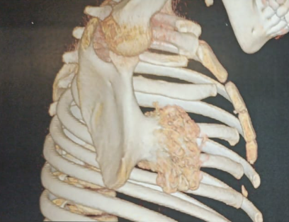

Fig 2 : Intraoperative View of Mass Removal from Shoulder/Back
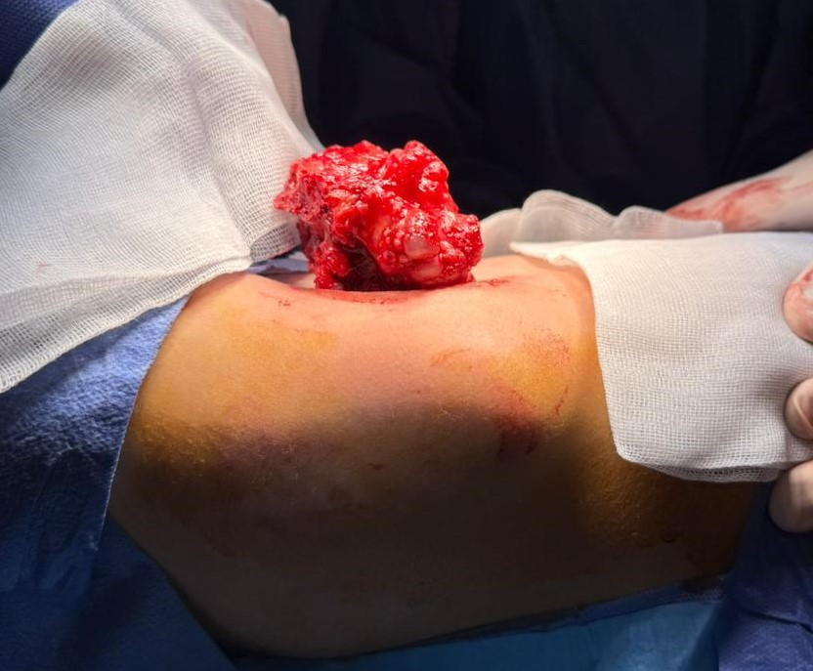
Fig 3 : Surgical Specimen of Bony/Tumoral Mass
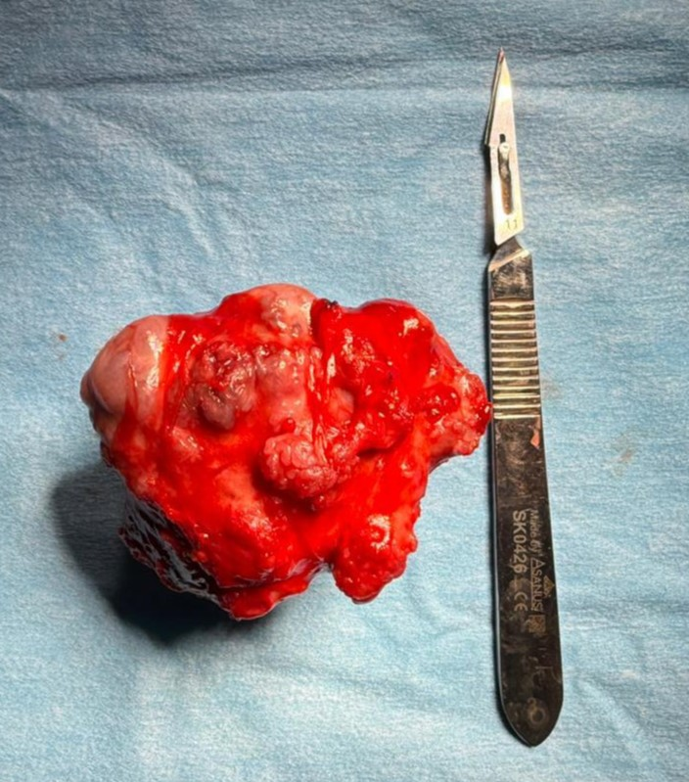

Fig 4 : Post-Operative View of Shoulder Girdle after Tumor Resection
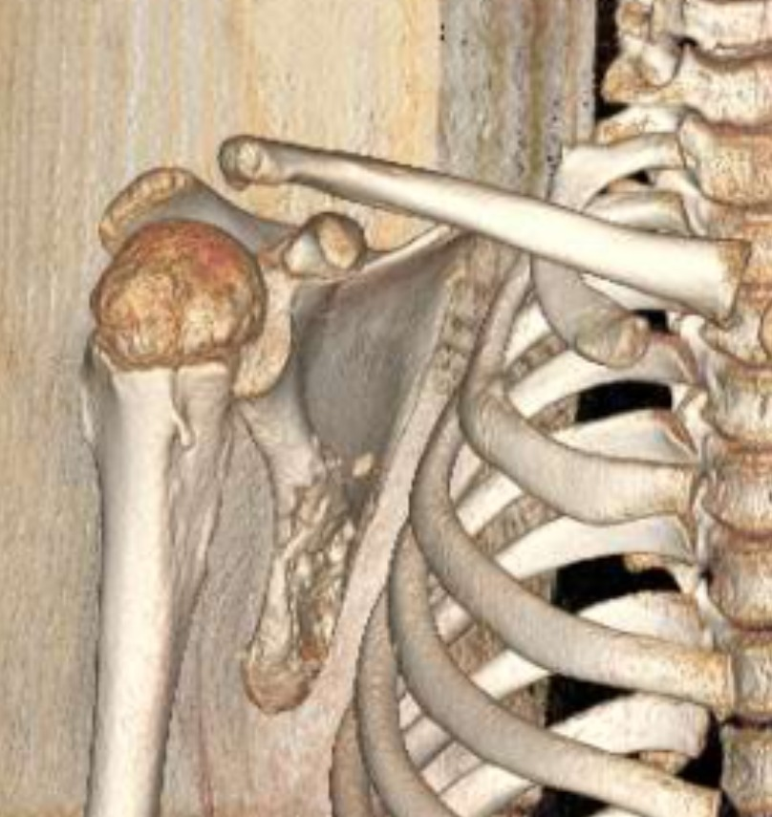
Fig 5 Massive Osteochondral Lesion of the Scapula
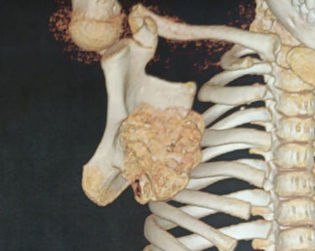
Fig 6 : Pre- or Post-Operative Clinical Image: Back and Shoulder Assessment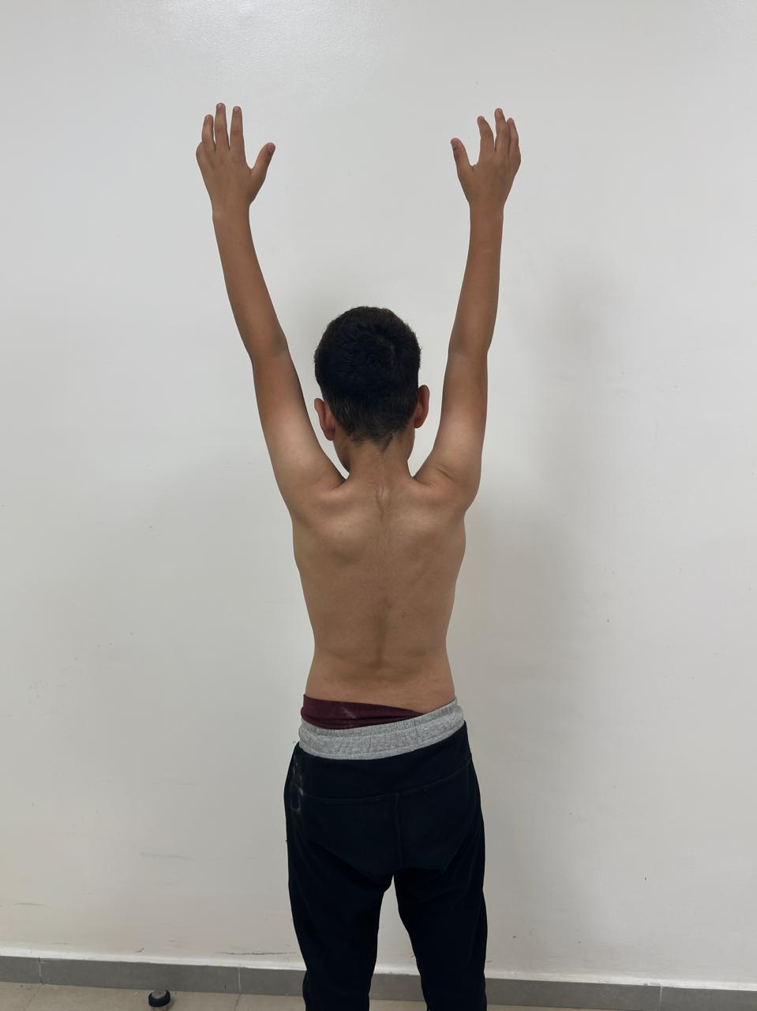

Fig 7 : Surgical Specimen of Tumor on the Operating Field

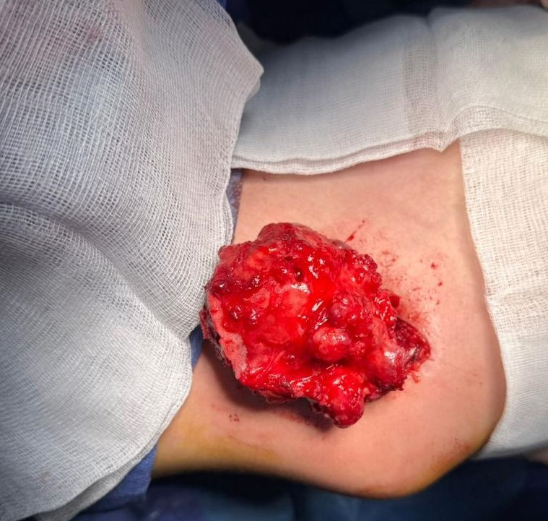
Fig 8 : Coronal CT View of the Shoulder Girdle
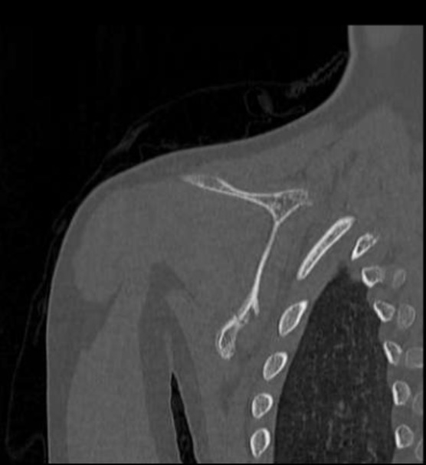
Fig 9 : Post-Operative Assessment of Shoulder Range of Motion (Anterior View)
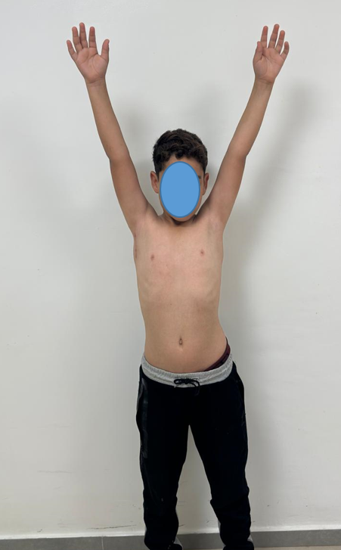
Fig 10 : Axial CT Scan of the Upper Chest Wall and Arm
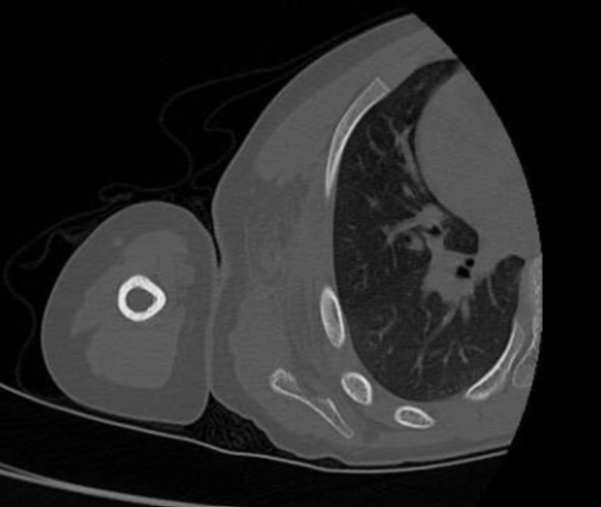
Fig 11 : Post-Operative Clinical Assessment of Posterior Torso
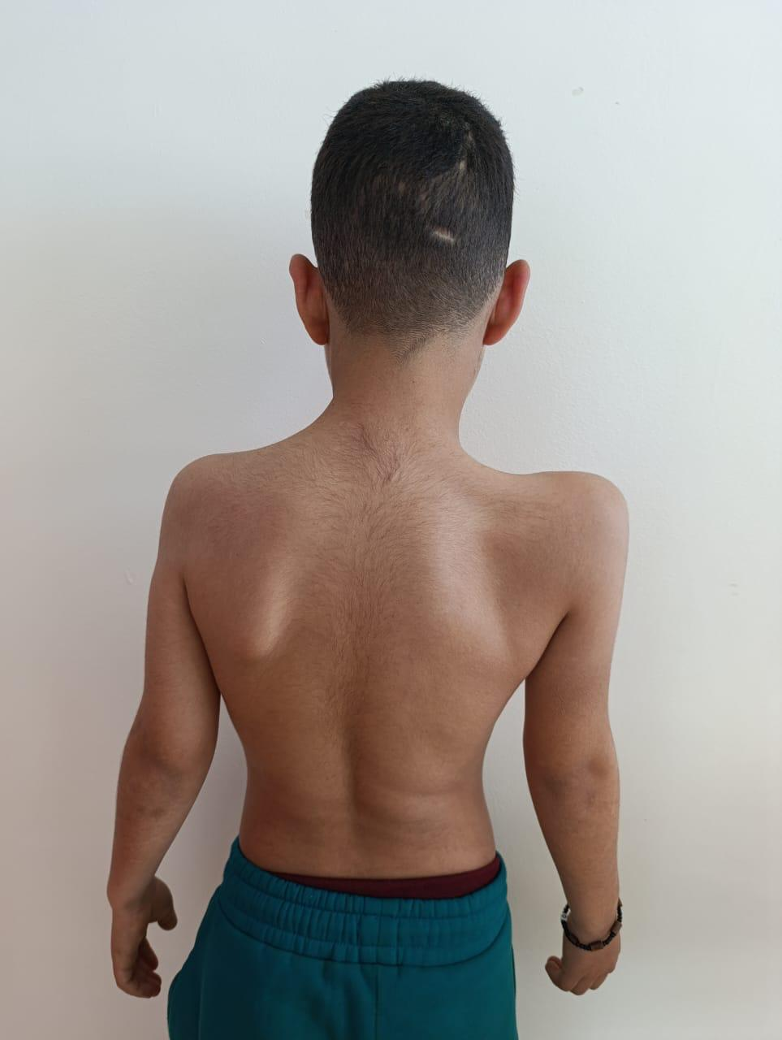
Fig 12 : Post-Operative Clinical Assessment of Anterior Torso
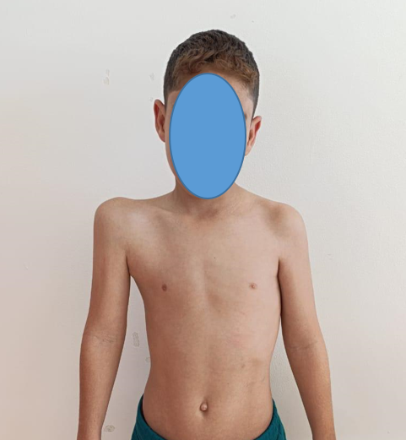
Fig 13 : CT Chest: Axial View of Scapular Mass
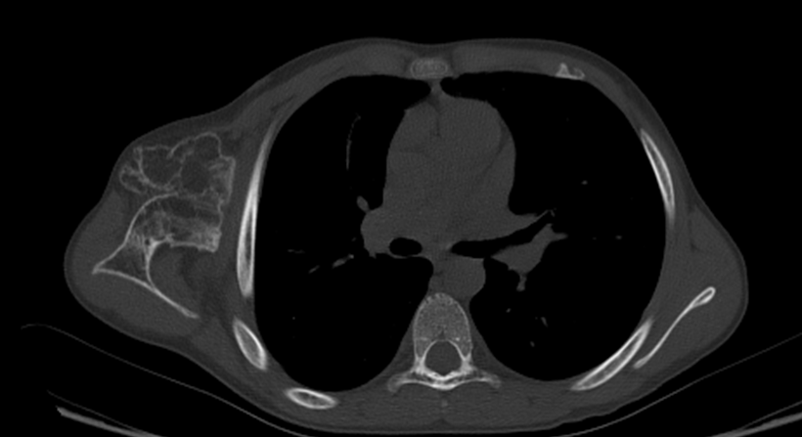
Fig 14 : CT Scan with Lung Window: Scapular Tumor
