Case report
Robotic Excision of a Para-Aortic Paraganglioma: Expanding Surgical Boundaries Through Controlled Decision-Making

Abstract
Paragangliomas are rare extra-adrenal tumors with potential catecholamine secretion, posing unique surgical challenges due to their vascularity and proximity to major vessels. We present a case of an elderly, obese woman diagnosed with a functional left-sided para-aortic paraganglioma, managed successfully using a robotic approach. The tumor’s location between the aorta and inferior vena cava (IVC), along with its vascular temperament, demanded deliberate dissection and careful intraoperative judgment. This case highlights how robotic surgery, when appropriately selected and cautiously executed, may expand the surgical horizon for retroperitoneal vascular tumors traditionally approached through open surgery.

Keywords: Para-aortic paraganglioma, robotic surgery, pheochromocytoma, retroperitoneal tumor, vascular dissection, decision-making, minimally invasive surgery

Introduction
Paragangliomas are rare neuroendocrine tumors arising from chromaffin tissue of the autonomic nervous system, and may occur outside the adrenal gland. When functional, they secrete catecholamines and mimic the clinical behavior of pheochromocytomas (1,2). While most pheochromocytomas are adrenal in origin, extra-adrenal paragangliomas present unique surgical challenges due to their unpredictable anatomical locations and vascularity (3).
Among these, para-aortic paragangliomas carry additional technical difficulty given their adjacency to major vascular structures such as the aorta, inferior vena cava, renal vessels, and surrounding organs. While open thoracoabdominal surgery has traditionally been recommended for such deep retroperitoneal lesions, the progressive refinement of robotic platforms has opened new possibilities. Yet, for the surgical team, the real challenge lies not merely in accessing the tumor but in the initial decision-making—whether the advantages of robotic vision, articulation, and control can safely overcome the anticipated anatomical complexity.
We present a case of functional para-aortic paraganglioma where this critical decision was made. The safe execution of robotic surgery in this context offers important lessons on the evolving boundaries of minimal access techniques for complex retroperitoneal tumors.

Case Presentation
An elderly obese woman, had a history of a fall around five years prior, leading to persistent backache. In 2023, she underwent a CT scan to evaluate the pain, which revealed a left-sided para-aortic mass. At that time, she was advised observation. Subsequently, she traveled to Canada to visit her children, where she underwent evaluation for hypertension. Investigations revealed massively raised urinary and plasma metanephrines, leading to the diagnosis of a functioning paraganglioma.
She returned to India in 2025 and presented to us for further evaluation. A DOTA-NOC PET/CT scan confirmed avid uptake at the tumor site, with no evidence of metastasis. The lesion measured approximately 6–7 cm and was located anterior to the vertebral body, just inferior and medial to the lower pole of the left kidney, nestled between the aorta and IVC.
A thoracoabdominal approach was initially considered, both by our team and as previously suggested by the treating facility in Canada. Such an approach would have provided excellent access to the retroperitoneal field. However, taking into account the patient’s obesity, age, and the potential for faster recovery through minimally invasive surgery, we opted to proceed with a robotic approach.

Surgical Technique
The patient was placed in the modified left lateral decubitus (kidney) position, with the table jack-knifed at the 12th rib level to open the retroperitoneal plane. A Veress needle was inserted approximately 1 inch medial to the left anterior superior iliac spine for pneumoperitoneum. A 12 mm VisiPort was inserted at this site under vision, followed by the introduction of all remaining robotic ports (R1–R4) and a 12 mm assist port, positioned in a curved configuration, taking care to avoid instrument crowding (7).
The descending colon was mobilized with finesse, and the retroperitoneum was accessed. The tumor was seen as a highly vascular, pulsatile mass—a visual reminder of its pheochromocytoma-like behavior (3,6). Dissection proceeded with deliberate caution, maintaining hemostasis while gently releasing the anterior and lateral tumor capsule.
A significant portion of the dissection was performed using fenestrated bipolar forceps, which provided controlled, precise coagulation in the highly vascular field. The monopolar curved scissors (hot shears) were used sparingly—only to divide tissue planes that were clearly bloodless. The vascular nature of the tumor necessitated this measured approach, emphasizing the dominance of bipolar technique for most of the operation.
The tumor was found to be closely applied to the aorta, with gonadal vessels coursing across it and the duodenum lying in close proximity. Despite the intimidating visual vascularity—common in robotic optics (8)—the field remained bloodless due to precise robotic movements.
Working on a functional catecholamine-secreting tumor, the intensity of the operative field was mirrored by a heightened physiological response among the surgical team. Each movement required inner composure as much as anatomical clarity—our own catecholamines surging in sympathetic resonance with the tumor’s volatile nature.
The mass was dissected fully and retrieved via the left iliac fossa port site, which was slightly enlarged for delivery. The 12 mm assist port was closed with a suture passer. The estimated blood loss was negligible. Postoperative recovery was uneventful.

Histopathology
Final histopathological examination confirmed the diagnosis of a left para-aortic paraganglioma. The resected mass measured 5 × 4 × 3.5 cm, consistent with intraoperative findings. Microscopy showed nests of chief cells (Zellballen pattern) with sustentacular cells at the periphery, confirming neuroendocrine origin. Mitotic activity was low, and margins were free of tumor.

Discussion
Paragangliomas are extra-adrenal neuroendocrine tumors derived from the paraganglionic system of the autonomic nervous system. They are histologically similar to pheochromocytomas but differ in their anatomic origin. While pheochromocytomas arise within the adrenal medulla, paragangliomas may occur anywhere along the sympathetic and parasympathetic chains, including the carotid body, jugulotympanic region, mediastinum, and retroperitoneum (1,2).
The retroperitoneal (or para-aortic) subtype is often associated with the sympathetic nervous system and tends to be functional—secreting catecholamines such as norepinephrine and dopamine. Clinical symptoms can include paroxysmal hypertension, palpitations, headaches, and sweating, though many cases remain asymptomatic until discovered incidentally (3,6).
Paragangliomas carry a genetic component in up to 30–40% of cases, with mutations in SDHB, SDHD, and other susceptibility genes linked to familial syndromes (2). Functional tumors pose unique perioperative risks, particularly during induction, tumor manipulation, and pneumoperitoneum, where catecholamine surges may lead to hemodynamic instability (4).
In this case, the proactive contributions of the endocrinologist and anesthesiologist were central to optimizing preoperative metabolic control and intraoperative hemodynamic safety, thereby enabling the surgeon to focus on anatomical precision and controlled dissection.
While classical surgical teaching would have favored open thoracoabdominal access for such deeply seated vascular tumors, advances in robotic technology — including tremor filtration, wristed instrumentation, magnified 3D vision, and stable tissue handling — have allowed surgeons to cautiously approach such lesions robotically. The key, however, remains not merely the availability of technology but thoughtful preoperative judgment about its safe applicability.
Recent literature underscores the growing adoption of robotic-assisted techniques in managing complex paragangliomas, particularly in anatomically challenging locations. A retrospective analysis involving 29 patients demonstrated that robotic surgery for large pheochromocytomas and paragangliomas (>6 cm) resulted in significantly reduced operative times, lower intraoperative blood loss, and decreased conversion rates to open surgery compared to traditional laparoscopic approaches (9).
Additionally, a 2024 case report described the successful robotic excision of a para-aortic paraganglioma in a patient with SDHB mutation, reinforcing the safety and precision of robotic intervention in hereditary cases (10).

From a surgical pedagogy standpoint, this case underscores several important lessons:
- Preoperative Decision-Making: Careful patient selection and surgical access strategy remain paramount.
- Planning and Port Placement: Adequate spacing and positioning are vital to avoid arm conflicts.
- Anatomical Adaptation: Colon mobilization techniques from nephrectomy and colorectal surgeries can be cross-utilized effectively.
- Robotic Mindfulness: Speed is not a virtue in vascular tumors; composure and micro-movements are.
- Perception and Reality: Visual magnification may intensify perceived risks—requiring the surgeon to recalibrate mental models.

Conclusion
This case illustrates that complex para-aortic paragangliomas, traditionally considered candidates for thoracoabdominal open surgery, may be successfully approached robotically when guided by disciplined preoperative decision-making, endocrine and anesthetic optimization, and cautious intraoperative technique. It is not solely robotic technology that permits such surgeries but the surgeon’s composure, judgment, and respect for tissue planes that ultimately ensure safety and success.

Ethics approval: This article is in compliance with ethical principles.

References
- Lenders JWM, Duh QY, Eisenhofer G, et al. Pheochromocytoma and paraganglioma: An endocrine society clinical practice guideline. J Clin Endocrinol Metab. 2014;99(6):1915–42.
- Fishbein L, Nathanson KL. Pheochromocytoma and paraganglioma: Understanding the complexities of the genetic background. Cancer Genet. 2012;205(1-2):1–11.
- Goffredo P, Sosa JA, Roman SA. Malignant pheochromocytoma and paraganglioma: A population-level analysis of malignant potential and survival. J Surg Oncol. 2013;107(6):659–64.
- Krauss T, Ferrara AM, Links TP, et al. Predictors of catecholamine-related perioperative complications in pheochromocytoma. J Clin Endocrinol Metab. 2018;103(12):4366–74.
- Snyder SK, Hamid KS, Roberson CR, et al. Laparoscopic resection of extra-adrenal pheochromocytoma: A single-institution series. J Am Coll Surg. 2010;210(6):718–23.
- Mayo SC, de Jong MC, Pulitano C, et al. Surgical management of hepatic neuroendocrine tumor metastasis: Results from an international multi-institutional analysis. Ann Surg Oncol. 2010;17(12):3129–36.
- Dipen Parikh. Partial nephrectomy step-by-step technique [YouTube Video]. 2016. Available from: https://www.youtube.com/watch?v=kuhvdscS8K0
- Nikiforchin A, Baron E, Wernberg JA, Sharma R. Paraaortic Extra-Adrenal Paraganglioma: Challenging Robotic Resection. Ann Surg Oncol. 2024;31:4197–4198.
- Ou MJ, Deng JH, Wen J, et al. Clinical analysis of robotic-assisted surgery in the treatment of large pheochromocytoma/paraganglioma: a study of 29 cases. Zhonghua Yi Xue Za Zhi. 2024;104(38):3604–3608.
- Neumann HPH, Bausch B, McWhinney SR, et al. Germ-line mutations in nonsyndromic pheochromocytoma. N Engl J Med. 2002;346(19):1459–66.

Fig 1 : Axial CT images
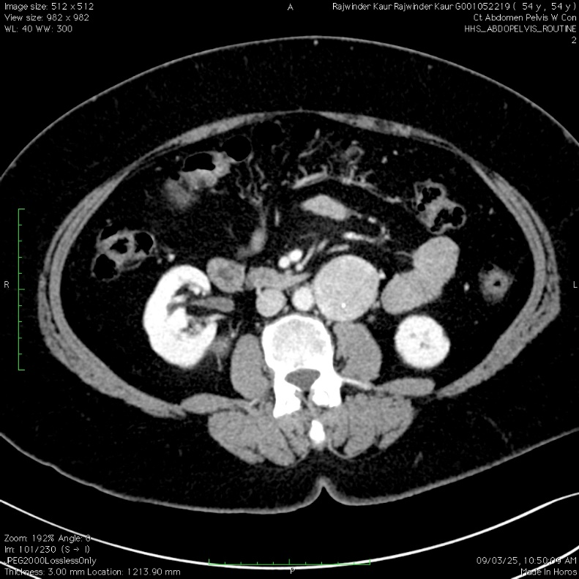

Fig 2 : Coronal CT images
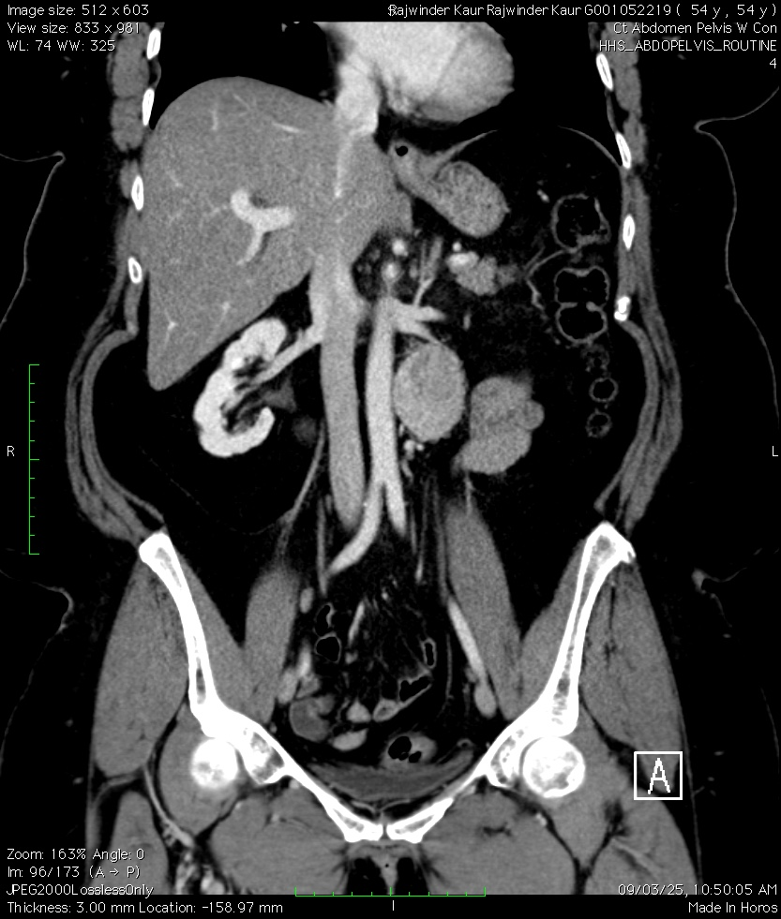

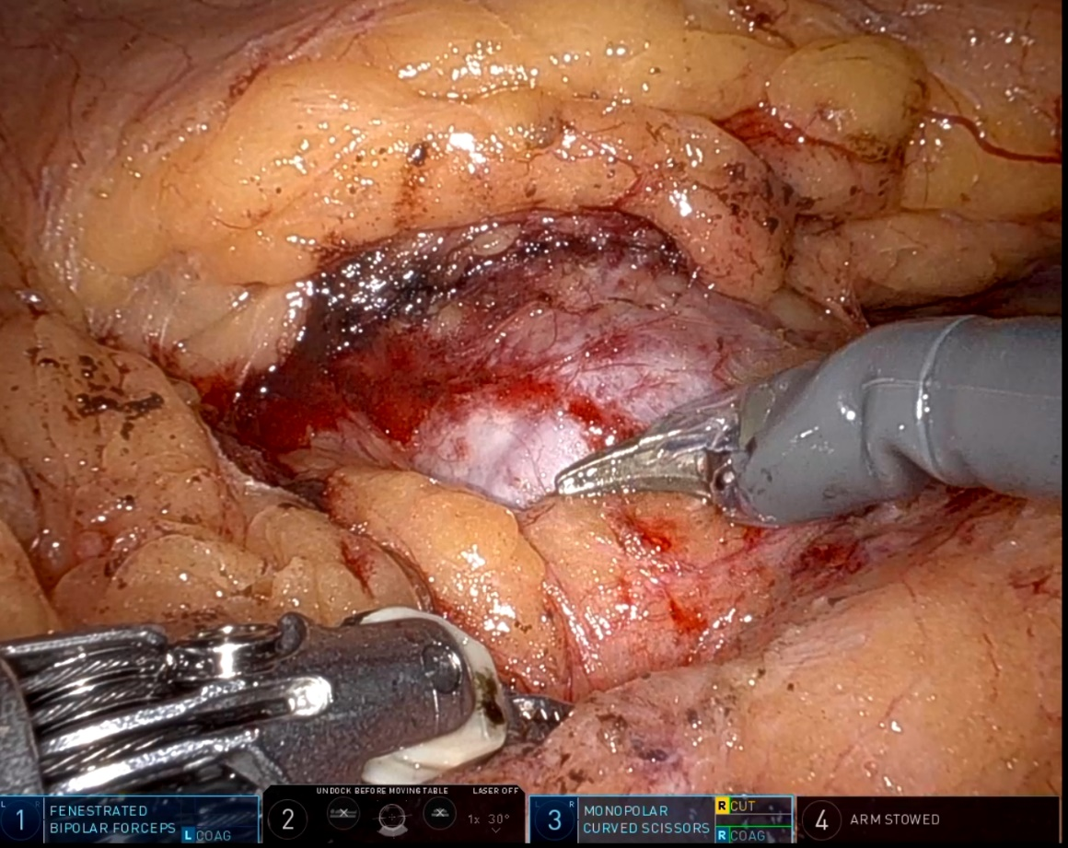
Fig 3 : Intraoperative robotic views

Fig 4 : A robotic-assisted laparoscopic surgery showing surgical instruments dissecting tissue inside the abdomen
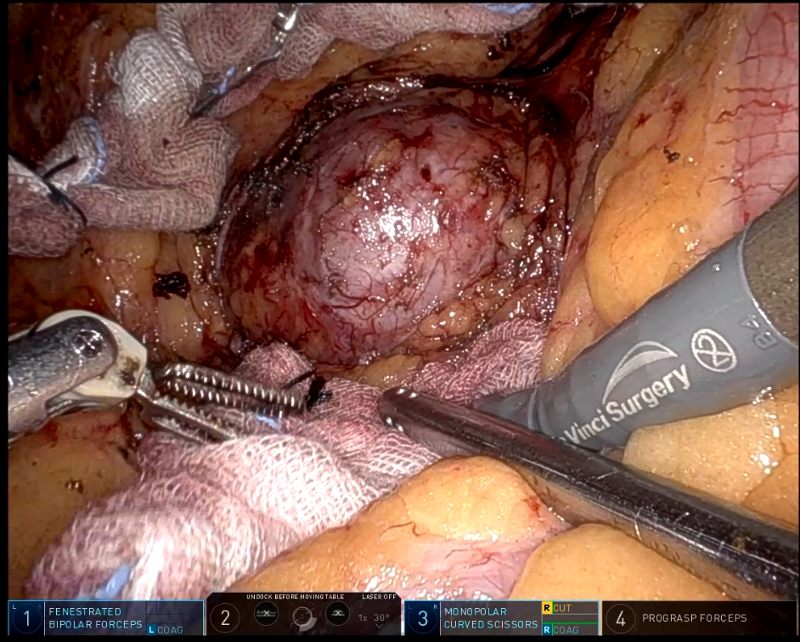

Fig 5 : Robotic Dissection of a Large, Vascular Surgical Mass
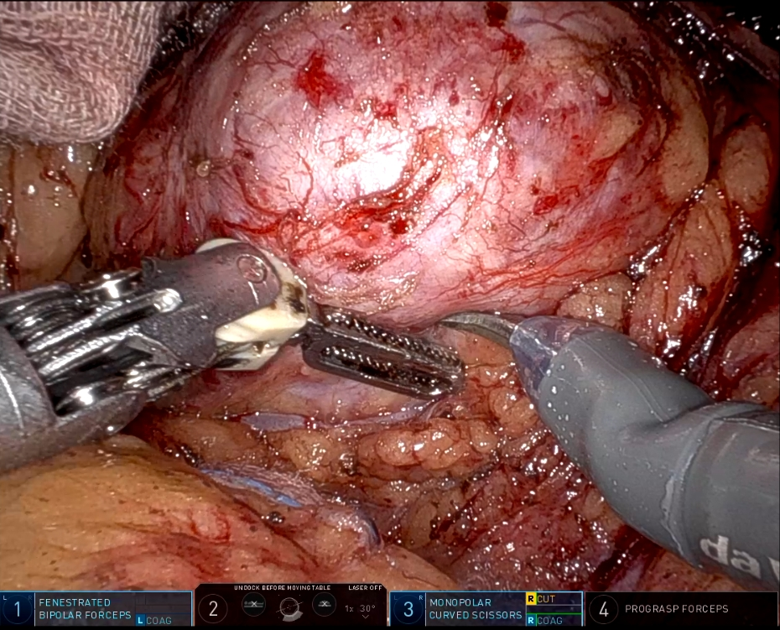

Fig 6 : Robotic Dissection and Coagulation of a Vascularized Soft Tissue Mass
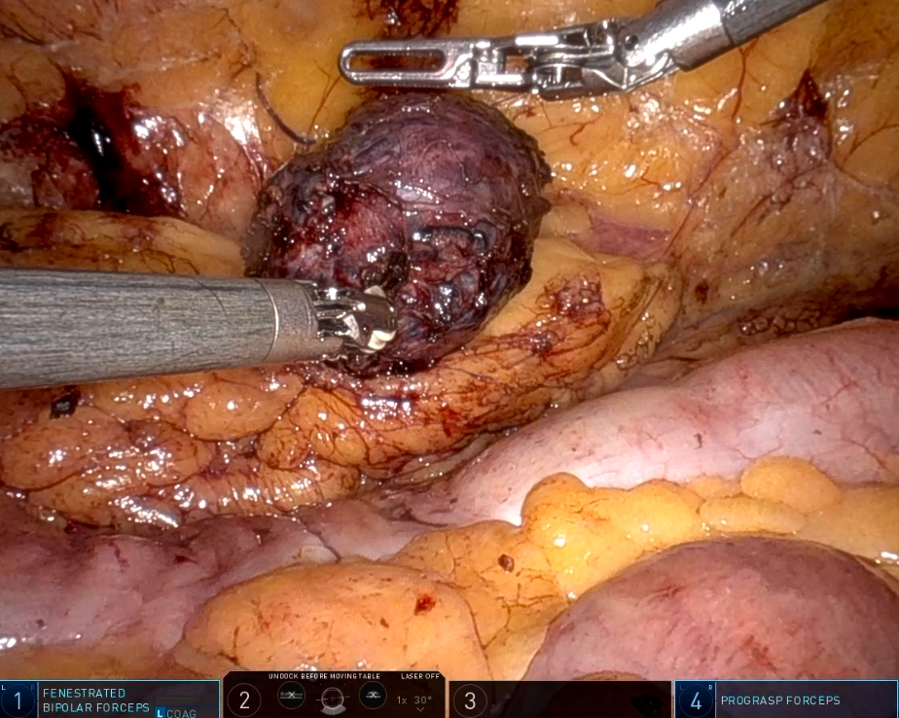

Fig 7 : Gross specimen with Scale

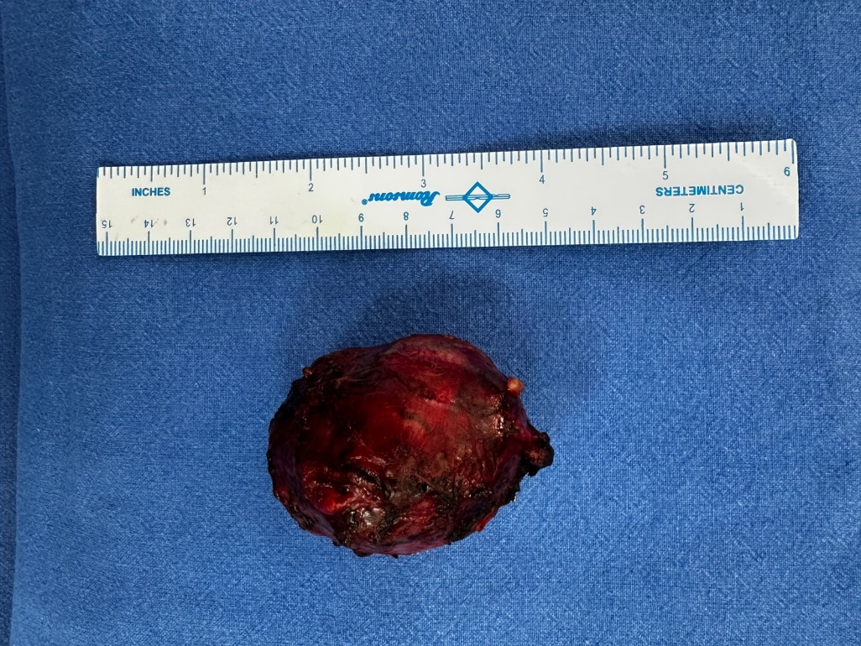

Histopathological photomicrograph
Plate 1 : Photomicrograph showing encapsulated tumor H&E, 20X

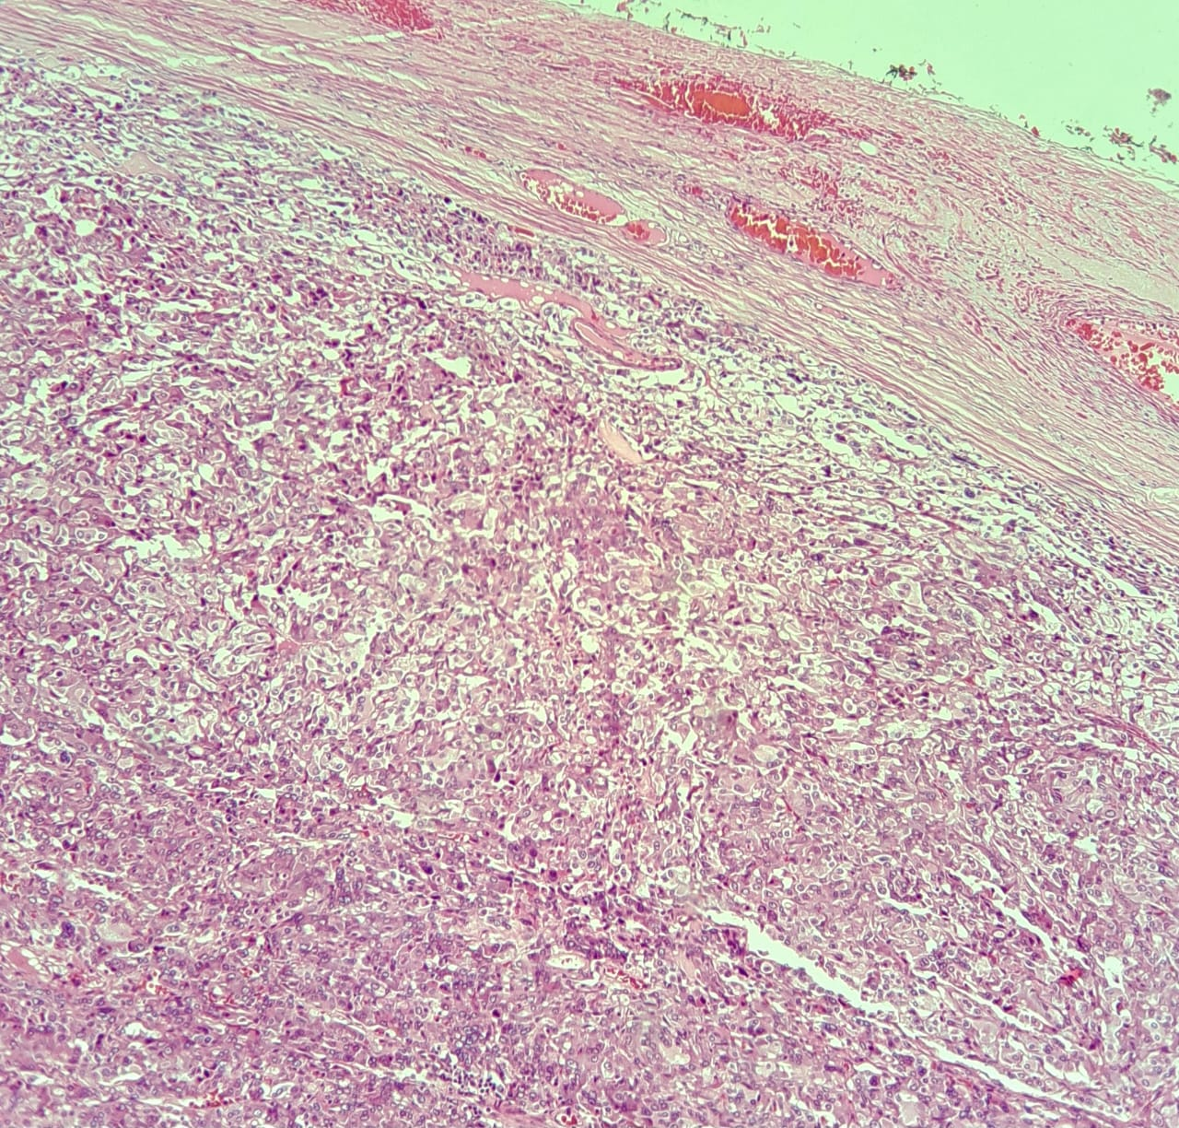
Plate 2 : Microscopic View of Tumor Tissue: Zellerballen/Nesting Pattern
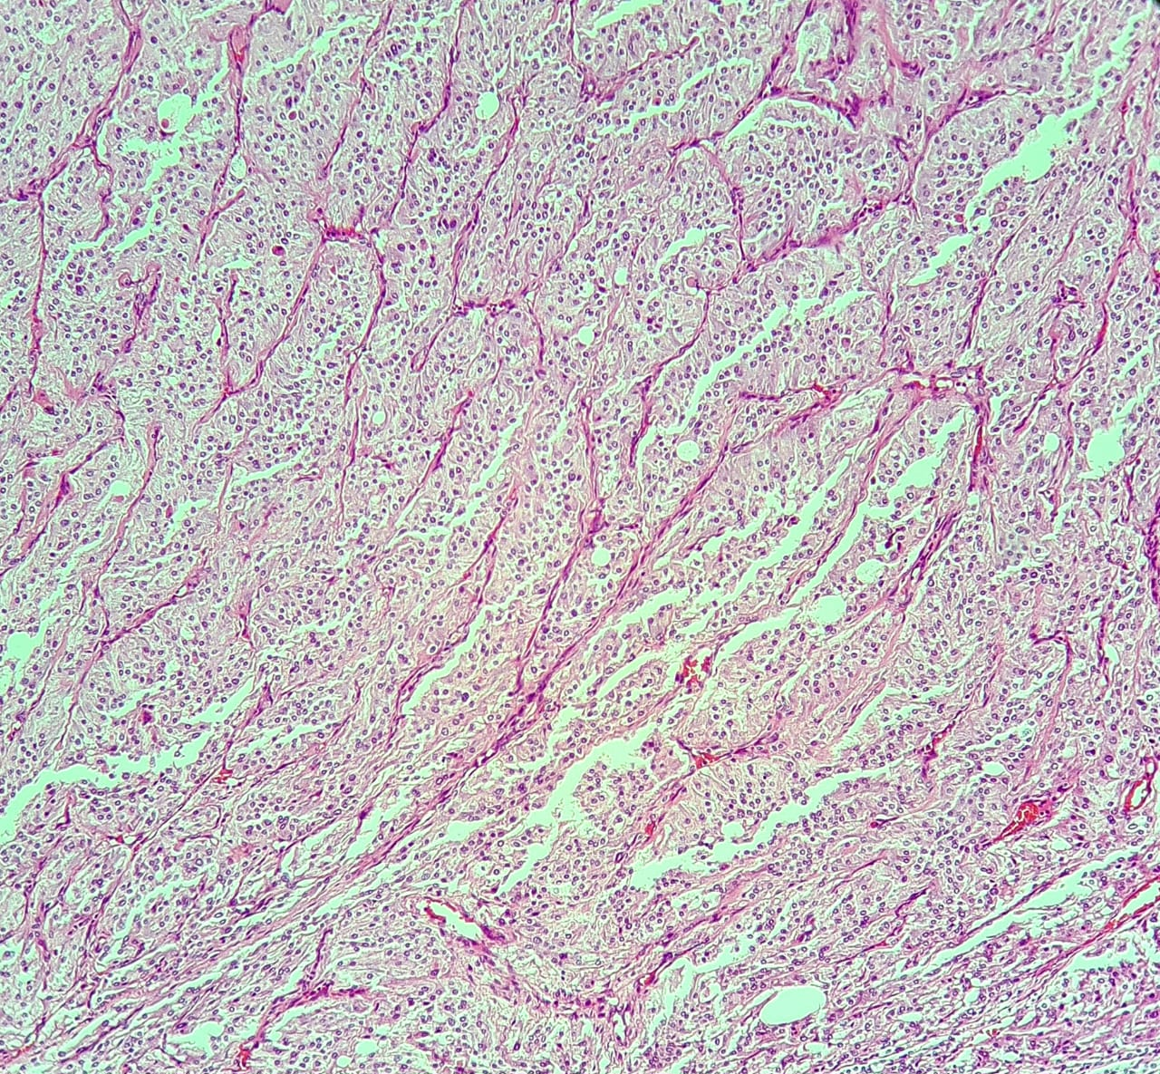

Plate 3 : Photomicrograph showing tumor cells arranged in nest H&E, 40X

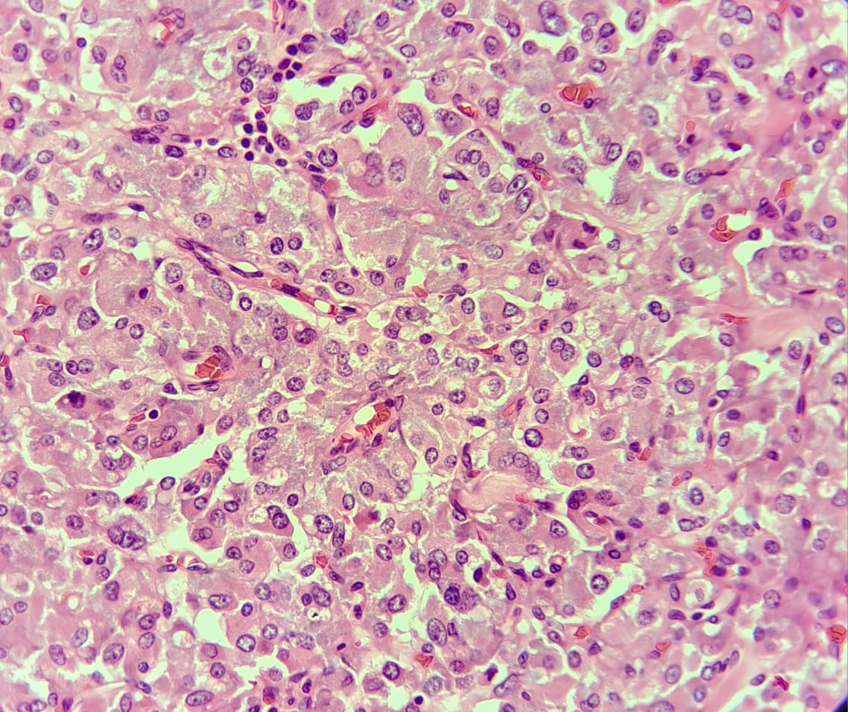

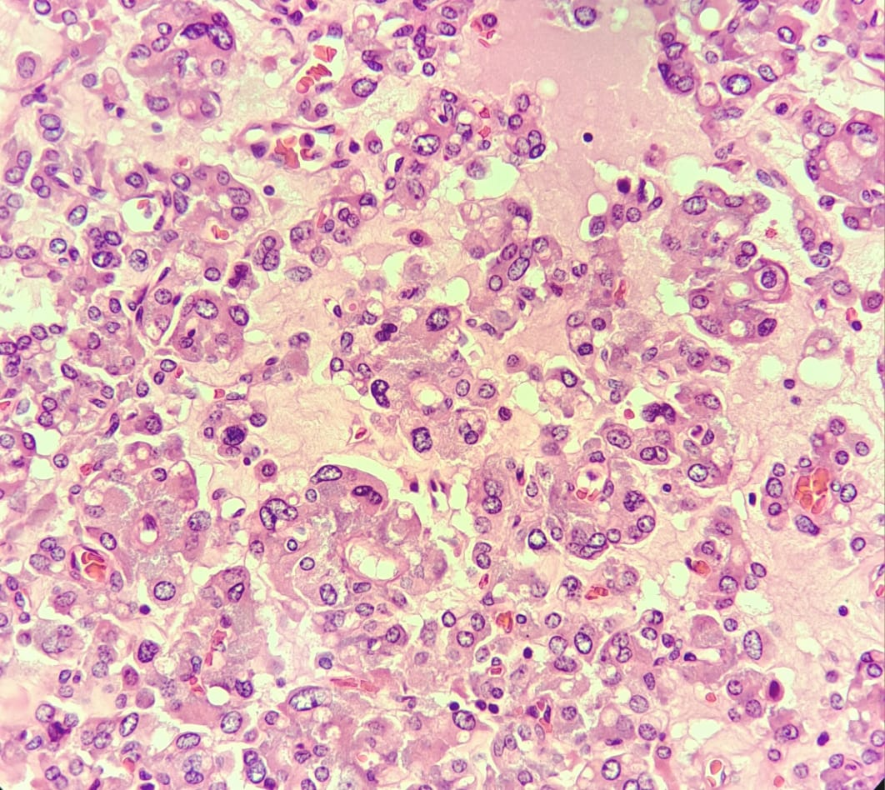
Plate 4 : High-Power Micrograph: Papillary and Solid Tumor Architecture with Nuclear Atypia

