Case report

One Hernia, Two Diagnoses: Amyand’s and Richter’s Hernia Revealed Intraoperatively

ABSTRACT

Introduction: Amyand’s hernia is characterized by the presence of the vermiform appendix within an inguinal hernia sac whereas Richter’s hernia refers to the herniation of antimesenteric border of bowel through the fascial defect. The coexistence of both hernias is rarely reported and the diagnosis usually made intraoperatively, creating unique challenges in surgical management.
Case Presentation: A 69-year-old gentleman with previous history of right inguinal hernia repair presented to the emergency department with recurrent and obstructed right inguinal hernia. Initial inguinal exploration was unsuccessful due to distorted anatomy hence converted to midline laparotomy. Intraoperatively revealed Amyand’s hernia and Richter’s hernia. Appendicectomy, bowel resuscitation and hernia repair was performed. The postoperative course was uneventful.
Discussion: The simultaneous occurrence of Amyand’s hernia and Richter’s hernia is extremely rare. The management can be challenging, depends on the clinical assessment of appendix and bowel viability intraoperatively.
Conclusion: This case illustrates the extremely uncommon case of combined hernia. It emphasize the importance of maintaining intraoperative vigilance to identify any coexisting pathologies and highlights the significance of individualized planning and prompt surgical intervention in the management of recurrent and combined hernia.

Keywords: Amyand’s hernia; Richter’s hernia

1. INTRODUCTION

Inguinal hernia is defined as the protrusion of abdominal content through the inguinal canal. It is among the most common surgical conditions, but unusual contents within the hernia sac remain rare and diagnostically challenging.

Amyand’s hernia, first described in 1735 by Claudius Amyand, refers to the presence of the vermiform appendix within an inguinal hernia sac. The overall prevalence is around 1% with acute appendicitis complicating the condition in approximately 0.8% to 0.13% of cases and it accounts for 0.1% of all appendicitis [1, 2]. Amyand’s hernia has been reported in patient with age ranging from neonatal period to 92 year old and more likely to be seen in pediatric population due to the presence of patent processus vaginalis [3]. It usually occurs at the right side, probably due to the normal anatomical location of appendix. Literature shows that men population account for over 90% of cases [4].

In 1958, Fabricius Hildanus documented the earliest known case of Richter’s hernia. However, it was in 1785 that the German surgeon August Gottlieb Richter provided a detailed and scientific description of this condition. Richter’s hernia characterized by the herniation of part of the bowel wall, typically the antimesenteric border without complete obstruction, and it accounting for 10% of strangulated hernias. It is more frequent in femoral canal (36-88%), followed by inguinal canal (12-36%) and abdominal wall defects (4-25%). The incidence of Richter’s hernia is higher in female population, which might be due to the fact that femoral hernia is more commonly happens in women compared to men. It typically occurs in elderly aged between 60 and 80 years. However, there have been reported instances in infants as well [5,6,7].

Here, we present a case of simultaneous occurrence of Amyand’s and Richter’s hernia that discovered intraoperatively during hernia repair, highlighting the importance of vigilance in surgical decision making.

2. CASE PRESENTATION

A 69-year-old gentleman with underlying diabetes, hypertension, and a previous history of right inguinal hernia repair presented to the emergency department with lower abdominal pain, vomiting and loose stool for past three days. On examination, there was an irreducible right inguinoscrotal swelling. Otherwise there was no sign of systemic sepsis. Laboratory tests showed mild leucocytosis, while abdominal radiograph suggested small bowel obstruction.

Patient was diagnosed as obstructed right inguinal hernia and posted for right open hernioplasty. Appendix was identified within the hernia sac intraoperatively. However, the procedure was converted to midline laparotomy due to distorted anatomy, which confirmed Amyand’s hernia with the appendix herniating through the deep inguinal ring. Additionally, a Richter’s hernia was noted, with a segment of small bowel partially entrapped at the antimesenteric border near the hernia orifice. The involved bowel showed contusion but viable mucosa.

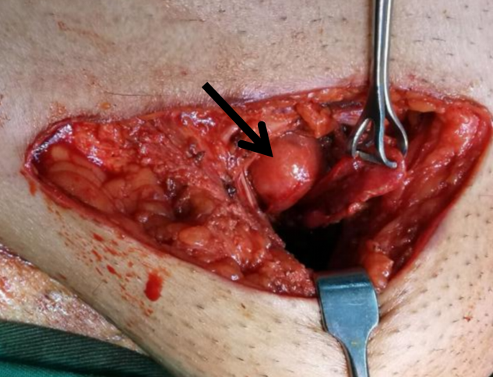

Figure1: Tip of appendix identified from inguinal incision

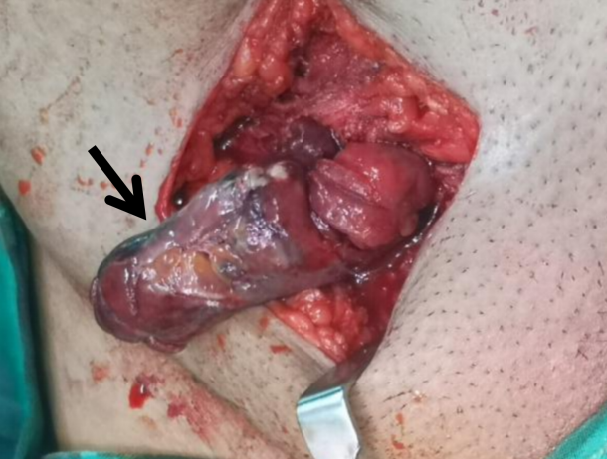

Figure 2: Inflamed appendix with surrounding slough.

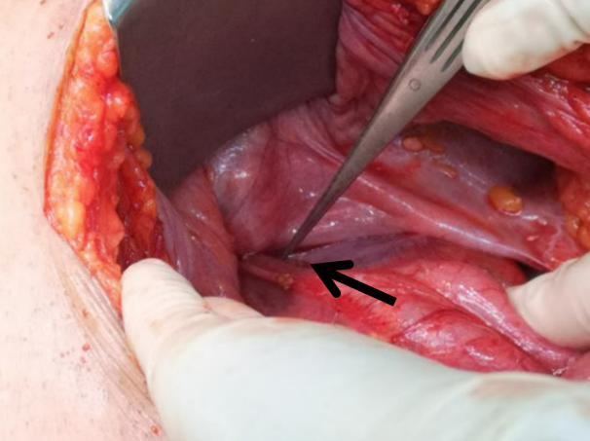

Figure 3: Base of appendix at deep ring from laparotomy incision.

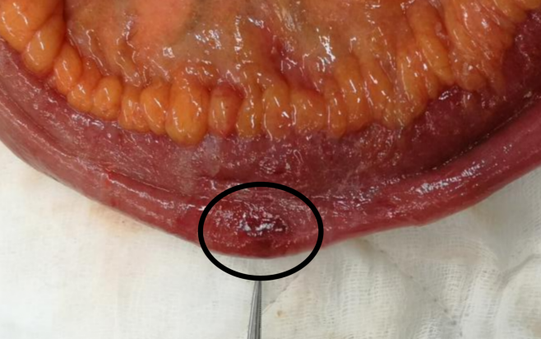
Figure 4: Segment of small bowel partially entrapped at the antimesenteric border near the hernia upon removal.
Surgical management consisted of appendicectomy, bowel resuscitation with warm saline packing of small bowel and oxygenation, hernia repair without the need for bowel resection. The postoperative course was uneventful and patient discharged well on day six postoperatively. At two-week follow-up, he remained well with no wound complications.

- DISCUSSION

Both Amyand’s hernia and Richter’s hernia are rare entities. The coexistence of dual pathologies is extremely uncommon. Preoperative diagnosis is almost impossible especially in emergency setting and the diagnosis usually made intraoperatively as in our case. Ultrasound or computed tomography may aid in clinical diagnosis in elective cases but not routinely performed in emergency cases.

Amyand’s hernia characterized by the herniation of appendix into the inguinal hernia sac. Most cases of Amyand’s hernia are identified incidentally during hernia repair. The presentation varies from incidental finding of a normal appendix to acute appendicitis within the hernia sac [8]. Perforated appendix accounts for 0.1% of all cases, leading to a significant increase in mortality rate ranging from 15-30% due to severe abdominal sepsis [9]. Management remains debated, but appendicectomy is generally performed when appendiceal inflammation or future diagnostic uncertainty is anticipated. Losanoff JE and Basson MD introduced a classification system with four categories based on the condition of appendix and the severity of sepsis which guides the management of Amyand’s hernia [10]. In our case, it classified as Type 2 Amyand’s hernia where appendix was inflamed without abdominal sepsis. Appendicectomy was performed and hernia repair was done without mesh repair in view of risk of surgical site infection.

Richter’s hernia, on the other hand, involves partial entrapment of the bowel wall leading to ischemia and necrosis without causing complete obstruction. Terminal ileum is the most common affected segment in Richter’s hernia [5]. Due to incomplete bowel obstruction, there is an increased risk of delayed presentation, diagnosis and treatment. Patient may present with abdominal pain and rarely with obstructive symptoms. By the time of presentation, the bowels may progress into ischemia, gangrene or perforation, highlighting the necessity for prompt identification and intervention. The management of Richter’s hernia requires timely surgical intervention either reduction with mesh repair or resection, based on bowel viability [11]. In the case of bowel ischemia, necrosis or perforation, laparotomy and bowel resection is mandatory. In this particular case, the bowel was contused but viable. Bowel resuscitation was performed without the need for resection, which improved the long-term outcome for the patient.

To our knowledge, there were very few reports described the simultaneous occurrence of Amyand’s and Richter’s hernia, making intraoperative recognition crucial [12]. In our case, distorted anatomy prompted conversion to laparotomy, ensuring accurate diagnosis and safe management. This case highlights the importance of maintaining intraoperative vigilance to identify any coexisting pathologies especially in the case of recurrent hernia. Tailored management which includes appendicectomy and bowel assessment without unnecessary resection optimizes patient outcomes.

4. Conclusion

The coexistence of Amyand’s and Richter’s hernia is extremely rare but clinically significant. Surgeons must maintain a high index of suspicion and adaptability during hernia surgery to ensure optimal outcomes. Further research and study is needed to for better patient management.

Consent

As per international standard, the patient’s written consent was obtained and preserved by author.

Ethical approval

Not applicable.

References

1.Faiz, N., Ahmad, N., & Singh, R. (2016). Case series on different presentations of Amyand's hernia. Archives of International Surgery, 6(3), 176.
2.Khalid, H., Khan, N. A., & Aziz, M. A. (2021). Amyand's hernia a case report. International journal of surgery case reports, 86, 106332.
3.Ivanschuk, G., Cesmebasi, A., Sorenson, E. P., Blaak, C., Loukas, M., & Tubbs, S. R. (2014). Amyand's hernia: a review. Medical science monitor : international medical journal of experimental and clinical research, 20, 140–146.
4.Călin M, Costache M, Ilie V, Călin A, Dăscălescu D, Dinu D, et al. Amyand’s hernia: case series and literature review. Romanian Journal of Experimental Surgery. 2024;11(1):7–11
5.Skandalakis, P. N., Zoras, O., Skandalakis, J. E., & Mirilas, P. (2006). Richter hernia: surgical anatomy and technique of repair. The American surgeon, 72(2), 180–184.
6.Steinke, W., & Zellweger, R. (2000). Richter's hernia and Sir Frederick Treves: an original clinical experience, review, and historical overview. Annals of surgery, 232(5), 710–718.
7. Katragadda, K., DeStefano, L. M., & Khan, M. F. (2019). A case of Richter hernia: a rare entity. ACS Case Rev Surg, 2(3), 5-7.
8.Michalinos, A., Moris, D., & Vernadakis, S. (2014). Amyand’s hernia: A review. American Journal of Surgery, 207(6), 989–995.
9.Morales-Cárdenas, A., Ploneda-Valencia, C. F., Sainz-Escárrega, V. H., Hernández-Campos, A. C., Navarro-Muñiz, E., López-Lizarraga, C. R., et al. (2015). Amyand hernia: Case report and review of the literature. Annals of Medicine and Surgery, 4(2), 113–115. 10.Losanoff, J. E., & Basson, M. D. (2007). Amyand hernia: what lies beneath--a proposed classification scheme to determine management. The American surgeon, 73(12), 1288–1290.
11.Al-Jawad, M., Alnasser, S., Lbabidi, N. A., Sheikh, A., Diarbakerly, B., & Kawas, A. (2024). Prevascular Richter’s hernia: A rare and challenging presentation of a potentially life-threatening condition: A rare case report. International Journal of Surgery Case Reports, 121, 110024.
12.Bori, A. K., Tebisso, A. D., Kahsay, A. B., & Goshu, E. M. (2024). A case report on rarer case of triple combined hernia: Management, challenges, and insights. International journal of surgery case reports, 122, 110051.

