Case report
Ammonium Bi-Urates in the Urine of a 10-Year-Old Boy: A Case Report from a Tertiary Care Hospital

Abstract
Background:
Ammonium bi-urate crystals are uncommon findings on urine microscopy, particularly in older children. Their presence may indicate underlying metabolic disturbances, dehydration, infection, or altered urinary pH. Recognizing these crystals is important to prevent urinary tract pathologies, including stone formation.
Case report:
A 10-year-old boy presented with low-grade fever and mild dehydration, but no urinary symptoms. Urine microscopy revealed numerous refractile, brownish-yellow “thorn-apple” crystals at near-neutral pH, which is consistent with ammonium bi-urate. The urine culture was sterile, and renal function test results were normal. The child was managed conservatively with hydration advice, resulting in complete resolution of the crystalluria on follow-up after three months.
Discussion:
Ammonium bi-urate crystalluria occurs when the urinary ammonia and urate concentrations increase under near-neutral pH conditions. Transient metabolic stress or reduced fluid intake can precipitate such crystals even in the absence of infection. Although historically observed in regions with a high prevalence of bladder stones and low phosphate diets, sporadic cases may occur in otherwise healthy children. Early recognition and hydration remain key to preventing stone disease progression.
Conclusion:
Ammonium bi-urate crystals, although rare in older children, may appear transiently during febrile or dehydrating illnesses. Recognition of their morphology and prompt correction of hydration status are vital for the resolution and prevention of recurrence. This case underscores the diagnostic importance of correlating urinary crystal morphology with clinical context.
Keywords:
Ammonium bi-urate crystals, crystalluria, dehydration, lithogenic risk, pediatric urine microscopy, thorn-apple crystals
Introduction
Crystalluria refers to the presence of crystals in urine sediment and is a frequent finding during routine microscopic examination. While most crystals are physiologic or transient, some types may indicate or predispose to urolithiasis or systemic metabolic abnormalities ¹⁻².
Pediatric urinary stone disease, once considered rare, is now increasingly reported, particularly involving renal and ureteric calculi. Despite a low prevalence of 2–3%, recurrence rates range from 6.5% to 54%. Given its risk of significant morbidity and potential progression to end-stage renal disease, pediatric urolithiasis has become a growing clinical concern ³⁻⁵.
Ammonium urate and ammonium bi-urate crystals are rare in modern clinical practice, particularly beyond infancy. They are typically associated with dehydration, urinary tract infections, metabolic acidosis, or diets rich in purines. These crystals are more frequently encountered in resource-limited regions or in areas endemic for bladder stones ⁶⁻⁷.
Ammonium bi-urate crystals have a distinctive “thorn-apple” morphology and are less soluble at neutral or slightly alkaline urinary pH levels. Recognition of these crystals is crucial because their persistence may precede the formation of ammonium urate stones ⁸. Here, we report a case of incidental detection of ammonium bi-urate crystals in an older child during evaluation for febrile illness, emphasizing the importance of hydration and monitoring.
Case Report
A 10-year-old male child presented to the outpatient department of the Raipur Institute of Medical Sciences, a tertiary care hospital Raipur, Chhattisgarh, India, with a history of low-grade fever lasting for four days. There were no associated urinary symptoms, such as dysuria, hematuria, flank pain, urgency, or frequency. The child’s appetite was slightly reduced during the febrile episode, and the parents reported a mild decrease in oral fluid intake. There was no history of gastroenteritis, vomiting, or recent illness, and no prior episodes suggestive of ureteric or metabolic disease. His medical history was unremarkable, with normal growth and development, and no history of nephrolithiasis or recurrent urinary tract infections. The child was not on any medications at the time of presentation.
On general physical examination, the patient appeared well nourished but mildly dehydrated, as evidenced by dry oral mucosa and slightly reduced skin turgor. At the time of examination, he was afebrile, and vital signs were within normal limits for age. Systemic examination revealed a soft, nontender abdomen without organomegaly or costovertebral angle tenderness. The results of cardiovascular, respiratory, and neurological examinations were unremarkable.

Table 1. Laboratory Investigations
Test | Result | Interpretation
Urine (Gross Examination) | Turbid, yellowish appearance | Suggestive of concentrated urine; possible mild dehydration
Urine dipstick | pH ≈ 6.5; no protein, no blood, nitrite/leukocyte esterase negative | Near-neutral urine
Urine (Microscopy Examination) | Numerous thorn-apple shaped ammonium bi-urate crystals, refractile, brownish-yellow; no casts or bacteria | Characteristic morphology
Urine culture | Sterile | Rules out infection
Serum creatinine, BUN | Normal | Normal renal function
Serum uric acid | Normal | No hyperuricemia
Spot urine uric acid: creatinine ratio | Normal | No hyperuricosuria
Electrolytes (Na⁺, K⁺, Cl⁻) | Normal | Balanced status
CBC | Mild neutrophilic leukocytosis | Suggests inflammatory response
CRP | 47.84 mg/L (elevated) | Confirms systemic inflammation
Widal test, MP smear, Dengue NS1/IgM | Negative | No evidence of enteric fever, malaria, or dengue
Ultrasound KUB | No stones or hydronephrosis | Normal study

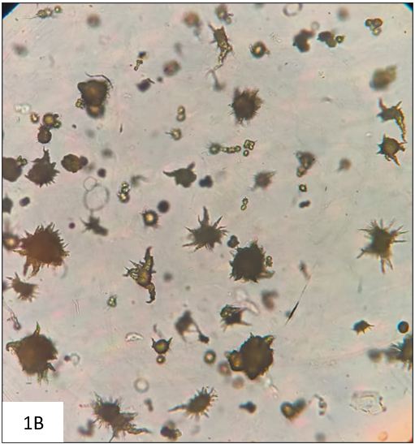
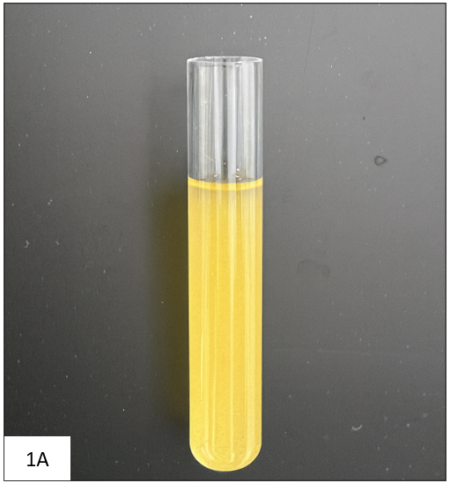

Figure 1: (A) Turbid yellowish urine sample, indicating concentration. (B) Unstained wet mount (×40) showing numerous refractile “thorn-apple” shaped ammonium bi-urate crystals.

Management and Outcome
The patient was managed conservatively with emphasis on correcting mild dehydration and optimizing dietary intake. He and his caregivers were counselled to increase daily fluid intake to approximately 1.5–2 liters per day, with the goal of maintaining clear, adequately diluted urine. Regular follow-up was advised with repeat urinalysis every four–six weeks to monitor for persistence or recurrence of crystalluria. At the 3-month follow-up visit, urine microscopy revealed complete resolution of the ammonium bi-urate crystals, and the urine appeared clear. The patient remained asymptomatic with normal renal function parameters and no new clinical concerns.
Discussion
Ammonium bi-urate crystalluria is an uncommon finding in pediatric urine microscopy and is rarely observed in routine practice. Its formation depends on the urinary urate concentration, ammonia levels, and urinary pH. These crystals typically appear in near-neutral to slightly alkaline urine, where the urate solubility decreases. Transient factors, such as dehydration, fever, or mild metabolic stress, may increase urinary ammonia and solute concentrations and promote crystal formation. While urease-producing infections are known to cause ammonium urate precipitation, the sterile urine culture in this case excluded the infection. Thus, crystalluria was likely due to transient dehydration and systemic inflammatory changes during the febrile episode, which temporarily altered urinary chemistry and favored crystal precipitation.
Clinical Relevance
Crystalluria often precedes stone formation. In children, ammonium urate stones have been described after episodes of gastroenteritis or severe dehydration (Ban et al., 2022). Our case differs in that it demonstrated crystalluria during a mild febrile illness without overt dehydration or infection and with spontaneous resolution upon hydration.
Differential Diagnosis
The differential diagnosis of crystalline deposits by urine microscopy includes uric acid, sodium or potassium urate, calcium oxalate, and phosphate crystals. However, these morphological differences are typically observed in more acidic or alkaline environments. The absence of triple phosphate crystals and negative urine culture excluded infection-related crystalluria in this case.
Comparison with Literature
Ammonium urate and ammonium bi-urate crystals are rare, but remain documented in specific populations and conditions. Klohn et al. (1986) described their occurrence with ammonium-rich urine, low phosphate intake, and dehydration in endemic regions ⁸. Borden and Dean (1979) reported ammonium acid urate stones in Navajo children, highlighting pediatric susceptibility linked to environmental and dietary factors ⁹. Kamoun et al. (1999) found ammonium urate as the stone nucleus in 38–45% of Tunisian pediatric cases, confirming its regional prevalence ¹⁰. In contrast, Gabrielsen et al. (2012) showed that these stones are uncommon and decrease with age in U.S. children ¹¹. Frochot and Daudon (2016) emphasized the prognostic value of crystalluria, noting that rare urate crystals may precede stone formation ¹².
Our findings are consistent with previously reported observations, demonstrating transient ammonium bi-urate crystalluria during mild dehydration that resolved completely with hydration, highlighting the importance of adequate fluid intake in preventing lithogenic risk.

Limitations
This case report had certain limitations that should be acknowledged. As this was a single-case observation, the findings cannot be generalized to a broader pediatric population. Larger studies or multicenter case series are needed to better understand the prevalence, underlying metabolic factors, and clinical implications of ammonium bi-urate crystalluria in children, especially in the context of transient dehydration or febrile illnesses.
Conclusion
Ammonium bi-urate crystals, though rare in older children, may appear transiently during febrile or dehydrating illnesses. Recognition of their distinctive morphology should prompt evaluation of hydration, dietary habits, and urinary pH. With timely conservative management, recurrence and progression to stone disease can be prevented. Awareness among clinicians and laboratory professionals ensures an appropriate evaluation.

​References
- Baumann JM, Affolter B. From crystalluria to kidney stones: some physicochemical aspects of calcium nephrolithiasis. World J Nephrol. 2014;3(4):256–67. Available from: https://pmc.ncbi.nlm.nih.gov/articles/PMC4220359/
- Letavernier E, Bazin D, Daudon M. Description of stone morphology and crystalluria improve diagnosis and care of kidney stone formers. Healthcare (Basel). 2022 Dec 20;11(1):2. Available from: https://www.mdpi.com/2227-9032/11/1/2
- Akın Y, Uçar M, Yücel S. Current medical treatment in pediatric urolithiasis. Turk J Urol. 2014. Available from: https://www.turkishjournalofurology.com
- Tasian GE, Kabarriti AE, Kalmus A, Furth SL. Kidney stone recurrence among children and adolescents. J Urol. 2016;197(1):246–52. Available from: https://pmc.ncbi.nlm.nih.gov/articles/PMC5161588/
- Pecoraro L, Zuccato A, Vitella R, Pietrobelli A, Piacentini G, Brugnara M. Pediatric nephrolithiasis: a changing landscape through time and space. Medicina (Kaunas). 2024 Dec 2;60(12):1993. Available from: https://www.mdpi.com/1648-9144/60/12/1993
- Bowyer R, Brockis JG. Biochemical aspects of the investigation of ammonium urate bladder stone formation in Indonesian children. Pathology. 1977;9(1):79–86. Available from: https://www.sciencedirect.com/science/article/abs/pii/S0031302516386962
- Soble JJ, Hamilton BD, Streem SB. Ammonium acid urate calculi: a reevaluation of risk factors. J Urol. 1999;161(3):869–73. Available from: https://pubmed.ncbi.nlm.nih.gov/10022703/
- Klohn M, Bolle JF, Reverdin NP, Susini A, Baud CA, Graber P. Ammonium urate urinary stones. Urol Res. 1986 Dec;14(6):315–8.
- Borden TA, Dean WM. Ammonium acid urate stones in Navajo Indian children. Urology. 1979;14(1):9–12. Available from: https://pubmed.ncbi.nlm.nih.gov/452233/
- Kamoun A, Daudon M, Abdelmoula J, Hamzaoui M, Chaouachi B, Houissa T, et al. Urolithiasis in Tunisian children: a study of 120 cases based on stone composition. Pediatr Nephrol. 1999;13(9):920–5. Available from: https://pubmed.ncbi.nlm.nih.gov/10603149/
- Gabrielsen JS, Laciak RJ, Frank EL, McFadden M, Bates CS, Oottamasathien S, et al. Pediatric urinary stone composition in the United States. J Urol. 2012 Jun;187(6):2182–7. Available from: https://pubmed.ncbi.nlm.nih.gov/22503021/
- Frochot V, Daudon M. Clinical value of crystalluria and quantitative morpho constitutional analysis of urinary calculi. Int J Surg. 2016 Dec 1;36(Pt D):624–32. Available from: https://www.sciencedirect.com/science/article/pii/S1743919116310329

