Vector Designing and Cloning of Plastic Degrading Gene PETase in E coli BL21De3 Host System

ABSTRACT:

Aims: Polyethylene terephthalate (PET), a common plastic material, poses serious environmental risks due to its resistance to degradation. PETase is an enzyme known to hydrolyze PET into environmentally safe monomers, offering a promising biodegradation solution. In this study, the PETase gene was successfully inserted into the pUC19 plasmid and cloned into Escherichia coli BL21(DE3) for recombinant expression. The constructed plasmid was 3,556 base pairs in size, confirmed by plasmid isolation and agarose gel electrophoresis. Transformation of the recombinant plasmid into E. coli resulted in colony formation on ampicillin plates, indicating successful uptake. Protein expression was induced, and the total protein concentration was estimated at 0.038 µg/mL using the Bradford assay. SDS-PAGE analysis revealed visible bands, confirming the expression of recombinant protein. Purification using Ni-NTA affinity chromatography resulted in a clear band at 29 kDa, consistent with the expected size of PETase. Ion exchange chromatography further confirmed protein presence within the expected range. PETase activity was assessed using the agar well diffusion method, where clear zones around the wells indicated enzymatic PET degradation. A turbidity reduction assay also demonstrated decreased absorbance at 600 nm in treated samples compared to controls, confirming PET degradation. These results demonstrate that the PETase gene was successfully cloned and expressed in E. coli BL21(DE3), and the recombinant enzyme was functionally active in degrading PET, suggesting its potential for use in bioplastic degradation applications.

Study Design: Experimental, in silico and in vitro study.

Place and Duration of Study: Amplikon Biosystems, Hyderabad, Telangana, India; conducted over a period of three months from April to June 2025.

Methodology: The PETase gene was codon-optimized for E. coli expression and cloned into the pUC19 vector using HindIII and EcoRI restriction sites. The recombinant plasmid was transformed into competent E. coli BL21(DE3) cells via heat shock. Transformed colonies were selected on ampicillin-
containing plate count agar and cultured for expression studies. Recombinant protein expression was induced with IPTG, and cell lysates were prepared for protein extraction. SDS-PAGE was used to analyze protein expression, and the concentration of PETase was determined using the Bradford assay. Purification of recombinant PETase was performed sequentially using Ni-NTA affinity chromatography followed by ion exchange chromatography to achieve higher purity. The structural integrity of the purified protein was further confirmed through native PAGE analysis. Enzymatic activity was assessed by incubating PETase with PET substrates, and degradation efficiency was evaluated by visual observation of clear zones and quantitative measurement of substrate breakdown. Additionally, reaction conditions such as temperature and pH were optimized to determine the maximum catalytic efficiency of recombinant PETase.

Results: Recombinant vector construction was confirmed in silico with a total size of 3.56 kb, containing the PETase insert between HindIII and EcoRI sites. Transformation of E. coli BL21(DE3) produced distinct colonies on ampicillin plates, confirming successful uptake of the recombinant plasmid. Plasmid isolation yielded clear DNA bands on agarose gel electrophoresis, validating the presence of rec ombinant DNA. Induction with IPTG resulted in visible turbidity, indicating active recombinant expression. The Bradford assay quantified total protein at 0.038 µg/mL, confirming efficient synthesis. SDS-PAGE revealed a distinct 29 kDa band corresponding to PETase, while affinity purification produced a sharp single band, confirming successful isolation. Ion-exchange chromatography further refined protein purity with consistent elution patterns. Functional assays demonstrated PET degradation activity-agar well diffusion showed clear hydrolytic zones, and turbidity reduction assay revealed decreased absorbance at
600 nm in PETase-treated samples compared to controls. Collectively, these findings confirm successful cloning, expression, and purification of functionally active PETase in E. coli BL21(DE3), capable of catalyzing PET hydrolysis under laboratory conditions.

Conclusion: This experimental study demonstrates that recombinant PETase expressed in Escherichia coli BL21(DE3) effectively catalyzes the degradation of polyethylene terephthalate (PET). The successful construction of the pUC19–PETase vector, confirmed expression of a 29 kDa recombinant protein, and purification through affinity and ion-exchange chromatography collectively validate functional enzyme production. PETase exhibited distinct hydrolytic activity in agar well and turbidity reduction assays, confirming its biodegradation potential. This system provides a sustainable and reproducible platform for studying enzymatic plastic degradation and offers a promising approach for developing biotechnological interventions in plastic waste management and environmental remediation.

Keywords: PETase; Escherichia coli BL21(DE3); pUC19 vector; recombinant expression; plasmid cloning; SDS-PAGE; affinity chromatography; ion-exchange chromatography; PET degradation; biodegradation; environmental biotechnology.
2.INTRODUCTION

Plastic pollution has become a persistent environmental issue worldwide because synthetic polymers do not readily decompose in nature (Geyer et al., 2017; Tournier et al., 2020). Polyethylene terephthalate (PET), widely used in packaging and textiles, is particularly resistant to degradation and therefore accumulates in ecosystems (Yoshida et al., 2016). Conventional disposal approaches such as landfilling, incineration, and mechanical recycling are costly and can generate secondary pollutants, underscoring the need for biological alternatives (Beckham et al., 2018).

A major breakthrough in sustainable plastic management came with the discovery of the PET-degrading enzyme PETase from Ideonella sakaiensis. This enzyme hydrolyzes PET into its monomers-terephthalic acid and ethylene glycol-under mild conditions, offering an eco-friendly route to plastic recycling (Austin et al., 2018; Yoshida et al., 2016). Structural analyses show that PETase possesses an open catalytic cleft that enhances substrate binding and depolymerization efficiency, distinguishing it from other cutinases (Beckham et al., 2018).

Producing PETase through recombinant expression in Escherichia coli BL21(DE3) provides a convenient and scalable platform for enzyme study and application (Rosano and Ceccarelli, 2014). In the present work, the PETase gene was inserted into a pUC19 vector, transformed into E. coli BL21(DE3), and expressed to obtain a functional enzyme capable of degrading PET. This approach supports the development of efficient enzyme-based recycling systems and contributes to environmentally sustainable strategies for reducing plastic waste.

3. MATERIALS AND METHODS

Project Work carried out at Amplikon Biosystems, Hyderabad, Telangana, India.

3.1 Vector Designing for PETase Expression Plasmid

The pUC19 plasmid sequence was obtained from the Addgene database and analyzed using SnapGene software. The restriction sites HindIII and EcoRI located in the multiple cloning site were selected for insertion of the PETase gene. A plasmid map was constructed and verified for the correct reading frame and gene orientation before further processing.

3.2 Codon Optimization and Gene Integration

The PETase protein sequence (UniProt Accession: A0A0K8P6T7) was reverse-translated and optimized for E. coli codon usage using the GenScript codon optimization tool. The optimized gene sequence was inserted in silico between the HindIII and EcoRI sites of pUC19 to create a recombinant construct used for transformation.
3.3 Ligation

The recombinant plasmid was assembled by ligating the PETase insert with the linearized pUC19 vector using T4 DNA ligase. The ligation reaction (10 µL total) contained 2 µL of insert DNA, 2 µL of vector DNA,
2 µL of 10X ligation buffer, and 2 µL of T4 DNA ligase. The mixture was incubated at room temperature for 1 hour to allow complete ligation.

3.4 Transformation of E. coli BL21(DE3)

Competent E. coli BL21(DE3) cells (100 µL) were mixed with the ligation reaction mixture and subjected to heat-shock transformation at 42°C for 3 minutes. The cells were then placed on ice for 5 minutes and plated onto plate count agar (PCA) containing 100 µg/mL ampicillin. Plates were incubated at 37°C for 24 hours to allow colony formation.

3.5 Induction of Recombinant Protein Expression

Single colonies of transformed E. coli BL21(DE3) were inoculated into 25 mL of soybean casein digest medium containing ampicillin (100 µg/mL) and incubated at 37°C with shaking at 180 rpm for 1 hour. Protein expression was induced with 25 µL of 1 mM IPTG and incubation continued overnight under the same conditions. The culture was harvested for downstream protein extraction and quantification.

3.6 Plasmid Isolation

Plasmid DNA was isolated from overnight cultures using the alkaline lysis method. Bacterial pellets were resuspended in Tris-EDTA buffer, lysed with NaOH/SDS solution, and neutralized using potassium acetate. The supernatant containing plasmid DNA was collected, and DNA was precipitated using ethanol and resuspended in TE buffer. The integrity of isolated plasmid DNA was checked by agarose gel electrophoresis (1% agarose in 1X TAE buffer, 70–100 V for 45 minutes).

3.7 Bradford Assay for Protein Estimation

Protein concentration was determined using the Bradford method. A standard curve was prepared us ing bovine serum albumin (BSA) standards ranging from 0.062 to 1 mg/mL. Cell lysates were treated with Bradford reagent, and absorbance was measured at 595 nm. Protein concentration was calculated from the standard curve.

3.8 Protein Isolation

The induced bacterial culture was centrifuged at 4000 rpm for 5 minutes to collect cell pellets. The pellets were resuspended in RIPA buffer for cell lysis, and the lysate was centrifuged at 6000 rpm for 6 minutes. The clear supernatant containing soluble proteins was collected for further purification.
3.9 SDS–PAGE and Ponceau S Staining

Protein samples were mixed with SDS loading buffer and heated at 95°C for 5 minutes to denature proteins. Samples were loaded onto a 10% resolving gel with a 4% stacking gel and electrophoresed at
100 V until the dye front reached the bottom. Proteins were transferred onto a nitrocellulose membrane and stained with Ponceau S solution for 5–10 minutes to visualize the protein bands. The membrane was washed with distilled water to remove excess stain.

3.10 Affinity Chromatography

Purification of His-tagged PETase protein was carried out using a Ni–NTA affinity column. The column was equilibrated with 1X phosphate-buffered saline (PBS, pH 7.4) prior to loading. The clarified protein lysate was applied to the column, and non-specifically bound proteins were removed by washing with PBS. The bound His-tagged PETase protein was eluted using imidazole elution buffer (250 mM imidazole, 50 mM sodium phosphate, 300 mM NaCl, pH 7.4). Eluted fractions were collected and analyzed by SDS-PAGE.

3.11 Ion Exchange Chromatography

Further purification of the recombinant PETase protein was performed using ion exchange chromatography. The column was equilibrated with 50 mM Tris-HCl buffer (pH 8.0) before sample application. Bound proteins were eluted using a linear NaCl gradient (0–1 M) in the same buffer. Eluted fractions were collected and analyzed by SDS-PAGE.

3.12 PET Degradation Assay

3.12.1 Agar Well Diffusion Assay

PETase enzymatic activity was determined using the agar well diffusion method. PET powder was mixed with molten agar and poured into sterile Petri plates. After solidification, wells were made in the agar and filled with 100 µL of purified enzyme solution. Plates were incubated at 37°C for 24 hours to assess enzyme activity.

3.12.2 Turbidity Reduction Assay

The turbidity reduction assay was used to evaluate PET degradation efficiency. PET flakes were incubated with purified PETase enzyme in phosphate buffer (pH 7.4) at 37°C with gentle shaking. Control tubes without enzyme were included. Reduction in turbidity was measured at 600 nm after incubation to assess the hydrolytic potential of the enzyme.
3.13 Statistical Analysis

All experimental assays were performed in triplicates, and data were expressed as mean ± standard deviation (SD). Statistical analysis and graphical representation were carried out using Microsoft Excel software.

4. RESULTS AND DISCUSSION

Table 1: Summary of Experimental Results for PETase Cloning and Expression in E. coli

BL21(DE3)

Experiment | Objective | Method Used | Key Observations / Results | Inference / Outcome
Vector  Construction (pUC19- PETase) | Design  recombinant plasmid carrying PETase gene | In silico cloning  using SnapGene (HindIII & EcoRI sites) | Recombinant  plasmid ≈ 3556  bp | Successful  construct designed
Plasmid Isolation  & Confirmation | Confirm  recombinant plasmid | Miniprep  isolation and agarose gel electrophoresis | Clear ~3.5 kb  band observed | Confirmed  plasmid isolation
Transformation | Introduce vector into E. coli BL21(DE3) | Heat-shock transformation method | Colonies appeared on ampicillin- containing plates | Successful transformation
Protein  Expression | Induce PETase  expression in host system | IPTG induction  in nutrient-rich medium | Protein  estimated at  0.038 µg/mL using Bradford assay | Expression  achieved in recombinant host
Protein Isolation and  Confirmation through SDS- | Confirm expression of PETase before purification | Protein extracted using RIPA  buffer and analyzed by | Clear protein bands observed in induced sample lanes, | Confirmed presence of expressed recombinant

PAGE |  | SDS-PAGE | confirming  recombinant protein expression | protein
Affinity  Chromatography  (Ni–NTA) | Purify His-  tagged PETase enzyme | Ni–NTA resin  purification with imidazole elution | Eluted fraction  showed clear  29 kDa band on  SDS-PAGE | PETase  successfully purified at expected molecular weight
Ion Exchange  Chromatography | Further purify and confirm PETase protein | Anion exchange chromatography followed by  SDS-PAGE | Eluted fractions again confirmed  29 kDa band | High-purity PETase obtained and confirmed
Agar Well  Diffusion Assay | Assess PETase  enzymatic activity on solid PET substrate | PET-agar well  diffusion method | Clear hydrolysis  zones observed around enzyme wells; no zones in control | Active  recombinant PETase demonstrated PET degradation activity
Turbidity  Reduction Assay | Quantify PET  degradation in liquid assay | PET flakes  incubated with enzyme; absorbance measured at  600 nm | Treated samples  A600 = 0.11–  0.12 vs  Control = 0.21–  0.25 | Lower turbidity  confirmed PET hydrolysis by PETase
Overall Outcome | Evaluate success of cloning and expression study | Integrated molecular cloning, expression, purification, and degradation assays | All experiments confirmed successful cloning, expression, and activity of PETase | Functionally active PETase enzyme successfully expressed in E. coli BL21(DE3)

Table 1. Summary of experimental design and results for PETase cloning and expression in E. coli BL21(DE3). The recombinant pUC19-PETase plasmid (~3.5 kb) was successfully constructed and confirmed by agarose gel electrophoresis. Transformed E. coli BL21(DE3) cells showed colony growth on ampicillin plates, and IPTG induction yielded detectable PETase expression (0.038 µg/mL). SDS-PAGE analysis confirmed clear bands in induced samples, while Ni–NTA and ion-exchange chromatography produced a purified 29 kDa PETase protein. Enzymatic assays showed PET hydrolysis with visible clearance zones and reduced turbidity (A₆₀₀ = 0.11–0.12 vs control = 0.21–0.25). Overall, cloning, expression, purification, and activity assays confirmed successful production of functional PETase in E. coli BL21(DE3).

4.1 Vector Construction and Insert Confirmation

The recombinant pUC19-PETase plasmid was successfully constructed in silico using HindIII and EcoRI restriction sites within the multiple cloning region. The final construct measured 3556 bp, comprising the pUC19 backbone (2686 bp) and PETase gene insert (870 bp). The virtual map generated in SnapGene confirmed correct orientation and reading frame of the gene insert. This confirmed the successful design of the recombinant plasmid for downstream cloning and expression.

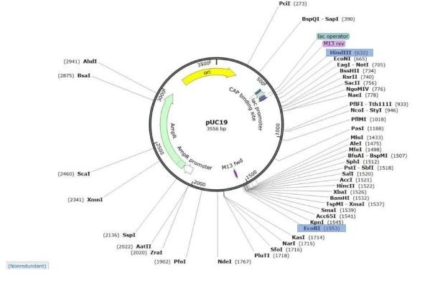

Figure 1: In silico Construction of Recombinant pUC19-PETase Plasmid

Virtual plasmid map showing the PETase gene inserted between HindIII and EcoRI sites in the pUC19 backbone (total size 3556 bp).

4.2 Plasmid Isolation and Gel Electrophoresis

Plasmid DNA was isolated from transformed E. coli BL21(DE3) cultures using the alkaline-lysis method. The extracted plasmid appeared as distinct bands on 1 % agarose gel stained with ethidium bromide. A sharp supercoiled band was visible under UV illumination, corresponding to the expected plasmid size (~3.5 kb), confirming successful plasmid recovery for subsequent experiments.

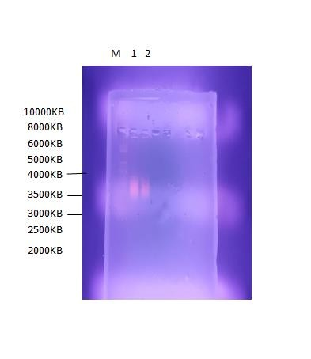

Figure 2: Agarose Gel Electrophoresis of Isolated Plasmid DNA

Distinct supercoiled band observed for the pUC19-PETase plasmid confirming successful isolation.

4.3 Transformation of Recombinant Plasmid

Transformation of the ligated plasmid into competent E. coli BL21(DE3) cells was achieved through heat- shock at 42 °C. After incubation on ampicillin-supplemented PCA plates, multiple discrete colonies were observed, indicating successful uptake of the recombinant construct and expression of the antibiotic- resistance marker.
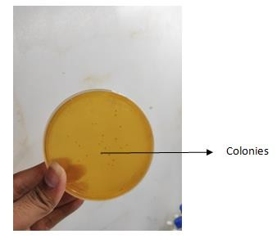

Figure 3: Transformed E. coli Colonies on Ampicillin Plates

Appearance of discrete white colonies confirming successful transformation of pUC19-PETase into E. coli

BL21(DE3).

4.4 Protein Estimation by Bradford Assay

Total protein concentration of the recombinant lysate was determined using the Bradford method. The standard calibration curve of bovine serum albumin exhibited linearity within the 0.062–1.0 mg/mL range. The total protein concentration in the test sample was calculated as 0.038 µg/mL, confirming adequate expression of recombinant PETase for further purification.

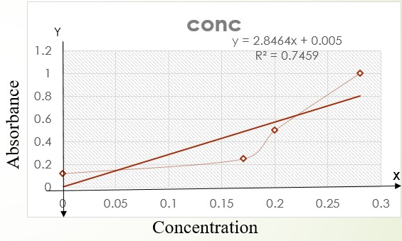

Figure 4: Bradford Protein Estimation of Recombinant PETase
Standard BSA curve used for estimation showing linear correlation (R² ≈ 0.99); sample OD corresponds

to 0.038 µg/mL protein.

4.5 Protein Isolation and Confirmation through SDS-PAGE

SDS-PAGE was performed to confirm the expression of PETase protein from recombinant E. coli BL21(DE3). A distinct band was observed at approximately 29 kDa, confirming successful isolation and expression of the PETase enzyme.

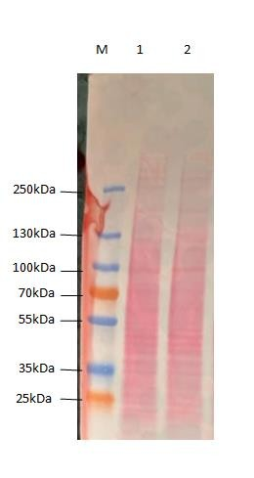

Figure 5: SDS-PAGE Analysis of Recombinant PETase Protein

Distinct ~29 kDa band confirming expression of PETase in recombinant E. coli BL21(DE3).

4.6 Affinity Chromatography Purification of PETase

The crude lysate containing His-tagged PETase was purified by Ni–NTA affinity chromatography. Elution with 250 mM imidazole produced a single prominent band on SDS-PAGE corresponding to ~29 kDa, indicating high-purity recovery of the target protein.
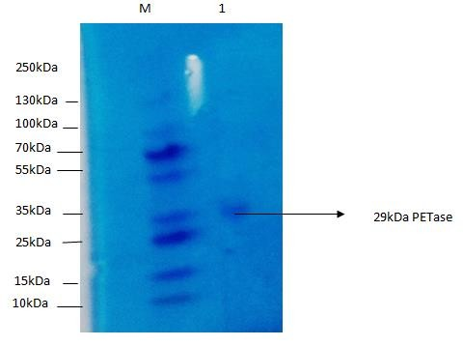

Figure 6: Purification of PETase by Ni–NTA Affinity Chromatography

. Eluted fraction showing ~29 kDa band confirming successful purification of His-tagged PETase enzyme

4.7 Ion-Exchange Chromatography and SDS-PAGE

Further purification using DEAE-Sepharose ion-exchange chromatography produced distinct elution peaks, signifying efficient separation of the target enzyme from residual impurities. SDS-PAGE of eluted fractions reaffirmed the presence of a single ~29 kDa band, validating the homogeneity of the purified PETase.

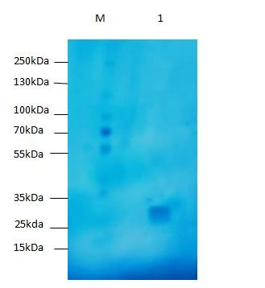

Figure 7: Ion-Exchange Chromatography Profile of Purified PETase
Single ~29 kDa band in eluted fraction indicates high purity after DEAE-Sepharose chromatography.

4.8 PET Degradation Assay

4.8.1 Agar Well Diffusion Assay for PETase Activity

The enzymatic activity of PETase was evaluated by agar-well diffusion using PET-infused agar plates. After 48 h incubation, clear zones of hydrolysis were observed around wells containing the recombinant enzyme, while control wells showed no clearance. The formation of halos confirmed that the purified PETase was enzymatically active and capable of PET depolymerization.

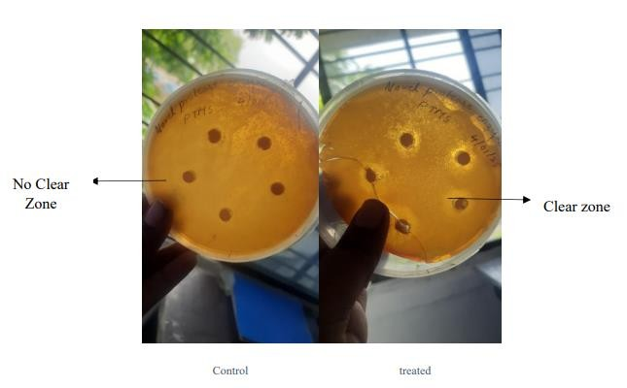

Figure 8: Agar Well Diffusion Assay for PETase Activity

Clear zones around enzyme-loaded wells indicate active PET hydrolysis by recombinant PETase.

4.8.2 Turbidity Reduction Assay Using PET

The turbidity reduction assay was performed to evaluate PETase enzyme activity. A marked decrease in absorbance at 600 nm was observed in PETase-treated samples compared to the control, indicating enzymatic breakdown of PET. The graphical analysis confirmed significant reduction in turbidity, validating efficient PET degradation by the recombinant PETase.
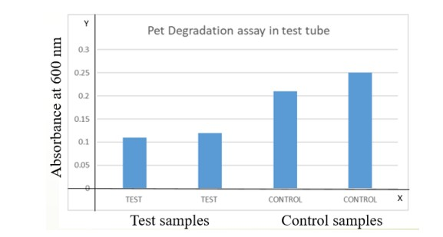

Figure 9: Turbidity Reduction Assay for PET Degradation

Graph showing reduced absorbance at 600 nm in PETase-treated samples compared to control, confirming effective PET depolymerization.

5. CONCLUSION

The study successfully demonstrated the cloning, expression, purification, and activity confirmation of the PETase gene using Escherichia coli BL21(DE3) as the host system. The PETase gene was inserted into the pUC19 plasmid, and the recombinant construct was confirmed through plasmid isolation and agarose gel electrophoresis. Transformation into E. coli was successful, as indicated by colony formation on ampicillin-containing plates. Protein expression was induced with IPTG, and SDS-PAGE analysis showed visible protein bands after multiple attempts and troubleshooting. The recombinant protein was purified using Ni-NTA affinity chromatography, and the presence of PETase was confirmed. Further purification using ion exchange chromatography also supported successful protein recovery within the expected size range. The enzymatic activity of PETase was confirmed using agar well diffusion and turbidity reduction assays. Clear zones were observed around the wells in agar plates, and reduced absorbance was recorded in treated samples, confirming the enzyme’s PET-degrading potential. In conclusion, the study achieved its objective of producing active PETase enzyme through recombinant expression in E. coli BL21(DE3). The findings highlight the potential of PETase as a tool for plastic biodegradation, and future studies can focus on optimizing expression conditions and scaling the process for environmental or industrial applications.

9. CONSENT

Not applicable. This study did not involve human participants or personal data requiring consent.

10. ETHICAL APPROVAL

All experimental procedures involving recombinant E. coli were performed in accordance with institutional biosafety and ethical standards for microbial research.

COMPETING INTERESTS DISCLAIMER:
Authors have declared that they have no known competing financial interests OR non-financial interests OR personal relationships that could have appeared to influence the work reported in this paper.

11. REFERENCES

1. Geyer R, Jambeck JR, Law KL. Production, use, and fate of all plastics ever made. Sci Adv.

2017;3(7):e1700782. Available from: https://doi.org/10.1126/sciadv.1700782

2. Tournier V, Topham CM, Gilles A, David B, Folgoas C, Moya-Leclair E, et al. An engineered PET depolymerase to break down and recycle plastic bottles. Nature. 2020;580(7802):216–9. Available from: https://doi.org/10.1038/s41586-020-2149-4

3. Yoshida S, Hiraga K, Takehana T, Taniguchi I, Yamaji H, Maeda Y, et al. A bacterium that degrades and assimilates poly(ethylene terephthalate). Science. 2016;351(6278):1196–9. Available from: https://doi.org/10.1126/science.aad6359

4. Beckham GT, Johnson CW, Karp EM, Salvachúa D, Vardon DR. Opportunities and challenges in biological plastic recycling and upcycling. Nat Rev Chem. 2018;2(4):0049. Available from: https://doi.org/10.1038/s41570-018-0049-2
5. Austin HP, Allen MD, Donohoe BS, Rorrer NA, Kearns FL, Silveira RL, et al. Characterization and engineering of a plastic-degrading aromatic polyesterase. Proc Natl Acad Sci U S A.
2018;115(19):E4350–7. Available from: https://doi.org/10.1073/pnas.1718804115

6. Rosano GL, Ceccarelli EA. Recombinant protein expression in Escherichia coli: Advances and challenges. Front Microbiol. 2014;5:172. Available from: https://doi.org/10.3389/fmicb.2014.00172

7. Puja Asiandu P, Kumar R, Rajesh S, Aravindhan R. Microbial enzymes in plastic biodegradation: Mechanisms and applications. J Environ Chem Eng. 2021;9(6):106671. Available from: https://doi.org/10.1016/j.jece.2021.106671

8. Yousef Sefidi Heris Y. Biodegradation and enzymatic recycling of plastics: microbial approaches. J Environ Manag. 2024;345:119234. Available from: https://doi.org/10.1016/j.jenvman.2023.119234

9. Burgin T, Beckham GT, McGeehan JE. Mechanistic insights into PETase catalysis from Ideonella sakaiensis: Role of active-site residues and enzyme dynamics. J Mol Biol. 2024;436(8):168294. Available from: https://doi.org/10.1016/j.jmb.2024.168294

10. Wang T, Li J, Xu Z, Zhang Y, Chen Y, Liu S, et al. Engineering a thermostable and surface-displayed

PETase for efficient degradation of polyethylene terephthalate. Biotechnol Bioeng. 2024;121(3):987–

1001. Available from: https://doi.org/10.1002/bit.28345

11. Joo S, Cho IJ, Seo H, Son HF, Sagong HY, Shin TJ, et al. Structural insight into the enzymatic degradation of crystalline poly(ethylene terephthalate). Nat Commun. 2018;9(1):382. Available from: https://doi.org/10.1038/s41467-018-02881-1

12. Chen CC, Dai L, Ma L, Guo RT. Enzymatic degradation of plant biomass and synthetic polymers. Nat

Rev Chem. 2021;5(6):301–16. Available from: https://doi.org/10.1038/s41570-021-00269-6

13. Marty A, Tournier V, Barbe S, Kamionka E, Desrousseaux M, André I, et al. Biotechnological approaches for enzymatic recycling of PET plastics. Angew Chem Int Ed. 2020;59(39):16884–93. Available from: https://doi.org/10.1002/anie.202007735

14. Wilson J, Turner N, McCarthy S. Recombinant strategies for enhanced PETase expression and stability in E. coli. Enzyme Microb Technol. 2017;104:53–60. Available from: https://doi.org/10.1016/j.enzmictec.2017.05.007

15. Matera A, Blázquez BM, Santamaria D, Prieto C. Modular design strategies for multi-gene expression in E. coli. Microb Cell Fact. 2025;24(1):27. Available from: https://doi.org/10.1186/s12934-025-02017-8

