Original Research Article

Evaluation of agricultural practices and socio- economic issues of market gardening urban area in Yopougon, Ivory Coast

.
ABSTRACT

Agriculture urban and peri-urban constitutes a major security lever food and income generation​ in Ivory Coast, particularly in the municipality of Yopougon where market gardening remains a activity strategic , but subjected to increasing land and health pressures . This study aimed to ... to identify the main market gardening production sites , to analyze the cultivation practices and the socio- economic and health issues there associates . A field survey was done from 132 producers and 88 retailers spread across 18 production sites covering eight zones of Yopougon , using structured questionnaires , direct observations and statistical analyses (Chi-square tests and analysis) in components main ones ). The results put in evidence a predominance female among producers ( 56.06%), predominantly married (93.18%), slightly educated , and operating small plots of land from 100 to 500 m² with a workforce basically family . Access to land remains precarious (37.88% squatting , 32.58% renting ) and the systems irrigation remain rudimentary (88.63% by watering) (manual ). Cultivation practices are intensive, with a near- systematic use fertilizer Minerals (97.73%) and chemical pesticides (100%), often without personal protective equipment (>90%). This activity generates income. monthly The average income is between 25,000 and 40,000 FCFA for more than half of market gardeners, but this exposes producers and consumers to significant health risks . results call for integrated policies aiming at security land tenure, technical training, promotion of agroecological practices and improvement of marketing channels to ensure the sustainability and resilience of the sector market gardener in Yopougon.

Keywords: Urban agriculture, farming practices, food safety, Yopougon, Ivory Coast.

1. INTRODUCTION

In a context urbanization galloping and growing demographic , the major cities from Africa sub-Saharan are facing challenges​ adults in terms of security food and livelihoods​​ ( Bâ & Cantoreggi , 2018; Giller et al., 2021) . In Abidjan, and more specifically in the municipality of Yopougon , market gardening busy a strategic place in the supply chain in fresh vegetables , all in facing multiple constraints structural factors that compromise its sustainability (Giller et al., 2021) . Instability land , fueled by occupation informal land use and evictions recurring costs weaken farms, while the intensive use of inputs chemicals and the use of quality irrigation water dubious increase health risks for producers and consumers ( Kuyah) et al., 2021; Nordey et al., 2017) . To this in addition a slight level a lack of training for actors Technical and organizational support , informal marketing channels , and precarious working conditions are all factors limiting the professionalization and socio- economic and environmental sustainability of the sector ( Bâ & Cantoreggi , 2018; Nordey et al., 2017; Kuyah et al., 2021) . Faced with these constraints , a approach systemic is essential to understanding the interactions between farming practices , socio- economic profiles and health risks, and to developing appropriate management strategies ( Kuyah) et al., 2021; Nordey et al., 2017) . It is from this perspective that the present study proposes to identify and characterize market gardening production sites in Yopougon , to evaluate in an integrated manner the cultivation practices , the profiles of producers , the modes of access to land , the systems irrigation and marketing channels , as well as analyzing health and environmental risks partners , in order to formulate technical and institutional recommendations aiming to improve the sustainability, food safety and resilience of market gardening in the face of increasing pressures.
2. material and methods
  - Study Site
The study was driving in the autonomous district of Abidjan, within the municipality of Yopougon, located between the forest classified as Banco and the Ébrié Lagoon, to the west of the geographical area North Abidjan. This municipality, slightly located off-center , at coordinates Geographic coordinates: 5°20'56" North latitude and 4°00'42" West longitude, covers a It covers an area of 16,420 hectares (164.2 km²), has an altitude ranging from 40 to 132 meters , and is home to 1,571,065 inhabitants. a density of 9,568 inhabitants/km², the study focuses on eight market gardening production areas: Adiopodoumé, Niangon -Adjamé, Niangon-Attié, Yopougon-Koweït, Yopougon -Santé, Yopougon-Séminaire, Béago - Village and Niangon -Sud/Lokoa Bité.
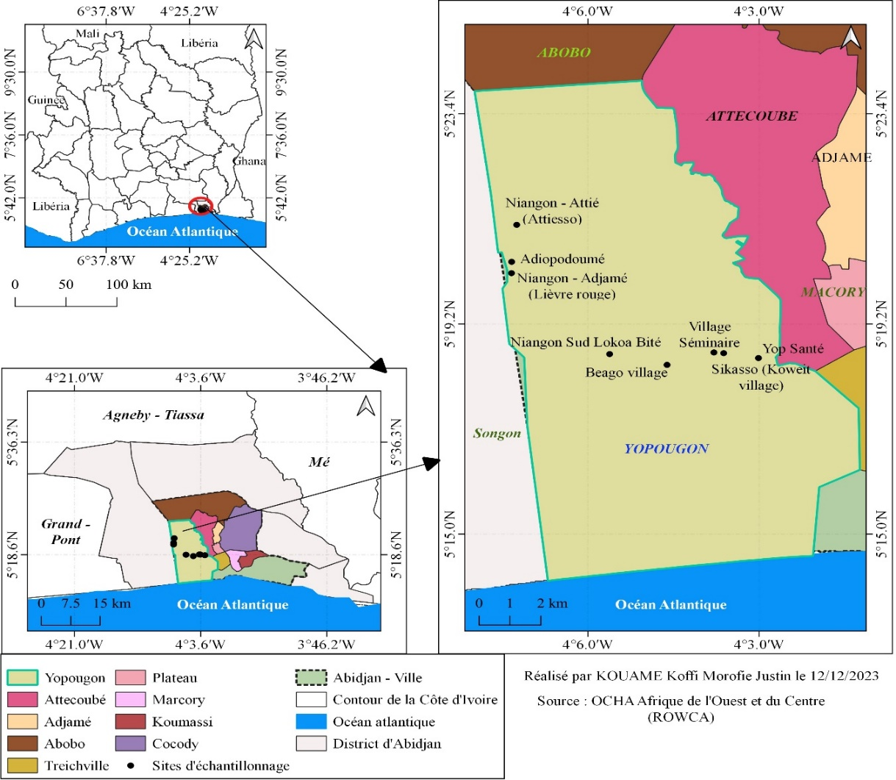
Fig.1. market gardening production areas in the municipality of Yopougon – Abidjan

  - Study Material
An investigation has been carried out between November 2022 and August 2024 among vegetable producers and traders, using structured questionnaires, semi - direct interviews and direct observations on the plots, in order to collect detailed data on cultivation practices, socio- economic conditions and marketing methods.
  - Sampling Collection
For this study, a sample exhaustive made up of 132 market gardeners and 88 traders , was mobilized in order to guarantee a representativeness optimal production and marketing dynamics in the municipality of Yopougon . Data collection combined several approaches methodological additional information : structured questionnaires to obtain information standardized on the characteristics sociodemographic factors , land acquisition methods , fertilization and irrigation systems , phytosanitary practices , incomes and constraints perceived ; semi- structured interviews allowing the collection of information qualitative In-depth research on management strategies and stakeholder perceptions; and direct observations on the plots , intended to validate and supplement the reported data . This methodological triangulation helped to reduce bias . related to self-declaration and obtaining a comprehensive and reliable overview of farming practices, socio- economic conditions, and dynamics commercial
  - Statistical data processing
The data has summer processed using XLSTAT software version 2025 , incorporating descriptive statistics , a analysis of variance (ANOVA) and Duncan's post-hoc test at the 5% significance level in order to to assess the significance of the differences between the means of the parameters studied . The associations between qualitative variables , such as gender and specialization cultural , have summer examined using the Chi-square test. Furthermore , a Analysis in Components Principal (PCA ) carried out to analyze the spatial structuring and traceability of marketing channels.

3. Results and discussion

3.1.1. Identification of Market Gardening Production Sites

At the end from a survey conducted in the municipality of Yopougon, eight potential market gardening areas have summer identified, distributed across eighteen production sites comprising a total of one hundred and sixty plots cultivated by one hundred and thirty -two market gardeners. The identified areas include Adiopodoumé (KM17), Niangon -Adjamé (Lièvre-Rouge), Niangon-Attié (Attiesso), Yopougon-Koweït (Assikasso), Yopougon -Santé, Yopougon-Séminaire , Béago -Village and Niangon -Sud
( Lokoa Bité). The majority of these areas are located in low-lying areas, particularly near the Ébrié Lagoon, along the watercourses water , near major outlets and storage areas garbage households , as well as in non -building zones or on slopes.

3.1. 2. Characteristics sociodemographic characteristics of operators
socio-demographic analysis of market garden producers shows a predominance female, with 56.06% women, predominantly aged 26 to 50 ( 81.82%) and married (93.18%), highlighting the central role of women and family in the activity market gardening . However , the weak level education, particularly among women of which 46% are illiteracy constitutes a factor​ limiting professionalization and the adoption of improved agricultural practices. Out of 132 producers Of those surveyed, 56.82% are of [nationality]. Ivorian, while that a significant proportion is of origin foreign, mainly Burkinabe (38%). Finally, market gardening represents the main, or even only, source of income for 95.45% of operators, confirming the importance economic of this activity for household subsistence and security local food.

Table 1. Distribution Sociodemographic data of market gardeners in Yopougon according to gender , age group and marital status

Producer characteristics​ | Number of employees (n=132) | Percentage (%)
Sex
Men | 58 | 43.94
Women | 74 | 56.06
Age group ( Years )
From 26 to 50 | 108 | 81.82
From 51 to 72 | 24 | 18.18
Marital status
Married | 123 | 93.18
Bachelor | 7 | 5.30
Widower​​​ | 2 | 1.52

Table 2. Distribution of vegetable producers according to nationality , experience and activity main

Producer characteristics​ | Number of employees (n=132) | Percentage (%)
Nationality
Ivorian | 75 | 56.82
Foreigner | 57 | 43.18
Number of years experience
Less than 5 years | 8 | 6.06
Between 5 and 10 years old | 38 | 28.79
More than 10 years | 86 | 65.15
Activity main
Yes | 126 | 95.45
No | 6 | 4.55

3.1. 3. Characteristics sociodemographic data of female traders

Table 3 shows the sale of vegetables and fruits at market garden sites in Yopougon East exclusively provided by women (100%). Among them, 47.73% have never been 52.27% were enrolled in school, while 52.27% have follow up a education formal . The grand The majority of female saleswomen, 89.77 %, are between 17 and 35 years old , compared to 10.23% who are over 35. Among women with formal education, 13.63% have reached the first cycle of secondary education and 10.23% the second cycle. The data reveal Also noteworthy is the predominance of Ivorian women , representing 90.91% of the workforce, compared to 9.09% foreign women. originating from the sub- region.

Table 3. Distribution Sociodemographics of fruit and vegetable vendors in Yopougon

Characteristics of female shopkeepers | Number of employees (n=88) | Percentage (%)
Sex
Women | 88 | 100
Age group ( Years )
From 17 to 35 | 79 | 89.77
From 36 to 50 | 9 | 10.23
Nationality
Ivorian | 80 | 90.91
Non- Ivorian | 8 | 9.09
Level study
Not enrolled in school | 42 | 47.73
Primary school (grades 1-5) | 25 | 28.41
Secondary (6th grade – 12th grade ) | 21 | 23.86

3.1.4. Characterization of market gardening operations in Yopougon

Agriculture urban area in Yopougon East dominated by small plots (100-500 m²), representing 75.76% of farms. Access to land depends on several modes: the squat or the occupation anarchic (37.88%), rental (32.58%), and inheritance (21.21%). Labor East mostly Family (84.85%). The activity East faced with conflicts land and to a instability due to evictions.

Fig 2. Distribution of areas cultivated by market gardeners

Table 4. Methods of land acquisition and types of farming

Land acquisition and development​ | Distribution
Land acquisition and development​ | Effective |  | Percentage (%)
Property land (n=8)  Private entities (companies, individuals, religious groups)  Community villager  Family | 3  3  2 | N=8 | 35  35  25
Access method (n=132)  Squatting or anarchic occupation  Legacy  Rental  Loan  Workforce​  Family  Mutual aid  Daily | 50  28  43  11  112  13  7 | N=132  N=132 | 37.88​  21.21  32.58  8.33  84.85  9.85  5.3

3.1.5. Farm typologies

The investigation into the market garden sites of Yopougon revealed a distribution gendered marked by cultures: men practice a crop diversity with lettuce (30.30%), cucumber (25%), chili pepper (15.91%) and other produce (13.64% each ), while women focus on leafy vegetables – spinach , sweet potato leaves , sorghum and dah (54.55% each) – with a very small share of lettuce (1.52%) and no fruit vegetable crops . The Chi-square test (Chi² = 12.8; ddl = 8; p = 0.0188) puts in evidence a significant association between sex and type of culture, confirming a specialization cultural according to gender.

Table 5. Distribution of vegetable types cultivated
Type of vegetables | Scientific name | Family | French name | Frequency
 |  |  |  | Man | Women | Total %
Vegetables leaves | Lactuca sativa L.  Spinacia oleracea  Matembele  Sorghum bicolor L.  Hibiscus sabdariffa | Compositae  Amaranthaceae  Convolvulaceae  Poaceae  Malvaceae | Lettuce  Spinach  Potato leaves​  Sorghum  Already | 40(30.30)  18(13.64)  18(13.64)  18(13.64)  18(13.64) | 2(1.52)  72(54.55)  72(54.55)  72(54.55)  72(54.55) | 31.82  68.18  68.18  68.18  68.18
Fruit vegetables | Capsicum frutescens L.  Cucumissativus L.  Lycopersicon esculentum Mill.  Solanum melongena L. | Solanaceae  Cucurbitaceae  Solanaceae  Solanaceae | Pepper  Cucumber  Tomato  Eggplant | 21(15.91)  33(25)  12(9.09)  18(13.64) | -  -  -  - | 15.91  25  9.09  13.64

3.1.6. Farming practices and pest management

Farming systems vary​ depending on the site. Irrigation is mainly carried out using cisterns (88.63%) and wells (9.10%), with a draining manual . The tools used are mostly traditional . Market gardening in Yopougon is a conventional system , using intensively fertilizers​ Minerals and poultry manure ( nearly 100% utilization ). Control against pests​ East exclusively chemical , with 100% of producers using pesticides. The dosage is often approximate and adherence to deadlines Before harvest is variable. Pesticide packaging is mostly discarded at production sites (94.70%). Furthermore , 97.73 % of market gardeners do not comply with adequate protective measures . during the preparation and application of pesticides.

Table 6. Water Sources irrigation and sowing practices in market gardening

Cultivation practices of market gardeners | Number of employees (n=132) | Percentage (%)
Source of crop supply
Watercourse​ | 3 | 2.27
Ceanes | 117 | 88.63
Well | 12 | 9.10
Sowing method
Indirect sowing ( nursery ) | 50 | 37.88
Direct seeding | 82 | 62.12

Table 7. Product Usage System plant protection products

Treatment Plant protection | Distribution | Number of employees (n= 132) | Percentage (%)
Application methods | Spraying ( backpack sprayer ) | 132 | 100%
Measuring instruments | Caps | 119 | 90.15%
 | Bottles | 13 | 9.85%
Suppliers (place of purchase ) | Plant protection product shops | 19 | 14.39%
 | Market retailers​ local | 113 | 85.61%
Pesticide storage | Shops ( home ) | 89 | 67.42%
 | Under a shelter (in the field) | 43 | 32.58%

Fig 3. Rate use of Personal Protective Equipment (PPE) by producers

3.1.7. Marketing and revenue
The producers finance their Self -funded activities . Sales are primarily conducted at production sites (97.4%). Revenue monthly averages are between 40,000 and 79,000 FCFA for the majority of producers (51.52%).
Table 8. Distribution of income among market gardeners in Yopougon

Income annual (FCFA) | Number of producers | Percentage (%) | Income monthly average (FCFA) | Income annual average (FCFA)
< 300,000 | 25 | 18.94 | 15,000 | 288,000
[300,000, 500,000[ | 36 | 27.27 | 25,000 | 468,000
[500,000, 1,000,000[ | 68 | 51.52 | 40,000 | 948,000
≥ 1,000,000 | 3 | 2.27 | 80,000 | 1,320,000
Total | 132 | 100 | 160,000 | 1,848,000

3.1.8. Health impact of the activity market gardening on the health of producers in Yopougon

The analysis of health risks among market gardeners in Yopougon reveals high exposure linked to intense physical labor, rudimentary tools, wastewater, and chemicals. All suffer from general fatigue (100%) and muscle pain (100%), followed by injuries (54.55%), malaria (95.45%), colds (75.76%), stomach aches (39.39%), coughs (33.33%), dyspnea (31.82%), headaches (28.03%), and athlete's foot (15.91%). Fatigue, identified as a trigger for other ailments, underscores the urgent need to improve working conditions, ensure the provision of protective equipment, and strengthen awareness of good hygiene and safety practices.

Fig 4. Frequency of practices at risk of contamination in vegetable production

3.2. DISCUSSION

The survey in Yopougon revealed eight market gardening areas across eighteen sites , mainly in the shallows near the lagoon and the waterways water , reflecting the dependence of agriculture urban water and land​ but Also a high vulnerability to contamination by wastewater , confirmed by microbial contamination​ widespread vegetable consumption despite metal levels​ heavy weak (Kouame et al., 2025). Market gardening East predominantly family-oriented, marked by a predominance female with little education and by the presence of producers Burkinabé , reinforcing both​ cohesion social resilience​ urban but limiting professionalization and adoption​ of innovations (Diekmann et al., 2020; Drottberger et al., 2021). Cultures are distributed according to gender, with male diversification ( lettuce 30.30%, cucumber 25%, chili pepper 15.91%) and specialization female consumption of leafy vegetables (54.55 % each), reflecting inequalities access to resources (Diekmann et al., 2020). Marketing , ensured exclusively by young and often uneducated women , argues empowerment but remains fragile due to the low access to training and good hygiene practices ( Diallo, M. and Wouterse , F. 2023 ) . Irrigation manual , the use fertilizer Minerals , poultry manure , and pesticides without precise dosage expose producers to health risks ( fatigue , injuries , illnesses) and increase contamination (Kouame et al., 2025). The sustainability of market gardening urban depends Therefore , securing land tenure , improving hygiene practices , providing technical support , and implementing public support policies are essential to guarantee both the health of producers , the sanitary quality of vegetables , and income stability (Diekmann et al., 2020; Drottberger) . et al., 2021).

4. Conclusion

The study shows that market gardening urban in Yopougon , although essential for income and security household food , remains a fragile activity , characterized due to the small size of the plots , the insecurity land , the weak level producer instruction and usage​ Intensive pesticide use without adequate protection . This situation increases health risks for producers and consumers and hinders the adoption of sustainable practices. To do so To ensure durability , it is necessary to secure access to land , to strengthen technical support and training ( particularly for women), promoting agroecological practices , improving storage and marketing infrastructure , and putting in place in work of public policies integrated in order to make this a real sector pillar of security food and resilience economic urban.

DISCLAIMER (ARTIFICIAL INTELLIGENCE)
Author(s) hereby declare that no generative ai technologies such as large language models (chatgpt, copilot, etc) and text-to-image generators have been used during writing or editing of this manuscript.

References

- Bâ, A., & Cantoreggi, N. (2018). Urban and peri-urban agriculture (UPA) and the economy of agri-urban households in Dakar (Senegal). International Journal of Environment, Agriculture and Biotechnology, 3, 195-207.
- Diekmann, L. O., Gray, L. C., & Thai, C. L. (2020). More than food: The social benefits of localized urban food systems. Frontiers in Sustainable Food Systems, 4, 534219.
- Drottberger, A., Melin, M., & Lundgren, L. (2021). Alternative Food Networks in Food System Transition—Values, Motivation, and Capacity Building among Young Swedish Market Gardeners. Sustainability, 13, 4502.
- Giller, K., Delaune, T., Silva, J., Van Wijk, M., Hammond, J., Descheemaeker, K., Van De Ven, G., Schut, A., Taulya, G., Chikowo, R., & Andersson, J. (2021). Small farms and development in sub-Saharan Africa: Farming for food, for income or for lack of better options?. Food Security, 13, 1431 - 1454.
- Kouame, KMJ, Kadjo, AC, Kouame, KA, Hamian, EL, Dago, S., Ouattara, MM and Akaki, KD (2025). Evaluation of the current sanitary quality of market garden produce in the municipality of Yopougon. European Journal of Nutrition and Food Safety, 17 (3), pp-144.
- Kuyah, S., Sileshi, G., Nkurunziza, L., Chirinda, N., Ndayisaba, P., Dimobe, K., & Öborn, I. (2021). Innovative agronomic practices for sustainable intensification in sub-Saharan Africa. A review. Agronomy for Sustainable Development, 41.
- Nordey, T., Basset-Mens, C., Bon, H., Martin, T., Delétré, E., Simon, S., Parrot, L., Despretz, H., Huat, J., Biard, Y., Dubois, T., & Malézieux, É. (2017). Protected cultivation of vegetable crops in sub-Saharan Africa: limits and prospects for smallholders. A review. Agronomy for Sustainable Development, 37.
- Diallo, M. and Wouterse, F. (2023). Agricultural development promises more growth and less poverty in africa: modelling the potential impact of implementing the comprehensive africa agriculture development programme in six countries. Development Policy Review, 41(3).

