blaCTX-M-G1, blaVIM, blaIMP, and mcr Genes in ESBL Bacilli isolated at Schiphra Protestant Hospital, Ouagadougou, Burkina Faso

ABSTRACT
Background and Objective: Gram-negative bacilli express a plethora of mechanisms that allow them to counteract the antibacterial properties of target antibiotics. Among them, production of β-lactamases remain the most worrying mechanism. Several bacteria produce several enzymes at the same time, giving them the character of multidrug-resistant bacteria. The aim of this work is to characterize bacterial strains producing ESBLs and harboring genes of resistance to carbapenems and colistin, which are last-resort antibiotics. Methodology: A total of 60 strains of Gram-negative bacilli isolated from biological samples at Shiphra Hospital in Ouagadougou were analyzed. These strains were first subjected to a sensitivity test against targated antibiotics using the diffusion method on Mueller-Hinton agar. Then a synergy test was performed for the phenotypic detection of ESBL production by the strains. Finally, a conventional PCR was performed to search for each of the targeted resistance genes. Results: Of the 60 strains studied, the sensitivity test showed that 86.67% and 88.33% were respectively resistant to ceftazidime and cefotaxime. However, high sensitivities to carbapenems were observed. They were 76.67% and 83.33% for meropenem and imipenem respectively. The synergy test revealed that 76.67% of our strains produced ESBLs. Electrophoresis of PCR products revealed 89.13% of strains carrying at least one of the resistance genes studied. All these strains harbored the CTX-M-G1 gene while 6.52% carried also the VIM gene. The IMP genes and the mcr genes were not detected. Conclusion: This study showed that several Gram-negative bacilli harbor resistance genes against last-resort antibiotics at the Schiphra Protestant Hospital. The results obtained raise the need to regulate the use of antibiotics in order to prevent the emergence of multidrug-resistant bacteria.
Keywords: Gram-negative bacilli, CTX-M-1, IMP, VIM, mcr

INTRODUCTION
Gram-negative bacteria including Enterobacteriaceae and non-fermentative Gram-negative bacteria are of significant clinical importance. Patients infected with these bacteria are at high risk of morbidity and in intensive care units (Wang et al., 2022 ; Oliveira et Reygaert, 2023) . In USA Liversi and colleagues report a variation in incidence of 0.3 to 2.93 infections per 100,000 person-years. Outside USA, cases of multidrug-resistant bacteria have already been reported on almost every continent. In Europe, for example, about 25,000 people die each year from infections caused by multidrug-resistant bacteria (Oliveira et Reygaert, 2023). In sub-Saharan Africa, the mortality rate linked to antimicrobial resistance is estimated at 27.3 deaths per year per 100,000 inhabitants (Da et al., 2023). β-lactams are the first-line molecules used in the management of infections caused by Gram-negative bacteria. Unfortunately, the massive and inappropriate use was quickly followed by the emergence of multidrug-resistant bacterial strains, several of which produce extended-spectrum β-lactamases (ESBLs) and carbapenemases (Nabti et al., 2020). CTX-M (cefotaximase-Munich) type enzymes have emerged as the predominant type of extended-spectrum β-lactamases produced by clinical isolates of Enterobacteriaceae worldwide (Zhuo et al., 2013). This would be the first enzyme that hydrolyzes extended-spectrum cephalosporins at a clinically significant level (Davies et al., 2010). In addition to ESBLs, metallo-β-lactamases (MBLs), initially encoded by chromosomes, have a broad substrate spectrum. They can catalyze the hydrolysis of almost all β-lactams, except monobactams (Palzkill et al., 2013). Metallo-β-lactamases such as VIM (Verona integron-encoded metallo-β-lactamase) and IMP (Imipenemase) cause the hydrolysis of various β-lactams, except monobactam (aztreonam) (Ghamgosha et al., 2015).
Due to these resistances, molecules such as colistin (bacterial natural product) despite their toxicity are used as a last resort treatment option for serious human infections caused by Gram-negative bacteria multi-resistant to carbapenems. However, resistance to this antibiotic has been reported in recent years. In 2015, Liu and colleagues described, for the first time, a mobile gene encoding colistin resistance (mcr-1) in E. coli strains (Liu et al ., 2016).
Recent global spread of colistin resistance gene threatens usefulness of this antibiotic¹.To date, ten slightly different variants of the mcr gene (mcr-1 to mcr-10) have been identified in different bacteria isolated from animals, food, humans and the environment. In Burkina Faso, the mcr gene and mainly the mcr-5 gene has been detected in hospital effluents (Melina et al.,2023) . The aim of work is to contribute to the alert and decision-making on bacterial multiresistance by providing scientific data on the genes responsible for resistance to β-lactams, colistin and carbapenems in strains of Gram-negative bacteria.

MATERIALS AND METHODS
Isolation and identification of bacterial strains
This was a prospective study carried on strains of Gram-negative bacilli over a period of four (04) months from December 2022 to March 2023. For the isolation and identification of bacterial strains, the biological samples were incubated in appropriate media. The stools were inoculated on Hektoen agar, a selective and differential medium intended for the isolation of enterobacteria, particularly Shigella and Samonella. The lactose, sucrose and salicin contained in this medium make it possible to differentiate the bacteria according to their ability to ferment carbohydrates and bromothymol blue is the pH indicator. Salmonella and Shigella, not being able to ferment these sugars, do not cause a change in the pH of the medium and its color remains unchanged. They were then inoculated in Leifson broth to look for Salmonella and then subcultured on SS agar (Salmonella-Shigella).
CSF, pus and effusion fluids were inoculated on CLED and CD agars. CLED (Cystine Lactose Electrolyte Deficient) agar allows the detection of Gram-negative bacilli. CD (Chromatic Detection) agar is a chromogenic medium that allows differentiation of microorganisms on the basis of colony colour and morphology. Urine was inoculated onto CLED and CD agars.
Antimicrobial Susceptibility Testing
Antibiotic resistance was assessed by the agar diffusion method in accordance with the recommendations of the Antibiogram Committee of the French Society of Microbiology and the European Committee on Antimicrobial Susceptibility Testing (CA-SFM/EUCAST). A bacterial suspension with turbidity equivalent to 0.5 McFarland was prepared from each isolate in isotonic saline and plated on Mueller-Hinton agar. β-lactams such as Augmentin (AUG 30μg), Meropenem (MEM 10μg), Cefotaxime (CTX 30μg), Ceftazidime (CAZ 30μg) and Imipenem (IMI 10μg) were used for strains susceptibility Testing.After incubation (37°C for 18-24 hours), strains were classified as susceptible (S), intermediate (I) and resistant (R) using critical inhibition diameter limits (Kaboré et al., 2022).
Double synergy test
The double synergy test was used to determine the bacterial strains producing ESBL. For this purpose, a bacterial suspension of turbidity equivalent to Mac Farland 0.5 was used to inoculate the Muller-Hinton agar medium in a Petri dish. Third-generation cephalosporin or Aztreonam disks were placed on either side of an amoxicillin + clavulanic acid disk, observing a center-to-center distance of 1.5 to 2 cm (Figure1). The production of ESBL is objectified by a characteristic image called a "Champagne cork" (potentiating effect of clavulanic acid) observed between clavulanic acid and third-generation cephalosporins.
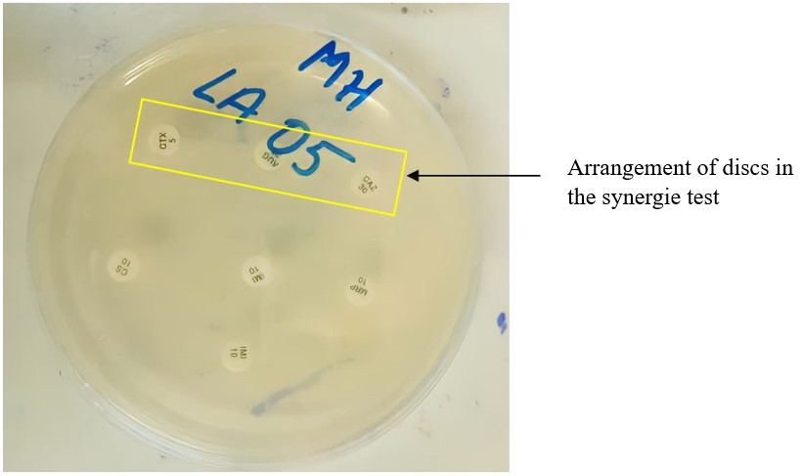
Figure1: Arrangement of the discs in the antibiogram
Molecular characterization of the expected genes
Extraction of bacterial DNA
DNA extraction from the bacterial strains studied was performed by the boiling method. From a young culture on MH medium in a Petri dish, an isolated colony is taken and suspended in 200 μL of distilled water previously aliquoted in labeled Eppendorf tubes. These suspensions were immersed in a water bath at 100 ° C for 15 min allowing bacterial lysis and release of the genetic material. Then, the suspensions were centrifuged at 12000g for 10 min and the supernatant containing the released DNA is transferred to a new Eppendorf tube. The DNA concentration was then determined using the Nanodrop spectrophotometer
PCR amplification
Multiplex PCRs were performed for the mcr and IMP genes. A 25 μL reaction mixture was prepared for each gene type, i.e. 4 μL of 5X Firepol® Master Mix, 0.5 μL of sense primer and 0.5 μL of antisense primer of each gene, 2 μL of bacterial DNA; the reaction volume was completed to 25 μL with PCR water. The VIM gene was searched for by single PCR with a final reaction volume of 25 μL (4 μL of the master mix, 0.5 μL for each of the primers, 2 μL of bacterial DNA and 18 μL of PCR water). As for the CTX-M-G1 gene, a simple PCR was performed with a reaction mix (4 μL of the master mix, 0.5 μL for each of the primers, 2 μL of bacterial DNA and 18 μL of PCR water).
PCR reactions were performed using the GeneAmp PCR System 9700 thermal cycler (Applied Biosystems, California, USA). The amplification programs used and the primer sequences of the different genes are listed in Table 1 and Table 2
Table 1: Temperature cycles according to gene
Genoa  Steps | CTX-M-G1 | mcr | VIM | IMP
Initial denaturation | 94°C/5 min | 94°C/15 min | 94°C/15 min | 94°C/15 min
Denaturation | 94°C/30s | 94°C/30s | 94°C/30s | 94°C/30s
Hybridization | 63°C/30s | 55°C/45s | 56°C/1 min | 56°C/ 1 min
Elongation | 72°C /30s | 72°C /1 min | 72°C /1 min | 72°C / 1 min
Final elongation | 72°C /7mn | 72°C /10 mins | 72°C /10 min | 72°C /10 min
Number of cycles | 35 | 35 | 35 | 35

Table 2: Nucleotide sequences of the different primers used and sizes of the expected bands
Genes sought | Primers | Sequences (5'-3') | Size (pb) | References
CTX-M-G1 | CTX-M-1 | F- 5' TCCAGAATAAGGAATCCCATGG-3'  R- 5' TGCTTTACCCAGCGTCAGAT-3' | 621 | Kim et al., 2009)
mcr | Mcr-1 | F- 5'AGTCCGTTTGTTCTTGTGGC-3'  R- 5'AGATCCTTGGTCTCGGCTTG-3' | 320 | Rebelo et al., 2018)
mcr | Mcr-2 | F- 5'CAAGTGTGTTGGTCGCAGTT-3'  R- 5'TCTAGCCCGACAAGCATACC-3' | 715 | Rebelo et al., 2018)
VIM | VIM | F - 5 GATGGTGTTTGGTCGCATA -3'  R - 5' CGAATGCGCAGCACCAG -3' | 390 | Ssekatawa, et al., 2021)
IMP | IMP-1 | F- 5' TGAGCAAGTTATCTGTATTC -3'  R- 5' TTAGTTGCTTGGTTTTGATG -3' | 139 | Ssekatawa, et al., 2021)
IMP | IMP-2 | F- 5' GGCAGTCGCCCTAAAACAAA -3'  R- 5' TAGTTACTTGGCTGTGATGG -3' | 139 | Ssekatawa, et al., 2021)

Agarose gel electrophoresis
PCR products were separated by agarose gel electrophoresis (1.5%). To do this, 1.5g of agarose was dissolved in 100mL of a 1.5X Tris-Acetate-EDTA solution, the whole heated in the microwave for 2 minutes for homogenization. Then, a volume of 5μL of ethidium bromide (BET) was added. The gel was poured, before solidification, into an electrophoresis tank with the comb well positioned for opening the sample wells. The 100 bp molecular weight marker was used to assess the expected sizes of the bands. Migration was carried out for 35 minutes under a voltage of 100V. The migration products obtained were visualized under UV light with the trans-illuminator (E-Box Vilber) and the photos were recorded.
Statistical analysis
The collected data were entered into Excel 2016. Antibiotic resistance rates were calculated using the formula P= 100n/N (with n the number of antibiotic-resistant strains and N the total number of strains studied). The same formula was used to calculate the prevalence of each gene as well as the prevalences of gene co-existence (with n the number of strains carrying the gene and N the total number of strains carrying resistance genes).
RESULTS
Distribution of bacterial species collected according to the samples analyzed
Among the samples analyzed, urines samples were the most represented in terms of the nature of the samples with 86.67% (Table 3). For this sample, Escherichia coli was the majority species with a proportion of 73.07% followed by Klebsiella pneumoniae (17.31%), Acinetobacter baumanii (5.77%), Morganella sp and Pseudomonas aeruginosa finishing with respectively 1.92%.
The proportion of stools was 6.67%. The species represented were Shigella sp (50%), Escherichia coli (25%) and Salmonella sp (25%).
The proportions of pus and ascitic fluid were 5% and 1.67%, respectively, consisting solely of Escherichia coli.
As for the isolated Gram-negative bacilli, enterobacteria were identified at more than 93.33% with a high frequency of Escherichia coli (71.67%) followed by Klebsiella pneumoniae with 15%. The proportion of non-fermentative Gram-negative bacilli was 6.67%.
Table 3: Distribution of bacterial species according to the nature of the samples collected
Samples  Strains |  | Urine | Saddles | Pus | Ascites fluid | Total | Percentage (%)
Enterobacteria  N= 56 (93.33%) | Escherichia coli | 38 | 1 | 3 | 1 | 43 | 71.67
Enterobacteria  N= 56 (93.33%) | Klebsiella pneumoniae | 9 | 0 | 0 | 0 | 9 | 15
Enterobacteria  N= 56 (93.33%) | Shigella sp. | 0 | 2 | 0 | 0 | 2 | 3.33
Enterobacteria  N= 56 (93.33%) | Salmonella sp. | 0 | 1 | 0 | 0 | 1 | 1.67
Enterobacteria  N= 56 (93.33%) | Morganella | 1 | 0 | 0 | 0 | 1 | 1.67
Non-fermenting Gram-negative bacilli  N= 4 (6.67%) | Acinetobacter baumanii | 3 | 0 | 0 | 0 | 3 | 5
Non-fermenting Gram-negative bacilli  N= 4 (6.67%) | Pseudomonas aeruginosa | 1 | 0 | 0 | 0 | 1 | 1.67
Total  Percentage (%) |  | 52 | 4 | 3 | 1 | 60 | 100
 |  | 86.67 | 6.67 | 5 | 1.67 | 100

Proportions of bacterial strains resistant to antibiotics
Most strains were resistant to cephalosporins and sensitive to carbapenems. Indeed, we observed high proportions of major resistances including 86.67% and 88.33% respectively for ceftazidime and cefotaxime. However, sensitivities in the proportions of 76.67% and 83.33% were noted for meropenem and imipenem respectively (Figure 2).
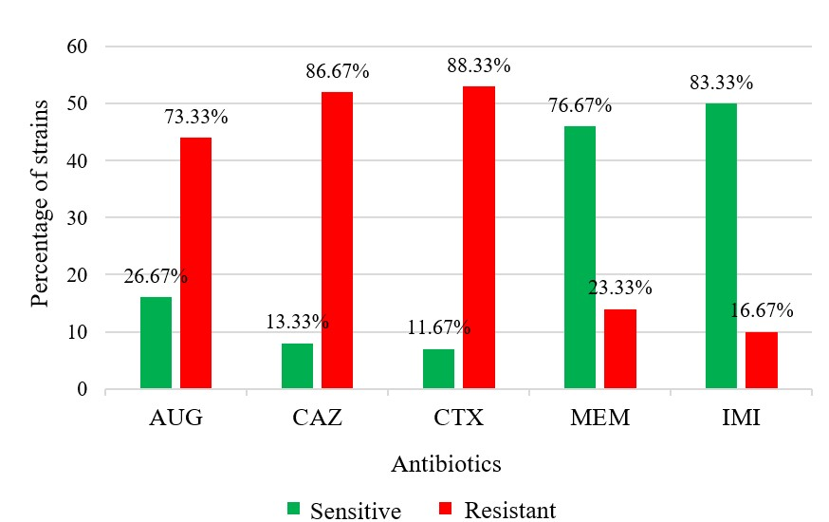
Figure 2: Histogram of proportions of strains resistant to the antibiotics used
Some bacteria showed multi-resistance, including 49 (81.67%) strains resistant to both cefotaxime and ceftazidime. Four (4) strains, or a proportion of 6.67%, were resistant to the carbapenems used as well as C3G. High proportions of resistant bacterial strains have been observed with Escherichia coli and Klebsiella pneumoniae
Proportion of bacterial strains producing BLSE
Of the 60 bacterial strains tested, 76.67% were producers of broad-spectrum β-lactamases. ESBL production is demonstrated by the image of the action synergy, referred to as the champagne cork effect, between the antibiotic discs. (Figure 3). Among these strains, enterobacteria represented 71.67% compared to 5% for non-fermentative Gram-negative bacteria. Among enterobacteria, E. coli was largely represented with a proportion of 73.91% followed by Klebsielle pneumoniae with 15.21%.
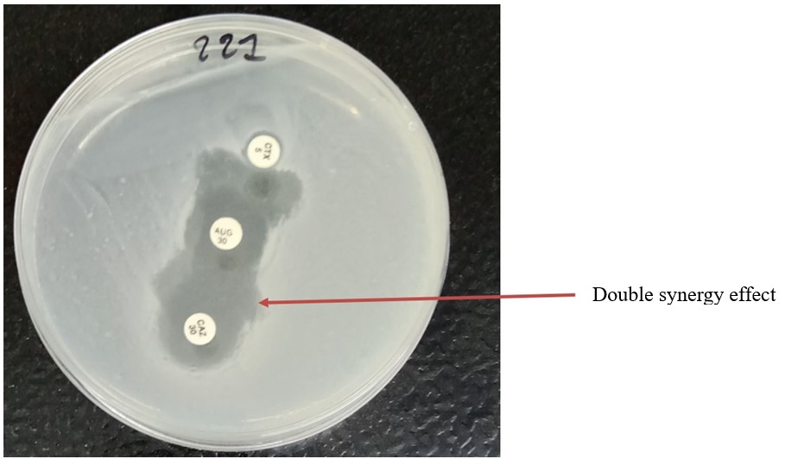
Figure3: Photo showing a bacterial strain producing broad-spectrum β-lactamases )..
Isolation of resistance genes
Electrophoretic migration at the end of PCR revealed amplicons around 621 bp (Figure 4) and 390 bp corresponding to the genes CTX-M-G1 and VIM (Figure 5), respectively. The genes mcr1 (320bp), mcr2 (715bp), IMP1 and 2 (139 bp) were not detected.
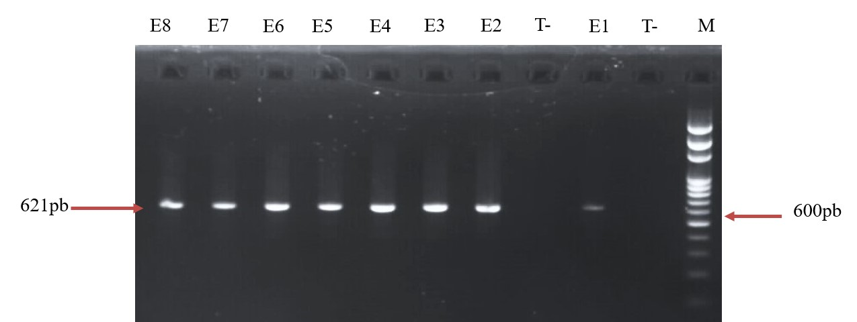
Figure4: Electrophoretic profile of CTX-M-G1 gene amplicons
Legend: M1: Molecular weight marker (100 bp DNA Ladder); T-: Negative control; Numbers E1 – E8 represent samples: E1 = 20; E2 = 23; E3 = 350; E4 = 362; E5 = 3149; E6 = 3361; E7 = 3387; E8 = 3443.
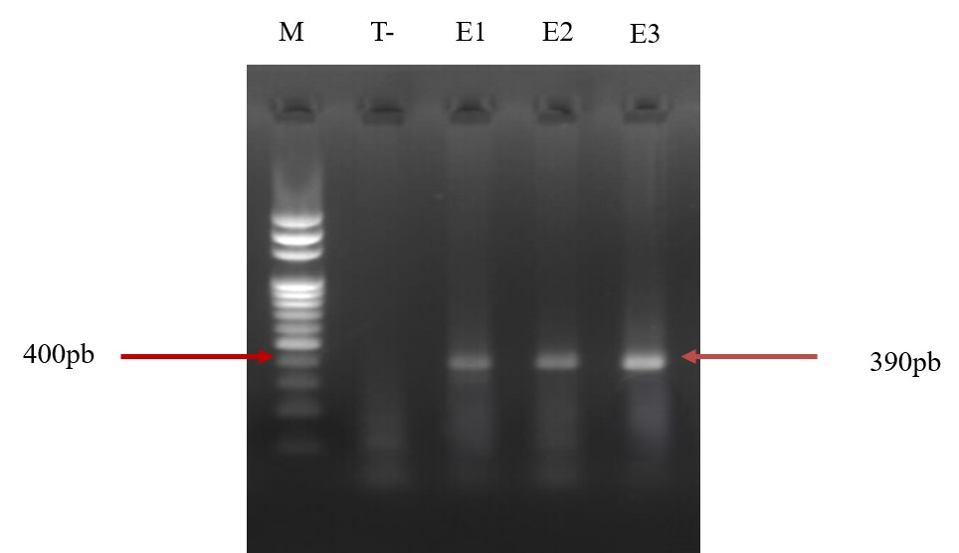
Figure 5:Electrophoretic profile of VIM gene amplicons
Legend: M1: Molecular weight marker (100 bp DNA Ladder); T-: Negative control; Numbers E1 – E3 represent samples: E1 = 228; E2 = 2532; E3 = 3149.
Frequencies of isolated genes
At the end of the electrophoretic migration, 89.13% of strains were found to carry at least one of the genes sought against 10.87% not harboring a gene among the strains producing ESBL. The CTX-M-G1 gene was isolated from 89.13% of strains and the VIM gene was isolated from 6.52%. All strains carrying the VIM gene also harbored the CTX-M-G1 gene. In our experimental conditions mcr and IMP genes were not found. Among the strains producing the CTX-M-G1 gene, Escherichia coli was represented at 73.17%, Klebsiella pneumoniae at 14.63%, Acinetobacter baumanii at 4.88% and 2.43% for each of Citrobacter sp, Pseudomonas aeruginosa and Morganella sp. Regarding the VIM gene, a proportion of 2.43% was found for each of Klebsiella pneumoniae, Acinetobacter baumanii and Pseudomonas aeruginosa.

DISCUSSION
During our studies, we found that urine is the sample that provides the most bacterial strains, of which Escherichia coli was the majority species with a proportion of 73.07% followed by Klebsiella pneumoniae (17.31%). The results of our study corroborate with those of other studies. Indeed, in most studies, the strains isolated come mainly from urine (Leroy et Tattevin 2012).. Urinary tract infection is a colonization by uropathogenic bacteria such as E. coli, K. pneumoniae and many others from the intestines and the environment (Zahir et al., 2019). The prevalence of urinary tract infection depends on multiple factors, including age and sex (Davison et al., 2000). Kassakian and colleagues reported a prevalence of urinary tract infections of 80% in Iceland (Kassakian, et Mermel, 2014).
In stools, the species represented were Shigella sp (50%), Escherichia coli (25%) and Salmonella sp (25%). Other studies have also reported the same trends. In Cameroon, proportions of 66.6%, 15.5% and 2.22% were reported respectively for Escherichia coli, Salmonella Spp. 15.5% and Shigella Spp in cases of diarrhea (Ateudjieu et al., 2018)
In our study, Enterobacteria were the most widely encountered with a proportion of 93.33%. Among them, Escherichia coli was represented in the majority with a proportion of 71.67% followed by Klebsiella pneumoniae with 15%. These same trends had been reported in Burkina in 2015 and in Togo in 2017, but with slightly lower prevalences in bacterial species (Zongo, et al., 2015; Toudji, et al., 2017). Among Gram-negative bacilli, enterobacteria are frequently isolated in bacteriology laboratories, with E. coli and Klebsiella spp being the most commonly encountered species (Zongo, et al., 2015).
The antibiotic susceptibility test showed high proportions of strains resistant to cephalosporins with 86.67% for ceftazidime and 88.33% for cefotaxime. However, most strains were sensitive to carbapenems although multiresistance was observed. Several studies have also reported high resistance to ceftazidime. This is particularly the case reported from Ethiopia with prevalence of 76.4% (Legese et al., 2022). In Ghana, however, Agyepong and colleagues reported only 40.5% resistance to ceftazidime in their studies of multidrug-resistant Gram-negative bacterial infections in a teaching hospital in 2018 (Agyepong et al., 2018).
Regarding cefotaxime, our results are similar to those of a study in South Africa carried out by Founou and his colleagues who found a frequency of 88% (Founou et al., 2018), just like those of Legese and his collaborators who reported a resistance of 78% in Ghana in 2022. In Burkina Faso, proportions of 91.03% had been reported in Gram-negative bacilli in 2015 respectively (Zongo, et al., 2015). However, an assessment of antibiotic susceptibility of Gram-negative bacteria showed a susceptibility to cefotaxime of 49.5% in Congo (Kabwit et al., 2020).
Resistance of Gram-negative bacilli to C3G has been reported worldwide. It is caused by their abusive, uncontrolled and inappropriate use. Indeed, faced with repeated exposures to these antibiotics, bacteria have developed multiple resistance mechanisms. The most important one is the production of ESBL enzymes (Oliveira et Reygaert, 2023). The spread of these enzymes within bacteria and the production of new variants to take into account many more groups of antibiotics is making the situation worse (Tooke et al., 2019).
Regarding carbapenems, the results of our study corroborate with those carried out in Nigeria where a sensitivity to imipenem and meropenem of 92% each was noted in 2014 then 83% in 2018 (Aruhomukama et Nakabuy, 2023).. In Rwanda, 85% sensitivity to imipenem was reported in 2024 (Bizimungu et al., 2024). However, in 2018, Zeynudin and colleagues found no resistance of Gram-negative bacteria to meropenem and imipenem in Ethiopia. They proposed that imipenem is an effective antibiotic for the management of infection caused by CTX-M-producing isolates (Zeynudin et al., 2018).
Of both strains studied, 76.67% were found to be producers of extended-spectrum β-lactamases. E. coli was largely represented with more than 73.91% followed by Klebsiella pneumoniae with 15.21%. Our results corroborate those of several other studies. Indeed, proportions of 66.02% and 71.7% of Gram-negative bacilli positive for ESBL were reported in Burkina Faso and Rwanda respectively (Leroy et Tattevin, 2012; Sutherland et al., 2019). . Lower rates of ESBL-producing Gram-negative bacilli have nevertheless been reported in other studies. Similar studies reported prevalences of 12.2% in the USAand between 44.6% and 49.3% in Ghana (Husna et al., 2023; Donkor et al., 2023). This finding is consistent with studies that suggest greater resistance in poorer areas where BLSE prevalence is very high compared to developed countries (Sangare et al.,2015)
The lack of routine surveillance in most countries, particularly in West Africa, does not allow for correct estimation of the proportions of BLSE among the strains isolated during infectious processes (Da et al., 2023). In addition, the prevalence of ESBL-producing enterobacteria varies between countries and contexts depending on whether the study was conducted in a community or hospital setting (Upadhyay et al., 2015). Our study showed a high frequency of CTX-M-G1 gene of 89.13% and VIM gene frequency of 6.52%. IMP and mcr genes were not detected. High frequencies of CTX-M were found in Ethiopia (95.8%) and²⁹ . Regarding group 1, a prevalence of 88.9% of which 83.33% was the CTX-M-15 variant was found in Algeria (Souna et al., 2022). The widespread misuse and excessive use of cephalosporins, especially cefotaxime, would be the probable cause of the selection and propagation of clones carrying the CTX-M gene (Benaissa et al., 2021).The high proportions of resistance to third-generation cephalosporins are explained by the production of plasmid-determined ESBLs, including the CTX-M-15 type, which has an epidemic character (Elrahem et al., 2023).
Regarding VIM and IMP genes, relatively low prevalences of VIM were also found in Uganda (10.7%) and Tanzania (12.3%).(Leroy et Tattevin 2012). In Egypt, these trends were higher where prevalences of 26.7% and 30% were reported for IMP and VIM respectively. However, Taha and colleagues did not observe the IMP gene in their study of the prevalence of carbapenem-resistant enterobacteriaceae in western Saudi Arabia (Taha et al., 2023).
Our results also showed that all isolates harboring the VIM gene also carried the CTX-M gene, a proportion of 6.52%. Other studies have previously discovered the coexistence of several variants of these genes within the same bacterial isolate. VIM-1/CTX-M-9 and VIM-1/CTX-M-2; VIM-1/CTX-M-15 associations have been highlighted in Spain and Turkey, respectively (Yildirim et al., 2007). These coexistences are possible thanks to the plasmid and clonal diversity that can be found in the same strain. In addition, large plasmids can incorporate several antibiotic resistance genes (Agyepong et al., 2018).The mcr gene was not detected under the conditions of our study. However, a metagenomic study of hospital, river and domestic wastewater from Burkina Faso, Benin and Finland found traces of the presence of these genes in these three countries, mcr-5 variant being the most frequently encountered (Melina et al., 2023). Other studies have also reported low proportions of the mcr-1 gene (0.7%) and mcr-2 gene (1.5%) particularly in China. Initially detected in animals, the mcr gene would be transmitted to humans by the consumption of animals infected by carrier bacteria (Zhang et al. 2018).

CONCLUSION
Bacterial resistance to antibiotics have become very worrying in the health sector. In Gram-negative bacilli, a multitude of mechanisms and genes are the cause. This study allowed us to isolate bacterial strains resistant to β-lactams and carbapenems, among which several are producers of ESBL and VIM-type carbapenemases. A significant proportion of strains harbor both the CTX-M gene and the VIM gene. The high proportions of resistance indicate that antibiotics of major interest are increasingly ineffective in the clinical setting. This work shows, like many other studies, that our hospitals are not immune to the ESBL and carbapenemases peril and calls into question the therapeutic options, surveillance and control measures for resistant bacteria.

References
Agyepong, N, Govinden, U, Owusu-Ofori, A, and Essack, SY. (2018). “Multidrug-resistant
gram-negative bacterial infections in a teaching hospital in Ghana,”Antimicrob. Resist.
Infect. Control, flight. 7, p. 37. Doi: 10.1186/s13756-018-0324-2.
Aruhomukama D. and Nakabuye, H. (2023). Investigating the evolution and predicting the
future outlook of antimicrobial resistance in sub-Saharan Africa using phenotypic data for Klebsiella pneumoniae : a 12-year analysis. BMC Microbiol., vol. 23, p. 214. Doi: 10.1186/s12866-023-02966-y.
Ateudjieu, J, Bita’a, LB, Guenou, E, Chebe, AN, Chukuwchindun, BA, Koukoum, APG,
Bisseck, ACZK. (2018). Profile and antibiosensitivity of pathogenic bacteria associated with diarrhea in patients consulting at the Regional Annex Hospital of Kousseri, Far North Cameroon. Pan Afr. Med. J., vol. 29. Doi : 10.11604/pamj.2018.29.170.14296.
Benaissa, H, Elmrimar, N, Belouad, E, Mechal, Y, Ghazouani, M, Bsaibiss, F. (2021). “Update on the resistance of Escherichia coli isolated from urine specimens in a Moroccan hospital: a review of a 7-year period”, Germs, vol. 11, no. 2, p. 189‑198. Doi : 10.18683/germs.2021.1256.
Bizimungu, O, Crook, P, Babane, JF and Bitunguhari, L. (2024). The prevalence and clinical context of antimicrobial resistance among medical inpatients at a referral hospital in Rwanda : a cohort study”. Antimicrob. Resist. Infect. Control, vol. 13, p. 22. Doi : 10.1186/s13756-024-01384-7.
Da, L., Somé, D., Yehouenou, C., e Somé, C., Zoungrana, J., Ouédraogo, AS., Lienhardt, C. andPoda, A. (2023). State of play of antibiotic resistance in sub-Saharan Africa. Medicine and Infectious Diseases Training 2 (1): 3‑12. https://doi.org/10.1016/j.mmifmc.2023.01.003.
Davies, J. and Davies, D. (2010). Origins and Evolution of Antibiotic Resistance. Microbiol. Mol. Biol. Rev. MMBR, flight. 74, no. 3, p. 417-433. Doi : 10.1128/MMBR.00016-10.
Davison, HC., Low, JC., and Woolhouse, ME. (2000). “What is antibiotic resistance and how
can we measureit ? », Trends Microbiol., vol. 8, no. 12, p. 554‑559. Doi : 10.1016/s0966-842x (00)01873-4.
Donkor, ES et al. (2023). “Multicenter Surveillance of Antimicrobial Resistance among Gram-Negative Bacteria Isolated from Bloodstream Infections in Ghana”. Antibiotics, vol. 12, no. 2, p. 255. Doi : 10.3390/antibiotics12020255.
Elrahem, AA, El-Mashad, N, Elshaer, M, Ramadan, H, Damiani, G, Bahgat, M.(2023). Carbapenem Resistance in Gram-Negative Bacteria : A Hospital-Based Study in Egypt. Med. Kaunas Lith., vol. 59, no. 2, p. 285, Feb. 2023 Doi : 10.3390/medicina59020285.
Founou, RC, Founou, LL, and Essack, SY. (2018). “Extended spectrum bêta-lactamase mediated resistance in carriage and clinical gram-negative ESKAPEbacteria : a comparative study between a district and tertiary hospital in South Africa”, Antimicrob. Resist. Infect. Control, vol. 7, no. 1, p. 134. Doi : 10.1186/s13756-018-0423-0.
Ghamgosha, M., Shahrekizahedani, S., Kafilzadeh, F., Bameri, Z., Taheri, RA and Farnoosh, G. (2015). Metallo-beta-Lactamase VIM-1, SPM-1, and IMP-1 genes among clinical Pseudomonas aeruginosa species isolated in Zahedan, Iran. Jundishapur J. Microbiol., flight. 8, no. 4, p. e17489. Doi: 10.5812/jjm.8(4)2015.17489.
Husna, A, RahmanRahman, M, Badruzzaman, ATM, Hasan, M, Islam, MR, Rahman, T, et al. (2023). Extended-Spectrum β-Lactamases (ESBL) : Challenges and Opportunities, Biomedicines, vol. 11, no. 11, p. 2937. Doi : 10.3390/biomedicines11112937.
Kaboré, B, Ouédraogo, GA, Cissé, H, Ouédraogo, HS, Sampo, E, Zongo, KJ et a(l. 2022).
“(GTG)5-PCR fingerprinting of multi-drug resistant Escherichia coli bacteria isolated from hospital in Ouagadougou, Burkina Faso”, BMC Microbiol., vol. 22, p. 118. Doi : 10.1186/s12866-022-02537-7.
Kabwit, MH, Kalenda, T, Tshamba, HM, Piema, RB, Mukengeshayi, AN, Kaj, FM. (2020). Evaluation of the sensitivity to antibiotics of uropathogenic germs isolated from women in artisanal mining activities in Kolwezi in Lualaba (DRC). Int. J. of Multidisciplinary and Current research, Vol 8, Doi : https://doi.org/10.14741/ijmcr/v.8.3.2.
Kassakian, SZ. and Mermel, LA. (2014). Changing epidemiology of infections due to extended spectrum beta-lactamase producing bacteria. Antimicrob. Resist. Infect. Control, flight. 3, no. 1, p. 9. Doi : 10.1186/2047-2994-3-9.
Kim J, Jeon S, Rhie H, Lee B, Park M, Lee H et al. (2009). Rapid detection of
extended spectrum β-lactamase (ESBL) for Enterobacteriaceae by use of a Multiplex PCR-based Method. Infection and Chemotherapy, 41(3), 181. DOI. https://doi.org/10.3947/ic.2009.41.3.181
Legese MH et al. (2022). “Sepsis : emerging pathogens and antimicrobial resistance in Ethiopian referral hospitals”. Antimicrob. Resist. Infect. Control, vol. 11, no. 1, p. 83. Doi : 10.1186/s13756-022-01122-x.
Leroy, H. and Tattevin, P. (2012). Urinary tract infections. EMC - AKOS Medicine Treaty, flight. 7, no. 2, p. 1‑6. Doi : 10.1016/S1634-6939(12)45377-7.
Liu, Y-Y., Wang, Y., Walsh, TR., Yi, LX., Zhang, R., Spencer, J. et al. (2016). Emergence of plasmid-mediated colistin resistance mechanism MCR-1 in animals and human beings in China : a microbiological and molecular biological study. Lancet Infect. Dis., vol. 16, no. 2, p. 161‑168. Doi : 10.1016/S1473-3099(15)00424-7.
Melina, AM, Haukka, K, Victorien, K, Dougnon, T, Bonkoungou, IJO, Garba, Z. (2023). Metagenomic analysis of the abundance and composition of antibiotic resistance genes in Hospital wastewater in Benin, Burkina Faso, and Finland. mSphere, vol. 8, no. 1, p. e00538-22. Doi : 10.1128/msphere.00538-22.
Nabti, L.Z. (2020). Sensitivity to antibiotics and essential oils of origanum glandulosumDesf : Escherichia coli strains isolated from urinary tract infection at Sétif University Hospital. http://dspace.univ-setif.dz:8888/jspui/handle/123456789/3686
Oliveira, J. and WC Reygaert (2023). Gram-Negative Bacteria”, in StatPearls, Treasure Island.
Available at: http://www.ncbi.nlm.nih.gov/books/NBK538213/ Accessed : July 3, 2023.
Palzkill, T. (2013). Metallo-β-lactamase structure and function. Ann. NY Acad. Sci., vol. 1277, no. 1, p. 91‑104. Doi : 10.1111/j.1749-6632.2012.06796. x.
Rebelo, AR, Bortolaia, V, Kjeldgaard, JS, Pedersen, SK, Leekitcharoenphon, P, Hansen, IM. et al. (2018). Multiplex PCR for detection of plasmid-mediated colistin resistance determinants, mcr-1, mcr-2, mcr-3, mcr-4 and mcr-5 for surveillance purposes. Eurosurveillance, vol. 23, no. 6, p. 17‑00672. Doi: 10.2807/1560-7917.ES.2018.23.6.17-00672.
Sangare, SA, Maiga, AI, Guindo, I, Maiga, A, Camara, N, Savadogo, S. et al.(2015). Prevalence of extended-spectrum β-lactamase-producing Enterobacteriaceae isolated from blood cultures in Africa. Médecine Mal. Infect., vol. 45, no. 9, p. 374‑382. Doi : 10.1016/j.medmal.2015.08.003.
Souna, D, Drissi, M, Almahmoud, I. and Maurin, M. (2022). Enterobacter cloacae Complex
and CTX-M Extended-Spectrum β-Lactamases in Algeria. Microb. Drug Resist. Larchmt. N, vol. 28, no 3, pp. 346‑354. Doi : 10.1089/mdr.2020.0535.
Ssekatawa, K, Byarugaba, DK, Nakavuma, JL, Kato, CD, Ejobi, F, Tweyongyere ,
R, Eddie WM. ( 2021). Prevalence of athogenic Klebsiella pneumoniae based on PCR capsular typing harboring carbapenemases encoding genes in Uganda tertiary hospitals”, Antimicrob. Resist. Infect. Control, vol. 10, no. 1, p. 57. doi: 10.1186/s13756-021-00923-w.
Sutherland, T, Mpirimbanyi, C, Nziyomaze, E, Niyomugabo, JP, Niyonsenga, Z, Muvunyi, CM. et al. (2019). Widespread antimicrobial resistance among bacterial infections in a Rwandan referral hospital. PLoS ONE, vol. 14, no. 8, p. e0221121. Doi : 10.1371/journal.pone.0221121.
Taha, R, Mowallad, A, Mufti, A, Althaqafi, A, Jiman-Fatani, AA, El-Hossary, D.(2023). “Prevalence of Carbapenem-Resistant Enterobacteriaceae in Western Saudi Arabia and Increasing Trends in the Antimicrobial Resistance of Enterobacteriaceae”. Cureus, vol. 15, no. 2, p. e35050, 2023. Doi : 10.7759/cureus.35050.
Tooke CL. et al. (2019). “β-Lactamases and β-Lactamase Inhibitors in the 21st Century”, J. Mol. Biol., vol. 431, no. 18, p. 3472‑3500. Doi : 10.1016/j.jmb.2019.04.002.
Toudji, AG, Djeri, B, Karou, SD, Tigossou, S, Ameyapoh, Y, and de Souza, C. (2017). Prevalence of strains of Enterobacteriaceae producing extended-spectrum beta-lactamases isolated in Togo and their sensitivity to antibiotics. Int. J. Biol. Chem. Sci., flight. 11, no. 3, Art. no 3. Doi: 10.4314/ijbcs.v11i3.19.
Upadhyay, S, Hussain, A, Mishra, S, Maurya, AP, Bhattacharjee, A. and Joshi, SR.(2015). Genetic Environment of Plasmid Mediated CTX-M-15 Extended Spectrum Beta-Lactamases from Clinical and Food Borne Bacteria in North-Eastern India. PLoS ONE, flight. 10, no. 9, p. e0138056. Doi : 10.1371/journal.pone.0138056.
Wang, Z, Bimal K, Yozen H, Matthew Z, Steven P, David Perlin, et al. (2022). A Naturally Inspired Antibiotic to Target Multidrug-Resistant Pathogens. Nature 601 (7894): 606-11. https://doi.org/10.1038/s41586-021-04264-x.
Yildirim, I, Ceyhan, M, Gur, D, Mugnaioli, C. and Rossolini, GM. (2007). First detection of
VIM-1 type metallo-beta-lactamase in a multidrug-resistant Klebsiella pneumoniae clinical isolate from Turkey also producing the CTX-M -15 extended-spectrum beta-lactamase. J. Chemother. Florence Italy, vol. 19, no. 4, pp. 467-468. Doi : 10.1179/joc.2007.19.4.467.
Zahir, H, Draiss, G, Rada, N, Abourrahouat, A, Aitsab, I, Sbihi, M. et al. (2019). Microbial
ecology and antibiotic sensitivity of bacteria isolated from urinary tract infections in children in Morocco. Rev. Francoph. Lab., vol. 2019, no. 511, pp. 65‑70. Doi : 10.1016/S1773-035X (19)30229-1.
Zeynudin, A, Pritsch, M, Schubert, S, Messerer, M, Liegl, G, Hoelscher, M, Belachew, T, Wieser, A. (2018). Prevalence and antibiotic susceptibility pattern of CTX-M type extended-spectrum β-lactamases among clinical isolates of gram-negative bacilli in Jimma, Ethiopia. BMC Infect. Dis., vol. 18, p. 524. Doi : 10.1186/s12879-018-3436-7.
Zhang, J, Chen, L, Wang, J, Butaye, P, Huang, K, Qiu, H et al. (2018). Molecular detection of colistin resistance genes (mcr-1 to mcr-5) in human vaginal swabs. BMC Res. Notes, vol. 11, no. 1, p. 143. Doi : 10.1186/s13104-018-3255-3.
Zhuo, C., Li, X., Zong, Z. and Zhong, N.-S. (2013). Epidemic Plasmid Carrying blaCTX-M-15 in Klebsiella penumoniae in China. PLoS ONE, flight. 8, no. 1, p. e52222. Doi: 10.1371/journal.pone.0052222.
Zongo, KJ, Metuor-Dabire, A, Compaore, LG, Sanou, I., Sangare, L, Simpore, J,
Zeba, B. (2015). First detection of blaTEM, SHV and CTX-M among Gram negative bacilli exhibiting extended spectrum -lactamase phenotype isolated at University Hospital Center, Yalgado Ouedraogo, Ouagadougou, Burkina Faso. African Journal of Biotechnology. 14(14), 1174–1180. DOI. https://doi.org/10.5897/AJB2014.13908

