Original Research Article

Hybridization, introgresssion and segregation among cultivated and feral members of the sorghum genus

Abstract
Aims: The East African region is a centre of diversity for sorghum, there is need for studies on the role of interspecific hybridization and introgression of domesticated sorghum genes in weedy backgrounds.
Study design: Interspecific hybridization between S. bicolor and the weedy accessions belonging to S. halepense, S. sudanense and S. bicolor ssp. verticilliflorum accessions was studied.
Methodology: At anthesis panicles of the weedy accessions were emasculated and pollinated with pollen from S. bicolor. The F₁, F₂ and BC₁ populations were evaluated for simple sequence repeat (SSR) loci and phenotypic polymorphisms.
Results: Averages of 5 unique and null alleles and Shannon information content of 1.255 were obtained in weedy sorghums on the loci assayed, showing high polymorphism and genetic differentiation of the accessions used in the study. Alleles of between 70 and 300bp were obtained from all loci except loci SB1764, SB5058, SB3420, SB2389 and loci SB3258. Phenotypic analysis of S. bicolor, S. sudanense, S. halepense and their F₁ progenies showed significant variation on vegetative traits. S. sudanense had greater number of tillers (3.3), number of branches (0.3), total seed number (3010) and photosynthesis (110); S. bicolor had a higher 100 seed weight (3,1g) while S. halepense had the least flowering (65,1%) but more ratooning (3.8). In contrast to their parental species, the F₁s had profuse tillering (2.3 - 3.4), were taller (121- 144 cm) and had more seed (2814 – 3243). The crosses had mid way clusters between respective parents in ssr loci dendogram analysis. A 3:1 and 1:1 segregation was observed in the F₁ and BC₁ populations respectively.
Conclusion: F₁ populations were obtained between S. halepense x S. bicolor and S. sudanense x S. bicolor. There is need for more studies on the role of crop to non-crop hybridization within the species.

Key words: Sorghum, interspecific hybridization, introgression, S. halepense, S. sudanense, SSR, polymorphism

Introduction
Interspecific hybrids within the sorghum genus have been reported to occur naturally and through forced or artificial hybridization [1,2]. This hybridization has significant contribution towards evolution partterns within the genus. Agriculturally important members of this genus are products of ancient interspecific hybridization events. S. almum (2n = 40) is believed to be a product of a hybridization event between S. bicolor and S. propinquum [3]. S. halepense has contribution from different members of the genus to its genome resulting in its segmental allopolyploid nature [4]. S. sudanense has been shown to be a segregate from a natural hybrid between S. bicolor and S. arundinaceum [5]. Artificial hybrids have been obtained and studied between S. bicolor and S. halepense [6].

In the genus sorghum, hybridization and introgression of S. bicolor alleles into S. halepense was shown to occur at rate between 0 to 100% depending on the proximity of the weed to the crop [7]. Hybridization and outcrossing has been shown in S. sudanense to occur at varying rates and it is depenedent on the genotype (R or B), date of pollination and panicle position [5]. The methods applied in assessing gene transfer by hybridization between domesticated and wild species include evaluation of seed set after forced hybridization, F₁ germination success, F₁ hybrid and F₂ viability and fertility. In addition, experiments involving field hybridization and evaluation of fitness of F₂ and subsequent generations have shown utility in evaluating interspecific hybridization [8]. The rate of hybridization has been previously used in spontaneous crosses involving S. halepense and S. bicolor as a good measure of introgression of crop genes into the weedy relatives [7]. Protein based genetic markers have been utilized to evaluate the incidence and the rate of hybridization between S. halepense and S .bicolor [7]. Hybridization and introgression of S. bicolor alleles in to S. sudanense using phenotypic makers has been previously reported [9]. Field studies have reported significant hybridization and introgression of crop alleles in feral sorghums with impact on sorghum diversity [10]. This study hypothesized that gene flow from S. bicolor to S. halepense, S. sudanense and S. bicolor ssp. verticilliflorum occurs at varying rates and influences the genetic and phenotypic characters in F₁ progenies. Parental, F₁, F₂ and BC₁ generations obtained from interspecific hybridization between S. halepense x S. bicolor, S. sudanense x S. bicolor and S. bicolor ssp. verticilliflorum x S. Bicolor were evaluated for SSR loci,

Materials and methods

Hybridization between S. bicolor and its wild species
Seeds of each of the four species namely S. bicolor (BTX623), S. halepense, S. sudanense and S. bicolor ssp. verticilliflorum were acquired from USDA germplasm bank USDA, ARS, Plant Genetic Resources Conservation Unit. The wild sorghum species of S. halepense, S. sudanense and S. bicolor ssp. verticilliflorum are weeds that have potential of being invasive in agricultural fields [11]. S. halepense, S. sudanense and S. bicolor ssp. verticilliflorum seeds were subjected to temperatures of 5⁰Cfor 10 days then to 45⁰C for 24 hours in a drying oven to break dormancy [12]. The seeds were then planted in germination racks with autoclaved soil mixture consisting of loamy soil, sand and manure in 3:1:1 ratio. The racks were kept wet in the greenhouse at 28/22⁰C day/night temperatures till germination. In order to synchronise flowering, the weedy sorghums S. halepense seed were germinated 11 days after the crop seed while, S. sudanense seed and S. bicolor ssp. verticilliflorum seed were germinated 22 days and 20 days before the crop.

Fifty seedlings of each of the crop and weedy species were transplanted into 30cm diameter pots containing autoclaved soil mixture (loamy soil, sand and manure; 3:1:1 ratio) in the greenhouse where the temperatures were maintained at 28/22⁰C dayand night temperatures respectively. A starter fertilizer mixture Polyfeed® NPK, 19:19:19 from Amiran Kenya (95μg/L nitrogen, phosphorus and potassium per day) was applied for 30mins two times a day and three times a week in irrigation water from germination till the onset of flowering. This was followed by a finisher fertilizer mixture Polyfeed® NPK, 18:9:27 from Amiran Kenya (90μg/L nitrogen, 45μg/L phosphorus and 67.5μg/L potassium per day) that was applied for 30mins, two times a day and three times a week in irrigation water until flowering stage. Plants were watered twice a day trough drip irrigation and maintained at 12/12 h day/night photoperiod. Dursban® 50W (chlorpyrifos) was used to control Lepidopteran and Homopteran pests at a rate of 0.28kg/ha. Polytrin® P440 EC was applied at 1.0 litre/ha to control Lepidopteran and Homopteran and mites, while the miticide Ortus®, SC 5% (fenpyroximate) was applied as a foliar spray at a rate of 0.05 Kg/ha during mite infestation. A second selfing population of S. bicolor, S. halepense, S. sudanense and S. bicolor ssp. verticilliflorum was raised and selfed. During flowering S. halepense, S. sudanense and S. bicolor ssp. verticilliflorum panicles were trimmed, emasculated and covered with translucent glassine bags [13]. Six florets were emasculated on nine spikes on each panicle. The weedy species were used reciprocally as male and female parent and six crosses were done as shown in Table 1. Pollination was done as soon as all the florets had protruding stigmas or before ten days from the emergence of the first stigmas. The pollen was collected from the S. bicolor panicles in pollen bags and immediately used to pollinate twenty panicles of emasculated S. halepense, S. sudanense and S. bicolor ssp. verticilliflorum panicles. The pollinated panicles were bagged and the seed was harvested, dried and threshed. The second filial (F₂) populations were obtained by selfing 20 F₁ plants from each of the two F₁ populations. First back cross (BC₁) populations were obtained.

Table 1. Number of reciprocal crosses between crop sorghum and wild sorghum species.
 | Cross | Number of spikes | Number of florets
1 | ♀S. halepense x ♂S. bicolor | 31 | 464
2 | ♀S. bicolor x ♂S. halepense | 37 | 262
3 | ♀S. sudanense x ♂S. bicolor | 273 | 1377
4 | ♀S. bicolor x ♂S. sudanense | 42 | 199
5 | ♀S. bicolor ssp. verticilliflorum x ♂S. bicolor | 17 | 123
6 | ♀S. bicolor x ♂S. bicolor ssp. verticilliflorum | 53 | 211
 |  | 453 | 2636
* The parent on the right is the male

Screening for polymorpism in the selfed wild species

Simple sequence repeat (SSRs) regions were identified from mapped sorghum sequences published on the NCBI genebank and defined sorghum SSRs [14,15,16]. The physical mapping data was obtained from the Comparative Grass Genomics Center [17] and Phytozome databases. The Simple Sequence Repeat Identification Tool (SSRIT) was used to identify the di, tri and tetra- nucleotide simple sequence repeats on the mapped probes [18]. The flanking primers for these repeats (Table 2) were obtained using the Primer 3 programme [19]. The primer sequences were sent and synthesized by InvitrogenTM on a 25 nmol scale of synthesis. The primers obtained were resuspended in nuclease free water to make a stock solution of 100µM. These were stored at -20⁰C in functional aliquots until PCR.

Table 2 Primer Set developed from the sorghum physical map
Marker  name | Forward primer (5' -> 3') | Reverse primer (5' -> 3')
SB297 | CAGTATATATGCGCACTGCTCGC | GGAAAGAGAGGTCGCTTTAATGGC
SB960 | GGCATGACATTCTTTCTAGCCCTG | GAAGGAGTCATTGGCCAAATCGTA
SB1764 | CTTGTGCTTGCTTGCACCATATTC | GTCGATGAGGAGCTTCATGCTCAG
SB2389 | GGAATCGGATTGGATTCTGTTCTG | CGCTGGACAACTCATCTTCACTTG
SB3008 | ATTTTGGTCCAGTTGCTCTTGCAT | CGTACGTGAGCGAGGATTGTTCTA
SB3420 | GAGCCAGCATGCATGATAATTGTT | CACAAAGGCATGACAGTCAATCAA
SB3860 | GAAAGCAGCTTCAGTGGTGTGTGT | GCTTCTGCTTCTGCTTCTGCTTCT
SB4396 | CATGACCATAGTGTGGTTGCATTG | AGCCTTCGTAATTCTGTCTCCACG
SB5058 | GAGAATTGGAAGAAAGCCTCGGTT | CAGAGCTCCTAAACGGTCCTCAAA
SB5458 | AATGTGGTGGTGTTGTGTCTCCAT | TCTACTGCTATCATCGCCTCCACC
SB858 | TTTCGTCTTCTTCCACATGACCAC | AGAAGATGGCGACAATCAGAAAGG
SB1287 | CGAGTAGCAGTTGTGTTTTTCCCC | AATCGTGTCATCCCTTGTCTTGGT
SB1799 | GTCACTTGGCATAATCCATCCCAT | CGGGTTATGTCGGTGTATGTAGCA
SB2866 | GCCTTCGTTCTTCCTCCTGTTCTT | TGGTTTTGTTGATCCTTTTGTCCC
SB3258 | ATTGTTGTCCTCCCCTCCACC | AGTACCTGAACCAGGCGTCGCT
SB3806 | TGGAGCGAGGATGTAAGATCTGTG | CCAGCCACACAATTAAGACCCAAT
SB3978 | CTGGTGAAGGTTGAAGAAAGGGTC | GCCACAAACATAAGGGGTTCACTC
SB4565 | ATCGATCGGTCAGGCAGTTTTCT | GATTCTCTCCGGATGGATCGAC
SB4688 | CTGTAAGCATGATGAAGGTCGTGG | AAGAAGGTGATGACAGGGATGGAG
SB5293 | TGAATAATGCACGCAGTAGCGTCT | TATTCCCACGGCTCGCTAGCTACT

Screening of parental F₁, F₂ and BC₁ genotypes for polymorphism using PCR
Leaves were collected from 3 week old plants of parental genotypes (S. bicolor, S. bicolor ssp. verticilliflorum, S. halepense and S. sudanense) from the greenhouse and maintained on ice till DNA extraction. The samples also included F₁ population, F₂ population and backcross BC₁ population. Genomic DNA was extracted using a modified CTAB based protocol [20, 21].

Polymerase chain reaction reaction
PCR was done in 0.5 ml tubes in a hybaid® thermocycler. Each sample had a total volume of 11 µl per reaction. The PCR denaturation and elongation temperatures were maintained at 94⁰C and 72⁰C respectively and all programmes were set for 35 cycles [21]. Agarose gel electrophoresis was done to evaluate the molecular weight, quantity and quality of DNA after total nucleic acid extraction and PCR on 0.8-1 % agarose gels (Qualex Gold, AGS, Heidelberg, Germany). PCR products were evaluated on 3-4 % UltraPure ™ Agarose gels. Electrophoresis was done at 120 volts for 2 hours. The gel was placed on a UV transilluminator and a photograph was taken.

Morphological measurements and data analysis
Vegetative and reproductive paramters were measured after every ten days during plant growth. These parameters included plant height, number of leaves during growth, culm width and number of tillers days to flowering, panicle dry weight, panicle shape, seed number, seed germination and plant dry weight. Photosynthetically Active Radiation (PAR) quantum light probe was used to measure the photon flux in the PAR at a wavelength range from 400nm to 700nm. Adaxial and abaxial readings were taken and the difference was determined as the actual PAR. The readings were taken over a 150 day period in 10 day intervals. PAR was defined in terms of photon (quantum) flux, calculated as the number of moles of photons in the radiant energy.

Genetic data analysis
Allelic variations, homozygosity and heterozygosity indices were estimated by using POPGENE version 1.31. Genetic distance, Identity and dendogram development were calculated with DARwin 5.0.157, [22]. Dissimilarity matrixes were developed in DARwin using the DICE coefficient for presence or absence data [23].
Analysis of variance (ANOVA) was applied to treatment effects, variances due to blocking and other random effects. Correlation analysis, regression analysis for vegetative and reproductive parameters were done using GENSTAT 14 (VSN 2012) program. The GENSTAT 14 program was also used to evaluate the phenotype of the parents, F₁ progenies, F₂ progenies and BC₁ progenies using principle component analysis (PCA), biplots analysis, discriminant analysis and calculation of Mahalanobis (D-squared) intergroup distances [24]. These techniques were used to statistically differentiate the parental populations and the progenies based on vegetative and reproductive parameters. SSR primer alignments on the genome and identification of matching protein domains was done in Phytozome and NCBI gene banks.

Results

Polymorphism among and within the species
SSR loci identified on the S. bicolor chromosomes exhibited polymorphism among and within the species (Table 3). The loci identified on S. bicolor chromosomes had specific alleles that were consistently seen on all crop samples (Table 4). Fragments ranged from 180bp to 300bp. Loci SB1764, SB2389, SB3420, SB1000X, SB5458, SB3258, SB3806 and SB5293 each had a 300bp fragment amplified from S. bicolor (Figure 1; Lanes 2, 4, 5, 6 7 12-15, Table 4) while loci SB960, SB3008, SB3860, and SB4396 gave a 200bp fragment each. The fragments with the least molecular weight were obtained from loci SB1799, SB858, SB297 and SB1287 and ranged from 70 to 190bp (Table 4).
Table 3. Allelic variation statistics for SSR loci in crop and weedy species
Locus | Chromosome | Position cM | Sample Size | na* | I*
SB297 | 1 | 20 | 126 | 6.0000 | 1.3876
SB960 | 2 | 2 | 152 | 8.0000 | 1.6641
SB1764 | 3 | 9 | 116 | 4.0000 | 1.1990
SB2389 | 4 | 2 | 108 | 3.0000 | 1.0133
SB3008 | 5 | 2 | 162 | 8.0000 | 1.9845
SB3420 | 6 | 4 | 110 | 3.0000 | 0.8626
SB3860 | 7 | 2 | 114 | 5.0000 | 1.3650
SB4396 | 8 | 7 | 130 | 6.0000 | 1.5216
SB5058 | 9 | 2 | 112 | 3.0000 | 0.5553
SB5458 | 10 | 17 | 118 | 5.0000 | 1.4969
SBI000X | 10 | 2 | 64 | 2.0000 | 0.2338
SB858 | 1 | 110 | 124 | 4.0000 | 0.9824
SB1287 | 2 | 95 | 112 | 4.0000 | 1.3197
SB1799 | 3 | 12 | 108 | 5.0000 | 1.3122
SB2866 | 4 | 40 | 136 | 6.0000 | 1.3347
SB3258 | 5 | 73 | 136 | 6.0000 | 1.4365
SB3806 | 6 | 92 | 108 | 6.0000 | 1.5131
SB3978 | 7 | 6 | 136 | 4.0000 | 1.1874
SB4565 | 8 | 70 | 132 | 6.0000 | 1.5317
SB4688 | 9 | 81 | 104 | 7.0000 | 1.6489
SB5293 | 10 | 86 | 152 | 3.0000 | 0.8092
Mean |  |  | 122 | 4.9524 | 1.2552
St. Dev |  |  |  | 1.6875 | 0.4018
* na = Observed number of alleles
* I = Shannon's Information index [17]

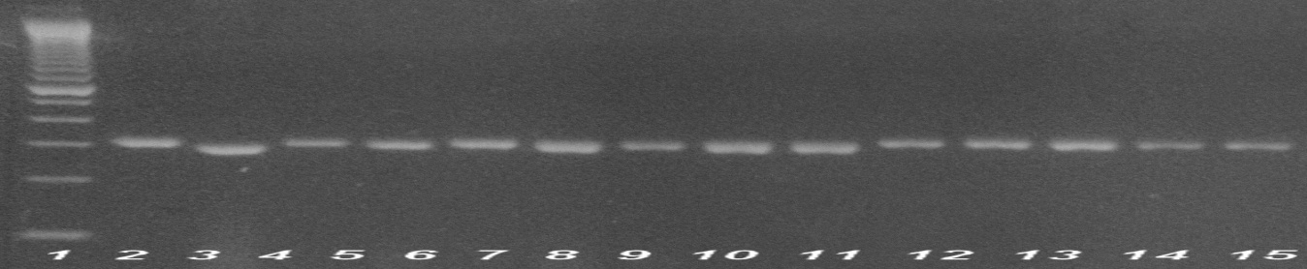
Figure 1. Agarose gel electrophoresis showing alleles from SSR loci analysis in S. bicolor populations. 290bp fragment in Ln 3, 8, 10, 11 from loci SB297, SB960, SB2866, SB3806. 300bp fragment in Ln 2, 4, 5, 6 7 12-15 from loci SB1764, SB2389, SB3420, SB1000X, SB5458, SB3258, SB3806.

The SSR loci utilized in this study were found to be present in both gene rich and non-gene rich regions on S. bicolor chromosomes.
Table 4. Alleles found in S. bicolor and in the wild species on 21 SSR loci
Locus | S. bicolor | S. sudanense | S. halepense | S. verticilliflorum
SB297 | 290/70 | 290/70 | 70 | 280/70
SB960 | 200 | 0 | 0 | 195
SB1764 | 300 | 300 | 850 | 890
SB2389 | 300 | 290 | 300 | 320
SB3008 | 200 | 200 | 195 | 195
SB3420 | 300 | 290 | 0 | 580
SB3860 | 200 | 200 | 0 | 0
SB4396 | 200 | 190 | 0 | 0
SB5058 | 250 | 0 | 320 | 390
SB5458 | 300 | 0 | 0 | 0
SBI000X | 300 | 300 | 280 | 270
SB858 | 180 | 180 | 190 | 190
SB1287 | 190 | 180 | 200 | 220
SB1799 | 180 | 160 | 160 | 160
SB2866 | 280 | 290 | 0 | 290
SB3258 | 300 | 400/290 | 280 | 290
SB3806 | 300/280 | 300 | 280 | 280
SB3978 | 300 | 310 | 290 | 290
SB4565 | 250 | 250 | 0 | 0
SB4688 | 220 | 200 | 200 | 200
SB5293 | 300 | 300 | 280 | 260
Locus SB5458 had null alleles in all the weedy species, loci SB5058 and SB960 had null alleles in S. sudanense while loci SB960, SB3860, SB4396, SB2866 and SB4565 gave no fragments on agarose gels in S. halepense (Figure 2, Table 4). Unique alleles were found on the loci in the weedy species with sizes ranging from 200bp, 250bp, 260bp, 270bp, 280bp, to 310bp. There were some unique alleles on locus SB1764 in S. halepense (850bp) and S. verticilliflorum (890bp) (Figure 3). Locus SB3258 showed a 400bp fragment in S. sudanense while locus SB1799 gave small fragments of 160bp in the wild species (Figure 3, Table 4).

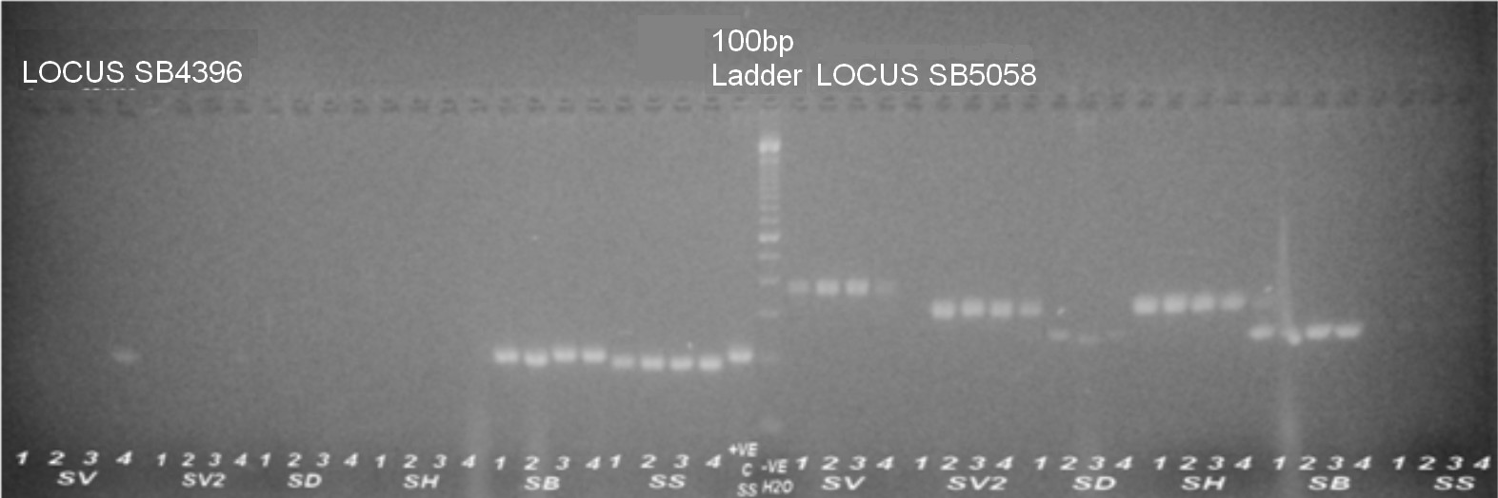
Figure 2. 4% agarose gel electrophoresis showing alleles and null alleles in wild sorghum populations on loci SB4396 and SB5058. SV- S. verticilliflorum, SD- Sorghum bicolor ssp. drummondii, SH- S. halepense, SB- Sorghum bicolor, SS- S. sudanense.

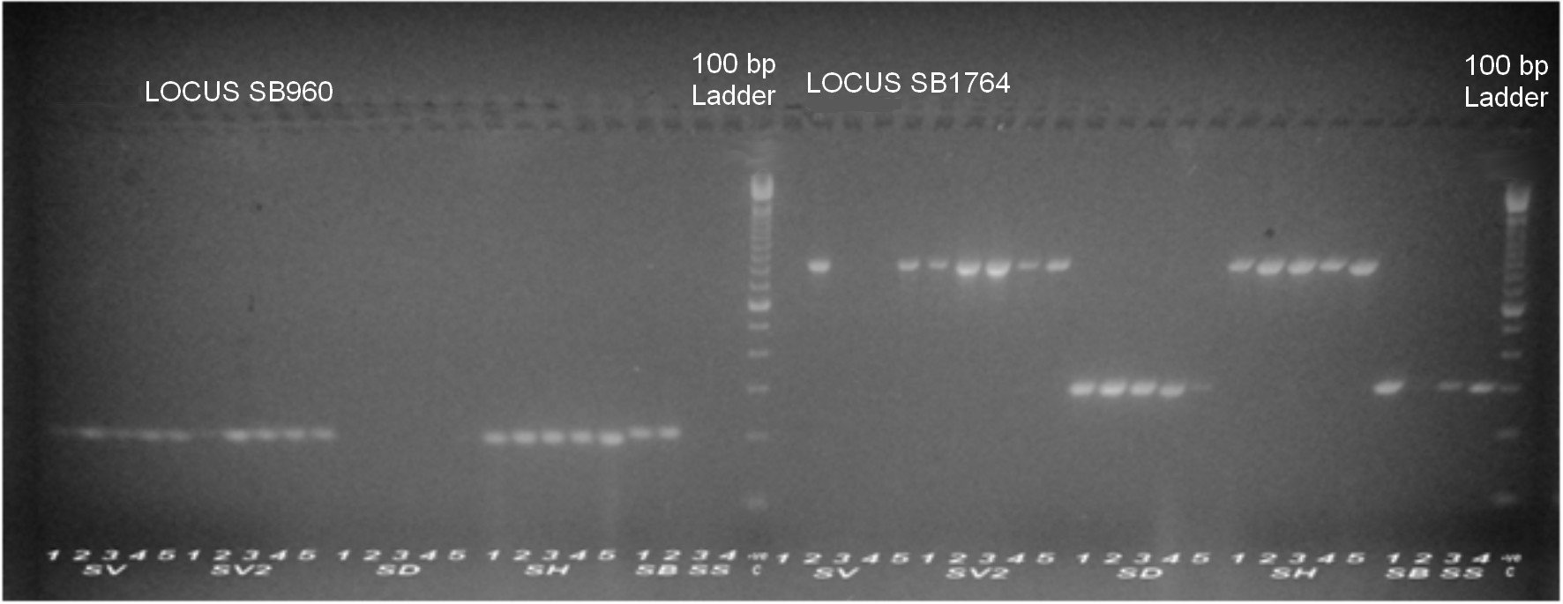
Figure 3. 4% agarose gel electrophoresis showing alleles and null alleles in wild sorghum populations on loci SB960 and SB1764. SV- S. verticilliflorum, SD- Sorghum bicolor ssp. drummondii, SH- S. halepense, SB- Sorghum bicolor, SS- S. sudanense.

Morphological differences and hybridization among the parental genotypes
Significant morphological differences were seen among the parental genotypes (p≤0.05), namely, S. bicolor, S. sudanense, S. halepense and S. bicolor ssp. verticilliflorum. Photosynthetic active radiation was high in S. sudanense which had a value of 110.17 followed by S. bicolor with a value of 92.15 and S. halepense with a value of 88.28. S. halepense had the least mean number of leaves (5.524) while S. sudanense and S. bicolor had 5.983 and 5.955 leaves respectively (Table 5). All the accessions expressed tillering at the first internode with S. sudanense giving the highest while S. bicolor and S. halepense had 1.083 and 1.505 mean number of tillers respectively. Height was most expressed in S. sudanense at 135.8cm, followed by S. bicolor at 111.8cm and S. halepense at 78.5cm. The number of branches above the first internode were observed most in S. sudanense. Branching in S. bicolor and S. halepense was not significantly different from zero. S. bicolor had the most wide culm at the first internode, with a mean diameter of 1.04 which was significantly different from S. sudanense (0.9755) and S. halepense at (0.9214) (Table 5).

Though S. bicolor had the most seeds per panicle in the three accessions (Figure 4), S. sudanense expressed the most number of seeds per plant due to profuse tillering. S. sudanense had a mean of 3010 seeds per plant S. bicolor had a mean of 1955 seeds while S. halepense had a mean of 1194 seeds per plant. S. sudanense plants had high seed weights with a mean of 147 grams per plant. Mean dry weight of seed per plant in S. bicolor and S. halepense was 105 grams and 78 grams respectively. The three species had approximately half of the total plant weight attributed to the weight of the panicles (Table 5).

Table 5. Phenotypic characteristics of parental accessions at maturity 150 days after germination.
Character | S. bicolor | S. halepense | S. sudanense | S.e.d
Number of plants | 108 | 36 | 48
Par | 92.15 | 88.28 | 110.17 | 2.478
Number of leaves | 5.983 | 5.524 | 5.955 | 0.0476
Number of tillers | 1.083 | 1.505 | 3.345 | 0.1497
Height (cm) | 111.8 | 78.5 | 135.8 | 4.43
Number of Branches | 0.017 | 0.087 | 0.3 | 0.0577
Culm width | 1.041 | 0.9214 | 0.9755 | 0.01196
% Flowering | 99.1 | 65.1 | 95.5 | 0.0357
Days to half bloom | 80-90 | 90-95 | 80-90
Number of panicles | 2.12 | 3.24 | 6.77 | 0.512
Number of ratoons | 1.39 | 3.76 | 1.4 | 0.51
Plant weight (g) | 244 | 245 | 315 | 57.6
Seed number | 1955 | 1194 | 3010 | 466
Panicle weight (g) | 105 | 78 | 147 | 43
100 Seed weight (g) | 3.10 | 2.21 | 1.31

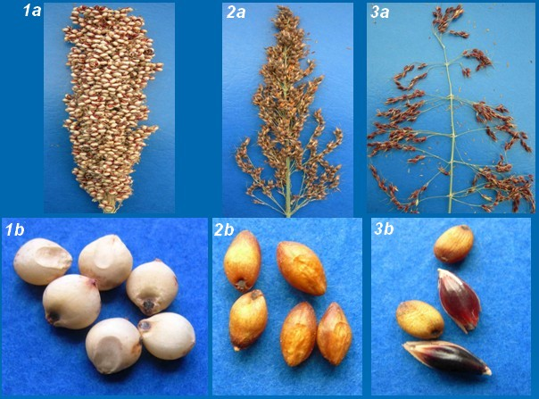
Figure 4. Panicle and seed characteristics of three species in the study. S. bicolor(1a) panicle (1b) seeds; S. halepense(2a) panicle (2b) seeds and S. sudanense (3a) panicle (3b) seeds.

There was successful hybridization between crop (S. bicolor) and all weedy (S. halepense, S. sudanense, S. verticilliflorum) sorghums assayed in the study. Hybridization between the sorghum crop and weed accessions varied significantly (p≤0.05) (Table 6). 65.7% of crosses between S. bicolor and S. halepense succeeded. There was 49% seed set in the cross between S. bicolor and S. sudanense, 11.9% seed set in the cross between S. bicolor and S. sudanense while 41% of florets pollinated set seed in the cross between S. bicolor and S. verticilliflorum. In the second S. bicolor accession (TX430), 18.6% of the seed set while pollinated with S. halepense, while 3.15% seed set was seen when florets were pollinated by S. sudanense (Table 6).
Table 6. Mean seed set of crosses made between sorghum crop and weed accessions
Cross | Mean % seed set | No. of panicles | S.e.d
S. bicolor x S. halepense | 65.73 | 5 | 11.90
S. bicolor x S. verticilliflorum (2) | 49.26 | 6 | 10.86
S. bicolor x S. sudanense | 19.93 | 4 | 13.31
S. bicolor x S.verticilliflorum | 41.67 | 1 | 26.61
S. sudanense x S. bicolor | 45.24 | 22 | 5.67
S. halepense x S. bicolor | 63.43 | 5 | 11.90
S. verticilliflorum x S. bicolor | 43.21 | 2 | 18.82
S. bicolor (TX430) x S. halepense | 18.59 | 8 | 9.41
S. bicolor (TX430) x S. sudanense | 3.15 | 4 | 13.31
S. verticilliflorum x S. bicolor (TX430) | 13.79 | 9 | 8.87
S. sudanense x S. bicolor (TX430) | 46.65 | 11 | 8.02
S. halepense x S. bicolor (TX430) | 60.86 | 5 | 11.90
* The parent on the right is the male.

Characteristics of the F₁ generations of S. bicolor x S. sudanense and S. sudanense x S. bicolor
The vegetative and reproductive characteristics of F₁ populations obtained from crosses between S. bicolor and the weedy sorghums S. halepense and S. sudanense showed poor germination in all crosses where the weed was the female parent. Lower numbers of successful germinations after breaking dormancy were seen in the crosses where S. halepense and S. sudanense were utilized as the female parents (Table 7). Germination was higher in all the F₁ progenies where S. bicolor was the female parent (>60). 86.4% of S. bicolor x S. halepense seeds planted germinated while 53% of S. halepense x S. bicolor seeds germinated S. bicolor x S. sudanense and S. sudanense x S. bicolor seeds germinated at 95% and 70% respectively (Table 7).
Table 7. Germination after breaking dormancy of F₁ plants obtained from crosses between crops and weeds in the sorghum genus
Germplasm | Total planted | % germination | S.e.d
S. bicolor | 400 | 87 | 21
S. halepense | 230 | 70.9 | 21
S. sudanense | 230 | 70.9 | 21
S. bicolor x S. halepense | 22 | 86.4 | 21
S. halepense x S. bicolor | 351 | 53 | 21
S. bicolor x S. sudanense | 21 | 95.2 | 21
S. sudanense x S. bicolor | 448 | 69.6 | 21
S. halepense x S. bicolor (Tx430) | 198 | 62.6 | 21
S. bicolor (Tx430) x S. halepense | 20 | 60 | 21
S. bicolor (Tx430) x S. sudanense | 10 | 60 | 21
* The parent on the right is the male

The variation on vital vegetative and reproductive characteristics of crop (S. bicolor), weed (S. halepense and S. sudanense) and their F₁ progenies (S. halepense x S. bicolor and S. sudanense x S. bicolor) were significant at (p≤0.05) (Table 8 and Table 5). Reproductive phase traits, including mean number of panicles, seed number, seed weight and number of ratoons showed increase in the F₁ plants obtained from crosses between S. halepense x S. bicolor and S. sudanense x S. bicolor. The increase was most pronounced in the S. halepense x S. bicolor cross which showed a 50% increase in seed number (2814) and number of panicles (3.54) S. sudanense x S. bicolor cross exhibited a decrease in the mean number of panicles at maturity from 6.77 in S. sudanense to 5.87 in the cross (Table 8 and Table 5). The F₁ panicle had the general features of the weed with open structure but the anthocyanin content in the glumes was maroon to red similar to that of the crop (Figure 5).

Table 8. Phenotypic characteristics of weed by crop F₁ progenies at maturity 140 days after germination.
 | S. halepense x S. bicolor | S. sudanense x S. bicolor | S.e.d
Number of plants | 96 | 96
Par | 99.6 | 88.64 | 2.478
Number of leaves | 5.694 | 5.933 | 0.0476
Number of Tillers | 2.257 | 3.362 | 0.1497
Height (cm) | 120.6 | 144 | 4.43
Number of branches | 0.088 | 0.197 | 0.0577
Culm width | 0.9885 | 0.9917 | 0.01196
% Flowering | 86.9 | 96.9 | 0.0357
Days to half bloom | 70-80 | 80-85
Plant weight (g) | 424 | 414 | 57.6
Number of panicles | 3.54 | 5.87 | 0.512
Number of ratoons | 2 | 2.21 | 0.51
Seed number | 2814 | 3243 | 466
Panicle weight | 182 | 195 | 43
100 seed weight | 2.71 | 1.41
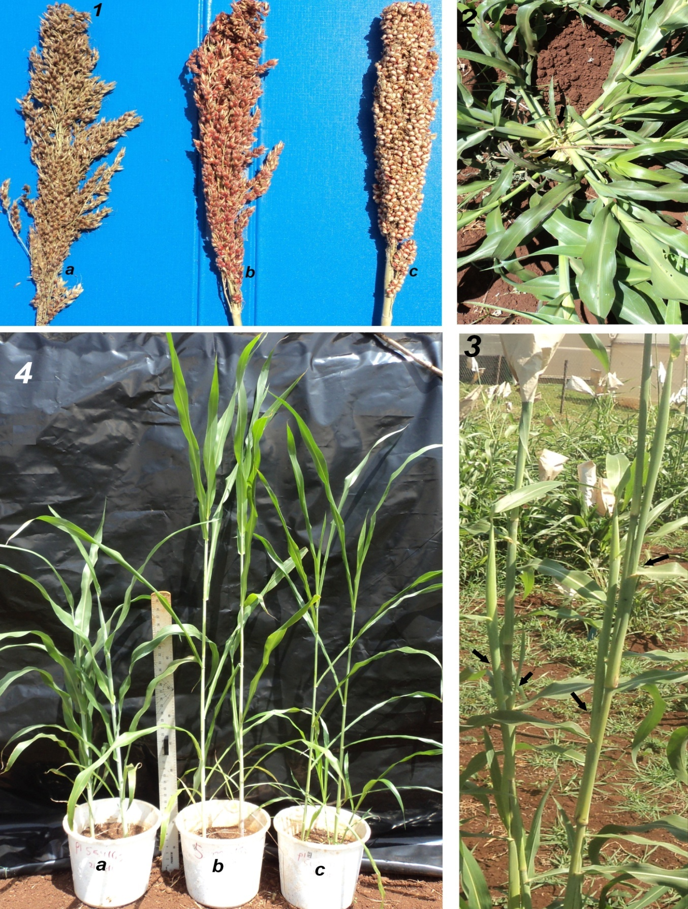
Figure 5. Seed, panicle and plant characteristics of F₁ crosses, showing differences in weedy parent 1a, cross 1b, and crop parent 1c. Profuse tillering (2); above first internode branching (3) and variation in height S. bicolor (4a), S. halepense x S. bicolor (4b) and S. halepense (4c).

Significant differences among species and across days from germination were observed on all growth phase parameters in S. bicolor, S. halepense and their F₁ generation (p≤0.05) (Figure 10a). Culm width measured at the base of the plant showed slow growth from germination to day 60, 50 and 70 in S. bicolor, S. halepense and S. bicolor x S. halepense respectively. S. bicolor consistently had wider culms than the other two populations (Figure 6a). Flowering began at between day 60 and 70 in all the materials. This continued at a first rate on all main stems and tillers of the species, achieving 50% flowering at 80-90 days in S. bicolor, 90 to 95 in S. halepense and 70-80 in S. bicolor x S. halepense. S. bicolor obtained above 90% flowering in 115 days from germination. S. bicolor x S. halepense and S. halepense did not obtain 85% flowering by day 140 (Figure 6b).

Exponential increase in plant height was seen between days 50 to 100 in the three species, but the S. bicolor x S. halepense cross was consistently taller than the parents (Figure 6c). Branches on the plants did not appear until day 80 when substantial branching was seen on the F₁ and S. halepense (Figure 6f). Number of leaves and the PAR had similar increase in the three species. S. bicolor consistently had more and wider leaves during growth and also had similar progression in PAR increase until day 110 when the increase leveled (Figure 6e,h). In contrast to this, tillering in the three species showed exponential increase from day 30 to day 60. At day 60 the F₁ had the most tillers (mean of 2.3) while S. halepense and S. bicolor averaged between 1.2 and 1.5. S. halepense increased tillering between days 70 and 90 while S. bicolor and the F₁ were at plateau (Figure 6g).

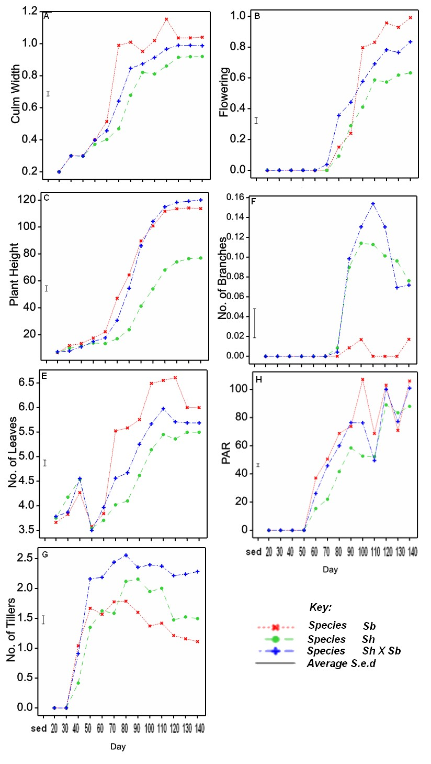
Figure 6. Morphological differences between F₁ progenies (S. halepense x S. bicolor) and their parents during growth phase.
Reproductive and vegetative features had significant differences among the species S. bicolor, S. sudanense and S. bicolor x S. sudanense and in days from germination to physiological maturity (p≤0.05) (Figure 7 a-c). Flowering began at between day 60 to 70 in all the three populations and 50% flowering was attained between days 80 and 90. More than 85% of all the plants in each of the three species had flowered by the 110th day. S. bicolor had 99% flowering by day 140 (Figure 7b). Branches developed on S. sudanense and the cross from day 80 to day 110. S. bicolor did not show significant branching (Figure 7f). The mean number of leaves and mean PAR increased exponentially between 40 to 110 days . S. bicolor had higher number of leaves throughout growth but showed similarity in PAR with S. sudanense. The F₁ had a consistent average increase in the number of leaves but was average to minimal in the PAR observed to 140 days (Figure 7h). Tillers were profuse in both S. sudanense and the S. sudanense x S. bicolor F₁. S. bicolor leveled at a mean of 2 tillers per plant at day 50. Both S. sudanense and the F₁ attained a mean of 4 tillers per plant at between day 80 and 90, but differences in mean number of tillers were not significant (Figure 7g).

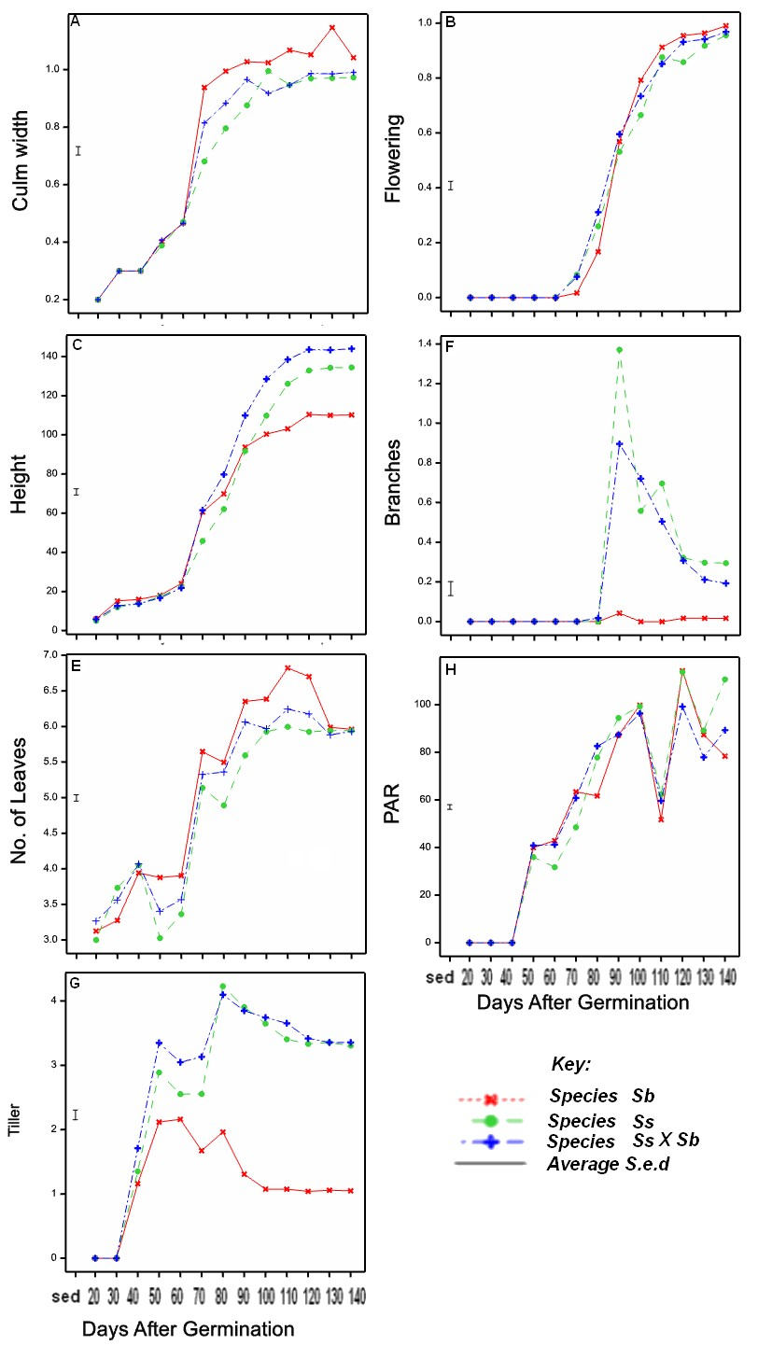
Figure 7. Morphological differences between F₁ progenies (S. sudanense x S. bicolor) and their parents during growth phase.

Regression between plant weight, seed weight, seed number and the number of panicle per plant were significant at (p≤0.05) (Figure 8). Similarly, seed weight had positive regression with seed number the number panicles despite the wide variations in seed size and panicle structure between weedy and crop populations.

The number of seeds per plant also showed significant regressions with the number of panicles per plants. Vegetative features that had significant regressions include culm width and height of plant. Height also had a positive regression with flowering in crop and weedy sorghum (Figure 8). Number of branches above the second internode and the photosynthetic active radiation (PAR) did not show any positive regression with all vegetative phase and reproductive phase features.

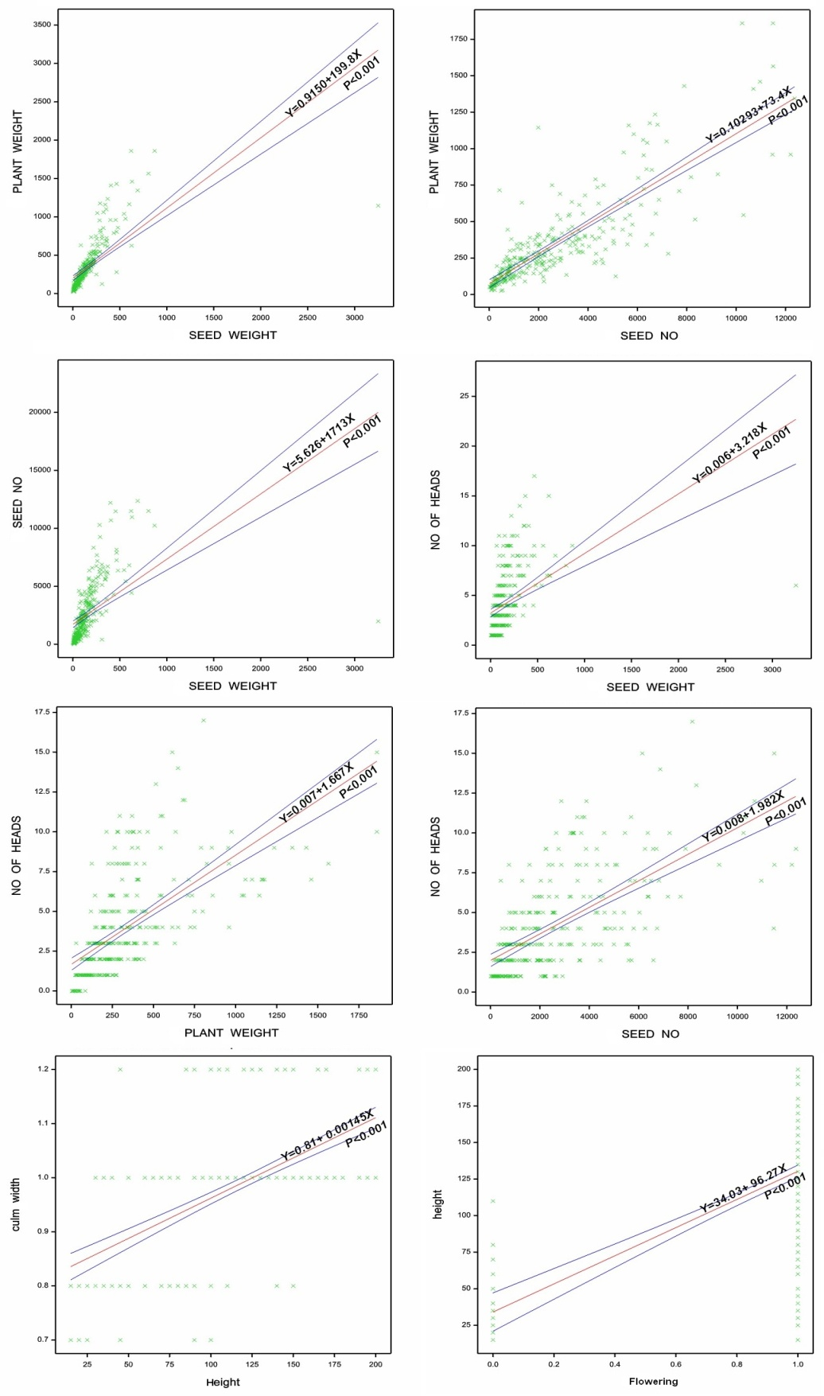
Figure 8. Regression analysis for vegetative characteristics and reproductive features in crop, weedy sorghum populations and their hybrids
Analysis of vegetative phase morphological features (culm width, number of leaves, plant height, number of tillers branches above second internode and PAR) using principal component biplot approach (PCA), showed significant variation in the weed crop and hybrid sorghum populations (Figure 9a). The first principle component (PC – 1) accounted for 37.13% of the variations while the second (PC – 2) accounted for 16.21%. In total the biplot explained 53.34% of the variation (Figure 9a).

PAR had latent vectors of 0.058 in PC – 1 and 0.697 in PC – 2. Percent bloom had latent vectors of 0.464 and –0.115 for PC – 1 and PC – 2 respectively. Number of branches had latent vectors of 0.102 and 0.651 for PC – 2. Culm width was loaded at latent vectors of 0.456 and –0.213 for the two principle components. Plant height had latent vectors of 0.526 and 0.012, number of leaves had 0.390 and –0.063 while tillers had 0.367 and 0.168 for principle component I and 2 respectively. Distinct clusters were seen in the biplots (Figure 9a). These differentiated S. bicolor, S. sudanense, S. halepense and their two F₁ populations.

Analysis of reproductive phase features also showed significant variation and clustering on biplot analysis of the five populations (Figure 9b). Number of post harvest ratoons, number of panicles, plants weight, seed number and seed weight were used in the analysis. PC – 1 explained 61.18% of the variation while PC – 2 explained 19.65% of the variation in the genotypes used. In total the biplot analysis explained 80.83% of the variation. Latent vectors for the number of panicles were 0.461 and 0.039 for PC – 1 and PC – 2; the number of ratoons had latent vectors of 0.134 and 0.976; for seed number they were 0.511 and – 0.152 for PC – 1 and PC – 2 respectively (Figure 9b).

Seed weight had latent vectors of 0.4749 in PC – 1 and –0.147 in PC – 2. S. bicolor, S. sudanense, S. halepense and the two F₁ progenies formed district clusters in the biplot (Figure 9b). The S. halepense and S. halepense x S. bicolor cross cluster was heavily influenced by ratoons while that of S. sudanense and S. sudanense x S. bicolor was heavily influenced by seed number and seed weight.

Discriminant analysis for the S. bicolor, S. halepense, S. sudanense and the F₁ populations showed significant clusters based on both vegetative and reproductive features of mature plants. The means of the five populations and their 95% confidence intervals differed significantly. The means for S. sudanense were closer to that of S. sudanense x S. bicolor while that of S. halepense was closer to that of S. halepense x S. bicolor. The mean for S. bicolor clustered away from the rest of the populations (Figure 10).

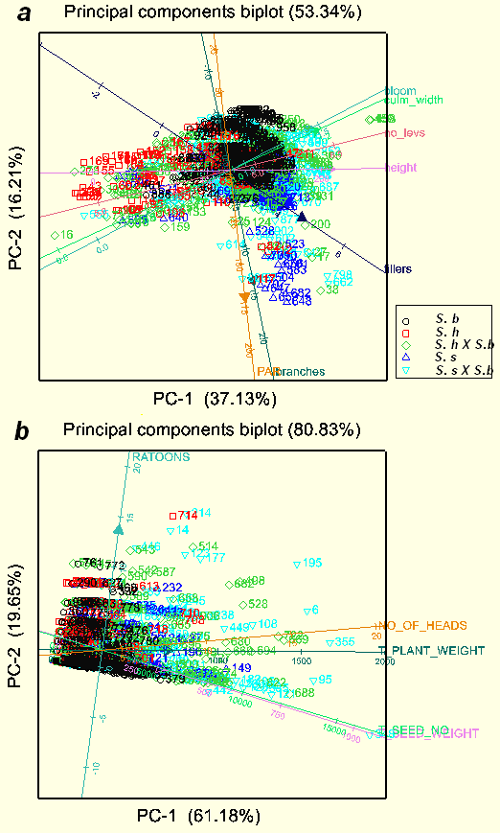
Figure 9. PCA and Biplots analysis for vegetative characteristics ;140 days from germination (a) and reproductive characteristics (b) in crop, weedy sorghums and their hybrids.

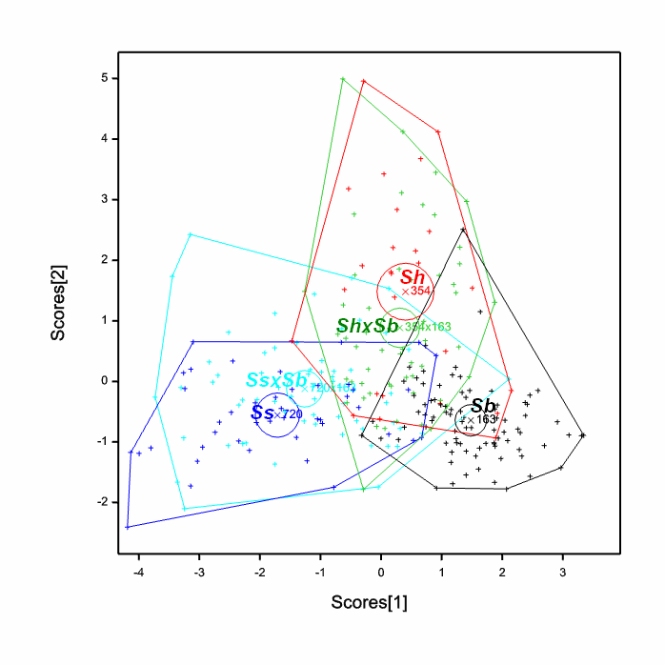

Figure 10. Discriminant analysis for S. bicolor (Sb), S. sudanense (Ss), S. halepense (Sh), and their F₁ crosses based on vegetative characteristics (140 days from germination) and reproductive fitness characteristics. Circles are 95% confidence intervals around population means (N=385).

F₁ individuals obtained from crosses done by hand, between S. sudanense x S. bicolor and S. halepense x S. bicolor were evaluated using polymorphic SSR loci. Locus SB1764 gave a 300bp fragment in S. bicolor, 300bp fragment in S. sudanense and 850bp in the S. halepense. In the F₁ generation these bands were consistently present. Locus SB3420 had 300bp in S. bicolor, 290bp in S. sudanense but no band in S. halepense. The F₁ population of S. sudanense x S. bicolor had both bands while that of S. halepense x S. bicolor had 300bp (Figure 11).
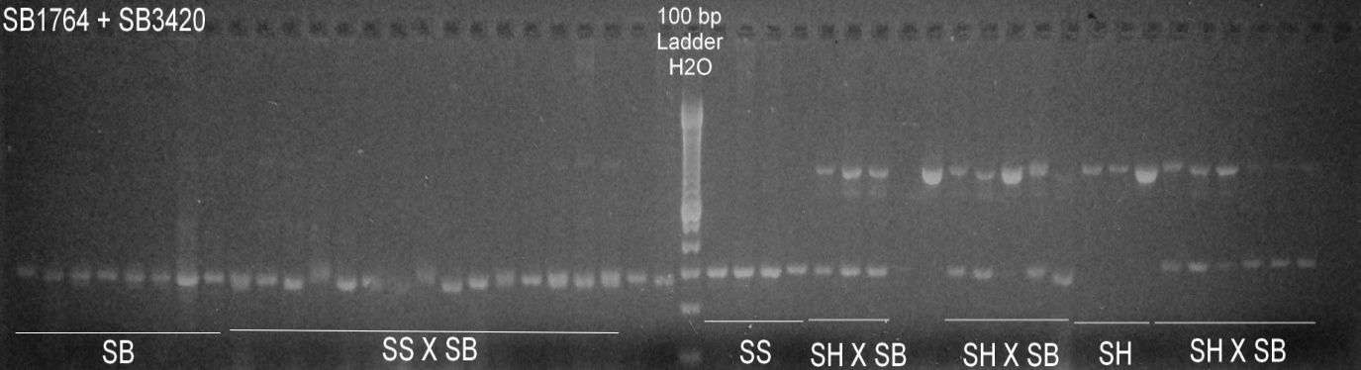
Figure 11. Agarose gel showing allelic differences between F₁ population of (S. sudanense (SS); S. halepense (SH); S. bicolor(SB) and their parents.

Genetic distance among the parents and the crosses
Dendogram analysis based on assayed SSR loci showed strong clusters among the parental populations. S. bicolor individuals were similar to each other (boot straps 42 to 72) while they clustered away from S. sudanense (bootstrap 88) and S. halepense (bootstraps 89) (Figure 12). The F₁ populations made mid way clusters between their respective female and male parents (Figure 13). All F₁ individuals from forced crosses had genotypes showing contribution from both of their respective parents. This was observed by a Mahalanobis (D-squared) test that characterized the close relationship between the cross and either of the parents (Table 9) based on vegetative and reproductive parameters. The S. halepense x S. bicolor population was genetically closer to S. halepense with values of 3.236 than it was to S. bicolor (4.313). Similarly, S. sudanense x S. bicolor population was closer to S. sudanense with values of 1.999 than it was to S. bicolor (8.135) (Figure 13) (Table 9).
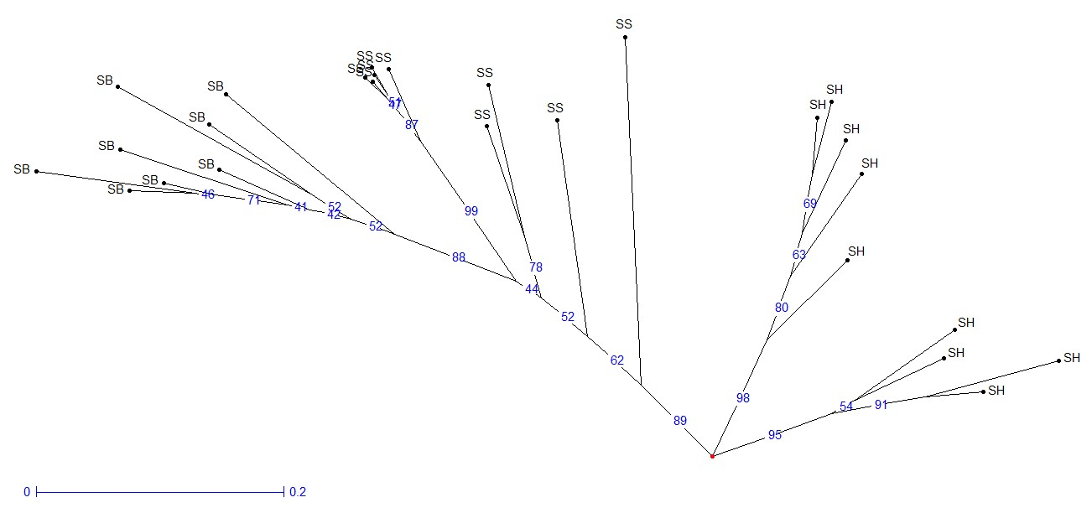
Figure 12. Dendogram showing the Genetic distance between the parents; S. bicolor, S. sudanense, and S. halepense

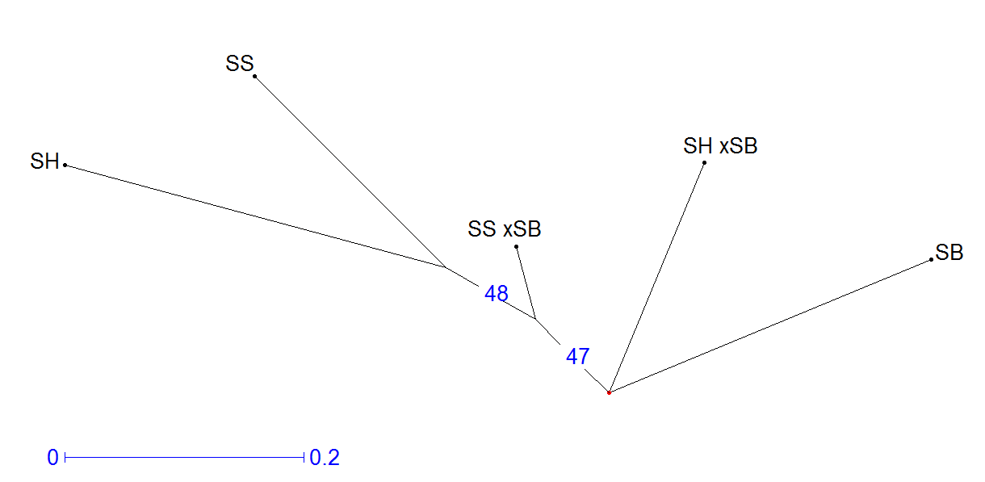

Figure 13. Dendogram showing the Genetic distance between the parents and F₁ progenies.

Table 9. Mahalanobis (D-squared) intergroup distances calculated from vegetative characteristics and reproductive fitness traits among crop, weedy sorghums and their hybrids.

 | S. bicolor | S. halepense | S. halepense x S. bicolor | S. sudanense | S. sudanense x S. bicolor
S. bicolor | 0
S. halepense | 6.558 | 0
S. halepense xS. bicolor | 4.313 | 3.236 | 0
S. sudanense | 10.669 | 9.835 | 7 | 0
S. sudanense xS. bicolor | 8.135 | 6.751 | 4.56 | 1.999 | 0

Characteristics of the F₂ and BC₁ generations
Selfing of the F₁ population was successful in both crosses (S. halepense x S. bicolor and S. sudanense x S. bicolor) and there was 100% seed set on the main stems and on tillers. Back crossing of the F₁ populations to their female weedy parents showed variation in the hybridization frequencies (Figure 14).
Figure 14. Hybridization frequencies of weedy parental populations with F₁ (weed x crop) populations.

Multiple PCR of polymorphic and codominant SSR loci in F₂ and BC₁ populations of S. halepense x S. bicolor and S. sudanense x S. bicolor gave the expected banding profile on agarose gel electrophoresis (Figure 15). The expected alleles (300, 250, 850 and 320) were seen in these segregating populations on the two loci SB5058 and SB1764. Segregation was seen in the advanced populations with some individuals losing one or more of the alleles from either of the parents. Normal Mendelian segregation was observed in the F₂ (100 plants) and BC₁ (100 plants) (Figure 15). This was observed on all the nine SSR loci assayed (SB3258, SB3806, SB3978, SB4688, SB1764, SB3008, SB3420, SB5058 and SB5458).
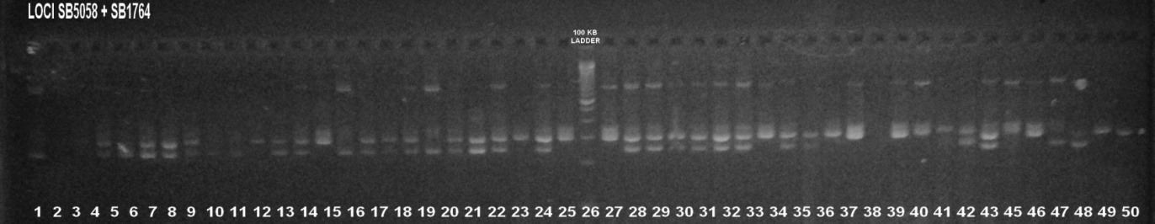
Figure 15. Agarose gel electrophoresis showing two loci (SB5058 and SB1764) multiplex PCR products within F₂ and BC₁ populations. Lanes 15to 25 represent the F₂ population from S. halepense x S. bicolor. Lanes 1-14 represent the F₂ population from S. sudanense x S. bicolor. BC₁ populations are shown from lanes 27 to 48. S. bicolor +ve control lanes 49 and 50

Discussion
The presence of unique and null alleles in weedy sorghums on SSR loci reported here gave useful polymorphism (Table 4). The Shannon information content was high in the SSR loci showing high polymorphism among the accessions used in the study (Table 3). High polymorphic information content on codominant SSR loci could be due to rapid change (loss or addition) of repeat motifs as a result of mutation, unequal crossover during meiosis, replication slippage and the effect of transposons and retroellements [18, 25]. Previous studies have demonstrated polymorphism at useful marker loci in sorghum [26, 27].

This polymorphism is maintained in wild populations of sorghums that may have experienced disruptive selection, preserving high polymorphism within given loci [28]. Directional selection pressure may not be important in wild sorghum populations, thus, allelic diversity on codominant SSR loci is maintained since no alleles are purified or heavily selected againist at any one locus [29]. The distribution of SSR loci in both gene coding and non-coding regions has been observed in the sorghum genome [14,16]. The wide genetic distance between the wild species and the crop sorghum resulted in high polymorphism on the SSR loci. S. bicolor and S. sudanense were observed to be genetically closer since S. sudanense is a diploid and a natural hybrid between S. bicolor (L.) Moench and S. arundinaceum. In contrast, S. halepense was further away due to its complex allopolyploidy [6].

Variations were obtained on important vegetative reproductive and morphological traits in weedy, crop and F₁ hybrids grown in noncompetitive field plots. S. bicolor, S. sudanense, S. halepense and their F₁ progenies differed on vegetative traits. The vegetative biomas, photosynthesis and seed characteristics showed differential expression among the three parental and two F1 populations. The features maintained in the cultivated sorghums enhance the domestication of species in crop agriculture [30]. The crop has larger panicles, more seeds and less tillers (Table 5). This is the opposite of the case in the weedy sorghums that have profuse tillering, branching and are taller than the crop (Table 5). High seed production, self compatibility, seed dormancy, seed longevity, short periods to flowering and vigorous growth rates have a positive conditioning effect on the invasiveness of both S. halepense and S. sudanense [1]. Higher seed set from hand hybridization was observed in reciprocal crosses between S. bicolor X S. halepense (Table 6) probably due to the greenhouse environment, flower morphology and pollinators’ efficiency. Wide crosses have been previously obtained in the species under different genetic and environmental conditions that maintained diverse features in interspecific derivatives [1, 31].

The F₁ progenies between S. halepense x S. bicolor and S. sudanense x S. bicolor grown in noncompetitive plots had increased expression of most vegetative and reproductive features both in growth phase and at maturity (Table 8; Figure 6). The vigour seen in both F₁ from S. halepense x S. bicolor and S. sudanense x S. bicolor could be attributed to the wide crossing and the subsequent hetorozygosity that masks poor homozygous loci. Increase of vegetative traits coorelated and regressed with increase in important reproductive traits (Figure 8). Parents and F₁s with large vegetative biomass produced more photosynthates and therefore stored more in seeds. PAR did not coorelate well with number of leaves due to the differences in leaf size. S. bicolor had larger leaves and more efficient photosynhate appropriation system than the weedy forms belonging to S. halepense and S. sudanense and therefore had higher seed weight. The number of tillers correlated with the number the number of panicles and also the number of seeds in the weedy forms and the F₁s. These are evolutionary important features that increase the fitness and frequency of given sorghum species within a given envinoment [32].

PCA biplot analysis and discriminant analysis showed difference between parents and the F₁ progenies on both vegetative and reproductive related traits. The F₁ progenies were more vigorous and this would be attributed to heterosis due to crossing two genotypes from wide genetic backgrounds. F₁ progenies obtained between Zea mays and Zea mays ssp. Mexicana have shown higher expression on most vegetative traits [33]. Similar results have been shown in crosses between crop sorghum and shattercane [34]. Despite showing heterosis, germination was exceedingly low in the F₁ progenies between S. halepense x S. bicolor and S. sudanense x S. bicolor where the weedy sorghums were used as female parents. Only 53 % of S. halepense X S. bicolor and 69.6 % of S. sudanense X S. bicolor seed germinated after breaking dormancy (Table 7) demonstrating a fitness penalty in the F₁ progenies when compared to the crop. Inheritance of the endosperm and germination features in the F₁ progenies were subject to maternal inheritance and some level of heterosis. Heterotic hybrids and their enhanced performance has been reported in previous studies within the the species [35].

High germination of upto 95.2% (Table 7) were observed in F₁ progenies where S. bicolor was the female parent. Hybridization between S. sudanense x S. bicolor ranged between 45% to 47% but the reciprocal cross ranged between 3% to 20% (Table 6). Hybridization between S. halepense x S. bicolor and its reciprocal crosses ranged between 60% to 66%. These differences in hybridization frequencies among the species studied (Table 6) would be attributed to flower morphology, pollen compatibility, environmental conditions during pollination and the efficiency during hand pollinaton.

Analysis of the ssr loci showed differential banding patterns between parents and the F₁ progeny The F₁ population had bands from both parental populations, showing successful interspecific hybridization between crop and distant weedy species. The crosses had mid way clusters between respective parents in dendogram analysis showing that the progeny had chromosomes from both species (Figure 12 and Figure 13). A Similar situation was obtained when vegetative characteristics and reproductive fitness traits were applied to calculate the Mahalanobis (D² squared) intergroup distances (Table 9). In previous studies F₁ progenies have been obtained in the sorghum genus between S. halepense and S. bicolor [7, 2], where the F₁ progenies did not show significant reproductive differences with the parents, though protein alloenzyme analysis had the expected variability. In addition, spontaneous interspecific hybridization has been shown to be important in populations of S. bicolor and S. sudanense [34] and S. halepense [36] yielding plants with midway features of the two parents.

Conclusions and Recommendations
In the study unique and null alleles were obtained in weedy sorghums on crop loci and high polymorphism was observed among the accessions used in the study. F₁ populations were obtained between S. halepense x S. bicolor and S. sudanense x S. bicolor. Phenotypic analysis showed significant variation on vegetative traits. Analysis at ssr loci showed differential banding patterns between parents and the F₁ progeny. The crosses had mid way clusters between respective parents on dendogram analysis. Polymorphic SSR loci shows great potential in genotyping crop weedy genetic resources in the sorghum genus. In addition, increasing the number of characterized loci in a study will enhance the utility of the assay. This assay can be recommended for situations when testing for the breeding condition of genetic material before advancement through generations of inbreeding to obtain homozygosity. However, for the SSR assay to be effective in isolating interspecific introgression of alleles in sorghum more genomic information on members of the genus is required. This needs to be accompanied with bioinformatics approaches to distinguish uniquely conserved sequences and polymorphisms associated with evolutionary important phenotypes. Due to the importance of the East African region as a centre of diversity for sorghum, there is need for more studies on the role of crop to non-crop hybridization and to define differences. This will go a long way in providing information on the potential risks of unintended transgene escapes into non-crop sorghums.

COMPETING INTERESTS DISCLAIMER:
Authors have declared that they have no known competing financial interests OR non-financial interests OR personal relationships that could have appeared to influence the work reported in this paper.

References
- Sias, C., Subramanian, N., Hodnett, G., Rooney, W., & Bagavathiannan, M. (2023). Rate of crop-weed hybridization in Sorghum bicolor × Sorghum halepense is influenced by genetic background, pollen load, and the environment. Evolutionary Applications, 16(4):781–796. DOI: 10.1111/eva.13536
- Arriola, P.E.and N.C. Ellstrand. 1997. Fitness of interspecific hybrids in the genus Sorghum: Persistence of crop genes in wild populations. Ecological applications 7:512–518. https://doi.org/10.1890/1051-0761(1997)007[0512:FOIHIT]2.0.CO;2
- Patil, R. B., Patil, S. G., Ramu, V., Dhanraj, A., & Patil, A. P. (2024). Wide hybridization in sorghum with tertiary gene pool for diversification of parental lines. Crop Science, 64(3), 1152–1164. https://doi.org/10.1002/csc2.21193
- Kong, W., Nabukalu, P., Cox, T. S., Goff, V. H., Pierce, G. J., Lemke, C., Robertson, J. S., Compton, R., Tang, H., & Paterson, A. H. (2020). Transmission genetics of a Sorghum bicolor × S. halepense backcross populations. Frontiers in Plant Science, 11, Article 467. https://doi.org/10.3389/fpls.2020.00467
- Li, J., Wang, L., Bible, P. W., Tu, W., Zheng, J., Jin, P., Liu, Y., Du, J., Wang, Y., & Zhan, Q. (2023). A chromosome-scale genome sequence of sudangrass (Sorghum sudanense) highlights the genome evolution and regulation of dhurrin biosynthesis. Theoretical and Applied Genetics, 136(6), 1715-1731. https://doi.org/10.1007/s00122-023-04262-9
- Habyarimana, E., Gorthy, S., Baloch, F. S., Ercisli, S., & Chung, G. (2022). Whole-genome resequencing of Sorghum bicolor and Sorghum bicolor × S. halepense lines provides new insights for improving plant agroecological characteristics. Scientific Reports, 12, Article 5556. https://doi.org/10.1038/s41598-022-09433-0
- Arriola, P.E. and N.C. Ellstrand. 1996. Crop-to-weed gene flow in the genus sorghum (Poaceae):Spontaneous interspecific hybridization between johnsongrass, Sorghum halepense, and crop sorghum, S. bicolor. American journal of botany.83:1153–1160. https://doi.org/10.1002/j.1537-2197.1996.tb13895.x
- Foster, J., Apaloo, J., De Leon, N., & Rooney, W. L. (2020). Development of novel perennial Sorghum bicolor × S. propinquum hybrids. Crop Science, 60(5), 2309-2320. https://doi.org/10.1002/csc2.20136
- Papapanagiotou, A. P., Travlos, I. S., Kanatas, P. J., Tataridas, A., Antonopoulou, C., & Gazoulis, I. (2024). Comparison of molecularly identified resistant and susceptible Johnsongrass (Sorghum halepense) populations at ALS gene, in the absence and presence of field crops. Genes, 15(11), 1415. https://doi.org/10.3390/genes15111415
- Bekele, E., Desalegn, T., Teshome, A., Geleta, M., & Bryngelsson, T. (2024). Genetic structure and gene flow in Ethiopian sorghum [Sorghum bicolor (L.) Moench] landraces. Genetic Resources and Crop Evolution, 71, 1093–1108. https://doi.org/10.1007/s10722-023-01687-5
- CABI (2023). Sorghum halepense (Johnson grass). In Invasive Species Compendium. Wallingford, UK: CABI. https://doi.org/10.1079/cabicompendium.50624
- Ndlovu, E., Maphosa, M., & Van Staden, J. (2024). In-vitro induced drought and heat stress on seed germination of diverse African sorghum germplasm. Plant Genetic Resources, 22(4), 251-257. https://doi.org/10.1017/S1479262124000212
- Nagaraja, T. E., Nandini, C., Bhat, S., & Parveen, G. S. (2023). Artificial hybridization techniques in small millets—A review. Frontiers in Plant Science, 14, 1112117. https://doi.org/10.3389/fpls.2023.1112117
- Yonemaru J., Ando T., Mizubayashi T., Kasuga S., Matsumoto T. and M. Yano, 2009. Development of Genome-wide Simple Sequence Repeat Markers Using Whole-genome Shotgun Sequences of Sorghum (Sorghum bicolor (L.) Moench). DNA Research, 16(3):187–193. https://doi.org/10.1093/dnares/dsp005
- Yonemaru, J., Kasuga, S., Kawahigashi, H., et al. (2022). QTL analysis of regrowth ability in bmr sorghum (Sorghum bicolor [L.] Moench) × sudangrass (S. bicolor subsp. drummondii) populations. Grassland Science, 68(4), 310-318. https://doi.org/10.1111/grs.12365
- Paterson, A.H., J.E. Bowers, R. Bruggmann, I. Dubchak, J. Grimwood, H. Gundlach, G. Haberer, U. Hellsten, T. Mitros, A. Poliakov, J. Schmutz, M. Spannagl, H. Tang, X. Wang, T. Wicker, A.K. Bharti, J. Chapman, F.A. Feltus, U. Gowik, I. V Grigoriev, E. Lyons, C. a Maher, M. Martis, A. Narechania, R.P. Otillar, B.W. Penning, A. a Salamov, Y. Wang, L. Zhang, N.C. Carpita, M. Freeling, A.R. Gingle, C.T. Hash, B. Keller, P. Klein, S. Kresovich, M.C. McCann, R. Ming, D.G. Peterson, Mehboob-ur-Rahman, D. Ware, P. Westhoff, K.F.X. Mayer, J. Messing, and D.S. Rokhsar. 2009. The Sorghum bicolor genome and the diversification of grasses. Nature 457(7229): 551–6. https://doi.org/10.1038/nature07723
- Chakrabarty, S., Mufumbo, R., Windpassinger, S., et al. (2022). Genetic and genomic diversity in the sorghum gene bank collection of Uganda. BMC Plant Biology, 22, 378. https://doi.org/10.1186/s12870-022-03770-y
- An, Y., Xia, X., Zheng, H., Yu, S., Jing, T., & Zhang, F. (2023). Multi-genome comprehensive identification of SSR/SV and development of molecular markers database to serve Sorghum bicolor (L.) breeding. BMC Genomic Data, 24, Article 62. https://doi.org/10.1186/s12863-023-01165-y
- Rozen S. and H J. Skaletsky, 2000. Primer3 on the WWW for general users and for biologist programmers. In: Krawetz S, Misener S (eds) Bioinformatics Methods and Protocols: Methods in Molecular Biology. Humana Press, Totowa, NJ, pp 365-386. https://doi.org/10.1385/1-59259-192-2:365
- Sathelly, K., Govindannagari, R., Pandey, S., Kompelli, S. K., Visarada, K. B. R. S., & Kaul, T. (2023). A modified CTAB method for efficient extraction of genomic DNA in Indian sweet sorghum (Sorghum bicolor L. Moench). Annals of Plant Sciences, 12(1), 123-130. https://doi.org/10.53729/aps.v12i1.118
- Magomere, Titus O.; Ngugi, Kahiu; Mutitu, Eunice; and Shibairo, Solomon and Obukosia, Silas D. 2015. Real Time PCR Mediated Determination of the Spontaneous Occurrence of Sorghum bicolor Alleles in Wild Sorghum Populations. African Journal of Biotechnology. Vol. 14(7): pgs. 551–568. DOI: 10.5897/ajb2014.13672
- Worku, M., Ahmed, I., Degu, A., & Dessalegn, Y. (2023). Genetic diversity and population structure among 133 elite sorghum genotypes as revealed by SNP markers. Genes, 14(5), 1012. https://doi.org/10.3390/genes14051012
- Liu, B., & Warnow, T. (2023). Weighted ASTRID: fast and accurate species trees from weighted internode distances. Algorithms for Molecular Biology, 18(1), Article 6. https://doi.org/10.1186/s13015-023-00230-6
- Navyashree, R., Mummigatti, U. V., Nethra, P., Basavaraj, B., & Hanamaratti, N. G. (2024). Evaluation of genetic diversity in sorghum (Sorghum bicolor L. Moench) genotypes for drought tolerance using Mahalanobis’ D² analysis. Journal of Advances in Biology & Biotechnology, 27(9), 90-97. https://doi.org/10.9734/jabb/2024/v27i91277
- Kalia, R.K., M.K. Rai, S. Kalia, R. Singh, and A. K. Dhawan. 2010. Microsatellite markers: an overview of the recent progress in plants. Euphytica. 177(3): 309–334. https://doi.org/10.1007/s10681-010-0286-9
- Ngugi, K. and Onyango, C. M. 2012. Analysis of the molecular diversity of Kenyan sorghum germplasm using microsatellites. Journal Of Crop Science And Biotechnology. 15(3) 189-194. 10.1007/s12892-012-0009-y.
- Riday H .2011. Paternity testing: a non-linkage based marker assisted selection scheme for outbred forage species. Crop Science. 51:631–641. 10.2135/cropsci2010.07.0390.
- Rutto, E. C., Kinyua, M., Chepkoech, E., & Were, B. (2025). Agro-morphological characterization and diversity analysis of selected sorghum genotypes in Kenyan agro-ecologies. Journal of Experimental Agriculture International, 47(7), 481-499. https://doi.org/10.9734/jeai/2025/v47i73588
- Casa, H. M., S.E. Mitchell, M.T. Hamblin, H. Sun, J.E. Bowers, A H. Paterson, C.F. Aquadro, and S. Kresovich. 2005. Diversity and selection in sorghum: simultaneous analyses using simple sequence repeats. TAG Theoretical and applied genetics. 111(1): 23–30. https://doi.org/10.1007/s00122-005-1952-5
- Doebley, J.F., B.S. Gaut, and B.D. Smith. 2006. Review The Molecular Genetics of Crop Domestication. Cell. 127: 1309–1321. DOI: 10.1016/j.cell.2006.12.006
- Meena, K., Jacob, J., Bhavyasri, M., Aruna, C., Sanjana Reddy, P., Rajendrakumar, P., & Visarada, K. B. R. S. (2024). Wide hybridization in sorghum with tertiary gene pool for diversification of parental lines. Crop Science. https://doi.org/10.1002/csc2.21193.
- Magomere, Titus O., Eliud K. Ngugi, Solomon I. Shibairo and Eunice Mutitu, 2022. Comparative Effect of Bacillus thuringiensis Endotoxins on the Fitness of F₁ Sorghum×Weed Hybrids. Biotechnology, 21: 30-38.DOI: 10.3923/biotech.2022.30.38
- Guadagnuolo, R., J. Clegg, and N. Ellstrand. 2006. Relative fitness of transgenic vs. non-transgenic maize×teosinte hybrids: a field evaluation. Ecological Applications. 16(5): 1967–1974. https://doi.org/10.1890/1051-0761(2006)016[1967:RFOTVN]2.0.CO;2
- Sahoo, L., and J. Schmidt. 2010. Growth and fitness components of wild × cultivated Sorghum bicolor (Poaceae) hybrids in Nebraska. American journal of botany. 97(10): 1610–1617. https://doi.org/10.3732/ajb.0900170
- Maulana, F., Perumal, R., Tesso, T., & Serba, D. D. (2023). Genomic prediction of hybrid performance in grain sorghum (Sorghum bicolor L.). Frontiers in Plant Science, 14, 1139896. https://doi.org/10.3389/fpls.2023.1139896
- VanGessel, M. J., & Bagavathiannan, M. (2022). Hybridization and gene flow between cultivated sorghum and weedy johnsongrass: ecological and management implications. Weed Science, 70(6), 815–832. https://doi.org/10.1017/wsc.2022.54.

