Ecological and Public Health Risks from Untreated Meat Processing Wastewater: Comparative Assessment in a Sub-Saharan African Urban Context

.
Abstract
Aims: To assess and compare the pollution load from a modern slaughterhouse facility (SH1) and a local market slaughter site (SH2) in Yaoundé, Cameroon, in order to evaluate how facility size and operational practices influence environmental contamination and public health risks.
Study Design: Descriptive comparative cross-sectional study.
Place and Duration of Study: The study was conducted at a municipal slaughterhouse (SH1) and a local market slaughter site (SH2) in Yaoundé, Cameroon, over a period of six months, with bi-monthly sampling and surveys.
Methodology: Surveys were administered to 20 workers and 120 residents per site to collect socio-environmental data. Wastewater samples from both sites were collected twice per month and analyzed for key physicochemical parameters (BOD₅, COD, conductivity) and bacteriological parameters (fecal coliforms). Water sources, wastewater generation volumes, and community health complaints were also recorded. Data were statistically compared between the two sites to identify differences in pollution load and related health effects.
Results: SH1 relied mainly on municipal water (47.5%) and generated higher wastewater volumes (5.1–7.9 m³/month) than SH2 (2.8–4.8 m³/month), which depended on wells (52.5%). SH1 exhibited greater pollution levels with BOD₅ = 3198 ± 296 mg/L, COD = 16,232 ± 3315 mg/L, and fecal coliforms = 6.2 × 10⁷ ± 3.6 × 10⁷ CFU/100 mL, while SH2 showed lower BOD₅ = 1702 ± 731 mg/L and COD = 7736 ± 869 mg/L, but higher conductivity = 4496.7 ± 1096.4 µS/cm. Both sites exceeded national and EU discharge standards. Odor was the most reported nuisance (22.8% at SH1; 23.6% at SH2). SH1’s wastewater correlated with respiratory (16.67%) and skin infections (16.52%), whereas SH2’s effluent was linked to waterborne diseases (14.34%).
Conclusion: Both slaughter sites significantly pollute their surrounding environments, with SH1 showing a higher overall pollution load. Untreated effluent discharge poses serious environmental and public health risks. Immediate implementation of appropriate wastewater treatment and management systems is essential to mitigate contamination and improve sanitary conditions.

Keywords: Slaughterhouse wastewater; water pollution; environmental impact; pathogens, organics

1. INTRODUCTION

Slaughterhouses play a critical role in the global food supply chain, serving as primary facilities for meat production to meet the ever-growing demand for animal protein. According to the Food and Agriculture Organization (FAO), global meat production reached 360 million metric tons in 2022, with projections indicating continued growth due to population expansion and rising incomes, particularly in developing countries (Dumlu, 2024). The slaughterhouse industry is a cornerstone of the agricultural sector, contributing significantly to national economies and employment (Corigliano & Algieri, 2024). Slaughterhouse operations generate large volumes of wastewater that pose significant environmental and public health risks (Cheng&Tao, 2017; Obidegwu et al., 2019). It has been reported that the slaughterhouse industry uses 24% of the freshwater consumed by the agricultural sector annually (Aleksić et al., 2020). In many developing countries like Cameroon, slaughterhouse industries and informally set up local butchering shops coexist, leading to concerns regarding the untreated discharge of their wastewater into the surrounding ecosystems due to lack of or inadequate effluent treatment systems (Rani et al., 2017; Aleksić et al., 2020).
International and national regulations govern the installation and operation of slaughterhouses to ensure environmental and public health protection. Internationally, the WHO/FAO Codex Alimentarius and the EU Industrial Emissions Directive (2010/75/EU) set standards for wastewater management, requiring treatment before discharge. Similarly, the US EPA Clean Water Act mandates pollutant reduction in slaughterhouse effluents. In Cameroon, however, regulatory enforcement is weak. While the Cameroon Water Law (Law No. 98/005) and the EIA Decree (No. 2013/0171/PM) provide guidelines for wastewater management (Tamasang, 2025), most slaughterhouses, especially local market slaughter sites, lack treatment systems and discharge untreated effluents into ecosystems. This regulatory gap highlights the need for stricter enforcement, capacity building, and investment in sustainable wastewater infrastructure to address environmental and health risks. Strengthening the regulatory framework is critical to improving slaughterhouse operations in Cameroon.
Wastes from meat and poultry industries include those generated by animals during livestock holding and processing (slaughtering, de-feathering or hide removal, eviscerating and trimming, washing, disinfecting and cooling), and the wastewater is usually composed by organic matter including proteins, blood residues, fats and lard (Burton et al. 2004; Masoumi et al. 2015). The discharge of untreated slaughterhouse wastewater can have severe consequences for the environment. The high organic load in the wastewater promotes excessive growth of algae and other aquatic plants, leading to eutrophication in receiving water bodies (Kanu & Achi, 2011; Akpor et al. 2014; Bashir et al. 2020). Slaughterhouse wastewater is a complex mixture of pollutants, including pathogenic microorganisms, antibiotics, hormones, Trace metals, and other contaminants, which pose significant risks to human health and the environment (Gržinić et al. 2023). These pollutants can contaminate surface and groundwater, rendering them unsafe for drinking, irrigation, and other uses (Mulu et al. 2013). Furthermore, contaminants such as Trace metals (e.g., Zn, Mn, Cu, and Fe) can bio-accumulate in the food chain, leading to long-term health risks (Sonone et al. 2020). The discharge of pathogens into water bodies also increases the risk of waterborne diseases in local communities (Oguntoke et al., 2009; Osiemo et al. 2013). Studies have consistently reported high levels of BOD₅, COD, TSS, FOG, nitrogen, and phosphorus in slaughterhouse wastewater, highlighting its highly polluting nature (Bustillo-Lecompte et al. 2016; Ng et al. 2022). In urban areas, local market slaughter sites, lack proper waste management systems, allowing wastewater to flow directly into nearby rivers( Ng et al. 2022). Unlike slaughterhouse facilities equipped for meat processing and storage, these facilities are rudimentary, with open drainage systems that exacerbate environmental contamination. Understanding the characteristics of both slaughterhouse facilities and local market slaughter sites wastewater is critical, as their operational practices and waste management approaches differ significantly, leading to varying environmental and health impacts.
In Yaoundé, the capital city of Cameroon there exists the Livestock Development Cooperation (the slaughterhouse facility that exclusively slaughters cattle) (SH1) and the main local market slaughter site of Mvo-ada market (SH2) that processes various animals, including pigs, goats, sheep, and poultry (Oben & Ndi, 2017; Takang et al. 2020). However, the wastewater treatment system in the SH1 is non-functional (Mbog Mbog et al. 2023), while SH2 lacks any treatment system altogether. Such an evaluation will provide a scientific basis for developing appropriate and effective treatment strategies to mitigate the adverse effects of slaughterhouse wastewater discharge in Yaoundé.
This study aims to provide a comprehensive understanding of the pollution load from both slaughterhouse facilities and local market slaughter sites, contributing to the development of effective wastewater management strategies to mitigate environmental degradation and health hazards.

2. MATERIALS AND METHODS
2.1 Description of Slaughterhouses
This study collected data from two slaughterhouses in Yaoundé: the LDC slaughterhouse (SH1) and the Mvog-ada market open-air mass slaughter area (SH2). The city's main slaughterhouse facility, the LDC slaughterhouse, is in Etoudi, Yaoundé I. It plays a key role in meat production, processing approximately 6,000 cattle monthly, yielding about 1,240 tons of beef (Matchawe et al. 2019). Slaughtering activities occur year-round, and wastewater is discharged continuously through a single channel into the river due to the failure of the originally installed treatment plant (Mbog Mbog et al. 2023).
The Mvog-ada market open-air mass slaughter site is classified as an informal slaughtering area situated in the District of Yaoundé V (Figure 1). It primarily processes pigs, poultry, goats, and sheep, with monthly slaughter numbers reaching approximately 1,000 pigs, 6,000 poultry, and 500 ruminants. The site comprises multiple pig fences under different ownership. Additionally, an association of independent slaughters operates within the premises, overseen by veterinary officers. Slaughtering happens daily in an open-air environment, from Monday to Sunday, leading to direct wastewater discharge into the river without treatment (Ndi &Oben, 2014). In slaughterhouses, water is crucial in various processes, primarily on the kill floor for carcass washing, viscera handling, offal processing, and general slaughterhouse cleaning (Ziara et al., 2018).

2.2 Survey
A survey was conducted to assess water usage, wastewater generation, and slaughterhouse activities’ environmental and health impacts. It included 20 workers and 120 nearby residents from each slaughterhouse (SH1 and SH2). Workers provided information on water sources (municipal, wells, boreholes, rivers) and wastewater-generating activities. The wastewater volume was measured using the manual flow rate measurement. Residents reported on issues like odor, water pollution, and disease prevalence. They also shared perceptions of the slaughterhouse’s impact on their quality of life and environmental changes since its establishment. The findings offer insights into community concerns and slaughterhouse practices affecting local water and sanitation conditions.
2.3 Sample collection
Wastewater samples were collected biweekly for six months from both slaughterhouses at the discharge point before entering the river, totaling 12 samples per site. Samples were taken at between 6 AM to 12 PM and composited. Two polyethylene and two sterilized borosilicate glass bottles were used, with the latter for bacteriological analysis. Bottles were pre-washed and autoclaved at 121°C for 15 minutes. Samples were transported to the laboratory following APHA (APHA, 1998) standard procedures for microbial and physicochemical analysis.
2.4 Physicochemical and bacteriological characterization of samples
pH, Total dissolved solids (TDS), and Electrical Conductivity (EC) were measured in situ using the HACH pH meter model HQ14d. The Total Suspended Solids (TSS) and Color was carried out by the "absorptiometer" method using a spectrophotometer model HACH DR 3900. Chemical Oxygen Demand (COD) was quantified with the close reflux dichromate reduction method at 150°C for 2 hours followed by a spectrophotometric quantification with a spectrophotometer model HACH DR 3900. Biological oxygen demand for five days (DBO₅) was quantified after five days of incubation in the darkness at 20°C with Oxytop head gas sensors after inhibiting nitrification. NH₄⁺-N was quantified with the Nessler method, NO₃⁻-N with the cadmium reduction (NitraVer 5) method, Cl⁻ with the DPD method, and Orthophosphate (PO₄³⁻) with the molybdovanadate method for extraction and quantification with a HACH DR 3900 UV spectrophotometer after acid digestion. For metals, after digestion, Fe²⁺ was determined using the Ferrover method, Cu²⁺ with the bicinchoninate method, and Cr⁶⁺ with the 1-5 diphenyl carbohydrazide method with a HACH DR 3900 spectrophotometer. These methods were carried out as described in Standard Methods for the Examination of Water and Wastewater (APHA, 1998; APHA, 2005). Fecal coliforms and fecal streptococci were quantified using the membrane filtration method (Rodier, 2009).
2.5 Data analysis
Statistical analysis, graphical representation, and interpretation of the results were conducted using OriginPro 2024. Descriptive statistics were applied to summarize the data. Visualization tools, including violin plots, chord plots, and pie charts, were employed to illustrate trends and relationships among the studied variables. Additionally, Pearson correlation analysis was performed at a p< 0.05 to evaluate the relationships between different water quality parameters for both SH1 and SH2 slaughtering facilities, with results presented in correlation matrices

3. results and discussion

3.1 Wastewater Generation
3.1.1 Source of fresh water
As reported by workers, two slaughterhouses had distinct primary water sources for their operations. In SH1, the municipal water supply accounted for the majority (47.5%), followed by wells (30%) and boreholes (25.5%), reflecting a structured, regulated supply typical of SH1 facilities (Ziara et al. 2018). Conversely, SH2 primarily depended on wells (52.5%), with municipal supply (25%), boreholes (15%), and rivers/streams (7.5%) serving as supplementary sources. The heavy reliance on wells and natural water sources reflected less formalized water supply practices, likely due to limited municipal infrastructure, a frequent challenge in developing regions (Khatri et al. 2008). This dependence on natural sources raised concerns regarding the hygienic quality of meat products from SH2, as natural sources are prone to contamination risks. These findings were visually represented in Figure 2.
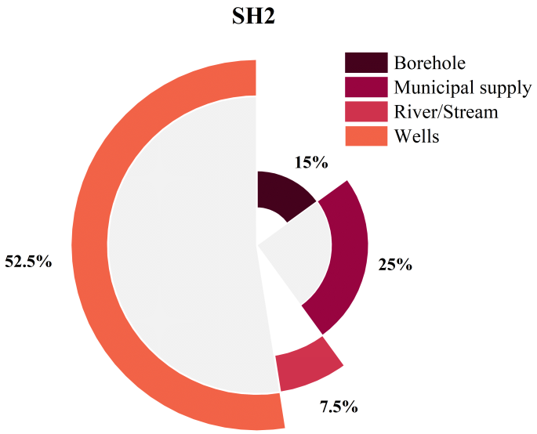
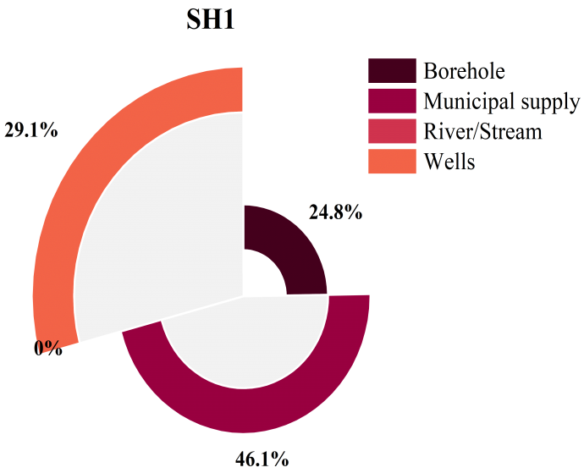

Figure 2. Source of fresh water used in both slaughterhouses (SH1: Slaughterhouse facility and SH2: Mvog-ada market slaughter site)

3.1.2 Sectors of wastewater production
Wastewater production varied between the two slaughterhouses (Figure 3). In SH1, facility cleaning was the primary source (40%), followed by animal processing (30%), animal holding (20%), and byproduct processing (10%). This distribution aligned with slaughterhouse facility standards, where sanitation is prioritized for regulatory compliance (Aleksić et al. 2020). In contrast, SH2 generated the majority of its wastewater from animal processing (45%), followed by animal holding (25%), facility cleaning (20%), and byproduct processing (10%). These findings indicated that SH2 allocated more water to direct animal handling, likely due to limited cleaning protocols and weaker regulatory oversight. The reduced focus on facility cleaning in SH2 reflected resource constraints or the absence of slaughterhouse facility hygiene standards, typical of local market slaughter sites (Ndi & Oben, 2014).
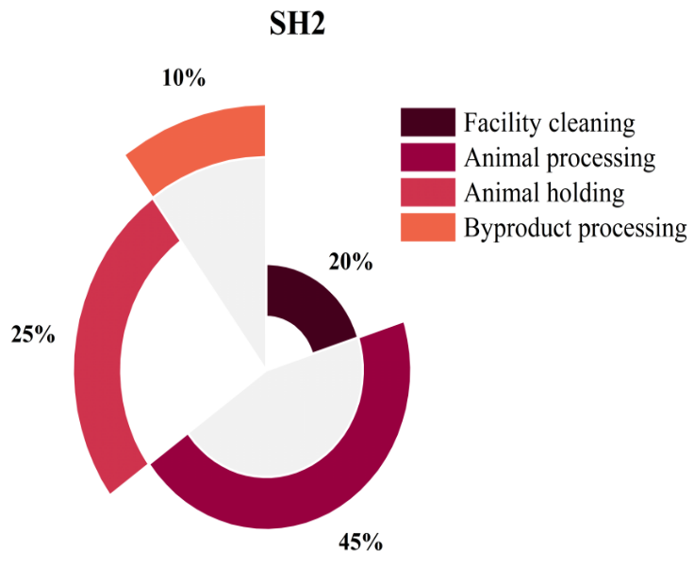
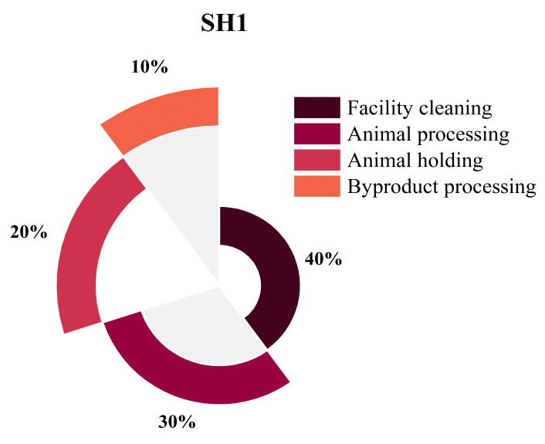
Figure 3. Main sectors of wastewater production in both slaughterhouses (SH1: Slaughterhouse facility and SH2: Mvog-ada market slaughter site)

3.1.3 Daily wastewater generation
During the six-month study, SH1 consistently generated more wastewater than SH2 (Figure 4), with daily volumes ranging from 5.1 m³ in April to 7.9 m³ in June. In contrast, SH2 produced between 2.8 m³ in May and 4.8 m³ in February. The higher wastewater production in SH1 was attributed to its operations, which primarily involved slaughtering larger animals, such as cattle, requiring more water for cleaning and processing (Aleksić et al. 2020). Fluctuations in wastewater quantity from April to June, were likely influenced by seasonal demand or variations in operational efficiency. Additionally, as a slaughterhouse facility, SH1 adhered to regulated cleaning schedules, which varied in intensity based on inspections, maintenance routines, or shifts in operational capacity.
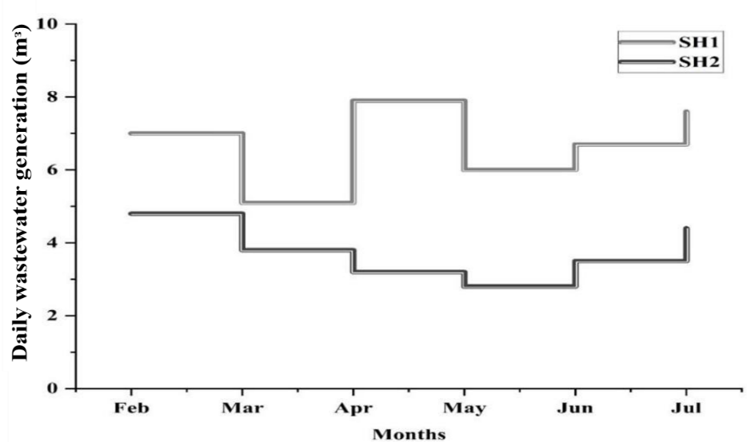
Figure 4: Average daily volume of wastewater produced in both slaughterhouses (SH1: Slaughterhouse facility and SH2: Mvog-ada market slaughter site)

3.2 Wastewater Characteristics of both facilities
The wastewater characteristics for both facilities were based on composite samples obtained from each slaughterhouse (Figure 5).

3.2.1 General variables
The physical parameters of slaughterhouse wastewater from SH1 and SH2 are presented in Figure 5(a,b). The pH values were neutral, with SH2 (7.82 ± 0.59) slightly higher than SH1 (7.58 ± 0.27). Temperature was marginally higher in SH2 (27.87 ± 0.75°C) compared to SH1 (26.52 ± 1.30°C), likely due to increased hot water usage (Musa et al. 2019). Color levels were higher in SH1 (9533.33 ± 5029.97 PtCo) than in SH2 (7486.11 ± 797.61 PtCo), suggesting higher organic or inorganic compounds. Electrical conductivity (EC) was significantly greater in SH2 (4496.67 ± 1096.44 µs/cm) than SH1 (1171.83 ± 540.36 µs/cm), indicating higher dissolved ion concentrations due to varying animal slaughtering and cleaning chemicals (Stanga, 2010). SH2 also had higher total dissolved solids (2919.06 ± 788.68 mg/l) than SH1 (1291.08 ± 115.39 mg/l), whereas SH1 exhibited slightly higher total suspended solids (3504.17 ± 709.61 mg/l) than SH2 (3019.96 ± 215.13 mg/l).

3.2.2 Chemical variables
Cl⁻ concentrations were higher in SH2 (114.25 ± 15.75 mg/l) than SH1 (83.50 ± 14.73 mg/l), likely due to salt used in processing and cleaning (Mulu et al., 2013). NO₃⁻-N levels were significantly elevated in SH1 (772.50 ± 57.30 mg/l) compared to SH2 (452.74 ± 53.73 mg/l), whereas NH₄⁺-N concentrations were greater in SH2 (158.06 ± 22.92 mg/l) than in SH1 (123.71 ± 36.85 mg/l). Slaughterhouse wastewater contains large amounts of blood, which decomposes into ammonium and nitrates via microbial activity (Limeneh et al. 2022). The higher wastewater volume in SH1 accounts for its elevated nitrate concentration. PO₄³⁻ levels were also higher in SH1 (135.75 ± 14.86 mg/l) compared to SH2 (120.28 ± 24.74 mg/l). Variations in phosphate levels depend on wastewater volume and facility operations. All these are illustrated Figure 5c.

3.2.3 Organic load variables
The organic load in terms of COD and BOD₅ are illustrated in 5d. The COD level showed a higher mean concentration in SH1 (16232.13 ± 3315.26 mg/l) compared to SH2 (7736.39 ± 868.75 mg/l), indicating a greater presence of oxidizable organic matter in the wastewater of SH1. This higher concentration is a result of the higher TSS present in SH1 compared to SH2, as described previously. Similarly, the mean BOD₅ is almost twice as high in SH1 (3197.54 ± 296.49 mg/l) as in SH2 (1702.22 ± 731.25 mg/l), further corroborating the higher organic load in SH1. Higher organic loads in slaughterhouse wastewater are often linked to blood, fat, and tissue residues, which increase BOD₅ and COD levels (Limeneh et al. 2022) . The elevated COD in SH1 suggests a higher proportion of oxidizable organic material, while the high BOD₅ indicates the presence of readily biodegradable organic compounds (Akpor et al. 2014). Excessive organic load in wastewater can lead to oxygen depletion in receiving water bodies, negatively impacting aquatic ecosystems by reducing dissolved oxygen availability for aquatic organisms (Akinnawo, 2023). Proper treatment is essential to mitigate these environmental risks.

3.2.4 Trace metal variables
Trace metal concentrations varied between SH1 and SH2 (Figure 5e). Fe²⁺ was higher in SH1 (15.73 ± 2.75 mg/l) than in SH2 (10.31 ± 2.70 mg/l), whereas Cu²⁺ was more concentrated in SH2 (9.23 ± 2.46 mg/l) compared to SH1 (6.29 ± 1.53 mg/l). Cr⁶⁺ levels remained low but were slightly higher in SH2 (0.38 ± 0.19 mg/l) than in SH1 (0.26 ± 0.13 mg/l). Trace metals accumulate in animal tissues, blood, and organs due to exposure to contaminated feed, water, or environment (Elliott et al. 2017; Poopak et al. 2024). These metals are then released into wastewater during slaughter and processing (Sapkota et al 2007). The higher metal content in SH2 wastewater suggests that animals may have consumed feed with elevated trace metal levels, influencing effluent composition. This highlights the need for monitoring feed sources to prevent excessive Trace metal contamination in slaughterhouse wastewater.

3.2.5 Bacteriological variables
Assessment of fecal coliforms and fecal streptococci as indicators of fecal contamination revealed an important contrast between the two slaughterhouses, with SH1 exhibiting dramatically higher counts of FC (6.2x10⁷ ± 3.6x10⁷ CFU/100ml) and FS (4.5x10⁷ ± 2.5x10⁵ CFU/100ml) compared to SH2 (1.6x10⁶ ± 1.2x10⁶ CFU/100ml for FC and 7.8x10⁵ ± 4x10⁵ CFU/100ml for FS) (Figure 5f). This indicates a significant difference in the microbiological quality of the wastewater, with SH1 presenting a greater potential health risk. The environmental conditions surrounding the slaughterhouses, such as temperature, humidity, and exposure to sunlight, can influence bacterial survival and proliferation. Warmer conditions, as observed in SH2, could promote bacterial growth; however, higher temperatures could also contribute to a faster die-off rate of fecal bacteria in wastewater holding areas, potentially lowering the concentration of fecal coliforms and streptococci in the discharged wastewater (Dean & Mitchell, 2022).
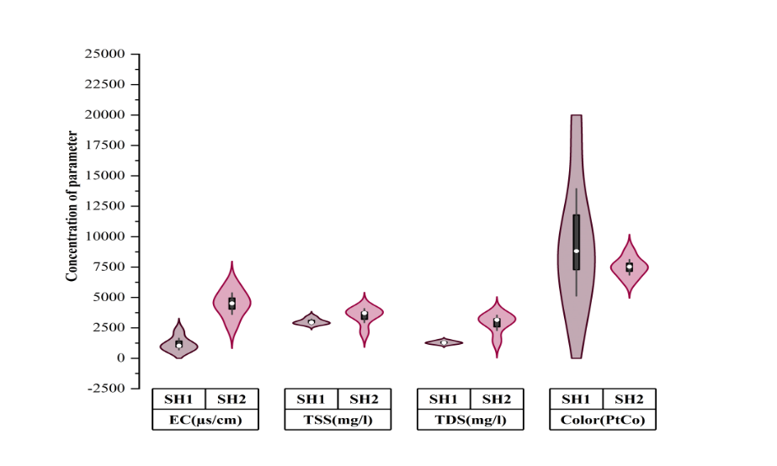
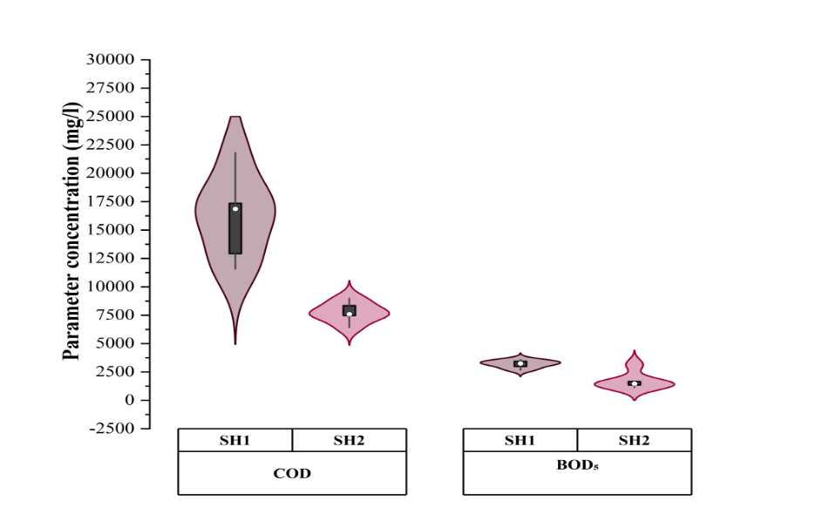
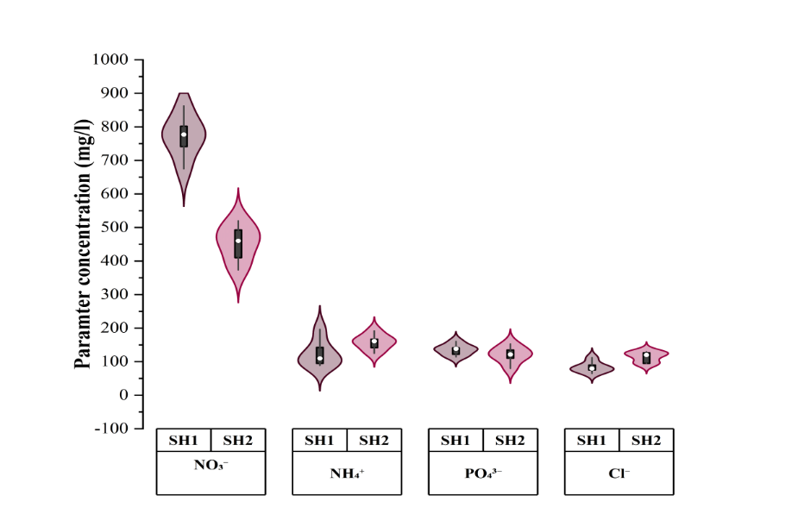
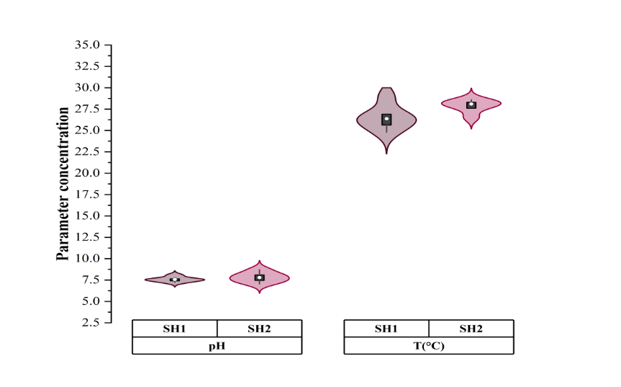
d
c
a
b
Figure

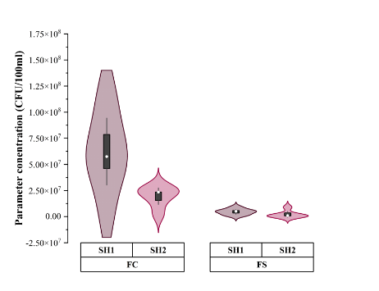
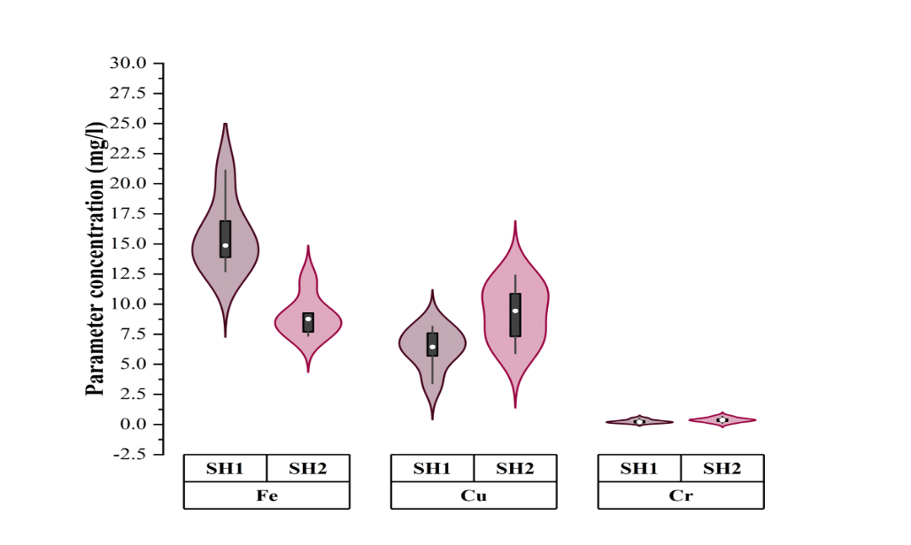
f
e

Figure 5. Mean concentration of physicochemical and bacteriological parameters in both slaughterhouses
3.3 Correlation between the studied variables in both slaughterhouses
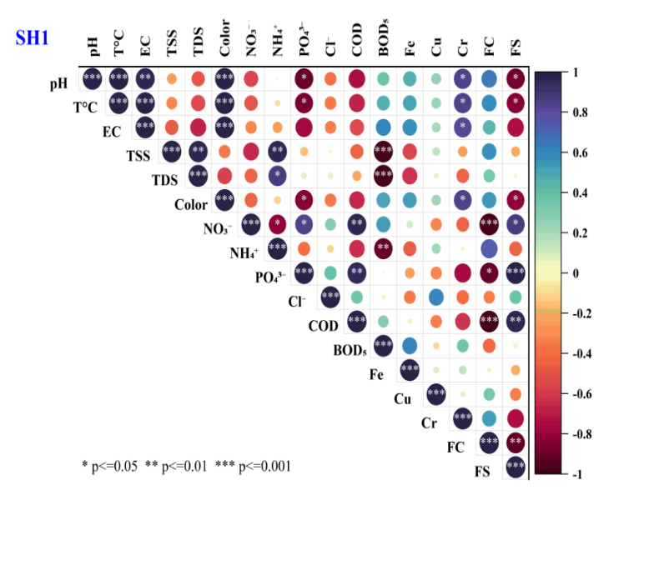
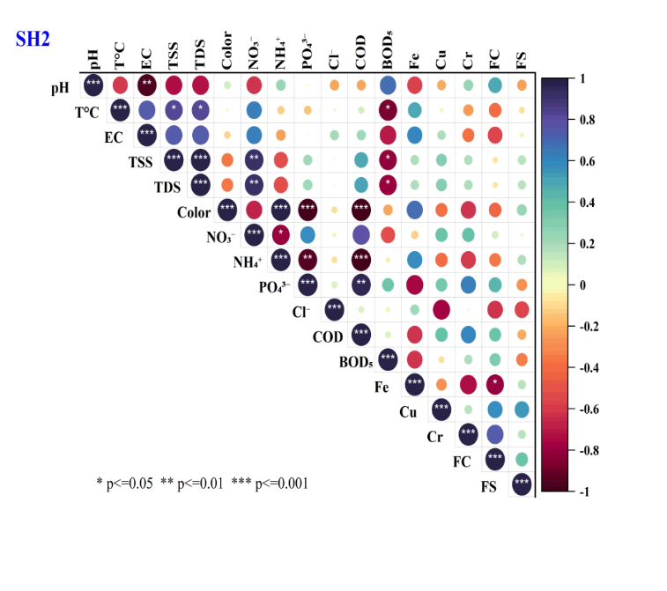
The correlation analysis of physicochemical and bacteriological variables at SH1 and SH2 revealed distinct patterns in wastewater characteristics (Figure 6). At SH1, strong positive correlations were observed between temperature, pH, and color, reflecting the influence of temperature on the solubility and reactivity of contaminants (Brusseau & Chorover, 2019). The negative correlations between phosphate and pH (r = -0.913, p < 0.05) and COD and pH (r = -0.748, p < 0.001) suggest that higher phosphate and organic pollutant levels contribute to the acidification of the wastewater (Akpor et al. 2014). In contrast, SH2 exhibited strong positive correlations between pH and electrical conductivity (r = 0.88298, p < 0.01) and TSS and TDS (r = 0.99993, p < 0.001), indicating a direct relationship between ionization and the solubility of solids. The significant negative correlations between ammonium (NH₄⁺) and color (r = -0.8136, p < 0.05) and phosphate (r = -0.94748, p < 0.01), and between COD and NH₄⁺ (r = -0.9991, p < 0.001), suggest that nitrogen dynamics play a key role in the transformation and removal of other contaminants (Malyan et al. 2021; Rahimi et al. 2020). These differences highlight the contrasting dynamics at SH1 and SH2, with SH1 exhibiting more complex interactions among organic and inorganic parameters, while SH2 shows a more interconnected relationship between suspended solids and nutrients, requiring different treatment strategies.

Figure 6. Correlation between the physicochemical and bacteriological variables in SH1 and SH2

3.4 Compliance of both Slaughterhouse Effluent with regulatory standards and implications of their untreated discharge
Slaughterhouse wastewater from both SH1 and SH2 facilities in Yaoundé was compared against the Cameroonian and EU guidelines as shown in Table 1, as well as Bustillo-Lecompte et al. (2016) working on the characterization of slaughterhouse wastewater. The pH of SH1 (7.6±2.4) and SH2 (7.8±3.7) remained within neutral to slightly alkaline levels, aligning with regulatory standards but differing from Bustillo-Lecompte et al. (2016), who reported a more acidic nature. pH is critical in influencing nutrient solubility and Trace metal dissolution, affecting aquatic ecosystems (Akpor et al. 2014). BOD₅ (SH1: 3198±296 mg/l; SH2: 21702±731 mg/l) and COD (SH1: 16232±3315 mg/l; SH2: 7736±869 mg/l) exceeded Cameroonian and EU limits, highlighting important organic pollution risks (Ziara et al. 2018). Such high levels deplete dissolved oxygen, harming aquatic life (Akpor et al. 2014; Maddah, 2023). TSS also surpassed permissible limits, increasing turbidity and endangering aquatic organisms. Nutrients such as NO₃⁻ (SH1: 772.5±57.3 mg/l; SH2: 452.7±53.7 mg/l), NH₄⁺-N (SH1: 123.7±36.9 mg/l; SH2: 158.1±22.9 mg/l), and phosphates (SH1: 135.8±14.9 mg/l; SH2: 120.3±24.7 mg/l) exceeded guidelines, promoting eutrophication and harmful algal blooms (Akinnawo, 2023). Trace metals, particularly copper and chromium, exceeded EU standards, posing ecological and health risks. Additionally, the presence of fecal coliforms and fecal streptococci indicates fecal contamination, heightening concerns over waterborne diseases (Tenebe et al. 2024). Untreated slaughterhouse effluent presents severe environmental and public health risks, necessitating effective treatment and regulatory compliance before discharge.
Table 1. Characteristics of wastewater from both facilities compared with regulatory standards
Parameters | SH 1 | SH2 | Bustillo-Lecompte & Mehrvar (2016) | Cameroonian standards | EU Guideline
pH | 7.6±2.4 | 7.8±3.7 | 6.5 | 6-9 | 6-9
T°C | 26.5±1.6 | 27.9±2.1 |  | 30
EC (µs/cm) | 1171.8±540.4 | 4496,7±1096,4 | / | / | /
Colour (PtCo) | 9533.3±5030 | 7486.1±797.6 | 289 | /
TSS (mg/l) | 3020.0±215.1 | 3504.2± 709.6 | 3092 | 50 | 30
TDS (mg/l) | 1291.1± 115.4 | 2919,1± 788,7 | / | / | /
NO₃⁻-N (mg/l) | 772.5±57.3 | 452.7±53.7 | / | 30 | 45
NH₄⁺-N (mg/l) | 123.7±36.9 | 158.1±22.9 | / | / | 10
Cl⁻ (mg/l) | 83.5 ± 14.7 | 114.3 ± 15.8 | / | /
PO₄³⁻ (mg/l) | 135.8±14.9 | 120.3±24.7 | 52.1 |  | 2
COD (mg/l) | 16232± 3315 | 7736±869 | 5577 | 200 | 125
BOD₅ (mg/l) | 3198±296 | 1702±731 | 2649 | 50 | 25
FC (CFU/100ml) | 6.2x10⁷ ± 3.6x10⁷ | 1.6x10⁶ ± 1.2x10⁶ | / | 2000 | 1000
FS (CFU/100ml) | 4.5x10⁷ ± 2.5x10⁵ | 7.8x10⁵ ± 4x10⁵ | / | 1000 | 1000
Fe²⁺ (mg/l) | 15.7 ± 2.7 | 10.3 ± 2.7 | / | / | /
Cu²⁺ (mg/l) | 6.3 ± 1.5 | 9.2 ± 2.5 | / | / | 1.3
Cr⁶⁺ (mg/l) | 0.3 ± 0.1 | 0.4 ± 0.2 | / | / | 0.1

3.5 Environmental and health impacts
3.5.1 Sociodemographic characteristics of respondents
The sociodemographic characteristics of respondents near slaughterhouses SH1 and SH2, as shown in Table 2, provided insights into community vulnerability, risk perception, and potential health and environmental concerns. The age distribution indicated that younger and middle-aged individuals (18–50 years) dominated both areas, comprising 80% of respondents at SH1 and 63% at SH2. This aligned with studies showing that younger populations were more engaged in reporting environmental issues, while older populations may have adapted to or normalized the conditions (Li et al. 2023). Gender distribution revealed that women constituted the majority of respondents (67% at SH1 and 70% at SH2), likely reflecting their higher presence at home and greater exposure to household and environmental pollution. Women were often primary caregivers and may have been more sensitive to sanitation issues, influencing their perception of slaughterhouse impacts (Oruganti et al. 2023). Years of residence indicated that a higher proportion of long-term residents (>5 years) lived near SH1 (57%) compared to SH2 (37%). In contrast, SH2 had more transient populations, with 53% residing for 1–5 years. This turnover may have influenced perceptions of pollution severity as newer residents might have been more critical of environmental conditions. Proximity to slaughterhouses varied significantly, with 57% of respondents near SH2 residing within 500 meters, compared to 46% at SH1. Studies have shown that individuals living closer to industrial facilities reported higher environmental dissatisfaction and health complaints due to increased exposure to emissions, odors, and waste runoff (Ajibade et al. 2021: Himu & Raihan, 2023). Conversely, fewer respondents resided beyond 1 km from SH2 (17%) compared to SH1 (25%), suggesting that SH2 may have been more integrated within a densely populated area.

Table 2. Sociodemographic characteristics of respondents living around both slaughter facilities
Variable | Characteristics | SH1 | SH2
Age | 18–30 | 40% | 33%
Age | 31–50 | 40% | 30%
Age | Above 50 | 20% | 37%
Age | Grand total | 100% | 100%
Gender | Female | 67% | 70%
Gender | Male | 33% | 30%
Gender | Grand total | 100% | 100%
Year of residence | 1–5 years | 30% | 53%
Year of residence | Less than 1 | 13% | 10%
Year of residence | More than 5 | 57% | 37%
Year of residence | Grand total | 100% | 100%
Distance from slaughterhouse | <500m | 46% | 57%
Distance from slaughterhouse | >1km | 25% | 17%
Distance from slaughterhouse | 500m–1km | 29% | 27%
Distance from slaughterhouse | Grand total | 100% | 100%

3.5.2 Link between wastewater issues and health problems
The chord diagrams for SH1 and SH2 (Figure 7) reveal significant overlaps in the connection between wastewater issues and health impacts, emphasizing odor and water pollution as dominant concerns. In SH1, odor is strongly associated with respiratory diseases (16.67%) and skin infections (16.52%), reflecting the role of air pollutants in public health challenges (Saxena, 2025). Similarly, in SH2, odor is the leading issue, tied to respiratory diseases (16.67%) and skin infections (15%), highlighting shared risks across both sites. Water pollution is a major factor, contributing to waterborne diseases in SH2 (14.34%) more significantly than in SH1 (11.33%), suggesting site-specific differences in wastewater handling. Solid waste dumping impacts respiratory diseases in both SH1 (15%) and SH2 (12.79%) but is also linked to pest infestations (12% in SH1, 10% in SH2). Effective treatment strategies are crucial to mitigate these risks.
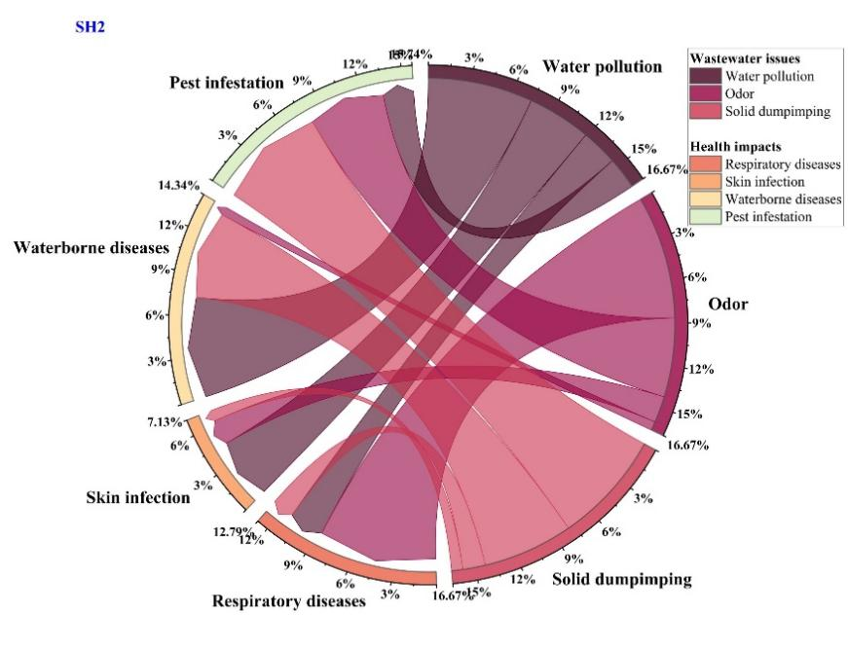
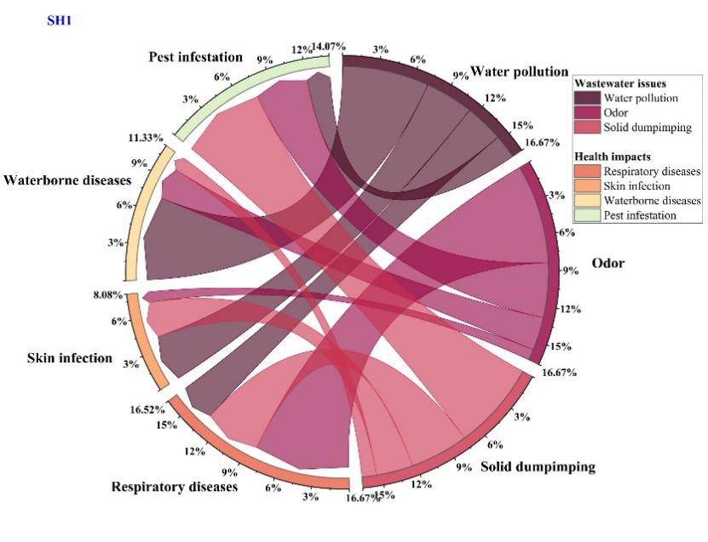
Figure 7. Link between wastewater issues and health impact faced by residents in both study areas.

3.5.3 Relationship between proximity to slaughterhouse and perceived impacts
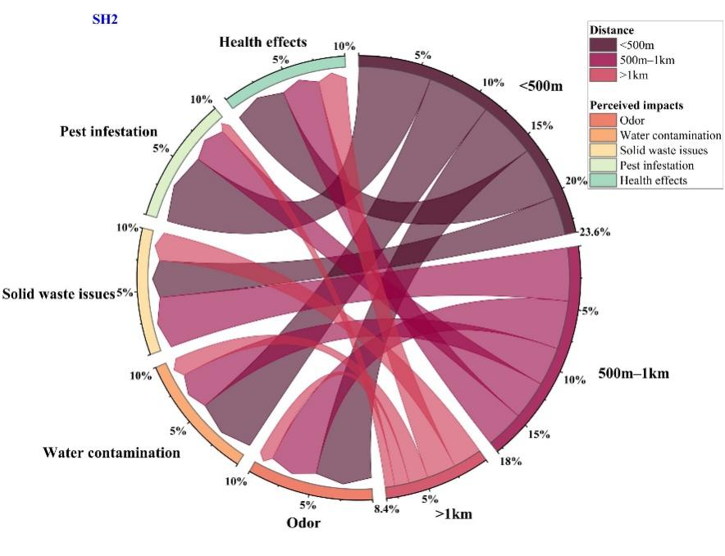
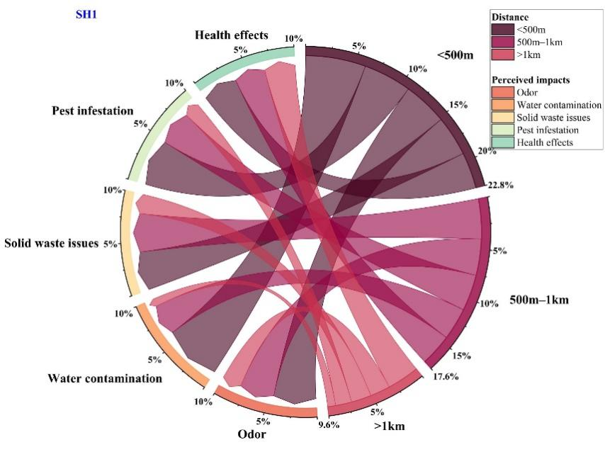
The analysis of perceived impacts from proximity to slaughterhouses SH1 and SH2 (Figure 8) highlights both shared and distinct concerns among residents, underlining significant environmental and health challenges. Odor was the most prevalent issue, particularly within 500 meters of the facilities, with 22.8% of residents near SH1 and 23.6% near SH2 identifying it as a major concern, consistent with previous studies on the impact of industrial odors (Saxena, 2025). Health effects, also a common concern, were reported by 10% of residents within this zone for both slaughterhouses, reflecting the potential risks associated with proximity to waste and emissions. Pest infestation was more problematic near SH2 (10%) than SH1 (5%), suggesting that waste management practices at SH2 might be less effective (Ndi & Oben, 2014). In areas between 500 meters and 1 kilometer, odor remained a dominant issue, though with a slight decrease in intensity, showing a gradation of impact with distance. Health concerns were higher at SH1 (20%) than SH2 (15%), possibly indicating varying contamination levels. Beyond 1 kilometer, odor concerns persisted at
Figure 8. Relationship between proximity to slaughterhouse and perceived impacts

reduced levels, and other issues like water contamination, pest infestation, and solid waste were minimal, emphasizing the need for targeted mitigation strategies to address health and environmental impacts, particularly within the first kilometer.

4. Conclusion
This study comprehensively analyzed wastewater characteristics from two slaughterhouses in Yaoundé, comparing slaughterhouse facility and local butcher shop facility facilities. The wastewater in SH1 and SH2 is estimated to peak at about 7.9 m³ and 4.8 m³, respectively. Most parameters monitored were overall higher in the slaughterhouse facility slaughterhouse facility (SH1) than the SH2 (SH2). Wastewater exhibited slightly alkaline pH, but BOD₅ and COD levels exceeded guidelines, demanding effective treatment to prevent environmental risks. Odor and water pollution are dominant concerns in both sites and are strongly associated with respiratory waterborne diseases and skin infections. Therefore, improved wastewater management and responsible waste practices are vital to minimize environmental impact, protecting human health and ecosystems. Adopting sustainable treatment methods can mitigate pollutants and promote a cleaner environment. Collaboration and research are key to finding innovative solutions for slaughterhouse wastewater treatment.

AcknowledgEments
The authors greatly appreciate all the wastewater Research Unit who supported this work and assisted in wastewater analysis throughout this study.

Competing interests
Authors have declared that no competing interests exist.

References

- Ajibade, F. O., Adelodun, B., Lasisi, K. H., Fadare, O. O., Ajibade, T. F., Nwogwu, N. A., Sulaymon, I. D., Ugya, A. Y., Wang, H. C., & Wang, A. (2021). Environmental pollution and their socioeconomic impacts. In Microbe Mediated Remediation of Environmental Contaminants (pp. 321–354). Woodhead Publishing. https://doi.org/10.1016/B978-0-12-821199-1.00025-0
- AkinnawO, S. O. (2023). Eutrophication: Causes, consequences, physical, chemical and biological techniques for mitigation strategies. Environmental Challenges, 12, 100733. https://doi.org/10.1016/j.envc.2023.100733
- Akpor, O. B., Otohinoyi, D. A., Olaolu, D. T., & Aderiye, B. I. (2014). Pollutants in wastewater effluents: Impacts and remediation processes. International Journal of Environmental Research and Earth Science, 3, 50–59. https://eprints.lmu.edu.ng/id/eprint/1023
- Aleksić, N., Nešović, A., Šušteršič, V., Gordić, D., & Milovanović, D. (2020). Slaughterhouse water consumption and wastewater characteristics in the meat processing industry in Serbia. Desalination and Water Treatment, 190, 98–112. https://doi.org/10.5004/dwt.2020.25745
- American Public Health Association (APHA). (1998). Standard Methods for the Examination of Water and Wastewater (20th ed.). American Public Health Association.
- American Public Health Association (APHA). (2005). Standard Methods for the Examination of Water and Wastewater (21st ed.). American Public Health Association.
- Bashir, I., Lone, F. A., Bhat, R. A., Mir, S. A., Dar, Z. A., & Dar, S. A. (2020). Concerns and threats of contamination on aquatic ecosystems. In E. Lichtfouse (Ed.), Bioremediation and Biotechnology: Sustainable Approaches to Pollution Degradation (pp. 1–26). Springer. https://doi.org/10.1007/978-3-030-35691-0_1
- Brusseau, M. L., & Chorover, J. (2019). Chemical processes affecting contaminant transport. In Environmental Pollution Science (pp. 113–130). Academic Press. https://doi.org/10.1016/B978-0-12-814719-1.00008-2
- Burton, C. H., Cumby, T. R., & Tinker, D. B. (2004). Treatment and disposal of poultry processing waste. In Poultry Meat Processing and Quality (pp. 345–376). Woodhead Publishing. https://doi.org/10.1533/9781855739031.345
- Bustillo-Lecompte, C., Mehrvar, M., & Quiñones-Bolaños, E. (2016). Slaughterhouse wastewater characterization and treatment: an economic and public health necessity of the meat processing industry in Ontario, Canada. Journal of Geoscience and Environment Protection, 4(4), 175–186. http://dx.doi.org/10.4236/gep.2016.44021
- Corigliano, O., & Algieri, A. (2024). A comprehensive investigation on energy consumptions, impacts, and challenges of the food industry. Energy Conversion and Management: X, 100661. https://doi.org/10.1016/j.ecmx.2024.100661
- Dean, K., & Mitchell, J. (2022). Identifying water quality and environmental factors that influence indicator and pathogen decay in natural surface waters. Water Research, 211, 118051. https://doi.org/10.1016/j.watres.2022.118051
- Donatien, Z. A., Aghaindum, A. G., & Pierre, N. (2017). Quantification of microbiological and physico-chemical variables during the purification of the wastewater from the Yaoundé Slaughterhouse and the receiving river system. International Journal of Current Microbiology and Applied Sciences, 6, 2252–2266.
- Dumlu, B. (2024). The global goose meat production quantity forecast for the 2023–2027 years. Selcuk Journal of Agriculture and Food Sciences, 38, 326–341. https://doi.org/10.15316/SJAFS.2024.030
- Elliott, S., Frio, A., & Jarman, T. (2017). Heavy metal contamination of animal feedstuffs: A new survey. Journal of Applied Animal Nutrition, 5, e8. https://doi.org/10.1017/jan.2017.7
- Gržinić, G., Piotrowicz-Cieślak, A., Klimkowicz-Pawlas, A., Górny, R. L., Ławniczek-Wałczyk, A., Piechowicz, L., Olkowska, E., Potrykus, M., Tankiewicz, M., Krupka, M., & Siebielec, G. (2023). Intensive poultry farming: a review of the impact on the environment and human health. Science of The Total Environment, 858, 160014.
- Himu, H. A., & Raihan, A. (2023). A review of the effects of intensive poultry production on the environment and human health. International Journal of Veterinary Research, 3(2), 55–106.
- Hu, Y., Cheng, H., & Tao, S. (2017). Environmental and human health challenges of industrial livestock and poultry farming in China and their mitigation. Environment International, 107, 111–130. https://doi.org/10.1016/j.envint.2017.07.003
- Kanu, I., & Achi, O. K. (2011). Industrial effluents and their impact on water quality of receiving rivers in Nigeria. Journal of Applied Technology in Environmental Sanitation, 1, 75–86.
- Khatri, K., Vairavamoorthy, K., & Porto, M. (2008). Challenges for urban water supply and sanitation in developing countries. In Water for a Changing World: Developing Local Knowledge and Capacity (pp. 93–112). CRC Press.
- Li, A., Toll, M., & Bentley, R. (2023). Mapping social vulnerability indicators to understand the health impacts of climate change: A scoping review. The Lancet Planetary Health, 7(11), e925–e937.
- Limeneh, D. Y., Tesfaye, T., Ayele, M., Husien, N. M., Ferede, E., Haile, A., & Kong, F. (2022). A comprehensive review on utilization of slaughterhouse by-product: Current status and prospect. Sustainability, 14, 6469. https://doi.org/10.3390/su14116469
- Maddah, H. A. (2023). Regression-based analytical models for dissolved oxygen in wastewater. Environmental Monitoring and Assessment, 195(11), 1346. https://doi.org/10.1007/s10661-023-11954-8
- Malyan, S. K., Yadav, S., Sonkar, V., Goyal, V. C., Singh, O., & Singh, R. (2021). Mechanistic understanding of the pollutant removal and transformation processes in the constructed wetland system. Water Environment Research, 93(10), 1882–1909. https://doi.org/10.1002/wer.1599
- Masoumi, Z., Shokohi, R., Atashzaban, Z., Ghobadi, N., & Rahmani, A. R. (2015). Stabilization of excess sludge from poultry slaughterhouse wastewater treatment plant by the Fenton process. Avicenna Journal of Environmental Health Engineering, 2, 1–5. https://doi.org/10.17795/ajehe3239
- Matchawe, C., Ndip, L. M., Zuliani, A., Ngonde, M. C., & Piasentier, E. (2019). Factors influencing Salmonella contamination and microbial load of beef carcass at the Yaoundé Slaughterhouse, Cameroon. Journal of Food Engineering, 9, 266–275. https://doi.org/10.17265/2159-5828/2019.07.002
- Mbog Mbog, S., Bot, B. V., Reounodji, A., & Bitondo, D. (2023). Assessment of wastewater management at the Etoudi Slaughterhouse in the Municipality of Yaoundé – Cameroon. International Journal of Environmental Protection and Policy, 11, 31–36. https://doi.org/10.11648/j.ijepp.20231102.12
- Mulu, A., Ayenew, T., & Berhe, S. (2013). Impact of slaughterhouses effluent on water quality of Modjo and Akaki River in Central Ethiopia. International Journal of Science and Research, 4(3).
- Musa, A., Idrus, S., Che Man, H., & Nik Daud, N. N. (2019). Performance comparison of conventional and modified upflow anaerobic sludge blanket (UASB) reactors treating high-strength cattle slaughterhouse wastewater. Water, 11(4), 806. https://doi.org/10.3390/w11040806
- Ndi, H. N., & Oben, E. E. E. (2014). Space and infrastructure functionality in Yaoundé markets. Journal of Geography and Geology, 6(2), 93–102. https://doi.org/10.5539/jgg.v6n2p93
- Ng, M., Dalhatou, S., Wilson, J., Kamdem, B. P., Temitope, M. B., Paumo, H. K., Djelal, H., Assadi, A. A., Nguyen-Tri, P., & Kane, A. (2022). Characterization of slaughterhouse wastewater and development of treatment techniques: a review. Processes, 10(7), 1300. https://doi.org/10.3390/pr10071300
- Obidegwu, C. S., Chineke, H. N., Ubajaka, C. N., & Adogu, P. O. (2019). Public health challenges in Somachi Main Abattoir Owerri, Nigeria: A review and field activity report. European Journal of Medical and Health Sciences, 1(2). https://doi.org/10.24018/ejmed.2019.1.2.34
- Oben, E. E. E., & Ndi, H. N. (2017). Market location analysis and efficiency in Yaoundé. African Journal of Social Sciences, 8(7).
- Oguntoke, O., Aboderin, O., & Bankole, A. (2009). Association of water-borne diseases morbidity pattern and water quality in parts of Ibadan City. Tanzania Journal of Health Research, 11(4). https://doi.org/10.4314/thrb.v11i4.50174
- Oruganti, P., Root, E., Ndlovu, V., Mbhungele, P., Van Wyk, I., & Berrian, A. M. (2023). Gender and zoonotic pathogen exposure pathways in a resource-limited community, Mpumalanga, South Africa: A qualitative analysis. PLOS Global Public Health, 3(6), e0001167. https://doi.org/10.1371/journal.pgph.0001167
- Osiemo, M. M., Ogendi, G. M., & M’Erimba, C. M. (2019). Microbial quality of drinking water and prevalence of water-related diseases in Marigat Urban Centre, Kenya. Environmental Health Insights, 13. https://doi.org/10.1177/1178630219836988
- Poopak, H., Raeeszadeh, M., & Salimi, B. (2024). Accumulation of Trace metals in meat and their relationship with water and food intake of aquatic animals in Kermanshah, western Iran. International Journal of Environmental Health Research, 34, 1453–1465. https://doi.org/10.1080/09603123.2023.2221640
- Rahimi, S., Modin, O., & Mijakovic, I. (2020). Technologies for biological removal and recovery of nitrogen from wastewater. Biotechnology Advances, 43, 107570. https://doi.org/10.1016/j.biotechadv.2020.107570
- Rani, Z. T., Hugo, A., Hugo, C. J., Vimiso, P., & Muchenje, V. (2017). Effect of post-slaughter handling during distribution on microbiological quality and safety of meat in the slaughterhouse facility and local butcher shop facility sectors of South Africa: A review. South African Journal of Animal Science, 47(3), 255–267. https://doi.org/10.4314/sajas.v47i3.2
- Rodier, J. (2009). L’analyse de l’eau, eau naturelle, eau résiduaire, eau de mer (9th ed.). Dunod.
- Sapkota, A. R., Lefferts, L. Y., McKenzie, S., & Walker, P. (2007). What do we feed to food-production animals? A review of animal feed ingredients and their potential impacts on human health. Environmental Health Perspectives, 115(5), 663–670. https://doi.org/10.1289/ehp.9760
- Saxena, V. (2025). Water quality, air pollution, and climate change: Investigating the environmental impacts of industrialization and urbanization. Water, Air, & Soil Pollution, 236(2), 1–40. https://doi.org/10.1007/s11270-024-07702-4
- Sonone, S. S., Jadhav, V. R., Sankhla, N. S., & Kumar, R. (2020). Water contamination by Trace metals and their toxic effect on aquaculture and human health through food chain. Letters in Applied NanoBioScience, 10(2), 2148–2166. https://doi.org/10.33263/LIANBS102.21482166
- Stanga, M. (2010). Sanitation: Cleaning and Disinfection in the Food Industry. John Wiley & Sons.
- Takang, E. E., LeBreton, M., Ayuk, C. E., & MacLeod, E. T. (2020). A socio-economic study of Fasciola infections in cattle and sheep at the Etoudi slaughterhouse, Yaoundé, Cameroon. Journal of Helminthology, 94, e92. https://doi.org/10.1017/S0022149X19000890
- Tamasang, C. F. (2025). Country report for Cameroon. In Legal Pathways to Sustainable Soil Management in Africa (pp. 179-240). Nomos Verlagsgesellschaft mbH & Co. KG.
- Tenebe, I. T., Babatunde, E. O., Ogarekpe, N. M., Emakhu, J., Etu, E. E., Edo, O. C., Omeje, M., & Benson, N. U. (2024). Detection and measurement of bacterial contaminants in stored river water consumed in Ekpoma. Water, 16(18), 2696.
- Ziara, R. M., Li, S., Subbiah, J., & Dvorak, B. I. (2018). Characterization of wastewater in two US cattle slaughterhouses. Water Environment Research, 90(9), 851–863. https://doi.org/10.2175/106143017X15131012187971

