Case study

Glaucoma Screening in Children with Mucopolysaccharidosis Type I: About 12 Cases

Abstract
Objective: To evaluate the prevalence, clinical characteristics, diagnostic challenges, and therapeutic outcomes of glaucoma in children diagnosed with mucopolysaccharidosis type I (MPS I).
Methods: A retrospective descriptive study was conducted on 12 pediatric patients (aged 4–17 years) with confirmed MPS I, followed jointly by the Pediatrics and Ophthalmology departments of HMIMV Hospital, Rabat.
Results: All patients exhibited corneal opacification with normal anterior chamber depth. The iridocorneal angle was open in seven cases. Pachymetry ranged from 580 to 735 μm (mean = 667 μm). Adjusted IOP ranged between 15 and 59 mmHg (mean = 20 mmHg). Three patients (25%) were diagnosed as glaucomatous or glaucoma suspects. Patients received enzyme replacement therapy, and the glaucoma was treated medically, with follow up showing significant improvement of IOP and Cup/Disc ratio.
Conclusion: Glaucoma represents a challenging but significant ocular manifestation of MPS I. Prevalence of glaucoma in MPSs patients (ranged from 2.1% to 12.5%) indicated that it was worthy of attention and further study so that quality of life for MPSs patients could be improved. Early, multimodal diagnostic evaluation and individualized management are crucial.

Introduction
Mucopolysaccharidoses (MPS) are inherited lysosomal storage disorders caused by enzymatic deficiencies involved in glycosaminoglycan degradation [1]. MPS type I results from a deficiency of α-L-iduronidase, leading to accumulation of GAGs in ocular tissues [2]. Ophthalmic involvement in MPS I includes corneal clouding, optic neuropathy, refractive errors, and retinal changes [3]. Glaucoma, although less frequent, can cause irreversible visual impairment if untreated [6]. This study aims to evaluate glaucoma prevalence and clinical features in pediatric MPS I cases [2].

Materials and Methods
A retrospective descriptive study was performed on 12 children with MPS type I [1]. This study is carried out in collaboration between the pediatrics department and the ophthalmology department.
The age of the children is comprised between 4 and 17 years old, with average age of MPS diagnosis at approximately 6 years old.
Ophthalmologic assessment included slit-lamp examination, gonioscopy, and intraocular pressure measurement by Goldmann and air tonometry [6]. Pachymetry and OCT were used for corneal and optic nerve evaluation [3]. All patients received enzyme replacement therapy initiated at a mean age of 4 years [2].

Results
All 12 patients presented with corneal opacity of varying degrees of severity (Fig 1). The anterior chamber depth appeared normal in all cases examined [4]. Seven patients for whom goniography or OCT was possible presented with an open iridocorneal angle.
IOP (ADJ) ranged from 15 to 59 mmHg, with a mean of 20 mmHg. The cup/disc ratio was estimated to be between 3/10 and 9/10 (in 9 patients for whom the examination was possible). Pachymetry ranged between 580 and 735 μm with a mean of 667 μm [2].
Among the 12 patients studied, three patients were diagnosed as glaucomatous or suspects based on IOP and optic nerve changes (Table 1).

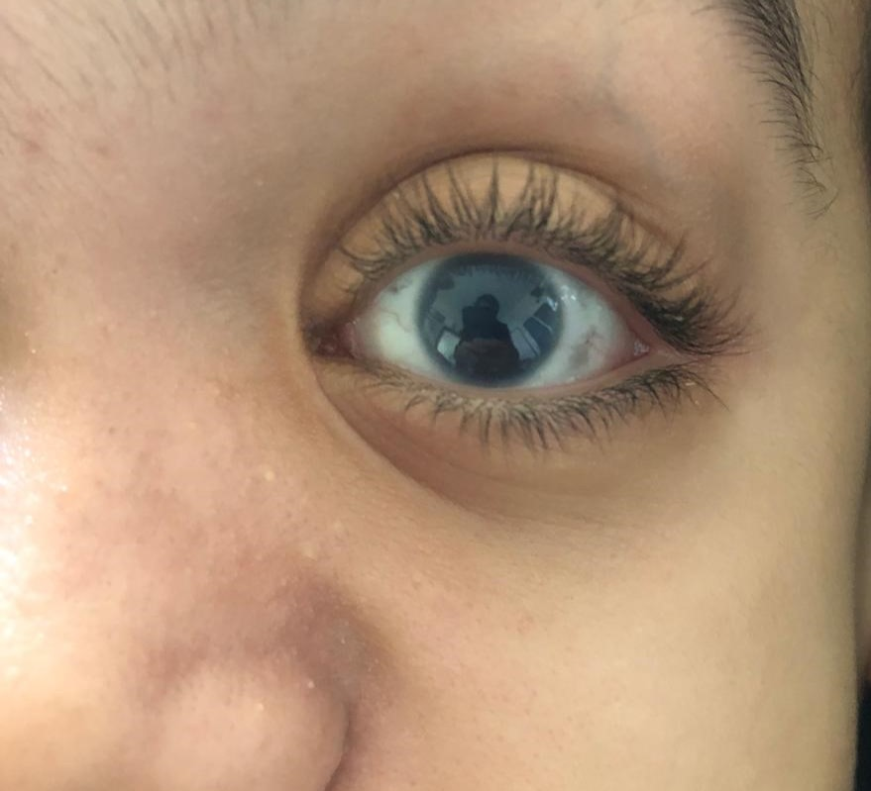
Figure 1 : Photography of a child with MPS1 showing a mild corneal opacity

Patient | Age (years) | Pachymetry (µm) | IOP (ADJ) (mmHg) | C/D ratio
1 | 6 | OD: 601  OS: 610 | 24  25 | 7/10  8/10
2 | 8 | OD: 593  OS: 585 | 29  21 | 8/10  5/10
3 | 14 | OD: 661  OS: 560 | 59  51 | 9/10  4/10
Table 1: Clinical characteristics of the three patients diagnosed or with suspicion of glaucoma Note. OD = Right Eye (Oculus Dexter); OS = Left Eye (Oculus Sinister); IOP = Intraocular Pressure; ADJ = Adjusted; C/D = Cup-to-Disc ratio.
Regarding the patients management:
From a pediatric perspective: all patients are receiving enzyme replacement therapy : the average age of treatment initiation is approximately 4 years.
From an ophthalmological perspective: treatment was based on medical therapy: a combination of prostaglandin (PG) and beta-blockers for patients 1 and 2, and quadruple therapy for patient 3 combined with oral acetazolamide. The outcome was marked by normalization of intraocular pressure (IOP) in patients 1 and 2, and a decrease in IOP in patient 3.
Quarterly follow-up was established to monitor progress under treatment: with stabilization of IOP and C/D ratio in all patients.
It should also be noted that patient 2 discontinued treatment against medical advice, without any significant change in their IOP or C/D ratio.

Discussion
MPS I is an autosomal recessive disorder caused by α-L-iduronidase deficiency [1]. Clinical manifestations include dysmorphic facial features, cardiovascular and respiratory problems, musculoskeletal and neurological issues, and intellectual disability [2]. Treatment relies on enzyme replacement therapy, currently available in Morocco, as well as hematopoietic stem cell transplantation for certain subtypes of MPS I, improving patients' life expectancy and quality of life [3].
Ocular manifestations include: Corneal opacity, observed in the majority of patients with MPS I and caused by the accumulation of GAGs in the corneal layers and disruption of collagen fiber alignment in the stroma [4]. Refractive errors, particularly hyperopia, are also found. Atrophy or swelling of the optic nerve head is less frequent. Ocular motility abnormalities are also present. MPS type 1 patients may have retinopathy with pigmentary retinal degeneration and associated electroretinogram changes [5].
Glaucoma was known to be related with MPS I [6]. Maric et al. revealed that newly diagnosed glaucoma patients had higher concentration of GAGs than those without glaucoma and implicated the relationship between GAGs and glaucoma [7]. Open angle glaucoma may be caused by abnormal GAGs deposition within TM, while angle closure glau-coma may result from abnormal accumulation of GAGs in anterior segment structures and/or ciliary body cysts [6;8].
The prevalence of glaucoma in MPS I ranges from 2.1% to 12.5% [4]. Its diagnosis poses multiple challenges including poor visibility and thick corneas [9]. The main cause is the very common corneal opacification in children with MPS I, which makes the progression of papillary excavation less visible, and the significant corneal thickness, which influences intraocular pressure readings [10]. Possible psychomotor deficits in these children make it difficult to perform and evaluate the visual field.
The patients in our study were considered glaucoma suspects based on elevated IOP in addition to signs of characteristic glaucomatous optic neuropathy on OCT.
Our study highlights the difficulties of diagnosing and monitoring glaucoma in our patients, but above all, the importance of early detection and a thorough diagnostic evaluation [2]. Assessment of IOP, corneal thickness, optic disc thickness, and iridocorneal angle should be performed whenever possible.
For a better assessment of IOP, it is useful to combine both applanation tonometer and air tonometer measurements [6]. Anterior segment topography and OCT are useful for assessing corneal thickness, the anterior chamber and the iridocorneal angle, in combination with UBM [11]. Furthermore, posterior segment OCT or optic nerve ultrasound can assess the appearance of the optic disc in patients with MPS.
Treatments for glaucoma in MPSs patients could follow the clinical guidelines for glaucoma: initial therapy was topical medication or laser trabeculoplasty; if patients failed to attain the target IOP during follow-up, additional therapies should be considered, such as trabeculectomy, non-penetrating deep sclerectomy and/or other glaucoma surgeries [12]. In addition to traditional treatments for glaucoma, hematopoietic stem cell transplantation may show good results for glaucoma treatment, though it needs more exploration [13]. Although enzyme replacement therapy (ERT) was safer than hematopoietic stem cell transplantation, eﬀect of ERT on ocular manifestations was limited and variable [14]. Corneal clouding of MPS I patients could remain stable after ERT [6]. ERT also could maintain stability of scleral thickness [6]. Retina–brain barrier and the avascular nature of cornea may reduce clinical eﬃcacy of ERT for treating eye pathology. With the development of treatment, prevalence of glaucoma would be higher, because MPS 1 patients who were treated by approved therapies would get longer life span. Current knowledge about the beneﬁts and risks of anti-glaucoma therapies for MPSs patients is limited, because MPSs patients with glaucoma were rarely reported. A multicenter retrospective case note review reported the impact of medical treatments on IOP of 12 eyes from MPSs patients with glaucoma: IOP of 7 eyes was reduced; 1 eye was less successfully treated; 2 eyes stopped receiving treatment; IOP of 1 eye was reduced after keratoplasty [15]. Our study have shown a significant improvement of IOP measurments within the time of follow up, under medical treatment only. The results were compliant with former reports: some reports showed improvements in IOP or vision after anti-glaucoma treatments [6]; however, other reports showed that anti-glaucoma treatments were not good enough [6;16].

Conclusion
MPS type I is a rare but severe disorder with significant ocular complications [1]. Abnormal accumulation of GAGs may cause glaucoma in MPSs patients by aﬀecting functions and structures of eye, including trabecular meshwork, cornea, ciliary body and sclera. Clinical manifestations and shortened life span could hamper diagnosis of glaucoma in MPSs patients and block knowledge accumulation on the beneﬁts and risks of anti-glaucoma therapies. Despite the fact that cases of glaucoma in MPSs patients were rarely reported, prevalence of glaucoma in MPSs patients (ranged from 2.1% to 12.5%) indicated that glaucoma in MPSs patients was worthy of attention and further study so that quality of life for MPSs patients could be improved. Early diagnosis and interdisciplinary management are essential for visual preservation [2]. Comprehensive evaluation and personalized treatment can enhance the quality of life [3].

References
[1] Ashworth JL, Biswas S, Wraith JE, Lloyd IC. Mucopolysaccharidoses and the eye. *Surv Ophthalmol.* 2006;51(1):1–17.
[2] Ashworth JL, Biswas S, Wraith JE, Lloyd IC. The ocular manifestations of the mucopolysaccharidoses. *Eye.* 2015;29(4):552–563.
[3] Imani M. Williams, Roberto Pineda, Vamsee K. Neerukonda et Anna M. Stagner. Mucopolysaccharidosis Type I–Associated Corneal Disease: A Clinicopathologic Study. Am J Ophthalmo, 2021-11-01, Vol 231, 39-47.
[4] Fenzl CR, Teramoto K, Moshirfar M. Ocular manifestations and management recommendations of lysosomal storage disorders I: mucopolysaccharidoses. Clin Ophthalmol. 2015 Sep 7;9:1633-44.
[5] Ganesh A, Bruwer Z, Al-Thihli K. An update on ocular involvement in mucopolysaccharidoses. Curr Opin Ophthalmol. 2013;24(5):379–388.
[6] Kong, Weijing & Zhang, Jing & Lu, Cheng & Ding, Yingxue & Meng, Yan. Glaucoma in mucopolysaccharidoses. Orphanet Journal of Rare Diseases. 2021. 16:312.
[7] Maric VD, Bozic MM, Cirkovic AM, Stankovic SD, Marjanovic IS, Grgurevic AD. Serum heparan sulfate and chondroitin sulfate concentrations in patients with newly diagnosed exfoliative glaucoma. PeerJ. 2019;7: e6920.
[8] Ahmed TY, Turnbull AM, Attridge NF, Biswas S, Lloyd IC, Au L, Ashworth JL. Anterior segment OCT imaging in mucopolysaccharidoses type I, II, and VI. Eye (Lond). 2014;28(3):327–36
[9] Sato T, Nishimura G, Ishii T. Ocular complications of mucopolysaccharidosis type I. *Am J Ophthalmol.* 2002;133(4):481–487
[10] McGrath O, Sornalingam K, Aslam T, Ashworth J. Changes in Corneal Clouding Over Time in Patients With Mucopolysaccharidosis. Cornea. 2023 Aug 1;42(8):992-999
[11] Javed A, Aslam T, Ashworth J. Use of new imaging in detecting and monitoring ocular manifestations of the mucopolysaccharidoses. Acta Ophthalmol. 2016;94(8):e676–82
[12] Blanco AA, Bagnasco L, Bagnis A, Barton K, Baudouin C, Bengtsson B, Bron A, Cordeiro F: European Glaucoma Society Terminology and Guidelines for Glaucoma, 4th Edition - Chapter 3: Treatment principles and options Supported by the EGS Foundation: Part 1: Foreword; Introduction; Glos-sary; Chapter 3 Treatment principles and options. Br J Ophthalmol 2017, 101(6):130–195
[13] Aldenhoven M, Wynn RF, Orchard PJ, O’Meara A, Veys P, Fischer A, Valayan-nopoulos V, Neven B, Rovelli A, Prasad VK, et al. Long-term outcome of Hurler syndrome patients after hematopoietic cell transplantation: an international multicenter study. Blood. 2015;125(13):2164–72.
[14] Summers CG, Fahnehjelm KT, Pitz S, Guﬀon N, Koseoglu ST, Harmatz P, Scarpa M. Systemic therapies for mucopolysaccharidosis: Ocular changes following haematopoietic stem cell transplantation or enzyme replace-ment therapy - a review. Clinic Exp Ophthalmol. 2010;38(1 (Supplment s1)):34–42
[15] Ashworth J, Flaherty M, Pitz S, Ramlee A. Assessment and diagnosis of suspected glaucoma in patients with mucopolysaccharidosis. Acta Ophthalmol. 2015;93(2):e111-117
[16] A. Hamma, M. Bousalah. Glaucoma and mucopolysaccharidosis type I: Report of two children. Jour Fr Ophtalmo, 2016-11-01, Vol 39, Nm 9, P 259-260.

