Original Research Article
Identification of Socio-Management Issues Associated with Technology Adoption of Sericulture Farmers of West Bengal, India.

ABSTRACT
Aims: To identify the factors and issues on technology adoption among sericulture farmers of West Bengal.
Study design: Tendency of technology adoption is assessed of 21 socio-management variables associated with sericulture, West Bengal, India using empirical data collected from 127 respondents under three districts.
Methodology: The independent 14 societal and 7 management factors were statistically analyzed using the path, and regression equations to understand the technology adoption at the farmers’ level.
Results: Path analysis showed the direct effect of utilization of information sources (x₁₀), socio-economic status (x₁₄), and the number of employment days per labour per year (x₁₉) on technology adoption. The regression analysis showed that utilization of information source (x₁₀), socio-economic status (x₁₄), number of employment days per year per labour (x₁₉), benefit-cost ratio (x₂₀), and social participation (x₈) have a distinctive impact on the consequent factor technology adoption (y).
Conclusion: If the identified issues can be addressed in terms of technology adoption, the number of sericulture farmers will be increased in the future that will increase the raw silk production and followed by economy growth.

Keywords: path analysis, regression equation, sericulture, socio-management variable, technology adoption.

1. INTRODUCTION

India is an agriculture-based country where 65% of the population relies on agriculture to continue their livelihood. The government of India has been promoting regular income and employment-oriented farming practices across the rural sectors and one such prospective farming activity is sericulture. It is considered a labor-intensive agricultural practice promoting rural employment worldwide followed by improving the living standard and lifestyle of the rural people by generating sufficient income opportunities. Sericulture is mainly practiced for the production of quality silk behind the involvement of various activities like; food plant cultivation, rearing of silkworms, cocoon production, and reeling. Presently, more than 58 countries across the world are involved in sericulture, and India significantly achieved the second position in the global silk market based on raw silk production. It is also recorded that nearly 7.5 million farmers under 59 thousand villages in India are actively engaged in sericulture and its allied activities [1] [2].

Research in the development of sericulture and silk industries in India as well as topics relating to the breeding of silkworms and food plants, and their pests and diseases, have been the main focus of studies in India for the last few decades. The scientific cause for the reduction in farmers' adoption of technology in this long-standing profession and thus the factors impacting their adoption has generally received less attention. The report says, that lack of education, technology adoption, and knowledge implementation, prior to unintentional practice errors like; handling of pesticides, and herbicides carelessly can pose serious health risks to agricultural farmers [3]. In sericulture, improved cultural practices and new technology adoption play a significant role in optimum revenue generation, and the technology development should be profitable and acceptable to the end user as well [4] [5] [6] [7]. A few studies have been conducted on issues related to social and management factors associated with the adoption behavior of sericulture technology for optimum revenue generation [8] [9] [10] [11] [12].

In this study, we have reported the major issues of socio-personal and management factors of the sericulture farmers as independent variables to assess the technology adoption as a dependent variable at the domestic level using various statistical tools. The present study envisages assessing the socio-personal and management issues associated with the sericulture farmers under a few districts of West Bengal, India at the grassroots level in relation to increasing the behavioral practices in technology adoption.

2. MATERIALS AND METHODS

2.1 Study area and sampling

The study was conducted in Murshidabad, Nadia, and South 24 Parganas districts of West Bengal, India. Based on the stable raw silk production for a long time in the said districts and where farmers are found highly responsive were selected that helped us to record their responses against questionnaires during the interview process intensively.

The pilot study was executed with precise and one-on-one meetings with a total of 127 respondents arranged at the village level under the district’s blocks. The purposive studies were conducted at block-level meetings under the said districts. Block Nabagram and Khargram were selected in Murshidabad district, and Karimpur-II and Kulpi were selected under Nadia and South 24 Pargana district, respectively (Fig.1).

2.2 Statistical tools and data analysis

The collected independent socio-management data of a total of twenty-one variables were statistically measured and extracted using path, and regression analysis using SPSS (AMOS) software to understand and identify the degree of relationship in between independent variable(s) along with dependent variable associated with farmer’s adoption of new technology. All the survey-based empirical field data were critically extracted using the path and multiple regression analysis to discern and identify the causal models between dependent and independent variables and to reduce the number of independent variables into factors, respectively to draw a significant conclusion.

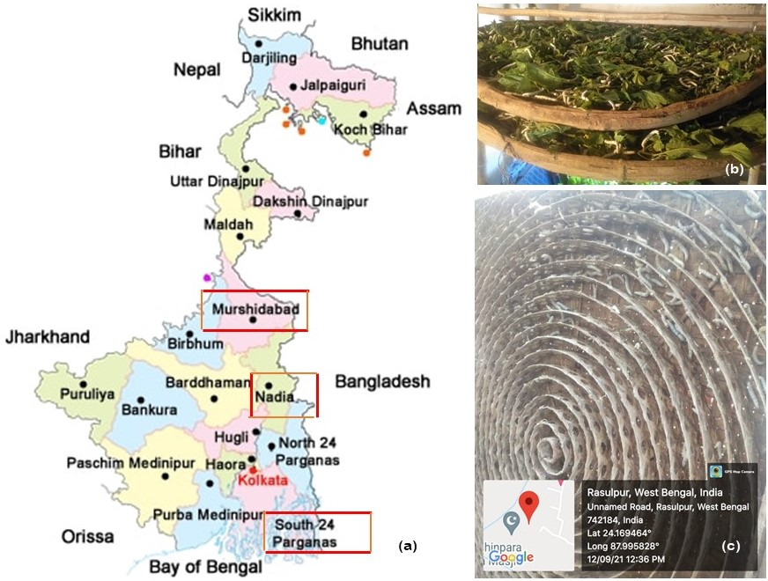

Fig. 1: (a) Locale of the study areas showing on the West Bengal state map of three districts, (b) Cultivation of mulberry silkworm on ‘Dala’, (c) Matured silkworms are mounted on ‘Chandrika’ for cocoon formation.

3. RESULTS AND DISCUSSION

3.1 Path analysis of technology adoption

The hypothesized causal connections among the independent variables were estimated using path analysis and data are summarized in Table 1. The independent socio-economic variables are denoted as x₁ – x₁₄ and management variables as x₁₅ – x₂₁ whereas the dependent variable is denoted as ‘y’. The direct, indirect, and residual effects of 21 exogenous independent variables on the dependent variable technology adoption were assessed as per data received from sericulture farmers. Table1 shows that the direct effect of utilization of information sources (x₁₀), socio-economic status (x₁₄), and the number of employment days per labour per year (x₁₉) have been substantial and they have occupied the 1st, 2^{nd,} and 3rd positions respectively, in terms of modal values and they have positive relationships between each other in terms of their highest indirect effects too. The technology adoption shall be increased among the farmers if they have the opportunity to utilize the recommended scientific information, societal status, economic stability, and experience with labour days. The indirect effect of socio-economic status (x₁₄), training received (x₉) and education (x₃) have also been found substantial in characterizing the performance of other variables indirectly. This implies that the implicit effects of all these variables on the other are substantial and imbibing. It has found that the highest indirect effect of as many as 9 variables has been routed through the variable socio-economic status (x₁₄) whereas land holding capacity (x₆) has found the highest negative value indicating no such impact on technology adoption at farmers’ level.

Table 1. Path analysis amongst the independent variables (x₁-x₂₁) on dependent variable adoption behavior (y).

Variables | Symbol | Total effect | Direct effect | Indirect effect | Highest indirect effect
Age | x₁ | 0.224 | 0.156 | 0.068 | 0.084(x₁₀)
Occupation | x₂ | 0.056 | -0.044 | 0.100 | 0.050(x₁₀)
Education | x₃ | 0.231 | -0.019 | 0.250 | 0.102(x₁₄)
Family type | x₄ | -0.057 | -0.084 | 0.027 | -0.019(x₁₈)
Family size | x₅ | -0.130 | 0.021 | -0.151 | -0.065(x₁₀)
Land holding | x₆ | -0.195 | 0.026 | -0.221 | -0.104(x₁₀)
Area under mulberry cultivation (acre) | x₇ | -0.148 | -0.043 | -0.105 | -0.063(x₁₀)
Social Participation | x₈ | 0.304 | 0.152 | 0.152 | 0.102(x₁₄)
Training received | x₉ | 0.310 | 0.026 | 0.284 | 0.124(x₁₄)
Utilization of Information source | x₁₀ | 0.705 | 0.464 | 0.241 | 0.169(x₁₄)
Mass Media exposure | x₁₁ | 0.325 | 0.023 | 0.302 | 0.119(x₁₄)
Economic motivation | x₁₂ | -0.073 | 0.084 | -0.157 | -0.079(x₁₄)
Marketing support | x₁₃ | -0.092 | -0.053 | -0.039 | -0.091(x₁₄)
Socio-economic status | x₁₄ | 0.614 | 0.326 | 0.288 | 0.240(x₁₀)
Types of rearing house | x₁₅ | -0.056 | -0.054 | -0.002 | -0.075(x₁₀)
No. of family member engaged in sericulture activities | x₁₆ | 0.002 | -0.018 | 0.020 | -0.067(x₁₄)
Production of mulberry leaf per unit area (kg) | x₁₇ | -0.006 | -0.056 | 0.050 | 0.045(x₁₂)
Cocoon production in Kg | x₁₈ | -0.033 | 0.119 | -0.152 | -0.078(x₁₄)
No of employment days / year / labour | x₁₉ | 0.323 | 0.196 | 0.127 | 0.083(x₁₀)
Benefit: cost ratio | x₂₀ | 0.112 | 0.116 | -0.004 | 0.047(x₁)
No. of years engaged in silkworm rearing | x₂₁ | -0.035 | 0.020 | -0.055 | -0.082(x₁₀)
Residual effect: 0.307

As per the study conducted it has been observed that farmers having higher socio-economic status are more forward in adopting new technologies and practices regarding sericulture. Farmers of higher socio-economic status are more interested in taking chances of more income by adopting updated technologies useful in sericulture. So, social status here gone so reticulate associative that 9 variables out of 21 variables have been drawn upon by social status to influence the technology adoption of sericulture farmers (Fig. 2). The residual effect is 0.307, which indicates that even with the combination of these 21 variables 30.70 percent of the variability of the predicted character, i.e. technology adoption could not be explained.

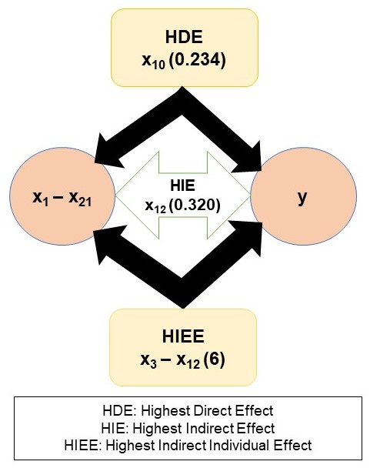

Fig. 2: Path diagram showing the effect of antecedent variables on Technology adoption (y).

3.2 Regression analysis and validation

Regression analysis was carried out for technology adoption (y) separately as a dependent variable using MDS (Minimum Data Set) as a predictor set (Table 2) where the probability of ‘F’ value ranged from 0.05 to 0.10. From this regression analysis, it has been observed that the five independent variables, viz. utilization of information source (x₁₀), socio-economic status (x₁₄), number of employment days per year per labour (x₁₉), benefit-cost ratio (x₂₀), and social participation (x₈) have appeared with distinctive impact on the consequent factor i.e., technology adoption.

Utilization of information source (x₁₀) is significantly regressing on technology adoption as it has done on the preceding consequent character knowledge. If the knowledge level increases, then the adoption behaviour of farmers will also have a positive change. Similarly, socio-economic status (x₁₄) and social participation (x₈) also affect the pattern of technology adoption. Farmer’s socio-economic status determines their knowledge level and the tendency of technology adoption behaviour towards sericulture activities.

The number of employment days per year per labour (x₁₉) has appeared to be one of the most important causes (factor) to impact on the adoption level. Hereby in this study, the farmers who are working more days yearly have experienced different activities of sericulture and as a result his or her adoption level of sericultural activities is increasing day by day. Benefit: cost ratio (x₂₀) affected the technology adoption as more the ratio more will be adoption tendencies.

From the regression analysis, it has been found that a total of 21 causal variables together can exert a 69.40 % impact on the consequence variable technology adoption. Five variables viz., utilization of information source (x₁₀), socio-economic status (x₁₄), number of employment days per year per labour (x₁₉), benefit: cost ratio (x₂₀), and social participation (x₈) have appeared with distinctive impact i.e., these five occupied 65.70% impact out of total 69.40% impact on the consequent factor i.e., technology adoption. It means the remaining 16 variables together are contributing only 3.70% of the total impact.

Table 2. Multiple regression analysis of technology adoption (y) vs. 21 causal variables (x₁-x₂₁) data sets.

Variables | Unstandardized Coefficients |  | Standardized Coefficients | T | Sig.
Variables | B | Std. Error | Beta | T | Sig.
Age (x₁) | 0.019 | 0.010 | 0.156 | 1.862 | 0.065
Occupation (x₂) | -0.232 | 0.333 | -0.044 | -0.697 | 0.488
Education (x₃) | -0.020 | 0.095 | -0.020 | -0.216 | 0.830
Family type (x₄) | -0.390 | 0.273 | -0.083 | -1.429 | 0.156
Family size (x₅) | 0.031 | 0.087 | 0.021 | 0.353 | 0.725
Land holding (x₆) | 0.085 | 0.403 | 0.024 | 0.212 | 0.832
Area under mulberry cultivation (acre) (x₇) | -0.170 | 0.467 | -0.040 | -0.365 | 0.716
Social participation (x₈) | 0.484 | 0.264 | 0.152 | 1.834 | 0.070
Training received (x₉) | 0.074 | 0.219 | 0.026 | 0.337 | 0.737
Utilization of information source (x₁₀) | 0.143 | 0.024 | 0.465 | 5.892 | 0.000
Mass media exposure (x₁₁) | 0.014 | 0.050 | 0.022 | 0.285 | 0.777
Economic motivation (x₁₂) | 0.025 | 0.032 | 0.083 | 0.785 | 0.434
Marketing support (x₁₃) | -0.050 | 0.105 | -0.053 | -0.482 | 0.631
Socio-economic status (x₁₄) | 0.368 | 0.088 | 0.325 | 4.163 | 0.000
Types of rearing house (x₁₅) | -0.289 | 0.374 | -0.054 | -0.773 | 0.441
No. of family member engaged in sericulture activities (x₁₆) | -0.028 | 0.104 | -0.019 | -0.266 | 0.791
Production of mulberry leaf per unit area (kg) (x₁₇) | 0.000 | 0.000 | -0.055 | -0.662 | 0.509
Cocoon production in kg (x₁₈) | 0.011 | 0.007 | 0.120 | 1.487 | 0.140
No of employment days / year / labour (x₁₉) | 0.029 | 0.009 | 0.196 | 3.120 | 0.002
Benefit: cost ratio (x₂₀) | 2.493 | 1.462 | 0.117 | 1.705 | 0.091
No. of years engaged in silkworm rearing (x₂₁) | 0.003 | 0.009 | 0.020 | 0.309 | 0.758
**P<0.01. *P<0.05.
[R² = 69.40%, Adj. R² = 63.30%, SE (est) =1.26297]

3.3 Analysis of the responsive variables with technology adoption (y)

Utilization of Information source (x₁₀) is significantly regressing on technology adoption as it has done on the preceding consequent character knowledge level. If the knowledge level increases, then the technology adoption behaviour of farmers will also have a positive change. Socio-economic status (x₁₄) and social participation (x₈) also significantly affect the technology adoption. Farmers' socio-economic status determines the knowledge level and technology adoption towards sericulture activities. The number of employment days per year per labour (x₁₉) has appeared to be one of the most important causes (factor) to have an impact on the adoption level. Here in the study area, the farmers who are working more days yearly have experienced different activities of sericulture and as a result, his or her adoption level of sericultural activities is increasing day by day. Benefit: cost ratio (x₂₀) affected the technology adoption as more the ratio more will be adoption activities.

Among all types of agricultural practices, sericulture is mostly done by the small and marginal farmers in rural districts of West Bengal, India, who are incapable of generating revenue due to some social and management-related constraints. Development initiatives have not been able to strengthen the hands of these sericulture farmers, resulting in a deduction to obtain the most benefits for those socio-economic and management issues. In West Bengal, sericulture remains an unimproved rural-based sector reliant on unskilled laborers as compared to other traditional silk-producing states like; Karnataka and Andhra Pradesh [13], owing to productivity disparities. Reports by experts in this sector believe that there is a big gap between the farmer’s productivity and yield potential in West Bengal [14] [15] [16] where the technology adoption level is very poor.

4. CONCLUSION

In this study, the assessment of social and management aspects related to the technology adoption level of sericulture farmers are identified and sorted. In path, and regression analysis, a few common independent variables like; utilization of information sources (x₁₀), socio-economic status (x₁₄), and number of employment days per labour per year (x₁₉) are found influential in having a positive impact on technology adoption (y). However, based on these findings, if the identified factors/variables can be addressed in terms of technology adoption, the number of sericulture farmers will increase in the future as well as raw silk production.

REFERENCES

1] Koshy, T. D. (1990). Silk export and development (Information, Procedures and Guideline). Ahis Publishing House, New Delhi, pp. 2-30.

2] Roy, D. C. (2013). Economy of North Bengal: A District Level Study. NL Publishers, Siliguri. pp. 629-639.

3] Damalas, C. A., Georgiou, E. B., Teodorou, M. G. (2006). Pesticide use and safety practices among Greek tobacco farmers: A survey. Int J Environ Health Res., 16(5), 339–348.

4] Gowda, R. P., Murthy, A. N. N., Muniraju, E. (2012). Technology Adoption in Sericulture Management in India: A Study. J Oper Mgmt., 10, 51–62.

5] Priyadarshini, B. M., Vijayakumari, N. (2017). A study on the adoption of improved Sericulture technologies and success of Sericulture in Chittoor and Kadapa districts of Andhra Pradesh, India. Int J Appl Agric Res., 12(1), 43-48.

6] Sivaranjani, B., Murugesh, K. A. (2019). Adoption of recommended technology by sericulture farmers in Krishnagiri district. Int J Curr Microbiol App Sci., 8(2), 2784-2788.

7] Jyothi, B. L., and Manjunatha, H. B. (2023). On-Farm Tree Mulberry Geometry: Biochemical, Growth and Yield Analysis in the Traditional Areas of Sericulture. International Journal of Plant & Soil Science, 35 (21), 686–692.

8] Geetha, G. S., Devi, R. G. (2008). Technology adoption and training needs of sericulture farmers: A case study in NGO. Indian J Agric Res., 42, 157–163.

9] Pezeshkirad, G., Tajer, M., Moghaddam, K. R. (2011). A study of the affecting factors in adoption of laser leveling by farmers in Fars Province. Iran J Agric Econ Dev Res., 41, 523–530.

10] Priyadarshini, B. M., Vijayakumari, N. (2013). A study on the knowledge and adoption level of improved sericulture practices by the farmers of Chittoor district. Ind J Agric Sci Res., 3(2), 43-46.

11] Sujatha, B., Reddy, P. L., Madduri, A. S. B., Reddy, B. A., Kumar, P. S., Naik, S. S. (2015). Socio-economic factors influencing the adoption levels of new sericulture technologies by different farming groups in Anantapur District of Andhra Pradesh. Int J Agr Ext., 3(2), 149-153.

12] Merat, A., Allahyari, M. S., Seidavi, A., Hubbard, W. (2018). Factors influencing the adoption of sericulture by farmers in Guilan Province, Iran. AIMS Agric Food, 3(1), 26–40.

13] Rathore, R. A., Sonawane, M. A., Roy, C. (2019). Technology Advancement & Its Adoption: A Booster for Sericulture Development and Expansion in Madhya Pradesh, India. Int J Soc Sci Eco Res., 4(5), 3618-3628.

14] Bagchi, S. N., Saha, A. K., Ghosh, A., Ghosh, S., Sengupta, D., Das, S. K., Sarkar, A. (2008). Development of sericulture in West Bengal through IVLP. Indian Silk, 47(2), 12-15.

15] Sengupta, M., Biswas, S., and Saha, S. (2023a). Factor and constraints involved in income generation from sericulture: a study in three districts of West Bengal. J Exp Agric Int., 45(11), 219–228.

16] Sengupta, M., Biswas, S., Mallick, P., and Saha, S. (2023b). Influence of Socio-personal and Management Factors to Generate the Knowledge Level of the Farmers Associated with Sericulture of West Bengal, India. Asian J Agric Ext Eco Sociol., 41(2), 47–61.

