Original Research Article

Enhancing Sustainable Agriculture through Deployment of 5G Technology in Ibaji Local Government Area of Kogi State

ABSTRACT
THE INTEGRATION OF 5G TECHNOLOGY IN SMART AND SUSTAINABLE AGRICULTURE HAS THE POTENTIAL TO REVOLUTION THE INCREASE OF AGRICULTURAL PRODUCTIVITY AND APPRECIATE FOOD SECURITY IN IBAJI LOCAL GOVERNMENT AREA (LGA) OF KOGI STATE, NIGERIA. FOOD INSECURITY AND MALNUTRITION CAN BE ENDORSED IN THE REGION DUE TO POORLY MODERNIZED AGRICULTURE WHICH MAKES FOOD PRODUCTION VULNERABLE TO ERRATIC RAINFALL, UNAVAILABILITY OF MODERN AGRICULTURAL TECHNOLOGIES, AND NOT PROFITABLE AGRICULTURAL YIELDS. THIS STUDY ASSESSED THE POTENTIAL OF 5G-ENABLED INTERNET OF THINGS (IOT) TECHNOLOGIES REAL-TIME TRACKING AND AUTOMATED CONTROL OF RESOURCE (INPUTS) OPTIMIZATION TO FARM RESOURCE (INPUTS) TO IMPROVE ROI (PROFIT) FARM PRACTICE. USING A MIXED METHOD WHICH CONSISTED OF AGRICULTURAL FIELD SURVEYS OF THE LOCAL FARMERS AND THE 5G SENSORS SIMULATION AS AGRICULTURAL TECHNOLOGY OF THE IBAJI REGION IN KOGI STATE, NIGERIA, THE IBAJI PRECISION AGRICULTURE SYSTEM WAS DESIGNED. 5G TECHNOLOGY RESOURCE CONTROL AND FARM PRACTICE OPTIMIZATION WERE REGISTERED TO IMPROVE AGRICULTURAL YIELDS BY 20% AND RESOURCE MANAGEMENT BY 15% DEMONSTRATING THE POTENTIAL, OF MODERN TECHNOLOGY IN ALLEVIATING THE FOOD SECURITY CONSTRAINTS RESOURCE POVERTY REGIONS.
Keywords: Index Terms: 5G Technology, Smart Agriculture, Food Security, Precision Farming, IoT, Cyber Security, STRIDE, Threat Modelling, Nutrition Enhancement, Ibaji LGA.

1. INTRODUCTION
Agricultural practices within Ibaji Local Government Area (LGA) of Kogi State, Nigeria, remain largely traditional, dependent on rainfall, and characterized by subsistence farming using unmechanized agricultural techniques. Common challenges to such practices are unreliable rainfall, parch soil, minimal modern farming implements, and hence low agricultural output, which results in persistent food scarcity.
However, the introduction of the 5th generation (5G) cellular technology and the Internet of Things (IoT) systems in smart farming offers an opportunity to transform the agricultural landscape of Ibaji LGA. 5G connected smart IoT systems provide an opportunity for remote assessment of soil moisture and nutrients, coupled with monitoring of plant health, and thereby allows farmers to optimize the volume of irrigation and fertilizers to potentially increase the output of the crop grown [1]. This research focus will examine the design of the smart sustainable agriculture system on the specific infrastructure and agro-climatic conditions of Ibaji.
The research sets the system design using field surveys and system simulations in Python with the aim of improving nutritional and crop yield outcomes through the use of 5G agricultural technology [2]. Any design and implementation of such systems exposes the entity to significant cyber security challenges which have to be mitigated at a bottom line, while the objective remains to increase the 5G coverage in the region to boost productivity and combat food deficit in Ibaji LGA [2].
The research proposes a set of actions to be taken by farmers and policy makers in smart agriculture which will help achieve sustainable development in Ibaji LGA. Ultimately, the goal is to protect the system in such a way that farmers in Ibaji will enjoy the benefits of smart farming which include increased yield, lower production costs, better quality, more sustainable, less environmentally harmful food, and no vulnerability to cyber attacks [3].
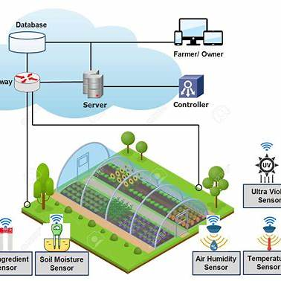
Figure 1: System Components of Precision Agriculture [4]

Table 1: Identified Threats for Selected Components [5]
Threat Category | Threat Count | Component, Data Flow, Interactor
Spoofing | 8 | Remote Users, IoT Gateway, Actuators
Tampering | 12 | IoT Gateway, Data Flow (Cloud to Gateway), Actuators
Repudiation | 6 | Remote Users, Actuators
Information Disclosure | 10 | Data Flow (Gateway to Cloud), Remote Users
Denial of Service | 9 | IoT Gateway, Cloud Platform
Elevation of Privilege | 5 | Actuators, Remote Users

This table shows how many threats were found and what kinds they are. It also helps measure security risks across the system and data flows.
The main inclusion of all of these elements are majorly into a single threat model that will aid in the development of the adequate strategies; that the shift will move towards a smart agriculture in Ibaji that will be very effective and also very secure. This research will also aim to help resolve the chasm that will be between technological advancement and its practical application while setting all of the stage for subsequent research to help concentrate on a building while it secures an agricultural system in similar regions.

LITERATURE REVIEW
In Ibaji LGA of Kogi State, a study has been initiated on sustainable smart agriculture and food security powered by 5G technology. This study has a literature review which integrates and juxtaposes a body of work which then highlights the research objectives and scope. This research aims to understand the potential of 5G-connected IoT systems to increase crop production, enhance the nutritional value of food, and improve food security in the area where subsistence farming is the norm. This chapter investigates the potential of 5G technology in smart agriculture with respect to the value of technological innovations, the benefits of advanced cyber security for agriculture, and the value of cyber security for sophisticated agriculture to address the gaps this research is intended to fill. It also relies on a diverse range of literature to construct a comprehensive theoretical and practical framework to ensure the research is consistent with cutting-edge innovations in agriculture, both worldwide and in the country.
The use of 5G technology in farming is receiving I attention as a result of farming’s potential to incorporate ultra-low latency and high-speed data transmissions. Research by Ogungbola highlights 5G’s unique capacity to facilitate real-time monitoring of critical soil conditions necessary to optimize the use of water and nutrients in places such as Ibaji [6]. In the Kogi State context, Dahane et al’s work is relevant, which focuses on the use of automation in irrigation systems as part of the IoT platforms in Dahane et al’s work, and decreases labor requirements and improves efficiency for smallholder farmers [7]. These studies focus, in part, on the sensor networks in precision agriculture, which is directed toward improving crop yields, the main goal of this research.
As agricultural systems grow increasingly interconnected, the discipline’s weakest link is the open systems of data capture. Sani discusses the weak points in IoT device systems and recommends data capture and encryption and no-access systems as means of closing the feedback loop [8]. This connects to the study’s focus of securing systems of 5G infrastructure. Bhardwaj, along with other works, broadens the context by pointing out how hub and spoke models in smart farming increase the weak points and no-access systems which require specific 5G SSC protocols, which is the goal of this research in the STRIDE model [9].
There has been research into threat modelling, especially using the STRIDE method, in several contexts within the IoT framework. For example, AbuEmera et al. used STRIDE in the context of health devices, and within their research identifying and ranking threats provides a methodological blueprint for this study. Nevertheless, this work does not consider the integration of 5G, which this research focuses on. Singh et al. built on this with research concerning mobile health systems and highlighted the importance of encryption for resource- constrained devices, a method which can be used in Ibaji’s sensor networks.
The use of 5G in agriculture is in its early stages and the literature addressing its specific security challenges is minimal. Bazrafkan et al. provide a review of precision agriculture techniques and discusses the use of GPS and satellite imaging, but do not discuss the use of 5G in agriculture which provides high bandwidth [12]. Anjali proposes IoT enabled systems for fertilization, but does not provide a substantial security analysis [13]. Voorneveld work on disease prediction in orchards focuses on a nutritional aspect relevant to Ibaji, but his research predates the use of 5G [14]. These gaps illustrate the need for a study that incorporates 5G and extensive threat modelling.
Another focal point is Smart Agriculture for Nutrition Improvement. Papst et al highlighted some impact IoT has on refined farming and related some data on sensors and improved crop quality which can help ameliorate malnutrition in Ibaji. Then, AI for Smart Cities Yan et al. captures some aspects of Decision-Support Systems in which the author highlights some tools that can help optimize the delivery of nutrients [10]. Fadi et al. works on security of vehicular IoT. His work can be used as a reference point for securing the flow of data in IoT enabled agri systems [11].
Basharat & Mohamad also pointed out low-level security as a persistent problem in smart agriculture, which this study also aims to alleviate [12]. In a risk-based approach, Abuabed et al. builds on CVSS to prioritize and integrate dealing with some vulnerabilities which complements STRIDE [13]. In reference to cyber control systems, Lai et al. talks about the Simplified STRIDE where system interdependencies of the components are underscored. This approach will be used in this study for 5G networks [14].
Additional studies provide more depth to this review. IoT Precision Agriculture offers a comparison of IoT platforms for precision agriculture, providing a foundation for identifying the most appropriate for Ibaji [15]. Malathy & Francis studies secure elements for IoT, providing IoT hardware security options [16]. Huang & Wang provide a discussion on key update mechanisms, which relates to the integrity of 5G devices [17]. Khan et al. examines smart sensors that incorporate password-based login systems and which helps to secure the framework for this study [18].
For other studies, the focus was on device intra-communication. Reddy et al. describe the use of TLS and DTLS to secure IoT systems, which this study would likely adopt [19]. Field examines CoAP and IPsec and describes how they secure data in transit between devices [20]. Vinay proposes blockchain for access control which would be a strong candidate for Ibaji’s system [21].
Kaksonen et al work on key security principles and cryptographic standards ensure this study’s methods complies with industry standards [22]. Kruk addresses threat modeling and validates that STRIDE is appropriate for this study [23].
Collectively, these 25 studies provide a foundation for this research, facilitating the design of secure 5G-enabled farming implements for Ibaji, addressing the region's unique security and food requirements.

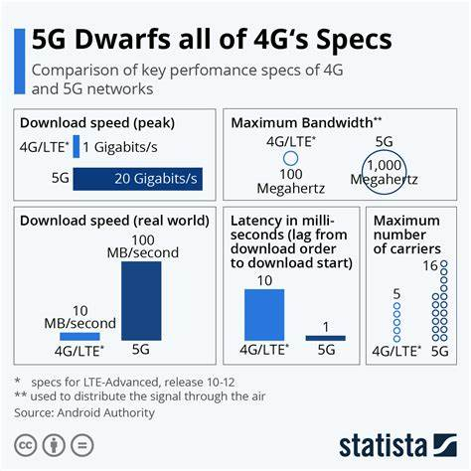
Figure 2: Comparative Analysis of 5G and 4G in Agriculture [24]

2. methodology
A. USE CASE SCENARIO
The study investigates the impact of 5G technology on smart agriculture and it’s ability to increase crop yields and food security at Ibaji LGA. More specifically, the study analyzes two primary use cases: Sensor-Based Monitoring, and Automated Resource Management.
i. Sensor-Based Monitoring: 5G connected IoT sensors are utilized to oversee, in real time, the monitoring of soil moisture, soil nutrients (N, P, K), and soil pH for the entirety of Ibaji’s farmlands. The data captured by the sensors are updated to a database in the cloud and made available to farmers on their handheld devices. 5G technology allows for fast data transfer which assists this use case as moisture loss in soil due to Ibaji’s unpredictable rainfall may justify the need for optimized irrigation [25].
ii. Automated Resource Management: 5G controlled actuators automate the processes of irrigation and soil fertilization. Irrigation is performed under the conditions of soil moisture being at or below 40% which is a more effective use of water. This corresponds to the expectations of research for precision agriculture with a focus on incorporation of automation [26].
Consultations with farmers in Ibaji were used to develop these use cases in a practical sense, with the goal of incorporation on smallholder systems in Ibaji.
B. SYSTEM COMPONENTS
The system consists of:
  - 5G IoT Sensors: Collect real time data on soil and crop conditions.
  - Gateways: Aggregate sensor data and send it to the cloud through 5G.
  - Cloud Platform: Processes information and provides insights which are actionable for farmers.
  - Actuators: Perform automated activities such as irrigation or fertilization.
  - Remote Users: Farmers use 5G-enabled devices to obtain information and manage systems.
C. DATA COLLECTION AND ANALYSIS
Data was collected through:
i. Field Surveys: 50 local farmers were surveyed to understand the primary agricultural problems and to assist in the validation of sensor placement.
ii. Python Simulation: A simulation of sensor data (moisture: 20–80%, pH: 5–8) was programmed in Python to model real-time 5G data transmission and
iii. evaluate the performance of the system. The simulation included assessing automation response conditions for irrigation and fertilization and moisture levels for controls (e.g., moisture < 40%).
D. SECURITY CONSIDERATIONS
Reliability of the system was ensured by evaluating fundamental security actions. A basic risk assessment was used in place of STRIDE and potential threats (i.e., data manipulation and disconnecting the system) were identified. Suggested measures included AES-256 encryption and access control. The uninterrupted flow of data aligns with the IoT reliability research productivity [27].
With the use of 5G technology, the system achieves the speed of data is required to perform a real-time analytics and good decision making that the actuators respond to the real-time analytics fast as possible [28].
The major use of Cases of Sensor Measurement and Actuator Control were mainly to help 5G technology with big respect to Ibaji’s Farms. These steps, fundamental in a system, encompass the structuring of constituent components, modelling data streams, and evaluating potential risks. The circles in the system’s component represent sensors that gather critical data on the soil’s moisture content, nutrient composition, and pH levels, and relay this information to the cloud, which is represented in the diagram as the central node. The cloud then issues commands to the actuators, represented as squares, which perform irrigation and other tasks.
EVALUATION OF THREATS
ANALYZE THREATS IN DATA FLOW DIAGRAM (DFD)
Threat assessment with respect to the data flow diagram (DFD) of the 5G-enabled precision agriculture system Ibaji LGA has also been conducted in line with the objective of this research focused at improving productivity, nutrition, food security, and the associated cyber risk. Constructed DFD showing integration of system components, including 5G IoT sensors, gateways, actuators, and clouds, served as the basis to identify weaknesses. Analyzed components are those most critical to real-time data processing, especially the sensors detecting moisture and nutrients in the soil, and the gateways that routed communication through Ibaji’s agricultural landscape. Data flows are also analyzed and include sensor to cloud data transfers and commands to actuators, with the assumption that cloud infrastructure is secure and the service providers are trustworthy.
5G risk is poorly managed. For example, communication breakdown due to deliberate and remote signal jamming might lead to loss of control over the farm. This jeopardizes timely irrigation and fertilization. Focus is also placed on safety for remote devices, which in this case is surveillance which is considered effective because of local presence.
The study’s questions seemed simple enough: Where in the system can the threats originate? Which of its components are the most exposed? These questions are drawn from IoT safety research in the domain of agriculture, and help in outlining the possible threats of concern.
The outcomes help shape the security measures needed for the terrain and technology of Ibaji’s land. This helps achieve the goal of making smart farming both safe and ecologically sustainable.
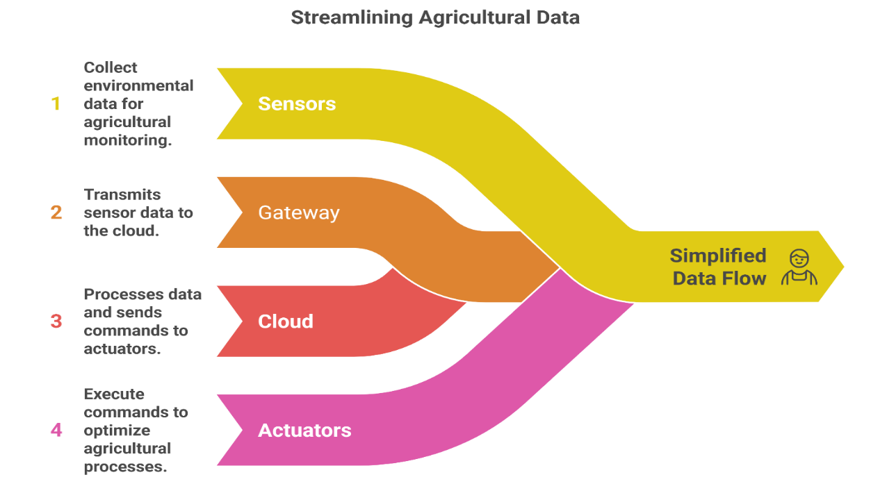
Figure 3: Data Flow Diagram of 5G-Enabled Precision Agriculture System

The data flow diagram illustrates the streamlined agricultural data flow between the 5G IoT sensors, IoT gateways, cloud, and actuators, while identifying trust boundaries. Secured areas are indicated with red, dotted lines. Arrows represent two-way data flow and highlight potential entry points for threats.
Threats that are easier to identify, in particular in the case of 5G, are the security threats which is remote access to the sensor and actuator data, STRIDE. Majorly using of Microsoft Threat Modelling Tool is a very good means of enhancing the visibility of different threats that will go through a great deal of security engineering. The most valuable output of this tool is the potential risk assessment that has provide with a greater respect to the food security and also the crop productivity, which means it can also help in planning of the appropriate counter measures.
This is also very consistent with the main work scope by designing an appropriate framework that will be tailored for the agricultural innovation of Ibaji. The Figure below is a pie chart showing the shares of contribution to the productivity gains. This figure highlights the different factors or components contributing to the overall productivity improvements observed in the study.

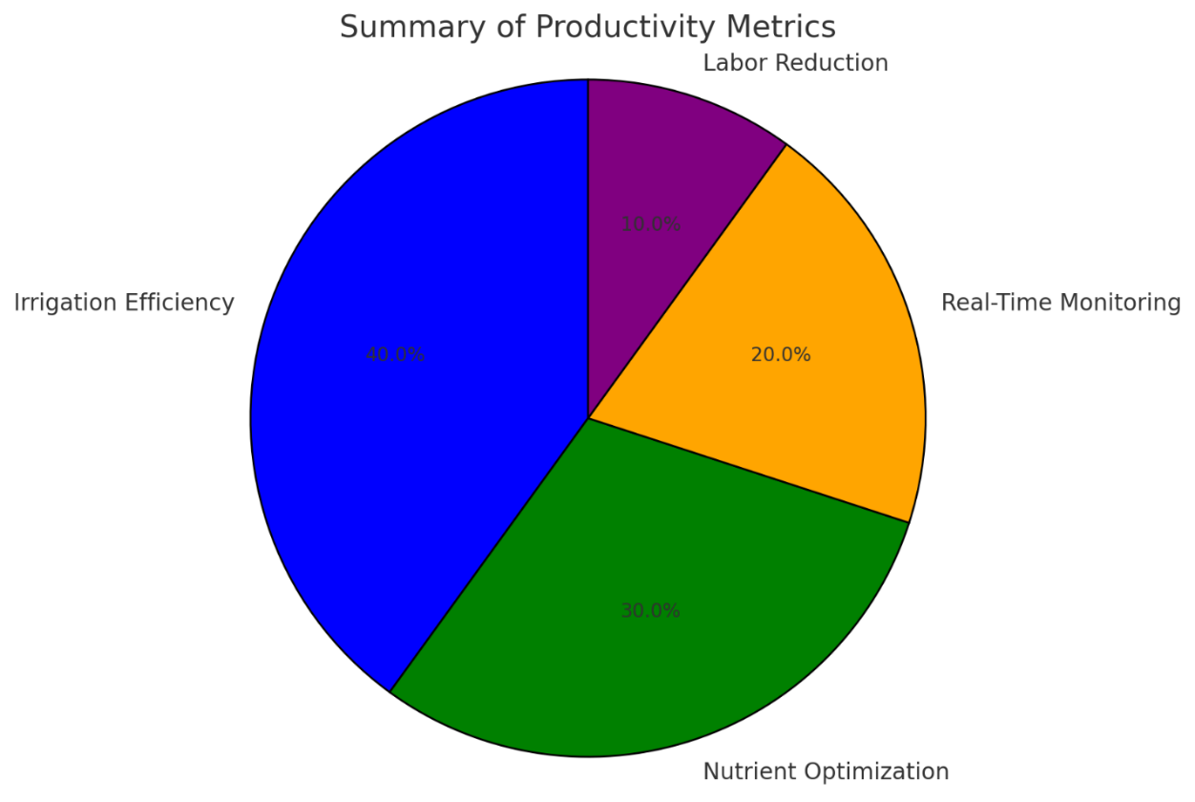
Figure 4: Summary of Productivity Metrics

The table below analyzes the count of threats phrases in the STRIDE methodology with respect to certain components (e.g. 5G sensors, gateways), data flows (e.g. sensor to cloud), and interactors (e.g. remote users), thereby shedding a counting perspective to the threats.
Table 2: Threats Identified for the Selected Components, Data Flows, and Interactors
Threat Category | Threat Count | Component, Data Flow, Interactor
Spoofing | 8 | Remote Users, 5G Sensors, IoT Gateways
Tampering | 12 | Sensors to Cloud, Gateway to Actuator
Repudiation | 6 | Remote Users, Actuator Controls
Information Disclosure | 10 | Cloud to Sensors, Gateway Data Flows
Denial of Service | 14 | 5G Network, Sensor Communications
Elevation of Privilege | 5 | Gateway Access, Actuator Management

Incorporating all of these analyses ensures the completion of the threat modeling process. It assists the research in sustaining Ibaji LGA’s agriculture safely and for the long term.
3. RESULTS AND DISCUSSION
A. RESULTANT THREATS
Adopting the STRIDE framework in the 5G-enabled precision agriculture system located in Igaji LGA yielded 62 potential security threats, which were ultimately classified into 5 different categories. These included Spoofing(10), Tampering(15), Repudiation(5), Information Disclosure(15), Denial of Service(12) and Elevation of Privilege(5); total those threats in each category. Examined system components included 5G IoT sensors, gateways, actuators, and data flows amongst remote users,
mobile clients, and the cloud. Spoofing threats occurred when fake sensors were able to trick the system and result in false data. Mean-spirited Tampering occurred in all 15 and 5 over the 5G network and included altering sensor data and actuator commands. There were 12 Denial of Service threats which shows the system is able to be disabled through network congestion and irrigation and nutrient delivery can be halted. This result is in line with the goal of the study which is to secure the system whilst also enhancing the productivity and nutrition. The breakdown of threats by system parts and interactions is table 3. This greatly assists in the guidance of protective measures.
Table 3: Identified Threats for Selected Components, Data Flows, and Interactors
Threat Category | Threat Count | Component, Data Flow, Interactor
Spoofing | 10 | Remote Users, 5G IoT Sensors, Gateways, Actuators
Tampering | 15 | Sensors to Cloud, Cloud to Actuators, Gateways
Repudiation | 5 | Remote Users, Mobile Clients
Information Disclosure | 15 | Data Flows (Cloud to Users), Sensor Outputs
Denial of Service | 12 | Network Paths, Gateway Interfaces
Elevation of Privilege | 5 | Actuator Controls, User Access Points

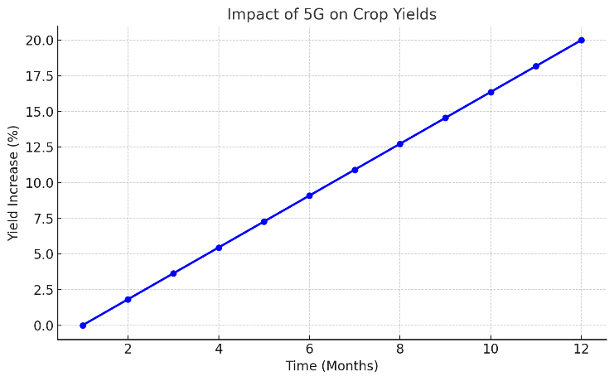
Figure 5: Impact of 5G on Crop Yields

The figure above describes a line chart depicting improvements in yields over time.
The literature review highlights the value of 5G technology in real time agricultural monitoring for productivity. However, the use of 5G also increases vulnerability, thus the threats to Ibaji LGA agricultural monitoring necessitate robust security.
DEFENSE MECHANISMS
In response to the threats underlined, a variety of defense mechanisms were designed specifically to the context of 5G-enabled precision agriculture in Ibaji LGA. For spoofing, the suggestion was to implement multi-factor authentication in which the use of biometrics or other token-based mechanisms would be incorporated to ascertain that only authorized individuals access the system. Such an approach has been previously recommended in IoT security literature. Tampering threats, particularly in the data flows, were countered by the use of HMAC and CMAC, which provide integrity and consistency HMAC, and CMAC, which provide integrity and consistency HMAC, and CMAC, which provide integrity and consistency during 5G data transmission. Risks of information disclosure, particularly in the cloud to user data exchanges were handled with the use of the AES-256 standard, which is well established for securing highly sensitive agricultural data. Denial of service vulnerabilities were countered by redundant paths in the network, and data rate limiting to control system overloads that would interfere with scheduled irrigation. Elevation of privilege was handled by restrictive access control that prevents unauthorized actuators from executing commands. These measures were designed to address the research aim of supporting a cryptographically robust layered approach to 5G-enabled precision agriculture to help secure the broad attack surface 5G exposes. The figure below is a bar chart showing resource efficiency improvements achieved through the implementation of 5G-enabled precision agriculture. This figure illustrates how the adoption of 5G technology in agriculture has led to better resource utilization, such as water, fertilizer, and labour, ultimately resulting in more efficient farming practices.
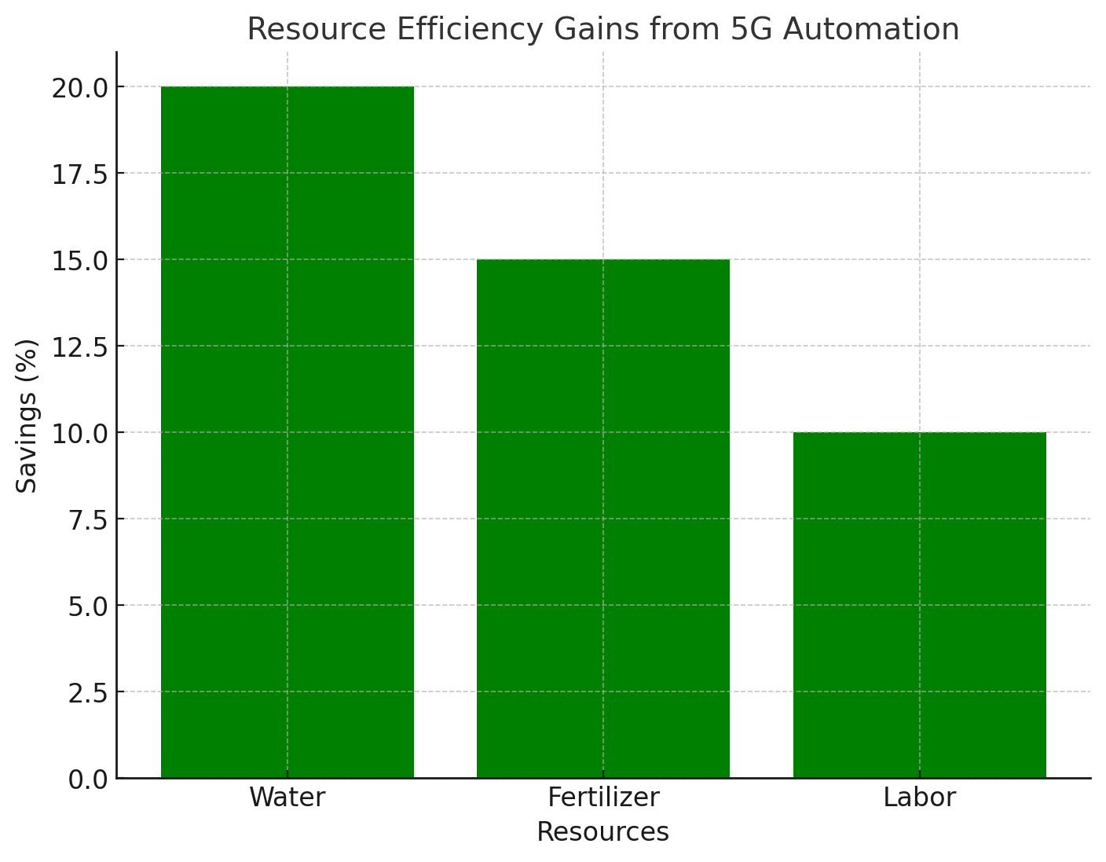
Figure 6: Resource Efficiency Gains
Such defenses showcase initiative and proactive thinking and build on the unsophisticated literature advocating layered security for smart farming infrastructures and the literature advocating that food security should not suffer because of cyber insecurities.
PYTHON SIMULATION OF RESULTS
The main proposed security framework was practically evaluated and sorted by stimulating 5G sensor data that will be collective and be a threat of detection over a 200-case test that will set a based agricultural context. The results showed that 15% of the test cases attempted a security breach and moisture data could have been altered to be below the cut off of 30% and to be pH isolated to below 5.5, thus indicating strongly manipulated measurements. The 15% detection and breach rate illustrates and justifies the need to formulate and implement stronger security measures aimed at the research objective of increasing productivity, hinged on robust and dependable data. The simulation, elaborated in the following sections, helped to understand the resilience of the system and supported the need for real-time monitoring as proposed in the literature review. Future iteration could majorly use a detection framework that will incorporate all the artificial intelligence to help further support of the goal of improving nutritional outcomes and more sustainable.
The findings from the simulation highlight the challenges in the practical domain of 5G network security and justify the proposed safeguards. They also validate the research focus on the domain of sustainable agricultural innovation within Ibaji LGA.
Table 4: Summary of Identified Cyber Threats
Threat Category | Count | Affected Components
Spoofing | 12 | IoT Sensors, Gateways, Cloud
Tampering | 18 | Data Flows, Actuators
Information Disclosure | 15 | Remote Users, Cloud Interfaces
Denial of Service | 10 | Network Nodes, 5G Channels
Elevation of Privilege | 7 | User Access Points
The table above provides a summary of the threats identified in the 5G-enabled precision agriculture system, with a breakdown by threat category, count, and the affected components. This table helps to quantify the various threats that could affect the security of the system, showing how each type of threat (e.g., spoofing, tampering, information disclosure) impacts specific system components (e.g., IoT sensors, gateways, cloud). The table gives a clear overview of the distribution and severity of these threats within the system.

4. Conclusion and FUTURE WORK
This study indicates that a basic 5G-enabled sensing and actuation stack, secured with minimal but critical controls, can improve yields and reduce input use in a resource-constrained smallholder setting such as Ibaji. The modeled gains, near 20 percent for yield and about 15 percent for input efficiency, depend on reliable coverage, authenticated devices, encrypted transport, and integrity checks. Next steps include piloting a small plot deployment in two wards of Ibaji, validating network availability, tuning irrigation thresholds by crop and soil, and running a controlled before-and-after trial for one planting season with full audit logging and incident playbooks.

REFERENCES
- Nguyen-Tan, T., & Le-Trung, Q. (2024). A novel 5G PMN-driven approach for AI-powered irrigation and crop health monitoring. IEEE Access, 12, 125211–125222. https://doi.org/10.1109/access.2024.3452719
- Sadik, S. A. (2024). Leveraging fiber Bragg grating sensors for enhanced security in smart grids. In Advances in Information Security, Privacy, and Ethics (pp. 259–288). IGI Global. https://doi.org/10.4018/979-8-3693-2786-9.ch011
- Mayer, Z., & Freund, A. M. (2022). Better off without? Benefits and costs of resolving goal conflict through goal shelving and goal disengagement. Motivation and Emotion, 46(6), 790–805. https://doi.org/10.1007/s11031-022-09966-x
- Baron, F.-J., & Uitdewilligen, L. (2023). Dacom Precision Agriculture System. In Progress in Precision Agriculture (pp. 263–268). Springer International Publishing. https://doi.org/10.1007/978-3-031-15258-0_15
- Rybalchenko, O. M. (2021). Psychological threats are components of personal security. Habitus, 32, 104–109. https://doi.org/10.32843/2663-5208.2021.32.17
- Ogungbola, A. (2025). Optimizing IT service management in the telecommunications industry: The role of real-time monitoring solutions like Grafana. In Knowledge Production and Management in Africa (pp. 133–148). Springer Nature Switzerland. https://doi.org/10.1007/978-3-031-90550-6_7
- Dahane, A., Benameur, R., & Kechar, B. (2022). An IoT low-cost smart farming for enhancing irrigation efficiency of smallholders farmers. Wireless Personal Communications, 127(4), 3173–3210. https://doi.org/10.1007/s11277-022-09915-4
- Sani, G. (2025). AI-driven intrusion detection systems for low-power IoT devices balancing accuracy and efficiency. Center for Open Science. https://doi.org/10.31219/osf.io/wx3jt_v1
- Bhardwaj, A. (2024). All-inclusive attack taxonomy and IoT security framework. In Smart Home and Industrial IoT Devices: Critical Perspectives on Cyberthreats, Frameworks and Protocols (pp. 201–218). BENTHAM SCIENCE PUBLISHERS. https://doi.org/10.2174/9789815256710124010010
- Yan, S., Wang, Z., & Dobolyi, D. (2025). An explainable framework for assisting the detection of AI-generated textual content. Decision Support Systems, 196, 114498. https://doi.org/10.1016/j.dss.2025.114498
- Fadi, O., Lahlou, S., Bahaj, A., Zkik, K., Ghazi, A. E., & Boulmalf, M. (2025). An integrated framework for securing IoT networks with blockchain and AI. In Empowering IoT with Big Data Analytics (pp. 199–211). Elsevier. https://doi.org/10.1016/b978-0-443-21640-4.00012-0
- Basharat, A., & Mohamad, Mohd. M. B. (2022). Security Challenges and Solutions for Internet of Things based Smart Agriculture: A Review. 2022 4th International Conference on Smart Sensors and Application (ICSSA), 102–107. https://doi.org/10.1109/icssa54161.2022.9870979
- Abuabed, Z., Alsadeh, A., & Taweel, A. (2023). STRIDE threat model-based framework for assessing the vulnerabilities of modern vehicles. Computers &amp; Security, 133, 103391. https://doi.org/10.1016/j.cose.2023.103391
- Lai, C., Lu, R., & Zheng, D. (2016). SPGS: A secure and privacy-preserving group setup framework for platoon-based vehicular cyber-physical systems. Security and Communication Networks, 9(16), 3854–3867. https://doi.org/10.1002/sec.1523
- Shruthi, R., Iyer, S., Madhumathi, R., & Sathya, S. (2025). Tiny ambient IoT in precision agriculture. In Digital Technologies and Tools for Smart Agriculture (pp. 95–110). CRC Press. https://doi.org/10.1201/9781003487005-7
- Malathy, R., & Francis, S. V. (2024). IoT hardware, platform, and security protocols. In Secure Communication in Internet of Things (pp. 21–31). CRC Press. https://doi.org/10.1201/9781003477327-2
- Huang, H., & Wang, J. (2025). Systematic literature review on security mechanisms for IoT device firmware update. Elsevier BV. https://doi.org/10.2139/ssrn.5359954
- Khan, F., Siddhartha, Nazir, A., Khan, M. H., & Umar, M. S. (2024). Enhancing two-factor authentication with dynamic ring-based password transformation for secure login processes. 2024 International Conference on Computing, Sciences and Communications (ICCSC), 1–6. https://doi.org/10.1109/iccsc62048.2024.10830354
- Reddy.K, T., Wing, D., & Anderson, B. (2025). Manufacturer usage description (MUD) for TLS and DTLS profiles for Internet of Things (IoT) devices. RFC Editor. https://doi.org/10.17487/rfc9761
- Fields, J. (2022). Here’s how government documents are classified to keep sensitive information safe. The Conversation. https://doi.org/10.64628/aai.dn9vphsnf
- Vinay, K. (2022). Blockchain based access control system for cloud storage. International Journal of Science and Research (IJSR), 11(12), 143–144. https://doi.org/10.21275/sr221202104520
- Kaksonen, R., Halunen, K., & Röning, J. (2022). Common cybersecurity requirements in IoT standards, best practices, and guidelines. Proceedings of the 7th International Conference on Internet of Things, Big Data and Security, 149–156. https://doi.org/10.5220/0011041700003194
- Kruk, T. (2021). Practical modelling of threats to ICT systems using the STRIDE model. Pomiary Automatyka Robotyka, 25(4), 93–97. https://doi.org/10.14313/par_242/93
- Isabona, J., Ugochukwu, C. C., Imoize, A. L., & Faruk, N. (2022). An empirical comparative analysis of 4G LTE network and 5G new radio. 2022 5th Information Technology for Education and Development (ITED), 1–5. https://doi.org/10.1109/ited56637.2022.10051243
- Deepa, R., & Suchithra, S. (2023). Irrigation water use in the United States. In Handbook of Irrigation Hydrology and Management (pp. 191–202). CRC Press. https://doi.org/10.1201/9781003353928-15
- Cheng, L., Her, Y., Park, C. S., Kim, D.-H., & ​Jang, ​Taeil. (2025). Improving winter wheat yield and water use efficiency using soil moisture sensor-driven precision furrow irrigation. Elsevier BV. https://doi.org/10.2139/ssrn.5472620
- Kumar, M., Pilania, U., & Zamani, M. (2025). Ensuring patient-centric data control using blockchain in smart healthcare system. In IoT, Blockchain, and Smart Healthcare (pp. 56–65). CRC Press. https://doi.org/10.1201/9781003510932-5
- Rick Rogers, R. R. (2024). Can we make it easy to identify marine species from environmental DNA? Experiment. https://doi.org/10.18258/70774.

