Original Research Article
Development and Performance Evaluation of a Submersible Rotary Drum Washer for Ginger Rhizomes

.
ABSTRACT

Washing is an important primary unit operation in handling of fresh root crops, particularly delicate rhizomes like ginger. Proper cleaning after harvest is essential before further processing or marketing contributing to the value addition at the farm level. Small scale farmers, however, lacks affordable and efficient washing equipment This study was done to design, fabricate, and evaluate the performance of a submersible rotary drum washer. The performance of the washer was evaluated in terms of machine capacity, washing efficiency, machine efficiency, and mechanical damage on cleaned ginger rhizomes. Loading weights (5 kg, 10 kg, 15 kg) and operating speeds0 (16 rpm and 28 rpm), and retention time (4 minutes) per cycle were used as the performance parameters. Analysis of Variance (ANOVA) for factorial experiment in Complete randomized Design (CRD) was used to analyze the results while comparison among treatment means was tested at 5% level of significance using Duncan’s Multiple Range Test (DMRT). Results revealed that an operating speed of 16 rpm, loading weight of 15 kg achieved maximum mechanical washing efficiency (93.11%), maximum machine efficiency (94.28%), and lowest mechanical damage (1.5%) on cleaned ginger rhizomes. The machine capacity is 172.42 kg/hr. The initial investment in fabricating the submersible rotary drum washer for ginger rhizomes was ₱43,630. The washers’ break-even weight is 64,815.43 kg of ginger rhizomes per year at a custom rate of ₱0.77/kg.
Keywords: Submersible, rotary washer, rhizomes, retention time

1. INTRODUCTION

Ginger is an herbaceous perennial, grown for its underground rhizomes, popularly called “hands” or “fingers”. Ginger is considered a profitable, high value, cash crop, which is used as spice in cooking, or as an ingredient in candies, beverages, and other various condiments (FAO, 2019). Ginger rhizomes is one of the world’s best-known spices and has been used for its health benefits in complementary medicine dates back 2,500 years (López et al., 2017). In recent years, ginger has gained popularity worldwide and is now classified as a superfood. A superfood is any food that is nutritionally dense and contains high levels of nutrient, minerals, and antioxidants that are beneficial for health and wellbeing (Singh, 2023).

In the Philippines, ginger is known as ‘Luya’ in Tagalog. It is grown in almost in all part of the country and is found cultivated in small patches for local demand. Fresh ginger is the most traded product, but there are opportunities for dried, pickled, preserved, candied, and powdered ginger. However, ginger processing is still in its infancy. In addition, ginger produced are sold only in the domestic market. It has yet to effectively tapped the global market for ginger exports. The Philippines produces an average of 27,425 MT of ginger, or about 1 percent of world production (FAO, 2019).

Ginger attains full maturity in 210-240 days after planting. Harvesting is done by loosening the soil and lifting the rhizomes from the soil (Weiss, 2002). First stage in postharvest processing is washing of rhizomes to remove the soil clinging to the surface of rhizome. If washing is delayed, the soil gets dries on the surface of rhizomes. Soil on the surface contaminates the rhizomes and makes it unsuitable for consumptions (Emers, 2012). Ginger, being a root crop and owing to its physical structure, containing heavy soil load which makes washing as an important and prime post-harvest operation. Manual washing of ginger is laborious and time-consuming process (Kumar et al., 2022).

Washing is the primary and an essential operation in the production and distribution of fresh root vegetables. Root vegetables like carrot, radish, ginger, etc. needs to be pre-cleaned before transporting from field to market (Shariff, 2022). Washing and sanitizing treatment can play an important role in reducing microbial population in fresh fruits and vegetables intended for fresh market or fresh processing, thereby improving product quality and safety. It is necessary to wash off mud and soil particles as a primary processing operation to improve the physical appeal and also to aid in further processing (Sapers, 2001).

Postharvest innovations show the beneficial impact of washing produce prior to taking it to the market. The costs for washing can be very low if running water is available. Washed produce has enhanced cosmetic appeals and buyers are willing to pay extra for this labor-saving convenience. Recent studies and literature reviews confirm that postharvest losses are still high at the farm, wholesale and retail level. Farmers have been losing their fruits and vegetables before they reach the final consumer in a less physical and quality state which led to loss market value, concerns about food safety, and lower incomes for growers (Kitinoja et al., 2002). Manual washing the rhizomes of ginger and turmeric is a labor-intensive process that adds significantly to the cost of final harvested products. Commercially available cleaning equipment makes the postharvest process easier, but only at a price and scale that would benefit large-scale operations (Muller et al., 2025).

According to surveys and informal interviews with ginger growers in the Province of Nueva Vizcaya, Philippines, the majority of farmers use manual washing to clean the rhizomes with running water, which has been shown to be time-consuming and labor-intensive process. However, some farmers use high-pressure sprayers to wash the rhizomes, which they claim causes damage to the rhizomes, such as peeling, leading to decline in quality and market value. At present, there is no primary and economical processing equipment like washers for ginger that can be used by small scale farmers. The primary motive of this study was to develop a batch type ginger washer that is capable of cleaning rhizomes in a gentle yet efficient manner without causing significant damage, and that is suitable for small scale operations.

2. material and methods

2.1. Main Components of the Machine

Feed hopper: It is mounted at the upper portion of the machine frame configures for directing the entry of unwashed rhizomes into the washing drum assembly and is inclined at 45° angle, and made from Gage 20 (1mm thick) stainless steel sheet.

Washing drum assembly: It comprises of a 600 mm diameter cylindrical perforated high-density polyethylene (HDPE) drum with length of 900 mm and a thickness of 3.5 mm with 12 mm perforations. It houses 6 food grade soft-bristle nylon brush mounted along the horizontal axis of the drum arrange at 60° angle.

Shaft: It serves as the central rotating part that supports and spins the drum, the shaft transmits torque from a motor, enabling it to perform work. The shaft was made up of stainless steel with a designation of 304. The total force that the shaft can carry was 345 N and the maximum allowable shear stress for stainless steel shaft was 200 MPa with a safe shear stress factor of 1.0 using equation 1 (Khurmi and Gupta, 2005), the diameter of the shaft was 25 mm which was supported by a bearing.

$d=\sqrt[3]{\frac{16T}{πτ}}$ (1)

where: T = Torque acting upon the shaft, N-m
$τ=$ maximum allowable shear stress, Pa
d = diameter of the shaft, mm

Power requirement: The power required to operate the machine is 1.5 Hp/1103.25 watts. The equations 2 and 3 (Khurmi and Gupta, 2005) were used in determining the required torque and power

$P=\frac{2πTN}{60}$ (2)

$T=Fr$ (3)

where: P = power requirement, watts
T = torque, N-m
N = speed, rpm
F = force, N
r = radius, m

Water basin: The water basin has dimensions of 900mm x 700mm x 400mm, and has a capacity of 245 Liters. It is composite in shape and made from Gage 20 (1mm thick) stainless steel.

Lever: Serves as the actuating mechanism to raise and lock the water basin into its operational position.

Machine frame: Function as the main structural support of the machine. It is fabricated from mild steel bar. The overall dimensions of the frame are 1.9 m height, 0.79 m width, and 1.09 m length.

Table 1. Material and selection for machine component

Component | Selected material | Criteria
Washing drum | HDPE plastic mesh | Corrosion resistance and food safety
Feed hopper | Stainless steel | Corrosion resistance and food safety
Bearing shaft | Mild steel shaft | Workability, wear resistance, and strength
Brush | Soft-bristle nylon | Durability and wear resistance
Water basin | Stainless steel | Corrosion resistance and food safety
Machine frame | Mild steel angle bars | Workability, strength, and low cost

2.2 Working Principles of the Washer

The washer was designed to operate in batches, with ginger rhizomes fed into the washing drum assembly through the feed hopper and drum door. Screws and bolts along the drum’s circumference and door to ensure proper locking and to prevent opening and spillage during washing operation. Once loaded, the drum door is closed and locked. The water basin is then raised and locked in its operational position prior to filling of 245 Liters of water, submerging half of the drum. The electric motor is turned on, driving the shaft to rotate the drum at a controlled operating speed. During washing operation, the ginger rhizomes are simultaneously subjected to immersion, tumbling, and gentle scrubbing by the soft-bristle brushes mounted inside the drum. After washing, the water basin is lowered to its original position, and the used water is discharge through the drain outlet. The cleaned ginger rhizomes are then manually unloaded out of the drum, completing a full washing cycle.

2.3 Performance Parameters of Washer

The washer was evaluated under three different loading weights (5 kg, 10 kg, and 15 kg), two drum operating speeds (16 rpm and 28 rpm), and a fixed retention time of four minutes per cycle, in three replications. The performance of the washer was evaluated in terms of machine capacity, washing efficiency, machine efficiency, and mechanical damage on cleaned ginger rhizomes as per the procedure mentioned below:

Machine capacity: The machine capacity of the machine is the amount of total input weight of the ginger per unit time during the actual operation. The washing capacity was calculated using equation 4 (Budynas and Nisbett, 2015).

$M_{c}=\frac{W_{T}}{T_{o}}$ (4)

where: $M_{c}$ = machine capacity, kg/hr
$W_{T}$ = total weight of input, kg
$T_{o}$ = washing time, hr

Washing efficiency: The ability of machine to remove the soil which was attached with the ginger rhizomes. The washing efficiency of machine was determined as the ratio of the difference of weight of ginger before and after washing to the weight before washing, on percentage basis. The washing efficiency was calculated by equation 5 (Scott et al., 1981).

$WE \left(\%\right)= \frac{W_{i}-W_{f}}{W_{i}}x100$ (5)

Where: $WE$ = washing efficiency, %
$W_{i}$ = mass of sample before washing, kg
$W_{f}$ = mass of sample after washing, kg

Machine efficiency: The quantitative efficiency of the machine in cleaning crops, on percentage basis. The machine efficiency was computed using equation 6 (PAES 223:2008).

${Eff}_{m}= \frac{M_{r}}{M_{b}}x100$ (6)

where: ${Eff}_{m}$ = machine efficiency, %
$M_{r}$ = soil-impurities removed from the ginger rhizomes, %
$M_{b}$ = Soil-impurities present in the ginger rhizomes, %

Mechanical damage: Ginger rhizomes that are damage (i.e., bruised/scratch, broken, sliced, etc.) as result of washing operation, on percentage basis. The mechanical damage was calculated using equation 7 (PAES 223:2008).

$D_{m}=\frac{D_{n}}{W_{i}}x100$ (7)

where: $D_{m}$ = mechanically damage ginger rhizomes, %
$D_{n}$ = net damage ginger rhizomes, g
$D_{n}$ = damage output weight (g) $–$ damage input weight (g)
$W_{i}$ = total weight of ginger rhizomes, g

2.4 Retention Time

The retention time for the ginger rhizomes remain inside the submersible rotating drum during washing operation was set to four minutes. The retention time was established during the machine’s preliminary testing, which produced satisfactory cleaned ginger rhizomes that are consumable and marketable. Three retention times (3, 4, and 5 minutes) were tested at different drum operating speeds of 16 rpm and 28 rpm during the preliminary testing of the machine.

2.5 Sample Preparation

Freshly harvested ginger rhizomes were purchased directly from the local farmers. Hawaiian variety of ginger were used in the study. Samples were divided into different batch loads weighing (5kg, 10kg, and 15kg). Each sample was kept in a woven polypropylene sack without removing soil and then transported directly from the field to the washing facility.

2.6 Statistical Analysis

The optimal operating speed of the washing drum was determined using two levels of drum operating speeds (16 rpm and 28 rpm). Three levels of loading weights (5kg, 10kg, 15kg), and a retention time (4 minutes) was considered in the testing. These are evaluated following the factorial experiment in Completely Randomized Design (CRD). Duncan’s Multiple Range Test (DMRT) was used to compare treatment means at 5% level of significance. Each experiment was replicated three times.

2.7 Cost Analysis

A cost analysis was performed to determine the cost of washing using the device. The following equations were used to compute the cost (Sta. Maria, 2000).

Depreciation:

$D=\frac{IC-SV}{N}$ (8)

where: D = depreciation, ₱/yr
IC = initial cost, ₱
SV = salvage value (10% of IC), ₱
N = life span of machine (5 years)

Fixed cost:

$FC=D+AI+I$ (9)

where: FC = fixed cost, ₱/yr
D = depreciation, ₱/yr
I = insurance and licenses, 2% of AI
AI = average on investment ($IC+SV/2)$, ₱/yr

Variable cost:

$VC=LC+RM+E$ (10)

where: VC = variable cost, ₱/yr
LC = labor cost, ₱yr
E = electricity, ₱/yr
RM = repair and maintenance, ₱yr

Custom rate:

$CR=\frac{\frac{LC}{OP}}{AWC}$ (11)

where: CR = custom rate, $₱$/kg
OT = operating time, hr
AWC = actual washing capacity, kg/hr

Break-even point:

$BEP=\frac{AFC}{\frac{CR-VC}{C}}$ (12)

where: BEP = break-even point, kg
AFC = annual fixed cost, ₱/yr
CR = custom rate, ₱/kg
VC = variable cost, ₱/yr
C = machine washing capacity, kg/hr

3. results and discussion

3.1 Fabricated Submersible Rotary Drum Washer

The machine was fabricated with locally available materials, ensuring low cost, and ease of access for repair and maintenance. The machine is powered by 1.5 Hp single-phase electric motor with integrated wheels on the main frame, making portable and easy to transport. It can be used regardless of gender, either individually or in groups.

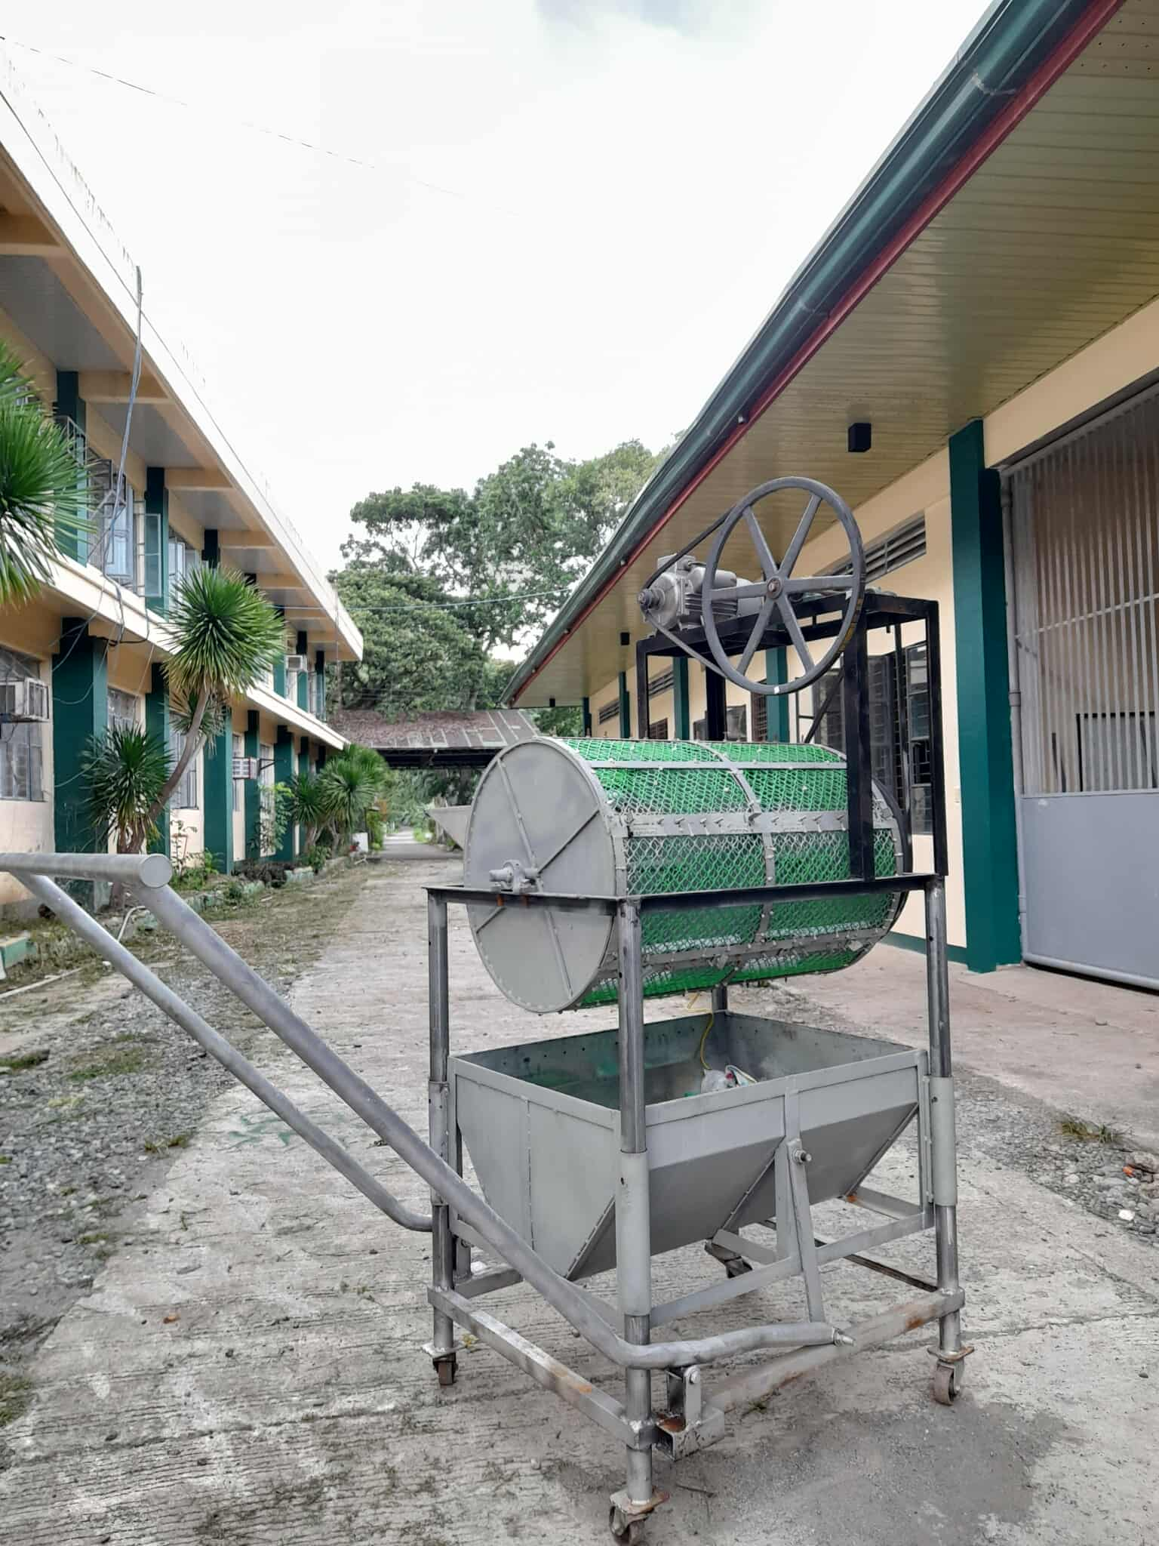

Figure 1. Fabricated submersible rotary washer

3.2 Performance Evaluation

Machine capacity (kg/hr)

The machine capacity increased with higher loading weight, ranging from 5 kg to 15 kg. The maximum machine capacity of 172.42 kg/hr was achieved at a loading weight of 15 kg. This trend indicates that larger loading weights enhance the output of the machine. Similarly, El-Ghobashy et al. (2020) reported that higher washer productivity is usually associated with high batch load and low retention time, which improve the efficiency of washing operation with minimize damage.

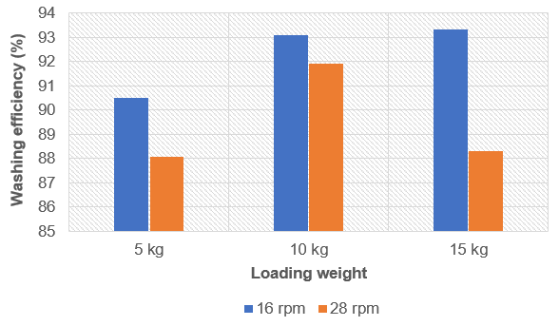

Figure 2. Washing efficiency as affected by loading weight and drum speed

Washing efficiency (%)

Figure 2 revealed that an increase in loading weight corresponded to higher washing efficiency. The highest mechanical washing efficiency (93.33%) was attained at a drum speed of 16 rpm with a 15 kg loading weight. While, higher drum speed of 28 rpm also yielded comparatively high washing efficiency, it resulted in damage to the ginger rhizomes due to increase of impact, friction, and tumbling during washing operation. This observation aligns with the findings of Moos et al. (2002), who reported that faster speed was not recommended to avoid produce damage, and that bristles with soft medium to medium hardness is effective cleaning without bruises. Similarly, Arora et al. (2007) stated that both washing time and speed have significant effects on the mechanical washing efficiency of root vegetables such as turmeric.

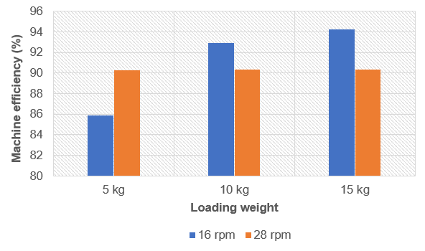

Figure 3. Machine efficiency as affected by loading weight and drum speed

Machine efficiency (%)

Figure 3 shows that the highest machine efficiency (94.28%) was attained at an operating drum speed of 16 rpm and a loading weight of 15 kg, indicating that speed and loading weight affect the machine’s efficiency. Although speed (28 rpm) yielded comparably high efficiency, it resulted in higher percentage of damage rhizomes. Similarly, Ugwu and Ozioko (2015) reported that the drum speed can significantly influence the machine’s performance.

Mechanical damage (%)

The results revealed that the highest percentage of mechanically damage rhizomes (2.76%) occurred at drum speed of 28 rpm, while the lowest mechanical damage (1.50%) was achieved at 16 rpm. This indicates that damage can be reduced by reducing the drum operating speed as well as the loading weight. This observation is similar to Kumar and Azad (2020), who reported that bruising percentage for root crops could be minimized by reducing the washer rotational speed and feed rate.

Cost Analysis

The cost of fabricating the machine was ₱43,630. Based on the basic assumptions considered, the washer had a break-even weight of 64,815.43 kg of ginger rhizomes enough to return the investment in one year. The washer is profitable when the quantity of ginger rhizomes exceeds the break-even weight at a custom rate of ₱0.77/kg, otherwise, the machine is expensive to use.

4. Conclusion

A rotary washer was developed and tested for cleaning ginger rhizomes. The ginger washer can be operated effectively under the optimum operating conditions established during testing which is 16 rpm drum speed, and 15 kg loading weight at a fixed retention time of 4-minute. Under these conditions, the washer achieved the maximum washing efficiency of 93.33%, maximum machine efficiency of 94.28%, and lowest mechanically damage rhizomes of 1.5%. The capacity of the machine was 172.42 kg/hr. The developed washer is suitable and can be recommended for small-to-medium scale operations.

References

Agricultural Machinery Testing and Evaluation Center. (2008). Agricultural machinery-multicrop washer-peeler-methods of test (Philippines Agricultural Engineering Standard: 233:2008. University of the Philippines Los Baños.

Arora, M., Seghal, V. K., & Sharma, S. R. (2007). Quality evaluation of mechanical washed and polished turmeric rhizomes. Journal of Agricultural Engineering, 44(2):39-43.

Budynas, R. G., & Nisbett, J. K. (2015). Shigley’s mechanical engineering design (10th ed.). McGraw Hill Education.

El-Ghobashy, H., Shaban, Y., El-Reheem, S. A., & El-Gawad, F. A. (2020). Development of small scale washing machine for root crops. International Journal od Advance Research, 8(5):35-43. http//dx.doi.org/10.21474/IJAR01/10905

Emers, M. (2012). Barrel washer for cleaning root crops. Alaska Agricultural Innovation Grant Report 2012. Department of Natural Resources, Alaska, USA.

Food and Agriculture Organization. (2019). Ginger value chain study in Nueva Vizcaya, Philippines – GCP/RAS/296/JPN. Bangkok.

Khurmi, R. S., & Gupta, J. K. (2005). Machine design textbook. Eurasia Publishing House (Pvt.) Ltd.

Kitinoja, L. & Kader, A. A. (2002). Small-scale postharvest handling practices: A Manual for Horticultural Crops (4th Edition). Postharvest Horticulture Series No. 8E: 44-45.

Kumar, T. V. A., Aradwad, P. P., Jaiswal, P., Rathod, S., Sahoo, P. K., & Mani, I. (2022). Development and evaluation of a battery operated ginger (Zingiber officinale) washer for small and marginal farmers. The Indian Journal of Agricultural Sciences, 92(9), 1071–1075. https://doi.org/10.56093/ijas.v92i9.109840

Kumar, V. & Azad, A. R. (2020). Performance evaluation of continuous types carrot washer for different roots crops. Journal of Pharmacognosy and Phytochemistry, 9(3):706-710.

López, E.I.C., Balcázar, M.F.H., Mendoza, J.M.R., Ortiz, A.D.R., Melo, M.T.O., Parrales, R.S. et al. (2017). Antimicrobial activity of essential oil of Zingiber officinale Roscoe (Zingiberaceae). American Journal of Plant Sciences, 8,1511-1524. https://doi.org/10.4236/ajps.2017.87104

Moos, J. A, Steele, D. D., & Kirkpatrick, D. C. (2002). Small-scale mechanical carrot washer for research sample preparation. Applied Engineering in Agriculture, Food and Process Engineering Institute, American Society of Agricultural Engineers, 18(2):235-241.

Muller, J., Crawford, D., Cabezón, R., Meekins, H., Kinslow, M. P., Laughlin, W., et al. (2025). Designs for small-scale postharvest washing of ginger/turmeric rhizomes: ENH1391/EP655, 9/2025. EDIS, 2025(5). https://doi.org/10.32473/EDIS-EP655-2025

Sapers, G.M. (2001). Efficacy of washing and sanitizing methods for disinfection of fresh fruits and vegetable products, Food Technol. Biotechnol., 39:305-311.

Scott, J. M., Dunsmore, D. J., & Keegan, M. D. (1981). Spray nozzle performance in cleaning food equipment. Trans. ASAE. 2(3):526-536.

Shariff, M. D., Rahman, I. U, Manish, M., Singh, P., Abhilash, M. (2022). Design and fabrication of root vegetable washer. International Journal for Research in applied Science & Engineering Technology. https://doi.org/10.22214/ijraset.2022.46484

Singh, M. (2023). Ginger Is A Superfood; Here Are Reasons Why You Should Consume It Regularly. NDTV. https://www.ndtv.com/health/ginger-is-a-superfood-here-are-reasons-why-you-should-consume-it-regularly-4027913

Ugwu, K. C. & Ozioko, R. E. (2015). Development and performance test of cassava peeling and washing machine. International Journal of Scientific and Engineering Research, 6(6), 1572-1579.

Weiss, E.A. (2002). Spice Crops. CAB International, Wallingford, UK, 261-268.

