Original Research Article

Study on the performance of cement-water glass double liquid grouting material

Abstract
In order to explore the performance of cement − water glass double liquid grouting material ; using ordinary Portland cement as cementitious material and water glass as admixture, the influence of water glass content of 40 %, 50 % and 60 % on the physical density and setting time of the consolidated body was investigated. At the same time, the high water pressure environment of deep well is simulated, and the influence mechanism of curing pressure on its strength is analyzed. The results show that with the increase of water glass content, the density of cement slurry decreases and the gelation time prolongs. Under the curing pressure, the compressive strength decreases first and then increases. Especially when the curing pressure is 2Mpa, the 7d compressive strength of the grouting material consolidation body is greatly improved, and it is about 10 % -20 % higher than that of the control group without curing pressure..

Keywords : water glass ; double liquid grouting material ; maintenance pressure ; compressive strength
1 Introduction
With the continuous exploitation of mineral resources, the mining depth is increasing, and the mining of coal resources is in the stage of comprehensive advancement to the deep^{[1-2]}.Therefore, deep mining has not only become an urgent problem in the development of coal resources, but also the main way to ensure the sustainable development of mineral resources^{[3]}.With the continuous exploitation of mineral resources, the mining depth is increasing. Under the interference of various external factors, the structure and mechanical properties of rock mass have undergone major changes. The rock mass of roadway surrounding rock is loose and fragile, and the phenomenon of underground roof fall and water inrush is frequent, which brings great hidden dangers to the safe and efficient production of mine ^{[4].} Grouting technology has become an effective means to reinforce fractured rock mass, seal cracks and prevent water inrush due to its labor-saving and effective characteristics^{[5]}.
Using cementitious materials to implement grouting engineering to control water disasters is a widely used water disaster control technology. Therefore, the study of grouting materials has important practical significance for mine production. At present, the commonly used grouting materials are divided into two categories : organic slurry and inorganic slurry ^{[6]}. Among them, inorganic cement slurry, because of its high strength after consolidation, low price and convenient configuration, has become the most widely used grouting material in the field of mining engineering. However, the traditional pure cement slurry has the disadvantages of long setting time, large liquid particles and poor slurry stability, which is limited in the field of plugging in dynamic water environment ^{[7]}. The cement − water glass double liquid grouting material is widely used in underground engineering due to its advantages of short gel time, high stone rate and strong permeability ^{[8]}. Pang Zongxia ^{[9]} et al.confirmed that the concentration of water glass and water-cement ratio within a certain range will significantly affect the setting time and compressive strength of cement − water glass double slurry ; Liu ^{[10]} et al. found that when the concentration of water glass was greater than 40 ° Bé, the growth rate of the basic mechanical properties of cement − water glass double slurry slowed down. YANG ^{[11]} et al. found that the compressive strength and durability of concrete soaked in water glass were significantly improved. Dou ^{[12]} found that after adding fly ash and slag to the cement-water glass grouting material, the hydration product Ca(OH)₂ is less than the traditional two-liquid slurry, and the corrosion resistance is enhanced. The existing research results mainly focus on the field process and grouting effect of cement − water glass double slurry, but few studies on the structure and mechanical properties of double liquid grouting materials under high pressure.
Based on the above analysis, the fluidity and setting time of cement − water glass double-liquid grouting materials with different CS volume ratios under a certain water-cement ratio were investigated. Based on the conventional indoor maintenance test, a new type of indoor maintenance device was developed, which can provide stable maintenance pressure. The strength evolution law of cement-water glass double slurry consolidation body under curing pressure of 0 MPa, 0.5 MPa, 1 MPa and 2 MPa was studied. The research results can provide some reference value for the systematic research and engineering application of cement − water glass grouting materials.

2 Raw materials and experimental methods
2.1 Test raw materials
Test raw materials : 1 P.O42.5R Portland cement. The chemical composition and performance parameters of Portland cement are shown in Table 1 and Table 2. The main performance parameters of water glass are shown in table 3.。

Table 1 Main components of Portland cement
 | CaO | SiO₂ | Fe₂O₄ | Al₂O₃ | K₂O | MgO | Na₂O | SO₃
mass fraction /% | 62.07 | 22.64 | 3.09 | 4.51 | 0.75 | 2.68 | 0.7 | 1.85

Table 2 Performance parameters of Portland cement
density（g/cm³） | setting time（min） |  | shear strength（Mpa） |  | compressive strength（Mpa）
3.15 | initial set 148 | final set 210 | 3d 5.9 | 28d 8.1 | 3d 28.6 | 28d 44.5

Table 3 Main parameters of sodium silicate
type | baume degree（Bé） | density（g/cm³） | Na₂O（%） | SiO₂（%） | modulus
Sodium silicate | 39 | 1.368 | 8.35 | 27.41 | 3.3

Cement-water glass slurry is also called CS slurry, C represents cement slurry, S represents water glass. Cement and water glass are the main agents, and the two are injected in a certain proportion in a double-liquid manner. If necessary, other additional agents can be added as required.。The mix ratio of grouting materials is shown in Table 4.
Table4 Grouting material mix proportion (%, mass ratio)
numbering | cement | water glass content
A1 | 100 | 40
A2 | 100 | 50
A3 | 100 | 60

According to Table 4, a single factor test was designed. The water-cement ratio was fixed at 0.8, the appropriate proportion of Portland cement and water was weighed respectively, and the mixer was added and stirred evenly. Subsequently, different amounts of water glass reagents were added and quickly stirred evenly to obtain three different proportions of cement − water glass two-liquid grouting materials.

2.2 laboratory equipment
In this experiment, the solidified body was cured under constant temperature and constant humidity conditions ( curing temperature is ( 20 ± 2 ) °C, curing humidity is 95 % RH ). Fig.1 shows a self-developed pressure stabilizing device for high-pressure seepage and consolidation test. The device mainly includes several parts such as pressure stabilizing liquid supply device, pulley assembly and counterweight device. It is connected with the curing tank to provide a stable high-pressure curing environment
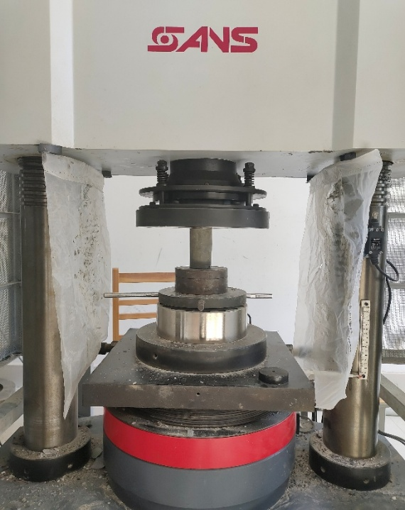
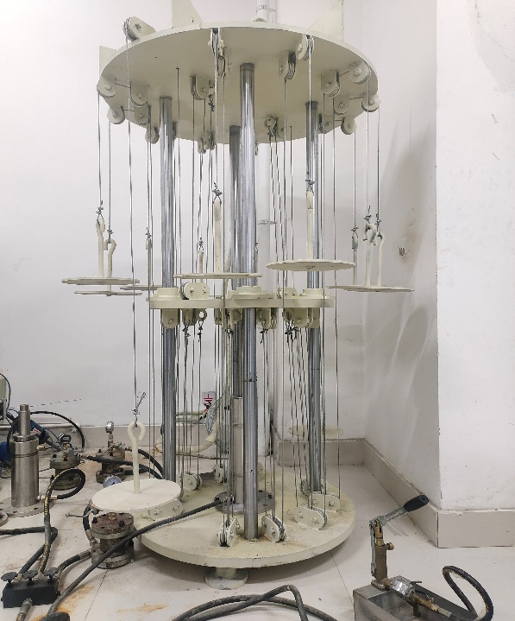
Fig. 1 Maintenance pressure equipment Fig.2 compression testing machine

2.3 Experimental method
In this experiment, the consolidation ratio of the consolidation body is in accordance with table 4, and the consolidation body with curing pressure of 0,0.5,1 and 2Mpa is taken as the research object, and the influence of curing pressure on consolidation strength is mainly analyzed. FAHEY et al ^{[13]} and ALIREZA^{[14]} found that the curing pressure plays a key role in the consolidation strength of the consolidated body within the first 48 h ; after the initial setting of the consolidated body is completed, the curing pressure is continuously applied. Although the curing pressure still has a certain influence on the strength development of the filling body, the influence is relatively small. Therefore, the curing pressure of all schemes in this study reached the specified pressure within 3 days of curing, and then cured to 7 days respectively.。
1 ) Compressive strength test. The above different slurry was poured into a curing tank with a height of 100 mm and an inner diameter of 50 mm. The paste filling body sample was taken out after curing to a specified time, and it was polished and placed on the YAW-6206 electro-hydraulic servo pressure testing machine shown in Figure 2 for compressive strength testing.
2 ) Density. The sample after curing was taken, and the surface moisture was dried with absorbent paper. The mass was m, and the density value was calculated according to ρ = m / v.
3 ) Slurry setting time. In this experiment, the inverted cup method was used to add C liquid and S liquid respectively in two clean beakers according to the test scheme. The beaker containing C liquid was inclined and poured into the beaker containing S liquid. At the same time, the timing was started and poured repeatedly. When the two-liquid slurry was not flowing in the beaker and kept inclined, the timing could be stopped. At this time, the data displayed on the stopwatch was the gelation time of the two-liquid slurry.。
4 ) fluidity. The above slurry was poured into a 60 mm × 70 mm × 100 mm ( high × upper inner diameter × lower inner diameter ) truncated conical circular mold, and the truncated conical circular mold was lifted. The slurry flows freely on the glass plane until it stops forming a circular slurry, and the measured circular diameter is the fluidity.

3 Result and discussion

3.1 Density
The density changes of different cement − water glass two-liquid grouting materials are shown in Table 5. When the volume ratio of CS is 40 %, 50 % and 60 %, the density of double slurry is 1.582, 1.560 and 1.543 g / cm3, respectively. With the increase of water glass content, the density of grouting material decreases gradually. It can be seen that the density of double liquid grouting material is negatively correlated with the content of water glass, and the incorporation of water glass will reduce the density of cement slurry ^{[15]}.
Table5 Density of cement-sodium silicate grouting material
numbering | A1 | A2 | A3
Density（g/cm³） | 1.582 | 1.560 | 1.543

3.2 Setting time
The proportion of water glass in double slurry will greatly affect the reaction rate of water glass and cement slurry, and the difference of reaction rate will lead to the difference of gelation time of double slurry. In this experiment, the same method was repeated for 3 times, and the average value was taken as the final value. The test results are shown in Figure 3.
Fig.3 Setting time of cement-sodium silicate grouting material

When the content of water glass is 40 %, 50 % and 60 %, the initial setting time of grouting material is 37 s, 45 s and 57 s respectively. It can be seen from the development trend that as the volume ratio of CS becomes larger, that is, the content of water glass becomes relatively high, the gelation time of the double slurry will gradually extend. This is because the added water glass is equivalent to the dilution of the C liquid, so that the distance between the solid particles in the double system increases, and the spatial flocculation structure of the double slurry cannot be formed within a certain period of time, thus prolonging the gelation time of the double slurry ^{[16]}.

3.3 Degree of fluidity
In the double slurry, the volume ratio of liquid A to liquid B will greatly affect some characteristics of the slurry. In this experiment, CS volume ratios of 0.4,0.5 and 0.6 were used for comparative tests. At the same time, other conditions remain unchanged, the water-cement ratio is 0.8, the water glass modulus is 3.3, the baume degree is 39 ° Bé, and the temperature is the normal indoor temperature. Because the solidification rate of the two-liquid slurry is fast after mixing, the solutions of the three ratios are solidified within 1 minute, so the time point when the two-liquid slurry solidifies into a solid is the final measurement standard. The test results are shown in Table 6.
Table.6 The results of the three CS volume-to-volume flow tests（Unit：mm）
Water-cement ratio | CS volume ratio
Water-cement ratio | 0.4 | 0.5 | 0.6
0.8 | 286.74 | 310.23 | 317.14
It can be seen from Table 6 that the fluidity of double slurry increases with the increase of CS volume ratio. This is because the viscosity of liquid water glass is smaller than that of cement slurry, and the mixing of liquid A and liquid B is equivalent to diluting liquid A with liquid B, so the fluidity shows an upward trend.

3.3 The effect of curing time on the strength of double slurry consolidation body
As shown in Fig.4, the 7 d strength is the early strength of the double slurry consolidation body, and the 14 d and 28 d strength are the middle strength and the later strength, respectively. When the curing pressure is atmospheric pressure, the strength of the double slurry consolidation body with a CS volume ratio of 0.4 gradually decreases with the increase of curing time. The strength of the double slurry consolidation body with a CS volume ratio of 0.5 does not change much with the increase of curing time. The strength of the double slurry consolidation body with a CS volume ratio of 0.6 decreases first and then increases with the increase of curing time.

Fig.4Compressive strength of double slurry material with curing time
On the whole, the strength of the consolidated body decreases with the increase of water glass content. The compressive strength of the specimens with a CS volume ratio of 0.4 in the curing time of 7d, 14d, and 28d is 17.58,16.64, and 14.58 Mpa. With the increase of curing time, the compressive strength of the specimens gradually decreases. The compressive strength of the specimens with a CS volume ratio of 0.5 is 12.27,11.08,11.36 Mpa. The strength of the specimens decreases slightly at first and then increases slightly, and the overall strength is relatively stable. The compressive strength of specimens with CS volume ratio of 0.6 was 8.96,7.71 and 11.2 Mpa. The strength of specimens was small at first, then increased, and reached the highest at 28 d.

3.4 The influence of curing pressure on the strength of double-slurry-consolidated body
Fig.5 shows the relationship between uniaxial compressive strength and curing pressure of double slurry consolidation under the same curing time. It can be seen from Figure 4 that when the curing time is constant, the uniaxial compressive strength of the double-slurry-consolidated body with CS volume ratio of 0.4 and 0.5 decreases first and then increases with the increase of curing pressure, while the uniaxial compressive strength of the double-slurry-consolidated body with CS volume ratio of 0.6 changes little with the increase of curing pressure.
Fig.5 Compressive strength of double slurry material with curing pressure

The curing time was 7 days. The compressive strength of A1 specimens was 12.40,9.79,9.31 and 13.59 Mpa under the curing pressure of 0,0.5,1 and 2 Mpa, respectively. The compressive strength of A2 specimens were 12.19,6.85,6.11 and 15.18 Mpa, respectively. The compressive strength of A3 specimens were 10.84,10.53,10.19 and 10.55 Mpa, respectively. The change rate of compressive strength of A1 high pressure curing specimen is -21 %, -25 % and 10 % compared with that of normal pressure curing specimen. The compressive strength change rate of A2 specimen is-44 %, -50 % and 25 % ; the change rate of compressive strength of A3 specimen is -3 %, -6 % and -3 %. The results show that under the condition of curing pressure, the change rate of compressive strength of A1 and A2 specimens is large. When the curing pressure is below 2Mpa, the compressive strength of the specimens will be reduced. When the curing pressure is 2Mpa, the compressive strength of the specimens can be enhanced. The compressive strength of A3 specimens changed little under the three curing environments, but it also showed a trend of decreasing first and then increasing.

4 Conclusion
1) A new type of pressure-stabilized curing test device has been independently developed, which makes up for the deficiency that the ordinary indoor curing test can not provide the curing pressure stably for a long time. It can simulate the curing environment of the consolidated body which is close to the site, narrow the gap between the indoor test and the field test, and lay a good foundation for the design of the ratio of the consolidated body on site.
2) With the increase of water glass content, the density of double liquid grouting material decreases and the gelation time prolongs.
3) When the curing pressure is 0 ~ 1MPa, the uniaxial compressive strength of the consolidated body decreases with the increase of the curing pressure, but the decreasing rate shows a decreasing trend. When the curing pressure is 1 ~ 2Mpa, the uniaxial compressive strength of the consolidated body increases.
4) Combined with the characterization results, when the pressure is 1 ~ 2Mpa, the sample with 50 % sodium silicate content is the most prominent, and the compressive strength is greatly improved. The compressive strength of the sample with 60 % water glass content is stable under pressure environment.

REFERENCES
- BAI Runcai, FU Ensan, MA Li, et al. Collaborative mining technological system of safety-green-high effi ciency-low carbon for open pit coal mine[J]. Journal of China Coal Society, 2024, 49(1): 298−308.
- SANG Shuxun, YUAN Liang, LIU Shiqi, et al. Geolo gical technology for carbon neutrality and its applica tion prospect for low carbon coal exploitation and utiliz ation[J]. Journal of China Coal Society, 2022, 47(4): 1430−1451.
- LIU Feng, GUO Linfeng, ZHANG Jianming, et al. Syn ergistic mode of digitalization-intelligentization-greeni ation of the coal industry and it’s path of building new coal productivity[J]. Journal of China Coal Society, 2024, 49(1): 1−15.
- Zhu Shikui, DING Ke. Optimization of support para meters of water rich roadway based on thickness of grouting reinforcement circle[J]. Safety in Coal Mine, 2021, 52(7): 193−199.
- Zhang Jiafan, HUANG Sicong, LIU Yang, et al. Ana lysis of diffusion law of dynamic water grouting in crack based on time-varying viscosity[J]. Safety in Coal Mines, 2023, 54(4): 119−125.
- Zhao Guangming, Wang Yanfen, AI Jie, et al. Development and prospect of cement-based grouting ma terials for coal mine[J]. Journal of China University of Mining & Technology, 2024, 53(1): 1−22.
- REN Lianwei, LI Bo, ZOU Youfeng, et al. Experimental study on performance of waste autoclaved blocks and coal gangue in coal mine goaf ground grouting improve ment[J]. Coal Science and Technology, 2023, 51(11): 51−62.
- LI Shuo, LUO Yunjun, QIN Bendong, et al. Mechanical characteristics of high-performance hybrid fiber con crete shaft lining in drainage settlement ground[J]. Safety in Coal Mines, 2022, 53(4): 216−223.
- PANG Zongxia, TIAN Limin. The indoor test and research of cement-silicate grout[J]. Shanxi Science & Technology of Communications, 2010(5): 15−16.
- LIU Bingke, CHEN Cheng. Study on super-fine cement sodium silicate mortar performance[J]. Architecture Technology, 2018, 49(11): 1191−1193.
- YANG LX, QIAN Y L, FANGQ Q, et al. Effects of re cycled coarse aggregate reinforcing treated by water glass on the performance of recycled concrete[C]//Proceedings of the 3rd International Conference on Materi al Engineering and Application (ICMEA 2016). Atlantis Press, 2016: 181−186.
- Dou Haijun. Investigation on the Performance and Microscopic Characteristics of Complex Cementitious-Sodium Silicate Two-shot Grouting Materials[D]. China University of Geosciences, 2014.
- FAHEY M, HELINSKI M, FOURIE A. Development of specimen curing procedures that account for the influence of effective stress during curing on the strength of cemented mine backfill[J]. Geotechnical and Geological Engineering, 2011, 29(5): 709−723.
- ALIREZA G. Coupled Thermo-Hydro-Mechanical-Chemical (THMC) processes in cemented tailings backfill structures and implications for their engineering design[D]. Ottawa: University of Ottawa, 2016.
- WU Maoyin, WANG Qicai, ZHANG Rongling, et al. Cementing performance and compressive strength of complex cementitions-sodium silicate two-shot grouting materials[J]. Bulletin of the Chinese Ceramic Soci ety, 2016, 35(9): 2741−2746.
- WANG Hongxi, ZHANG Gaozhan, DING Qinjun, HU Shuguang, TAN Shunhui, LI Yongjun. Research on the Performance of Double Solution Grouting Material with Alkali-Activated Industry Waste Slag [J]. Journal of Building Materials,2007(03):374-378.

