Research progress on mechanical properties of fiber reinforced concrete based on scanning electron microscopy

Abstract: Fiber reinforced concrete has the characteristics of high strength, high toughness, high durability, good environmental protection performance and harmless distribution of cracks, which can significantly improve the fundamental defects of traditional concrete such as strong but not tough, brittle and easy to crack. In view of the main factors affecting the performance of fiber reinforced concrete, this paper mainly analyzes its mechanical properties from the aspects of compressive strength and flexural strength, uses SEM to carry out relevant tests, and explores the mechanism of fiber playing a role in fiber reinforced concrete from a microscopic point of view, and studies the mechanical properties of fiber reinforced concrete.
Keywords: fiber reinforced concrete, mechanical properties, scanning electron microscopy.
0. Introduction
In recent years, with the rapid development of China 's highway network, railway network, urban rail transit and other transportation facilities, as well as the rapid development of infrastructure construction such as the South-to-North Water Diversion Project and the West-to-East Gas Pipeline Project, the demand for the production process and performance of various types of concrete in modern civil and hydraulic engineering continues to update, and the corresponding basic theory and preparation technology need to be improved urgently. Therefore, the fiber reinforced concrete has excellent mechanical properties such as tensile resistance, crack resistance, toughening, fatigue resistance and impact resistance (Anas et al., 2022; Zhao et al., 2023; Zhang et al., 2023). It is characterized by " crack but not broken. " It is suitable for application in bridge deck pavement, airport runway, railway sleeper, shield segment, civil building floor and prefabricated parts with complex stress distribution, fatigue resistance and impact resistance [1].These structures are subjected to repeated load for a long time. Under this repeated load, brittle failure will occur in concrete structures [2].However, the addition of fiber can improve brittle failure and greatly improve the deformation ability of concrete [3]. Fiber reinforced concrete is a kind of high strength material widely used in construction, roads, bridges and other fields, which is very important to ensure the safety and reliability of the structure [4]. Therefore, it is very important to study the mechanical properties of fiber reinforced concrete, so SEM scanning can be used as a way to study the mechanical properties of fiber reinforced concrete from the micro level, and to prove the data obtained from the macro test, so as to better explain the relevant mechanism of fiber reinforced concrete.
- SEM principle and specimen preparation
  - SEM principle
Scanning electron microscope (SEM) is an observation method between transmission electron microscope and optical microscope (Marshall et al., 2023; Ural, 2021). It uses a focused narrow high-energy electron beam to scan the sample, and excites various physical information through the interaction between the beam and the material. The information is collected, amplified, and re-imaging to achieve the purpose of characterizing the microscopic morphology of the material [5].
The resolution of the new scanning electron microscope can reach 1 nm ; the magnification can reach 300,000 times and above continuously adjustable ; and the depth of field is large, the field of view is large, and the imaging stereoscopic effect is good [6]. The schematic diagram of scanning electron microscope is shown in Fig.1.
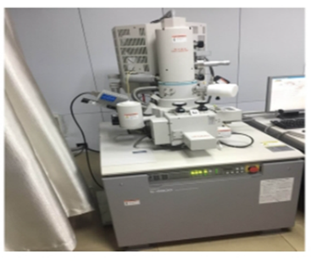
Fig.1 [7] S-4000 environmental scanning electron microscope
  - Specimen preparation
In the study of the microstructure of fiber reinforced concrete by SEM technology, it is necessary to carry out the relevant treatment of the test specimen after the test, and the maximum size of the specimen is not more than 10 mm. The surface of these specimens needs to be fully ground, and the specimens are placed in anhydrous ethanol to prevent further hydration. Before the test, the specimen should be placed in an oven at 60℃to dry it, after the completion of the gold sputtering layer and the sample vacuum pumping into vacuum, the scanning electron microscope [8].
2 The application of SEM in fiber reinforced concrete
The crack resistance and ductility of plain concrete are poor, and it is brittle failure when it is destroyed, which is inconsistent with the safety of the project. In recent years, scholars at home and abroad have adopted different ways to enhance these properties of concrete. Among them, mixing random fibers into concrete is a more effective and convenient way. Therefore, in the test of mechanical properties of concrete mixed with fibers, various data are obtained in various macroscopic mechanical tests. Through the test data, the best ratio will be obtained, but the mechanism of enhancing mechanical properties will be difficult to explain at the macro level. Therefore, it is very important to study it at the micro level.
2.1 Basalt fiber reinforced concrete
The basalt fiber is an inorganic non-metallic fiber made of natural basalt ore through a wire drawing drain plate in a high-temperature melting state. In order to explore the law of corrosion and deterioration of basalt fiber reinforced concrete by composite salt solution, Wang et al. [9] set up concrete specimens with different fiber content and different concentrations of salt solution. After 24 hours of circulation mechanism, it was found that the addition of basalt fiber improved the corrosion resistance of concrete. In the analysis of the test results, the macroscopic surface changes of the specimens were recorded, and the preliminary conclusions were drawn. The effect of the fiber was further determined by the change law of the mass loss rate and the relative dynamic elastic modulus of the specimens. At the same time, it was concluded that the macroscopic durability was the most stable when the fiber content was 0.3 %. Finally, a scanning electron microscope test was performed on the specimens with a fiber content of 0.3 %, and the specimens with a content of 0 were used as a comparison to explain the mechanism at the micro level. See Figure 2 [9].
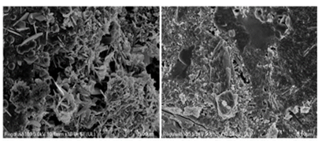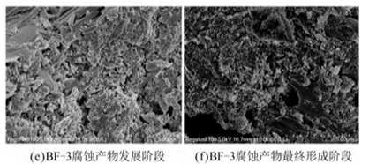
Fig.2 [9] Microscopic characteristics of specimens under erosion of composite salt
Compared with ordinary concrete, it is found that the specimens mixed with basalt fiber have less pores, cracks and corrosion products in the whole process of composite salt solution erosion, and the whole remains dense. As the cycle progresses, the formation rate of corrosion products is slow, which explains the mechanism of basalt fiber at the micro level. That is, the incorporation of basalt fiber delays the growth rate of corrosion products such as gypsum and ettringite.
Gaozhen [10] and others through the establishment of concrete damage mechanics model for numerical simulation, using electron microscopy to scan different basalt fiber content of concrete specimens after the destruction of the image, and from the microscopic point of view of basalt fiber enhancement mechanism of interpretation. In the preparation of basalt fiber reinforced concrete specimens, a fiber dry mixing method was proposed to improve the dispersibility. The content of fiber is 0.0 %, 0.2 % and 0.3 % respectively, and the length is 6mm and 12mm. The concrete specimens of 28 d age with different fiber content and length were observed by electron microscopy, as shown in Fig.3. The optimum fiber length is 6mm. The incorporation of basalt fiber has a dual effect on the compressive strength of concrete. This is because the incorporation of fiber can effectively inhibit the generation and development of internal cracks in concrete. However, due to its own hydrophobicity, there is a gap between fiber and cement matrix, which increases the weak interface layer of concrete and is not conducive to the improvement of concrete strength. At the same time, if the length of the fiber is too long, it will cause the phenomenon of agglomeration in the concrete due to uneven mixing, resulting in a decrease in compressive strength. However, due to the crack resistance effect and weak interface effect of basalt fiber on concrete, the incorporation of fiber improves the mechanical properties of concrete to a certain extent under the condition of controlling the dosage and length.
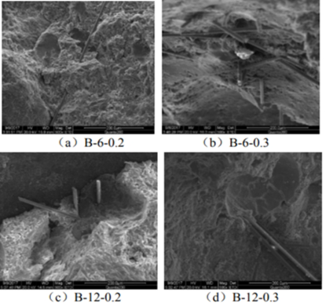
Fig.3 [10] Microstructure of fiber interface of basalt fiber reinforced concrete in each group
2.2 Carbon fiber reinforced concrete
Yang et al. [7] believed that when the carbon fiber content was 0.3 %, the compressive properties of concrete could be significantly improved, and the compressive strength of 28d concrete was 10.28 % higher than that of the reference group. The analysis results are shown in Fig.4. It can be seen from Fig.4 that the compressive strength of concrete increases with the increase of age. When the fiber content is 0.3 % and 0.6 %, the compressive strength of concrete is higher than that of the reference specimen. When the content of carbon fiber is more than 0.6 %, the compressive strength decreases gradually, and the decrease is the largest when the content is 1.5 %.
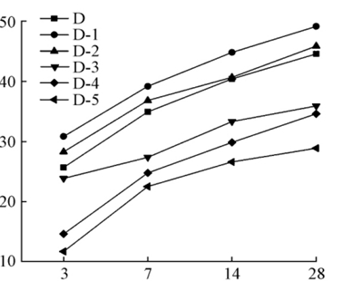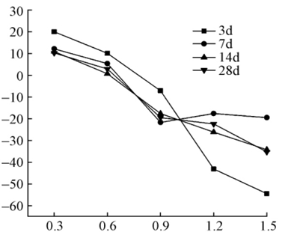
Fig.4 [7] The relationship between compressive strength and age and carbon fiber content.
Adding carbon fiber to concrete, after full mixing and vibrating, the fiber will be disorderly and disorderly distributed in the cement paste, resulting in spatial constraints. In the process of concrete setting and hardening, the segregation phenomenon caused by the settlement of coarse and fine aggregates is prevented. At the same time, the lapping effect of the fiber can form a dense three-dimensional mesh space structure [11], as shown in Figure 5. Reduce the generation of internal cracks in concrete and inhibit its further development, and further improve the compressive properties and crack resistance of concrete. The addition of fiber can also improve the pore structure inside the concrete and reduce the generation of macropores. If the amount of carbon fiber is too much, the carbon fiber cannot be fully dispersed in the cement paste, which will produce a loose network structure, forming a weak interface area, resulting in a decrease in the strength of the concrete. As shown in Figure 6.
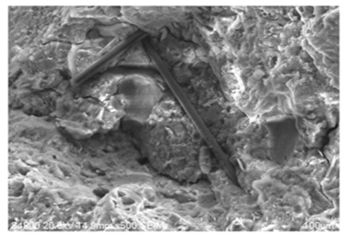
Fig. 5 SEM photos of three-dimensional network structure of carbon fiber
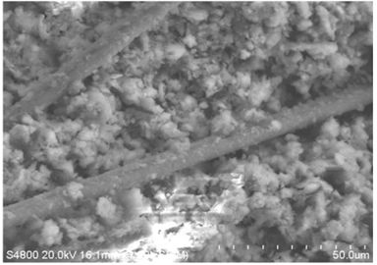
Fig. 6 SEM photos of pine mesh structure
3.The combination of SEM and other technologies
In the study of the mechanical properties and microscopic analysis of hybrid fiber concrete mixed with basalt fiber, polypropylene fiber and fly ash, Hormanlin et al. [12] used SEM electron microscope scanning and NMR nuclear magnetic analysis to carry out the microscopic analysis of hybrid fiber concrete. SEM can be more intuitive to see that the internal structure of the concrete specimen mixed with fiber has been greatly improved, with fewer cracks and pores, and the concrete as a whole maintains good compactness. Through NMR nuclear magnetic analysis, the pore structure inside the concrete specimen is reflected by the relaxation time, as shown in Figure 7. The best mix ratio can be determined according to the peak value of relaxation time.
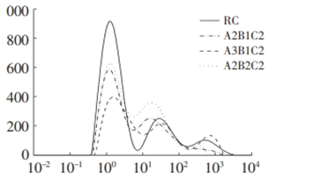
Fig 7 [12] The relationship between relaxation time and signal intensity in different groups.
Kwok L. Chung et al. [13] used SEM electron microscopy to predict the compressive strength of concrete based on early effective conductivity measurement, which explored the prediction of concrete strength, such as compressive strength, porosity, water content and solidification time. In this experiment, conductivity or resistivity was used to monitor the change of porosity in cement paste and concrete. The relative dielectric constant in different frequency ranges was studied as an index, and a correlation model with compressive strength was established. Therefore, the porosity of the structure is an important research object. The SEM is used to scan the concrete with different water-cement ratios, as shown in Figure 8. It can be found that the larger the water-cement ratio is, the larger the porosity is, and there are more macropores, which will lead to lower compressive strength. The specimen with the lowest water-cement ratio has almost no micropores and is more dense.
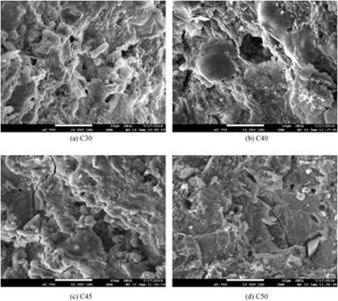
Fig.8 [13] Scanning electron microscope images of different water-cement ratios
Zhang et al. [14] studied the microstructure of the micro-cement paste interface by means of scanning electron microscopy when analyzing the performance degradation and strength prediction of hybrid fiber reinforced concrete after high temperature. It was found that with the gradual increase of temperature, free water and bound water evaporated, and a large number of pores gradually formed inside the concrete. C-S-H and calcium hydroxide would gradually decompose, the internal structure would gradually destroy, and the strength would decrease rapidly. However, at 200 ℃, due to the secondary hydration reaction, this will make the compressive strength of concrete increase slightly at this time. Finally, combined with BP neural network, the compressive strength of hybrid fiber reinforced concrete after different temperature is predicted. As shown in Figure 9, it is found that the predicted data in the model are basically fitted with the experimental data, which has great reliability.
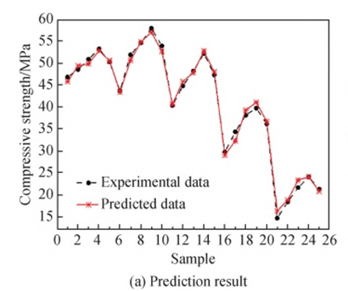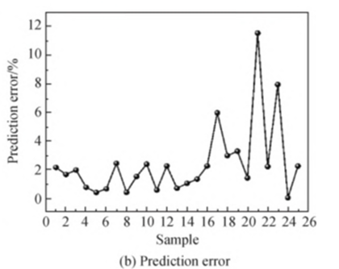
Fig.9 BP neural network model prediction results
4. Conclusion and prospect
SEM scanning technology provides a new research method for the study of concrete at the micro level, and builds a link between the microstructure and the macro structure. At present, this technology has become a common method to study the microstructure of concrete. With the development of science and technology, researchers gradually pursue the structural change information of materials in time and space, which requires electron microscopy. It has higher signal strength, faster scanning speed, faster data processing speed, equipped with high-sensitivity detectors, high-efficiency sample processing accessories and other working capabilities to achieve high-throughput characterization in time and space [15]. High-throughput rapid characterization is one of the development directions of scanning electron microscopy. On the one hand, high-throughput characterization of electron microscopy is to obtain a large number of surface morphology, structure, composition and other structural information of the sample in a short time. On the other hand, it is to detect different positions or different samples of the sample in a short time. The basic function of the scanning electron microscope is to observe the microstructure of the sample. However, with the development and application of various detector technologies, the scanning electron microscope has gradually transformed into a carrying platform, integrating a variety of sample processing technologies and a variety of detectors, and transforming into a sample multi-information collection and comprehensive analysis system, which meets the researchers ' requirements for the integrated characterization of the fine structure and performance of the material. The integration of equipment platform and function integration is one of the main trends in the development of electron microscopy characterization technology. The function of scanning electron microscopy is not only the characterization of sample microstructure, but also can be combined with multiple technologies to fully study the microstructure of concrete and draw more convincing conclusions.
In general, scanning electron microscopy technology has developed rapidly, image resolution is getting higher and higher, the range of electron gun beam options is getting larger and larger, low vacuum technology and low voltage technology are more mature, and it has gradually become the mainstream configuration of electron microscopy. With the subdivision of the research field, the electron microscopy characterization technology shows a diversified development trend. The demand for in-situ characterization of sample structure has promoted the development of large sample silos, low vacuum, and high-throughput characterization electron microscopy. The development and application of rapid sample processing technology and computer image three-dimensional reconstruction technology have enabled the electron microscope to realize the collection of 3D structure information of the sample. The combination of electron microscopy, characterization technology and sample rapid processing technology has gradually transformed the scanning electron microscope into a comprehensive platform with the functions of observation of tissue morphology, composition analysis, visual processing and performance testing, and has gradually become a powerful tool for the research and development of concrete materials.
5.Reference
[1] He, Z., & Wang, H. (2021). Fatigue performance analysis of steel fiber reinforced concrete beams combined with homogenization theory. Bulletin of the Chinese Ceramic Society, *40*(8), 2574-2583.
[2] Zhao, J., Liao, L., Zhang, F., et al. (2020). Experimental study on flexural performance and fiber distribution of steel fiber reinforced concrete. Journal of Building Materials, *23*(4), 838-845.
[3] Bai, M., Niu, D., Jiang, L., & Miao, Y. (2013). Study on improvement of mechanical properties and microstructure of concrete by steel fiber. Bulletin of the Chinese Ceramic Society, *32*(10), 2084-2089.
[4] Hou, W. (2015). Experimental study on flexural fatigue and crack resistance of steel fiber reinforced concrete. Concrete, (6), 96-99.
[5] Ling, Y., Zhong, J., Tang, X., et al. (2018). Working principle and application of scanning electron microscope. Shandong Chemical Industry, *47*(9), 78-79+83.
[6] Chen, Y., Lin, Y., Zhang, H., et al. (2006). Comparison of scanning electron microscopy and atomic force microscopy. Chinese Journal of Stereology and Image Analysis, *11*(1), 53-58.
[7] Yang, H., Wang, H., Wang, H., et al. (2021). Experimental study on mechanical properties of carbon fiber reinforced lightweight aggregate concrete. Building Structure, *51*(11), 108-112+46.
[8] Liang, N., Geng, S., & Mao, J. (2024). Investigation on cracking resistance mechanism of basalt-polypropylene fiber reinforced concrete based on SEM test. Construction and Building Materials, *411*, 134284.
[9] Wang, C., Li, X., Ge, G., et al. (2023). Experimental study on corrosion deterioration of basalt fiber reinforced concrete under composite salt erosion and dry-wet coupling. Composites Science and Engineering, (2), 75-83.
[10] Gao, Z., Cao, P., Sun, X., et al. (2018). Analysis of compressive strength and micro-characterization of basalt fiber reinforced concrete. Journal of Hydroelectric Engineering, *37*(8), 111-120.
[11] Du, G., Li, L., Wang, Z., et al. (2024). Experimental study on dynamic compression properties of carbon fiber reinforced concrete after high temperature cooling. Materials Reports.
[12] Huo, M., Yang, G., Cao, Y., et al. (2024). Mechanical properties and micro-analysis of hybrid fiber reinforced concrete. China Concrete and Cement Products, (4), 59-62.
[13] Chung, K. L., Wang, L., Ghannam, M., Guan, M., & Luo, J. (2021). Prediction of concrete compressive strength based on early-age effective conductivity measurement. Journal of Building Engineering, *35*, 101998.
[14] Zhang, J., Liu, H., Wang, J., et al. (2023). Performance degradation analysis and strength prediction of hybrid fiber reinforced concrete after high temperature. Bulletin of the Chinese Ceramic Society, *42*(4), 1260-1269.
[15] Gao, X., Zhang, A., & Zhang, L. (2019). Development and application of scanning electron microscopy and characterization technology. Science and Technology Innovation Herald, *16*(19), 99-103.
[16] Anas, M., Khan, M., Bilal, H., Jadoon, S., & Khan, M. N. (2022). Fiber reinforced concrete: a review. Engineering Proceedings, 22(1), 3.
[17] Zhao, C., Wang, Z., Zhu, Z., Guo, Q., Wu, X., & Zhao, R. (2023). Research on different types of fiber reinforced concrete in recent years: An overview. Construction and Building Materials, 365, 130075.
[18] Zhang, P., Wang, C., Gao, Z., & Wang, F. (2023). A review on fracture properties of steel fiber reinforced concrete. Journal of Building Engineering, 67, 105975.
[19] Marshall, A. G., Damo, S. M., & Hinton, A. (2023). Revisiting focused ion beam scanning electron microscopy. Trends in Biochemical Sciences, 48(6), 585-586.
[20] Ural, N. (2021). The significance of scanning electron microscopy (SEM) analysis on the microstructure of improved clay: An overview. Open Geosciences, 13(1), 197-218.

