Mechanism Analysis of Bursting Oscillations in a Nonlineat Oscillator with Two-Scale Coupling in the Frequency Domain

.
ABSTRACT

This paper aims to investigate the influence of amplitude modulation and coexisting attractors on the formation mechanism of complex bursting oscillations in slow-fast coupled nonlinear systems. Taking a modified three-dimensional van der Pol–Duffing system as the research object, a parametric excitation with frequency far less than the natural frequency is introduced into the system, establishing a slow-fast system model with two-scale coupling characteristics in the frequency domain. Regarding the excitation term as a slow-varying parameter, the equilibrium points, limit cycles, and their bifurcation structures in the fast subsystem are systematically analyzed, revealing the coexistence conditions of different attractors and their impact on the dynamics of the full system.

It is found that when the modulation amplitude is low, the slow process of the system is significantly prolonged, exhibiting typical quasi-static relaxation oscillation behavior; whereas when the modulation amplitude increases, the relaxation oscillations suddenly disappear, and the system enters a stable equilibrium state or aperiodic oscillation state. Further analysis indicates that the coexistence of multiple attractors in the fast subsystem may lead to multiple bursting solutions in the full system: trajectories may evolve within a single attracting basin or traverse multiple attracting basins sequentially, thereby forming merged bursting oscillations. In addition, due to the inertia effect, trajectories may directly pass through the parameter intervals corresponding to certain attractors, leading to the disappearance of related bifurcation effects; whereas when the excitation frequency is sufficiently low, the previously disappeared attractors may reappear. When the parameter interval between two types of codimension-1 bifurcation points is extremely short, the system may also exhibit compound bursting patterns similar to those induced by codimension-2 bifurcations.

The research in this paper reveals the synergistic influence mechanism of coexisting attractors in slow-fast systems on relaxation oscillations and bursting dynamics under amplitude modulation conditions, enriching the multiscale dynamical theory of nonlinear oscillators and providing new theoretical references for the study of modulation-induced dynamical evolution in other complex nonlinear systems.

Keywords: (Amplitude modulation; slow-fast system; coexisting attractors; bursting oscillations; Duffing system; nonlinear dynamics)

- INTRODUCTION

Relaxation oscillations (Szmolyan, P. & Wechselberger, M.,2004, Ginoux, J. M. & Letellier, C.,2012, Liu W et al.,2003, Van Der Pol, B. & Van Der Mark, J.,1928, Krupa, M. & Szmolyan, P.,2001) represent a class of nonlinear dynamical phenomena widely observed in nature and engineering systems, characterized by periodic bursts and slow variations under the coupling of fast and slow variables (Peña, M. & Kalnay, E.,2004, Abramov, R. V.,2011, Omelchenko, I., Rosenblum, M. & Pikovsky, A.,2010). This oscillatory form is commonly present in laser outputs, neuronal firing, chemical reactions, self-excited oscillation circuits, and other systems, holding significant importance for understanding the time-domain behavior and energy evolution mechanisms of complex systems. Due to the frequent accompaniment of multi-time-scale coupling, nonlinear feedback, and bifurcation mutations in relaxation oscillations, research on their mechanisms has remained a key topic in nonlinear science.
Among the numerous models describing nonlinear oscillatory behaviors, the Duffing system (Ge, Z. M. & Ou, C. Y.,2007, Li, Z et al., 2015, Agrawal et al., 1998) and its variants are widely adopted due to their concise structure and rich dynamical characteristics. This system not only exhibits continuous evolution processes from periodic oscillations to period-doubling bifurcations (Syta et al.,2014) and chaotic attractors (Farmer, J. D.,1928) but also reveals complex dynamical behaviors under slow-fast coupling through the introduction of external modulations. In recent years, with the development of slow-fast system theory (Lobry, C et al.,1999), researchers have begun to analyze the evolutionary features of nonlinear systems from a multi-time-scale perspective, with particular attention to the influence of external modulations (such as amplitude modulation and frequency modulation) on system bifurcations and dynamical patterns. Among these, amplitude modulation has been proven to be an effective dynamical control mechanism, capable of prolonging the system's quasi-static slow processes, altering bifurcation structures, and even inducing abrupt changes and disappearance of oscillations.
On the other hand, an increasing number of studies indicate that multiple attractors (including equilibrium points, limit cycles, and hidden attractors) may coexist simultaneously in the fast subsystem, and the interactions among these coexisting attractors significantly alter the overall dynamical landscape of the system. The multiple coexistence of attractors in the fast subsystem may lead to trajectory switching between different attracting basins in the full system, generating bursting oscillations, multi-stable coexistence, trajectory jumps, and other complex phenomena. However, systematic research on the interactions among "amplitude modulation–slow-fast coupling–attractor coexistence" remains insufficient, especially in the frequency-domain two-scale framework, where the influence mechanism on the formation and disappearance of relaxation oscillations lacks in-depth exploration.
Based on this, this paper takes a modified three-dimensional van der Pol–Duffing system (Kuiate, G et al.,2018) as the research object, introducing low-frequency parametric excitation to construct a frequency-domain two-scale coupling model, regarding the excitation term as a slow-varying parameter, and systematically analyzing the equilibrium points, limit cycles, and bifurcation structures of the fast subsystem. Through slow-fast analysis and phase diagram transformation methods, the influence laws of amplitude modulation intensity and coexisting attractor structures on the evolution of bursting oscillation patterns are revealed. The study indicates that when the modulation amplitude is low, the system exhibits delayed relaxation oscillations; whereas when the modulation amplitude is high, the relaxation oscillations disappear, and the system enters stable or aperiodic states. The coexistence of multiple attractors in the fast subsystem can induce multiple bursting solutions or merged bursting behaviors, and when trajectories directly cross certain parameter intervals, bifurcation effects temporarily disappear; when the excitation frequency is sufficiently low, these attractors may reappear.
The primary research objective of this paper is to reveal the synergistic mechanism of coexisting attractors in slow-fast systems on bursting oscillation dynamics under amplitude modulation conditions. The research outcomes not only enrich the theoretical framework of nonlinear systems under multi-time-scale coupling conditions but also provide new ideas and methods for understanding and controlling complex dynamical behaviors under amplitude modulation.

2.Mathematical Model and the Bifurcations

The three-dimensional nonlinear system mathematical model is given as follows:
$$\dot{x}=-x+y+w$$
$$\dot{y}=-ay+bz-x^{2}y$$
$$\dot{z}=-y+z$$
Where $x,y,z$ are the state variables of the system,and $w=A\sin{(Ωt)}$ is the slow-varying external excitation, with Ω assumed to be much smaller than the natural frequency of the system to investigate the impact of two-scale coupling on the system behavior, and $a b$ are the system parameters.
To calculate the equilibrium points Nash Jr, J.,1950), set:
$$\dot{x}=0,\dot{y}=0,\dot{z}=0$$
yielding
$$-a\left(x-w\right)+b\left(x-w\right)-x^{2}\left(x-w\right)=0$$
$$y=x-w$$
$$z=x-w$$
The equilibrium points can be expressed as $E\left(x,y,z\right)=E(x_{0},x_{0}-w,x_{0}-w)$,where $x_{0}$ satisfies $-a\left(x_{0}-w\right)+b\left(x_{0}-w\right)-{x_{0}}^{2}\left(x_{0}-w\right)=0$.
If $y=0$ an equilibrium point varying with parameter $w$ is obtained:
$$E_{0}\left(x,y,z\right)=E_{0}(w,0,0)$$
If $y≠0$ and $b-a≥0$, a pair of symmetric equilibrium points is obtained:
$$E_{+}\left(x,y,z\right)=E_{+}(\sqrt{b-a},\sqrt{b-a}-w,\sqrt{b-a}-w)$$
$$E_{-}\left(x,y,z\right)=E_{-}(-\sqrt{b-a},-\sqrt{b-a}-w,-\sqrt{b-a}-w)$$
To analyze the stability of the equilibrium points, the Jacobian matrix of the system is derived:
$$J=\left[\begin{matrix}-1 & 1 & 0 \\ -2xy & -a-x^{2} & b \\ 0 & -1 & 1\end{matrix}\right]$$
The stability is determined by the characteristic equation
$$p\left(λ\right)=λ^{3}+\left(a+x^{2}\right)λ^{2}+\left(b+2xy-1\right)λ+\left(-a+b-x^{2}-2xy\right)=0$$
where
$$p_{2}=a+x^{2}$$
$$p_{1}=b+2xy-1$$
$$p_{1}=b+2xy-1$$
According to the Hurwitz criterion (DeJesus, E. X. & Kaufman, C.,1987, Bodson, M.,2020, Ho, M. T., Datta, A. & Bhattacharyya, S. P.,1998) if all coefficients are positive and the constant term is zero:
$$p_{1}>0$$
$$p_{2}>0$$
$$p_{0}=-a+b-x^{2}-2xy=0$$
a fold bifurcation (Kuznetsov, Y et al.,2004, Kadar, F., Stepan, G. & Habib, G.,2025, Gritli, H.,2012)may occur, leading to an exchange of stability at the equilibrium points.
If all coefficients are positive and the product of coefficients$p_{1}$ and $p_{2}$ equals the constant term $p_{0}$,
$$p_{2}>0$$
$$p_{0}>0$$
$$p_{0}=p_{1}p_{2}$$
a Hopf bifurcation (Marsden, J. E., & McCracken, M.,2012) may occur, generating a limit cycle.( He, J. H.,2005).
Figure 1 illustrates the variations in the system's equilibrium points and their stability with the bifurcation parameter $w$ , with fixed system parameters $a=-0.1,b=3.0$. This figure is drawn using numerical continuation methods, utilizing software to track equilibrium branches. The horizontal axis represents parameter $w$ ,and the vertical axis represents state variable $x$. The blue solid lines represent stable equilibrium branches, and the blue dashed lines represent unstable equilibrium branches. The red points mark bifurcation points, where "PF" denotes fold bifurcations and "H" denotes Hopf bifurcations. The symmetric structure in the figure reflects the approximate symmetry of the system near $w=0$.

When $1.04881<\left|w\right|<1.76068$, there exists a stable equilibrium branch corresponding to equilibrium point $E_{0}\left(x,y,z\right)=E_{0}(w,0,0)$, and two horizontal unstable equilibrium branches corresponding to equilibrium points $E_{±}\left(x,y,z\right)=E_{±}(±\sqrt{b-a},±\sqrt{b-a}-w,±\sqrt{b-a}-w)$. At $\left|w\right|=1.76068$, i.e., points ${PF}_{1}$ and ${PF}_{2}$ , transcritical bifurcations (Buonomo, B.,2015) occur, transforming the stable equilibrium point $E_{0}$ into an unstable one, and the unstable equilibrium point $E_{-}$ into a stable one. The subsequently transformed stable equilibrium points undergo supercritical Hopf bifurcations at $\left|w\right|=2.18665$, i.e., points $H_{1}$ and $H_{4}$, generating a stable limit cycle, which further encounters the already transformed unstable equilibrium point $E_{0}$ and eventually disappears.

oscillations from a single period to a double period. Subsequently, the parameter w continues to change, triggering a continuous period-doubling bifurcation cascade: from the period-2 cycle bifurcating to a period-4 cycle, then to period-8, period-16, and higher-order period-doubling cycles. This cascade process is self-similar, with the parameter intervals between bifurcation points shrinking in a geometric proportion, and the convergence rate governed by the Feigenbaum constant $δ≈4.6692$.Specifically, the parameter differences between adjacent bifurcation points $Δw_{n}$ satisfy $\lim_{n→∞}{{Δw_{n}}/{Δw_{n+1}}}=δ$, leading to the infinite accumulation of bifurcation points within a finite parameter interval. In the narrow interval where |w|＜1.04881, this rapid accumulation of the cascade highlights the system's parameter sensitivity; when the cascade accumulates to the critical point, the system dynamics abruptly shift from ordered period-doubling behavior to chaotic states, forming a chaotic attractor, accompanied by positive Lyapunov exponents (Dingwell, J. B.,2006,Dingwell, J. B.,2006, Wolf, A et al.,2006), as shown in Figure 2, which quantifies the exponential divergence rate of adjacent trajectories, confirming the chaotic behavior. In the center of this interval, chaotic phenomena may appear intermittently through intermittency windows or periodic windows, where brief periodic behaviors are embedded in the chaotic background, further enriching the dynamical complexity.

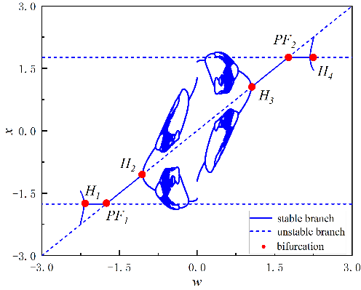
Fig. 1. Bifurcation diagram of equilibrium points versus parameter $w$ for $a=-0$.1,$b=3.0$
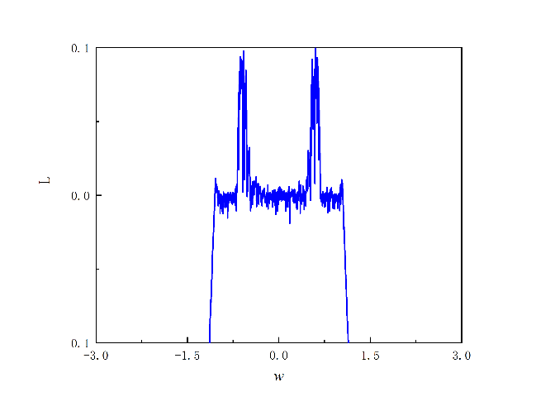
Fig. 2. Lyapunov exponent spectrum versus the bifurcation parameter $w$ for$a=0.1,b=3.0$

2.Dynamical Evolution and Pattern Transition Mechanism

The previous chapter analyzed the system's one-parameter bifurcation diagram. When $\left|w\right|＜1.04881$, it can be observed that the system has only one chaotic attractor, with two supercritical Hopf bifurcation points at both ends. This means that when $\left|A\right|＜1.76068$, only one chaotic attractor can influence the dynamical behavior of the entire system. When $|w| < 1.76068$, it can be observed that the system has a central chaotic attractor and stable equilibrium branches at both ends, which means that when $|A| < 1.76068$, the system trajectory is not only influenced by the chaotic attractor but also by the two equilibrium branches. When $\left|w\right|＜3$, it can be observed that the system has a central chaotic region, equilibrium branches with stability changes, and limit cycles produced by Hopf bifurcations, making the system's dynamical behavior further complex.

3.1 Localized Oscillation Dynamics

First, the case where $|A|＜1.04881$ is discussed. Figure 3 illustrates the time series plot (Goswami, B.,2019), phase diagram (Okamoto, H., & Massalski, T. B.,1990), and the superposition of the transformed phase diagram with the one-parameter bifurcation diagram under fixed parameter $A = 0.75$. Figure 3.a describes the evolution of the system state variable x with time t, where the trajectory of x exhibits a clear periodic oscillation pattern. Figure 3b describes the evolution trajectory of the system state variables x and y, with the phase diagram presenting a closed, elliptical curve cluster, indicating the existence of a stable attractor.

In Figure 3c, the Hopf bifurcation occurs at $|w|=1.04881$, while when $|A|＜1.04881$, no bifurcations occur within the region, so the system is only influenced by the central chaotic attractor, and the system trajectory undergoes periodic oscillations solely under the influence of the chaotic attractor.
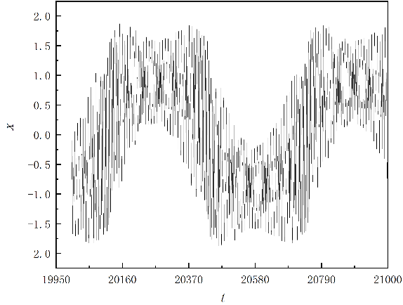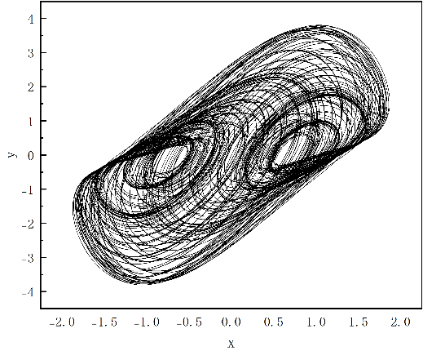
(a) (b)

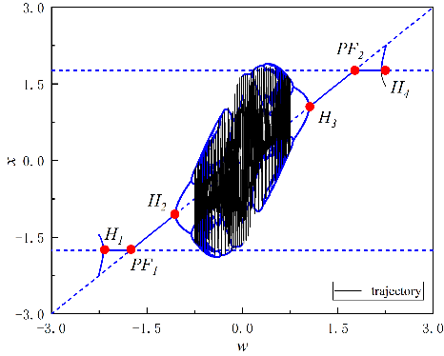
(c)
Fig. 3. Time series, phase diagram, and combined bifurcation–phase diagram of the system for $A=0.75$, showing periodic oscillations.

3.2 Multi-Stable Interaction and Delayed Transition

Figure 4 illustrates the time series plot, phase diagram, and the superposition of the transformed phase portrait with the one-parameter bifurcation diagram under fixed parameter $A=1.2$.

In Figure 4c, the Hopf bifurcation occurs at $|w|=1.04881$. When $|A|＜1.76068$, the system trajectory crosses the Hopf bifurcation point, influenced not only by the chaotic attractor but also by the stable equilibrium branch $E_{0}$. The system trajectory starts from $w=-1.2$, influenced by the stable equilibrium branch $E_{0}$, and moves along $E_{0}$. When it reaches w=-1.04881, i.e., point $H_{1}$, it undergoes a Hopf bifurcation, transforming the stable equilibrium branch $E_{0}$ into an unstable one. However, due to the delay effect (Nowlis, S. M et al.,1990), the system trajectory does not immediately respond to the Hopf bifurcation but first continues along the already transformed unstable equilibrium branch $E_{0}$. When it moves to around $w=0.25$, it begins to oscillate under the influence of the chaotic attractor and subsequently converges onto $E_{0}$, which has become a stable equilibrium branch again due to the Hopf bifurcation. This system is symmetric, and when $w$ decreases, the system trajectory behaves similarly.

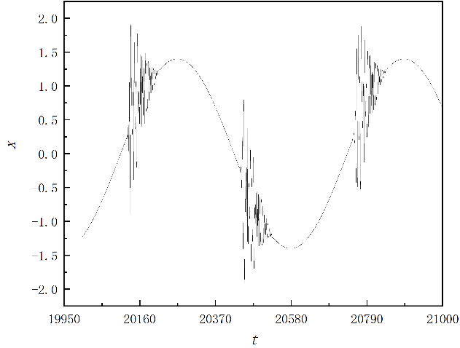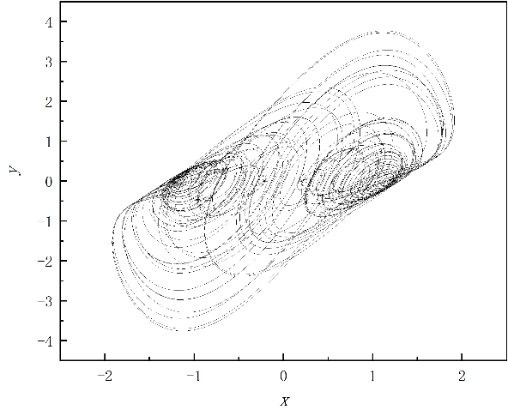
(a) (b)

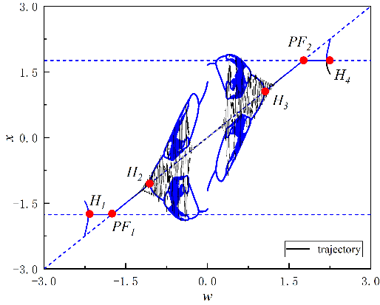
(c)
Fig. 4 Time series, phase diagram, and combined bifurcation–phase diagram of the system for $A=1.2$, showing periodic oscillations.

3.3 Global Chaotic Evolution and Complex Bursting

Figure 5 illustrates the time series plot, phase diagram, and the superposition of the transformed phase diagram with the one-parameter bifurcation diagram under fixed parameter $A=2.2$.

In Figure 5c, the Hopf bifurcation occurs at |w|=1.04881 and |w|=2.18665, and the transcritical bifurcation occurs at |w|=1.76068. When |A|＜3, the system trajectory crosses all bifurcation points, generating more complex dynamical phenomena. Starting from $w=-1.2$, the system trajectory is first influenced by the stable equilibrium branch $E_{0}$, moving along $E_{0}$. When it reaches $w=-1.04881$, i.e., point $H_{1}$, it undergoes a Hopf bifurcation, transforming the stable equilibrium branch $E_{0}$ into an unstable one. However, due to the delay effect, the system trajectory does not immediately respond to the Hopf bifurcation but first continues along the already transformed unstable equilibrium branch $E_{0}$. When it moves to near $w=0$, it begins to oscillate under the influence of the chaotic attractor and subsequently converges onto $E_{0}$, which has become a stable equilibrium branch again due to the Hopf bifurcation, moving along $E_{0}$. As w continues to increase to $w=1.76068$, i.e., point ${PF}_{2}$, a transcritical bifurcation occurs, but due to the delay effect, the system trajectory does not immediately respond to the transcritical bifurcation but first continues along the already transformed unstable equilibrium branch $E_{0}$. As w continues to increase to $w=2.18665$, it converges onto the limit cycle and subsequently, via the Hopf bifurcation, converges onto the transformed stable branch E+. When w decreases to $=1.76068$, i.e., point ${PF}_{2}$, influenced by the transcritical bifurcation, the system trajectory moves from $E_{+}$ to $E_{0}$, which has been transformed back into a stable branch, and so forth in reciprocal motion.

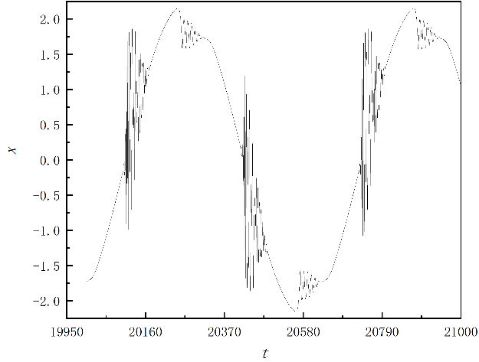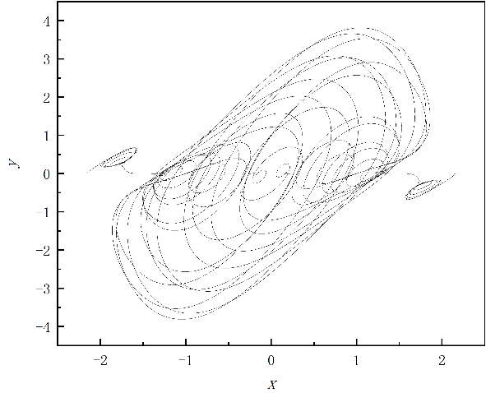
(a) (b)

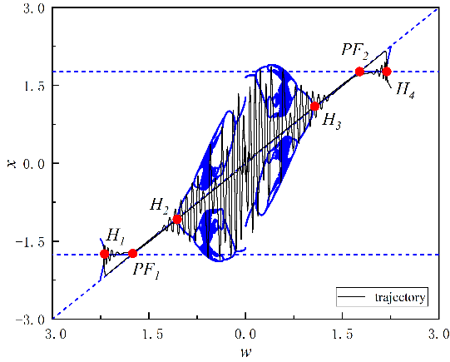
(c)
Fig. 5. Time series, phase diagram, and combined bifurcation–phase diagram of the system for $A=2.2$, showing periodic oscillations.

4. Conclusion

This study focuses on the interaction mechanism between amplitude modulation and coexisting attractors in a nonlinear slow–fast system, aiming to clarify their influence on bursting and relaxation oscillations. Based on a modified three-dimensional Van der Pol–Duffing oscillator, a two-scale coupled model was established and analyzed using the fast–slow decomposition and numerical continuation. The main conclusions can be summarized as follows:
(1) Amplitude modulation plays a dual role in shaping the slow–fast dynamics.
When the modulation index is low, the system exhibits an extended quasi-static slow process, indicating that amplitude modulation effectively regulates the slow subsystem. However, as the modulation amplitude increases, relaxation oscillations gradually weaken and eventually disappear. This transition suggests that strong modulation can destroy the balance between fast and slow subsystems, leading to an abrupt change in oscillatory behavior.
(2) The coexistence of attractors in the fast subsystem is the key origin of complex bursting oscillations.
Analysis of the equilibrium points, limit cycles, and their bifurcations reveals that multiple coexisting attractors can generate diverse bursting patterns through basin switching. System trajectories may move between different attraction basins, producing hybrid or merged bursting behaviors. When the trajectory directly crosses the parameter intervals associated with certain attractors, the corresponding bifurcation effects vanish, a phenomenon referred to as inertial crossing.
(3) The coupling between amplitude modulation and coexisting attractors introduces a new nonlinear mechanism.
Amplitude modulation not only alters the system’s energy flow but also restructures the interactions among multiple attractors. When the modulation frequency is sufficiently low and the modulation index is large, the system exhibits attractor merging and the disappearance of relaxation oscillations, revealing a new mechanism of modulation-induced disappearance of oscillations.
(4) The findings have potential implications for vibration control and complex system analysis.
Amplitude modulation provides an effective means to regulate the oscillatory amplitude and rhythm in nonlinear systems, while the identification of coexisting attractors offers theoretical guidance for controlling multistability in nonlinear circuits, mechanical oscillators, and biological rhythmic models.
In summary, this work elucidates the cooperative influence of amplitude modulation and attractor coexistence on the bursting and relaxation dynamics of a slow–fast nonlinear oscillator. The revealed mechanisms enrich the theoretical framework of modulation-driven nonlinear dynamics and offer new perspectives for the analysis and control of multi-scale nonlinear systems. Future work may extend these findings to other forms of modulation (e.g., frequency or mixed modulation) and noise-driven perturbations to further generalize the understanding of complex multi-scale behaviors.

References

Kuznetsov, Y. A., Meijer, H. G., & van Veen, L. (2004). The fold-flip bifurcation. International Journal of Bifurcation and Chaos, 14(07), 2253-2282.
Li, Z., Chen, D., Zhu, J., & Liu, Y. (2015). Nonlinear dynamics of fractional order Duffing system. Chaos, Solitons & Fractals, 81, 111-116.
Liu, W., Xiao, D., & Yi, Y. (2003). Relaxation oscillations in a class of predator–prey systems. Journal of Differential Equations, 188(1), 306-331.
Lobry, C., Sari, T., & Touhami, S. (1999). Fast and slow feedback in systems theory. Journal of Biological Systems, 7(03), 307-331.
Marsden, J. E., & McCracken, M. (2012). The Hopf bifurcation and its applications (Vol. 19). Springer Science & Business Media.
Nash Jr, J. F. (1950). Equilibrium points in n-person games. Proceedings of the National Academy of Sciences, 36(1), 48-49.
Okamoto, H., & Massalski, T. B. (1990). Binary alloy phase diagrams. ASM International, Materials Park, OH, USA, 12, 3528-3531.
Omelchenko, I., Rosenblum, M., & Pikovsky, A. (2010). Synchronization of slow-fast systems. The European Physical Journal Special Topics, 191(1), 3-14.
Peña, M., & Kalnay, E. (2004). Separating fast and slow modes in coupled chaotic systems. Nonlinear Processes in Geophysics, 11(3), 319-327.
Syta, A., Litak, G., Lenci, S., & Scheffler, M. (2014). Chaotic vibrations of the Duffing system with fractional damping. Chaos: An Interdisciplinary Journal of Nonlinear Science, 24(1).
Krupa, M., & Szmolyan, P. (2001). Relaxation oscillation and canard explosion. Journal of Differential Equations, 174(2), 312-368.
Van Der Pol, B., & Van Der Mark, J. (1928). LXXII. The heartbeat considered as a relaxation oscillation, and an electrical model of the heart. The London, Edinburgh, and Dublin Philosophical Magazine and Journal of Science, 6(38), 763-775.
Wolf, A., Swift, J. B., Swinney, H. L., & Vastano, J. A. (1985). Determining Lyapunov exponents from a time series. Physica D: Nonlinear Phenomena, 16(3), 285-317.
Szmolyan, P., & Wechselberger, M. (2004). Relaxation oscillations in R3. Journal of Differential Equations, 200(1), 69-104.
Bodson, M. (2020). Explaining the Routh–Hurwitz criterion: A tutorial presentation [focus on education]. IEEE Control Systems Magazine, 40(1), 45-51.
Nowlis, S. M., Mandel, N., & McCabe, D. B. (2004). The effect of a delay between choice and consumption on consumption enjoyment. Journal of Consumer Research, 31(3), 502-510.

