Case Report

Bilateral Supernumerary Roots in the Maxillary Third Premolars of a Dog: A Case Report

.

ABSTRACT

Anatomical variations in canine dentition, including supernumerary roots, are uncommon but clinically significant, as they may complicate dental procedures. This report describes a rare bilateral occurrence of supernumerary roots in the maxillary third premolars (107 and 207) of a 15-year-old female dog. Radiographic evaluation confirmed three distinct roots per tooth. The teeth were extracted due to severe periodontal disease affecting the supporting structures. This case emphasizes the importance of routine intraoral radiographs in veterinary dentistry for detecting anatomical anomalies and contributes to the understanding of dental variations in dogs.

Keywords: Canine dentition; maxillary premolars; periodontal disease; intraoral radiography; supernumerary roots.

1. INTRODUCTION

The dental anatomy of dogs is well documented in the literature, including specific formulas for both deciduous and permanent dentition [1–3]. In adult animals, the maxillary arch consists of incisors, canines, premolars, and molars. The maxillary third premolar (PM3; teeth 107 and 207, according to the modified Triadan numbering system) typically presents two roots: one mesiobuccal and one distal. However, anatomical variations, such as the presence of supernumerary roots, may occur, although they are uncommon in maxillary premolars [4]. Studies have reported an approximate prevalence of 6.3% for supernumerary roots in dogs, affecting mainly the incisors but also occasionally premolars [5]. These anomalies are clinically relevant, as they may complicate dental procedures such as extractions and endodontic treatments, emphasizing the importance of radiographic diagnosis. The present case report describes a bilateral variation in a female dog, contributing to the understanding of dental anomalies in canines.

2. PRESENTATION OF CASE

A 15-year-old, 28-kg, spayed mixed-breed female dog was presented to the veterinary clinic in August 2025 for a routine dental examination. The owner did not report any specific clinical signs such as pain, dysphagia, chewing difficulty, or halitosis. The medical history indicated an up-to-date vaccination protocol and no previous systemic diseases.
During a detailed oral examination, advanced periodontal disease associated with grade II gingivitis was observed, with no evidence of dental fractures or abscesses. Based on these findings, dental scaling and polishing were performed under general anesthesia, along with a full-mouth intraoral radiographic evaluation.

Radiographs revealed a bilateral anatomical variation in the maxillary third premolars (107 and 207), each presenting three distinct roots instead of the two typically described (Figure 1). The images showed well-defined root contours, with the supernumerary roots located in the mesiopalatal region and exhibiting morphology similar to the mesiobuccal roots. Despite this uncommon anatomical finding, there were no radiographic signs of endodontic compromise.
Conversely, severe alveolar bone loss was identified, predominantly affecting the furcation areas, consistent with advanced-stage periodontal disease. Diffuse bone rarefaction, discontinuity of the lamina dura, and significant loss of periodontal support were also observed. The remaining teeth showed normal anatomy and radiographic appearance for the species.

Due to the severe compromise of the periodontal supporting structures, characterized by marked bone loss and furcation involvement, extraction of the maxillary third premolars (107 and 207) was performed. The procedure was uneventful, and examination of the extracted material confirmed the presence of three distinct roots in each tooth (Figure 2). Postoperative care included oral hygiene management, periodic professional prophylaxis, and annual radiographic follow-up to monitor bone healing and prevent recurrence of periodontal disease.

3. discussion

Dental anatomical variations in dogs, including supernumerary roots, represent developmental anomalies that may be associated with genetic, environmental, or idiopathic factors [4,6,7]. Although more frequently described in deciduous teeth—such as cases of biradicular maxillary canines [8,9]—reports involving permanent teeth remain sporadic. In a study conducted with 285 dogs, supernumerary roots were identified in 18 animals, predominantly affecting incisors but also occasionally occurring in premolars [5]. Similar cases in the literature include the description of a supernumerary root in the mandibular second molar of a Staffordshire Terrier, with no associated clinical manifestations [10].

In the present case, the bilateral occurrence of the anomaly suggests a probable genetic origin, possibly hereditary, although no familial history was available to confirm this hypothesis. From a clinical perspective, the presence of additional roots may increase the risk of root fractures during extraction procedures and complicate endodontic therapy, which may require specific techniques such as multirooted sectioning. Furthermore, such variations can predispose the patient to periodontal disease due to the increased complexity of maintaining adequate hygiene in these areas, highlighting the importance of continuous monitoring.

Radiographic diagnosis proved to be essential, consistent with current recommendations for the use of imaging in veterinary dentistry [1–3]. This case underscores the value of routine intraoral radiographs, through which dental anomalies may be detected that would otherwise remain underdiagnosed.
4. Conclusion

The present report describes a rare bilateral anatomical variation consisting of supernumerary roots in the maxillary third premolars of a female dog, without immediate clinical repercussions. These findings highlight the importance of imaging in veterinary dentistry and contribute to the understanding of dental anomalies in dogs. Furthermore, future studies with a genetic approach may help elucidate the etiology of such variations.

DISCLAIMER (ARTIFICIAL INTELLIGENCE)
Author(s) hereby declare that NO generative AI technologies such as Large Language Models (ChatGPT, COPILOT, etc) and text-to-image generators have been used during writing or editing of manuscripts.

CONSENT
It is not applicable.

ETHICAL APPROVAL
Animal Ethic committee approval has been collected and preserved by the author(s).

COMPETING INTERESTS
Authors have declared that no competing interests exist.

References

- Merck Veterinary Manual. 2025a. Dentition, Dog. Available At: Https://Www.Merckvetmanual.Com/Multimedia/Image/Dentition-Dog [Accessed 13 August 2025].
- Merck Veterinary Manual. 2025b. Dentition And Dental Nomenclature Of Animals. Available At: Https://Www.Merckvetmanual.Com/Digestive-System/Dental-Development-And-Anatomy/Dentition-And-Dental-Nomenclature-Of-Animals [Accessed 13 August 2025].
- Dvm360. 2025. Dentistry 101: Surfaces Of Teeth And Directions In The Mouth. Available At: Https://Www.Dvm360.Com/View/Dentistry-101-Surfaces-Teeth-And-Directions-Mouth [Accessed 13 August 2025].
- Lacerda, M., Oliveira, S., & Queiroz, D. 2000. Variações Anatômicas Na Dentição De Cães Sem Raça Definida. Ciencia Rural, 30, Pp.655-659. Https://Doi.Org/10.1590/S0103-84782000000400016 [Accessed 24 September 2025].
- Acta Veterinaria Brno. 2001. Teeth Abnormalities In The Dog. Available At: Https://Actavet.Vfu.Cz/Media/Pdf/Avb_2001070010065.Pdf [Accessed 13 August 2025].
- Menzies, R., Reiter, A., & Lewis, J. 2012. Anomalia Do Desenvolvimento Dentário Em Um Gato. Journal Of Veterinary Dentistry, 29, Pp.112-113. Available At: Https://Journals.Sagepub.Com/Doi/Epdf/10.1177/089875641202900206 [Accessed 24 September 2025].
- Verstraete, F., & Terpak, C. 1997. Anatomical Variations In The Dentition Of The Domestic Cat. Journal Of Veterinary Dentistry, 14, Pp.137-140. Https://Doi.Org/10.1177/089875649701400403 [Accessed 24 September 2025].
- Bi-Rooted Primary Maxillary Canines: A Case Report. 2019. Journal Of Medical Case Reports. Available At: Https://Jmedicalcasereports.Biomedcentral.Com/Articles/10.1186/S13256-019-2174-9 [Accessed 13 August 2025].
- Double-Rooted Maxillary Primary Canine: A Case Report And Literature Review. 2020. Dergipark. Available At: Https://Dergipark.Org.Tr/Tr/Download/Article-File/2016962 [Accessed 13 August 2025].
- Presence Of A Supernumerary Root Of The Right Mandibular Second Molar In A Staffordshire Terrier: A Case Report. 2025. Researchgate. Available At: Https://Www.Researchgate.Net/Publication/388793647_Presence_Of_A_Supernumerary_Root_Of_The_Right_Mandibular_Second_Molar_In_A_Staffordshire_Terrier_A_Case_Report [Accessed 13 August 2025].

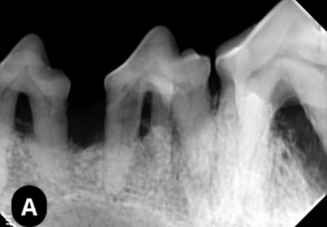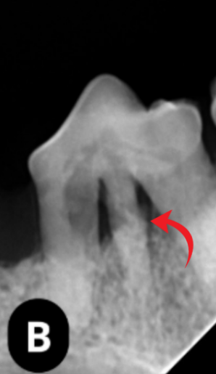
Figure 1. In A, digital intraoral radiograph obtained using the bisector technique. In B, digital intraoral radiograph using the Clark technique, demonstrating the presence of the accessory root.

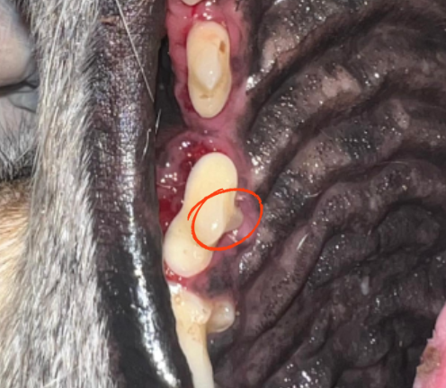
Figura 2. Photographic image of the upper right third premolar tooth (107), highlighting the evident supernumerary root (area marked in circle).

