Development and Evaluation of Inclined Plate Metering Mechanism for Groundnut Seed

Abstract
The study was conducted to evaluate the effect of forward speed, inclination angle of the metering plate, and cell size on the seed metering performance of a groundnut planter. The performance parameters considered were Quality of Feed Index, Multiple Index, Miss Index, and Average Seed Spacing, analyzed using Response Surface Methodology (RSM). Results revealed that the Quality of Feed Index ranged from 78% to 90%, with the highest value of 90% achieved at a forward speed of 1.5 km/h, inclination angle of 35°, and cell size of 7.975 mm. The Multiple Index and Miss Index varied between 2.5-12.5% and 0-12.5%, respectively, and both increased with higher forward speeds, larger cell sizes, and greater inclination angles. Average seed spacing ranged from 14.5 cm to 24.5 cm, with a spacing of 19.9 cm found closest to the target of 20 cm under the same optimal conditions. The results indicate that moderate operational settings-particularly a forward speed of 1.5 km/h, inclination angle of 35°, and cell size of 7.975 mm-provide the best overall metering performance and uniform seed placement, thereby improving planting efficiency.
Keywords: Seed metering plate, groundnut planter, performance parameters
Introduction
Precision planting refers to the accurate placement of individual seeds in the soil at predetermined spacing to ensure optimal plant population and uniform growth. Traditionally, such precision was achieved manually using hand dibblers. However, the development of sowing equipment fitted with single-seed metering mechanisms-known as precision planters-has enabled greater accuracy and efficiency in seed placement. The earliest precision planters were horizontal plate types, featuring cells along the periphery of the metering plate (Datta, 1974). The seed metering plate plays a pivotal role in planter machinery, regulating the pickup, transport, and deposition of seeds into the soil. The inclination angle of this plate-defined as the angle between the plate’s metering surface and a reference horizontal plane-significantly affects key planting performance parameters, including seed spacing, seed rate, missed and multiple-seed indices, seed damage, and emergence uniformity. In Indian agricultural practices, inclined plate planters are widely adopted for large-seeded crops such as maize, groundnut, soybean, chickpea, cotton, gram, and sunflower due to their superior seeding performance.
During seed metering, the plate moves through the hopper, lifts seeds to the top of its rotation, and releases them into the delivery tube (Kepner et al., 1978). Ideally, each cell on the plate should hold a single seed, ensuring complete cell fill and uniform seed distribution along the row-an essential factor for precision planting. Achieving consistent seed placement promotes uniform germination and crop emergence, ultimately enhancing yield by optimizing the utilization of soil moisture, nutrients, and sunlight (Donald, 1963).
However, under field conditions, occurrences of missed and multiple seed drops are inevitable, leading to non-uniform seed spacing. For inclined plate metering mechanisms, parameters such as forward operating speed, plate inclination angle, and seed level within the hopper greatly influence distribution uniformity (Chhinnan et al., 1975; Chauhan et al., 1999; Yadachi et al., 2013; Sharma et al., 2013). Despite existing research, limited studies have specifically examined the impact of metering plate inclination in groundnut planters, considering the crop’s distinct seed geometry, handling characteristics, planting depth, and row spacing requirements.
To improve the precision of such agricultural machinery, various optimization approaches have been employed to determine optimal operational parameters. Among these, statistical optimization techniques such as the Taguchi method and response surface methodology have been commonly utilized for parameter optimization in agricultural machinery (Yazgi & Degirmencioglu, 2007; Singh et al., 2008; Hosseini & Shamsi, 2012; Ozturk et al., 2012).
The present study therefore aims to systematically investigate the effect of varying the inclination angle, speed and cell size of the metering plate in a groundnut planter on performance parameters of seed metering in laboratory condition, providing design recommendations for improved groundnut planter development.
2. Materials and methods
2.1: Metering System
Mechanical seed metering devices in planter usually have cells on a moving member to have positive seed metering. Commonly recommended metering systems on planters are horizontal plate, inclined plate, vertical rollers with cells, and cups over the periphery (Anon, 1991). A large number of planter designs are available for smaller seeds, but very little information is available on small seed like groundnut, particularly under Indian situations. Hence, the present study was conducted with the objective to design the metering mechanism for groundnut and to evaluate it for uniformity of seed placement. The Chandra variety of groundnut was selected to design metering plate. Since groundnut seeds are very susceptible to mechanical damages, therefore, metering with vertical and horizontal plate metering mechanism were not considered. Laboratory experiment was thus conducted with inclined plate cell type metering mechanism. The metering plate was designed on the basis of engineering properties of groundnut and seed to seed spacing of groundnut. In this study seed to seed spacing was taken as 20 cm.

Diameter and number of cells
Diameter of the metering plate was determined as follows:

Diameter of the metering plate (D_{m}) = $\frac{V_{m}}{{πN}_{m}}$ (Sharma and Mukesh, 2010)
Where, D_{m} = Diameter of seed metering plate
V_{m} = Peripheral speed of plate (16.5 m/min for minimum breakage of seed)
N_{m} = RPM of the seed metering plate (50-60 rpm)
Putting the values in above equation D_{m} = $\frac{16.5 m/min}{3.14×50}$ = 0.105m = 10.5 cm ⁓ 11 cm
Number of cells on the periphery of the metering plate was determined on the basis of ground wheel diameter, gear ratio between ground wheel and metering plate and desired seed to seed spacing.

Number of cells was calculated by following equation:
Number of cells on periphery of metering plate = $\frac{π×D_{g}}{i×X}$
Where, D_{g} = Diameter of ground wheel, (38cm)
i = gear ratio (1:1)
X= seed to seed spacing (20cm)
Therefore, number of cells on the periphery of metering plate = $\frac{3.14×38}{1×20}$ = 5.96 ⁓ 6 cells
Physical and engineering properties of groundnut seeds
Physical and engineering properties of groundnut seeds relevant to the design and evaluation of the metering plate were determined (table 1).

Table 1. Physical and engineering properties of groundnut seeds

S. No. | Parameters | Maximum | Minimum | Average | SD
 | Length | 13.8 | 11.5 | 12.6 | 0.788
 | Width | 6.83 | 5.25 | 6.83 | 0.579
 | Thickness | 5.8 | 4.2 | 5.40 | 0.445
 | Equivalent diameter (mm) | 7.8 | 6.8 | 7.28 | 0.322
 | Sphericity | 0.63 | 0.50 | 0.58 | 0.045
 | Geometric mean diameter (mm) | 7.60 | 6.80 | 7.0 | 0.30
 | Angle of repose (degree) | 28.66 | 26.64 | 27.65 | 0.77
 | Coefficient of friction | 0.49 | 0.35 | 0.41 | 0.05

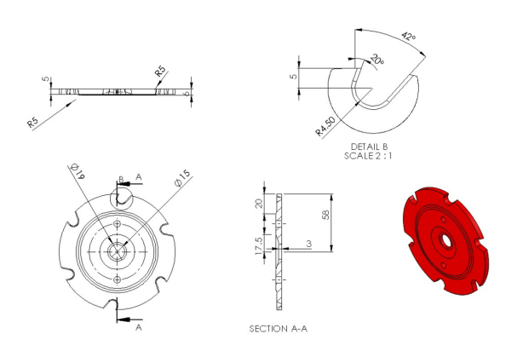
Fig. 1: View of CAD design of metering plate

Laboratory test of metering plate
Metering plate was tested for its performance at the laboratory, Department of Farm Machinery and Power Engineering, SHUATS, Prayagraj. Observations were taken on the spacing between two adjacent seeds for different independent and response variables listed in table 2. Metering plate was tested at three levels of planter speed i.e., 1, 1.5 and 2 km/h. Metering plate was set to three different angles with horizontal i.e., 25, 35 and 45 degrees. Further, three sizes of cells on the periphery of the plate were taken i.e., 7.25 (100% of the groundnut seed size), 7.975 (110% of the groundnut seed size) and 8.7 mm (120% of the groundnut seed size).

Table 2: Parameters under study
Independent variables | Levels | Level values | Dependent variables
Forward speed of planter (A) (km/h) | 3 | 1, 1.5, 2 | Seed spacing  Quality of feed index  Miss index  Multiple index
Inclination angle of plate (B) (Deg.) | 3 | 25, 35, 45
Size of cell (C) (mm) | 3 | 7.25, 7.97, 8.7

Performance parameters
Quality of feed index
The quality of feed index (I_{fq}) is the percentage of spacing that are more than half but no more than 1.5 times the theoretical spacing. The quality of feed index is an alternate way of presenting the performance of misses and multiples. The quality of feed index can be given as:

$$I_{fq}= \frac{n_{2}}{N}$$
or I_{fq} = 100 - (I_{miss} + I_{mult})
Where,
n₂ = Spacing that are more than half but no more than 1.5 times the theoretical spacing
N = Number of measured spacing

Miss index
For calculation of missing index in the field, distance of 5m was chosen randomly from each row at each speed. The distances between two successive seeds were measured using scale so that missing index can be calculated. For easy and accurate measurement of seed spacing, seeds were dropped at lower depth (at top surface) of the field. Missing index was calculated as:
$$I_{miss}= \frac{n_{1}}{N}$$
where: n₁ is number of spacing >1.5S
N is total number of measured spacing
Multiple index
The multiples index (I_{mult}) is defined as the percentage of spacing that are less than or equal to half of the theoretical spacing of the seeds. The multiples index is given as:
$$I_{mult}= \frac{n_{1}}{N}$$
Where,
N₁ = Number of in the first region
N = Number of spacing
Experimental Design
Response Surface Methodology (RSM) was used to design the experiment. Under RSM, Central Composite Design (CCD) was selected to design the experiment for the variables given in table 3.

Table.3: Design of experiment using CCD for laboratory evaluation of seed metering mechanism
Exp. No. | A: Forward speed  (km/h) | B: Inclination angle of seed box  (deg.) | C:Cell size (mm)
1 | 1.5 | 25 | 8.7
2 | 2 | 25 | 7.975
3 | 2 | 35 | 7.25
4 | 1.5 | 35 | 7.975
5 | 1 | 25 | 7.975
6 | 2 | 35 | 8.7
7 | 1.5 | 35 | 7.975
8 | 1 | 45 | 7.975
9 | 1.5 | 45 | 7.25
10 | 1.5 | 35 | 7.975
11 | 2 | 45 | 7.975
12 | 1.5 | 45 | 8.7
13 | 1.5 | 25 | 7.25
14 | 1.5 | 35 | 7.975
15 | 1 | 35 | 7.25
16 | 1.5 | 35 | 7.975
17 | 1 | 35 | 8.7

Results and Discussion

Average seed spacing
The seed spacing of groundnut was evaluated under various machine and operational parameters, namely the forward speed of the planter (A), the inclination angle of the metering plate (B), and the metering plate cell size. The experimental results obtained through the Response Surface Methodology (RSM) are presented in Table 2. The maximum seed spacing of 24.5 cm was recorded at a forward speed of 2 km/h, a plate inclination of 45°, and a cell size of 7.975 mm. Conversely, the minimum seed spacing of 14.5 cm occurred at a forward speed of 1 km/h, an inclination of 25°, and a cell size of 8.7 mm. Overall, the average seed spacing ranged between 14.5 cm and 24.5 cm. A seed spacing of 19.9 cm-closely aligning with the targeted spacing of 20 cm-was achieved at a forward speed of 1.5 km/h, an inclination angle of 35°, and a cell size of 7.975 mm (Figure 1). These results align with the findings of Rajaiah et al. (2018) for paddy planters and Udayveer et al. (2022) for groundnut planters, where similar effects of operational speed on seed spacing were reported. It was further observed that the average seed spacing increased notably with higher inclination angles of the metering plate and greater forward speeds. This trend can be attributed to the reduced efficiency of seed pickup by the metering plate cells under these conditions. Similarly, an increase in cell size also led to greater seed spacing, likely due to multiple seeds being captured within larger cells, thereby disrupting the uniformity of distribution.
(c) | (d)
Figure 2: Average seed spacing (a) forward speed and inclination angle of seed metering plate (b) forward speed and cell size (c) cell size and inclination angle of seed metering plate (d) predicted vs actual
Miss Index
The maximum miss index of 12.5% was recorded at a forward speed of 2 km/h, a metering plate inclination of 45°, and a cell size of 7.975 mm. The minimum miss index, recorded at 0%, occurred at a forward speed of 1.5 km/h, an inclination angle of 25°, and a cell size of 8.7 mm. Overall, the miss index values ranged between 0% and 12.5%. The influence of forward speed (A), inclination angle (B), and cell size (C) on the miss index is illustrated in Figure 2. It was observed that the average miss index increased noticeably with an increase in the inclination angle of the metering plate. Similar observations were reported by Yadachi et al. (2012). This phenomenon can be attributed to the improper pickup of seeds by the metering cells at higher inclination angles. Additionally, an increase in the cell size of the metering plate also led to a higher miss index, which may be due to the tendency of larger cells to capture multiple seeds irregularly, thereby affecting uniformity in seed metering.
 | 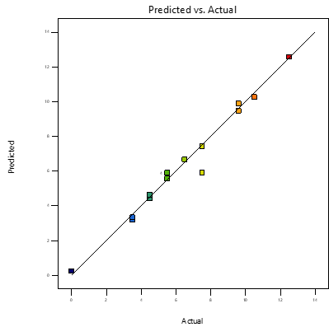
(c) | (d)
Figure 3: Miss index (a) forward speed and inclination angle of seed metering plate (b) forward speed and cell size (c) cell size and inclination angle of seed metering plate (d) predicted vs actual
Multiple Index
The maximum multiple index of 12.5% was observed at a forward speed of 1.5 km/h, a metering plate inclination angle of 25°, and a cell size of 8.7 mm. Conversely, the minimum multiple index of 2.5% occurred at a forward speed of 1 km/h, an inclination angle of 35°, and a cell size of 7.25 mm. The multiple index values were found to range between 2.5% and 12.5%. The influence of forward speed (A), inclination angle (B), and cell size (C) on the multiple index is illustrated in Figure 3. It was evident that the multiple index increased notably with a decrease in the inclination angle of the metering plate. Furthermore, an increase in both the forward speed of the planter and the cell size of the metering plate also resulted in a higher multiple index. This behavior can be attributed to the improper pickup of seeds by the metering plate cells at lower inclination angles and higher operating speeds. Similarly, larger cell sizes tend to capture more than one seed at a time, leading to multiple seed drops and consequently higher multiple index values.
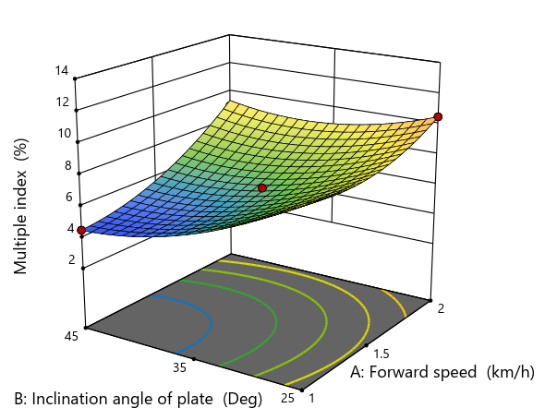 | 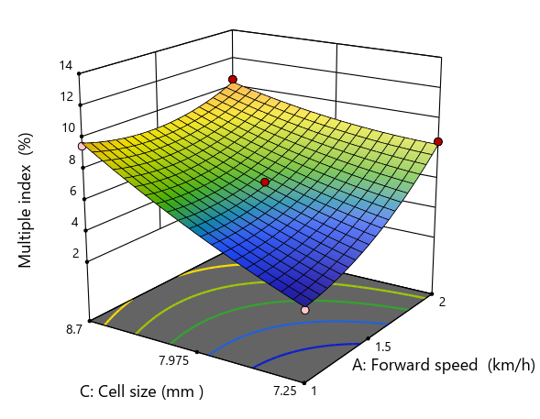
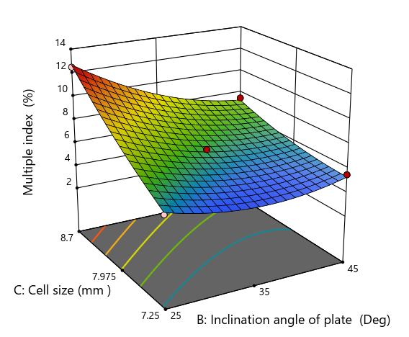 | 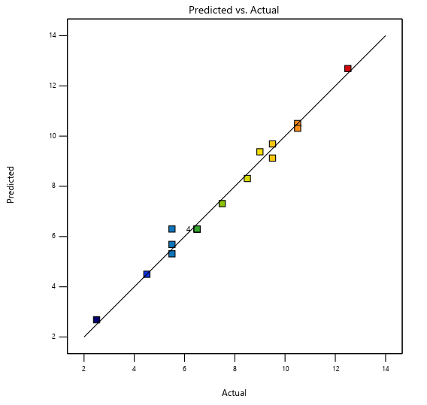
(c) | (d)
Figure 4: Multiple index (a) forward speed and inclination angle of seed metering plate (b) forward speed and cell size (c) cell size and inclination angle of seed metering plate (d) predicted vs actual
Quality of Feed Index
The maximum Quality of Feed Index (QFI) of 90% was recorded at a forward speed of 1.5 km/h, an inclination angle of 35°, and a cell size of 7.975 mm. The minimum QFI of 78% was observed at a forward speed of 2 km/h, an inclination angle of 45°, and the same cell size of 7.975 mm. Overall, the QFI values ranged between 78% and 90%. The combined effects of forward speed (A), inclination angle (B), and cell size (C) on the Quality of Feed Index are illustrated in Figure 4. It was observed that the QFI initially increased and subsequently decreased with rising inclination angles of the metering plate and higher forward speeds. This trend can be attributed to the fact that, at lower inclination angles, the multiple index was higher, whereas at higher inclination angles (45°), the miss index increased-both leading to a reduction in overall QFI. The intermediate operating conditions, particularly an inclination angle of 35° and a forward speed of 1.5 km/h, resulted in the highest QFI of 90% due to minimal miss and multiple indices under these settings. Although the cell size of the metering plate also influenced QFI, the corresponding F-value was found to be statistically insignificant.
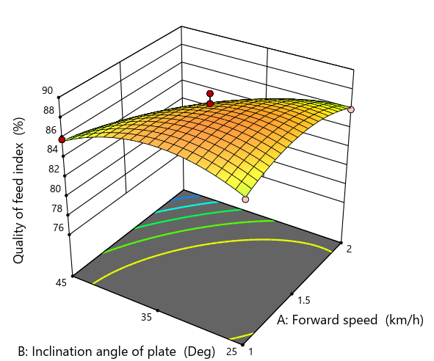 | 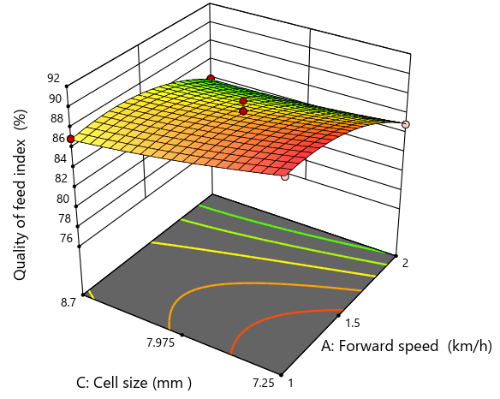
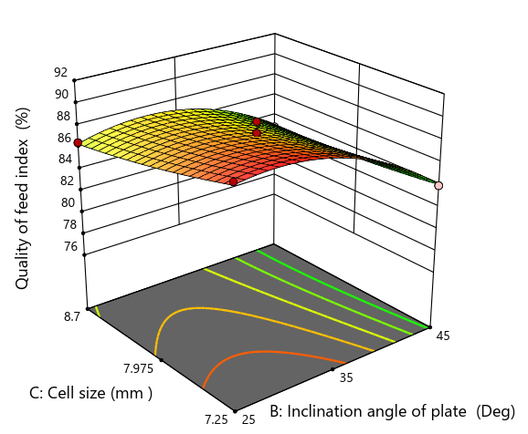 | 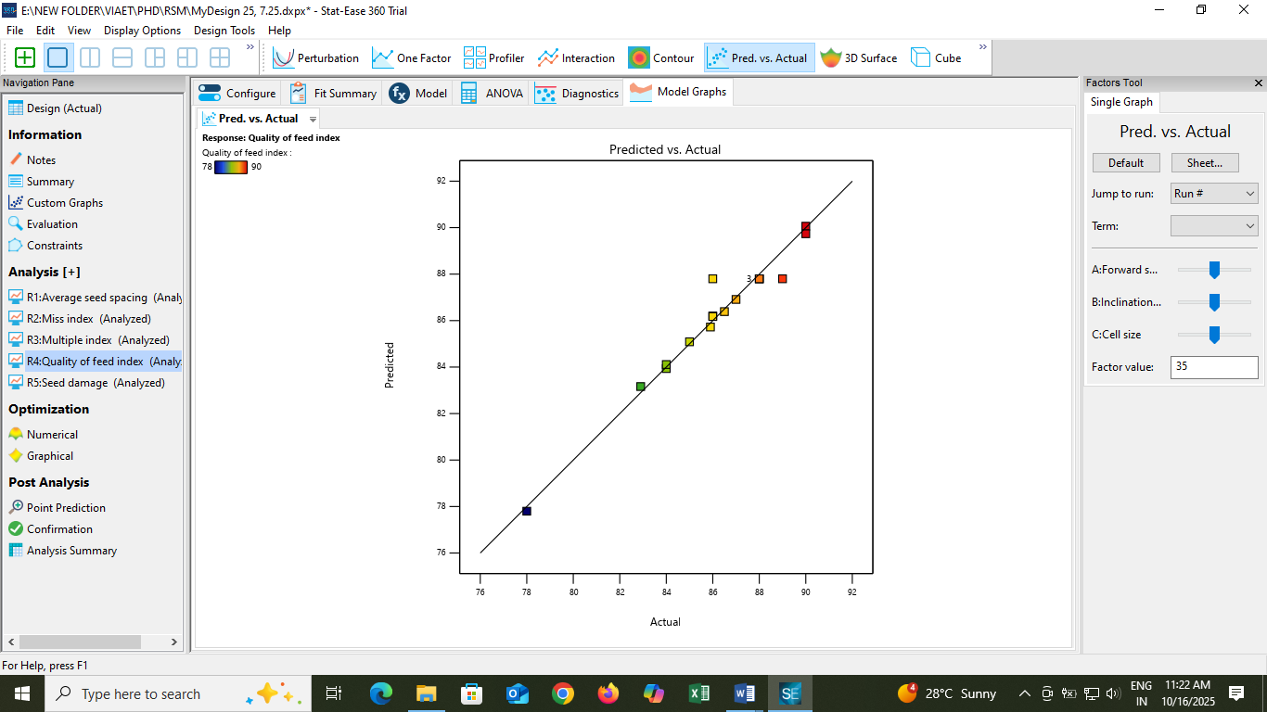
(c) | (d)
Figure 5: Quality of feed index (a) forward speed and inclination angle of seed metering plate (b) forward speed and cell size (c) cell size and inclination angle of seed metering plate (d) predicted vs actual
Conclusion:
The performance of the planter was significantly influenced by the forward speed, inclination angle of the metering plate, and cell size. The optimal operating condition for achieving the highest Quality of Feed Index (90%) was found at a forward speed of 1.5 km/h, an inclination angle of 35°, and a cell size of 7.975 mm. At this setting, both miss and multiple indexes were minimized. Increasing the inclination angle, cell size, or forward speed beyond these values led to higher miss and multiple indexes and lower feed quality. Therefore, maintaining moderate operational parameters ensures efficient seed placement and uniform spacing for improved planting performance.

DISCLAIMER (ARTIFICIAL INTELLIGENCE)

Author(s) hereby declare that NO generative AI technologies such as Large Language Models (ChatGPT, COPILOT, etc) and text-to-image generators have been used during writing or editing of this manuscript.

References
Chauhan, A. M., Dhingra, H. S., & Bhatia, B. S. (1999). Seed placement behaviour of sunflower. AMA, Agricultural Mechanization in Asia, Africa and Latin America, 30(4), 9–11.
Chhinnan, M. S., Young, J. H., & Rohrbach, R. P. (1975). Accuracy of seed spacing in peanut planting. Transactions of the ASAE, 18, 828–831.
Datta, R. K. (1974). Development of some seeders with particular reference to pneumatic seed drills. The Harvester, Indian Institute of Technology, Kharagpur, 16, 26–29.
Donald, C. M. (1963). Competition among crop and pasture plants. Advances in Agronomy, 15, 1–118.
Hosseini, S. S., & Shamsi, M. (2012). Performance optimization of a rotary mower using Taguchi method. Agronomy Research, 10(1), 49–54.
Kepner, R. A., Bainer, R., & Barger, B. L. (1978). Crop planting. In Principles of Farm Machinery (3rd ed., pp. 209–236). CBS Publishers and Distributors, India.
Ozturk, I., Yildirim, Y., Hinislioglu, S., Demirl, B., & Kus, E. (2012). Optimization of seed flow evenness of fluted rolls used in seed drills by Taguchi method. Scientific Research and Essays, 7(1), 78–85.
Pardeshi, I. L., Singh, K. P., Kumar, M., Srinivas, K., & Srivastva, A. K. (2008). Optimization of machine parameters for a precision planter. Biosystems Engineering, 100, 591–600.
Rajaiah, P., Mani, I., Kumar, A., Lande, S. D., Parray, R. A., Singh, A. K., & Vergese, C. (2018). Comparative study of mechanical and electronic paddy planter for direct seeding. International Journal of Current Microbiology and Applied Sciences, 7(9), 1284–1294.
Sharma, D. N., & Mukesh. (2008). Farm Machinery Design.
Sharma, V. K., Sharma, D. N., & Kumar, D. (2013). Development and evaluation of tractor drawn inclined cell plate type Bt cotton planter. International Journal of Agricultural Engineering, 6(2), 329–334.
Singh, U. V., Moses, S. C., Maheshwari, T. K., & Alam, R. N. (2018). Comparative study of mechanical and electronic paddy planter for direct seeding. International Journal of Current Microbiology and Applied Sciences, 7(9), 1284–1294.
Yadachi, S., Mani, I., Kalra, M. S., Kumar, A., & Sahoo, P. K. (2013). Development and evaluation of inclined plate metering mechanism for carrot seed. Agricultural Engineering Today, 35(1), 10–16.
Yazgi, A., & Degirmencioglu, A. (2007). Optimization of the seed spacing uniformity performance of a vacuum-type precision seeder using response surface methodology. Biosystems Engineering, 97(3), 347–356.

