INTELLIGENT DRILLING OPTIMIZATION SYSTEMS: USING MACHINE LEARNING AND AUTOMATION TO REDUCE NONPRODUCTIVE TIME AND IMPROVE WELL DELIVERY OUTCOMES

ABSTRACT

Aim: This study examines how intelligent drilling optimization systems (IDOS), driven by machine learning (ML) and automation technologies, can reduce nonproductive time (NPT) and enhance well delivery outcomes in the oil and gas industry. It aims to synthesize recent developments in artificial intelligence (AI)-based drilling systems, highlighting their operational benefits, performance improvements, and potential challenges.
Study Design: A comprehensive peer review of recent advancements in intelligent drilling optimization between 2020 and 2025, focusing on the integration of ML algorithms, automation frameworks, and real-time data analytics in upstream petroleum operations. The review emphasizes the practical impact of these technologies on NPT reduction, drilling efficiency, and sustainable well delivery.
Methodology: The review adopts a systematic approach, sourcing publications from Google Scholar, Scopus, ScienceDirect and IEEE Xplore. Studies were selected based on relevance to predictive analytics, automation in well control, and data-driven optimization.
Results: Findings reveal that ML and automation technologies significantly improve drilling performance by enabling predictive maintenance, real-time anomaly detection, and autonomous control of drilling parameters. Algorithms such as artificial neural networks (ANNs), support vector machines (SVM), and reinforcement learning (RL) have achieved measurable reductions in NPT—ranging from 20% to 35%—by forecasting downhole conditions and optimizing rate of penetration (ROP). Additionally, the integration of digital twins and edge computing has improved simulation accuracy, minimized operational risks, and facilitated adaptive decision-making. The convergence of robotics, IoT, and cloud analytics further supports continuous optimization and improved well delivery performance.
Conclusions: Intelligent drilling systems remain limited by challenges such as data heterogeneity, lack of model standardization, and skill gaps in AI implementation. Future research should focus on hybrid modeling approaches that combine physics-based and ML-driven analytics, as well as developing unified frameworks for cross-field data integration to enhance scalability and interpretability.

Keywords: Intelligent Drilling, Machine Learning, Nonproductive Time, Artificial Intelligence, Reinforcement Learning.

1. INTRODUCTION

The oil and gas industry has undergone immense digital transformation in recent years, particularly regarding drilling optimization. While exploration and production are moving toward more complex geological environments, operational efficiency with a reduction of nonproductive time has become a key concern for operators [1]. Conventionally, drilling operations were heavily reliant on human expertise and discretionary decisions. While these may have been effective in certain contexts, too often this led to delays, safety risks, and inefficiencies because of unpredictable subsurface conditions [2, 3]. Digitalization and advanced data analytics have made it possible to incorporate ML and automation into the drilling process as an innovative game-changer-a new class of systems known as Intelligent Drilling Optimization Systems, or IDOS [4 – 6]. These utilize AI, big data, and automation to optimize drilling parameters, predict anomalies, and improve well delivery outcomes in real-time (See Figure 1).

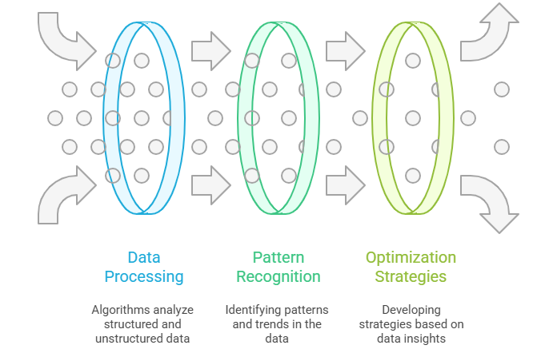

Figure 1: Data Processing for Drilling Optimization

Intelligent drilling optimization relies on data-driven algorithms that can process massive volumes of structured and unstructured data generated by sensors, logging tools, mud systems, and downhole instruments during drilling operations [7, 8]. Machine learning models such as ANN, SVM, RF, and deep learning algorithms are then applied to analyze streams of these data with the aim of predicting drilling dysfunctions, estimating the rate of penetration, and providing optimum weight-on-bit and rotary speed parameters [9, 10]. These models are strong in their ability to learn from previous operations and their improvement with increased data gathering. The ability to self-learn and adapt automatically constitutes what makes ML-based drilling systems superior to conventional methods that rely on static empirical formulas or engineering heuristics.

Automation amplifies this capability by allowing intelligent systems to perform drilling adjustments autonomously. The automated systems utilize real-time monitoring tools through feedback control loops, making alterations to the drilling parameters in real time for optimal performance in wells with unforeseeable conditions [11, 12]. For instance, automated rigs fitted with robotics and advanced sensors can manage repetitive tasks that are hazardous to humans, reducing their exposure to hazardous environments and hence boosting their safety performance [13]. These systems also allow consistent execution of drilling and better operational predictability for cost reduction and higher well delivery rates.

Some of the most innovative development in recent years is the application of digital twins in drilling operations. The digital twin herein refers to a virtual replica of a physical drilling system that effectively simulates and mirrors real-time data (See Figure 2).

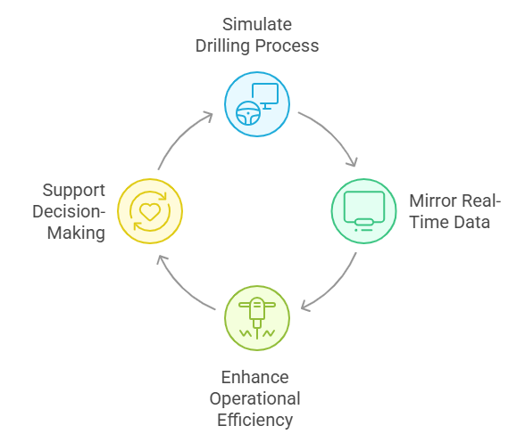

Figure 2: Digital Twin Cycle for Drilling Systems

This technology enables engineers to anticipate problems, optimize drilling plans, and develop informed decisions based on accurate virtual models [13, 14]. Digital twins can simulate wellbore conditions and foresee potential failures before they actually happen, thus helping operators plan intervention in advance [15]. When combined with cloud computing and IoT technologies, digital twins improve collaboration among the remote drilling teams and onsite personnel, enabling better decision-making processes [16, 17].

In regard to the adoption of intelligent drilling systems, significant and measurable improvements in key performance indicators, such as NPT reduction, ROP enhancement, wellbore stability improvement, and drilling accuracy improvement, have been realized. Predictive maintenance applications have been one of the successful stories in preventing equipment failure and reducing downtime [18, 19]. Furthermore, ML algorithms using historical data learned from wells have been able to predict drilling hazards related to differential sticking, kick detection, and bit wear. The ability of these predictive analytics not only to smoothen operations but also to make environmental sense in reducing energy waste and optimizing resource utilization is a positive attribute [20 – 22].

Despite this remarkable progress, several issues still hamper the full unleashing of intelligent drilling optimization. Data quality and availability are among the major barriers to implementing IO. Drilling operations generate a large volume of heterogeneous data from different manufacturers, formats, and legacy systems, which makes data integration complicated [23, 24]. Poor data labeling and inconsistency can decrease the accuracy of ML models and hamper their reliability in real-world applications. Another major challenge is the deficiency of standardized frameworks and protocols for implementing intelligent systems across the wide spectrum of drilling environments. Different regions and operators use different workflows and technologies, which creates difficulty in developing universally applicable models [25].

While the field of automation has clear benefits, it also creates new problems, especially regarding the adaptation of the workforce and ethical concerns. Increased reliance on autonomous systems means less human overview, raising problems of accountability and trust in algorithmic decision-making. There is a gap in the skills workforce, with many professionals in the oil and gas sector lacking proper training in AI, data science, and automation technologies, thus limiting intelligent system adoption on a global level [26 – 28]. However, the growing application of intelligent drilling optimization systems is a reflection of the wider trend of digitization now sweeping across industrial sectors under the banner of Industry 4.0. Within oil and gas exploration, this transformation emphasizes the amalgamation of cyber-physical systems, IoT, and advanced analytics in driving towards operational excellence [23, 24, 19]. By integrating these technologies, drilling operations become increasingly autonomous, data-centric, and predictive rather than reactive. Machine learning algorithms can, for example, perform real-time pattern recognition, which pinpoints subtle changes in drilling parameters that could potentially indicate hazardous or inefficient situations. Likewise, IoT sensors at the rig floor, mud pumps, and downhole environments collect continuous streams of data that feed AI-driven models, adjusting parameters such as torque, pressure, and bit speed. This dynamic interplay between automation and data intelligence ensures decisions are both rapid and evidence-based to execute safer and more cost-effective well delivery [22].

More importantly, well drilling optimization contributes much to the sustainability and environmental responsibility of contemporary energy production. Drilling operations quite often provoke criticism concerning their environmental impact in terms of energy consumption, emission, and waste disposal. Data-driven optimization allows firms to save energy, decrease drilling waste, or increase the lifetime of drilling equipment by maintaining optimal operating conditions [23]. For instance, predictive maintenance systems can identify early signs of wear on drill bits or mud motors, thus allowing the reduction of catastrophic failures along with material waste [30]. Automation also decreases the necessity for repetitive manual operations, which means a reduction in human error and an increase in operational safety. In the long term, such improvements not only reduce operation costs but also contribute to global sustainability objectives such as net-zero emissions and resource efficiency. The synergy between ML, automation, and sustainability therefore reshapes the oil and gas landscape, moving it closer to a more intelligent and responsible future for drilling operations.

Although various works have been conducted on machine learning and automation for drilling optimization, a number of research gaps still exist. First, there is a need for standardized and interoperable frameworks that can integrate data from multiple drilling platforms for enhancing model generalization. Also, few studies have ever tried integrating physics-based models with data-driven approaches, though such combinations could improve predictive accuracy and interpretability. This study tends to address this gap as it will not only strengthen the scientific understanding of intelligent drilling systems but also accelerate their practical implementation for safer, more efficient, and more sustainable oil and gas operations.

2. METHODOLOGY

The adopted methodology in this study was a peer review approach, which aimed to synthesize recent research regarding the application of intelligent drilling optimization systems using machine learning and automation to minimize nonproductive time and improve well delivery performance. The review process was based on a structured approach to identifying, assessing, and summarizing key studies that provided insights into the integration of AI, data analytics, and automated control systems in drilling operations. The search for literature was done based on reputable and scholarly databases, including Google Scholar, Scopus, IEEE Xplore, and ScienceDirect. These databases were chosen since they represent the most extensive coverage of engineering, energy, and computer science publications that address drilling technologies, automation, and AI applications.

Relevant articles published within the period of 2020-2025 were identified to mark the beginning of the literature search. A set of key search terms, including “intelligent drilling optimization,” “machine learning in well drilling,” “automation in oilfield operations,” “nonproductive time reduction,” and “real-time drilling data analytics,” was used to retrieve a total of 165 records from Google Scholar (n = 65), Scopus (n = 45), IEEE Xplore (n = 30), and ScienceDirect (n = 25). After removing duplicates, 115 unique records remained and underwent screening based on title and abstract. Out of these, 85 studies were excluded as they were either unrelated to drilling optimization or dealing with conventional, non-automated drilling techniques. Further, some articles were excluded based on being merely conceptual comments and reviews unsupported by any empirical evidence. Therefore, 30 full-text articles were assessed for eligibility, out of which 11 studies have been finally selected to include in this qualitative analysis. The selection of studies was based on their empirical or simulation-based orientation toward machine learning algorithms, predictive analytics, and automated drilling control systems aimed at improving drilling efficiency and reducing related operational downtime.

The studies were reviewed, considering credibility and recency. It included only peer-reviewed publications in the English language to maintain accuracy and reliability of the findings. Selected studies were analyzed concerning methodological aspects, models used for analyses, and the research findings. Most of the reviewed research employed data-driven modeling, optimization algorithms such as reinforcement learning and neural networks, and real-time data analytics for drilling performance prediction. The integration of automation technologies, including robotic control systems and sensor-based data acquisition, also often emerged as a necessary component for building intelligent drilling systems.

However, the review was not without its limitations. One major limitation was the exclusion of non-English publications, where valuable insights could have been omitted in regions that are rapidly advancing in oilfield automation. Another limitation is related to the diversity of methodological approaches among the selected studies, making some direct comparisons of results difficult to perform. Despite these constraints, this review gives a comprehensive synthesis of current knowledge and shows how machine learning and automation transform the process of drilling collectively into one that is more efficient, predictive, and less prone to errors.

3. RESULTS AND DISCUSSION

3.1 Reduction of Non‑Productive Time (NPT) through ML‑Driven Systems

This study shows that intelligent drilling optimization systems, integrating machine‑learning algorithms, real‑time data analytics, automation, and digital twin environments, have the potential to drastically reduce NPT (See Figure 3) in drilling operations. It has been shown that real‑time monitoring, when supplemented with predictive maintenance and anomaly detection frameworks, enables reductions in NPT of 20 % to 35% [16, 31 – 34]. These improvements are driven by three primary mechanisms: Firstly, ML models enable early detection of anomalies like pump failures, drill‑string washouts, or unexpected torque events, thus leading to timely interventions before these events escalate into expensive downtime [9, 10]. Secondly, the optimization of drilling parameters in real time, such as WOB, RPM, flow rates, and hydraulics, is improving ROP and reducing non‑productive events [35].

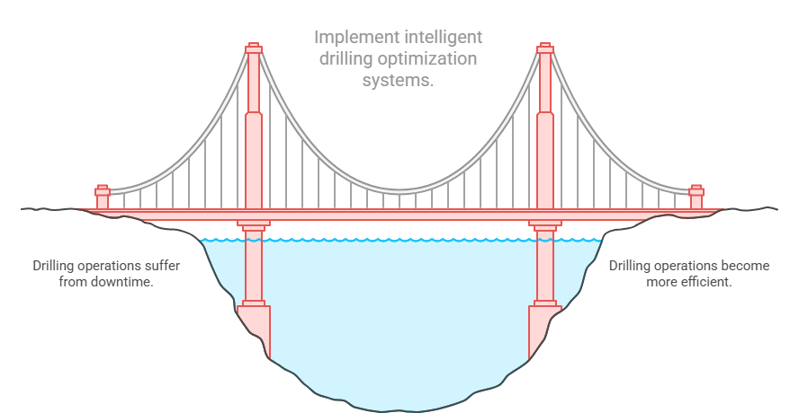

Figure 3: Reducing NPT in Intelligent Drilling Optimization

Also, integrated digital twins, edge computing, and IoT sensor networks ensure a coherent data ecosystem supporting rapid decision-making and adaptive response at the rig [17, 36, 37]. Altogether, these methods make it possible for drilling teams to operate more effectively, deliver wells more consistently, and achieve measurable reductions in non‑productive time, confirming the transformative potential of IDOS in modern upstream operations.

3.2 Improvement in Drilling Efficiency and Well Delivery Outcomes

Beyond reducing non-productive time, IDOS significantly improve drilling efficiency and well delivery metrics. ANN-based models for ROP prediction have shown predictive accuracy with coefficients of determination around 0.92–0.93, well above that of traditional empirical models [31, 38]. Similarly, optimization studies using multilayer perceptron networks in conjunction with evolutionary algorithms have also reported ROP improvements exceeding 50% in field applications [34, 39]. In addition, machine-learning algorithms on drilling hydraulics, such as standpipe pressure and annular pressure loss predictions, assist in real-time decision-making and efficient adjustments of parameters, leading to reduced delays in operations and improvement in well performance [5, 9, 40]. These results confirm that IDOS are not limited to the reduction of wasted time but are effective in optimizing the productive phase of drilling, enabling faster, safer, and more consistent well delivery.

3.3 Role of Automation, Digital Twins and Edge Computing

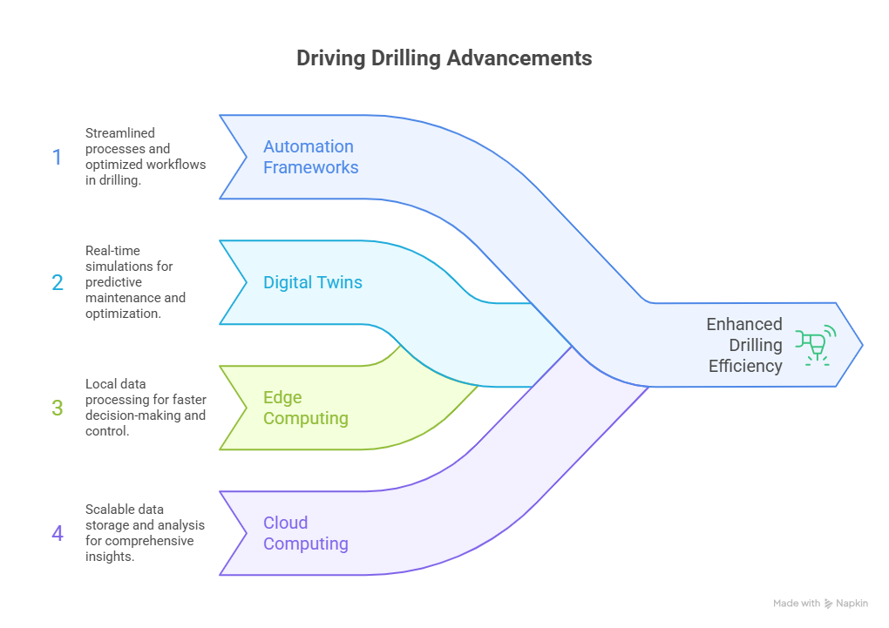

Figure 4: Enhancing Drilling Efficiency

Automation frameworks, digital twins, and edge or cloud computing are thus critical enablers of the improvements seen in drilling efficiency (See Figure 4) and NPT reduction. Digital twins allow operators to simulate drilling scenarios in real time, assess interactions between parameters, and predict potential problems before they happen [15, 31, 41]. Edge computing and IoT sensor networks provide immediate processing and communication of data to enable automation systems to make proactive adjustments in drilling parameters. Consequently, the combination of ML models with this integrated infrastructure assures that data-driven insights can be translated into actionable operations on the rig without delay [40]. The literature unequivocally points out that the synergy of these technologies, rather than the application of ML in isolation, produces the most significant performance gains, confirming that system architecture and real-time adaptability remain keys to maximizing the benefits of IDOS.

3.4 Challenges and Limitations

Despite promising results, a number of challenges persist in the deployment of IDOS. Data heterogeneity and quality remain major hurdles. Variations in rig configurations, sensor types, formation geology, and operation protocols generate fragmented datasets that might affect model performance and generalizability [7, 23, 42]. Model interpretability is another concern; the "black-box" nature of deep neural networks generally limits trust and adoption among drilling engineers [9, 28, 34]. Workforce skills and organizational readiness form other barriers: successful implementation requires training personnel in ML interpretation, automation interfaces, and data governance [26, 29]. In addition, scalability and transferability of ML models across different rigs, fields, or geological settings remain limited, while many successful case studies remain context-specific [4, 25]. Finally, pure data-driven models without integration of physics-based insights can be incomplete for such complex scenarios where wellbore mechanics, bit wear, and formation interactions dominate; hence, hybrid modeling approaches are necessary to integrate ML with physics-based analytics [15, 29].

3.5 Synthesis and Future Directions

Synthesis of the literature reviewed suggests that the IDOS involving ML, automation, and real-time data demonstrates consistently strong potentials for NPT reduction by approximately 20–35%, while improving ROP and holistic well delivery performance. Full potential benefits are realized when predictive monitoring, anomaly detection, and automated adjustment of parameters occur in concert rather than in isolation. Current bottlenecks do not relate to algorithmic capability but rather to issues of data infrastructure, model interpretability, interoperability across rigs and fields, and organization readiness. In these regards, future development must be focused on hybrid modeling approaches which embed physics-based and ML-driven analytics, the development of uniform data frameworks to facilitate integration across multiple fields, and workforce training programs targeted at both analytical and operational competencies. In this regard, edge computing, IoT networks, and high bandwidth communications, including 5G offshore, will further enable autonomous and adaptive well delivery systems [17, 31, 34].

3.6 Implications for Well Delivery Performance

The operational impact of IDOS adoption is significant. Reduced NPT directly relates to faster drilling cycles, better rig utilization, and lower cost per foot drilled. Better predictive capabilities on downhole conditions enable drilling teams to proactively optimize parameters, reducing bit wear, enhancing ROP, and mitigating risks such as stuck pipe, kicks, or washouts. Digital twin frameworks allow scenario simulations and real-time optimization, offering more consistent benchmarking of well delivery performance. With exploration and production increasingly being done in deep water, ultra-deep, and unconventional wells, the agility and predictive capability availed by IDOS become critical elements for attaining operational efficiency and competitiveness. Overall, intelligent, automated drilling optimization offers a clear pathway to safer, faster, and more cost-effective well delivery in complex operational environments.

4. CONCLUSION

This review shows that IDOS fuses machine learning, automation, real-time analytics, and digital twins into one powerful transformative capability for upstream petroleum operations. Evidence from recent studies indicates that IDOS is able to reduce non-productive time while improving drilling efficiency, rate of penetration, and key overall well delivery outcomes. The greatest benefits are achieved when predictive monitoring, real-time parameter optimization, and automation are applied in a synergistic manner. However, these advantages are constrained by several challenges, including data heterogeneity, model interpretability, workforce skill gaps, and limited scalability across different rigs or geological settings. To fully harness the potential of IDOS, future research and industry efforts need to be directed at hybrid physics-ML modelling, unified data frameworks, and organizational capacity building. In general, the deployment of intelligent drilling optimization affords a pathway to safer, faster, and more cost-efficient well delivery in an increasingly complex drilling environment.

REFERENCES

1. Alagoz E, Alghawi Y, Ergul MS. Innovation in exploration and production: How technology is changing the oil and gas landscape. Journal of Energy and Natural Resources. 2023;12(3):25-9.

2. Ochulor OJ, Sofoluwe OO, Ukato A, Jambol DD. Technological advancements in drilling: A comparative analysis of onshore and offshore applications. World Journal of Advanced Research and Reviews. 2024;22(2):602-11.

3. Adekoya OO, Isong D, Daudu CD, Adefemi A, Okoli CE, Tula OA. Reviewing the advancements in offshore drilling technologies in the USA and their global impact. World Journal of Advanced Research and Reviews. 2024;21(1):2242-9.

4. Agbaji AL. An empirical analysis of artificial intelligence, big data and analytics applications in exploration and production operations. InInternational Petroleum Technology Conference 2021 Mar 16 (p. D101S043R001). IPTC.

5. Ogbu AD, Ozowe W, Ikevuje AH. Data science’s pivotal role in enhancing oil recovery methods while minimizing environmental footprints: An insightful review. Computer Science & IT Research Journal. 2024;5:1621-33.

6. Wang J, Luo X, Zhang X, Du S. Artificial General Intelligence (AGI) Applications and Prospect in Oil and Gas Reservoir Development. Processes. 2025;13(5):1413.

7. Zhou X, Li W, Dong W. Big data-driven oil well optimization: Technological innovation and future outlook. Advances in Resources Research. 2024 Oct 18;4(4):534-50.

8. Onukwulu EC, Agho MO, Eyo-Udo NL, Sule AK, Azubuike C. Advances in automation and AI for enhancing supply chain productivity in oil and gas. International Journal of Research and Innovation in Applied Science. 2024;9(12):654-87.

9. Olukoga TA, Feng Y. Practical machine-learning applications in well-drilling operations. SPE Drilling & Completion. 2021 Dec 15;36(04):849-67.

10. Olafadehan OA, Ahaotu ID. Comparative analysis of machine learning algorithms in predicting rate of penetration during drilling. Journal of Petroleum Chemistry and Engineering. 2023;1(1):32-47.

11. Jamil N, Khan MR, Ali Shah SH, - Z, Al Maktoumi AS. Enhancing Drilling Efficiency Through Automated Data Management and Artificial Intelligence for Real-Time Monitoring Services. InSPE EOR Conference at Oil and Gas West Asia 2025 May 12 (p. D011S012R003). SPE.

12. Enemosah A. Intelligent decision support systems for oil and gas control rooms using real-time AI inference. International Journal of Engineering Technology Research & Management. 2021 Dec;5(12):236-44.

13. Egbumokei PI, Dienagha IN, Digitemie WN, Onukwulu EC, Oladipo OT. Automation and worker safety: Balancing risks and benefits in oil, gas and renewable energy industries. International Journal of Multidisciplinary Research and Growth Evaluation. 2024 Jul;5(4):2582-7138.

14. Wanasinghe TR, Wroblewski L, Petersen BK, Gosine RG, James LA, De Silva O, Mann GK, Warrian PJ. Digital twin for the oil and gas industry: Overview, research trends, opportunities, and challenges. IEEE access. 2020 Jun 1;8:104175-97.

15. Saini GS, Fallah A, Ashok P, van Oort E. Digital twins for real-time scenario analysis during well construction operations. Energies. 2022 Sep 8;15(18):6584.

16. Meza EB, Souza DG, Copetti A, Sobral AP, Silva GV, Tammela I, Cardoso R. Tools, Technologies and Frameworks for Digital Twins in the Oil and Gas Industry: An In-Depth Analysis. Sensors. 2024 Oct 6;24(19):6457.

17. Narayana SS. Synergizing edge computing and cloud integration for enhanced efficiency in the oil and gas industry. J. Comput. Eng. Technol. 2024;15:63-71.

18. Tiddens W, Braaksma J, Tinga T. Exploring predictive maintenance applications in industry. Journal of quality in maintenance engineering. 2022 Feb 11;28(1):68-85.

19. Molęda M, Małysiak-Mrozek B, Ding W, Sunderam V, Mrozek D. From corrective to predictive maintenance—A review of maintenance approaches for the power industry. Sensors. 2023 Jun 27;23(13):5970.

20. Adekunle BI, Chukwuma-Eke EC, Balogun ED, Ogunsola KO. A predictive modeling approach to optimizing business operations: A case study on reducing operational inefficiencies through machine learning. International Journal of Multidisciplinary Research and Growth Evaluation. 2021;2(1):791-9.

21. Ukoba K, Olatunji KO, Adeoye E, Jen TC, Madyira DM. Optimizing renewable energy systems through artificial intelligence: Review and future prospects. Energy & Environment. 2024 Nov;35(7):3833-79.

22. Bansod M. Advanced Predictive Analytics Driving Sustainable and Equitable Green Innovations Through Data-Driven Optimization and Strategic Insights. InAdvancing Social Equity Through Accessible Green Innovation 2025 (pp. 1-16). IGI Global Scientific Publishing.

23. Nguyen T, Gosine RG, Warrian P. A systematic review of big data analytics for oil and gas industry 4.0. IEEE access. 2020 Mar 9;8:61183-201.

24. Shah V, Shah J, Dudhat K, Mehta P, Shah M. Big data analytics in oil and gas industry. Emerg. Technol. Sustain. Smart Energy. 2022 Aug 3:37-55.

25. Epelle EI, Gerogiorgis DI. A review of technological advances and open challenges for oil and gas drilling systems engineering. AIChE Journal. 2020 Apr;66(4):e16842.

26. Johnson M, Jain R, Brennan-Tonetta P, Swartz E, Silver D, Paolini J, Mamonov S, Hill C. Impact of big data and artificial intelligence on industry: developing a workforce roadmap for a data driven economy. Global Journal of Flexible Systems Management. 2021 Sep;22(3):197-217.

27. Sircar A, Yadav K, Rayavarapu K, Bist N, Oza H. Application of machine learning and artificial intelligence in oil and gas industry. Petroleum Research. 2021 Dec 1;6(4):379-91.

28. Tariq Z, Aljawad MS, Hasan A, Murtaza M, Mohammed E, El-Husseiny A, Alarifi SA, Mahmoud M, Abdulraheem A. A systematic review of data science and machine learning applications to the oil and gas industry. Journal of Petroleum Exploration and Production Technology. 2021 Dec;11(12):4339-74.

29. Wanasinghe TR, Trinh T, Nguyen T, Gosine RG, James LA, Warrian PJ. Human centric digital transformation and operator 4.0 for the oil and gas industry. Ieee Access. 2021 Aug 9;9:113270-91.

30. Nwulu EO, Elete TY, Erhueh OV, Akano OA, Omomo KO. Leveraging predictive modelling to enhance equipment reliability: A generic approach for the oil and gas industry. International Journal of Engineering Research and Development. 2024;20(11):951-69.

31. Li G, Song X, Tian S, Zhu Z. Intelligent drilling and completion: A review. Engineering. 2022;18:33–48.

32. Du S, Huang C, Ma X, Fan H. A review of data-driven intelligent monitoring for geological drilling processes. Processes. 2024 Nov 8;12(11):2478.

33. Liu G, Tang Y, Zhang H, Li R, Wang H, Liu B, Zhang S, Zhu H, Liu D, Ma S. Advances in artificial intelligence and digital twin for tunnel boring machines. Artificial Intelligence Review. 2025 Jun 4;58(9):257.

34. Sui D. Real-Time Drilling Performance Optimization Using Automated Penetration Rate Algorithms with Vibration Control. Fuels. 2025 May 2;6(2):33.

35. Tharayil SM, Azmi IM, M AL, M AM. A Machine Learning Approach to Optimize Drilling Operations in Real-Time. InAbu Dhabi International Petroleum Exhibition and Conference 2025 Nov 3 (p. D041S145R003). SPE.

36. Yazdi M. Integration of IoT and edge computing in industrial systems. InAdvances in Computational Mathematics for Industrial System Reliability and Maintainability 2024 Feb 25 (pp. 121-137). Cham: Springer Nature Switzerland.

37. Akerele JI, Collins A, Alozie CE, Abieba OA, Ajayi OO. The evolution and impact of cloud computing on real-time data analysis in oil and gas operational efficiency. International Journal of Management and Organizational Research. 2024;3(1):83-9.

38. Wang J, Li C, Cheng P, Yu J, Cheng C, Ozbayoglu E, Baldino S. Data integration enabling advanced machine learning ROP predictions and its applications. InOffshore Technology Conference 2024 Apr 29 (p. D041S049R003). OTC.

39. Ebrahimabadi A, Afradi A. Prediction of rate of penetration (ROP) in petroleum drilling operations using optimization algorithms. Rudarsko-geološko-naftni Zbornik. 2024 Jul 4;39(3):119-30.

40. Zhang F, Feng Y, Li X. Application of big data and artificial intelligence in oilfield production optimization and intelligent management: A systematic analysis of real-time monitoring and parameter optimization. Advances in Resources Research. 2025 Jan 18;5(1):16-30.

41. Shi J, Dourthe L, Li D, Deng L, Louback L, Song F, Abolins N, Verano F, Zhang P, Groover J, Gomez Falla D. Real-time underreamer vibration predicting, monitoring, and decision-making using hybrid modeling and a process digital twin. SPE Drilling & Completion. 2023 Jun 14;38(02):201-19.

42. Elahifar B, Hosseini E. Automated real-time prediction of geological formation tops during drilling operations: an applied machine learning solution for the Norwegian Continental Shelf. Journal of Petroleum Exploration and Production Technology. 2024 Jun;14(6):1661-703.

